

Proposed FMCSA MMUCC 5th Edition FDE Elements

FMCSA PAR Working Group Committee



April 24, 2017

USDOT

1200 New Jersey Ave, SE, Washington, DC 20590

# Crash Data Elements

The crash level data elements describe the overall characteristics of the crash.

## C1. Crash Identifier

|  |  |  |
| --- | --- | --- |
| Definition | The unique identifier within a given year that identifies a given crash within a State. | |
| Attribute Values: | | Specify 1 |
| *xyz…n* | State specific identifier |  |
| Rationale | Used to document a specific crash. If this identifier is available at the scene, it can also be recorded on the EMS record for linkage purposes. Enables subfiles to be created for analyses and linked back to the crash data file. | |
| Edit Checks: | | |
| E(C)01.01  E(C)01.02 | Minimum Length: x (State should set to its own minimum)  Maximum Length: n (State should set to its own maximum) | |

## C2. Crash Classification

|  |  |  |
| --- | --- | --- |
| Definition | Subfield 1 of this element is used to identify ownership of the land where the crash occurred. Subfield 2 of this element is used to identify the characteristics of the crash with respect to its location on or off a trafficway. Refer to Figure 1 for examples. Subfield 3 of this element includes a motor vehicle traffic crash within a traffic incident scene or within a traffic queue in either direction resulting from a prior traffic incident. | |
| Attribute Values: | |  |
| Subfield 1 | Ownership | Select 1 |
| 01  02 | Public Property  Private Property |  |
| Subfield 2 | Characteristics | Select 1 |
| 01  02  03  *Note:* | Trafficway, On Road  Trafficway, Not on Road  Non-trafficway  An example diagram of the trafficway can be found in Figure 1: Diagram of a Trafficway. below. |  |
| Subfield 3 | Secondary Crash? | Select 1 |
| 01  02 | No  Yes |  |
| Rationale | The information this data element provides is used to classify the crash as being a motor vehicle traffic crash or not based on the location where it occurred. Collecting this data on the crash report allows research and resources to be targeted and countermeasures to be evaluated based on the characteristics of the crash. | |
| Edit Checks: | | |
| E(C)02.01  E(C)02.02  E(C)02.03 | If Subfield 2(C2) =1 (Trafficway, On Road), or 2 Trafficway, Not on Road) then “V14. Trafficway Description” is a required field for each vehicle involved in the crash.  If Subfield 2(C2) =1 (Trafficway, On Road)), or 2 Trafficway, Not on Road) then “V15. Total Lanes in Roadway” is a required field for each vehicle involved in the crash.  If Subfield 2(C2) =1 (Trafficway, On Road)), or 2 Trafficway, Not on Road) then “V16. Roadway Alignment and Grade” is a required field for each vehicle involved in the crash. | |

## C3. Crash Date and Time

|  |  |  |
| --- | --- | --- |
| Definition | Subfield 1: The date (year, month, and day) and time (00:00-23:59) at which the crash occurred, formatted as YYYYMMDDHHMM. Subfield 2 provides the time that all lanes are available for traffic flow. | |
| Attribute Values: | |  |
| Subfield 1 | Crash Date and Time | Specify 4 |
| *Current*  01-12  01-31  0000-2359  99 | Year (YYYY)  Month (MM)  Day (DD)  Valid Military Time (HHMM) - (Code Midnight as “0000”)  Unknown (*not* to be used for YYYY)  *Example: 2017, 99, 99, 99 denotes only the year is known.*  *2017, 02, 99, 2251 denotes February 2017 at 2251 hours, but day of month was unknown.* |  |
| Subfield 2 | Time of Roadway Clearance | Specify 1 |
| 0000-2359  99 | Valid Military Time (HHMM) - (Code Midnight as “0000”)  Unknown |  |
| Rationale | Important for management/administration, evaluation, and linkage. | |
| Edit Checks: | | |
| E(C)03.01  E(C)03.02  E(C)03.03  E(C)03.04 | Crash date cannot be greater than the current date.  Time fields must be in the range 0000 to 2359.  DD should not exceed the number of days in MM.  In a leap year, DD may be 1-29 if MM=02. | |

## C4. Crash County

|  |  |  |
| --- | --- | --- |
| Definition | The county or equivalent entity in which the crash physically occurred. | |
| Attribute Values: | | Specify 1 |
| 001-996 | County Name  *GSA Geographic Locator Codes (GLC) found at* [*www.gsa.gov*](http://www.gsa.gov)*.* |  |
| Rationale | Important for analyses of local programs. Critical for linkage of the crash file to other State data files (EMS, hospital, roadway, etc.). Important for intrastate comparisons. | |
| Edit Checks: | | |
| E(C)04.01  E(C)04.02 | The value of “C5. Crash City/Place (political jurisdiction)” must be within the boundary of the value of “C4. Crash County”.  The value of “C6. Crash Location” must be within the boundary of the value of “C4. Crash County”. | |

## C5. Crash City/Place (Political Jurisdiction)

|  |  |  |
| --- | --- | --- |
| Definition | The city/place (political jurisdiction) in which the crash physically occurred. | |
| Attribute Values: | | Specify 1 |
| 0001-9996  9997  9999 | City/Place Name  *GSA Geographic Locator Codes (GLC) found at* [*www.gsa.gov*](http://www.gsa.gov)*.*  Other  Unknown |  |
| Rationale | Important for analyses of local area programs or for linkage of the State crash file to other State data files (EMS, hospital, roadway, etc.). | |
| Edit Checks: | | |
| E(C)05.01  E(C)05.02 | The value of “C5. Crash City/Place (political jurisdiction)” must be within the boundary of the value of “C4. Crash County”.  The value of “C6. Crash Location” must be within the boundary of the value of “C5. Crash City/Place (political jurisdiction)”. | |

## C6. Crash Location

|  |  |  |
| --- | --- | --- |
| Definition | The exact location in the trafficway to document where the first harmful event of the crash occurred.  *Note: It is not expected that States collect all three attributes. The following attributes are presented in order of preference/accuracy.* | |
| Attribute Values: | | Specify 2 |
| dd.mm.ss D  dd.mm.ss D  LRS value 1  LRS value 2  Link Node #  Offset | Latitude (degrees.minutes.seconds + compass direction)  Longitude (degrees.minutes.seconds + compass direction)  or  Linear Referencing System (LRS)  or  Link Node + Offset System (not recommended) |  |
| Rationale | Critical for problem identification, prevention programs, engineering evaluations, mapping, and linkage purposes. The location information in a crash file must have the capability to be linked to location information in other traffic records systems to study site-specific safety issues.  *Latitude/Longitude:* The optimum method for recording crash locations is by Lat/Long coordinates, which are universal. States can collect the GPS coordinates by one of three recommended methods: 1) directly through the use of GPS devices available on scene, 2) through use of clickable maps integrated into electronic crash reporting software, or 3) through conversion of a LRS coordinate to Lat/Long coordinates.  It should be noted that use of GPS units requires data collection agencies to verify the relative accuracy of those units and to maintain them (regular calibration, etc.) to ensure quality data.  *LRS:* An LRS can create complex overlays of multiple events or occurrences along a route to support corridor planning, pavement rehabilitation, or other complex analysis. An LRS permits users to share information maintained by different data providers across different data layers. An LRS is not created by the geographic information system (GIS), but is actually replicated to model what is in the field. All linear data (traffic volumes, pavement types, speed limit zones, etc.) and point data (crashes, signs, etc.) collection efforts need only specify the location or endpoint locations in terms of the LRS components. | |
| Edit Checks: | | |
| E(C)06.01 | State should set up the minimum and maximum value for latitude and longitude based on the state boundaries. | |

## C7. First Harmful Event

|  |  |  |
| --- | --- | --- |
| Definition | The first harmful event is defined as the first injury- or damage-producing event of the crash. | |
| Attribute Values: | |  |
|  | Non-Collision Harmful Events | Select 1 |
| 01  02  03  04  05  06  07  08 | Cargo/Equipment Loss or Shift  Fell/Jumped From Motor Vehicle  Fire/Explosion  Immersion, Full or Partial  Jackknife  Other Non-Collision  Overturn/Rollover  Thrown or Falling Object |  |
|  | Collision With Person, Motor Vehicle, or Non-Fixed Object |  |
| 09  10  11  12  13  14  15  16  17  18  19  20 | Animal (live)  Construction Equipment (backhoe, bulldozer, etc.)  Farm Equipment (tractor, combine harvester, etc.)  Motor Vehicle in Transport  Other Non-Fixed Object  Other Non-motorist  Parked Motor Vehicle  Pedalcycle  Pedestrian  Railway Vehicle (train, engine)  Strikes Object at Rest from MV in Transport  Struck by Falling, Shifting Cargo or Anything Set in Motion by MV |  |
|  | Collision With Fixed Object |  |
| 21  22  23  24  25  26  27  28  29  30  31  32  33  34  35  36  37  38  39  40  41  99 | Bridge Overhead Structure  Bridge Pier or Support  Bridge Rail  Cable Barrier  Concrete Traffic Barrier  Culvert  Curb  Ditch  Embankment  Fence  Guardrail End Terminal  Guardrail Face  Impact Attenuator/Crash Cushion  Mailbox  Other Fixed Object (wall, building, tunnel, etc.)  Other Post, Pole or Support  Other Traffic Barrier  Traffic Sign Support  Traffic Signal Support  Tree (standing)  Utility Pole/Light Support  Unknown |  |
| Rationale | Needed for uniformity in reported motor vehicle crash statistics, understanding crash causation, and identifying possible crash avoidance countermeasures. For analytic purposes, it may be desirable to collect and use information about subsequent events, some of which may be harmful. See “V20. Sequence of Events.” | |
| Edit Checks: | | |
| E(C)07.01  E(C)07.02  E(C)07.03  E(C)07.04  E(C)07.05  E(C)07.06  E(C)07.07  E(C)07.08  E(C)07.09 | If “C7. First Harmful Event” = 17 (Pedestrian) then at least one involved person must have “P4. Non-Motorist Person Type” = 06 (Pedestrian).  If “C7. First Harmful Event” = 16 (Pedalcycle) then at least one involved person must have “P4. Non-Motorist Person Type” = 04 (Bicyclist) or “P4. Non-Motorist Person Type” = 05 (Other Cyclist).  If “C7. First Harmful Event” = 14 (Other Non-motorist) then at least one involved person must have “P4. Non-Motorist Person Type” = 07 (Other Pedestrian (wheelchair, person in a building, skater, pedestrian conveyance)), 08 (Occupant of a Non-Motor Vehicle Transportation Device), or 09 (Unknown type of Non-Motorist).  If “C7. First Harmful Event” = 12 (Motor Vehicle in Transport) or 15 (Parked Motor Vehicle) then “C9. Manner of Crash/Collision Impact” cannot be blank.  If “C7. First Harmful Event” = 15 (Parked Motor Vehicle) then “V18. Motor Vehicle Maneuver/Action” for the struck vehicle must = 09 (Parked).  If “C7. First Harmful Event”= 17 (Pedestrian), 16 (Pedalcycle), or 14 (Other Non-motorist) then the “NM4. Non-motorist Location at Time of Crash” cannot be blank.  If “C7. First Harmful Event” is not 12 (Motor Vehicle in Transport) or 15 (Parked Motor Vehicle) then “C9. Manner of Crash/Collision Impact” must = 00 (Not a Collision Between Two Motor Vehicles).  If “C7. First Harmful Event” = 12 (Motor Vehicle in Transport), 15 (Parked Motor Vehicle), 19 (Strikes Object at Rest from MV in Transport) or 20 (Struck by Falling, Shifting Cargo or Anything Set in Motion by MV), then “C20. Number of Motor Vehicles Involved ” should include a minimum of two vehicles.  If “C7. First Harmful Event” = 15 (Parked Motor Vehicle) then “V18. Motor Vehicle Maneuver/Action” must = 09 (Parked) for at least one motorized vehicle in the crash. | |

## C8. Location of First Harmful Event Relative to the Trafficway

|  |  |  |
| --- | --- | --- |
| Definition | The location of the first harmful event as it relates to its position within or outside the trafficway. See Figure 1 (p.17) for diagrams of the trafficway. | |
| Attribute Values: | |  |
| 01  02  03  04  05  06  07  08  09  10  99 | Gore  In Parking Lane or Zone  Median  Off Roadway, Location Unknown  On Roadway  On Shoulder, Left Side  On Shoulder, Right Side  Outside Road/Right-of-Way  Roadside  Separator/Traffic Island  Unknown | Select 1 |
| Rationale | Important to identify highway geometric deficiencies. | |
| Edit Checks: | | |
| E(C)08.01 | If “C7. First Harmful Event” = 24 (Cable Barrier), 25 (Concrete Traffic Barrier), 27 (Curb), 28 (Ditch), 29 (Embankment), 31 (Guardrail End), 32 (Guardrail Face), 38 (Traffic Sign Support), 39 (Traffic Signal Support), 41 (Utility Pole/Light Support) then “C8. Location of First Harmful Event Relative to the Trafficway” should equal 01 (Gore), 03 (Median), 09 (Roadside) or 10 (Separator/Traffic Island). | |

## C9. Manner of Crash/Collision Impact

|  |  |  |
| --- | --- | --- |
| Definition | The identification of the manner in which two motor vehicles in transport initially came together without regard to the direction of force. This data element refers only to crashes where the first harmful event involves a collision between two motor vehicles in transport. See Figure 2 (p. 23) for a diagram of the manner of collision. | |
| Attribute Values: | |  |
| 00  01  02  03  04  05  06  07  98  99 | Not a Collision Between Two Motor Vehicles  Angle  Front to Front  Front to Rear  Rear to Rear  Rear to Side  Sideswipe, Opposite Direction  Sideswipe, Same Direction  Other  Unknown | Select 1 |
| Rationale | Important for evaluation of occupant injuries and structural defects. This data element can be used in conjunction with “V18. Motor Vehicle Maneuver/Action” to describe the crash. | |
| Edit Checks: | | |
| E(C)09.01  E(C)09.02  E(C)09.03  E(C)09.04  E(C)09.05  E(C)09.06  E(C)09.07 | If “C7. First Harmful Event” is not 11 (Motor Vehicle in Operation) or 14 (Parked Motor Vehicle) then “C9. Manner of Crash/Collision Impact” must be blank.  If “C7. First Harmful Event” = 11 (Motor Vehicle in Operation) or 14 (Parked Motor Vehicle) then “C9. Manner of Impact” must contain values and must not = 00 (Not a Collision Between Two Motor Vehicles).  If “C7. First Harmful Event”= 40 (Unknown) then “C9. Manner of Crash/Collision Impact” must = 99 (Unknown).  If “C20. Number of Motor Vehicles Involved”=1 then “C9. Manner of Crash/Collision Impact” must be blank.  If “V13. Direction of Travel Before Crash” contains values showing vehicles traveling the same direction, “C9. Manner of Crash/Collision Impact” cannot be any of the following: (02) Front to Front, (06) Sideswipe, Opposite Direction, (05) Rear to Side, or (04) Rear to Rear.  If “V13. Direction of Travel Before Crash” contains values showing vehicles traveling in opposing directions, “C9. Manner of Crash/Collision Impact” cannot equal 03 (Front to Rear), 07 (Sideswipe, Same Direction), or 05 (Rear to Side).  If “V13. Direction of Travel Before Crash” contains values showing vehicles traveling in perpendicular directions, “C9. Manner of Crash/Collision Impact” must equal 02 (Front to Front), 01 (Angle), 05 (Rear to Side), 98 (Other) or 99 (Unknown). | |

## C10. Source of Information

|  |  |  |
| --- | --- | --- |
| Definition | Affiliation of the person completing the crash report. | |
| Subfield 1 | Source of Information | Select 1 |
| 01  02 | Law Enforcement Agency  Civilian |  |
| Subfield 2 | Law Enforcement Agency Identifier | Specify 1 |
| *9-characters*  999999997 | NCIC Originating Agency Identifier (OAI)  Not Applicable |  |
| Rationale | Important for quality control and identification purposes. The law enforcement reporting agency identifier is critical to report SAFETYNET crashes. | |
| Edit Checks: | | |
| E(C)10.01 | If only law enforcement agencies are allowed to complete form and enter data into the State database, the value cannot = 02 (Civilian). | |

## C14. Contributing Circumstances – Roadway Environment

|  |  |  |
| --- | --- | --- |
| Definition | Apparent environmental or roadway conditions which may have contributed to the crash. | |
| Attribute Values: | |  |
| 00  01  02  03  04  05  06  07  08  09  10  11  12  13  14  15  16  17  18  19  20  98  99 | None  Animal(s)  Debris  Glare  Non-Highway Work  Obstructed Crosswalks  Obstruction in Roadway  Prior Crash  Prior Non-Recurring Incident  Regular Congestion  Related to a Bus-Stop  Road Surface Condition (wet, icy, snow, slush, etc.)  Ruts, Holes, Bumps  Shoulders (none, low, soft, high)  Toll Booth/Plaza Related  Traffic Control Device  Traffic Incident  Visual Obstruction(s)  Weather Conditions  Work Zone (construction/maintenance/utility)  Worn, Travel-polished Surface  Other  Unknown | Select 1-2 |
| Rationale | Important to identify existence of unusual conditions that could be useful in determining the need for additional traffic control devices or geometric improvements. (Non-motorists are covered in traffic units.)  Important to determine highway maintenance and possible engineering needs. | |
| Edit Checks: | | |
| E(C)14.01  E(C)14.02  E(C)14.03  E(C)14.04 | If “C14. Contributing Circumstances, Roadway Environment”= 18 (Weather Conditions), then the value of “C11. Weather Condition” cannot equal 03 (Clear).  If “C14. Contributing Circumstances, Roadway Environment”= 00 (None), no other attributes can be selected.  If “C14. Contributing Circumstances, Roadway Environment”= 15 (Traffic Control Device), then “V17. Type of Traffic Control” must not = 00 (No Controls).  If “C14. Contributing Circumstances, Roadway Environment” = 19 (Work Zone (construction/maintenance/utility)), then “C18. Work Zone Related”, Subfield1 must = 02 (Yes); and Subfields 2, 3, 4, and 5 must not be blank. | |

## C18. Work Zone-Related (Construction/Maintenance/Utility)

|  |  |  |
| --- | --- | --- |
| Definition | A crash that occurs in or related to a construction, maintenance, or utility work zone, whether or not workers were actually present at the time of the crash. ”Work zone-related” crashes may also include those involving motor vehicles slowed or stopped because of the work zone, even if the first harmful event occurred before the first warning sign. See Figure 6 for a diagram of the work zone area. | |
| Attribute Values: | |  |
| Subfield 1 | Was the crash in a construction, maintenance, or utility work zone or was it related to activity within a work zone? | Select 1 |
| 01  02  99 | No  Yes  Unknown |  |
| Subfield 2 | Location of the Crash | Select 1 |
| 01  02  03  04  05  98 | Before the First Work Zone Warning Sign  Advance Warning Area  Transition Area  Activity Area  Termination Area  Not Applicable/Not Within or Related to a Work Zone |  |
| Subfield 3 | Type of Work Zone | Select 1 |
| 01  02  03  04  05  98 | Lane Closure  Lane Shift/Crossover  Work on Shoulder or Median  Intermittent or Moving Work  Other Type of Work Zone  Not Applicable/Not Within or Related to a Work Zone |  |
| Subfield 4 | Workers Present | Select 1 |
| 01  02  98  99 | No  Yes  Not Applicable/Not Within or Related to a Work Zone  Unknown |  |
| Subfield 5 | Law Enforcement Present | Select 1 |
| 01  02  98 | No  Yes  Not Applicable/Not Within or Related to a Work Zone |  |
| Rationale | Important to assess the impact on traffic safety of various types of on-highway work activity, to evaluate Traffic Control Plans used at work zones, and to make adjustments to Traffic Control Plans for the safety of workers and the traveling public. This data element needs to be collected at the scene because work zones are temporary or moving operations that are not recorded in permanent road inventory files. | |
| Edit Checks: | | |
| E(C)18.01  E(C)18.02 | If “C7. First Harmful Event” = 19 (Work Zone/Maintenance Equipment) then Subfield 1 must = 02 (Yes), and Subfield 2, Subfield 3, Subfield 4, and Subfield 5 cannot = 98 (Not Applicable/Not Within or Related to a Work Zone).  If Subfield 1 = 01 (No), Subfields 2, 3, 4 and 5 must = 98 (Not Applicable/Not Within or Related to a Work Zone). | |

## C19. Crash Severity

|  |  |  |
| --- | --- | --- |
| Definition | The severity of a crash based on the most severe injury to any person involved in the crash.  *Source:* Derived from “P5. Injury Status” for each person involved in the crash. | |
| Attribute Values: | |  |
| 01  02  03  04  05  99 | (K) Fatal Injury**  (A) Suspected Serious Injury  (B) Suspected Minor Injury  (C) Possible Injury  (O) Property-Damage-Only  Unknown | Select 1 |
| Rationale | Provides a classification of the severity of the crash for the user without having to search through the person level records. This simplifies the use of the crash data file for producing reports by crash severity.  **If attribute is selected the Fatal Crash Section must be completed.** | |
| Edit Checks: | | |
| E(C)19.01 | If attribute 01 ((K) Fatal Injury) is selected, elements “F1. Attempted Avoidance Maneuver”, “F2. Alcohol Test Type and Results” and “F3. Drug Test Type and Results” must not be blank. | |

## C20. Number of Motor Vehicles Involved

|  |  |  |
| --- | --- | --- |
| Definition | The total number of motor vehicles (automobiles, single-unit trucks, truck combinations, motorcycles, etc.) that are involved in the crash.  *Source:* Derived by counting the number of motor vehicles involved in a crash as indicated in “V2. Motor Vehicle Unit Type and Number.” | |
| Attribute Values: | |  |
| *x* | Number of motor vehicles involved | Specify 1 |
| Rationale | Provides for the user a count of the number of motor vehicles involved in the crash without having to count the number of motor vehicle records. This simplifies the use of the crash data file for producing reports in which the number of involved motor vehicles is needed. | |
| Edit Checks: | | |
| E(C)20.01 | If “C7. First Harmful Event” = 11 (MV in Transport), 14 (Parked MV), 18 (Struck by Falling, Shifting Cargo or Anything Set in Motion by MV) or 19 (Work Zone/Maintenance Equipment) then “C20. Number of Motor Vehicles Involved” must = 2 or more. | |

## C21. Number of Motorists

|  |  |  |
| --- | --- | --- |
| Definition | The total number of motorists refers to the count of occupants of motor vehicles involved in the crash.  *Source:* Derived by counting the number of motorists involved in the crash as indicated in “P4. Person Type.” | |
| Attribute Values: | |  |
| *x* | Number of Motorists | Specify 1 |
| Rationale | Provides for the user a count of the number of occupants of motor vehicles involved in the crash without having to count the number of person level records. This simplifies the use of the crash data file for producing reports or carrying out analyses in which the number of motorists is needed or in identifying crashes involving motorists. | |
| Edit Checks: | | |
| E(C)21.01 | “C21. Number of Motorists” should be greater than or equal to “C20. Number of Motor Vehicles” unless “C7. First Harmful Event” = 14 (Parked MV) or V19 Subfield 1 = 00 (Non-collision) or V19 Subfields 2 or 3 = 16/04 (Vehicle Not at Scene). | |

## C22. Number of Non-Motorists

|  |  |  |
| --- | --- | --- |
| Definition | The total number of non-motorists refers to the count of persons that are not occupants of motor vehicles (pedestrians, pedalcyclists, etc.).  *Source:* Derived by counting the number of non-motorists involved in the crash as indicated in “P4. Person Type.” | |
| Attribute Values: | |  |
| *x* | Number of Non-Motorists | Specify 1 |
| Rationale | Provides the total count of non-motorists involved in the crash without having to manually count the number of non-motorist records. This should be derived when possible. | |
| Edit Checks: | | |
|  | None | |

## C23. Number of Non-Fatally Injured Persons

|  |  |  |
| --- | --- | --- |
| Definition | The total number of persons injured, excluding fatalities within 30 days in the crash.  *Source:* Derived by counting the number of persons with suspected serious, suspected minor or possible injuries resulting from the crash as indicated in “P5. Injury Status.” | |
| Attribute Values: | |  |
| *x* | Number of Non-Fatally Injured Persons | Specify 1 |
| Rationale | Provides for the user a count of the number of persons injured in the crash without having to search through the person level records. This simplifies the use of the crash data file for producing reports in which the number of injured persons is needed. | |
| Edit Checks: | | |
| E(C)23.01 | “C23.Number of Non-Fatally Injured Persons” must not be greater than the sum of “C21.Number of Motorists” and the number of persons coded as 04 (Non-Motorist) in“P4.Person Type”. | |

## C24. Number of Fatalities

|  |  |  |
| --- | --- | --- |
| Definition | The total number of fatalities (motorists and non-motorists) that resulted from injuries sustained as the result of a specific motor vehicle crash. In reporting fatality statistics, a 30-day counting rule is generally used (only deaths that occur within 30, 24-hour periods of a crash are counted).  *Source:* Derived by counting number of persons fatally injured in the crash from *(K) Fatal Injury* listed in “P5. Injury Status.” | |
| Attribute Values: | |  |
| *x* | Number of Fatalities | Specify 1 |
| Rationale | Provides for the user a count of the number of persons fatally injured in the crash without having to search through the person level records. This simplifies the use of the crash data file for producing reports in which the number of fatalities is needed or in identifying crashes involving a fatality. | |
| Edit Checks: | | |
| E(C)24.01  E(C)24.02 | “C24. Number of Fatalities” must not be greater than the sum of “C21. Number of Motorists” plus the number of persons coded as 04 (Non-Motorist) in“P4. Person Type”.  If *Number of Fatalities* > 0, elements “F1. Attempted Avoidance Maneuver”, “F2. Alcohol Test Type and Results” and “F3. Drug Test Type and Results” must not be blank. | |

## C25. Alcohol Involvement

|  |  |  |
| --- | --- | --- |
| Definition | Law enforcement suspected or documented that at least one driver or non-motorist involved in the crash had used alcohol, regardless of legal limit.  *Source:* Derived from the driver and non-motorist elements, “P20. Law Enforcement Suspects Alcohol Use” and “P21. Alcohol Test.” | |
| Attribute Values: | |  |
| 01  02  99 | No  Yes  Unknown | Select 1 |
| Rationale | Provides a way for the user to easily identify alcohol-related crashes without having to search through the person level records. | |
| Edit Checks: | | |
|  | None | |

## C26. Drug Involvement

|  |  |  |
| --- | --- | --- |
| Definition | Law enforcement suspected or documented that at least one driver or non-motorist involved in the crash had used drugs.  *Source:* Derived from the driver and non-motorist elements, “P22. Law Enforcement Suspects Drug Use” and “P23. Drug Test.” | |
| Attribute Values: | |  |
| 01  02  99 | No  Yes  Unknown | Select 1 |
| Rationale | Provides a way for the user to easily identify drug-related crashes without having to search through the person level records. | |
| Edit Checks: | | |
|  | None | |

# Vehicle Data Elements

The motor vehicle data elements describe the characteristics, events, and consequences of the motor vehicle(s) involved in the crash.

## V1. Vehicle Identification Number (VIN)

|  |  |  |
| --- | --- | --- |
| Definition | A unique combination of alphanumeric characters assigned to a specific motor vehicle that is designated by the manufacturer. | |
| Attribute Values: | |  |
| *xyz…n* | Manufacturer assigned number (permanently affixed to the motor vehicle) | Specify 1 |
| Rationale | Important to identify specific motor vehicle design characteristics and occupant protection systems for effectiveness evaluations. | |
| Edit Checks: | | |
| E(V)01.01 | Where VIN decoding software is used, check for a valid decode and match values for “V5. Motor Vehicle Make” and “V6. Motor Vehicle Model Year”. | |

## V2. Motor Vehicle Unit Type and Number

|  |  |  |
| --- | --- | --- |
| Definition | Motor vehicle unit type and number assigned to uniquely identify each motor vehicle involved in the crash. This number is not assigned to non-motorists. | |
| Attribute Values: | |  |
| Subfield 1 | Type | Select 1 |
| 01  02  03 | Motor Vehicle in Transport  Parked Motor Vehicle  Working Vehicle/Equipment |  |
| Subfield 2 | Number | Specify 1 |
|  | Sequential Number |  |
| Rationale | Uniquely identifies each motor vehicle unit involved in the crash. Permits occupants to be assigned to the appropriate motor vehicle. | |
| Edit Checks: | | |
| E(V)02.01  E(V)02.02  E(V)02.03  E(V)02.04  E(V)02.05 | If “C7. First Harmful Event” = 11 (Motor Vehicle in Transport) then at least one involved vehicle must equal “V2. Motor Vehicle Unit Type and Number” Subfield 1 = 01 (Motor Vehicle in Transport).  If “C7. First Harmful Event” = 14 (Parked Motor Vehicle) then at least one involved vehicle must equal “V2. Motor Vehicle Unit Type and Number” Subfield 1 = 02 (Parked Motor Vehicle) and another vehicle in the crash must equal “V2. Motor Vehicle Unit Type and Number” Subfield 1 = 01 (Motor Vehicle in Transport).  If “C7. First Harmful Event” = 19 (Work Zone / Maintenance Equipment) then at least one involved vehicle must have “V2. Motor Vehicle Unit Type and Number” Subfield 1 = 03 (Working Vehicle/Equipment) and another vehicle in the crash must have “V2. Motor Vehicle Unit Type and Number” Subfield 1 = 01 (Motor Vehicle in Transport).  If “V2. Motor Vehicle Unit Type and Number” Subfield 1 equals 01 (Motor Vehicle in Transport), then “V18. Motor Vehicle Maneuver/Action” must not equal 09 (Parked) for the same vehicle.  If “V2. Motor Vehicle Unit Type and Number” Subfield 1 equals 02 (Parked Motor Vehicle), then “V18. Motor Vehicle Maneuver/Action” must equal 09 (Parked) for the same vehicle. | |

## V3. Motor Vehicle Registration State and Year

|  |  |  |
| --- | --- | --- |
| Definition | The State, commonwealth, territory, Indian nation, U.S. Government, foreign country, etc., issuing the registration plate and the year of registration as indicated on the registration plate displayed on the motor vehicle. For foreign countries, MMUCC requires only the name of the country. Border States may want to collect the name of individual Canadian Provinces or Mexican states. Refer to Appendix E: ANSI State FIPS and USPS Codes (p. 202) and Appendix F: ISO 3166-2 Codes for Canada and Mexico (p. 204). | |
| Attribute Values: | |  |
| Subfield 1 | Identifier | Specify 1 |
| 00  *Appendix E Appendix F*  99 | No Driver Present  State Identifier  *State, foreign country, U.S. government, Indian Nation, etc.*  Unknown |  |
| Subfield 2 | MV Registration | Specify 1 |
| *YYYY* | Year of Motor Vehicle Registration |  |
| Rationale | This element is critical in providing linkage between the crash and motor vehicle registration files to access the motor vehicle identification number. | |
| Edit Checks: | | |
| E(V)03.01 | Motor Vehicle Registration year cannot be greater than current year. | |

## V4. Motor Vehicle License Plate Number

|  |  |  |
| --- | --- | --- |
| Definition | The alphanumeric identifier or other characters, exactly as displayed, on the registration plate or tag affixed to the motor vehicle. For combination trucks, motor vehicle plate number is obtained from the truck tractor. | |
| Attribute Values: | |  |
| *xyz…n* | Alphanumeric Identifier  *(Assigned by the State, foreign country, U.S. Government, or Indian Nation)* | Specify 1 |
| Rationale | Critical for linkage between the crash and motor vehicle registration files. | |
| Edit Checks: | | |
|  | None | |

## V5. Motor Vehicle Make

|  |  |  |
| --- | --- | --- |
| Definition | The manufacturer-assigned, coded name applied to a group of motor vehicles. | |
| Attribute Values: | |  |
|  | Name  *Assigned by motor vehicle manufacturer* | Specify 1 |
| Rationale | Important for use in identifying motor vehicle make, for evaluation, research and crash comparison purposes. | |
| Edit Checks: | | |
|  | None | |

## V6. Motor Vehicle Model Year

|  |  |  |
| --- | --- | --- |
| Definition | The year that is assigned to a motor vehicle by the manufacturer. | |
| Attribute Values: | |  |
| *YYYY* | Model Year  *(Year as assigned by motor vehicle manufacturer and obtained from the vehicle registration.)* | Specify 1 |
| Rationale | Important for use in identifying motor vehicle model year for evaluation, research, and crash comparison purposes. | |
| Edit Checks: | | |
| E(V)06.01  E(V)06.02 | The value of “V6. Motor Vehicle Model Year” cannot exceed current year.  If YYYY is not derived from VIN, Compare YYYY to decoded value from VIN position 10. | |

## V7. Motor Vehicle Model

|  |  |  |
| --- | --- | --- |
| Definition | The manufacturer-assigned code denoting a family of motor vehicles (within a make) that have a degree of similarity in construction, such as body, chassis, etc. | |
| Attribute Values: | |  |
| *Model code* | Code for Model  *(Assigned by motor vehicle manufacturer and obtained from the vehicle registration.)* | Specify 1 |
| Rationale | Important for use in identifying the motor vehicle model for evaluation, research, and crash comparison purposes. | |
| Edit Checks: | | |
|  | None | |

## V8. Motor Vehicle Body Type Category

|  |  |  |
| --- | --- | --- |
| Definition | The category indicating the general configuration or shape of a motor vehicle distinguished by characteristics such as number of doors, rows of seats, windows, or roof line. Personal conveyances – such as skateboards, motorized toy cars, and wheelchairs are not considered motor vehicles. | |
| Attribute Values: | |  |
| Subfield 1 | Body Type Category | Select 1 |
| 01  02  03  04  05  06  07  08  09  10  11  12  13  14  15  16  17  18  19  20  21  22  23  24  25  26  27  28  98 | All-Terrain Vehicle/All-Terrain Cycle (ATV/ATC)  Golf Cart  Snowmobile  Low Speed Vehicle  Moped or motorized bicycle  Recreational Off-Highway Vehicles (ROV)  2-Wheeled Motorcycle  3-Wheeled Motorcycle  Auto Cycle  Passenger Car  Passenger Van (< 9 seats)  (Sport) Utility Vehicle  Pickup  Cargo Van**  Construction Equipment (backhoe, bulldozer, etc.)  Farm Equipment (tractor, combine harvester, etc.)  Single-Unit Truck**  Truck Tractor**  Motor Home  9- or 12-Passenger Van**  15-Passenger Van**  Large Limo**  Mini-bus**  School Bus**  Transit Bus**  Motorcoach**  Other Bus Type**  Other Trucks  Other |  |
| Subfield 2 | Number of Trailing Units | Select 1 |
| 01-03  97 | Number of trailers  Not Applicable (vehicle with no trailing units) |  |
| Subfield 3 | Vehicle Size *Note: GVWR is used for single-unit trucks and other body types. GCWR is used for combination trucks or any vehicle with a trailing unit.* | Select 1 |
| 01  02  03 | Light (Less than 10,000 lbs. GVWR/GCWR)  Medium (10,001 – 26,000 lbs. GVWR/GCWR)**  Heavy (Greater than 26,000 lbs. GVWR/GCWR)** |  |
| Subfield 4 | Did this motor vehicle display a hazardous materials (HM) placard? | Select 1 |
| 01  02 | No  Yes** |  |
| Rationale | Important to identify the specific type of motor vehicle involved in the crash for evaluation and comparison purposes.  **If attribute is selected from Subfield 1, 3 or 4, the Large Vehicle/Hazardous Materials Section must be completed.** See Figure 7: FMCSA Body Types. | |
| Edit Checks: | | |
| E(V)08.01  E(V)08.02 | If any value in V8.Subfield 1, 3, or 4 is one of the marked large vehicle codes (indicated by **), [“V23. Towed due to Disabling Damage” = 02 (Towed Due to Disabling Damage) and/or (the sum of “C22. Number of Non-Fatally Injured Persons” and “C23. Number of Fatalities” is greater than 0)], then the Large Vehicle/Hazardous Materials Section must be completed.  If V8 Subfield 2 is not = 97, *and* the LV section is required (see E(V)08.01), then trailing unit information in LV2, LV3, LV4, LV5, and LV6 is required and must have the same number of Subfields completed (maximum of 4) as the number shown in V8 Subfield 2. | |

### Body Types Requiring Large Vehicle and Hazardous Materials Section Completion

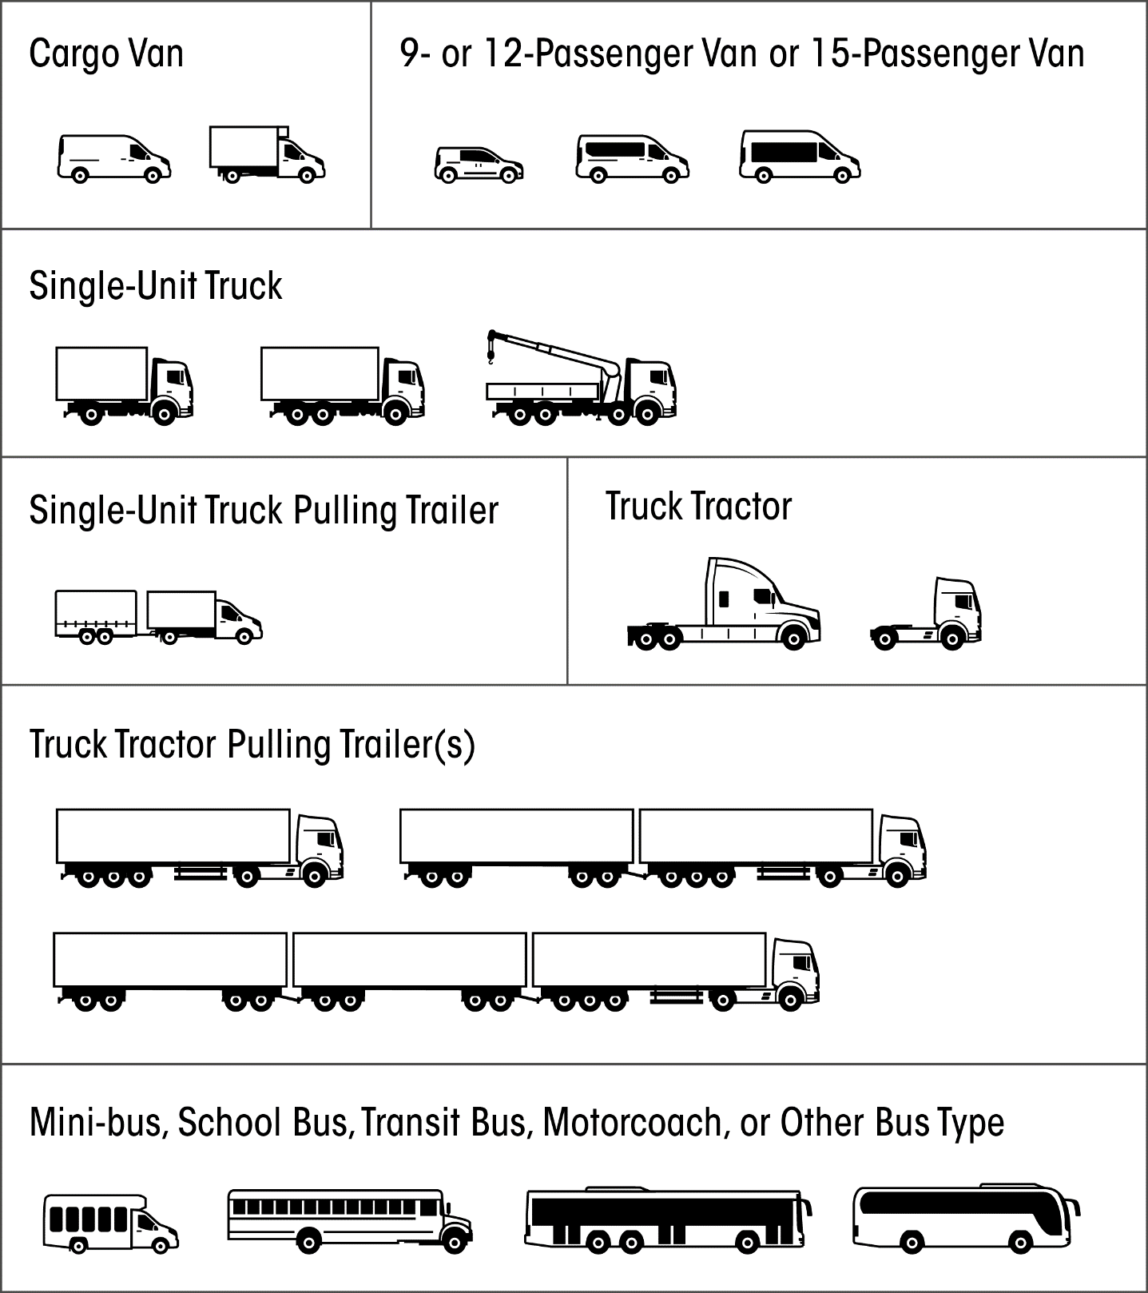

Figure 1: FMCSA Body Types

## 

## V9. Total Occupants in Motor Vehicle

|  |  |  |
| --- | --- | --- |
| Definition | The total number of injured and uninjured occupants in this motor vehicle involved in the crash, including persons in or on the motor vehicle at the time of the crash. | |
| Attribute Values: | |  |
| *x* | Total number of injured and uninjured occupants including the driver | Specify 1 |
| Rationale | Important for the officer at the scene to indicate how many people (injured and uninjured) are involved for reporting purposes. Useful for evaluating the effectiveness of countermeasures that prevent or reduce injury and injury severity. | |
| Edit Checks: | | |
| E(V)09.01 | Value of “V9. Total Occupants in Motor Vehicle” must equal the total number of Person Records for this vehicle number. | |

## V10. Special Function of Motor Vehicle in Transport

|  |  |  |
| --- | --- | --- |
| Definition | The type of special function being served by this vehicle regardless of whether the function is marked on the vehicle, at the time of the crash. Buses are any motor vehicle with seats to transport nine (9) or more people, including the driver seat, but not including vans owned and operated for personal use. | |
| Attribute Values: | |  |
| 00  01  02  03  04  05  06  07  08  09  10  11  12  13  14  15  16  17  18  19  20  21  22  23  98  99 | No Special Function  Bus – School (Public or Private)  Bus – Childcare/Daycare  Bus – Transit/Commuter  Bus – Charter/Tour  Bus – Intercity  Bus – Shuttle  Bus – Other  Farm Vehicle  Fire Truck  Highway/Maintenance  Mail Carrier  Military  Ambulance  Police  Public Utility  Non-Transport Emergency Services Vehicle  Safety Service Patrols – Incident Response  Other Incident Response  Rental Truck (Over 10,000 lbs.)  Towing – Incident Response  Truck Acting as Crash Attenuator  Taxi  Vehicle Used for Electronic Ride-hailing (transportation network company)  Other  Unknown | Select 1 |
| Rationale | Important to evaluate the outcome of vehicles used for special uses that are involved in crashes. | |
| Edit Checks: | | |
| E(V)10.01  E(V)10.02 | If “C17. School Bus Related” = 02 (Yes, School Bus Directly Involved) then there must be at least one vehicle with “V10. Special Function of Motor Vehicle in Transport”= 01 (Bus – School (Public or Private)).  If “V8. Motor Vehicle Body Type Category” = 20, 21, 23-27, “V10. Special Function of Motor Vehicle in Transport” must = 1-7. | |

## V18. Motor Vehicle Maneuver/Action

|  |  |  |
| --- | --- | --- |
| Definition | The controlled maneuver for this motor vehicle prior to the beginning of the sequence of events. | |
| Attribute Values: | |  |
| 01  02  03  04  05  06  07  08  09  10  11  12  13  98  99 | Backing  Changing Lanes  Entering Traffic Lane  Leaving Traffic Lane  Making U-Turn  Movements Essentially Straight Ahead  Negotiating a Curve  Overtaking/Passing  Parked  Slowing  Stopped in Traffic  Turning Left  Turning Right  Other  Unknown | Select 1 |
| Rationale | Important for crash evaluation, particularly when combined with sequence of events. | |
| Edit Checks: | | |
| E(V)18.01 | If “V18. Motor Vehicle Maneuver/Action” is equal to 09 (Parked), then “V2. Motor Vehicle Unit Type and Number” Subfield 1 must not equal 01 (Motor Vehicle in Transport). | |

## V19. Vehicle Damage

|  |  |  |  |  |
| --- | --- | --- | --- | --- |
| Definition | Subfield 1 of this element is intended to collect the approximate contact point on this vehicle associated with this vehicle’s initial harmful event. If the initial harmful event does not involve a collision, then code the attribute, *Non -Collision* (refer to glossary). If the initial harmful event for this vehicle involves striking another vehicle, person, or property (a collision event) by virtue of a load/cargo that falls from or is propelled by the vehicle, then code the attribute, *Cargo Loss*. If the vehicle is not at the scene for the officer to assess the initial point of contact, location of damaged area(s), or resulting extent of damage, then code the attribute, Vehicle Not at Scene, for all three Subfields.  Subfield 2 identifies all areas damaged on the vehicle as a result of this crash.  Subfield 3 identifies the extent to which the damage identified in Subfield 2 affects the vehicle’s operability rather than the cost to repair.  Refer to Appendix H: Clock-point Diagrams for Different Types of Motor  Vehicles (p. 209) for a larger version of the clock-point diagrams. | | | |
| Attribute Values: | | |  | |
| Subfield 1 | Initial Point of Contact | | Select 1 | |
| 00  01  02  03  04  05  06  07  08  09  10  11  12  13  14  15  16  99 | Non-Collision    Top  Undercarriage  Cargo Loss  Vehicle Not at Scene  Unknown | |  | |
| Subfield 2 | Location of Damaged Area(s) | | **Enter 1-13** | |
| 00  01-12  13  14  15  16 | No damage  12-Point Clock Diagram *See clock diagrams from Subfield 1*  Top  Undercarriage  All areas  Vehicle Not at Scene |  | | |
| Subfield 3 | Resulting Extent of Damage | | | Select 1 |
| 00  01  02  03  04 | No damage  Minor Damage  Functional Damage  Disabling Damage  Vehicle Not at Scene | | |  |
| Rationale | Important for use in evaluating injury severity in relation to motor vehicle impact and crash severity. | | | |
| Edit Checks: | | | | |
| E(V)19.01  E(V)19.02  E(V)19.03  E(V)19.04 | If “V19. Vehicle Damage” Subfield 1 =16 (Vehicle Not at Scene) then, V19.Subfield 2 =16 (Vehicle Not At Scene) and V19.Subfield 3 =4 (Vehicle Not At Scene)  If “V19. Vehicle Damage” Subfield 2 (V19) = 00 (No Damage) then, V19.Subfield 3 = 00 (No Damage)  If “V19. Vehicle Damage” Subfield 3 (V19) = 00 (No Damage), 01 (Minor Damage), or 02 (Functional Damage) then, “V23. Towed Due to Disabling Damage” must not =2 (Towed Due to Disabling Damage)  If “V23. Towed Due to Disabling Damage” =2 (Towed Due to Disabling Damage) then, “V19. Vehicle Damage” Subfield 3 must =03 (Disabling Damage) | | | |

## V20. Sequence of Events

|  |  |  |
| --- | --- | --- |
| Definition | The sequence of events are events in sequence related to this motor vehicle, including non-harmful events, non-collision events and collision events. For examples, refer to Appendix G: Sequence of Events Examples. | |
| Attribute Values: | |  |
| 01  02  03  04  05  06  07  08  09  10  11  12  13  14  15  16  17  18  19  20  21  22  23  24  25  26  27  28  29  30  31  32  33  34  35  36  37  38  39  40  41  42  43  44  45  46  47  48  49  50  51 | Non-Harmful Events  Cross Centerline  Cross Median  End Departure (T-intersection, dead-end, etc.)  Downhill Runaway  Equipment Failure (blown tire, brake failure, etc.)  Ran Off Roadway Left  Ran Off Roadway Right  Reentering Roadway  Separation of Units  Other Non-Harmful Event  Non-Collision Harmful Events  Cargo/Equipment Loss or Shift  Fell/Jumped From Motor Vehicle  Fire/Explosion  Immersion, Full or Partial  Jackknife  Other Non-Collision Harmful Event  Overturn/Rollover  Thrown or Falling Object  Collision With Person, Motor Vehicle, or Non-Fixed Object  Animal (live)  Motor Vehicle in Transport  Other Non-Fixed Object  Other Non-motorist  Parked Motor Vehicle  Pedalcycle  Pedestrian  Railway Vehicle (train, engine)  Strikes Object at Rest from MV in Transport  Struck by Falling, Shifting Cargo or Anything Set in Motion by Motor Vehicle  Work Zone/Maintenance Equipment  Collision With Fixed Object  Bridge Overhead Structure  Bridge Pier or Support  Bridge Rail  Cable Barrier  Concrete Traffic Barrier  Culvert  Curb  Ditch  Embankment  Fence  Guardrail End Terminal  Guardrail Face  Impact Attenuator/Crash Cushion  Mailbox  Other Fixed Object (wall, building, tunnel, etc.)  Other Post, Pole or Support  Other Traffic Barrier  Traffic Sign Support  Traffic Signal Support  Tree (standing)  Utility Pole/Light Support  Unknown Fixed Object | Select 1-4 |
| Rationale | Important for use in conjunction with “V21. Most Harmful Event for this MV” and “V18. Motor Vehicle Maneuver/Action” to generate complete information about the crash. | |
| Edit Checks: | | |
| E(V)20.01  E(V)20.02  E(V)20.03  E(V)20.04  E(V)20.05  E(V)20.06  E(V)20.07  E(V)20.08  E(V)20.09  E(V)20.10 | If any Subfield of “V20. Sequence of Events” = 48 (Traffic Signal Support), then “V17. Traffic Control Device” must not = 00 (No Controls).  If any Subfield of “V20. Sequence of Events” = 24 (Pedalcycle), at least one “P4. Person Type” in the crash must = 04 (Bicyclist) or 05 (Other Cyclist).  If any Subfield of “V20. Sequence of Events” = 25 (Pedestrian), then at least one “P4. Person Type” in the crash must = 06 (Pedestrian) or 07 (Other Pedestrian (wheelchair, person in a building, skater, personal conveyance, etc.)).  If any Subfield of “V20. Sequence of Events” = 20 (Motor Vehicle In Transport), 23 (Parked Motor Vehicle), 28 (Struck by Falling, Shifting Cargo or Anything Set in Motion by Motor Vehicle), or 29 (Work Zone/Maintenance Equipment), then “C20. Number of Motor Vehicles Involved” must = 2 or more.  If “V2. Motor Vehicle Unit Type and Number” Subfield 1 = 01 (Motor Vehicle in Transport) for this vehicle and any Subfield of “V20. Sequence of Events” = 20 (Motor Vehicle In Transport), then there must be another vehicle record with “V2. Motor Vehicle Unit Type and Number” Subfield 1 = 01 (Motor Vehicle in Transport).  If “V2. Motor Vehicle Unit Type and Number” Subfield 1 equals 01 (Motor Vehicle in Transport) for this vehicle and any Subfield of “V20. Sequence of Events” = 23 (Parked Motor Vehicle), then there must be another vehicle record with “V2. Motor Vehicle Unit Type and Number” Subfield 1 = 02 (Parked Motor Vehicle).  If “V2. Motor Vehicle Unit Type and Number” Subfield 1 equals 01 (Motor Vehicle in Transport) for this vehicle and any Subfield of “V20. Sequence of Events” = 29 (Work Zone/Maintenance Equipment), then there must be another vehicle record with “V2. Motor Vehicle Unit Type and Number” Subfield 1 = 03 (Work Zone/Maintenance Equipment).  If “V20. Sequence of Events” includes only one value in the range from 11-51 (a harmful event), then “V21. Most Harmful Event for this Motor Vehicle” must be the same as “V20. Sequence of Events”.  If any Subfield of “V20. Sequence of Events” = 01 (Cross Centerline), then “V14. Trafficway Description” Subfield 1 should equal 02 (Two Way) for this vehicle.  If any Subfield of “V20. Sequence of Events”= 02 (Cross Median), then “V14. Trafficway Description” Subfield 1 should = 02 (Two Way) and Subfield 2 should = 02 (Divided, Flush Median (greater than 4ft wide)), 03 (Divided, Raised Median), or 04 (Divided, Depressed Median). | |

## V21. Most Harmful Event for this Motor Vehicle

|  |  |  |
| --- | --- | --- |
| Definition | Event that resulted in the most severe injury or, if no injury, the greatest property damage involving this motor vehicle. | |
| Attribute Values: | |  |
| 01  02  03  04  05  06  07  08  09  10  11  12  13  14  15  16  17  18  19  20  21  22  23  24  25  26  27  28  29  30  31  32  33  34  35  36  37  38  39  40  41 | Non-Collision Harmful Events  Cargo/Equipment Loss or Shift  Fell/Jumped From Motor Vehicle  Fire/Explosion  Immersion, Full or Partial  Jackknife  Other Non-Collision Harmful Event  Overturn/Rollover  Thrown or Falling Object  Collision With Person, Motor Vehicle, or Non-Fixed Object  Animal (live)  Motor Vehicle in Transport  Other Non-Fixed Object  Other Non-motorist  Parked Motor Vehicle  Pedalcycle  Pedestrian  Railway Vehicle (train, engine)  Strikes Object at Rest from MV in Transport  Struck by Falling, Shifting Cargo or Anything Set in Motion by Motor Vehicle  Work Zone/Maintenance Equipment  Collision With Fixed Object  Bridge Overhead Structure  Bridge Pier or Support  Bridge Rail  Cable Barrier  Concrete Traffic Barrier  Culvert  Curb  Ditch  Embankment  Fence  Guardrail End Terminal  Guardrail Face  Impact Attenuator/Crash Cushion  Mailbox  Other Fixed Object (wall, building, tunnel, etc.)  Other Post, Pole or Support  Other Traffic Barrier  Traffic Sign Support  Traffic Signal Support  Tree (standing)  Utility Pole/Light Support  Unknown Collision With Fixed Object | Select 1 |
| Rationale | Important for use in conjunction with the Sequence of Events (V20) to generate complete information about the crash. | |
| Edit Checks: | | |
| E(V)21.01  E(V)21.02  E(V)21.03 | If “V21. Most Harmful Event for this Vehicle”=15 (Pedalcycle), at least one “P4. Person Type” in the crash must =4 or 5 and at least one Subfield of “V20. Sequence of Events” must =26(pedalcycle)  If “V21. Most Harmful Event for this Vehicle”=16 (Pedestrian), then at least one “P4. Person Type” in the crash must =6 or 7 and at least one Subfield of “V20. Sequence of Events” must =27(Pedestrian)  “V21. Most Harmful Event for this Vehicle” must equal at least one subfield of “V20. Sequence of Events”. | |

## V22. Hit and Run

|  |  |  |
| --- | --- | --- |
| Definition | Refers to cases where the vehicle or the driver of the vehicle in transport is a contact vehicle in the crash and departs the scene without stopping to render aid or report the crash. | |
| Attribute Values: | |  |
| 01  02 | No, Did Not Leave Scene  Yes, Driver or Car and Driver Left Scene | Select 1 |
| Rationale | Important for uniformity, quality control and identification purposes in reported motor vehicle crash statistics. | |
| Edit Checks: | | |
| E(V)22.01 | “V22. Hit and Run” should not = 02 (Yes, Driver or Car and Driver Left Scene) for more than one vehicle record. | |

## V23. Towed Due to Disabling Damage

|  |  |  |
| --- | --- | --- |
| Definition | Disabling damage implies damage to the motor vehicle that is sufficient to require the motor vehicle to be towed or carried from the scene. Towed Due to Disabling Damage identifies whether a vehicle involved in a crash is removed from the scene. Towing assistance without removal of the vehicle from the scene, such as pulling a vehicle out of a ditch, is not considered to be “towed” for the purposes of this element. | |
| Attribute Values: | |  |
| 00  01  02 | Not towed  Towed, But Not Due to Disabling Damage  Towed Due to Disabling Damage | Select 1 |
| Rationale | Towed Due to Disabling Damage is important for identifying non-injury, “tow-away” crashes due to damage sustained in the crash. This information is vital to Federal Motor Carrier Safety Administration in their selection criteria for truck and bus crashes. | |
| Edit Checks: | | |
| E(V)23.01 | If any value in V8 Subfield 1, 3, or 4 is one of the marked large vehicle codes (indicated by **), and [“V23. Towed due to Disabling Damage” = 02 (Towed Due to Disabling Damage) and/or (the sum of “C22. Number of Non-Fatally Injured Persons” and “C23. Number of Fatalities” is greater than 0)], then the Large Vehicle/Hazardous Materials Section must be completed. | |

## V24. Contributing Circumstances, Motor Vehicle

|  |  |  |
| --- | --- | --- |
| Definition | Pre-existing motor vehicle defects or maintenance conditions that may have contributed to the crash. | |
| Attribute Values: | |  |
| 00  01  02  03  04  05  06  07  08  09  10  11  12  13  98  99 | None  Brakes  Exhaust System  Body, Doors  Steering  Power Train  Suspension  Tires  Wheels  Lights (head, signal, tail)  Windows/Windshield  Mirrors  Wipers  Truck Coupling / Trailer Hitch / Safety Chains  Other  Unknown | Select 1 |
| Rationale | Important for determining the significance of pre-existing problems, including equipment and operation, in motor vehicles involved in crashes that could be useful in determining the need for improvements in manufacturing and consumer alerts. | |
| Edit Checks: | | |
|  | None | |

# Person Data Elements

The person data elements describe the characteristics, actions, and consequences to the persons involved in the crash.

### **Level 1: All Persons Involved**

## P1. Name of Person Involved

|  |  |  |
| --- | --- | --- |
| Definition | The full name of the individual involved in the crash. | |
| Attribute Values: | |  |
|  | Name | Specify 1 |
| Rationale | This data element should be collected to facilitate linkage when names are available in the health and insurance files and to corroborate the driver license number of drivers. When possible, obtain this information from the driver license. | |
| Edit Checks: | | |
| E(P)01.01 | Compare to current record in the Driver License File. | |

## P2. Date of Birth

|  |  |  |
| --- | --- | --- |
| Definition | The year, month, and day of birth, (or age to be used only when date of birth cannot be obtained), of the person involved in a crash. | |
| Attribute Values: | |  |
| Subfield 1 | Date of Birth | Specify 1 |
| *YYYY*  01-12  01-31  99 | Year (YYYY)  Month (MM)  Day (DD)  Unknown  *Example: 2017, 99, 99 denotes only the year is known.*  *2017, 02, 99 denotes February 2017, but day of month was unknown.* |  |
| Subfield 2 | Age | Specify 1 |
| *AAA* | Age |  |
| Rationale | Accurate reporting of date of birth is used to assess the effectiveness of occupant protection systems for specific age groups, and to identify the need for safety programs directed toward them. This element is also critical in providing linkage between the crash, EMS, and hospital records. | |
| Edit Checks: | | |
| E(P)02.01 | If “P4. Person Type” Subfield1 = 01 (Driver), compare to Date of Birth in the Driver License File. | |

## P4. Person Type

|  |  |  |
| --- | --- | --- |
| Definition | Type of person involved in a crash. | |
| Attribute Values: | |  |
| Subfield 1 | Person Type | Select 1 |
| 01  02  03  04  05  06  07  08  09  99 | Motorist  Driver  Passenger  Occupant of MV Not in Transport  Non-Motorist**  Bicyclist  Other Cyclist  Pedestrian  Other Pedestrian (wheelchair, person in a building, skater, personal conveyance, etc.)  Occupant of a Non-Motor Vehicle Transportation Device  Unknown Type of Non-Motorist  Unknown |  |
| Subfield 2 | Incident Responder? | Select 1 |
| 01  02  03  04  05  06  98  99 | No  Yes, Type of Incident Responder  EMS  Fire  Police  Tow Operator  Transportation (i.e. maintenance workers, safety service patrol operators, etc.)  Other  Unknown |  |
| Rationale | Person type and presence of incident responders allows classification to evaluate specific countermeasures designed for specific groups of people.  **If attribute is selected from Subfield 1, the Non-Motorist Crash Section must be completed.** | |
| Edit Checks: | | |
| E(P)04.01  E(P)04.02  E(P)04.03 | If “P4. Person Type” Subfield 1 = 04 - 09, then Non-Motorist Crash Section must be completed.  If “P4. Person Type” Subfield 1 = 01 (Driver) or 02 (Passenger), then “V2. Motor Vehicle Unit Type and Number” Subfield 1 must equal 01 (Motor Vehicle in Transport) for the vehicle number identified in “P6. Occupant’s Motor Vehicle Unit Number”.  If “P4. Person Type” Subfield 1 = 03 (Occupant of MV Not in Transport), then “V2. Motor Vehicle Unit Type and Number” Subfield 1 must equal 02 (Parked Motor Vehicle) or 03 (Working Vehicle/Equipment) for the vehicle number identified in “P6. Occupant’s Motor Vehicle Unit Number”. | |

## P5. Injury Status

|  |  |  |
| --- | --- | --- |
| Definition | The injury severity level for a person Involved in a crash. The determination of which attribute to assign should be based on the latest information available at the time the report is completed, except as described below for fatal Injuries.  Fatal Injury (K): A fatal injury is any injury that results in death within 30 days after the motor vehicle crash in which the injury occurred. If the person did not die at the scene but died within 30 days of the motor vehicle crash in which the injury occurred, the injury classification should be changed from the attribute previously assigned to the attribute “Fatal Injury.”  Suspected Serious Injury (A): A suspected serious injury is any injury other than fatal which results in one or more of the following:   * Severe laceration resulting in exposure of underlying tissues/muscle/organs or resulting in significant loss of blood * Broken or distorted extremity (arm or leg) * Crush injuries * Suspected skull, chest or abdominal injury other than bruises or minor lacerations * Significant burns (second and third degree burns over 10% or more of the body) * Unconsciousness when taken from the crash scene * Paralysis   Suspected Minor Injury (B): A minor injury is any injury that is evident at the scene of the crash, other than fatal or serious injuries. Examples include lump on the head, abrasions, bruises, minor lacerations (cuts on the skin surface with minimal bleeding and no exposure of deeper tissue/muscle).  Possible Injury (C): A possible injury is any injury reported or claimed which is not a fatal, suspected serious or suspected minor injury. Examples include momentary loss of consciousness, claim of injury, limping, or complaint of pain or nausea. Possible injuries are those that are reported by the person or are indicated by his/her behavior, but no wounds or injuries are readily evident.  No Apparent Injury (O): No apparent injury is a situation where there is no reason to believe that the person received any bodily harm from the motor vehicle crash. There is no physical evidence of injury and the person does not report any change in normal function. | |
| Attribute Values: | |  |
| 01  02  03  04  05 | (K) Fatal Injury**  (A) Suspected Serious Injury  (B) Suspected Minor Injury  (C) Possible Injury  (O) No Apparent Injury | Select 1 |
| Rationale | Necessary for injury outcome analysis and evaluation. This element is also critical in providing linkage between the crash, EMS, and hospital records.  *Note:* The Federal Highway Administration’s (FHWA) Safety Performance Management Measures Final Rule (23 CFR 490) and the National Highway Traffic Safety Administration’s (NHTSA) Uniform Procedures for State Highway Safety Grants Program Interim Final Rule (23 CFR 1300) establish a single, national definition for States to report serious injuries per the Model Minimum Uniform Crash Criteria (MMUCC) 4th Edition “*Suspected Serious Injury (A)*” attribute found in the “Injury Status” element.  **If attribute is selected the Fatal Crash Section must be completed.** | |
| Edit Checks: | | |
| E(P)05.01 | If “P5. Injury Status” = 01 ((K) Fatal Injury), the Fatal Crash Section must be completed. | |

### **Level 2: All Occupants**

## P6. Occupant’s Motor Vehicle Unit Number

|  |  |  |
| --- | --- | --- |
| Definition | The unique number assigned for this crash to the motor vehicle in which this person was an occupant. Persons ejected or who fall from a vehicle are still considered occupants. | |
| Attribute Values: | |  |
| 01-*n* | Number to indicate in which motor vehicle the occupant was located | Specify 1 |
| Rationale | Important to link occupants back to motor vehicles in which they were riding. Necessary, for example, to evaluate the effect motor vehicle type and specific make/model have on occupant protection effectiveness and injury status. | |
| Edit Checks: | | |
|  | None | |

## P7. Seating Position

|  |  |  |
| --- | --- | --- |
| Definition | The location for this occupant in, on, or outside of the motor vehicle prior to the first event in the sequence of events. Refer to Figure 8 (p. 70) for diagram of common vehicle types, to include ambulance seating/positioning. | |
| Attribute Values: | |  |
| 01  02  03  04  05  06  07  08  09  10  11  12  13  14  15  98  99 | Row  Front  Second  Third  Fourth  Other Row (bus, 15 passenger van, etc.)  Unknown Row  Seat  Left (*usually the motor vehicle or motorcycle driver except for postal vehicles and some foreign vehicles*)  Middle  Right  Unknown Seat  Other Location  Other Enclosed Cargo Area  Riding on Motor Vehicle Exterior (non-trailing unit)  Sleeper Section of Cab (truck)  Trailing Unit  Unenclosed Cargo Area  Not Applicable  Unknown | Select 1-2 |
| Rationale | Without known seating position for each person in the motor vehicle, it is not possible to fully evaluate, for example, the effect of occupant protection programs. | |
| Edit Checks: | | |
| E(P)07.01  E(P)07.02  E(P)07.03 | If “P7. Seating Position” any value = 05 (Other Row (bus, 15 passenger van, etc.)), “V8. Motor Vehicle Body Type Category” should = 20-26.  If “P7. Seating Position” = 12-16, 98, or 99 then only this one value may be used.  If “P7. Seating Position” first field is not equal to 12-16, 98, or 99 then it must equal 01-06 and the second field must equal 07-11. | |

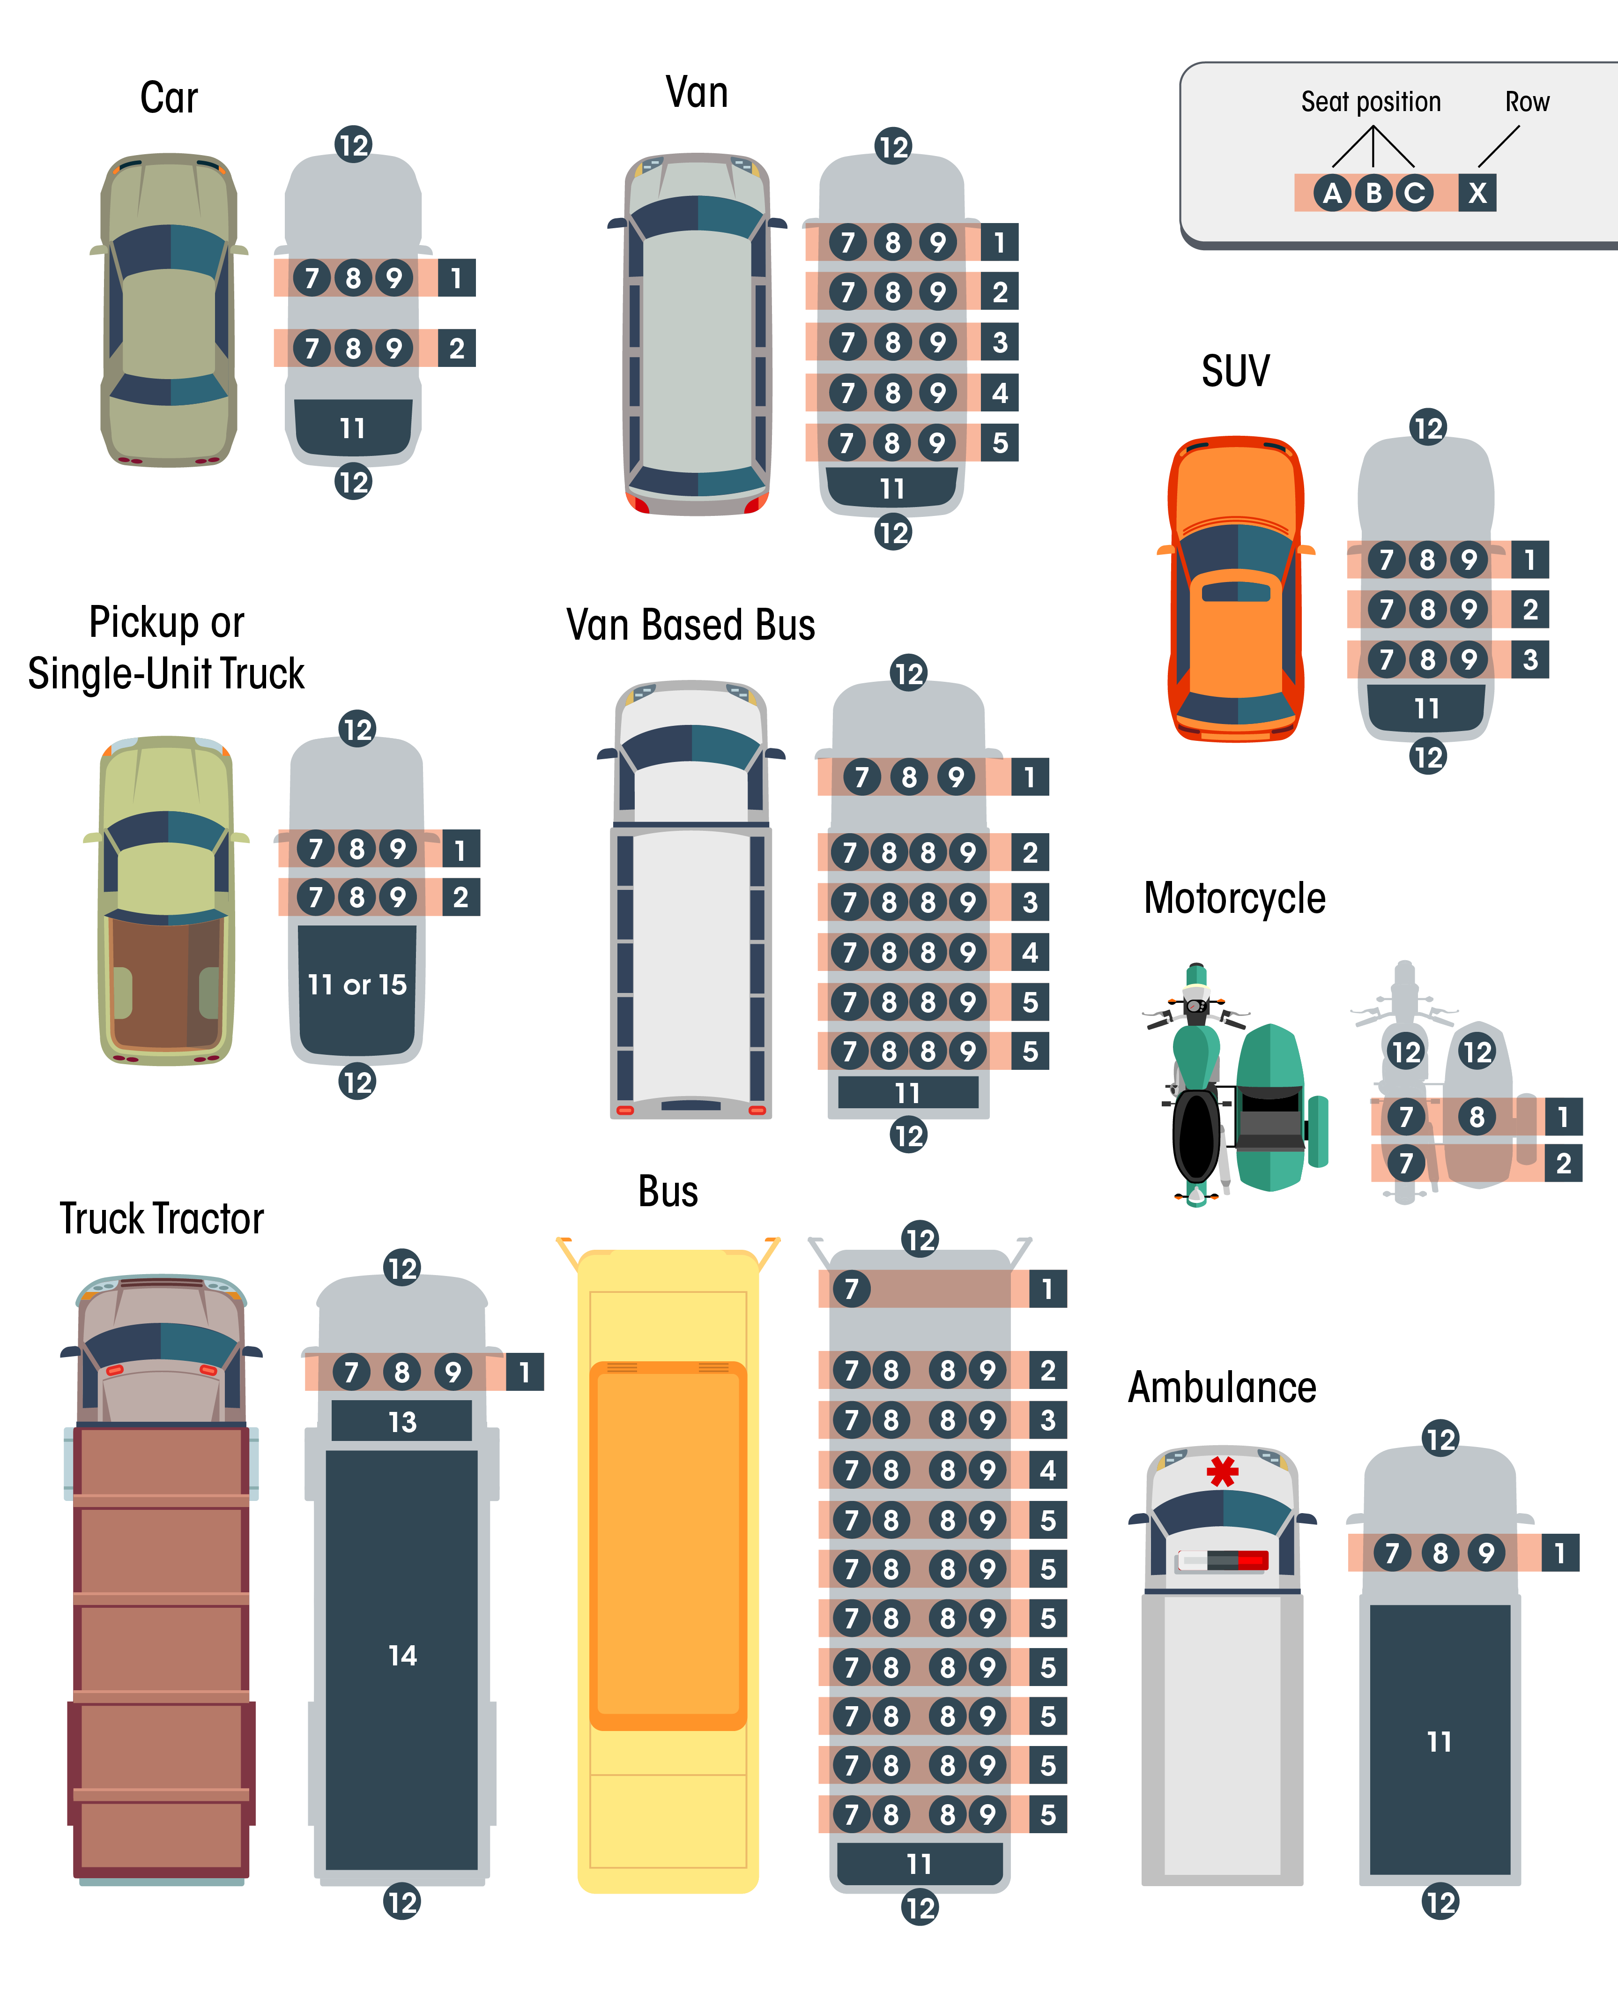

Figure 2: Example Seating Positions for Typical Vehicle Types

## P8. Restraint Systems/Motorcycle Helmet Use

|  |  |  |
| --- | --- | --- |
| Definition | The restraint equipment in use by the occupant, or the helmet use by a motorcyclist, at the time of the crash. | |
| Attribute Values: | |  |
| Subfield 1 |  | Select 1 |
| 01  02  03  04  05  06  07  08  09  10  11  12  13  14  15  97  98  99 | Restraint Systems  Booster Seat  Child Restraint System – Forward Facing  Child Restraint System – Rear Facing  Child Restraint – Type Unknown  Lap Belt Only Used  None Used – Motor Vehicle Occupant  Restraint Used – Type Unknown  Shoulder and Lap Belt Used  Shoulder Belt Only Used  Stretcher  Wheelchair  Motorcycle Helmet Use  DOT-Compliant Motorcycle Helmet  Not DOT-Compliant Motorcycle Helmet  Unknown If DOT-Compliant Motorcycle Helmet  No Helmet  Not Applicable  Other  Unknown |  |
| Subfield 2 | Any Indication of Improper Use? | Select 1 |
| 01  02 | No  Yes |  |
| Rationale | Proper classification of the use of available occupant restraint systems and helmet use is vital to evaluating the effectiveness of such equipment. | |
| Edit Checks: | | |
| E(P)08.01 | If “V8. Motor Vehicle Body Type Category” = 05 (Moped or motorized bicycle), 07 (2-Wheeled Motorcycle), or 08 (3-Wheeled Motorcycle) for the vehicle in “P6. Occupant’s Motor Vehicle Unit Number” then “P8. Restraint Systems/Motorcycle Helmet Use” must = 12-15 or 98-99. | |

## P9. Air Bag Deployed

|  |  |  |
| --- | --- | --- |
| Definition | Deployment status of an airbag relative to a position in the vehicle for this occupant. See Figure 9: Air Bag Diagram (p.73). | |
| Attribute Values: | |  |
| 00  01  02  03  04  05  97 | Not Deployed  Deployment  Curtain  Front  Side  Other (knee, air belt, etc.)  Deployment Unknown  Not Applicable | Select 1-4 |
| Rationale | Necessary to evaluate the effectiveness of airbags and other occupant protection equipment. | |
| Edit Checks: | | |
| E(P)09.01  E(P)09.02  E(P)09.03 | If “P9. Air Bag Deployed” = 01-05 then “V6. Motor Vehicle Model Year” should be greater than 1997 for the vehicle in “P6. Occupant’s Motor Vehicle Unit”.  If “P9. Air Bag Deployed” = 01-05 then “P7. Seating Position” should equal the outboard seats in the first three rows.  If “P9. Air Bag Deployed” = 02 (Front) then “P7. Seating Position” should equal 01 (Front) row. | |

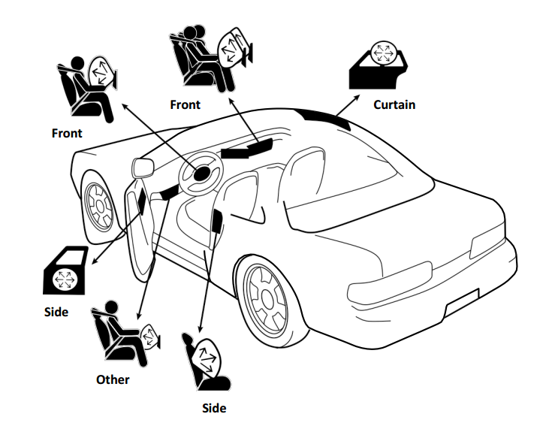

Figure 3: Air Bag Diagram

## P10. Ejection

|  |  |  |
| --- | --- | --- |
| Definition | Occupant completely or partially thrown from the interior of the motor vehicle, excluding motorcycles, as a result of a crash. | |
| Attribute Values: | |  |
| 00  01  02  97  99 | Not Ejected  Ejected, Partially  Ejected, Totally  Not Applicable  Unknown | Select 1 |
| Rationale | Occupant protection systems prevent or mitigate ejections to various degrees. Analyses of the effectiveness of safety systems depend on information from this data element. | |
| Edit Checks: | | |
| E(P)10.01  E(P)10.02 | If “V8. Motor Vehicle Body Type Category” = 05 (Moped or motorized bicycle), 07 (2-Wheeled Motorcycle), or 08 (3-Wheeled Motorcycle) for the vehicle in “P6. Occupant’s Motor Vehicle Unit Number” then “P10. Ejection” must = 97 (Not Applicable).  If “P10. Ejection” = 00 (Not Ejected), 01 (Ejected, Partially), or 02 (Ejected, Totally) then “P7. Seating Position” must not = 13 (Riding on Motor Vehicle Exterior). | |

### **Level 3: All Drivers**

## P11. Driver License Jurisdiction

|  |  |  |
| --- | --- | --- |
| Definition | The geographic or political entity issuing a driver license. Includes the States of the United States (including the District of Columbia and outlying areas), Indian Nations, U.S. Government, Canadian Provinces, and Mexican States (including the Distrito Federal), as well as other jurisdictions. | |
| Attribute Values: | |  |
| Subfield 1 | Type | Select 1 |
| 00  01  02  03  04  05  06  97  99 | Not Licensed  Canada  Indian Nation  International License (other than Mexico, Canada)  Mexico  State  U.S. Government  Not Applicable  Unknown |  |
| Subfield 2 | Name of Jurisdiction (ANSI Code) | Specify |
|  | *Provide the specific State, Province or Nation indicated on the Driver’s License (see Appendix E: ANSI State FIPS and USPS Codes or Appendix F: ISO 3166-2 Codes for Canada and Mexico)* |  |
| Rationale | Necessary to evaluate the effectiveness of various licensing laws. This element is also critical in providing linkage between the crash and driver license files at the State level. | |
| Edit Checks: | | |
|  | None | |

## P12. Driver License Number, Class, CDL and Endorsements

|  |  |  |
| --- | --- | --- |
| Definition | A unique set of alphanumeric characters assigned by the authorizing agent issuing a driver license to the individual. See Figure 10: FMCSA CDL Endorsements, Visor Card (Front) (p. 75) and Figure 11: FMCSA CDL Commercial Motor Vehicle Groups, Visor Card (Back) (p. 76) for reference.  Class indicates the type of driver’s license issued by the State and the type of motor vehicle the driver is qualified to drive.  Class A: Any combination of vehicles with a gross combination weight rating (GCWR) of 26,001 pounds or more provided the GVWR of the vehicle(s) being towed is in excess of 10,000 pounds.  Class B: Any single vehicle with a GVWR of 26,001 or more pounds, or any such vehicle towing a vehicle not in excess of 10,000 pounds GVWR.  Class C: Any single vehicle, or combination of vehicles, that does not meet the definition of Class A or Class B, but is either designed to transport 16 or more passengers, including the driver, or is used in the transportation of materials found to be hazardous which require the motor vehicle to be placarded.  Class M: Motorcycles, Mopeds, Motor-Driven Cycles.  Regular Driver License Class: Any regular or standard driver license issued for the operation of automobiles and light trucks by States that separate these vehicles from Class “C”. Other class designation codes such as “D”, “R” and others may be used by States to indicate a regular driver license class.  Commercial Driver License (CDL): This indicates whether the driver license is a commercial driver license (CDL). In addition, this information is important to separate the non-commercial licenses included by some States in Class C with the commercial licenses.  Endorsements: This indicates any endorsements to the driver license, both commercial and non-commercial. | |
| Attribute Values: | |  |
| Subfield 1 | License Number | Specify |
|  | *License Number – Alphanumeric identifier assigned by the authorizing jurisdiction (State, foreign country, U.S. government, Indian Nation, etc.).* |  |
| Subfield 2 | Class | Select 1 |
| 00  01  02  03  04  05  97 | None  Class A  Class B  Class C  Class M  Regular Driver License Class  Not Applicable |  |
| Subfield 3 | Commercial Driver License (CDL) | Select 1 |
| 01  02 | No  Yes |  |
| Subfield 4 | Endorsements | Select 1 |
| 00  01  02  03  04  05  06  07 | None/Not Applicable  H - Hazardous Materials  N - Tank Vehicle  P - Passenger  S - School  T - Double/Triple Trailers  X - Combination of Tank Vehicle and Hazardous Materials  Other non-commercial license endorsements (e.g., motorcycle, etc.) |  |
| Rationale | This information is mandated by FMCSA for commercial drivers. This element is critical to providing linkage between the crash and driver license files at the State level. | |
| Edit Checks: | | |
|  | None | |

### FMCSA Commercial Driver’s License Endorsements and Class

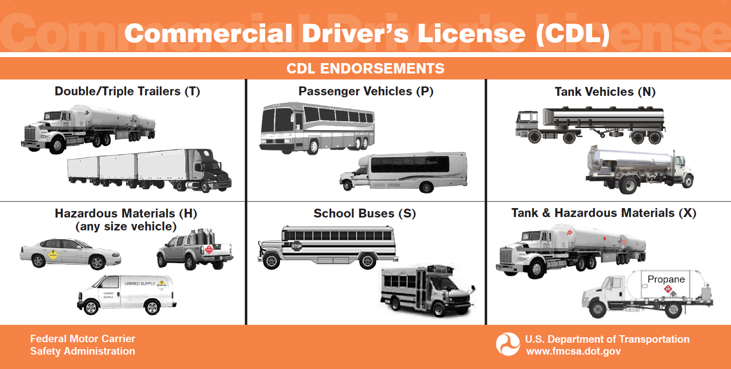

Figure 4: FMCSA CDL Endorsements, Visor Card (Front)

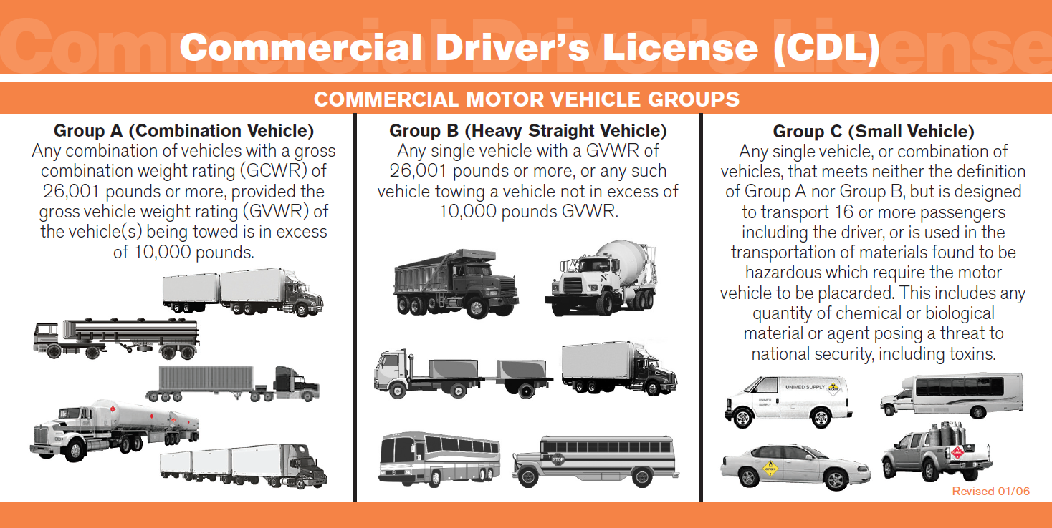

Figure 5: FMCSA CDL Commercial Motor Vehicle Groups, Visor Card (Back)

## P13. Speeding Related

|  |  |  |
| --- | --- | --- |
| Definition | Indication of whether the investigating officer suspects that the driver involved in the crash was speeding based on verbal or physical evidence and not on speculation alone. | |
| Attribute Values: | |  |
| 01  02  03  04  99 | No  Exceeded Speed Limit  Racing  Too Fast for Conditions  Unknown | Select 1 |
| Rationale | Important for evaluating preventive programs and engineering assessments. | |
| Edit Checks: | | |
| E(P)13.01 | If “P13. Speeding Related” = 01 (Exceeded Speed Limit) then “V12. Motor Vehicle Posted/Statutory Speed Limit” must not = 97 (Not Applicable) or 99 (Unknown) | |

## P14. Driver Actions at Time of Crash

|  |  |  |
| --- | --- | --- |
| Definition | The actions by the driver that may have contributed to the crash. This data element is based on the judgment of the law enforcement officer investigating the crash and need not match “P15. Violation Codes.” | |
| Attribute Values: | |  |
| 00  01  02  03  04  05  06  07  08  09  10  11  12  13  14  15  16  98  99 | No Contributing Action  Disregarded Other Road Markings  Disregarded Other Traffic Sign  Failed to Keep in Proper Lane  Failed to Yield Right-of-Way  Followed Too Closely  Improper Backing  Improper Passing  Improper Turn  Operated Motor Vehicle in Inattentive, Careless, Negligent, or Erratic Manner  Operated Motor Vehicle in Reckless or Aggressive Manner  Over-Correcting/Over-Steering  Ran Off Roadway  Ran Red Light  Ran Stop Sign  Swerved or Avoided Due to Wind, Slippery Surface, Motor Vehicle, Object, Non-Motorist in Roadway, etc.  Wrong Side or Wrong Way  Other Contributing Action  Unknown | Select 1-4 |
| Rationale | Important for evaluating the effect that dangerous driver behavior has on crashes. | |
| Edit Checks: | | |
| E(P)14.01 | If “P14. Driver Actions at Time of Crash” = 13(Ran Red Light) or 14 (Ran Stop Sign) then “V17. Traffic Control Device” must not = 00 (No Control). | |

## P16. Driver License Restrictions

|  |  |  |
| --- | --- | --- |
| Definition | Restrictions assigned to an individual’s driver license by the license examiner.  Source: Obtained by linking Driver License Number, Class, CDL and Endorsement (P12) for in-State drivers to the driver license number in the driver history data system. | |
| Attribute Values: | |  |
| Subfield 1 | Driver Restrictions | Specify 1-3 |
| 00  01  02  03  04  05  06  07  08  09  10  11  12  13  14  15  16  17  98 | None  Alcohol Interlock Device  CDL Intrastate Only  Corrective Lenses  Farm Waiver  Except Class A Bus  Except Class A and Class B Bus  Except Tractor-Trailer  Intermediate License Restrictions  Learner’s Permit Restrictions  Limited to Daylight Only  Limited to Employment  Limited-Other  Mechanical Devices (special brakes, hand controls, or other adaptive devices)  Military Vehicles Only  Motor Vehicles Without Air Brakes  Outside Mirror  Prosthetic Aid  Other |  |
| Subfield 2 | Alcohol Interlock Present? | Select 1 |
| 01  02  99 | No  Yes  Unknown |  |
| Rationale | Used to identify if a driver involved in crash has limitations on their driver license. | |
| Edit Checks: | | |
| E(C)15.01 | If “P4. Person Type” Subfield 1 = 01 (Driver), “P16. Driver License Restrictions” Subfield 1 = 01 (Alcohol Interlock Device) and Subfield 2 = 01 (No), then “P15. Violation Codes” should not = 00 (No Violation) or 99 (Unknown). | |

## P17. Driver License Status

|  |  |  |
| --- | --- | --- |
| Definition | The current status of an individual’s driver license at the time of the crash.  Source: Obtained by linking Driver License Number, Class, CDL and Endorsement (P12) with the Driver History data file. | |
| Attribute Values: | |  |
| Subfield 1 | Type Applicable for This Person | Select 1 |
| 01  02  03 | Non-CDL Driver license  Non-CDL Restricted Driver license (Learner’s permit, Temporary/Limited, Graduated Driver license, etc.)  Commercial Driver License (CDL) |  |
| Subfield 2 | Status | Select 1 |
| 00  01  02  03  04  05  06  99 | Not Licensed  Canceled or Denied  Disqualified (CDL)  Expired  Revoked  Suspended  Valid License  Unknown |  |
| Rationale | Used to identify if a driver involved in crash is in compliance with the limitations of their driver license. | |
| Edit Checks: | | |
| E(P)17.01  E(P)17.02 | If “P4. Person Type” Subfield 1 = 01 (Driver) and “P17. Driver License Status” Subfield 2 (*Status*) does not = 06 (Valid License) then “P15. Violation Codes” should not = 00 (No Violation) or 99 (Unknown).  If “P4. Person Type” Subfield 1 = 01 (Driver), “V8. Motor Vehicle Body Type Category” equals any of the marked commercial vehicle types (marked with **), and “P17. Driver License Status” Subfield 1 does not = 03 (Commercial Driver License) then “P15. Violation Codes” should not = 00 (No Violation) or 99 (Unknown). | |

### **Level 4: All Drivers and Non-Motorists**

## P18. Distracted By

|  |  |  |
| --- | --- | --- |
| Definition | Distractions that may have influenced driver/non-motorist performance, involving both an action taken by the driver/non-motorist and the source of the distraction. | |
| Attribute Values: | |  |
| Subfield 1 | Action | Select 1 |
| 00  01  02  03  99 | Not Distracted  Talking/listening  Manually Operating (texting, dialing, playing game, etc.)  Other Action (looking away from task, etc.)  Unknown |  |
| Subfield 2 | Source | Select 1 |
| 01  02  03  04  05  06  07  97  99 | Hands-Free Mobile Phone  Hand-Held Mobile Phone  Other Electronic Device  Vehicle-Integrated Device  Passenger/Other Non-Motorist  External (to vehicle/non-motorist area)  Other Distraction (animal, food, grooming)  Not Applicable (Not Distracted)  Unknown |  |
| Rationale | Important to identify specific driver behavior during a crash and understand and mitigate the effects of distracting activities. | |
| Edit Checks: | | |
| E(P)18.01  E(P)18.02 | If “P18. Distracted By” Subfield 1 = 02 (Manually Operating (texting, dialing, playing game, etc.)), then P18 Subfield 2 should not = 05 (Passenger/ Other Non-Motorist) or 06 (External (to vehicle/non-motorist area)).  If “P18. Distracted By” Subfield 1 = 00 (Not Distracted), then Subfield 2 must = 97 (Not Applicable (Not Distracted)). | |

## P20. Law Enforcement Suspects Alcohol Use

|  |  |  |
| --- | --- | --- |
| Definition | Driver or non-motorist involved in the crash suspected by law enforcement to have used alcohol. | |
| Attribute Values: | |  |
| 01  02  99 | No  Yes  Unknown | Select 1 |
| Rationale | Alcohol-related crashes remain a serious traffic safety problem. Identifying crashes in which alcohol may have been involved will help evaluate the effectiveness of programs to decrease the incidence of drunk driving or to identify problem areas. | |
| Edit Checks: | | |
| E(P)20.01 | If “P20. Law Enforcement Suspects Alcohol Use” = 02 (Yes), then “P22. Alcohol Test” Subfield 1 (*Test Status*) should not = 00 (Test Not Given) or 99 (Unknown if Tested), and P22 Subfield 2 and Subfield 3 should not = 97 (Not Applicable).  *Note: States may wish to use this as a warning edit if their practices allow officers to indicate suspicion without testing the BAC.* | |

## P21. Alcohol Test

|  |  |  |
| --- | --- | --- |
| Definition | Indication of the presence of alcohol by test, type, and result. | |
| Attribute Values: | |  |
| Subfield 1 | Test Status | Select 1 |
| 00  01  02  99 | Test Not Given  Test Given  Test Refused  Unknown if Tested |  |
| Subfield 2 | Type of Test | Select 1 |
| 01  02  03  97  98 | Blood  Breath  Urine  Not Applicable (Test Not Given)  Other |  |
| Subfield 3 | BAC Test Result | Specify 1 |
| *Value*  01  97  99 | *Value*  Pending  Not Applicable (Test Not Given)  Unknown |  |
| Rationale | Alcohol remains the most prevalent drug involved in motor vehicle crashes. Capturing alcohol concentration whenever a driver or non-motorist is tested will provide an accurate assessment of the role of alcohol involvement. The type of test used to obtain the alcohol concentration also is important information to collect. | |
| Edit Checks: | | |
| E(P)21.01 | If “P21. Alcohol Test” Subfield 3 reports a BAC test value, then P21 Subfield 1 and P21 Subfield 2 must not equal 97 (Not Applicable/test not given); P21 Subfield 1 should not equal 00 (Test not given) or 99 (Unknown if Tested); and P21 Subfield 2 must not be blank. | |

## P22. Law Enforcement Suspects Drug Use

|  |  |  |
| --- | --- | --- |
| Definition | Driver or non-motorist involved in the crash suspected by law enforcement to have used drugs. | |
| Attribute Values: | |  |
| 01  02  99 | No  Yes  Unknown | Select 1 |
| Rationale | Drug-related crashes remain a serious traffic safety problem. Identifying crashes in which drugs may have been involved will help evaluate the effectiveness of programs to decrease the incidence of driving while under the influence of drugs. | |
| Edit Checks: | | |
| E(P)22.01 | If “P22. Law Enforcement Suspects Drug Use” = 02 (Yes), “P23. Drug Test” Subfield 1 should not equal 00 (Test not given) or 99 (Unknown if Tested). | |

## P23. Drug Test

|  |  |  |
| --- | --- | --- |
| Definition | Indication of the presence of drug test, type, BAC result and overall result. Excludes drugs administered post-crash. | |
| Attribute Values: | |  |
| Subfield 1 | Test Status | Select 1 |
| 00  01  02  99 | Test Not Given  Test Given  Test Refused  Unknown if Tested |  |
| Subfield 2 | Type of Test | Select 1 |
| 01  02  03  97  98 | Blood  Saliva  Urine  Not Applicable (Test Not Given)  Other |  |
| Subfield 3 | Drug Test Result | Select 1-4 |
| 01  02  03  04  05  06  07  08  97  99 | Negative  Positive Test Results  Amphetamine  Cocaine  Marijuana  Opiate  Other Controlled Substance  PCP  Other Drug (excludes post-crash drugs)  Not Applicable (Test Not Given)  Unknown |  |
| Rationale | Identifying drug-related crashes help develop and evaluate programs directed at reducing their involvement. Whenever evidence of other drug use is available, it should be captured. | |
| Edit Checks: | | |
| E(P)23.01 | If “P23. Drug Test” Subfield 3 = 01 (Negative) or 02 (Positive), then Subfield 1 should not equal 00 (Test Not Given) and Subfield 2 should not equal 97 (Not Applicable (Test Not Given)). | |

### **Level 5: All Injured**

# Large Vehicles and Hazardous Material Section

The Federal Motor Carrier Safety Administration (FMCSA) analyzes crashes involving large vehicles, including a truck with a gross vehicle weight rating greater than 10,000 pounds and any motor vehicle designed primarily to transport nine (9) or more persons, as well as vehicles carrying hazardous materials in order to identify safety risks and develop and evaluate safety countermeasures. FMCSA relies on crash reports to accomplish this mission and has created the Large Vehicle and Hazardous Materials (LVHM) Section in MMUCC 5th Edition to enhance the quality and accuracy of crash data. Following an NTSB recommendation, the LVHM Section incorporates elements to collect data on up to three trailing units.

Currently, there is no Federal database that collects this type of information, and it would allow the Agency to study trailer use and safety. The addition of the trailing unit data elements, the LVHM Section includes elements to capture vehicle weights and special permitting (e.g. oversize). If a crash fits the reporting criteria for the LVHM section, both elements in the main MMUCC and LVHM Section must be captured in order to align with the model minimum criteria. For that reason, several elements in main MMUCC include triggers to alert the States and law enforcement personnel that they must fill out the LVHM Section based on the attribute(s) selected. Each of these elements is completed only for large vehicles or hazardous material-carrying vehicles.

### Truck and Bus Crashes Reportable to FMCSA

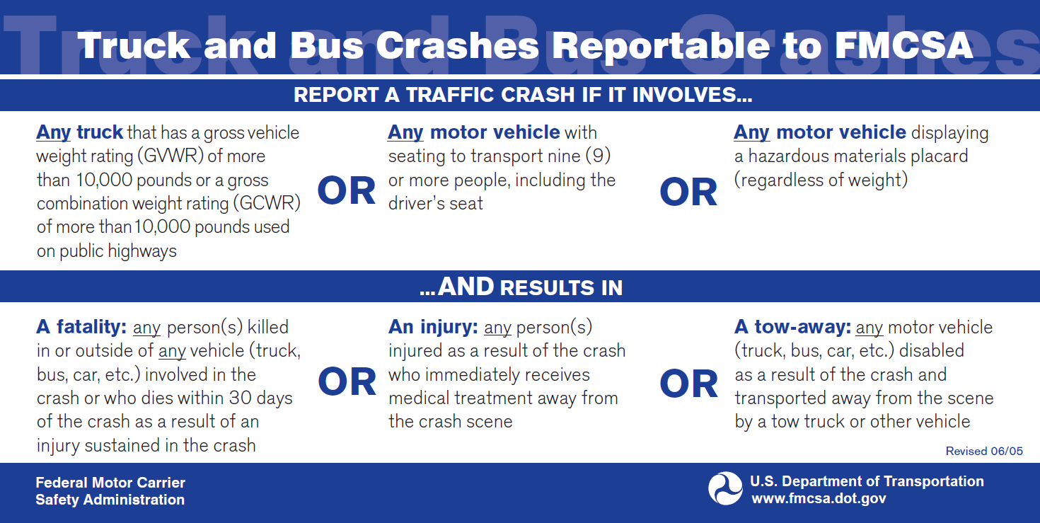

Figure 6: FMCSA Reportable Crashes, Visor Card (Front)

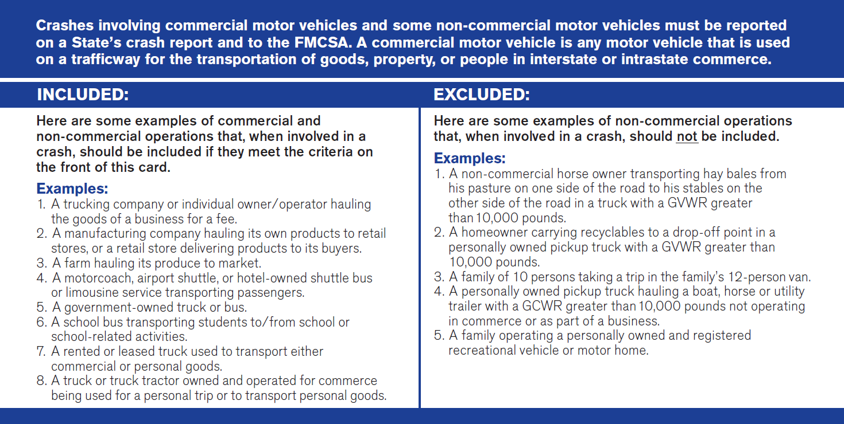

Figure 7: FMCSA Reportable Crashes, Visor Card (Back)

### **Driver (s)**

## LV1. CMV License Status and Compliance with CDL Endorsements

|  |  |  |
| --- | --- | --- |
| Definition | CDL Status indicates the status for a driver’s Commercial Driver’s License (CDL) if applicable. Compliance with CDL Endorsements indicates whether the vehicle driven at the time of the crash requires endorsement(s) on a CDL and whether this driver is complying with the CDL endorsements. | |
| Attribute Values: | |  |
| Subfield 1 | CMV License Status | Select 1 |
| 00  01  02  03  04  05  06  07  98  99 | No CDL  Cancelled or Denied  Disqualified  Expired  Revoked  Suspended  Learner’s Permit  Valid  Other – Not Valid  Unknown License Status |  |
| Subfield 2 | Compliance with CDL Endorsement(s) | Select 1 |
| 00  01  02  03  99 | No Endorsement(s) Required for the Vehicle  Endorsement(s) Required, Complied With  Endorsement(s) Required, Not Complied With  Endorsement(s) Required, Compliance Unknown  Unknown if Required |  |
| Rationale | Used to identify if a driver involved in a crash is in compliance with the limitations and endorsements of their commercial driver’s license. | |
| Edit Checks: | | |
| E(LV)01.01  E(LV)01.02 | If “LV1. CMV License Status and Compliance with CDL Endorsements” Subfield 1 = 07 (Valid) then “P12. Driver License Number, Class, CDL and Endorsements” Subfield 3 must = 02 (Yes) and “P17. Driver License Status” Subfield 1 must = 03 (Commercial Driver License).  If “LV1. CMV License Status and Compliance with CDL Endorsements” Subfield 2 = 00 (No Endorsement(s) Required for the Vehicle), then “LV8. Vehicle Configuration” must not = 03 (Bus (seats more than 15 occupants, including driver), 09 (Truck Tractor/Double), or 10 (Truck Tractor/Triple), “LV9. Cargo Body Type” must not = 03 (Cargo Tank), “LV10. Hazardous Materials (Cargo Only)” Subfield 1 must = 0000 (No HM Placard Displayed), and “V8. Motor Vehicle Body Type Category” of this vehicle must not = 24 (School Bus). | |

### **Vehicle(s)**

## LV2. Trailer License Plate Number

|  |  |  |
| --- | --- | --- |
| Definition | The alphanumeric identifier or other characters, exactly as displayed, on the registration plate or tag affixed to each trailer. For combination trucks, trailer plate numbers are obtained for a maximum of three trailers. | |
| Attribute Values: | |  |
| Subfield 1 | First Trailer Behind Tractor | Specify 1 |
| 97 | License Plate 1 – Alphanumeric identifier  Not Applicable (Bus or truck with no trailing units) |  |
| Subfield 2 | Second Trailer Behind Tractor | Specify 1 |
| 97 | License Plate 2 – Alphanumeric identifier  Not Applicable (Bus or truck with no additional trailing units) |  |
| Subfield 3 | Third Trailer Behind Tractor | Specify 1 |
| 97 | License Plate 3 – Alphanumeric identifier  Not Applicable (Bus or truck with no additional trailing units) |  |
| Rationale | Critical for linkage between the crash and trailer registration files. | |
| Edit Checks: | | |
| E(LV)02.01 | The same subfields must be completed for each of LV2, LV3, LV4, LV5, LV6 and LV11. | |

## LV3. Trailer VIN (s)

|  |  |  |
| --- | --- | --- |
| Definition | A unique combination of alphanumeric characters assigned to each trailer that is designed by the manufacturer. | |
| Attribute Values: | |  |
| Subfield 1 | First Trailer Behind Tractor | Specify 1 |
| 97  99 | VIN 1 – *Manufacturer assigned number permanently affixed to trailer*  Not Applicable (Bus or truck with no trailing units)  Unknown (information unavailable) |  |
| Subfield 2 | Second Trailer Behind Tractor | Specify 1 |
| 97  99 | VIN 2 – *Manufacturer assigned number permanently affixed to trailer*  Not Applicable (Bus or truck with no trailing units)  Unknown (information unavailable) |  |
| Subfield 3 | Third Trailer Behind Tractor | Specify 1 |
| 97  99 | VIN 3 – *Manufacturer assigned number permanently affixed to trailer*  Not Applicable (Bus or truck with no trailing units)  Unknown (information unavailable) |  |
| Rationale | Important to identify specific trailer design characteristics and occupant protection systems for effectiveness evaluations. | |
| Edit Checks: | | |
| E(LV)03.01 | The same subfields must be completed for each of LV2, LV3, LV4, LV5, LV6 and LV11. | |

## LV4. Trailer Make(s)

|  |  |  |
| --- | --- | --- |
| Definition | The distinctive (coded) name applied to a group of trailers by a manufacturer. | |
| Attribute Values: | |  |
| Subfield 1 | First Trailer Behind Tractor | Specify 1 |
| 97  99 | Make 1 – *Name assigned by manufacturer*  Not Applicable (Bus or truck with no trailing units)  Unknown (information unavailable) |  |
| Subfield 2 | Second Trailer Behind Tractor | Specify 1 |
| 97  99 | Make 2 – *Name assigned by manufacturer*  Not Applicable (Bus or truck with no trailing units)  Unknown (information unavailable) |  |
| Subfield 3 | Third Trailer Behind Tractor | Specify 1 |
| 97  99 | Make 3 – *Name assigned by manufacturer*  Not Applicable (Bus or truck with no trailing units)  Unknown (information unavailable) |  |
| Rationale | Important for identifying trailer makes for evaluation, research and crash comparison purposes. | |
| Edit Checks: | | |
| E(LV)04.01 | The same subfields must be completed for each of LV2, LV3, LV4, LV5, LV6 and LV11. | |

## LV5. Trailer Model(s)

|  |  |  |
| --- | --- | --- |
| Definition | The manufacturer-assigned code denoting a family of trailers within a make that have a degree of similarity in construction, such as body, chassis, etc. | |
| Attribute Values: | |  |
| Subfield 1 | First Trailer Behind Tractor | Specify 1 |
| 97  99 | Model 1 – *Name assigned by manufacturer*  Not Applicable (Bus or truck with no trailing units)  Unknown (information unavailable) |  |
| Subfield 2 | Second Trailer Behind Tractor | Specify 1 |
| 97  99 | Model 2 – *Name assigned by manufacturer*  Not Applicable (Bus or truck with no trailing units)  Unknown (information unavailable) |  |
| Subfield 3 | Third Trailer Behind Tractor | Specify 1 |
| 97  99 | Model 3 – *Name assigned by manufacturer*  Not Applicable (Bus or truck with no trailing units)  Unknown (information unavailable) |  |
| Rationale | Important for identifying trailer models for evaluation, research and crash comparison purposes. | |
| Edit Checks: | | |
| E(LV)05.01 | The same subfields must be completed for each of LV2, LV3, LV4, LV5, LV6 and LV11. | |

## LV6. Trailer Model Year(s)

|  |  |  |
| --- | --- | --- |
| Definition | The year that is assigned to a trailer by the manufacturer. | |
| Attribute Values: | |  |
| Subfield 1 | First Trailer Behind Tractor | Specify 1 |
| 97  99 | Model Year 1 – *Name assigned by manufacturer*  Not Applicable (Bus or truck with no trailing units)  Unknown (information unavailable) |  |
| Subfield 2 | Second Trailer Behind Tractor | Specify 1 |
| 97  99 | Model Year 2 – *Name assigned by manufacturer*  Not Applicable (Bus or truck with no trailing units)  Unknown (information unavailable) |  |
| Subfield 3 | Third Trailer Behind Tractor | Specify 1 |
| 97  99 | Model Year 3 – *Name assigned by manufacturer*  Not Applicable (Bus or truck with no trailing units)  Unknown (information unavailable) |  |
| Rationale | Important for identifying trailer model years for evaluation, research and crash comparison purposes. | |
| Edit Checks: | | |
| E(LV)06.01 | The same subfields must be completed for each of LV2, LV3, LV4, LV5, LV6 and LV11. | |

## LV7. Motor Carrier Identification

|  |  |  |
| --- | --- | --- |
| Definition | The identification number, name and address of an individual, partnership or corporation responsible for the transportation of persons or property as indicated on the shipping manifest. See Figure 14: Determining Responsible Carrier, FMCSA Visor Card (Front) (p. 108) and Figure 15: Determining Responsible Carrier, FMCSA Visor Card (Back) (p. 109) for reference. | |
| Attribute Values: | |  |
| Subfield 1 | Identification Type | Select 1 |
| 01  02  97  99 | US DOT Number  State Number  Not Applicable  Unknown/Unable to Determine |  |
| Subfield 2 | Country/State Code | Specify 1 |
|  | *Non-US Country Code (e.g. Mexico or Canada)*  *US State Code* |  |
| Subfield 3 | Identification Number | Specify 1 |
|  | *US DOT Number – up to 7 digits, right justified*  *If not a US DOT Number, include State issued Identification Number and State* |  |
| Subfield 4 | Name | Specify 1 |
|  | Motor Carrier Name |  |
| Subfield 5 | Motor Carrier Address | Specify 1 |
|  | Motor Carrier Address and Country  *Street Address 1*  *Street Address 2*  *City, State Zip*  *Country* |  |
| Subfield 6 | Type of Carrier | Select 1 |
| 01  02  03  04 | Interstate Carrier  Intrastate Carrier  Not in Commerce/Government  Not in Commerce/Other Truck or Bus |  |
| Rationale | *Required by the Federal Motor Carrier Safety Administration (FMCSA) CFR 350.201. The FMCSA has the authority to fine and sanction unsafe interstate (and some intrastate) truck and bus companies. A key way to identify potentially unsafe motor carriers is to collect crash data by the identification number, name, and address of the company. The street address allows FMCSA to visit carriers and conduct reviews of compliance with the Federal Motor Carrier Safety Regulations and provides a crosscheck for the correct identity of the carrier. The identification number (found on the truck tractor, and assigned by the U.S. DOT or by a State) is a key element for carrier identification in the FMCSA databases for crash and other carrier information. This data element is collected at the scene to meet FMCSA 90 day reporting requirements.  Hierarchy: When Identification Numbers are available from more than one Source (Issuing Authority), the order of reporting priority follows:  1) US DOT number;  2) MC/MX (ICC) number;  3) Mexican or Canadian issued number; or  4) State issued numbers. | |
| Edit Checks: | | |
|  | None | |

### How to Find the Responsible Carrier and Correct U.S. DOT Number

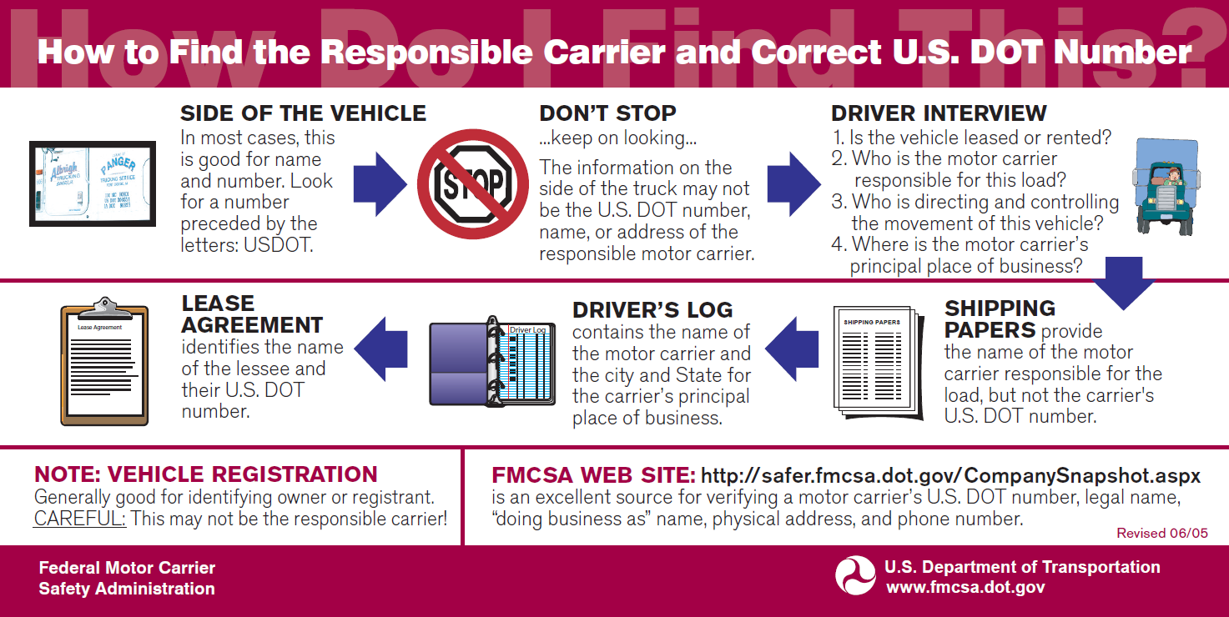

Figure 8: Determining Responsible Carrier, FMCSA Visor Card (Front)

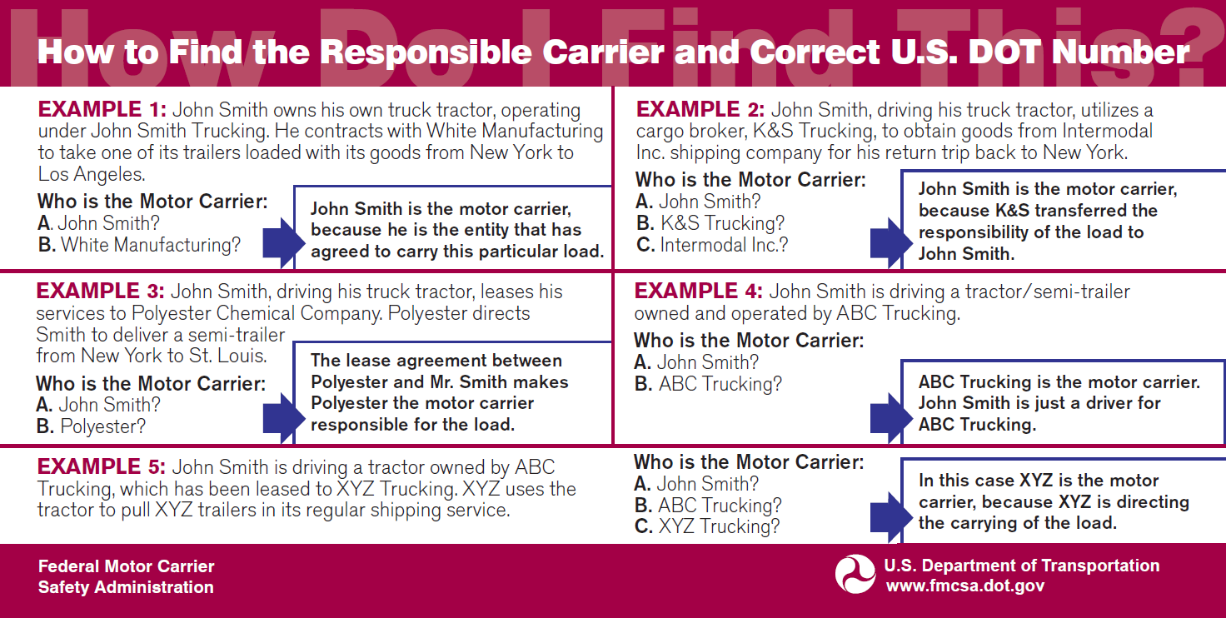

Figure 9: Determining Responsible Carrier, FMCSA Visor Card (Back)

## LV8. Vehicle Configuration

|  |  |  |  |
| --- | --- | --- | --- |
| Definition | Indicates the general configuration of this motor vehicle. | | |
| Attribute Values: | | |  |
| Subfield 1 | Vehicle Configuration | | Select 1 |
| 01  02  03  04  05  06  07  08  09  10  11  99 | Vehicle 10,000 lbs. or less placarded for hazardous materials  Bus/Large Van (seats for 9-15 occupants, including driver)  Bus (seats more than 15 occupants, including driver)  Single-Unit Truck (2-axle and GVWR more than 10,000 lbs.)  Single-Unit Truck (3 or more axles)  Truck Pulling Trailer(s)  Truck Tractor (bobtail)  Truck Tractor/Semi-Trailer  Truck Tractor/Double  Truck Tractor/Triple  Truck More Than 10,000 lbs., cannot classify  Unknown | |  |
| Subfield 2 | Special Sizing | | Select 1-4 |
| 00  01  02  03  04 | No special sizing  Over-height  Over-length  Over-weight  Over-width |  | |
| Subfield 3 | Permitted? | | Select 1 |
| 01  02 | Non-permitted Load  Permitted Load | |  |
| Rationale | **Required by the Federal Motor Carrier Safety Administration (FMCSA) CFR 350.201. This data element provides information about the general configuration of the motor vehicle that is important to evaluate the types of motor vehicles that have the most crashes and the effectiveness of various safety countermeasures. This data element is collected at the scene because FMCSA requires reporting within 90 days. | | |
| Edit Checks: | | | |
| E(LV)08.01  E(LV)08.02 | If trailer information is provided in LV2-LV6 and LV11, then “LV8. Vehicle Configuration” Subfield 1 must = 06 (Truck Pulling Trailer(S)), 08 (Truck Tractor/Semi-Trailer), 09 (Truck Tractor/Double), or 10 (Truck Tractor/Triple).  If LV8 Subfield 1 = 02 (Bus/Large Van (seats for 9-15 occupants, including driver) or 03 (Bus (seats more than 15 occupants, including driver), then “LV9. Cargo Body Type” must = 01 (Bus) and “V8. Motor Vehicle Body Type Category” of this vehicle must = 20-28 (bus attributes). | | |

## LV9. Cargo Body Type

|  |  |  |
| --- | --- | --- |
| Definition | The type of body for buses and trucks more than 10,000 GVWR. Refer to Figure 16 (p. 112) for chart displaying types of cargo *body types*. | |
| Attribute Values: | |  |
| 00  01  02  03  04  05  06  07  08  09  10  11  12  13  97  98  99 | No Cargo Body (*bobtail, light MV with hazardous materials [HM] placard, etc.*)  Bus  Auto Transporter  Cargo Tank  Concrete Mixer  Dump  Flatbed  Garbage/Refuse  Grain/Chips/Gravel  Intermodal Container Chassis  Log  Pole-Trailer  Van/Enclosed Box  Vehicle Towing Another Vehicle  Not Applicable (*MV 10,000 lbs. or less, not displaying HM placard*)  Other  Unknown | Select 1 |
| Rationale | *Required by the Federal Motor Carrier Safety Administration (FMCSA) CFR 350.201. This data element provides additional information about the motor vehicle, including all major cargo body types. The information it provides can be important in helping FMCSA make decisions on regulatory strategies for different types of motor vehicles. This data element is collected at the scene because FMCSA requires reporting within 90 days. | |
| Edit Checks: | | |
| E(LV)09.01 | If trailer information is provided in LV2-LV6 and LV11, then “LV9. Cargo Body Type” must not = 00 (No Cargo Body (*bobtail, light MV with hazardous materials [HM] placard, etc.*)). | |

### FMCSA Cargo Body Types

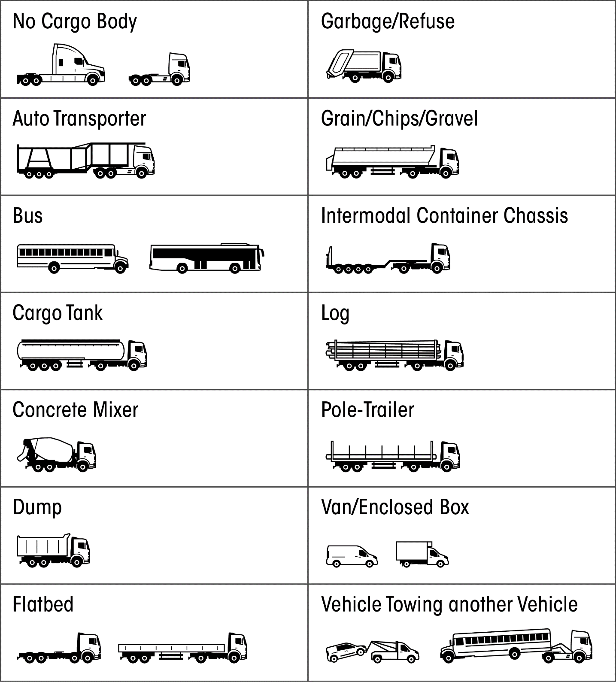

Figure 10: FMCSA Cargo Body Types, Visor Card (Back)

## LV10. Hazardous Materials (Cargo Only)

|  |  |  |
| --- | --- | --- |
| Definition | Indication of the hazardous materials identification and class being transported by the motor vehicle, and whether or not hazardous materials were released. (Refer to Figure 17 (p. 114) and Figure 18 (p. 115) for charts displaying hazardous materials classes and reporting information.) | |
| Attribute Values: | |  |
| Subfield 1 | Hazardous Materials ID | Specify |
| 0000  *xxxx*  9999 | No HM Placard Displayed  4-digit Hazardous Materials ID number or name taken from the middle of the diamond or from rectangular box  Unknown |  |
| Subfield 2 | Hazardous Materials Class | Specify |
| 00  *X*  99 | No HM Placard Displayed  1-digit Hazardous Materials Class number from the bottom of diamond  Unknown |  |
| Subfield 3 | Release of hazardous materials from a cargo compartment (e.g. trailer), cargo container (e.g. tank) or from a package? | Select 1 |
| 01  02  97  99 | No  Yes  Not Applicable  Unknown if Released |  |
| Rationale | *Required by the Federal Motor Carrier Safety Administration (FMCSA) CFR 350.201. FMCSA devotes special attention to motor carriers that transport hazardous materials (HM), including calculating risk assessments, determining response methods, imposing tighter regulations and conducting compliance reviews on a higher percentage of HM carriers. Getting good data on crashes involving trucks carrying HM and whether HM are spilled during the crashes helps FMCSA focus law enforcement efforts. This data element is collected at the scene because FMCSA requires reporting within 90 days.  Guideline for recording multiple HMs: - If a HM spill has occurred and you know which material was released, always record that material; - If 2 HMs at different classes (1-9), report the material from the DOT Hazmat Table 1 (below) and its associated 4-digit UN number before materials in Table 2 (below). Table 1 includes Hazard Class/Divisions 1.1, 1.2, 1.3, 2.3, 4.3, 5.2, 6.1, 7; - If 2 HMs of the same class, report the material in greatest quantity if information is available, or the first material listed on report if not. | |
| Edit Checks: | | |
| E(LV)10.01  E(LV)10.02 | If “LV10. Hazardous Materials (Cargo Only)” Subfield 1 = 0000 (No HM Placard Displayed), then Subfield 2 must = 00 (No HM Placard Displayed).  If “LV10. Hazardous Materials (Cargo Only)” Subfield 1 does not = 0000 (No HM Placard Displayed), then “LV7. Motor Carrier Identification” Subfield 1 should = 01 (US DOT Number) | |

### Reporting Hazardous Materials Information

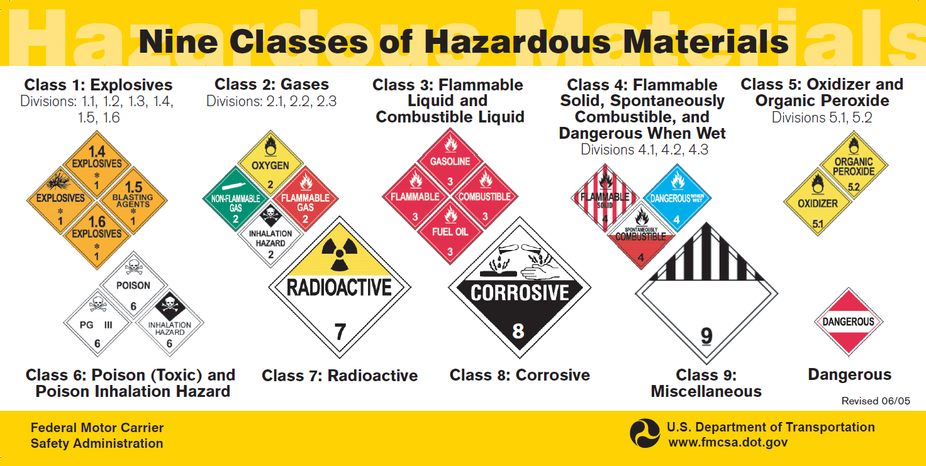

Figure 11: Nine Classes of Hazardous Materials, FMCSA Visor Card (Front)

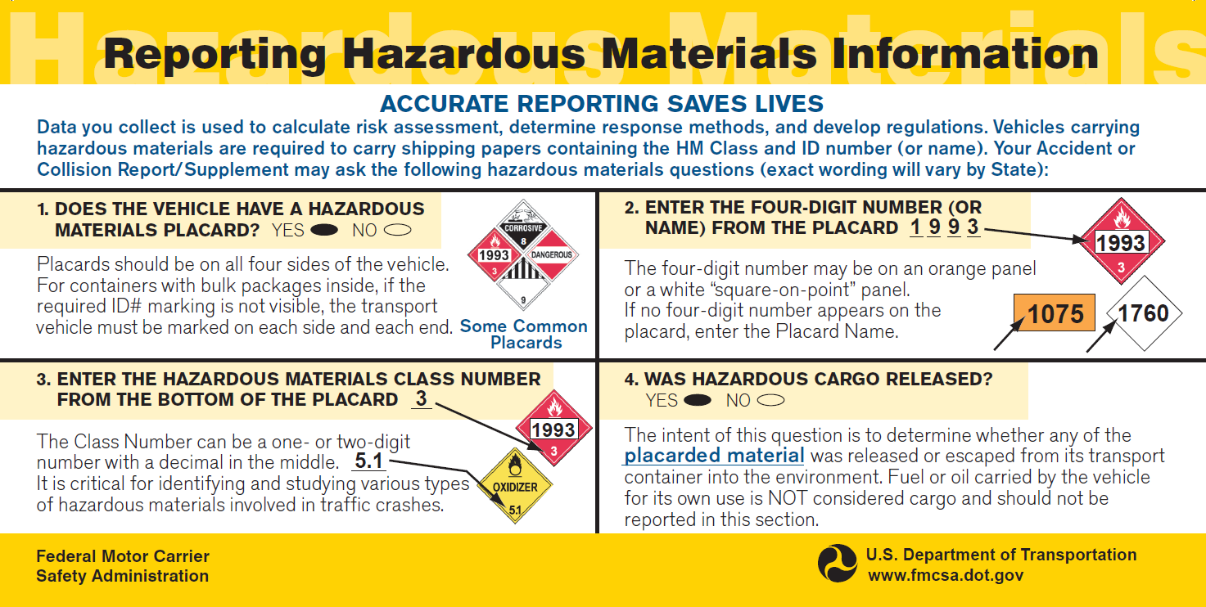

Figure 12: Reporting Hazardous Materials Information, FMCSA Visor Card (Back)

**Table 1**

|  |  |  |
| --- | --- | --- |
| Category of material (Hazard class or division number and additional description, as appropriate) | Placard name | Placard design section reference (§) |
| 1.1 | EXPLOSIVES 1.1 | 172.522 |
| 1.2 | EXPLOSIVES 1.2 | 172.522 |
| 1.3 | EXPLOSIVES 1.3 | 172.522 |
| 2.3 | POISON GAS | 172.540 |
| 4.3 | DANGEROUS WHEN WET | 172.548 |
| 5.2 (Organic peroxide, Type B, liquid or solid, temperature controlled) | ORGANIC PEROXIDE | 172.552 |
| 6.1 (material poisonous by inhalation (see § 171.8 of this subchapter)) | POISON INHALATION HAZARD | 172.555 |
| 7 (Radioactive Yellow III label only) | RADIOACTIVE1 | 172.556 |

1 RADIOACTIVE placards are also required for: All shipments of unpackaged LSA-I material or SCO-I; all shipments required by §§ 173.427, 173.441, and 173.457 of this subchapter to be operated under exclusive use; and all closed vehicles used in accordance with § 173.443(d).

**Table 2**

|  |  |  |
| --- | --- | --- |
| Category of material (Hazard class or division number and additional description, as appropriate) | Placard name | Placard design section reference (§) |
| 1.4 | EXPLOSIVES 1.4 | 172.523 |
| 1.5 | EXPLOSIVES 1.5 | 172.524 |
| 1.6 | EXPLOSIVES 1.6 | 172.525 |
| 2.1 | FLAMMABLE GAS | 172.532 |
| 2.2 | NON-FLAMMABLE GAS | 172.528 |
| 3 | FLAMMABLE | 172.542 |
| Combustible liquid | COMBUSTIBLE | 172.544 |
| 4.1 | FLAMMABLE SOLID | 172.546 |
| 4.2 | SPONTANEOUSLY COMBUSTIBLE | 172.547 |
| 5.1 | OXIDIZER | 172.550 |
| 5.2 (Other than organic peroxide, Type B, liquid or solid, temperature controlled) | ORGANIC PEROXIDE | 172.552 |
| 6.1 (other than material poisonous by inhalation) | POISON | 172.554 |
| 6.2 | (None) |  |
| 8 | CORROSIVE | 172.558 |
| 9 | Class 9 (see § 172.504(f)(9) ) | 172.560 |
| ORM-D | (None) |  |
|  |  |  |

Figure 13: FMCSA Table 1 and Table 2

## LV11. Total Number of Axles

|  |  |  |
| --- | --- | --- |
| Definition | The number of axles in use at the time of the crash on each unit of a large truck or combination-unit vehicle. “Lift” or “tag” axles that are down should be included in this total. | |
| Attribute Values: | |  |
| Subfield 1 | Truck Tractor | Specify 1 |
| *xx*  99 | *Number of Axles*  Unknown (information unavailable) |  |
| Subfield 2 | First Trailer Behind Tractor | Specify 1 |
| *xx*  97  99 | *Number of Axles*  Not Applicable (Bus or truck with no trailing units)  Unknown (information unavailable) |  |
| Subfield 3 | Second Trailer Behind Tractor | Specify 1 |
| *xx*  97  99 | *Number of Axles*  Not Applicable (Bus or truck with no trailing units)  Unknown (information unavailable) |  |
| Subfield 4 | Third Trailer Behind Tractor | Specify 1 |
| *xx*  97  99 | *Number of Axles*  Not Applicable (Bus or truck with no trailing units)  Unknown (information unavailable) |  |
| Rationale | This data element is a recommendation from a Federal Advisory Committee consisting of State and local law enforcement, truck and bus industries and safety advocates. The number of axles can be used as an indicator of vehicle weight and other special vehicle configurations. | |
| Edit Checks: | | |
| E(LV)11.01 | The same subfields must be completed for each of LV2, LV3, LV4, LV5, LV6 and LV11. | |

# Dynamic Data Elements

Dynamic data elements are those items that are either in such a state of flux or so new to the evolving discipline in acquisition they cannot yet be measured reliably. These elements are termed “dynamic” because they are provisional and subject to technical correction on a more frequent basis as our understanding of the phenomena evolve.

## Motor Vehicle Automation

The fifth edition of the Model Minimum Uniform Crash Criteria (MMUCC) introduces the new dynamic element *“Motor Vehicle Automation”,* to address concerns about the rapidly developing technological development of automated vehicles. Advanced levels of automation and the push to deploy this technology into the motoring arena are creating a paradigm shift to the traditional notion of all aspects of the operation of motor vehicles. Consequently, the discussion regarding this data element raised a number complex issues, including (a) how to classify vehicle automation technology and (b) the most reliable and practical ways to collect vehicle automation data. Because of the fluidity of this data, NHTSA and GHSA consider this to be a dynamic data element, or an aspirational target. Technological developments and new regulations may precipitate the need for out-of-cycle changes to this data element. As a result, States should consider the following when adopting this dynamic data element:

* Automated vehicle technologies and associated guidance—including the SAE standard referenced in the data element—are fluid and expected to change.
* Collecting information about vehicle automation is difficult because (a) law enforcement considers collecting this data through observation unreliable at best and (b) a centralized database on vehicle automation does not yet exist.

In light of the Department of Transportation’s *Federal Automated Vehicles Policy: Accelerating the Next Revolution in Roadway Safety* and the rapid pace of automated vehicle technologies, NHTSA and GHSA propose continuing engagement on this issue and will host an annual stakeholders’ meeting at the International Forum on Traffic Records and Highway Information Systems. These sessions will provide an open forum for continued discussion of crash data collection and emerging automated vehicle technologies with federal, state, and industry stakeholders. This continued engagement will allow NHTSA and GHSA to make timely technical updates to the dynamic data element “*Motor Vehicle Automation*”.

## DV1. Motor Vehicle Driving Automation System(s)5F[1]

|  |  |  |
| --- | --- | --- |
| Definition | “The hardware and software that are collectively capable of performing part or all of the dynamic driving task on a sustained basis; this term is used generically to describe any system capable of level 1-5 driving automation.” (SAE 2016)6F[2]  *No Automation: 1F[3] The full-time performance by the human driver of all aspects of the dynamic driving task, even when enhanced by warning or intervention systems.  *Driver Assistance: Driver assistance system of either steering or acceleration/deceleration using information about the driving environment and with the expectation that the human driver perform all remaining aspects of the dynamic driving task.  *Partial Automation: The driving mode-specific execution by one or more driver assistance systems of both steering and acceleration/deceleration using information about the driving environment and with the expectation that the human driver perform all remaining aspects of the dynamic driving task.  *Conditional Automation: The driving mode-specific performance by an automated driving system of all aspects of the dynamic driving task with the expectation that the human driver will respond appropriately to a request to intervene.  *2F[4]High Automation: The driving mode-specific performance by an automated driving system of all aspects of the dynamic driving task, even if a human driver does not respond appropriately to a request to intervene.  *Full Automation: The full-time performance by an automated driving system of all aspects of the dynamic driving task under all roadway and environmental conditions that can be managed by a human driver.  Dynamic driving task includes the operational (steering, braking, accelerating, monitoring the vehicle and roadway) and tactical (responding to events, determining when to change lanes, turn, use signals, etc.) aspects of the driving task, but not the strategic (determining destinations and waypoints) aspect of the driving task.  Driving mode is a type of driving scenario with characteristic dynamic driving task requirements (e.g., expressway merging, high-speed cruising, low speed traffic jam, closed-campus operations, etc.).  Request to intervene is notification by the automated driving system to a human driver that s/he should promptly begin or resume performance of the dynamic driving task. | |
| Attribute Values: | |  |
| Subfield 1 | Automation System or Systems in Vehicle | Select 1 |
| 01  02  99 | No  Yes  Unknown |  |
| Subfield 2 | Automation System Levels in Vehicle | Select 1-5 |
| 00  01  02  03  04  05  06  99 | No Automation  Driver Assistance  Partial Automation  Conditional Automation  High Automation  Full Automation  Automation Level Unknown  Unknown |  |
| Subfield 3 | Automation System Levels Engaged at Time of Crash | Select 1-5 |
| 00  01  02  03  04  05  06  99 | No Automation  Driver Assistance  Partial Automation  Conditional Automation  High Automation  Full Automation  Automation Level Unknown  Unknown |  |
| Rationale | As motor vehicles become increasingly automated, States will have the ability to measure how the different levels of vehicle automation affects traffic safety. | |
| Edit Checks: | | |
|  | None | |

Figure 14: SAE International’s Levels of Driving Automation; SAE International Standard J3016 (2014)

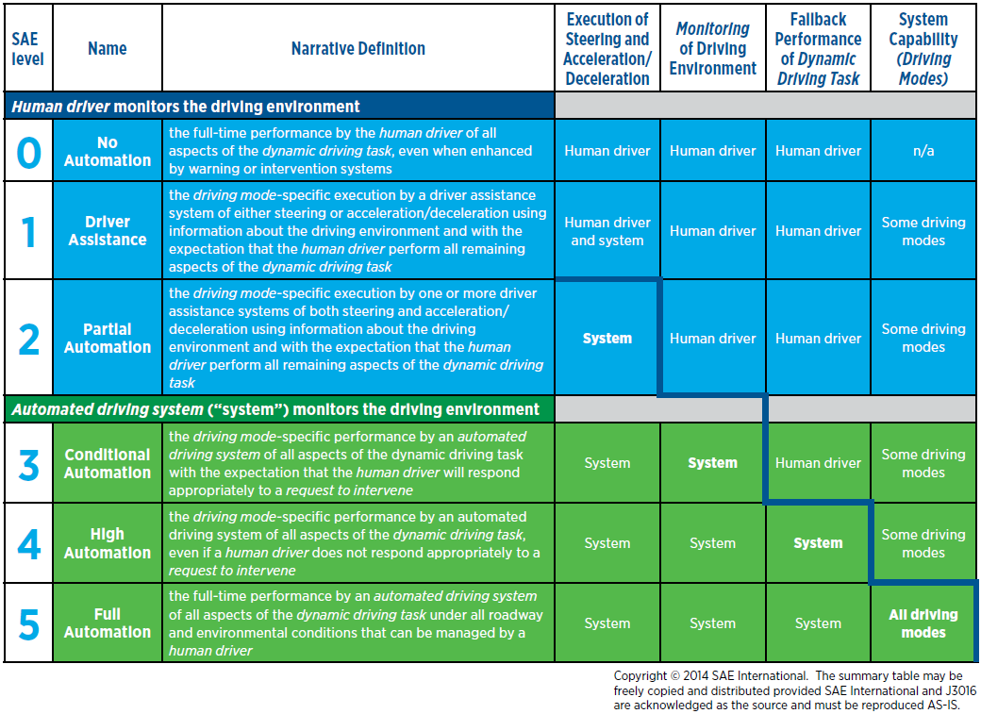

1. Definitions adopted from SAE International’s publication, “Automated Driving: Levels of Driving Automation Are Defined in New SAE International Standard J3016” (2014).
2. SAE International Standard J3016TM, “Taxonomy and Definitions for Terms Related to Driving Automation Systems for On-Road Motor Vehicles” (SEP2016), <http://standards.sae.org/j3016_201609/>.
3. *Refer to Figure 21 for SAE Levels of Driving Automation.*
4. *\*Refer to Figure 21 for automation level determination.*