Department of Transportation
Federal Motor Carrier Safety Administration
Office of Research and Information Technology

Unified Registration System (URS) Operating Authority Types and Statuses

November 17th, 2016

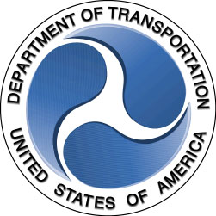

URS Operating Authority Registration Types

- Motor Carrier, Property
- Motor Carrier, Property Household Goods
- Motor Carrier, Passenger
- Motor Carrier, Passenger Regular Route
- Motor Carrier, Passenger Charter/Special Operations
- Motor Carrier, Property Temp
- Motor Carrier, Property Household Goods Temp
- Motor Carrier, Passenger Temp
- Motor Carrier, Property Enterprise
- Motor Carrier, Property Household Goods Enterprise
- Motor Carrier, Passenger Enterprise
- Motor Carrier, Property MX Commercial Zone
- Motor Carrier, Passenger MX Commercial Zone
- Motor Carrier, Property MX Long Haul
- Motor Carrier, Property Household Goods MX Long Haul
- Motor Carrier, Passenger Charter/Special Operations MX Long Haul
- Motor Carrier, Property NNA
- Motor Carrier, Property Household Goods NNA
- Motor Carrier, Passenger NNA
- Broker, Property
- Broker, Household Goods
- Freight Forwarder, Property
- Freight Forwarder, Household Goods

URS Operating Authority Registration Statuses

Active (U.S. and Canadian Motor Carriers, All Brokers, All Freight Forwarders)
Provisional (Mexican and NNA Motor Carriers)
Permanent (CVSA Decal) – NNA Motor Carriers only
Permanent (Mexican and NNA Motor Carriers)
Revoked (All Entities)
Suspended (All Entities)

