PRISM

Performance and Registration Information
Systems Management

Law Enforcement Training
Instructor Manual

June 2010

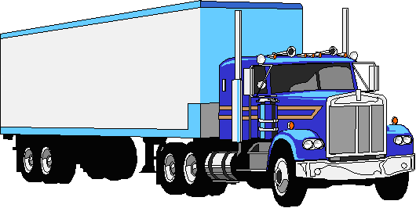

Federal Motor Carrier Safety Administration
Office of Safety Programs
1200 New Jersey Avenue, SE
Washington, D.C. 20590
Preface

This PRISM Law Enforcement Training Manual has been prepared to assist states in implementing the PRISM project requirements.

When a state enters the PRISM program there are changes made in the state’s IRP processing and additional tools are provided for law enforcement to use at the roadside. There are changes in forms and additional computer information is available. Moreover, registration actions may be taken against a registrant or motor carrier based on their safety performance in PRISM.

The training includes a general overview of PRISM concepts in a slide presentation. The slides are annotated for the trainer. In addition, this manual details the changes to the IRP registration system that are of interest to enforcement as well as descriptions of the Federal enforcement /tracking system for motor carriers.

Further there is information on the various technologies available to access information at the roadside. These sections need to be customized by the state by eliminating any sections for a technology that is not used by the state. Lastly, the section on what to do when a vehicle is stopped at the roadside also needs to be customized to match the laws/authority of the state.

This version of the training manual is for the use of the training coordinator. After making the appropriate modifications and deletions, this manual can be used for the training of commercial vehicle inspectors and other members of law enforcement.
The material should be tailored to the level of knowledge necessary for the type of enforcement by the agency. For example, law enforcement from the lead agency for MCSAP should be trained in all aspects of the PRISM program, specifically those requirements relating to the targeted vehicles and the USDOT Number. Municipal officers and the Sheriff should have a general understanding of the PRISM information available that could be helpful while investigating crashes. Parts of this manual can be made into a law enforcement brochure for those that do not need all of the information.

To be sure you have the most current information, check the PRISM section of the CVISN web site for the latest version of this training package.

http://cvisn.fmcsa.dot.gov/default.aspx?PageID=prism

Note: Items in “red” are to be customized for your state.

Overview Slide Presentation

The Overview slide presentation is contained in a separate Power Point file named “PRISM Law Enforcement Training Slides - Part 2”.

Remove this page from the manual for law enforcement personnel being trained.
Table of Contents

What is PRISM? 1
Registration 1
Enforcement 2
PRISM Benefits 3
Getting to the Target File 5
Query Central 7
PRISM NLETS Query 10
SAFER Website 12
ISS 14
What to do? 15
Identify the Motor Carrier Responsible for Safety 15
Check for Target Status 20
Stop the Vehicle – Place it Out-of-Service 20
Inspect and Upload to ASPEN/TraCS 21
ASPEN 22
Query Central to ASPEN 23
TraCS 29

What is PRISM?

The Performance and Registration Information Systems Management (PRISM) program was developed to meet the challenge of reducing the number of commercial vehicle crashes of a rapidly expanding interstate carrier population. It has increased the efficiency and effectiveness of federal and state safety efforts through a more accurate process for targeting the highest-risk carriers, which allows for a more efficient allocation of scarce resources for compliance reviews and roadside inspections. The PRISM program requires that motor carriers improve their identified safety deficiencies or face progressively more stringent sanctions up to the ultimate sanction of a Federal Out-of-Service order and concurrent State registration suspensions. The PRISM program has proven to be an effective means of getting motor carriers to improve their compliance and performance deficiencies.

PRISM links the commercial vehicle registration process to motor carrier safety to achieve two purposes. One is to determine the safety fitness of the motor carrier prior to issuing license plates and two is to influence the carrier to improve its safety performance through an improvement process and, where necessary, the application of registration sanctions.

The PRISM program includes two major processes - the Commercial Vehicle Registration Process and Enforcement. The performance of unsafe carriers is improved through a comprehensive system of identification, education, awareness, data gathering, safety monitoring and treatment.

Registration

The International Registration Plan (IRP) commercial vehicle registration process of the states provides the framework for the PRISM program. Registration is the initial point of contact in the PRISM process between the motor carrier, registrant or motor vehicle owner and the government.

A system of accountability is established. The USDOT Numbers are collected and validated to ensure accountability so that no vehicle is plated without identifying an entity that is responsible for its safe operation during the registration year. The safety fitness of each carrier can then be checked prior to issuing vehicle registrations. Those motor carriers that have been prohibited from operating in interstate commerce by the Federal Motor Carrier Safety Administration may have their ability to register vehicles denied by the State. The use of registration sanctions also provides powerful incentive for unsafe carriers to improve their safety performance.

The cab cards are bar-coded. If the motor carrier responsible for safety is not expected to change during the registration period, the card will contain the carrier information in the bar-code. In addition, the cab card has the name, mailing address and USDOT Number for the motor carrier responsible for safety printed on the card.

Bar-coding improves the accuracy of information recorded at the roadside and also speeds up the inspection process resulting in improved efficiencies for roadside enforcement officers as well as the motor carrier industry.

Enforcement

The Motor Carrier Safety Improvement Process (MCSIP) is the means by which carrier safety is systematically tracked and improved. MCSIP is a data-driven process that uses current safety event information such as crashes, inspections, driver violations, compliance review data and other data to assess and monitor motor carrier safety performance. Safety events are assigned to the motor carrier responsible for safety of the motor vehicle and are weighted according to severity, frequency and time since the occurrence.

The process is designed to improve the safety performance of carriers with demonstrated poor safety performance through accurate identification, performance monitoring and treatment.

Once the carrier exceeds the bounds of the established safety threshold, the motor carrier enters MCSIP. MCSIP includes several stages of progressively stronger warnings to motor carriers and provides opportunities for the motor carriers to improve operations and return to a safe condition. Within MCSIP, carriers with potential safety problems are identified and prioritized for an on-site review using the data-driven, performance-based tool Motor Carrier Safety Status (SafeStat) prioritization methodology developed for the PRISM program. Under SafeStat a carrier’s safety performance is assessed based on all available data (roadside inspection, compliance reviews (CRs), crashes, enforcement history). New safety information is added to this data source on a continuous basis, and SafeStat uses this information to provide current safety indicators for all carriers for which there is sufficient data.

If the motor carriers’ safety performance improves, they will work their way out of the MCSIP Process and their MCSIP Step will return to 00. MCSIP Step values in the ranges of 2 through 22, 31 through 39 and 70 through 89 show that the carrier has been placed in MCSIP and is targeted, but can continue to operate while they attempt to improve their MCSIP Step values. If the motor carrier’s safety performance does not improve, then FMCSA issues an Out-of-Service Order (OOSO.)

There are four general instances in which the FMCSA will order a motor carrier to cease interstate operations:

- When the motor carrier receives a final unsatisfactory safety rating from the FMCSA.

- When, after exhausting all due process options, the motor carrier fails to pay Federal fines levied from FMCSA enforcement actions.

- When the motor carrier is determined to be an imminent hazard.

- When a new entrant fails an audit or does not schedule an audit within 18 months.

MCSIP Step values in the range of “52” through “68” –exclude “59” - indicate that the carrier has received a Federal Out-of-Service order (OOSO) or a Federal and State Out-of-Service order. Vehicles assigned for Safety to carriers with these MCSIP Step values should not be operating on the Interstate highways.

Step 59 is for state use only. It will represent a state Out-of-Service order on intrastate vehicles.

PRISM Benefits

PRISM demonstrates the following safety, economic and productivity benefits:

Accountability - Identification of the motor carrier (via their USDOT number) responsible for the safe operation of the vehicles being registered has produced a major safety benefit.
Safety events (e.g. inspection, accident, driver moving violations) affecting a PRISM registered vehicle can be more accurately tied back to the responsible motor carrier.

A Performance-Based Approach to Safety Management - The primary means for identifying potentially poor performing carriers is through an accumulation of carrier, vehicle and driver-specific safety events that is then linked to the carrier through the carrier’s USDOT number. Carriers are identified, treated and released from a safety improvement program based upon demonstrated highway performance after safety treatments have been applied.

Improved Productivity - The PRISM program has increased the efficiency and effectiveness of federal and state safety efforts through:

- Efficient allocation of scarce resources through more accurate targeting of compliance reviews to focus on the highest-risk carriers, and:

- The use of a warning letter as an effective, inexpensive alternative for carriers with less severe safety problems.

Improved Data Quality - The PRISM program has shown that an improvement in the accuracy and timeliness of data will result in better resource allocation and heightened efficiencies in the administration of major federal and state safety programs. Several of the most notable data improvement initiatives are listed below:

- Development of a procedure for obtaining current census and operational data on interstate motor carriers as part of the state’s annual vehicle registration renewal process;

- Development of a procedure for using plate numbers as a means to more effectively assign inspection and accident data to the responsible motor carrier;

- Use of automated procedures for data collection in the field to eliminate typing errors in critical fields on accident and inspection reports, like USDOT number, plate number and VIN. An example of effective automated procedures is the bar-coding of motor carrier identifying information on cab cards and the use of pen-based, lap-top computers to read the bar-coded information and automatically enter the data on state enforcement forms.

Improved Motor Carrier Safety – The PRISM program requires that motor carriers improve their identified safety deficiencies or face progressively more stringent sanctions up to a Federal Out-of-Service order and concurrent State registration suspensions. For carriers with less severe safety problems, the PRISM program pioneered the use of a Warning Letter as an alternative to an on-site review. The Warning Letter has proven to be an extremely effective and inexpensive means of improving safety performance.

Customer Service – PRISM provides a one-stop shopping opportunity for carriers to obtain a USDOT Number, meet Congressionally mandated data update requirements, and get their IRP license plates simultaneously. Through the PRISM program, the state registration offices can issue USDOT numbers on behalf of the federal government.

Getting to the Target File

There are multiple methods to use to obtain targeted carrier and targeted vehicle information. In the figure below, the five common methods are identified along with information on the timeliness of each method. As you will see, Query Central provides up-to-the minute information on OOSO. ISS information provides adequate information for determining if an inspection should be done, however, due to the timeliness additional queries should be done before enforcing an OOSO to be sure it is still in effect.
Training Coordinator: Check for the latest version of this chart on the PRISM website

The timeliest data for specific vehicle information is the routine NLETS from state systems. Some states provide real-time while others update nightly. The additional NLETS query for targeted information is on a one-day delay.

Training Coordinator: Check for the latest version of this chart on the PRISM website

Training Coordinator – The following information is for the specific access methods.

If your organization does not use Query Central, PRISM NLETS messages, or ISS, eliminate the information that is not needed from your manual.

In addition, if your state uses CVIEW, add screen shots of your state’s CVIEW carrier and vehicle inquiry and response messages and insert them in this manual.

Query Central

Query Central provides inquiry capability by USDOT Number for Carriers and either the VIN or the Plate Number and State for vehicles. Query Central uses the SAFER-PRISM database for much of its data and also uses the MCMIS database for Out-of-Service order information. Query Central requires connection through FMCSA COMPASS, or a VPN (Virtual Private Network) or a connection through AAMVA.

Note the “Alert” on the top line for the OOSO. Query Central has the up-to-the minute information on OOSO directly from MCMIS.

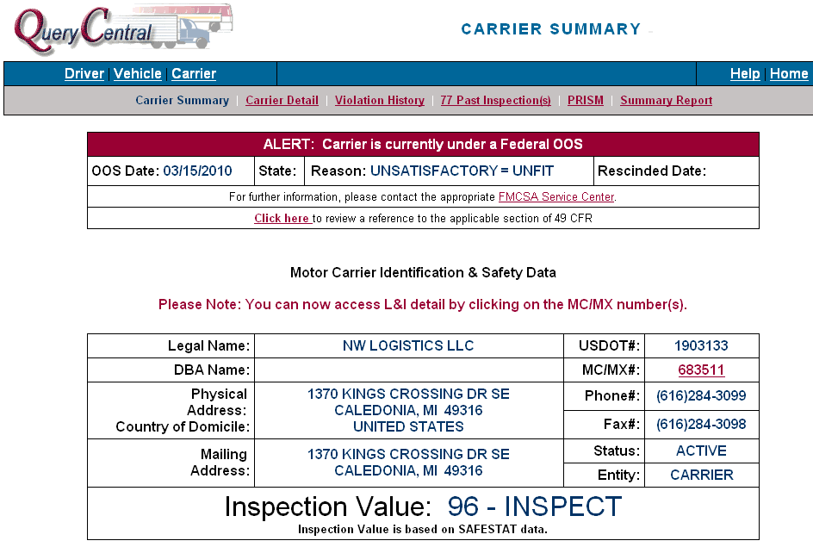

A drop down menu button will also bring up the list of OOS 49 CFR sites for all the OOS reasons.

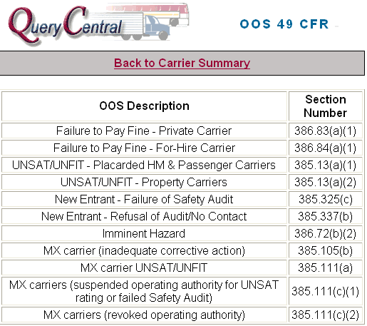

To obtain the list of targeted vehicles associated with this OOS carrier, click on the PRISM link from the menu bar at the top of the screen.

The CARRIER PRISM SUMMARY screen will then be displayed as shown in the next screenshot.
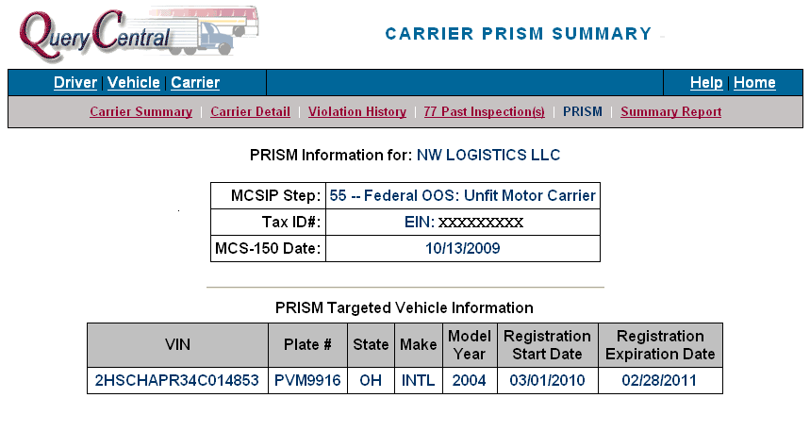

PRISM NLETS Query

In addition to the NLETS vehicle queries already available to law enforcement, PRISM provides inquiry capability by USDOT Number for a Carrier Status Request (ACQ) and either VIN or License Plate and State for Vehicle Status Request (AVQ) for targeted information. NLETS uses the SAFER-PRISM database for both Carrier and Vehicle inquiries.
Carrier Status Request (ACQ) by USDOT Number and
Vehicle Status Request (AVQ) by Plate & Jurisdiction or VIN

All NLETS Carrier Status Response Messages provide the exact same data elements. Differences will be noticed in the Heading that appears above the data fields.

The following messages can be found depending on the value of the MCSIP Step:

NLETS Response Message | MCSIP Steps
Carrier is NOT Targeted | 00, 30, 99
Carrier is Targeted | 2-22, 31-39, 70-89
Carrier is Under Federal OOSO | 54, 55, 57, 63, 64, 65, 66
Carrier Registration is under State OOSO | 59
Carrier is Under Federal OOSO AND State OOSO | 52, 53, 60, 61, 62, 67, 68
*NOT ON FILE | *Vehicle not on PRISM Target File

NLETS Carrier Status Response Sample
PRISM Carrier Data

Officer does a Carrier Status Request (ACQ) and enters USDOT Number 178097

MSG FROM NLETS 3745
ACR.AVLIC0000. TO:DEST IA07710B5
*MRI0056917.
TXT
PRISM Target File
Alert Message
CARRIER IS UNDER FEDERAL OOS.
IMMINENT HAZARD.

DOT/178097.
NAM/ACTION CARRIER INC.
ADR/700 E 52ND STREET NORTH.
CITY/SIOUX FALLS.ST/SD.ZIP/57104.
CAR TARG-HIST IND/T.MCSIP STEP/54.MCSIP DATE/11122008.
PAGE/01 OF/01.

PRISM Target File
Alert Message

Note: Remember the NLETS information is not updated in real time. Confirm if an OOSO is still in effect.

NLETS Vehicle Status Response Sample
PRISM Carrier and Vehicle Data

Officer does a Vehicle Status Request (AVQ) and enters License Plate Number 13AF9M Jurisdiction of MO
MSG FROM NLETS 3639
AVR.AVLIC0000. TO:DEST IA07710B5
*MRI0055497.
TXT
CARRIER IS TARGETED.
PRISM Target File
Alert Message

DOT/1816966.
NAM/STALLION TRANSPORT LLC.
DBA/.
ADR/817 SUNDALE ST.
CITY/BISMARCK.ST/MO.ZIP/63624.
CAR TARG-HIST IND/T.MCSIP STEP/7.MCSIP DATE/12182009.
VMA/FORD.VYR/2004.VIN/1FDXW47P84ED62797.
LIC/13AF9M.LIS/MO.REG EFF DATE/10012009.REG EXP DATE/09302010.
VEH TARG-HIST IND/T.
PAGE/01 OF/01.
;200611071045/200611071045
T175 29
MESSAGE FROM NLTS
055520

Note: Remember the NLETS information is not updated in real time. Confirm if an OOSO is still in effect.
PRISM Target File
Alert Message

SAFER Website

The SAFER website can be accessed through the Internet at http://safer.fmcsa.dot.gov and provides inquiry capability by USDOT Number or Name for motor carrier data. The SAFER Website uses the SAFER-PRISM database for their inquiries.

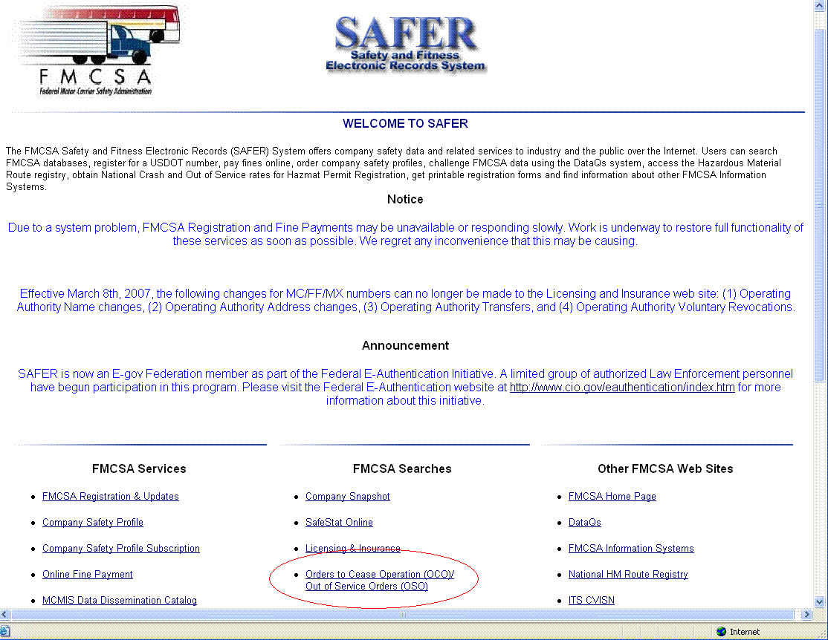

From the SAFER homepage click on the “Orders to Cease Operation (OCO)/
Out of Service Orders (OSO)” link, this is listed under the FMCSA Searches section.

Enter a USDOT #, MC/MX #, or Carrier Name and then click on the Search button.

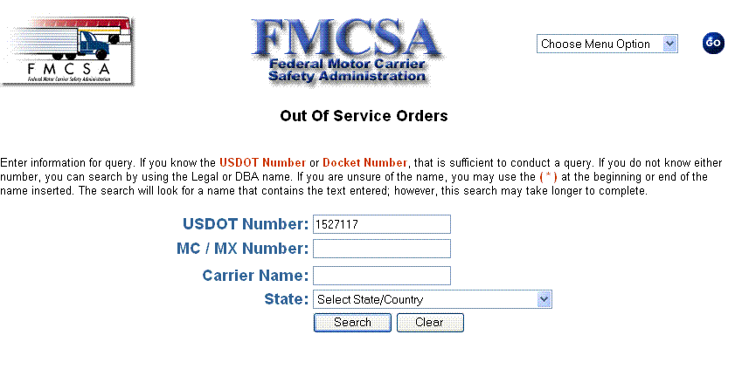

The following screen with the OOS Category will then appear as seen in this screenshot below.

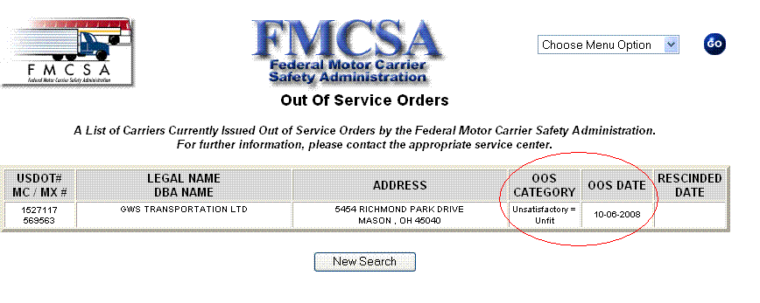

ISS

The Inspection Selection System (ISS) contains motor carrier data on all motor carriers. The ISS data file is made available on a monthly basis and can be downloaded from http://infosys.fmcsa.dot.gov by States and distributed to law enforcement personnel for use in their laptop computer systems. Technical Support still supplies several states with CDs.
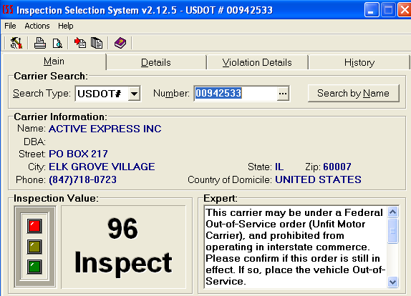

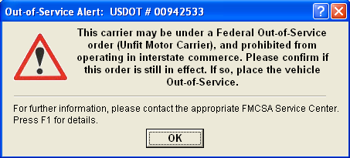

Note: Remember the ISS information is not updated in real time. Confirm if an OOSO is still in effect.

What to do?

Identify the Motor Carrier Responsible for Safety

Since PRISM is a data driven program, the quality of the SafeStat rankings is only as accurate as the carrier safety data. Therefore, it is crucial that every effort be made to assure current, correct safety data and account for all events.

Obviously, the inspector should start with the side of the truck. But, don’t stop there – keep on looking. Check the cab card to determine if a motor carrier responsible for safety is listed. If it is listed, it was not expected to change during the registration year. Keep in mind this is the best information at the time of registration. This could change. If the motor carrier name is listed and therefore not expected to change, look at the registrant name. If they are the same, then the carrier responsible for safety is most likely what is listed on the card.
Cab Card Example 1
Registrant is the MCRS

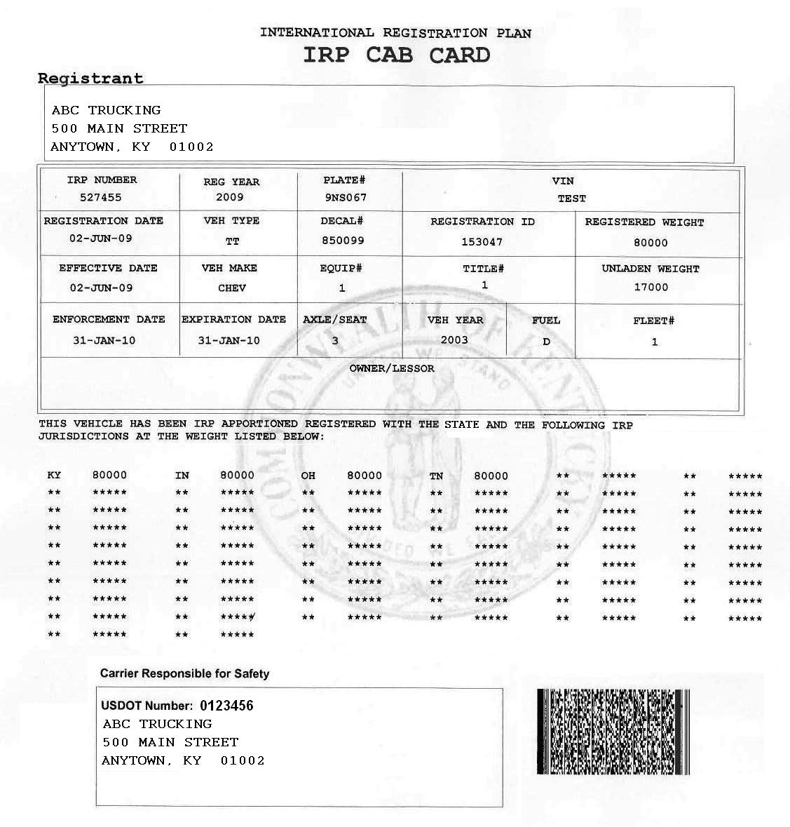

If, however, the motor carrier responsible for safety is different than the registrant, you must look further to see if the motor carrier responsible for safety has changed even though it was not expected to do so.

Cab Card Example 2
Registrant and MCRS are Different
MCRS is not expected to change

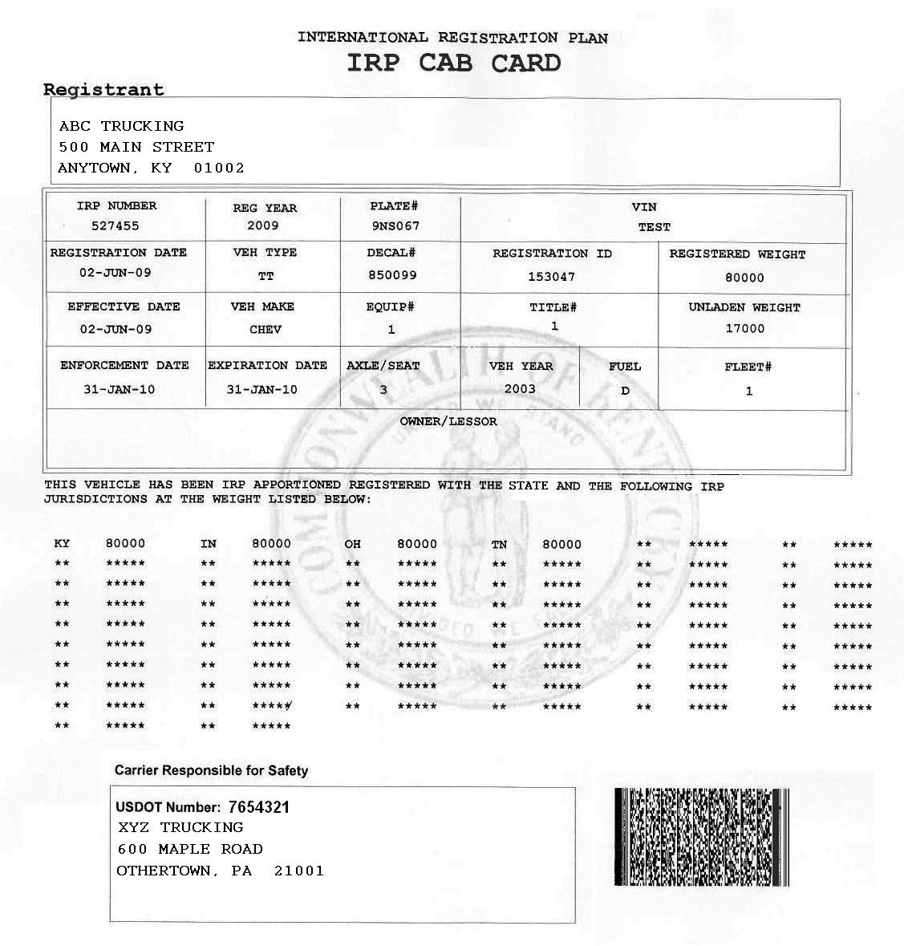

If the motor carrier responsible for safety field is blank, or states that the motor carrier is expected to change, then the lease arrangement at the time of registration was not expected to remain in effect for the entire registration year.

Cab Card Example 3
Registrant and MCRS are Different
MCRS is expected to change

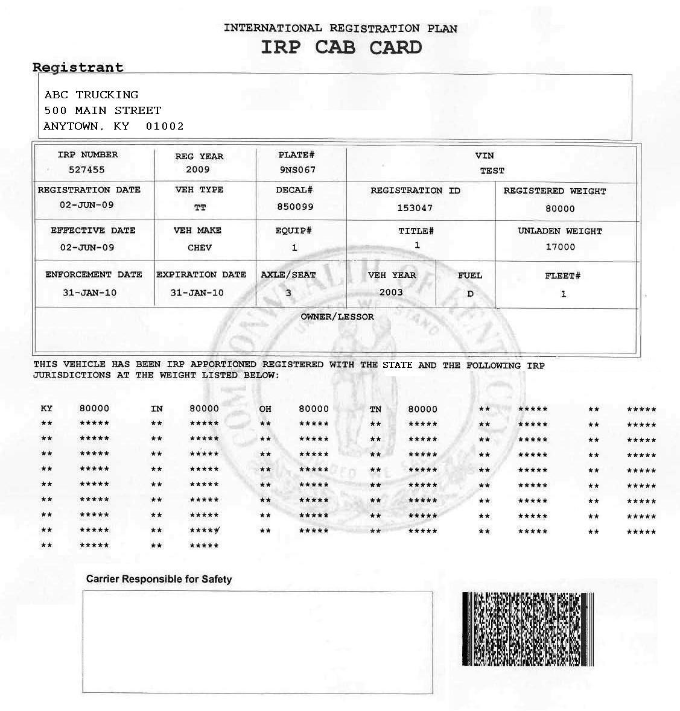

Cab Card Example 4
Registrant and MCRS are Different
MCRS is expected to change

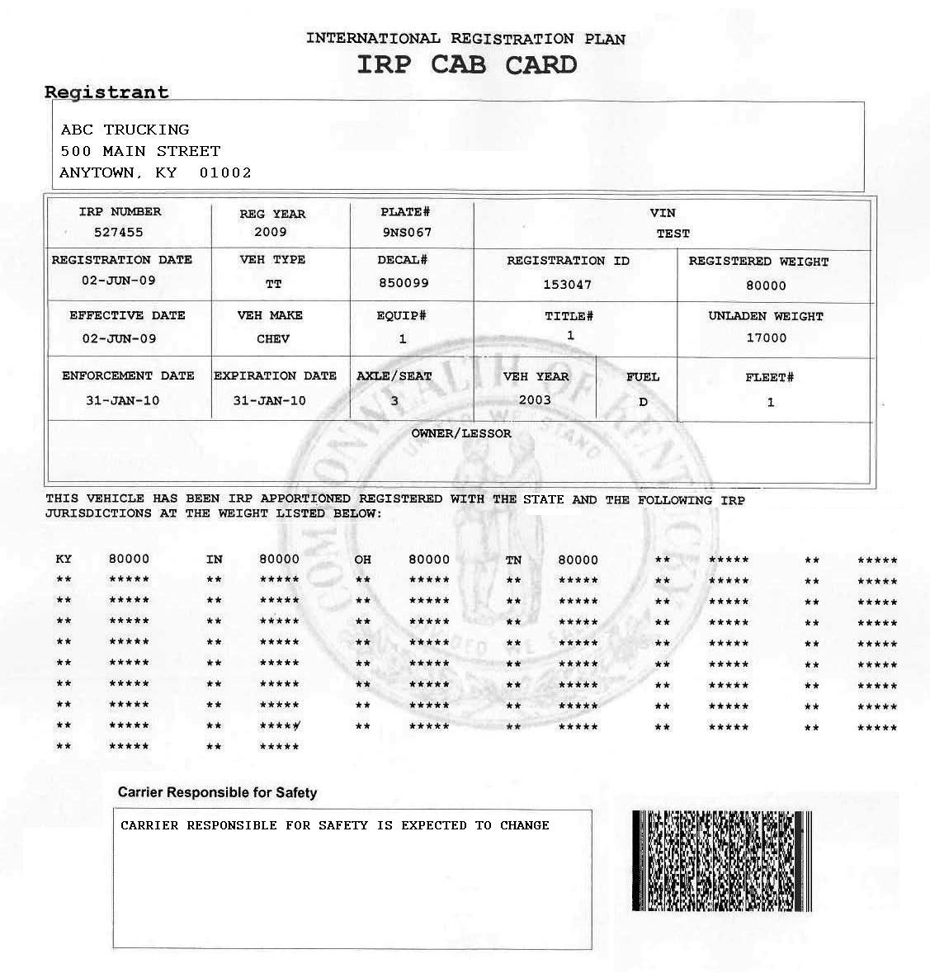
In some states, when there is a lease situation and the MCRS is expected to change during the registration year, the MCRS block has the message -“Carrier Responsible for Safety is expected to change.”

As of January 2010, a PRISM Requirement is to add this message.

You should also check the shipping papers and the driver log as well as a lease agreement if present to be certain who is the motor carrier responsible for safety.

With this help, the inspector can make an accurate determination of who is the motor carrier responsible for safety.

Notice of Caution: When using the information displayed on a cab card to determine the motor carrier responsible for safety, be advised that not all jurisdictions that barcode information on their cab cards are PRISM Compliant and predetermine the motor carrier responsible for safety Some of the states that are not PRISM Compliant are barcoding their cab cards with the registrant information, which may or may not also be the motor carrier responsible for safety.

Check for Target Status

After you have determined the proper motor carrier responsible for safety, check the target file by use of Query Central, NLETS carrier query or CVIEW. If the carrier is OOS, then follow your state’s laws for action.

Training Coordinator: Customize the list of methods to query the target file from the list above and also include the action for the roadside enforcement officer allowed by your state’s law.

Stop the Vehicle – Place it Out-of-Service

If authorized, physically retrieve plates and/or confiscate the vehicle.

The CVSA guidelines now provide enforcement personnel at the roadside with the ability to place vehicles out of service (OOS) that are operating under the authority of a motor carrier that was issued an OOSO.

If a valid OOSO is discovered and verified, enforcement personnel must place only the power unit OOS, and should indicate the appropriate FMCSR section that pertains to the OOSO on the inspection report (and citation if issued.) The inspection report should include instructions to the carrier to contact FMCSA at the number in the OOSO document they received previously. The enforcement official should also inform the driver that this OOSO is a carrier violation and will have no bearing on his/her driver record.

If an OOSO cannot be verified at the time of inspection, the vehicle should not be placed OOS but the enforcement official should make copies of pertinent paperwork (e.g., bills of lading, receipts, etc.), if possible, to demonstrate that the carrier was operating in interstate commerce at the time of the inspection. Evidence of violation of the OOSO may include the FMCSA document prohibiting interstate operations and a copy or facsimile of the inspection or crash report indicating interstate activity. Enforcement personnel should forward the information as soon as possible to the appropriate FMCSA Division Office for follow-up to determine the carrier’s actual operating status at the time of the inspection. If the FMCSA Division Office determines that the carrier was operating while a valid OOSO was in effect, then an enforcement case may be initiated by the Division Office.

The carrier is OOS until the OOSO has been officially rescinded by FMCSA.

NOTE: All Federal OOSO are issued and rescinded by the FMCSA Enforcement Team.
Enforcement personnel will not be notified by FMCSA when the carrier’s OOSO has been satisfied. In order to verify that the OOSO has been rescinded, the enforcement official will need to either utilize the above listed Federal databases or contact the appropriate FMCSA Service Center to obtain the status of the OOSO.

Inspect and Upload to ASPEN/TraCS

The bar code on the cab card can assist the inspectors in completing the ASPEN and/or TraCS forms in a timelier manner. If the carrier responsible for safety remains the same as that printed and bar-coded on the cab card, the completion of the inspection forms will be faster and easier to do. The following pages show how the coding can assist.

ASPEN

From the main toolbar within ASPEN, click on the “Barcode” menu option, and select “Import Barcode Data” as shown in the screenshot below.

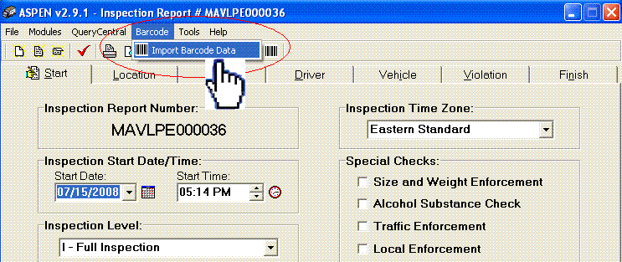

Scanning the Cab Card with the “Import Barcode Data” window open will import the Vehicle Data into the window as seen below in this screenshot.

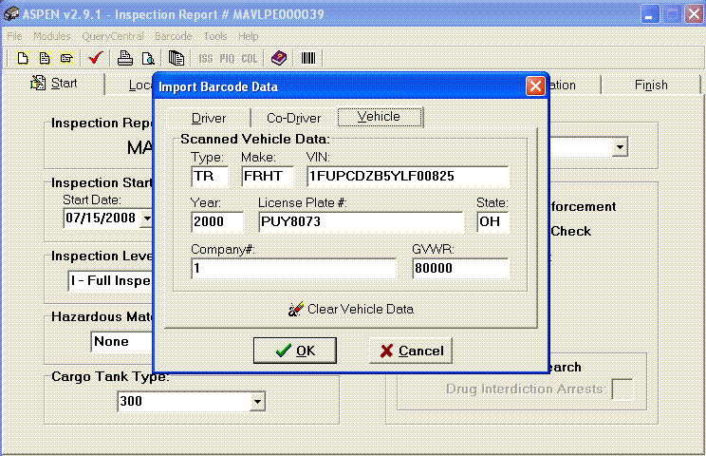

Query Central to ASPEN

To perform a vehicle search, enter a VIN or Plate/State combination and then click on the “Search” button.

Training Coordinator: If your state has purchased bar code readers from Code Corporation and has programmed to import additional information, include the following sentence instead of the sentence above.

When a Cab Card is scanned into Query Central, the USDOT Number and VIN are automatically populated in the search fields. To perform a vehicle search, click on the “Search” button next to the VIN field.

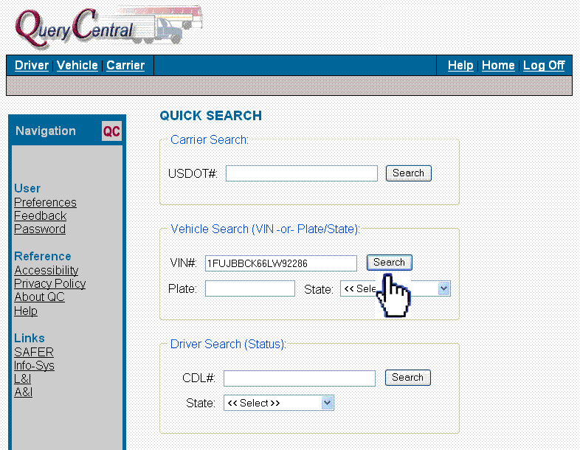

From the VEHICLE SUMMARY screen, click on the “Download Data for ASPEN” button. A pop-up will inform the user that the download is complete.

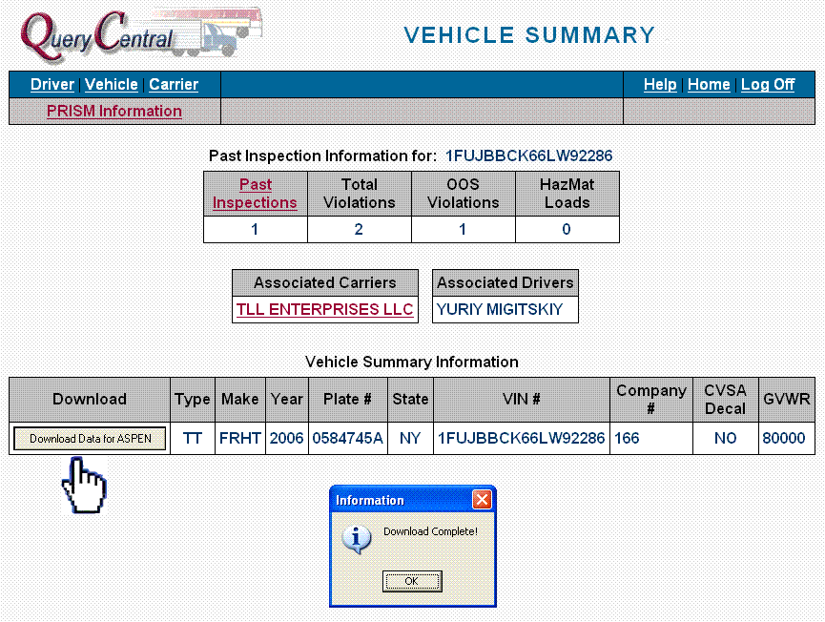

Next, from within ASPEN, click on the “Query Central” option in the top menu bar and select “Import Vehicle Data” from the drop-down list.

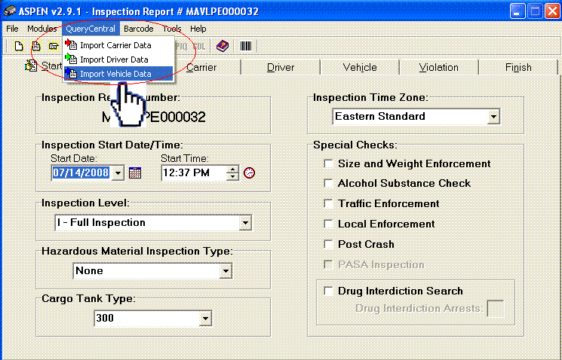

Click on the Vehicle Tab, and the information that was downloaded from Query Central is now populated in ASPEN.

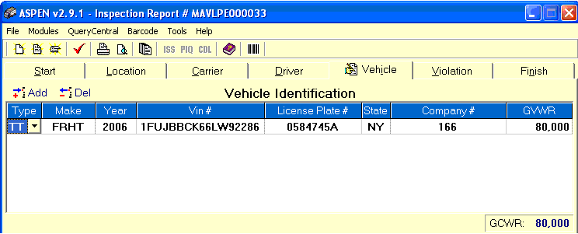

To perform a carrier search, enter the USDOT# and then click on the “Search” button.

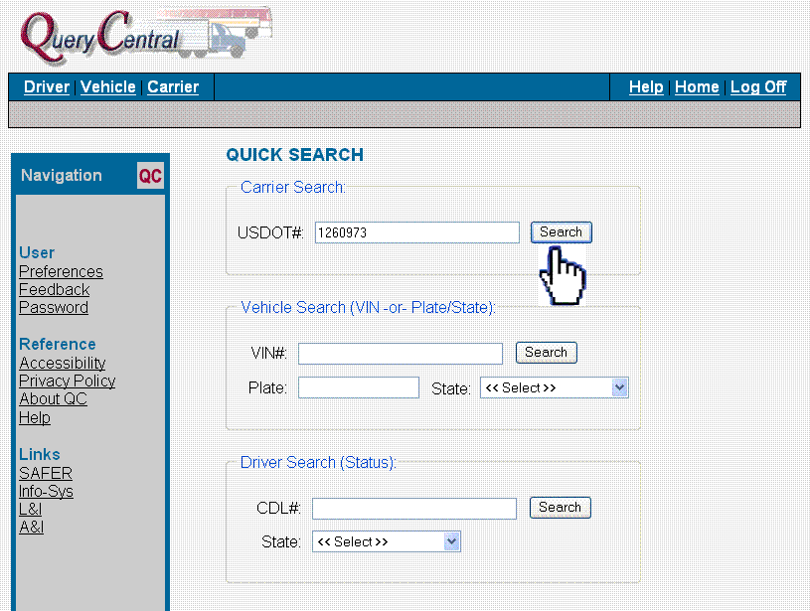

Next, click on the “Download Data for ASPEN” button. A pop-up will inform the user that the download is complete.

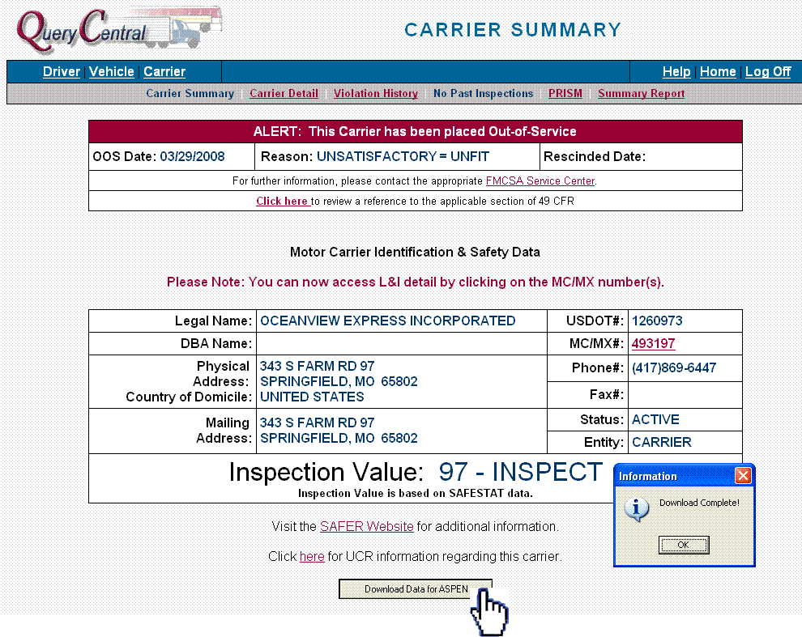

Next, from within ASPEN, click on the “Query Central” option in the top menu bar and select “Import Carrier Data” from the drop-down list.

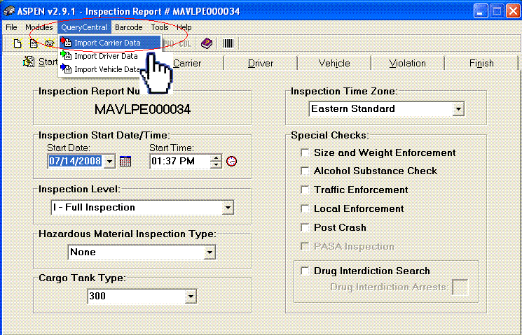

Click on the Carrier Tab, and the information that was downloaded from Query Central is now populated in ASPEN.

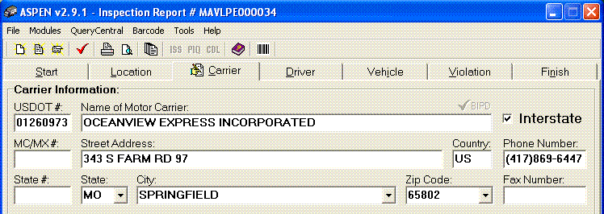

TraCS

Scanning into TraCS moves the data into the Common Information Manager.
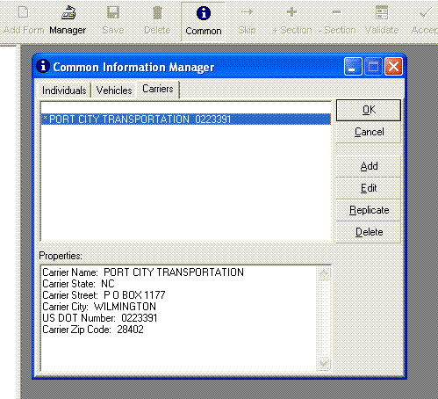

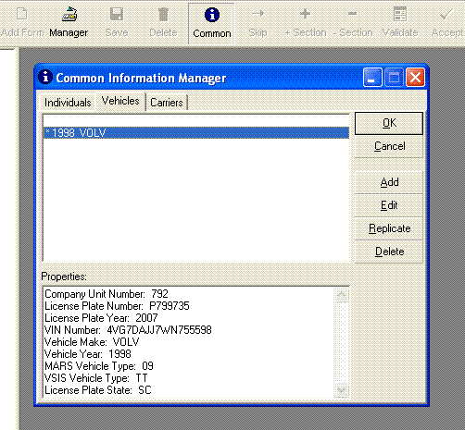

The data can be used to auto-populate the fields in the Forms section of TraCS.
