II.A.1. Miles completed by each carrier in the pilot program 1

II.A.2 Information on crashes involving vehicles in the pilot program 2

II.A.3 List of affiliates of carriers involved in the pilot program 9

II.A.4 SMS Scores of affiliates of carriers involved in the pilot program 10

Transportes Olympic – affiliate OMC Carriers LLC 10

Transportes Olympic – affiliate Fernando Paez Transport, Inc. DBA Olympic Transport (#535886) 10

Moses Alvarez Perez – no affiliate listed or identified 11

Baja Express – affiliate Carlos Tirado Valdez #1636580 – INACTIVE 11

Transportes del Valle de Guadalupe – affiliate Jose Alejandro Torres Osorio #1902901 11

Servicios Refrigerados Internacionales – affiliate SRI Trucking LLC #1614866 12

Higienicos y Desechables – affiliate Comercializadora Mexicana Trading Inc. #1540294 12

Jose Guadalupe Morales – affiliate Jose Guadalupe Morales Guevara #1217935 13

GCC – affiliate American Cement Co., Inc. #269815 13

GCC – affiliate GCC Dacotah Inc. DBA GCC of America #1747865 14

GCC – affiliate CRM Acquisitions, Inc. DBA Consolidated Ready Mix, Inc. #1451833 14

GCC – affiliate Alliance Concrete, Inc. #229282 – INACTIVE 15

GCC – affiliate Alliance Transportation, Inc. #448872 15

Transportes Monteblanco – affiliate MG Alimentos Inc. #1442274 16

Transportes Monteblanco – affiliate Transportes Monteblanco #1871386 16

Grupo Behr – affiliate Logix Transport Inc. #2210821 17

Grupo Behr – affiliate Pacific Customs Services FF9476-P – NO SMS SCORES 17

Grupo Behr – affiliate Maria Guadalupe Carrillo Cervantes #1553781 17

Ram Trucking – affiliate Zaro Transportation LLC #1741743 18

Ram Trucking – affiliate Auto Transportes Zaros #1421433 18

Servicio de Transporte Internacional y Local – affiliate International Transportation Services Inc. #2257332 19

Sergio Tristan Maldonado – affiliate Maria Higinia Tristan Maldonado DBA Trujillo’s Transfer #1771021 19

TRACSO – affiliate XIM Enterprises LLC - #2340741 – no current operating authority 20

IDLA – affiliate Hector Serrano Lee DBA Importaciones y Distribuciones Latina American Gami #1983616 20

II.A.5 How many border crossings or inspections for border crossing were related to trips that went beyond the commercial zones? Breakdown by carrier. 21

II.A.6 List of pilot program application dismissals with an explanation of why each was dismissed. 22

II.A.7 How many months has each pilot program carrier been in the program? Timeline of applications over the period of the program: When did each carrier apply? When did each carrier obtain authority? 23

II.A.8 Data on insurance verification: How many 30-day notices has the Agency issued to carriers in the pilot program? 24

II.A.9 How many pilot program carriers have been found in violation of the prohibition on point-to-point transportation? 25

II.B.1 Number of inspections completed at the border 26

II.B.2 Number of inspections completed beyond the border and in which States 26

Transportes Olympic – State Inspection Reports – Mississippi 27

Transportes Olympic – State Inspection Reports – Nebraska 28

Transportes Olympic – State Inspection Reports – Texas (1 of 2) 30

Transportes Olympic – State Inspection Reports – Texas (2 of 2) 31

II.B.3 Breakdown of types of inspections that were conducted (Levels I-V) 33

II.B.4 Table format of violations and OOS rates by carrier 34

II.B.4 Violations by carrier 35

Transportes Olympic 35

Moises Alvarez Perez 37

Baja Express 37

Transportes Del Valle de Guadalupe 38

Servicios Refrigerados Internacionales 39

Higienicos y Desechables del Bajia 39

Jose Guadalupe Morales DBA Fletes Morales 40

Transportes Monteblanco 41

GCC Transportes 44

Servicio de Transporte Internacional y Local 53

Grupo Behr de Baja California 59

RAM Trucking 61

Sergio Tristan Maldonado DBA Tristan Transfer 62

TRACSO 65

IDLA 65

II.C.1 Representative sample of electronic HOS data for drivers in the pilot program 66

II.C.2 Aggregate summary of what FMCSA has observed regarding HOS information. Breakout by violation. 67

II.C.3 What percentage of HOS data is completely electronic versus manual input of driving time from the driver into the electronic logging device (ELD)? 68

II.C.4 HOS documentation/violations data for pilot program carriers and drivers before they entered the pilot program – Carriers 69

II.C.4 HOS documentation/violations data for pilot program carriers and drivers before they entered the pilot program – Drivers 70

II.D.1 Clear explanation of how the Agency arrived at the number of inspections needed for the optimal number of data for the analysis (4100) and switch from using crash data to inspections data 71

II.D.2 Was there anything that specified over how many carriers those inspections must occur? FR notice stated that the Agency’s goal was to have at least 30-40 carriers in the pilot program. 72

II.E.1 Inspection data for enterprise and certificate carriers: number of inspections, driver and vehicle OOS rates, violation rates for key violations 73

II.E.2 Do enterprise and certificate carriers have CVSA decals? If so, how many enterprise and certificate carriers/vehicles have the CVSA decals? 74

II.E.3 Table of Mexican commercial trucking industry by power units, number of carriers, etc. for purposes of understanding how representative are the 14 carriers in the pilot program 75

II.F.1 What is the basis of comparison population to arrive at the conclusion that 46 carriers would be sufficient to evaluate the pilot program? 76

II.G. How much of FMCSA’s resources have gone into the pilot program? 77

II.H.1 Breakdown of Mexican commercial motor vehicle industry: numbers of carriers, carrier size, etc. 78

II.H.2 Mexican commercial vehicle inspection activities and results. 78

[This page left blank intentionally.]

## II.A.1. Miles completed by each carrier in the pilot program

| **Carrier** | **Cumulative Mileage**  **(as of 06/15/2014)** |
| --- | --- |
| Transportes Olympic de Mexico | 489,297 |
| Moises Alvarez Perez dba Distribuciones Pescador | 1,856 |
| Baja Express Transportes | 9,269 |
| Transportes del Valle de Guadalupe | 108,440 |
| SRI – Servicos Refrigerados Internacionales | 72,500 |
| Higienicos y Desechables del Bajio | 1,032 |
| Jose Guadalupe Morales dba Fletes Morales | 33,991 |
| Grupo Behr de Baja California | 14,755 |
| STIL – Servicio de Transporte Internacional y Local | 112,967 |
| Ram Trucking | 32 |
| GCC Transportes | 159,399 |
| Sergio Tristan Maldonaldo dba Tristan Transfer | 1316 |
| TRACSO – Transportation and Cargo Solutions | 0 |
| Transportes Monteblanco | 186,963 |
| IDLA | 0 |
| **TOTAL** | **1,191,817** |

*Note: As of June 15, 2014*

## II.A.2 Information on crashes involving vehicles in the pilot program

Pilot carrier Grupo Behr experienced a crash on June 18, 2013, in San Diego, CA. The crash report filed by the San Diego Police Department as report #CA0006118287 identified two vehicles involved in the crash, with 1 injury sustained, and towaway required.

See attached accident report summary from MCMIS and original San Diego Police Department report.

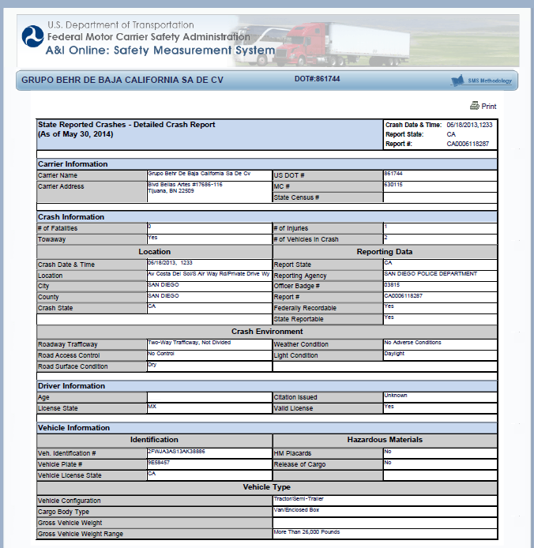

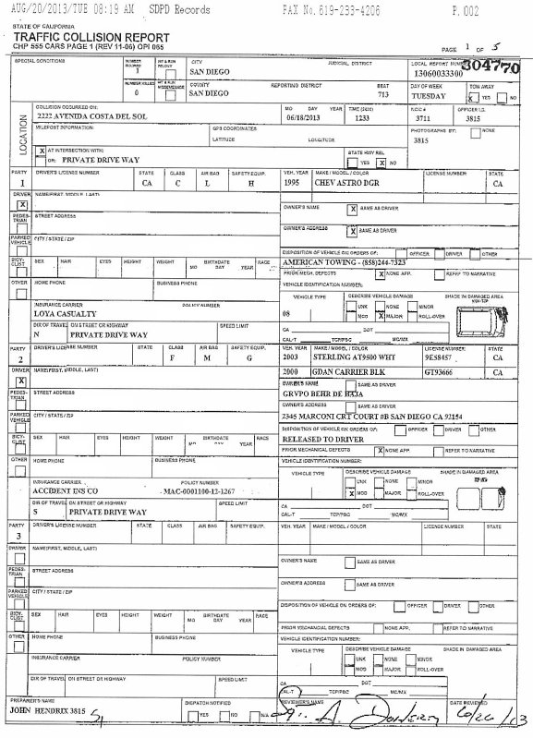

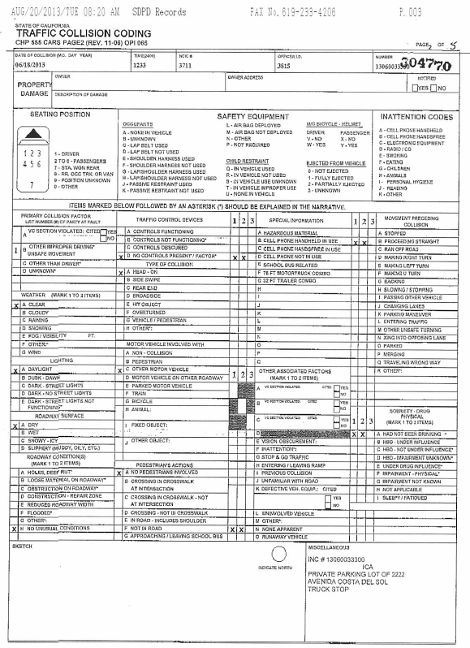

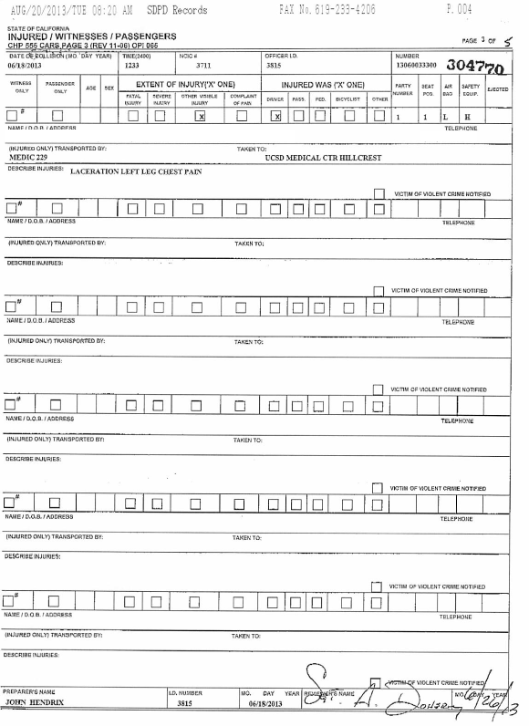

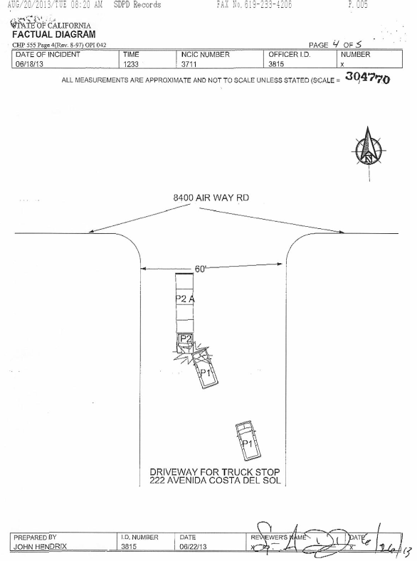

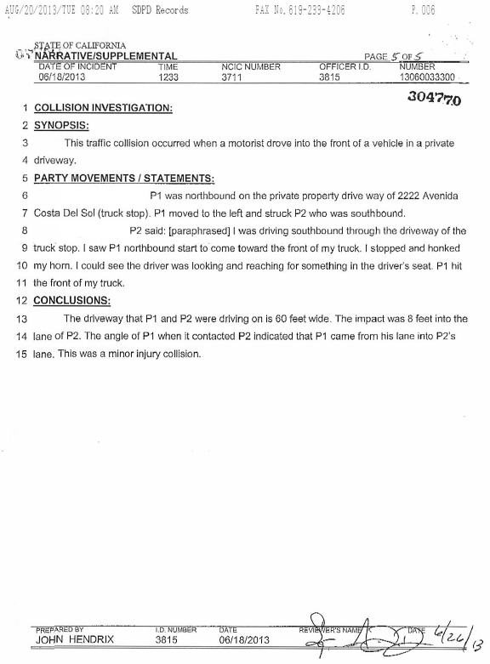

## II.A.3 List of affiliates of carriers involved in the pilot program

| **Carrier** | **Applicant Identified Affiliate?** | **Name / DOT # of Affiliate** | **Relationship** |
| --- | --- | --- | --- |
| Transportes Olympic | Yes | OMC Carrier, LLC (#1281837), Fernando Paez Transport, Inc. DBA Olympic Transport (#535886) | Company executive same |
| Moises Alvarez Perez | No | None | N/A |
| Baja Express | Yes | Carlos Tirado Valdez Baja Express (#1636580) | Company executive same |
| Transportes del Valle | Yes | Jose Alejandro Torres Osorio Transportes Del Valle De Guadalupe (#1902901) | Company executive same |
| SRI | Yes | SRI Trucking, LLC (#1614866) | Company official same |
| Higienicos y Desechables | Yes | Comercializadora Mexicana Trading Inc. (#1540294) | Company principal same |
| Jose Guadalupe Morales dba Fletes Morales | Yes | Jose Guadalupe (#1217935) | Company official same |
| Grupo Behr | Yes | Logix Transport Inc. (#2210821), Pacific Customs Services (FF#9476-P), Maria Guadalupe Carrillo Cervantes (#1553781) | Company official same; use of vehicle and/or driver |
| STIL | Yes | International Transportation Services, Inc. (#2257332) | Company principal(s), mailing addresses same |
| Ram Trucking | Yes | Zaro Transportation LLC (#1741743), Auto Transportes Zaros (#1421433) | Company principals same |
| GCC | Yes | American Cement Co., Inc. (#269815); GCC Dacotah Inc DBA GCC of America (#1747865), CRM Acquisitions, Inc. DBA Consolidated Ready Mix, Inc. (1451833), GCC Alliance Concrete, Inc. (229282), Alliance Transportation, Inc. (448872) | Corporate parent owns cement producing plants in US states |
| Sergio Tristan Maldonaldo DBA Tristan Transfer | No | Maria Higinia Tristan Maldonado DBA Trujillo’s Transfer (#1771021) | Sister of principal |
| TRACSO | Yes | XIM Enterprises LLC (#2340741) | Company president same |
| Transportes Monteblanco | Yes | Mg Alimentos Inc. (#1442274), Transportes Monteblanco (#1871386) | Company executive same |
| IDLA | Yes | Hector Serrano Lee DBA Importaciones y Distribuciones Latina America Gami (#1983616) | Company principals father-son relationship; address same |

## II.A.4 SMS Scores of affiliates of carriers involved in the pilot program

### Transportes Olympic – affiliate OMC Carriers LLC (#1281837)

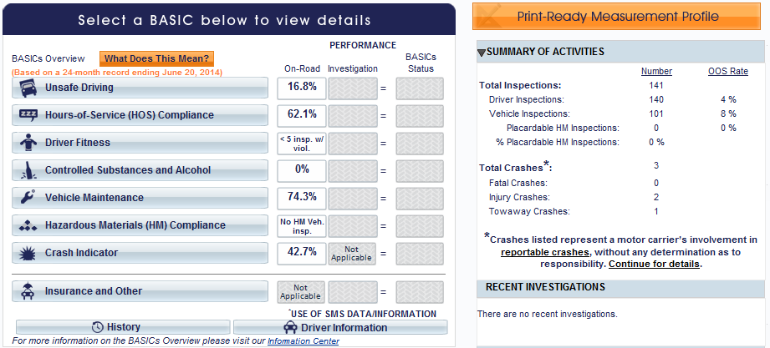

### Transportes Olympic – affiliate Fernando Paez Transport, Inc. DBA Olympic Transport (#535886)

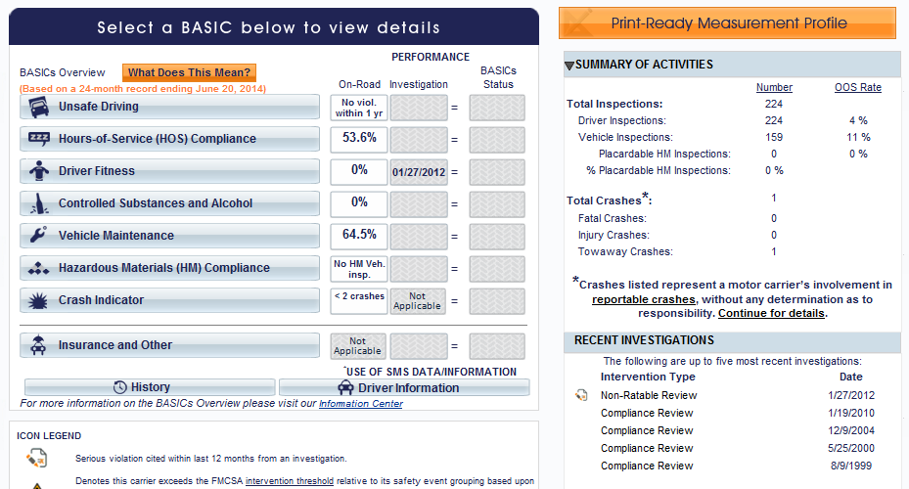

### Moses Alvarez Perez – no affiliate listed or identified

### Baja Express – affiliate Carlos Tirado Valdez #1636580 – INACTIVE

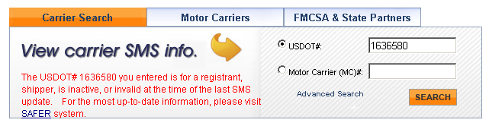

### Transportes del Valle de Guadalupe – affiliate Jose Alejandro Torres Osorio #1902901

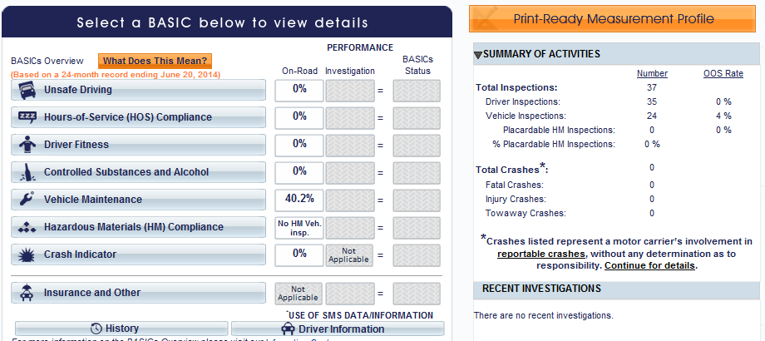

### Servicios Refrigerados Internacionales – affiliate SRI Trucking LLC #1614866

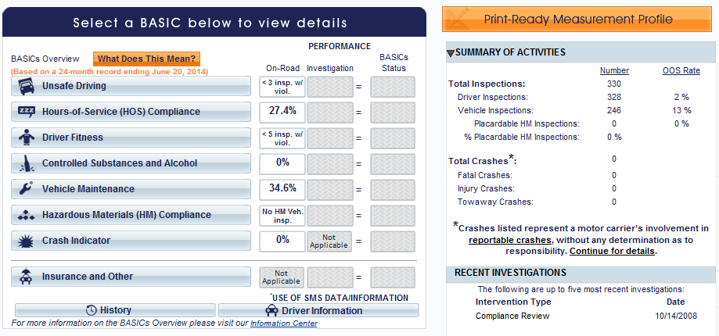

### Higienicos y Desechables – affiliate Comercializadora Mexicana Trading Inc. #1540294

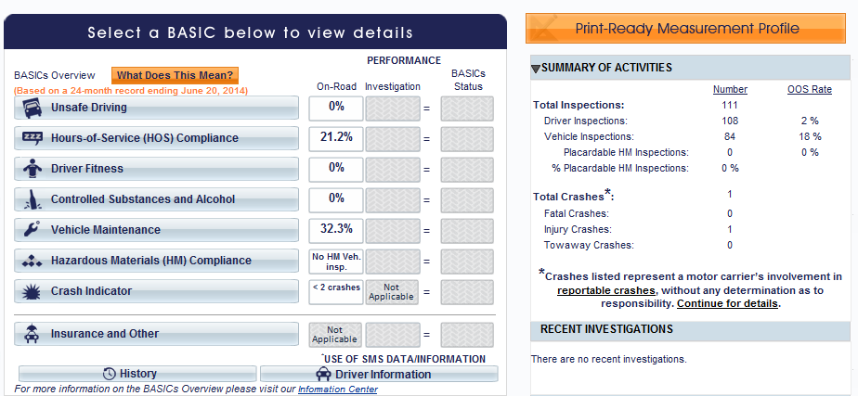

### Jose Guadalupe Morales – affiliate Jose Guadalupe Morales Guevara #1217935

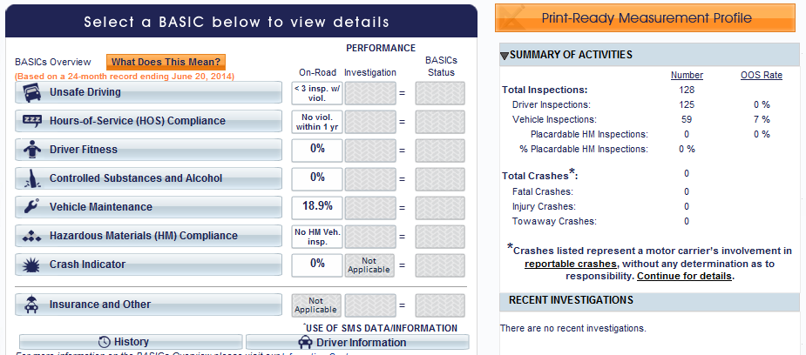

### GCC – affiliate American Cement Co., Inc. #269815

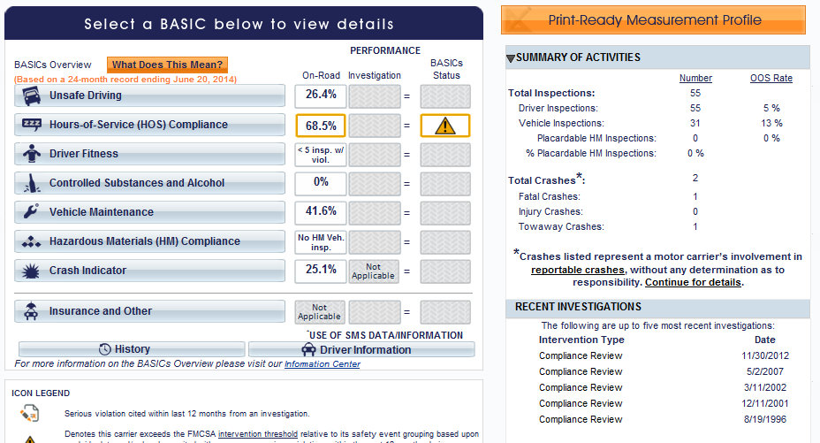

### GCC – affiliate GCC Dacotah Inc. DBA GCC of America #1747865

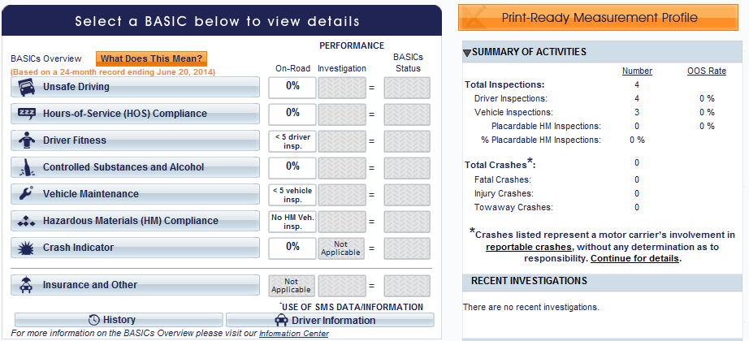

### GCC – affiliate CRM Acquisitions, Inc. DBA Consolidated Ready Mix, Inc. #1451833

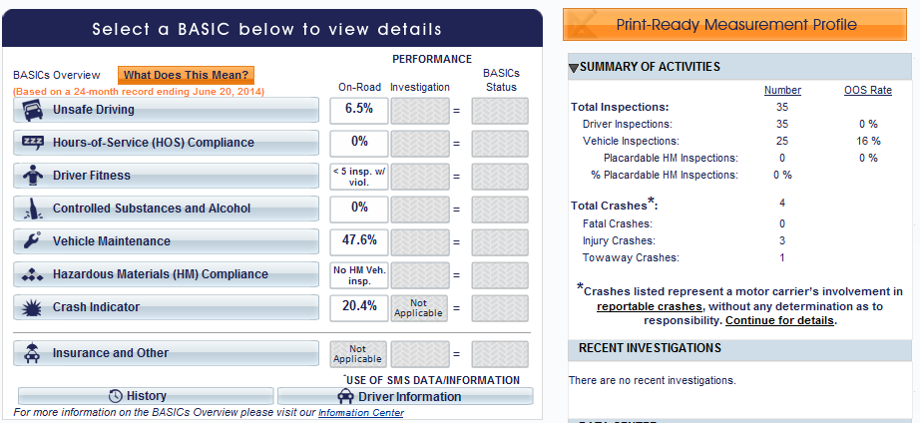

### GCC – affiliate Alliance Concrete, Inc. #229282 – INACTIVE

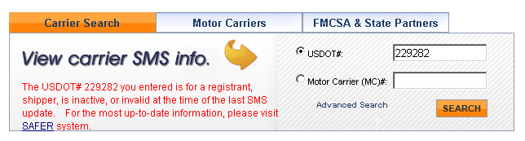

### GCC – affiliate Alliance Transportation, Inc. #448872

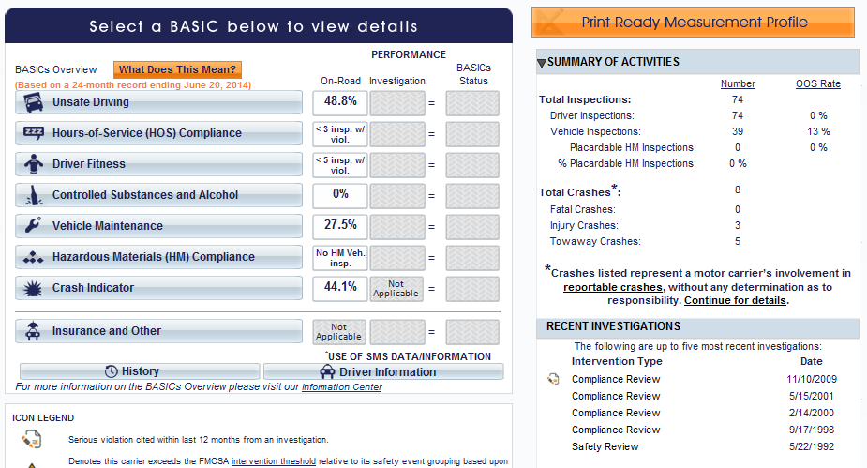

### Transportes Monteblanco – affiliate MG Alimentos Inc. #1442274

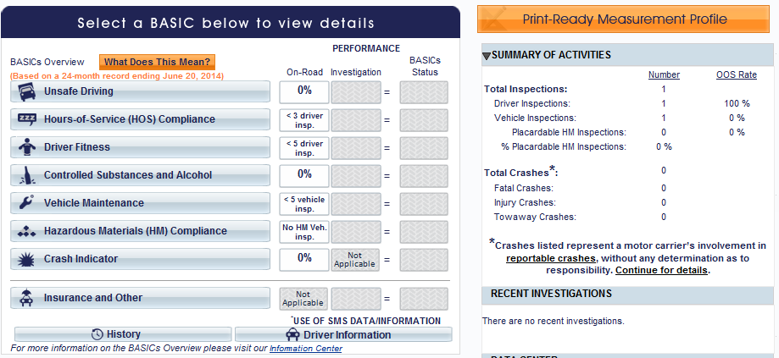

### Transportes Monteblanco – affiliate Transportes Monteblanco #1871386

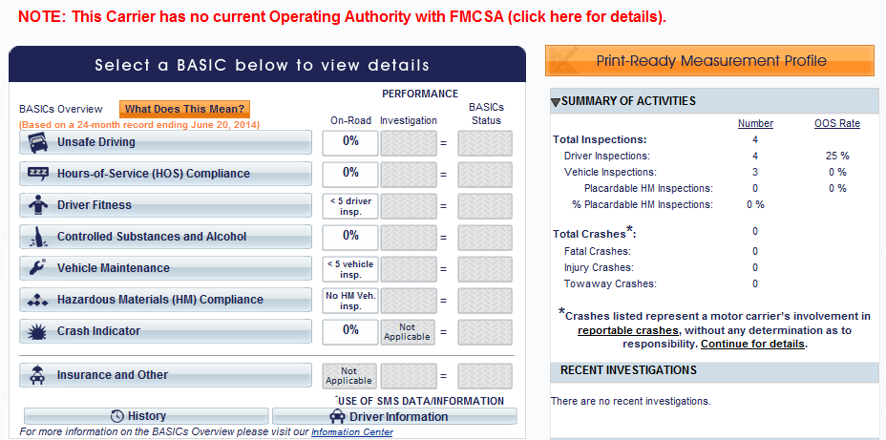

### Grupo Behr – affiliate Logix Transport Inc. #2210821

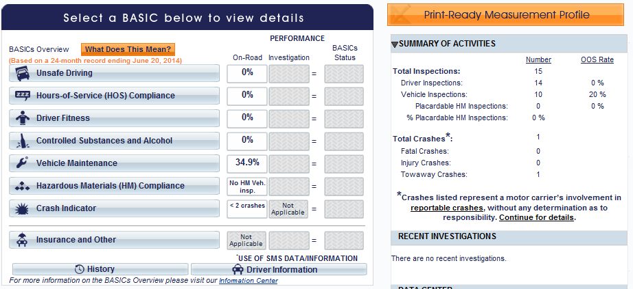

### Grupo Behr – affiliate Pacific Customs Services FF9476-P – NO SMS SCORES

### Grupo Behr – affiliate Maria Guadalupe Carrillo Cervantes #1553781

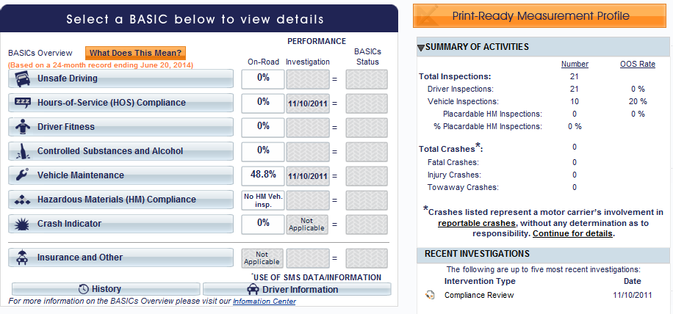

### Ram Trucking – affiliate Zaro Transportation LLC #1741743

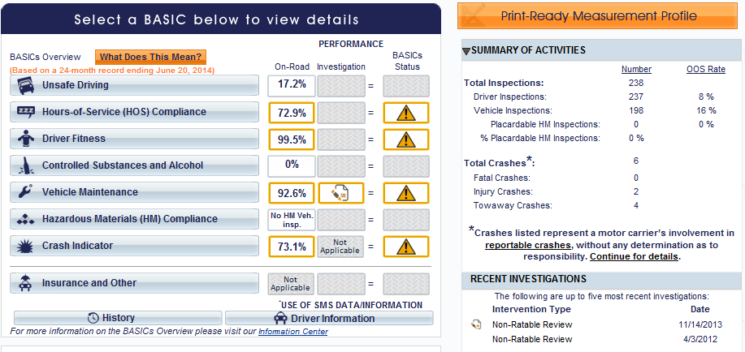

### Ram Trucking – affiliate Auto Transportes Zaros #1421433

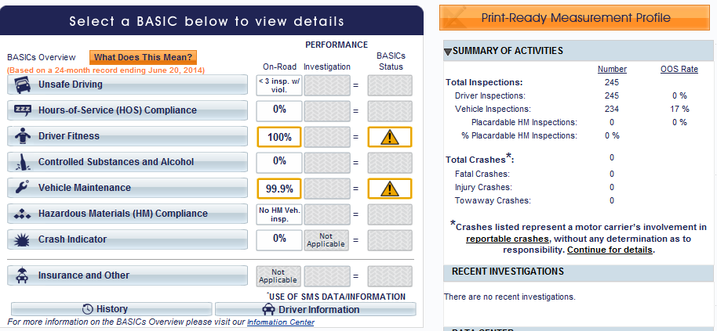

### Servicio de Transporte Internacional y Local – affiliate International Transportation Services Inc. #2257332

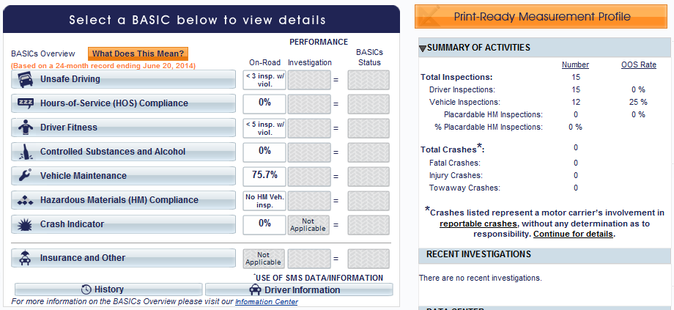

### Sergio Tristan Maldonado – affiliate Maria Higinia Tristan Maldonado DBA Trujillo’s Transfer #1771021

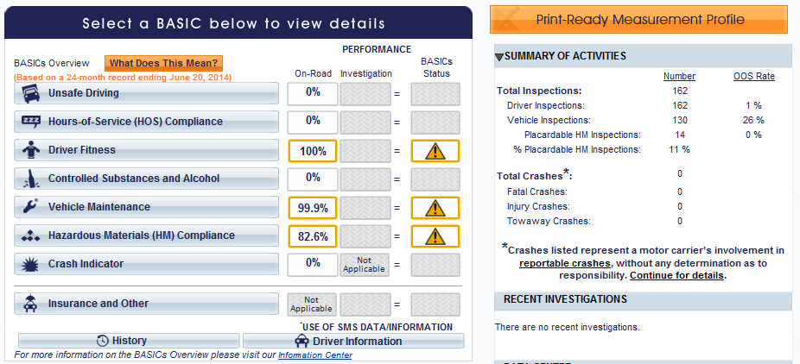

### TRACSO – affiliate XIM Enterprises LLC - #2340741 – no current operating authority

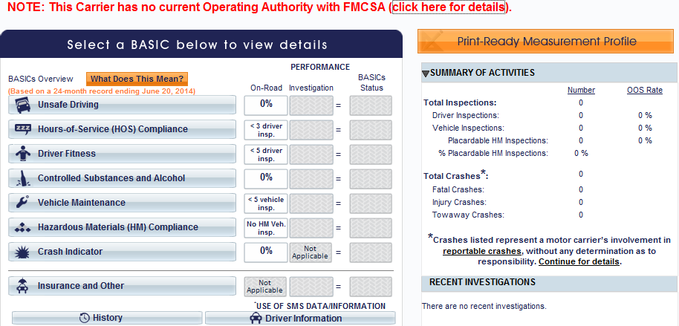

### IDLA – affiliate Hector Serrano Lee DBA Importaciones y Distribuciones Latina American Gami #1983616

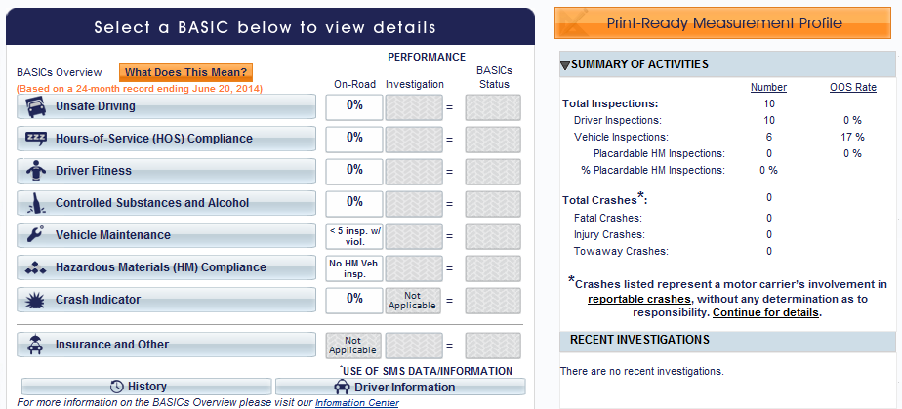

## II.A.5 How many border crossings or inspections for border crossing were related to trips that went beyond the commercial zones? Breakdown by carrier.

|  |  |  |  |  |  |
| --- | --- | --- | --- | --- | --- |
| **Carrier** | **Total Number of Crossings** | **Destination Beyond CZ** | **Inspections for Trips Beyond CZ** | **Federal Inspections** | **State Inspections** |
| Transportes Olympic | 292 | 279 | 235 | 231 | 4 |
| Moises Alvarez Perez | 8 | 7 | 7 | 6 | 1 |
| Baja Express | 250 | 25 | 8 | 7 | 1 |
| Transportes del Valle | 470 | 229 | 102 | 93 | 9 |
| SRI | 135 | 118 | 32 | 29 | 3 |
| Higienicos y Desechables | 9 | 4 | 2 | 2 | 0 |
| Jose Guadalupe Morales | 175 | 71 | 28 | 26 | 2 |
| Grupo Behr | 556 | 18 | 1 | 1 | 0 |
| STIL | 13598 | 99 | 18 | 17 | 1 |
| Ram Trucking | 5 | 0 | 0 | 0 | 0 |
| GCC | 5033 | 3 | 0 | 0 | 0 |
| Sergio Tristan (revoked 6/2014) | 60 | 0 | 0 | 0 | 0 |
| TRACSO | 3 | 0 | 0 | 0 | 0 |
| Transportes Monteblanco | 314 | 287 | 285 | 285 | 0 |
| IDLA | 10 | 10 | 10 | 10 | 0 |
| **TOTAL** | **5046** | **1150** | **728** | **707** | **21** |

## II.A.6 List of pilot program application dismissals with an explanation of why each was dismissed.

|  |  |  |  |  |
| --- | --- | --- | --- | --- |
| **Carrier** | **USDOT/MX #** | **Reason** | **Additional Info** |  |
| Montemayor Espinoza Trucking | USDOT 555258 MX 229315 | By request |  |  |
| Transportes Unimex SA de CV | USDOT 1739863 | Safety rating | Conditional rating |  |
| Amador Valdez | USDOT 998139 MX 420558 | Security vetting |  |  |
| Ricardo Herrera Bolanos | USDOT 2358460 MX 815070 | By request | Wanted OP-2 app |  |
| Y & R Fashion Mex S de RL de CV | USDOT 1678162 MX 616838 | Violations | Scope of authority |  |
| Jose Luis Hernandez Avila dba Comodin Transport | USDOT 1658186 MX 609991 | Violations | Driver qualifications |  |
| Adriana de Leon Amara dba Autotransportes Impacto | USDOT 2117609 MX 738224 | PASA failure | Drug/alcohol testing program |  |
| Luis Edmundo Grijalva Gamez dba Transportes Grihop | USDOT 1598518 MX 591621 | Violations | Scope of authority |  |
| Figueroa Robles Gabriel - Akemigabby Transport | USDOT 2301851 MX [none] | Violations | Scope of authority |  |
| MediMexico S de RL de CV | USDOT 626455 MX 326227 | Violations | Scope of authority |  |
| Josue Ivan Rodriguez Angulo- Transportes Divalo | USDOT 1816618 MX 659717 | Security vetting |  |  |
| Trinity Industries de Mexico S de RL de CV | USDOT 610385 M 468284 | By request |  |  |
| Autotransportes Libre Comercio SA de CV | USDOT 1189128 MX474824 | Safety rating | Conditional |  |
| Gerardo Antonio Smith Sarabia dba Las Transport | USDOT 2294430 MX [none] | Security vetting |  |  |
| Maria Isabel Mendivil Velarde dba Transportes Julian Villa | USDOT 1548345 MX 659717 | Violations | Scope of authority, affiliates |  |
| Nature Flavor Produce S de RL de CV | USDOT 2120188 MX 739089 | By request |  |  |
| Aguirre Ramos Jorge Luis | USDOT 1286830 MX 500933 | By request |  |  |
| Jorge Luis Cardena Romo dba Transportes MOR SA de CV | USDOT 555687 MX 228295 | PASA failure | Drug/alcohol testing program |  |
| Road Machinery | USDOT 2091627 MX 729757 | By request |  |  |
| TransMex Inc SA de CV | USDOT 710381 MX 1324695 | Safety rating | Conditional rating |  |
| Especializados Willie SA de CV | USDOT 2295065 MX 787211 | By request |  |  |

## II.A.7 How many months has each pilot program carrier been in the program? Timeline of applications over the period of the program: When did each carrier apply? When did each carrier obtain authority?

|  |  |  |  |  |  |  |
| --- | --- | --- | --- | --- | --- | --- |
| **Carrier Name** | **USDOT No.** | **Docket No.** | **Application Received** | **Provisional Authority Granted** | **# of Months in Pilot** | **Permanent Authority Granted** |
| Transportes Olympic de Mexico S de RL de CV | 555188 | MX239409 | 7/19/2011 | NA-1 | 33 | 10/14/2011 |
| Moises Alvarez Perez DBA Distribuidora Marina el Pescador | 677516 | MX313931 | 9/7/2011 | 12/28/2011 | 30 | 5/23/2013 |
| Baja Express Transportes SA de CV | 2194257 | MX777490 | 9/21/2011 | 3/30/2012 | 27 | 9/30/2013 |
| Transportes Del Valle de Guadalupe SA de CV | 2208377 | MX785563 | 11/8/2011 | 6/12/2012 | 24 | 5/23/2013 |
| Servicios Refrigerados Internacionales SA de CV | 1052546 | MX440938 | 10/26/2011 | 7/24/2012 | 23 | 5/23/2013 |
| Higienicos y Desechables del Bajio SA de CV | 710491 | MX327700 | 9/2/2011 | 8/1/2012 | 22 | 5/23/2013 |
| Jose Guadalupe Morales Guevara DBA Fletes Morales | 683409 | MX316863 | 10/26/2011 | 9/4/2012 | 21 | 3/4/2014 |
| Transportes Monteblanco SA de CV | 1059694 | MX443410 | 10/5/2011 | 10/19/2012 | 20 | 6/20/2013 |
| GCC Transportes SA de CV | 650155 | MX701100 | 9/7/2011 | 10/9/2012 | 20 | 7/16/2013 |
| Servicio de Transporte Internacional y Local SA de CV | 557341 | MX226885 | 10/13/2011 | 6/17/2013 | 12 | NA-2 |
| Grupo Behr de Baja California SA de CV | 861744 | MX630115 | 7/21/2011 | 2/19/2013 | 16 | 2/19/2013 |
| RAM Trucking SA de CV | 2063285 | MX721816 | 3/30/2012 | 6/11/2013 | 12 | NA-2 |
| Sergio Tristan Maldonado DBA Tristan Transfer | 2348928 | N/A | 10/10/2012 | 7/25/2013 | 11 | None-revoked |
| TRACSO - Transportation and Cargo Solutions | 779973 | 347064 | 4/8/2012 | 11/4/2013 | 8 | NA-2 |
| IDLA | 2448536 | 861978 | 10/24/2013 | 5/23/2014 | 1 | NA-2 |

NOTE:

NA-1 – Transportes Olympic participated in the prior demonstration program and received credit for that participation for meeting the minimum 18-month requirement in provisional pilot authority, thus being granted permanent authority from the start of the pilot.

NA-2 – Permanent pilot authority not yet granted; requires minimum 18 months in provisional authority status before granting of permanent pilot authority.

# of Months counted through June 2014

## II.A.8 Data on insurance verification: How many 30-day notices has the Agency issued to carriers in the pilot program?

| **Carrier** | **Insurance Effective Date** | **30-Day Notice**  **Sent** | **Replacement**  **Date** |
| --- | --- | --- | --- |
| Transportes Olympic | 7/20/2013 | NA | NA |
| 7/20/2012 | 6/20/2013 | 8/1/2013 |
|  | | | |
| Moises Alvarez Perez | 12/21/2013 | 12/21/2013 | 12/21/2013 |
| 12/21/2012 | 12/21/2012 | 12/21/2012 |
| 12/21/2011 |  | 12/21/2012 |
|  | | | |
| Baja Express | 10/5/2013 | 10/5/2013 | 10/5/2013 |
| 10/5/2012 | 10/5/2013 | 10/5/2013 |
|  | | | |
| Transportes del Valle | 7/20/2013 | 7/20/2014 | NA |
| 7/20/2012 | 6/20/2013 | 7/20/2013 |
| 6/6/2012 | 6/19/2013 | 7/20/2013 |
|  | | | |
| SRI | 12/4/2013 | NA | NA |
| 7/17/2013 | 12/13/2013 | 12/4/2013 |
| 7/12/2012 | 6/17/2013 | 7/17/2013 |
|  | | | |
| Higienicos y Desechables | 7/26/2013 | NA | NA |
| 7/26/2012 | 6/26/2013 | 7/26/2013 |
|  | | | |
| Jose Guadalupe Morales | 8/28/2013 | NA | NA |
| 8/28/2012 | 8/28/2013 | 8/28/2013 |
|  | | | |
| Grupo Behr | 1/29/2014 | NA | NA |
| 1/25/2011 | 1/29/2014 | 1/29/2014 |
|  | | | |
| STIL | 6/15/2013 |  |  |
|  | | | |
| Ram Trucking | 8/17/2013 | NA | NA |
| 6/6/2013 | 8/17/2013 | 8/17/2013 |
|  | | | |
| GCC | 9/1/2008 | 10/11/2008 | 9/1/2009 |
|  | | | |
| Sergio Tristan Maldonado | 7/19/2013 | NA | NA |
|  | | | |
| TRACSO | 10/28/2013 | NA | NA |
|  | | | |
| Transportes Monteblanco | 4/6/2014 | NA | NA |
|  | 4/6/2013 | 4/27/2013 | 4/6/2014 |
|  | 4/6/2012 | 4/6/2013 | 4/6/2013 |
|  | | | |
| IDLA | 5/15/2014 | NA | NA |

## II.A.9 How many pilot program carriers have been found in violation of the prohibition on point-to-point transportation?

No potential violation investigated by the Division has resulted in a positive finding of a violation.

| **Carrier** | **Potential Violations Identified** | **Investigation Pending Results** |
| --- | --- | --- |
| Transportes Olympic | 19 | 2 |
| Moises Alvarez Perez | 0 | 0 |
| Baja Express | 0 | 0 |
| Transportes del Valle | 0 | 0 |
| SRI | 0 | 0 |
| Higienicos y Desechables | 0 | 0 |
| Jose Guadalupe Morales | 0 | 0 |
| Grupo Behr | 1 | 1 |
| STIL | 0 | 0 |
| Ram Trucking | 0 | 0 |
| GCC | 0 | 0 |
| Sergio Tristan Maldonado | 15 | 0 |
| TRACSO | 0 | 0 |
| Transportes Monteblanco | 0 | 0 |
| IDLA | 0 | 0 |
| **TOTAL** | **35** | **3** |

## II.B.1 Number of inspections completed at the border

## II.B.2 Number of inspections completed beyond the border and in which States

| **Carrier** | **Total # of Inspections Performed** | **# of Inspections Completed at Border** | **# of Inspections**  **Beyond Border**  **by State Officers** | **State of**  **Inspection** | **# of Inspections**  **in State** |
| --- | --- | --- | --- | --- | --- |
| Transportes Olympic | 235 | 231 | 4 | MS  NE  TX | 1  1  2 |
| Moises Alvarez Perez | 8 | 8 | 0 | NA | NA |
| Baja Express | 55 | 55 | 0 | NA | NA |
| Transportes del Valle | 103 | 103 | 0 | NA | NA |
| SRI | 33 | 33 | 0 | NA | NA |
| Higienicos y Desechables | 8 | 8 | 0 | NA | NA |
| Jose Guadalupe Morales | 52 | 52 | 0 | NA | NA |
| Grupo Behr | 60 | 60 | 0 | NA | NA |
| STIL | 2859 | 2859 | 0 | NA | NA |
| Ram Trucking | 4 | 4 | 0 | NA | NA |
| GCC | 1299 | 1299 | 0 | NA | NA |
| Sergio Tristan Maldonado | 34 | 34 | 0 | NA | NA |
| TRACSO | 1 | 1 | 0 | NA | NA |
| Transportes Monteblanco | 285 | 285 | 0 | NA | NA |
| IDLA | 10 | 10 | 0 | NA | NA |
| **TOTAL** | **5046** | **5042** | **4** |  |  |

### Transportes Olympic – State Inspection Reports – Mississippi

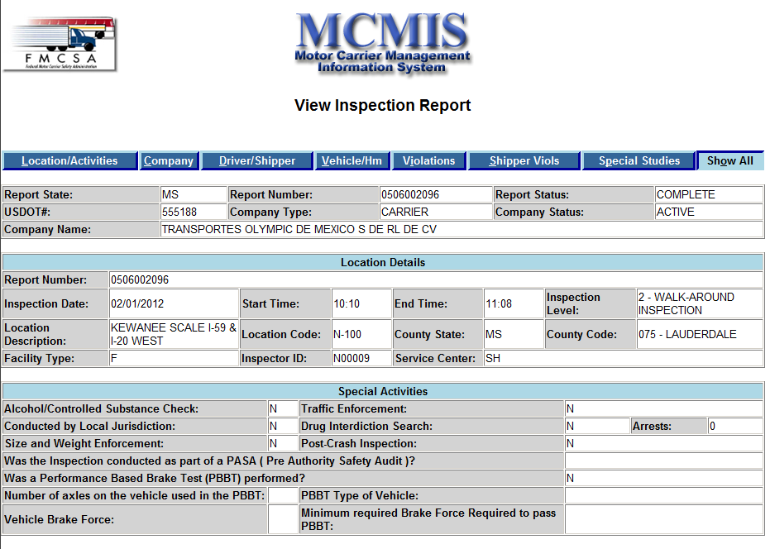

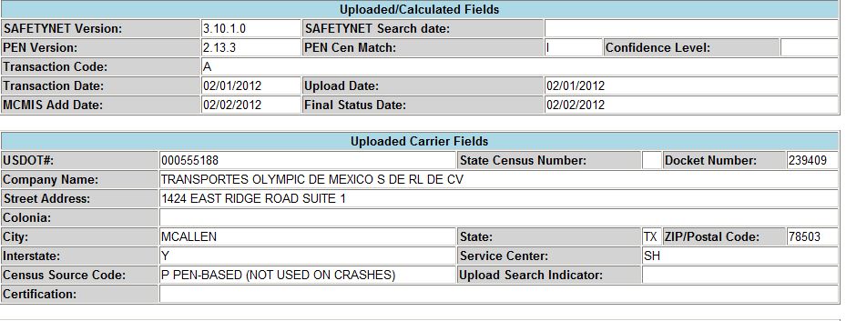

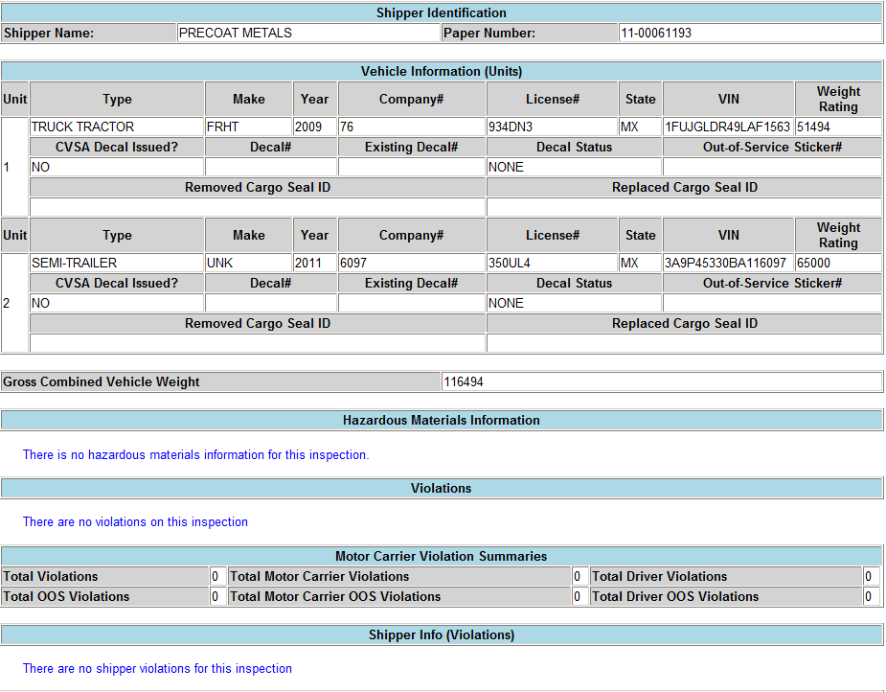

### Transportes Olympic – State Inspection Reports – Nebraska

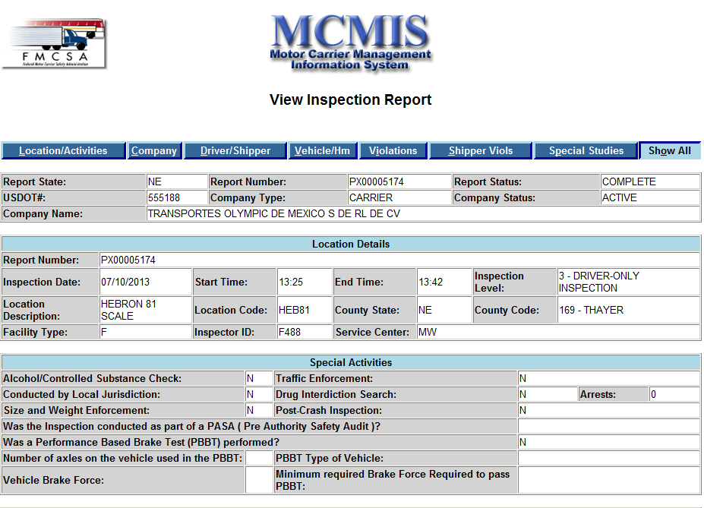

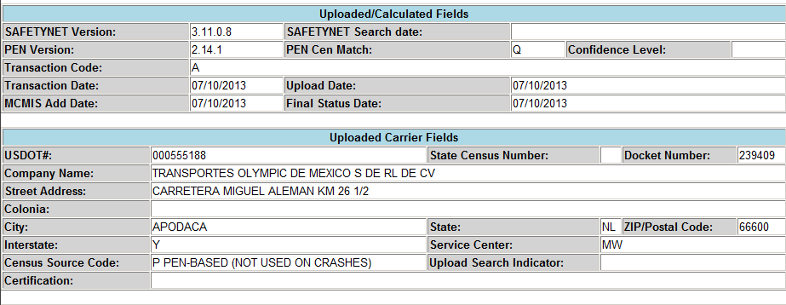

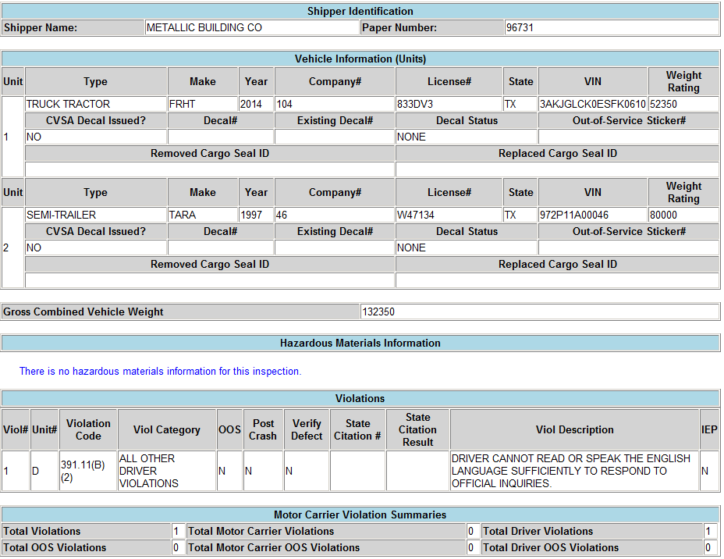

### Transportes Olympic – State Inspection Reports – Texas (1 of 2)

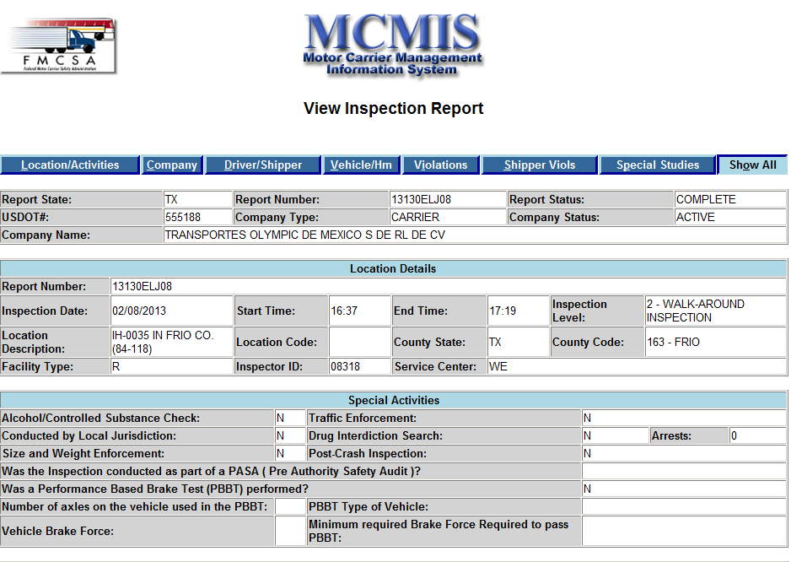

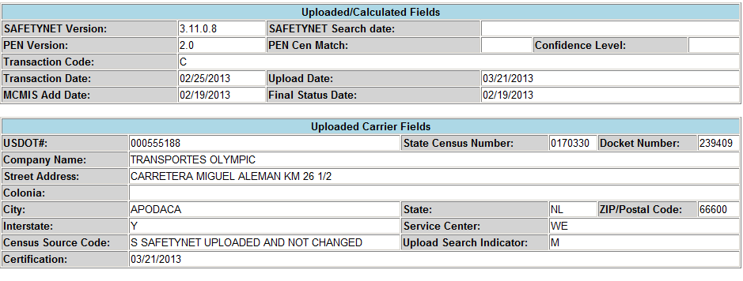

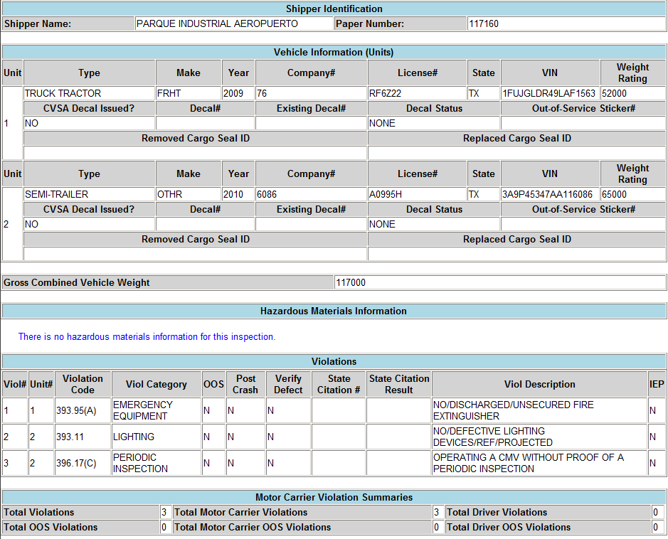

### Transportes Olympic – State Inspection Reports – Texas (2 of 2)

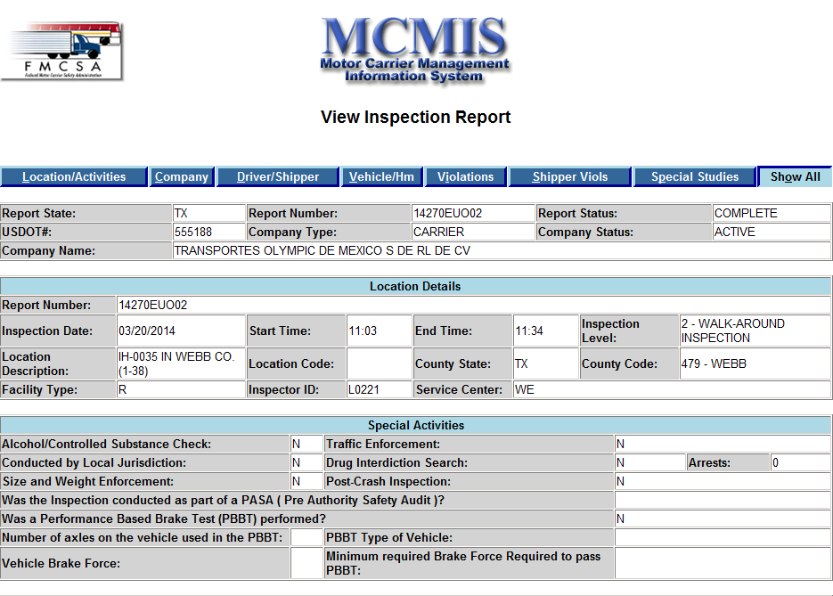

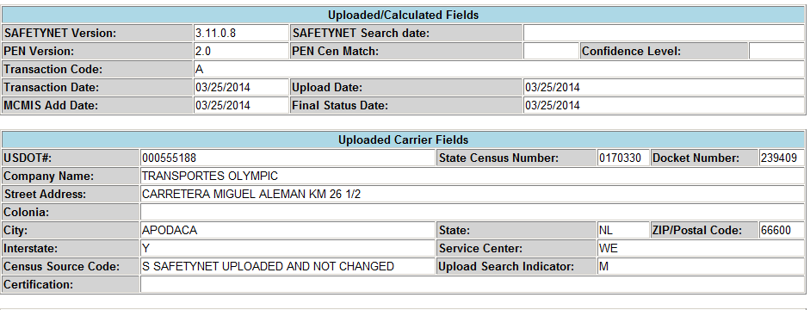

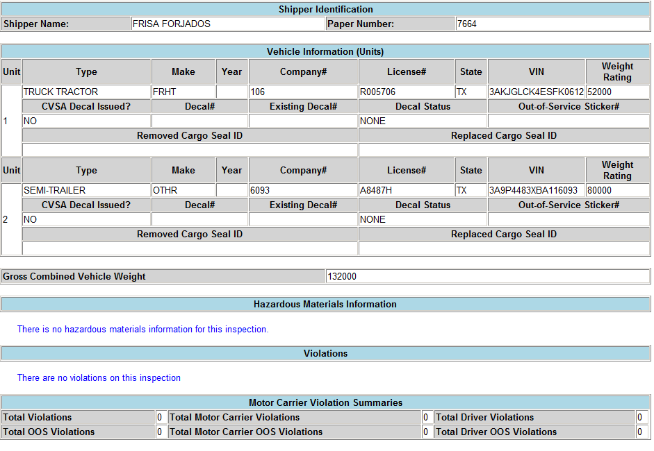

## II.B.3 Breakdown of types of inspections that were conducted (Levels I-V)

| **Carrier** | **Level I** | **Level II** | **Level III** | **Level IV** | **Level V** | **Total** |
| --- | --- | --- | --- | --- | --- | --- |
| Transportes Olympic | 52 | 16 | 167 | 0 | 0 | 235 |
| Moises Alvarez Perez | 6 | 0 | 2 | 0 | 0 | 8 |
| Baja Express | 11 | 1 | 43 | 0 | 0 | 55 |
| Transportes del Valle | 25 | 10 | 68 | 0 | 0 | 103 |
| SRI | 21 | 0 | 12 | 0 | 0 | 33 |
| Higienicos y Desechables | 6 | 0 | 0 | 0 | 2 | 8 |
| Jose Guadalupe Morales | 20 | 1 | 31 | 0 | 0 | 52 |
| Grupo Behr | 43 | 0 | 15 | 2 | 0 | 60 |
| STIL | 322 | 31 | 2506 | 0 | 0 | 2859 |
| Ram Trucking | 3 | 1 | 0 | 0 | 0 | 4 |
| GCC | 225 | 66 | 1007 | 1 | 0 | 1299 |
| Sergio Tristan Maldonado | 16 | 1 | 17 | 0 | 0 | 34 |
| TRACSO | 1 | 0 | 0 | 0 | 0 | 1 |
| Transportes Monteblanco | 42 | 1 | 242 | 0 | 0 | 285 |
| IDLA | 10 | 0 | 0 | 0 | 0 | 10 |
| **TOTAL** | **803** | **128** | **4110** | **3** | **2** | **5046** |

## II.B.4 Table format of violations and OOS rates by carrier

| **Carrier** | **Pilot Program OOS Rate** | | **Violation Totals** | |
| --- | --- | --- | --- | --- |
| **Vehicle** | **Driver** | **Vehicle** | **Driver** |
| Transportes Olympic | 2.94 | 1.28 | 47 | 5 |
| Moises Alvarez Perez | 0.00 | 0.00 | 4 | 0 |
| Baja Express | 16.67 | 1.82 | 13 | 5 |
| Transportes del Valle | 20.00 | 0.00 | 27 | 2 |
| SRI | 4.76 | 3.03 | 6 | 4 |
| Higienicos y Desechables | 12.50 | 0.00 | 7 | 2 |
| Jose Guadalupe Morales | 4.76 | 0.00 | 21 | 2 |
| Grupo Behr | 23.26 | 1.67 | 63 | 6 |
| STIL | 10.48 | 0.14 | 153 | 24 |
| Ram Trucking | 0.00 | 0.00 | 6 | 0 |
| GCC | 13.06 | 0.00 | 217 | 1 |
| Tristan Transport* | 23.53 | 2.94 | 76 | 2 |
| TRACSO | 0.00 | 0.00 | 0 | 0 |
| Transportes Monteblanco | 11.63 | 0.35 | 64 | 1 |
| IDLA | 0.00 | 0.00 | 0 | 0 |
| **TOTAL** | **9.57 (AV)** | **0.75 (AV)** | **704** | **54** |

*Pilot program authority revoked

## II.B.4 Violations by carrier

[Note: Entries in **BOLD FACE** denote out-of-service violations.]

### Transportes Olympic

| **Violation** | **Violation Descriptions** | **Total Number of Violations** | | **Inspection (Conducted By)** | |
| --- | --- | --- | --- | --- | --- |
| **Vehicle** | **Driver** | **Federal** | **State** |
| **393.9(a)** | **Inoperative stop lamps on both right and left side** | 1 | 0 | x |  |
| 393.75C | Tire depth less than 1/32" | 1 | 0 | x |  |
| 393.55(e)  393.75(a)(2) | Defective ABS Indicator lamp;  Inner Tire at axle 4 tire tread separation | 2 | 0 | x |  |
| 395.8(f)(1) | Driver's record of duty status not current | 0 | 1 | x |  |
| 396.5b | leaking wheel hub cap at axle 4 right side | 1 | 0 | x |  |
| 393.47a  393.55a   393.75a4 | Small retaining pi missing on axle 5 left side.  ABS lamp malfunction (exterior).  Tire - cut on sidewall not exposing ply and/or belt material at axle 5 left side outer. | 3 | 0 | x |  |
| 393.95a  393.11  396.17c | Fire extinguisher violation - not charged.  Defective side marker lamp LR  NoneNo/Expired CMV inspection certificate/Annual DOT None | 3 | 0 |  | x |
| 393.95b   393.55e  393.3a1t | No spare fuses as required.  Defective ABS malfunction indicator lamp for trailer manufactured after 3/1/1998.  Axle #5 right outer tire has uneven tread wear. | 3 | 0 | x |  |
| **392.9a2** | **Operating beyond the scope of operating authority granted.** | 0 | 1 | x |  |
| **395.3b2** | **Driving after 70 hours ion duty in an 8 day period. (property carrying vehicle) on 6/24/13 at 8:15am** | 0 | 1 | x |  |
| 393.45b2 | Brake hose or tubing chafing and or kinking, axle #4 left side at time of inspection. | 1 | 0 | x |  |
| 391.11b2  393.55e | Driver cannot read or speak English language sufficiently to respond to official inquiries.  No or defective ABS Malfunction Indicator lamp for trailer manufactured after 3/1/1998. | 1 | 1 | x |  |
| 393.104 | Damaged securement system/tiedown strap; has cracks or cuts/burns through webbing. | 1 | 0 | x |  |
| 391.11b2 | Driver cannot read or speak English language sufficiently to respond to official inquiries. | 0 | 1 |  | x |
| **383.23a2** | **operating CMV w/o a CDL** | 0 | 1 | x |  |
| 365.511 | Fail to display current CVSA decal; Mexico domiciled carrier with permanent authority. | 1 | 0 | x |  |
| 393.45b2 | Brake hose or tubing chafing or kinking at tandem axle (in front of axle #4) | 1 | 0 | x |  |
| 393.45B2 | BRAKE HOSE CHAFING AT AXLE 5 (REINFORCEMENT PLY IS NOT DAMAGED) | 1 | 0 | x |  |
| 393.205 | WHEEL FASTENERS LOOSE AND/OR MISSING - AXLE #5 PASS SIDE FASTENERS ARE MISSING 2 ADJACENT. | 1 | 0 | x |  |
| 393.55E | INOPERABLE ABS MALFUNCTION INDICATOR LAMP FOR TRAILER MANUFACTURED AFTER 3/1/1998 | 1 | 0 | x |  |
| 393.55E | INOPERABLE ABS MALFUNCTION INDICATOR LAMP FOR TRAILER MANUFACTURED AFTER 3/1/1998 | 1 | 0 | x |  |
| 393.45B2 | AXLE #4 LEFT AND RIGHT SIDE BRAKE CHAMBER HOSES ARE CHAFING. | 1 | 0 | x |  |
| 393.55E | NO OR DEFECTIVE ABS MALFUNCTION INDICATOR LAMP FOR TRAILER MANUFACTURED AFTER 3/1/1998, ABS INOPERABLE DURING TEST. | 1 | 0 | x |  |
| 396.3A1T | AXLE #4 LEFT SIDE DUAL TIRES HAVE UNEVEN TREAD WEAR. | 1 | 0 | x |  |
| 393.55D3   393.75A2 | Defective ABS malfunction indicator for towed vehicles on vehicles manufactured after Feb 2001.  Axle 5 right side outer tire has uneven tread wear. | 2 | 0 | x |  |
| 393.55 | DEFECTIVE ABS MALFUNCTION INDICATOR LAMP FOR TRAILER MANUFACTURED AFTER 3/1/1998 | 1 | 0 | x |  |
| 393.45B2 | BRAKE HOSE CHAFING AT AXLE 5. | 1 | 0 | x |  |
| 393.55E | NO OR DEFECTIVE ABS MALFUNCTION INDICATOR LAMP FOR TRAILER MANUFACTURED AFTER 3/1/1998 | 1 | 0 | x |  |
| 393.75C   393.45D | Axle 4 left inner tire tread depth less than 2/32 inch in 3 separate locations.  Brake connections with leaks on axle 5 at distribution valve. | 2 | 0 | x |  |
| 396.3A1T | AXLE #4 RIGHT SIDE INSIDE TIRE HAS UNEVEN WEAR. | 1 | 0 | x |  |
| 393.48B2 | BRAKE HOSE CHAFING AT AIR RESERVOIR TANK AND AXLE 5. | 1 | 0 | x |  |
| 393.55E | ABS MALFUNCTION INIDCATOR LAMP FOR TRAILER MANUFACTURED AFTER 3/1/1998 IS INOP | 1 | 0 | x |  |
| 393.55C2  393.47E  393.53B | MISSING ABS SYSTEM ON TRAILER.  CLAMP TYPE BRAKE OUT OF ADJUSTMENT ON AXLE 4 LEFT SIDE.  CMV MANUFACTURED AFTER 10/19/1994 HAS AUTOMATIC AIRBRAKE ADJUSTMENT SYSTEM THAT FAILS TO COMPENSATE FOR WEAR. | 3 | 0 | x |  |
| 393.55 | DEFECTIVE ABS MALFUNCTION INDICATOR LAMP FOR TRAILER MANUFACTURED AFTER 3/1/1998 | 1 | 0 | x |  |
| 393.45B2 | BRAKE HOSE CHAFING ON TOP OF AXLE 4 AND 5 OF TRAILER | 1 | 0 | x |  |
| 393.45B2 | BRAKE HOSES ARE CHAFING AT AXLE 5 | 1 | 0 | x |  |
| 393.55E | DEFECTIVE ABS MALFUNCTION INDICATOR LAMP FOR TRAILER MANUFACTURED AFTER 3/1/1998 | 1 | 0 | x |  |
| 393.47D | CRACKED BOTTOM BRAKE LINING ON AXLE #5 RIGHT SIDE | 1 | 0 | x |  |
| 393.55E  393.75A2  396.3A1B | DEFECTIVE ABS MALFUNCTION INDICATOR LAMP FOR TRAILER MANUFACTURED AFTER 3/1/1998.  AXLE #4 RIGHT SIDE OUTER TIRE HAS TREAD SEPARATION ON THE SIDEWALL.  AIR RESEVOIR TANK IN FRONT OF AXLE 5 HAS AIR LEAK. | 3 | 0 | x |  |

### Moises Alvarez Perez

|  |  |  |  |  |  |
| --- | --- | --- | --- | --- | --- |
| **Violation Code** | **Violation Description** | **Number of Violations** | | **Inspections**  **Conducted By** | |
|  | **Vehicle** | **Driver** | **Federal** | **State** |
| 396.5(b) | Oil Leak | 1 | 0 | x |  |
| 396.3a1   393.9 | x2 left side jam nut not pushed back.  Inoperable required lamp - rear left corner side marker lamp (right one insufficient brightness) | 2 | 0 | x |  |
| 392.2 | Overweight single axle or axle end. Axle 2 scale weight 23240 lbs, Legal weight 20000 lbs. Adj wgt 23000 lbs. Overweight 3000 lbs. | 1 | 0 | x |  |

### Baja Express

| **Violation Code** | **Violation Description** | **Number of Violations** | | **Inspections Conducted By** | |
| --- | --- | --- | --- | --- | --- |
| **Vehicle** | **Driver** | **Federal** | **State** |
| **393.11e**  392.2 | **Stop lamp inop - Fixed on scene**  Left mudguard required | 2 | **0** |  | x |
| 392.2  392.2RG | OVERWEIGHT SINGLE AXLE OR AXLE END. AXLE 2 21,000, LEGAL 20,000. OVER 1,000.  OPERATING IN EXCESS OF DECLARED GROSS WEIGHT. 30,760, DECLARED WEIGHT 26,000, OVER 4,500. | 2 | **0** |  | x |

### Transportes Del Valle de Guadalupe

| **Violation Code** | **Violation Description** | **Number of Violations** | | **Location of Violation** | |
| --- | --- | --- | --- | --- | --- |
| **Vehicle** | **Driver** | **Federal** | **State** |
| 395.8 | Record of duty status violation; Missing shipping documents information and V2 unit # | 0 | 1 | x |  |
| **392.9a** | **Failing to secure load - 1-2 large rocks not secured on top of load "water fall rock".** | 1 | 0 | x |  |
| **393.100c** | **Failure to prevent cargo shifting - 2 loose straps; various wooden crates broken, cargo shifting, loose debris. Inadequate securement.** | 1 | 0 | x |  |
| **393.110B** | **INSUFFICIENT TIEDOWNS TO PREVENT FORWARD MOVEMENT FOR LOAD NOT BLOCKED BY HEADERBOARD, BULKHEAD, OR OTHER CARGO - 2 TIEDOWNS REQUIRED; 6 PALLETS OF ROOFING TILES.** | 1 | 0 |  | x |
| 393.209e | Power steering violations - leaking fluid | 1 | 0 | x |  |
| 393.45(d)  **392.9(a)** | Brake connection with Leaks  **Failure to secure - 10 of 10 straps loose** | 2 | 0 | x |  |
| 393.45d  393.47e  393.53b  393.207a | Brake connections w/leaks or constrictions.  Clamp or rotor type brake out of adjustment.  CMV manufactures after 10/19/94 has automatic airbrake adjustment system that fails to compensate for wear.  Axle positioning parts defective/missing | 4 | 0 | x |  |
| 393.47A   396.3A1 | OTHER DEFECTIVE CONDITIONS - AXLE 2 - BRAKE LINING CONTAMINATED  APPLIED AIR LOSS BETWEEN AXLE 4 AND 5 RELAY VALVE; COMPRESSOR MAINTAINS | 2 | 0 | x |  |
| 393.47E  396.3A1  396.3A1 | CLAMP OR ROTOR-TYPE BRAKE OUT OF ADJUSTMENT. AXLE 4 RIGHT SIDE.  GENERAL MAINTENANCE - L/S FRONT OF AXLE 4 FRONT SPRING HANGER LOWER FLANGE CRACKED (MARKED).  GENERAL MAINTENANCE - L/S EQUALIZER HANGER AT REAR - SMALL CRACKS AT REPAIR WELDS (MARKED). | 3 | 0 |  | x |
| 393.47e  393.45d | Clamp or rotor type brake out of adjustment.  Brake connections w/leaks or constrictions. | 2 | 0 | x |  |
| **393.75a3** | **Tire flat and/or audible air leak. Audible air leak on axle 5, left inner tire.** | 1 | 0 | x |  |
| 393.95(B)  393.83G  396.5B  393.207C | No spare fuses;  Exhaust leak;  Oil/Grease leak;  Leaf spring assembly defective | 4 | 0 | x |  |
| 396.3a1 | Inspection - repair and maintenance of parts and accessories - spring pack bracket on right side loose. | 1 | 0 | x |  |
| **396.3a1** | **Brakes out of Service - The number of defective brakes is equal to or greater than 20% of the service brakes on the vehicle or combination.** | 1 | 0 |  | x |
| **396.5B**  **396.3A1**    393.75C | **HUBS - OIL AND/OR GREASE LEAKING FROM HUB - INNER WHEEL. CONTAMINATED BRAKES.  BRAKES OOS - NUMBER OF DEFFECTIVE BRAKES IS EQUAL OR GREATER THAN 20 PERCENT OF THE SERVICE BRAKES ON THE VEHICLE OR COMBINATION**.  TIRE TREAD - DEPTH LESS THAN 2/32 INCH - AXLE 4 RIGHT SIDE OUTER. | 3 | 0 | x |  |

### Servicios Refrigerados Internacionales

| **Violation Code** | **Violation Description** | **Total Number of Violations** | | **Inspection**  **Conducted By** | |
| --- | --- | --- | --- | --- | --- |
| **Vehicle** | **Driver** | **Federal** | **State** |
| 395.8 | Record of Duty status violation (general/form and manner) - missing shipping documents information. | 0 | 1 | x |  |
| 393.9a | inoperable required lamp - V2 front side marker lights inop - left and right | 1 | 0 | x |  |
| 396.5b | Oil leak at differential axle 2 | 1 | 0 | x |  |
| **395.3a2    393.47** | **Driving beyond 14 hr duty period (property carrying vehicle) Driving 38 mins beyond 14 hr rule (excessive time at Customs)  Inadequate brakes for safe stopping - V2 X5 Left side cracked drum; opens upon brake application (marked)** | 1 | 1 | x |  |
| 393.9TS | Inoperative turn signal - V1 Right front turn signal inop. | 1 | 0 | x |  |
| 396.5b | Oil leak under differential axle #2 | 1 | 0 | x |  |
| 393.9a | Inoperable required lamp - clearance lamp on right side, 1 out of 4 out. | 1 | 0 | x |  |
| 3953.8 | Record of duty status violation - missing commodity, shipper information, and signature on EOBR. | 0 | 1 | x |  |
| 395.15G | ONBOARD RECRODING DEVICE INFO NOT AVAILABLE. BLUE LIGHT IS ON, UNABLE TO RESET, MUST BE FIXED W/IN 72HRS. TELETRAC REFERENCE NUMBER: 267662 | 0 | 1 | x |  |

### Higienicos y Desechables del Bajia

| **Violation Code** | **Violation Description** | **Total Number of Violations** | | **Inspection**  **Conducted By** | |
| --- | --- | --- | --- | --- | --- |
| **Vehicle** | **Driver** | **Federal** | **State** |
| 392.2  **392.9a(a)(2)**  393.80 | No registration present at time of vehicle.  **Operating beyond scope of granted authority - Operating vehicle w/o an active DOT EOBR.**  No or defective rear vision mirror - Driver side mirror broken or loose. | 3 | 0 | x |  |
| 395.8    393.47e   393.45d   393.47a | Record of duty status violation - Missing unit number of veh 2, shipping documents information and showing co-driver, but no co-driver present.  Inadequate brakes for safe stopping - axle #1 left side, contamination in between the brake shoe and brake lining.  Audible air leak at brake connections axle 3 left side.  Inadequate brakes for safe stopping - axle 2 left side, inner seal leaking, contaminating between brake shoe and brake lining. | 3 | 1 | x |  |
| 395.8 | Record of duty status violation - driver failed to log out last night after being placed OOS; system shoes driver at 21 hours driving. | 0 | 1 | x |  |
| 396.5B | OIL LEAK; DIFFERENTIAL OIL LEAKING. | 1 | 0 | x |  |

### Jose Guadalupe Morales DBA Fletes Morales

| **Violation Code** | **Violation Description** | **Total Number of Violations** | | **Inspection**  **Conducted By** | |
| --- | --- | --- | --- | --- | --- |
| **Vehicle** | **Driver** | **Federal** | **State** |
| 390.21a | Not marked IAW regs - need to add "X" at the end of DOT Number | 1 | 0 | x |  |
| 393.45d   396.3a1t | Brake connections with leaks or constrictions - V1 to V2 air leak at emergency air tubing.   Tires - V2 x5 right side in and out; outer circumference cracked/dry rot on both sides if each tire. | 2 | 0 | x |  |
| 393.45b2 | Brake hose or tubing chafing and/or kinking - service tandem air hose worn to cord. | 1 | 0 | x |  |
| 393.45 | Brake connection with leaks or constrictions - V1 to V2 air leak at emergency air tubing connection. | 1 | 0 | x |  |
| 396.5b | Hubs - oil and/or grease leaking from hub - inner wheel. AX-4 L/inner wheel. | 1 | 0 | x |  |
| 393.75c  396.3a1 | Tire tread depth less than 2/32 inch right inner tire.  General maintenance - left hub leaking | 2 | 0 |  | x |
| 396.5B  393.9A | OIL LEAK - DIFFERENTIAL.  INOPERABLE REQUIRED LAMP - UPPER LEFT MARKER. | 2 | 0 | x |  |
| 395.3A2    393.95E | DRIVING BEYOND 14 HOUR DUTY PERIOD (PROPERTY CARRYING VEHICLE) - REQUIRED 30 MINUTE REST NOT TAKEN IN A PERIOD OVER 8 HOURS.  NO/DISCHARGED/UNSECURED FIRE EXTINGUISHER. | 1 | 1 | x |  |
| 393.75C  396.3A1T  396.5A  393.9A | TIRE TREAD DEPTH LESS THAN 2/32 INCH - AXLE 4 LEFT SIDE OUTER.  TIRES - SIDEWALL SEPARATION ON AXLE 5 LEFT SIDE INNER.  FAILING TO ENSURE THAT VEHICLE IS PROPERLY LUBRICATED - AXLE 4 LEFT HUB - LOW LUBRICANT.  INOPERABLE REQUIRED LAMP - LEFT LOW BEAM - FIXED ON SPOT. | 4 | 0 | x |  |
| 392.2RG | NO COPY OF REGISTRATION WITH VEHICLE. | 1 | 0 |  | x |
| 392.2RG | NO COPY OF REGISTRATION WITH VEHICLE. | 1 | 0 |  | x |
| 395.8 | RECORD OF DUTY STATUS VIOLATION - MISSING TOTAL MILEAGE. | 0 | 1 | x |  |
| **392.9A2**  **393.207F**  392.2RG | **SPARE TIRE NOT SECURED.**  **SUSPENSION AIR BAGS ALMOST FLAT.**  NO REGISTRATION WITH VEHICLE | 3 | 0 |  | x |
| 393.75C | TIRE TREAD DEPTH LESS THAN 2/32 INCH (AXLE 5 LEFT INNER TIRE) | 1 | 0 | x |  |
| 390.21a | Not marked IAW regs - need to add "X" at the end of DOT Number | 1 | 0 | x |  |
| 393.45d   396.3a1t | Brake connections with leaks or constrictions - V1 to V2 air leak at emergency air tubing.   Tires - V2 x5 right side in and out; outer circumference cracked/dry rot on both sides if each tire. | 2 | 0 | x |  |

### Transportes Monteblanco

| **Violation** | **Violation Description** | **Total Number of Violations** | | **Inspection Conducted By** | |
| --- | --- | --- | --- | --- | --- |
| **Vehicle** | **Driver** | **Federal** | **State** |
| 393.209e   393.83g   365.511b   393.45b  365..511 | Power steering gear box seal is leaking.  Exhaust leak under truck cab and/or sleeper (turbo clamp).  Fail to display current CVSA decal: Mexico domicile carrier with permanent authority.  Axle #5 has brake hose/tubing chaffing.  Fail to display current CVSA decal: Mexico domicile carrier with permanent authority. | 5 | 0 | x |  |
| 393.209e   393.83g   365.511b    365..511 | Power steering gear box seal is leaking.  Exhaust leak under truck cab and/or sleeper (turbo clamp).  Fail to display current CVSA decal: Mexico domicile carrier with permanent authority.  Fail to display current CVSA decal: Mexico domicile carrier with permanent authority. | 4 | 0 | x |  |
| 393.83g  393.55e  393.11 | Exhaust leak under truck cab and/or sleeper (turbo clamp).  ABS inoperable lamp rear left side.  Missing rear left ID lamp. | 3 | 0 | x |  |
| 393.11 | Missing rear left ID lamp. | 1 | 0 | x |  |
| 392.2  365.511 | Failure to pay UCR fee (2011 and 2012)  Fail to display current CVSA decal: Mexico-domicile carrier with permanent authority. | 2 | 0 | x |  |
| 392.2  365.511 | FAILURE TO PAY UCR FEE.  FAIL TO DISPLAY CURRENT CVSA DECAL - MX DOMICILE CARRIER WITH PERM AUTHORITY. | 2 | 0 | x |  |
| 392.2  **396.3a1b** | Failure to pay UCR fee (2011 and 2012)  **Axle #5 left side spring brake chamber has non-manufacture holes (2) in the spring brake housing section of parking brake.** | 2 | 0 | x |  |
| 392.2 | Failure to pay UCR fee (2011 and 2012) | 1 | 0 | x |  |
| 392.2UCR | Failure to pay UCR fee (2011 and 2012) | 1 | 0 | x |  |
| 393.95a | Discharged fire extinguisher at time of inspection. | 1 | 0 | x |  |
| 393.55e | ABS inoperable rear lamp left side | 1 | 0 | x |  |
| 393.2UCR  393.95b  396.5b  393.55e | Failure to pay UCR fee (2013)  No spare fuses as required.  Axle #5 right side has hub seal fluid oil leak.  No or defective ABS malfunction indicator lamp for trailer manufactured after 3/1/1998. | 4 | 0 | x |  |
| 392.2 | Failure to pay UCR fee (2011, 2012, 2013) | 1 | 0 | x |  |
| 393.55 | No or defective ABS malfunction indicator. Lamp for trailer manufactured after 3/1/1998, ABS indicator stays on during test. | 1 | 0 | x |  |
| **396.3a1** | **Axle #4 passenger side bearing hub cap is missing allowing an open view into hub assembly.** | 1 | 0 | x |  |
| 393.55e   396.3a1 | No or defective ABS malfunction indicator lamp for trailer manufactured after 3/1/98, ABS inoperable during test.   Axle #5 left side inner tire has cut on sidewall. | 2 | 0 | x |  |
| 393.55e | Defective ABS malfunction indicator lamp for trailer manufactured after 3/1/1998. | 1 | 0 | x |  |
| 393a  393.83g  393.209e  392.2  396.5a  396.3a1  393.55  **393.207a** | Inoperable back up lamp.  Exhaust leak under truck cab and/or sleeper (turbo clamp).  Power steering gearbox and hose has leaks.  Failure to pay UCR fee.  Failing to ensure that vehicle is properly lubricated (transmission oil leak).  Missing transmission clutch cover.  Defective ABS Malfunction indicator lamp for trailer manufactured after 3/1/1998.  **Axle #5 right side has axle positioning clamp loose.** | 8 | 0 | x |  |
| 393.95b  393.11  396.3a1 | No spare fuses.  Reverse Lamp inoperable.  Clutch plate cover is missing. | 3 | 0 | x |  |
| 392.2 | Failure to pay UCR fee. | 1 | 0 | x |  |
| 393.45b2 | Brake hose or tubing chafing and/or kinking at tandem axle (in front of axle #4) | 1 | 0 | x |  |
| **393.23a2** | **Operating a CMV without a CDL. Expired med certificate (7/18/13)** | 0 | 1 | x |  |
| 393.45b2 | Brake hose or tubing chafing and/or kinking at tandem axle (in front of axle #4) | 1 | 0 | x |  |
| 393.45b2 | Brake hose or tubing chafing and/or kinking at tandem axle (in front of axle #4) | 1 | 0 | x |  |
| 393.45b2 | Brake hose or tubing chafing and/or kinking at tandem axle (in front of axle #4) | 1 | 0 | x |  |
| 393.45b2 | Brake hose or tubing chafing and/or kinking at tandem axle (in front of axle #4) | 1 | 0 | x |  |
| 393.45D | AUDIBLE AIR LEAK ON TRAILER GLADHAND (SERVICE CONNECTION) | 1 | 0 | x |  |
| 393.55E | NO ABS MALFUNCTION INDICATOR LAMP FOR TRAILER MANUFACTURED AFTER 3/1/1998 | 1 | 0 | x |  |
| 392.2  393.55E | Failure to pay UCR fee.  Missing ABS malfunction indicator lamp for trailer manufactured after 3/1/1998. | 2 | 0 | x |  |
| 393.45B2 | BRAKE HOSE CHAFING AT AXLE 5 | 1 | 0 | x |  |
| 393.55E  392.2UCR | MISSING ABS MALFUNCTION INDICATOR LAMP FOR TRAILER MANUFACTURED AFTER 3/1/1998.  FAILURE TO PAY UCR FEE. | 2 | 0 | x |  |
| 393.45B2  393.55E | BRAKE HOSE AT AXLE #4 AND AXLE #5 ARE CHAFING.  DEFECTIVE ABS MALFUNCRION INDICATOR LAMP FOR TRAILER MANUFACTURED AFTER 3/1/1998. | 2 | 0 | x |  |
| **393.48A**  393.45B2 | **INOP BRAKE RIGHT SIDE AXLES 4 AND 5**  BRAKE HOSE AT TANDEM AXLE CHAFING (IN FRONT OF AXLE 4) | 2 | 0 | x |  |
| **393.48A**   396.9C2 | **INOP BRAKE RIGHT SIDE AXLES 4 AND 5 (REPEAT VIOLATION)**  OPERATING AN OOS VEHICLE AS PER DRIVER/VEHICLE EXAMINATION DATED 4/10/14 WITH SAME VIOLATION | 2 | 0 | x |  |
| 393.55E | DEFECTIVE ABS MALFUNCTION INDICATOR LAMP FOR TRAILER MANUFACTURED AFTER 3/1/1998. | 1 | 0 | x |  |

### GCC Transportes

| **Violation** | **Violation Descriptions** | **Total Number of Violations** | | **Inspection (Conducted By)** | |
| --- | --- | --- | --- | --- | --- |
| **Vehicle** | **Driver** | **Federal** | **State** |
| **396.3a1** | **Audible air leak at axle #1. Right side brake chamber when foot brake is applied, vehicle is able to maintain air pressure at this time.** | 1 | 0 | x |  |
| 393.209  393.9a   393.53b | Power Steering oil leak at the steering box.  Inoperable side marker lamp at right rear.  CMV manufactured after 10/19/94 does not have an automatic airbrake adjustment system that compensates for wear on axles 4 and 5. | 3 | 0 | x |  |
| **393.9a** | **Does not have an operative turn signal visible on each side of the rearmost vehicle of a combination of vehicles.** | 1 | 0 | x |  |
| **393.75a3** | **Left side axle #5 inner tire registering less than 50% of the required psi indicated on tire sidewall 35/110.** | 1 | 0 | x |  |
| **393.45** | **Axle 1; left brake hose cut extending through the outer reinforcement ply [Ref: 393.45a]** | 1 | 0 | x |  |
| 396.3a1b | Audible leak at relay valve above axle 4; when brakes are applied (able to maintain air pressure) | 1 | 0 | x |  |
| 393.47e | Clamp type brake out of adjustment, axle 4, left side at 2 1/8" | 1 | 0 | x |  |
| **393.75a3**  393.45b2  393.43 | **Axle 3 right inside tire has less than 50% inflation pressure as marked on tire sidewall, marked 110 psi, actual psi is 50.**  Axle 4 right brake hose chafing.  Emergency gladhand has bled black; indicates that the trailer spring brake control valve is defective [Ref: 393.43e] | 3 | 0 | x |  |
| **393.75(a)(3)** | **Axle 5 Left inside tire has less than 50% inflation pressure as marked on the tire sidewall, marked 120 psi autual 40 psi** | 1 | 0 | x |  |
| **393.9A**  **393.28  393.47E  393.53B**  **393.75A3** | Inoperable required lamp - license plate lamp.  Improper or no wiring protection as required, cable damaged exposing inner cable, tractor to trailer harness.  Clamp brake out of adjustment.  CMV manufactured after 10/19/94 has an automatic airbrake adjustment system that fails to compensate for wear.  **Axle #4 right outside outer tire has 45/120 psi which is less than 50% of the tire inflation pressure recommended on sidewall of tire.** | 5 | 0 | x |  |
| **393.207c**   396.5b | **Leaf spring assembly - cracked/broken/missing broken leaf spring/ above axle 4 left.**  Oil/grease leak inner wheel seal leak/axle 5 right. | 2 | 0 |  | x |
| **393.75a2** | **Tire has visually observable bump/knot on axle 4 left outer.** | 1 | 0 | x |  |
| 393.47a | Axle 3 right side brake linings loose on brake shoe, movement exceeds 1/16 of an inch. | 1 | 0 | x |  |
| 396.5b | Oil dripping from left side engine | 1 | 0 | x |  |
| **393.75a3** | **Axle #3 right side outer tire has 35/110PSI which is less than 50% of the recommended pressure on the tire sidewall.** | 1 | 0 | x |  |
| 393.9   396.5b | Rear license plate lamp inoperable.  Oil dripping from tight side of engine. | 2 | 0 | x |  |
| 393.47e  393.53b | Right and left side axle #5 clamp type brakes out of adjustment.  CMV manufactured after 10/19/94 has an automatic airbrake adjustment system that fails to compensate for wear. | 2 | 0 | x |  |
| **393.201a** | **Cracked frame extending from the frame siderail web around the radius and into the bottom flange above axle 3 right rear area.** | 1 | 0 | x |  |
| **393.9**  393.207e  **393.207a** | **Inoperable Lamp (other than head/tail) - Left rear turn signal.**  Torsion bar - loose/broken loose/axle 4 right (bushing only)  **Improper axle position part - broken/loose/missing bolt spins/axle 5 right torsion bar.** | 3 | 0 |  | x |
| **393.45** | **Emergency (red) tubing to gladhand audible air leak not at a proper connection, maintains air pressure.** | 1 | 0 | x |  |
| 396.3a1 | Support at frame to left landing gear cracked at weld. | 1 | 0 | x |  |
| 396.3A1 | Discharge pipe at rear of trailer loose | 1 | 0 | x |  |
| 393.53b  393.47e | Defective/inoperative automatic slack (brake) adjusters axle 4 right.  Brake out of adjustment - clamp rotor axle 4 right. | 2 | 0 |  | x |
| 393.9 | Inoperable right stop lamp. | 1 | 0 |  | x |
| **393.75a3** | **Tire has 45/125PSI, left side #3 outer tire. Less than 50% of the recommended tire inflation.** | 1 | 0 | x |  |
| **393.75a3** | **Tire has 55/120PSI, left side #5 inner tire. Less than 50% of the recommended tire inflation pressure.** | 1 | 0 | x |  |
| 393.205c | Wheel fasteners loose 1/8 at axle #4 left side. | 1 | 0 | x |  |
| 393.47e  393.207e  396.3a1  393.9a | Clamp type brake out of adjustment at axle 4 right inside, measures at 2 1/8 inch at the time of inspection.  Torsion bar loose between axles 4 and 5 left side (rushing only)  Audible air leak at relay valve between axles 4 and 5 when brakes are applied, maintains air pressure.  rear license plate lamp inoperable. | 4 | 0 | x |  |
| **393.75a3** 393.201a   393.207a | **Axle 5 left outer tire has 50/120 psi, less than 50% of the inflation pressure marked on sidewall of tire.**  Frame cracked at repair weld on right side next to landing gear and left side cross-member next to landing gear.  Axle positioning parts defective, torsion bar loose, bushing only in front of axle 5 right. | 3 | 0 | x |  |
| 393.207f | Air bag/spring is leaking on axle 5 | 1 | 0 | x |  |
| 393.47e | Clamp type brake out of adjustment, axle 5 left side at 2 1/8 inch | 1 | 0 | x |  |
| **393.45**   393.47e   393.53b  396.3a1   393.201a | **Emergency brake tubing damaged exposing second ply at glad hand connection (ref 393.45a).**  Clamp type brake out of adjustment on axle 5 left side.  CMV manufactured after 10/19/1994 has an automatic airbrake adjustment system that fails to compensate for wear.   Audible air leak at relay valve above axle 4 when brakes are applied (able to maintain air pressure).  Frame cracked on right side above axle 5. | 5 | 0 | x |  |
| 396.3a1 | Audible air leak at relay valve behind cab, maintains air pressure. | 1 | 0 | x |  |
| 393.53b  393.47e   393.47e  393.47e | Defective/inoperable automatic slack (brake) adjusters axle 4 and 5 right brakes out of adjustment axle left 4.  Brake out of adjustment - clamp/rotor axle 4 right brake out of adjustment 2 1/8 inch.  Brake out of adjustment - clamp/rotor axle 5 right brake out of adjustment 2 1/8 inch  Brake out of adjustment - clamp/rotor axle 4 left brake out of adjustment 2 1/8 inch | 4 | 0 |  | x |
| 396.31a | Relay leak at axle 5 when brakes are being applied (maintaining air pressure). | 1 | 0 | x |  |
| 393.55e | No ABS malfunction indicator lamp for trailer. Manufactured after 3/1/98, missing. | 1 | 0 | x |  |
| 393.9  393.11  393.11  393.9  **393.9** | Defective turn signal lamp (right and rear left).  Defective side marker lamp - left center.  Defective ID lamp (front/rear) - center rear.  Defective turn signal lamp - right and left front.  **Defective turn signal lamp - right and left.** | 5 | 0 |  | x |
| 396.3a1b   393.207a | Brakes (general) - audible air leak at relay valve between axle 4 and 5.  Axle 5 right side; loose torsion rod. | 2 | 0 | x |  |
| 393.47e  393.53b  **396.3a1** | Clamp type brake out of adjustment at right axle 4 and right axle 5; part of 20% rule.  CMV manufactured after 10/19/94 - automatic airbrake adjustment system fails to compensate for wear.  **Brakes OOS - the number of defective brakes is equal to or greater than the 20% of the service brakes on the vehicle or combination.** | 3 | 0 | x |  |
| **396.3a1**  393.9a  393.209e  393.75a4   396.5b  393.83g | **Left side fuel tank with a dripping leak.**  Left front high beam and rear right side tail lamp inoperable.  Oil dripping from power steering gear box.  Axle 3 right inner tire has a cut at the sidewall, not showing belt material at time of inspection.  Oil dripping from left side of engine.  exhaust leak at the front clamp on first flexpipe. | 6 | 0 | x |  |
| 393.9  **393.9** | Inoperable lamp - inop hazard lamp rear left.  **Inoperable lamp - inop signal lamp rear left.** | 2 | 0 |  | X |
| 393.70b  393.55e  393.95a  393.75a4 | Defective upper fifth wheel assembly, left side 1 of 10 fasteners loose.  ABS malfunction lamp towed CMV mfg>2/98, does not turn on when brakes applied.  Fire extinguisher does not have Underwriters Laboratories rating.  Axle 2 left inside tire cut; not exposing ply at this time. | 4 | 0 | x |  |
| 396.3a1  393.45b2  396.3a1 | Foot relay valve has audible leak when brakes are applied; maintains air pressure.  Axle 4 left brake hose chafing with each other.  Relay valve between axle 4 and axle 5 has audible air leak; maintaining air pressure. | 3 | 0 | x |  |
| 393.45d  396.3a  393.201a   396.3a1 | Audible air leak at proper connection at blue glad hand coupler connection not sealed properly.  Audible air leak under the air dryer filter behind the left cab area, maintains air pressure.  Frame cracked at repaired weld inside the left side gear area bottom flange.  audible air leak at the relay valve behind air reservoir tank above axle 4; maintains air pressure. | 4 | 0 | x |  |
| 393.45d   393.55e  393.45b2 | Audible air leak at proper connection at blue glad hand coupler connection not sealed properly.  ABS malfunction lamp towed CMV mfg>2/98, does not turn on when brakes applied.  Brake hose chafing against hose rubber separator above axle 4 center area. | 3 | 0 | x |  |
| 393.205c  393.75h | Wheel fastener loose; 1 of 10 on axle #4 left side.  Underinflated tire at axle #4 right side outer. | 2 | 0 | x |  |
| 393.53b  393.47e | Defective/inoperative automatic slack (brake) adjusters axle 5 right.  Brake out of adjustment - clamp/rotor axle 5 right/ | 2 | 0 |  | x |
| **393.201a** | **Frame cracked. Left side landing gear.** | 1 | 0 |  | x |
| **393.75H** | **Tire - underinflated; 60/120 psi axle 5 right outer.** | 1 | 0 |  | x |
| 393.207a  396.3a1 | Axle positioning parts defective, loose torsion bar on axle #4 right side (due to worn bushing)  Brake relay valve with and audible air leak behind axle #4 (maintains air pressure) | 2 | 0 | x |  |
| **393.45**  393.55e  393.207f | **Damage extending through the outer reinforcement ply at brake hose above axle#2 right side.**  ABS malfunction indicator lamp for trailer inoperable when brakes applied.  Audible air leak at axle #5 left side air bag, maintains air pressure. | 3 | 0 | x |  |
| **393.201a** | **Frame cracked at side rail webbing around the radius in tot eh bottom flange, next to left side landing gear.** | 1 | 0 | x |  |
| 393.47e | Clamp or rotor type brake out of adjustment. | 1 | 0 | x |  |
| 393.53b  393.47e  393.75a2  396.3a1 | Defective/inoperative automatic slack (brake) adjusters; axle 5 right.  Brake out of adjustment - clamp/rotor axle 5 left.  Tread/sidewall separation; axle 4 right inner.  Fail to repair/maintain any CMV subject to your control - loose shock axle 5 left. | 4 | 0 |  | x |
| 396.5b | Oil leak from the front right side of the engine | 1 | 0 | x |  |
| 393.201a | Frame repair weld is cracked above left side of landing gear. | 1 | 0 | x |  |
| 391.11b2   396.3a1 | Driver must be capable of reading and speaking English sufficiently to converse with the general public in commercial zone.  Audible air leak at relay valve above axle 4; when air brakes are applied (able to maintain air pressure). | 1 | 1 | x |  |
| 396.3a1 | Audible air leak at axle #1 left side brake chamber when brakes are applied (ruptured diaphragm). | 1 | 0 | x |  |
| 393.83g | Exhaust leak at front clamp of flex pipe | 1 | 0 | x |  |
| 393.7 | 5th wheel lower mounting to frame with 1 of 5 fasteners loose on the right side. | 1 | 0 | x |  |
| 393.47e  393.53b   396.3a1 | Clamp type brake out of adjustment on axle #4 right side.  CMV manufactured after 10/19/94 has an automatic airbrake adjustment system that fails to compensate for wear.  Audible air leak at relay valve above axle 4; when brakes are applied (able to maintain air pressure) | 3 | 0 | x |  |
| 393.55e   393.201a | Defective ABS malfunction indicator lamp for trailer manufactured after 3/1/1998, ABS lamp stays on at all times.  Cross-member behind 5th wheel has 4 of 5 fasteners loose. | 2 | 0 | x |  |
| **393.75a2**   393.47e | **Axle #5 right outer tire has a bulge apparently related to sidewall separation.**  Clamp type brake out of adjustment at axle #5, measure at 2 1/8/ inch at the time of inspection | 2 | 0 | x |  |
| **393.75a3**   393.43 | **Tire has 60/125 PSI, left side #2 inner tire. Less than 50% of recommended tire inflation pressure marked on sidewall.**  Trailer no bleed back relay valve not functioning properly, trailer air pressure drains when emergency glad handle is disengaged. | 2 | 0 | x |  |
| 396.3a1 | Fail to repair/maintain any CMV subject to control air leak at gladhand above #2. | 1 | 0 |  | x |
| 393.201a | Frame cross-member is cracked above left side of landing gear. | 1 | 0 | x |  |
| 393.53b  393.47E  **393.9** | Defective/inoperative automatic slack (brake) adjusters; brake out of adjustment axle 4 right 2 1/8.  Brake out of adjustment - clamp/rotor axle 4; right brake out of adjustment 2 1/8.  **Inoperable lamp other than head/tail - right turn signal inoperable.** | 3 | 0 |  | x |
| 393.11 | Inoperable required lamp; license plate. | 1 | 0 | X |  |
| 393.11  393.47a   396.3a1 | Defective sidemarker, lamp rear most left.  Brakes not maintained in good working order (general) air leak brake chamber proper connection 4 left.  Fail to repair/maintain any CMV subject to you control air leak splitter valve above axle 5. | 3 | 0 |  | x |
| 392.2w  392.2w  392.2w   392.2w   396.3a1 | Over allowable gross weight 80220-80000-220 over gross weight.  Overweight group of axles 39100-38000-1100 over group of axles.  Over 34,000lbs tandem axle 34760-34000-760 over tandem axle 2 and 3.  Over 34,000lbs tandem axle 34440-34000-440 over tandem axle 4 and 5.  Fail to repair/maintain any CMV subject to control air leak service glad hand. | 5 | 0 |  | x |
| 393.207f  393.45d | Airbag at axle 2 right side with audible air leak at a proper connection, vehicle maintains air pressure.  Tubing connections to relay valve with air leaks at proper connection in front of the firewall. | 2 | 0 | x |  |
| 396.3a1b | Brake (general) - audible air leak at service and emergency glad hands when brakes applied. | 1 | 0 | x |  |
| 396.3a1 | Distribution valve between axle 4 and 5 with an audible leak when brakes are applied. (Maintaining pressure) | 1 | 0 | x |  |
| 393.55e | Missing exterior ABS malfunction indicator lamp for trailer manufactured after 3/1/1998. | 1 | 0 | x |  |
| 393.13c2   396.5b | Lower retroreflective sheet/reflex mfg <12/93 insufficient retroreflective/lower rear.  Oil/grease leak hub seal oil leak/axle 4 left. | 2 | 0 |  | x |
| 393.53b   393.47e  393.75a2  393.9 | Defective/inoperable automatic slack (brake) adjusters.   Brake out of adjustment - clamp/roto axle 4 left.  Tread/sidewall separation - 2 /4 inch.  Inoperable lamp other than head/tail - left stop. | 0 | 0 |  | x |
| **393.9ts** | **Inoperative turn signal. Left rear turn signal out.** | 1 | 0 |  | X |
| 393.47e  396.3a1b | Axle #4 - left side brake out of adjustment.  Axle #4 left side brake chamber leaking. | 2 | 0 | x |  |
| 393.207e   **393.207a** | Torsion bar bushings worn at axle #5 right side; no axle shifting movement.  **Axle positioning parts defective, loose U-bolts on axle #4 left side.** | 2 | 0 | x |  |
| 393.11 | Defective license plate lamp - not lighted when activated. | 1 | 0 |  | x |
| 392.2W   396.3A1 | Over 34,000 lbs tandem axle over tandem axle 2 and 3. 34,300/34,000/300lbs over.  Fail to repair/maintain any CMV subject to your control. Loose Shock axle 4 left. | 2 | 0 |  | X |
| 396.3a1b | Brakes (general) - air leak at a relay above axle 2 when brakes are applied. | 1 | 0 | x |  |
| 393.78 | Windshield washing system inop. | 1 | 0 | x |  |
| 393.45b2 | Emergency brake tubing kinked under spring guard, no restricting airflow. | 1 | 0 | x |  |
| 393.11 | DEFECTIVE LICENSE PLATE LAMP - INOP | 1 | 0 |  | x |
| 393.11  392.2W | DEFECTIVE LICENSE PLATE LAMP - INOP  OVER 34,000LBS - TANDEM AXLE 2 AND 3 (34,860 LBS/34,000 - 860LBS OVER) | 2 | 0 |  | x |
| 393.53B  393.47E  393.47E  **393.9** | DEFECTIVE/INOP AUTOMATIC SLACK (BRAKE) ADJUSTERS AXLE 4 LEFT, AXLE 5 RIGHT.  BRAKE OUT OF ADJUSTMENT - CLAMP/ROTO AXLE 5 RIGHT  BRAKE OUT OF ADJUSTMENT - CLAMP/ROTO AXLE 4LEFT.  **INOP/OBSCURED LAMP - NO LEFT STOP LAMP, NO RIGHT STOP LAMP.** | 4 | 0 |  | x |
| 396.3A1   393.55E   393.83G  393.78  396.3A1 | RELAY VALVE ABOVE AXLE 4 WITH AUDIBLE AIR LEAK WHEN BRAKES APPLIED, VEH MAINTAINS AIR PRESSURE.  MISSING ABS MALFUNCTION INDICATOR LAMP FOR TAILER MANUFACTURED AFTER 3/1/1998.  EXHAUST LEAK UNDER TRUCK RIGHT SIDE BEHIND FIRST CLAMP AT FLEX PIPE AND AT TURBO.  WINDSHILD WIPERS INOP.  RELAY VALVE ABOVE AXLE 3 LEFT SIDE FRAME WITH AUDIBLE LEAK WHEN BRAKES APPLIED, VEH MAINTAINS AIRE PRESSURE. | 5 | 0 | x |  |
| 396.31A   393.207E | FAIL TO REPAIR/MAINTAIN A CMV SUBJECT TO CONTROL SERVICE GLAD HAND AIR LEAK IN FRONT OF TRAILER.  TORSION BAR LOOSE.BROKES AXLE 5 LEFT (BUSING ONLY). | 2 | 0 |  | x |
| **393.207E**  392.2W  392.2W  392.2W | **TORSION BAR - LOOSE/BROKEN LOOSE BOLT AXLE 4 LEFT.** OVERWEIGHT GROUP OF AXLES - AXLES 2/5 68900/68000/900.  OVER 34000 LBS - TANDEM AXLES 4/5 34500/34000/500  OVER 34000 LBS. TYANDEM AXLES 2/3 34480/34000/480 | 4 | 0 |  | x |
| 393.47E | CLAMP-TYPE BRAKE OUT OF ADJUSTMENT, AXLE 5 RIGHT SIDE AT 2 1/8 INCH | 1 | 0 | x |  |
| 393.201A | CRACK ON FRAME AT PREVIOUS REPAIR WELD LEFT SIDE ABOVE LANDING GEAR NOT EXTENDING TOWARD RADIUS. | 1 | 0 | x |  |
| 393.47E  393.53B | BRAKE OUT OF ADJUSTMENT - AXLE 5.  DEFECTIVE AUTOMATIC SLACK ADJUSTERS - AXLE 5 | 2 | 0 |  | x |
| 393.207A | AXLE 4 LEFT SIDE, SPRINGER HANGER CRACKED. | 1 | 0 | x |  |
| 392.2W  392.2W  392.2W  396.5B-HWSLIW  396.5B-HWSLIW  396.5B-HWSLIW | Over allowable gross weight - axles 1-5 (80400/80000/400 lbs over)  Over 34,000 lbs tandem axles - axles 2/3 (34600/34000/660 lbs over)  Over 34,000 lbs tandem axles - axles 2/3 (34500/34000/500 lbs over)  Hubs - wheel seal leaking - inner wheel - axle 4 right  Hubs - wheel seal leaking - inner wheel - axle 4 left  Hubs - wheel seal leaking - inner wheel - axle 5 left | 6 | 0 |  | x |
| 393.3A1BA  **393.47D** | BOLT TYPE OR DD-3 TYPE BRAKE OUT OF ADJUSTMENT.  I**NSUFFICIENT BRAKE LININGS - AXLE 3 LEFT SIDE, MISSING A PORTION OF THE LOWER BRAKE LINING.** | 2 | 0 | x |  |
| 393.45D | AUDIBLE AIR LEAK AT BRAKE PROPER CONNECTION ON AXLE 5 RIGHT SIDE (MAINTAINS AR PRESSURE) | 1 | 0 | x |  |
| 393.9 | INOPERABLE/OBSCURED LAMP (OTHER THAN HEAD/STOP/TAIL/TURN SIGNAL) - INOP SIDEMARKER LAMP RIGHT FRONT | 1 | 0 |  | x |
| **393.201A** | **FRAME CRACKED EXTENNDING FROM THE FRAME SIDERAIL WEB AROUND THE RADIUS AND INTO THE BOTTOM FLANGE BEHIND AXLE #4 RIGHT SIDE APROX 3 1/4 INCH (RECENT WELD REPAIR)** | 1 | 0 | x |  |
| 393.9  393.9 | INOPERABLE /OBSCURED LICENSE PLATE LAMP INOP.  INOPERABLE /OBSCUREDSTOP LAMP - REAR RIGHT STOP LAMP. | 2 | 0 |  | x |
| 393.9 | INOPERABLE REQUIRED LAMP - LICENSE PLATE | 1 | 0 | x |  |
| **393.9TS** | **INOPERABLE/OBSCURED TURN SIGNAL LAMP - RIGHT TURN SIGNAL INOP)** | 1 | 0 |  | x |
| 396.3A1B | BRAKES - ON THE VALVE ABOVE AXLE 2 WHEN BRAKES APPLIED. | 1 | 0 | x |  |
| 396.3A1 | BRAKES - AUDIBLE LEAK AT AXLE 5 LEFT SIDE BRAKE CHAMBER, BLOWN DIAPHRAGM. | 1 | 0 | x |  |
| 393.9 | INOPERABLE HEADLAMP (LOW BEAM) AT LEFT FRONT. | 1 | 0 | x |  |
| 393.7 | FIFTH WHEEL ANCHOR PLATE (LEFT SIDE) HAS A LOOSE FASTENER 1 OF 9. | 1 | 0 | x |  |
| 393.207A | AXLE POSITIONING PARTS DEFECTIVE - AXLE 5 RIGHT SIDE TORSION ROD IS LOOSE. | 1 | 0 | x |  |
| 393.9A | INOPERABLE RIGHT REAR SIDE MARKER LAMP | 1 |  |  |  |
| 392.33   393.9  393.9  393.207E | OPERATING CMV WITH LAMP/ REFLECTOR OBSCURRED - LEFT REAR AND RIGHT LAMP AND REFLECTORS OBSCYRRED BY DIRT.  INOPERABLE/OBSCURRED STOP LAMP - LEFT REARMOST INOP WHEN ACTIVATED.  INOP/OBSCURED LICENSE PLATE LAMP - INOP WHEN ACTIVATED.  TORSION BAR LOOSE/BROKEN - LEFT AXLE 5 LOOSE (BUSHING ONLY) | 4 | 0 |  | x |
| 393.75A4  393.201A   396.3A1 | TIRE CUT - NOT EXPOSING PLY AT AXLE 2 LEFT SIDE INNER.  FRAME WITH 3/4 INCH CRACK AT PREVIOUS REPAIR WELD, RIGHT SIDE ABOVE LANDING GEAR.  RELAY VALVE ABOVE AXLE 5 LEFT SIDE WITH AUDIBLE AIR LEAK WHEN BRAKES APPLIED, VEH MAINTAINS PRESSURE. | 3 | 0 | x |  |
| 393.201A   396.A1 | FRAME WITH 3/4 INCH CRACK AT PREVIOUS REPAIR WELD, RIGHT SIDE ABOVE LANDING GEAR.  RELAY VALVE ABOVE AXLE 5 LEFT SIDE WITH AUDIBLE AIR LEAK WHEN BRAKES APPLIED, VEH MAINTAINS PRESSURE. | 2 | 0 | x |  |
| 393.75A4   393.45B2   **393.75A23** | AXLE 2 OUTER TIRE HAS A CUT AT THE SIDEWALL, NOT SHOWING BELT MATERIAL AT TIME OF INSPECTION.  Brake hoses chafing against each other above axle 2 right side brake chamber.  **Axle 5 right outer tire has less than 50% of the max inflation pressure, measures 50 out of 110 psi.** | 3 | 0 | x |  |
| 396.3A1   396.3A1   **392.9AA2-C** | Relay valve above axle #2 - audible air leak when brakes applied. Maintains air pressure.  Relay valve between axle 4 and 5 - audible air leak when brakes applied. Maintains air pressure.  **Operating cmv beyond scope of operating authority, w/o electronic monitoring device.** | 3 | 0 | x |  |
| **392.9AA2** | **Operating cmv beyond scope of operating authority, w/o electronic monitoring device (INOP)** | 1 | 0 | x |  |
| 393.75A4 | Axle 5 right inner tire has cut at the inner sidewall, not showing belt material at time of inspection. | 1 | 0 | x |  |
| 393.45B3 | BRAKE HOSE CHAFING - AXLE 5 RIGHT SIDE | 1 | 0 |  | x |

### Servicio de Transporte Internacional y Local

| **Violation** | **Violation Description** | **Total Number of Violations** | | **Inspection (Conducted By)** | |
| --- | --- | --- | --- | --- | --- |
| **Vehicle** | **Driver** | **Federal** | **State** |
| 396.5b | Oil leak (engine oil leak at oil pan gasket) | 1 | 0 | x |  |
| 396.5b | Oil leak engine oil pan. | 1 | 0 | x |  |
| **395.3A2** | **Driving beyond 14 hour duty period (property carrying vehicle).** | 0 | 1 | x |  |
| **395.3A2** | **Driving beyond 14 hour duty period (property carrying vehicle). At 10pm to 10:41pm and 10:52pm to 6:33and 7:39am till time of stop.** | 0 | 1 | x |  |
| 395.8a | no driver's record of duty status 7/11/13 driver had been on duty for 13 hours and 15 minutes and does not have RODS. | 0 | 1 | x |  |
| **393.9TS** | **INOPERATIVE TURN SIGNAL RIGHT REAR AND MIDDLE INOP** | 1 | 0 | x |  |
| 393.207A | AXLE 4 R/S WORN AIRBAG. | 1 | 0 | x |  |
| **393.9T**  396.5B | **TAIL LIGHTS INOP.** OIL AND/OR GREASE LEAK. TRANSMISSION. | 2 | 0 | x |  |
| 393.75A3 | TIRE WITH AUDIBLE AIR LEAK. V2 AXLE 5 RIGHT INNER AIR LEAK. | 1 | 0 | x |  |
| **395.3A2** | **DRIVING BEYOND 14 HOUR DUTY PERIOD (PROPERTY CARRYING VEH)** | 0 | 1 | x |  |
| **392.2-SLLEWA3**   392.2-SLLEWG3 | **V-2, AXLE 4 AND 5 - SCALL WEIGHT 38940 LBS. ADJUSTED WEIGHT: 38700 LBS. Over weight: 4700lbs.** V-1 exceeded allowable gross weight: 80940lbs. | 2 | 0 |  | x |
| 392.2 | NO COPY OF STATE REGISTRATION | 0 | 1 | x |  |
| 392.2RG | V-2 DISPLAYING DIFFERENT PLATE THAN ON THE REGISTRATION CARD (T308845 PLATE NUMBER ON VEHICLE) | 1 | 0 |  | x |
| 392.2 | UNSAFE CONDITION OF VEHICLE IMMEDIATE HAZARD - CONTAINER NOT PROPERLY SECURED. RESTING ON R/FRONT LOCKING PIN. | 1 | 0 |  | x |
| **392.2** | **EXCEEDING ALLOWABLE GROSS WEIGHT (>5000 LBS OVER). WEIGHT 34,860LBS, TOLERANCE -200LBS. ADJUSTED 34,600. OVER 600LBS** | 1 | 0 |  | x |
| **393.19   392.2** | **Turn signals required - turn signal inop.   OVERWEIGHT SINGLE AXLE OR AXLE END (1-2500LBS OVER - EXCEEDING TANDEM AXLE WEIGHT, AXLE 4/AXLE 5 AT 34860LBS, 860LBS OVER.** | 2 | 0 |  | x |
| 393.95 | DISCHARGED AND UNSECURED FIRE EXTINGUISHER. | 1 | 0 | x |  |
| 393.5B | OIL/GREASE LEAK. EXCESSIVE OIL LEAKING AT BOTTOM OF ENGINE. | 1 | 0 | x |  |
| 396.5B | OIL/GREASE LEAK. Axle 5 hubs on right and left sides | 1 | 0 | x |  |
| 393.9TS | INOPERATIVE TURN SIGNAL. LEFT REAR LIGHT. | 1 | 0 | x |  |
| 396.5 | HUBS - NO VISIBLE OR MEASURABLE LUBRICANT SHOWING IN THE HUB - INNER WHEEL ON AXLE 4 RIGHT SIDE AND AXLE 5 LEFT SIDE. | 1 | 0 | x |  |
| 396.5 | OIL/GREASE LEAK. EXCESSIVE OIL LEAKING AT BOTTOM OF ENGINE. | 1 | 0 | x |  |
| **393.45D** 393.75H | **BRAKE CONNECTIONS WITH LEAKS OR CONSTRICTIONS - AXLE 1 RIGHT SIDE.** UNDERINFLATED TIRE - AXLE LEFT SIDE | 2 | 0 | x |  |
| **395.15G** | **ONBOARD RECORDING DEVICE INFO NOT FOUND** | 1 | 1 | x |  |
| **393.19** | **TURN SIGNALS REQUIRED - LEFT REAR TURN SIGNAL INOP.** | 1 | 0 |  | x |
| **393.19**   396.3A1 | **SIGNALS REQUIRED - RIGHT SIDE TURN SIGNAL INOP**  GENERAL MAINT - AIR TANK ABOVE AXLES HAS 2 MOUNTING BOLTS LOOSE DIRECTLY ABOVE AXLE 5 | 2 | 0 |  | x |
| 392.2RG  **393.9** | Current tabs required - month tab missing.  **Required Lamp inop - brake lights inop.** | 1 | 0 |  | x |
| 396.3A1B | OTHER BRAKE VIOLATIONS - AXLE 5 L/CLEVIS JAM NUT LOOSE | 1 | 0 |  | x |
| 393.75C | TIRE TREAD DEPTH LESS THAN 2/32 INCH - AXLE 4 LEFT SIDE OUTER | 1 | 0 |  | x |
| 395.15G | ON BOARD RECORDING DEVICE INFO NOT AVAILABLE. | 0 | 1 | x |  |
| 393.47E  396.3A1B | CLAMP OR ROTO TYPE BRAKE OUT OF ADJUSTMENT.  AXLE 2 RIGHT BRAKE PUSHROD JAM NUT BACKED OFF. | 2 | 0 |  | x |
| 396.3A1B   393.201E | AUDIBLE AIR LEAK BETWEEN AXLE 4 AND 5 WITHOUT APPLIED BRAKES.  REAR BUMPER CRACKED. | 2 | 0 | x |  |
| 393.45 | Brake tubing or hose defective - AXLE 4 RIGHT SIDE EMERGENCY HOSE HAS A CUT CORD EXPOSED (MARKED) | 1 | 0 |  | x |
| **393.48A   365.511** | **INOP/DEFECTIVE BRAKES - AXLE 3 RIGHT SIDE - AIR LEAK UPON BRAKE APPLICATION (COMPRESSOR MAINTAINS).  FAIL TO DISPLAY CURRENT CVSA DECAL - MX-DOMICILE CARRIER WITH PERM AUTH.** | 2 | 0 | x |  |
| 393.81  396.5B | Horn INOP.   OIL LEAK (ENGINE AIR COMPRESSOR GASKET) | 2 | 0 | x |  |
| 395.15G | ON BOARD RECORDING DEVICE INFO NOT AVAILABLE. GPS INOP, LOGGING INOP. | 0 | 1 | x |  |
| 393.12  393.75C   393.75C  393.75A2 | TURN SIGNALS REQUIRED. RIGHT FRONT TURN SIGNAL INOP.  TIRE TREAD DEPTH LESS THAN 2/32 INCH - R/AXLE 4 INNER/OUTER TIRE.  TIRE TREAD LESS THAN 2/32 INCH - L/AXLE 4 INNER TIRE.  TIRE PLY OR BELT MATERIAL EXPOSED - R/AXLE 5 INNER TIRE CORD EXPOSED. | 4 | 0 |  | x |
| 396.5B | OIL LEAK (NEXT TO ENGINE OIL PAN/LEFT) | 1 | 0 | x |  |
| 396.5B | OIL LEAK (ENGINE OIL LEAK AT OIL PAN GASKET) | 1 | 0 | x |  |
| 396.5B | OIL LEAK (ENGINE OIL LEAK AT OIL PAN AND TRANSMISSION GASKETS) | 1 | 0 | x |  |
| 396.5B | OIL LEAK (ENGINE OIL LEAK AT OIL PAN AND TRANSMISSION GASKETS) | 1 | 0 | x |  |
| **393.126** | **FAILURE TO ENSURE INTERMODAL CONTAINER SECUREMENT (RIGHT FRONT LOCKING PIN NOT SECURED)** | 1 | 0 |  | x |
| **393.11**  **396.3A1**  393.75C | **STOP LAMP REQUIRED ON BOTH SIDES - V2 LEFT AND RIGHT STOP LAMPS INOP.  GENERAL MAINT - RIGHT LANDING GEAR PAD FULL OF LOOSE DIRT AND ROCK.** TIRE TREAD DEPTH LESS THAN 2/32 INCH - V2 AXLE 2 INNER AND OUTER TIRES WORN. | 3 | 0 |  | x |
| **393.11** | **STOP LAMPS REQUIRED - LEFT AND RIGHT SIDE INOP** | 1 | 0 |  | x |
| **393.11  393.19**  393.9   393.75C | **STOP LAMPS REQUIRED.  TURN SIGNALS REQUIRED - BOTH REAR TURN SIGNALS INOP.** REQUIRED LAMPS INOP - TAIL LIGHTS INOP, INSPECTION DURING DAYTIME.  TIRE TREAD DEPTH LESS THAN 2/32 INCH - AXLE 1, RIGHT OUTER. | 4 | 0 |  | x |
| **393.45**  393.11  396.3A1 | **SLIDING TANDEM SERVICE HOSE CUT THROUGH CORD.**  STOP LAMPS REQUIRED - RIGHT SIDE INOP.  AUDIBLE AIR LOSS ABOVE AXLE 5 LEFT SIDE BY RELAY VALVE UTL. (COMP MAINTAINS) | 3 | 0 |  | x |
| 393.11  393.207A | Stop lamps required - right side inop.  Axle positioning violation - axle 5 left torque arm is loose. | 2 | 0 |  | x |
| **393.75C** | **TIRE TREAD DEPTH LESS THAN 2/32 INCH. AXLE 5 LEFT SIDE INNER AND OUTER TIRES** | 1 | 0 | x |  |
| **393.9** | **REQUIRED LAMPS INOP - NO BRAKE LIGHTS** | 1 | 0 |  | x |
| **392.9AA2** | **OPERATING BEYOND SCOPE OF AUTHORITY GRANTED** | 1 | 0 | x |  |
| **393.11** | **STOP LAMPS REQUIRED - LEFT AND RIGHT BRAKE LAMPS INOP** | 1 | 0 |  | x |
| **392.9AA2** | **OPERATING BEYOND SCOPE OF AUTHORITY GRANTED** | 1 | 0 | x |  |
| 396.3A1B | OTHER BRAKE VIOLATIONS - X2 RIGHT- APPLIED AIR LOSS AT BRAKE CHAMBER (COMPRESSOR MAINTAINS) | 1 | 0 |  | x |
| **393.19** | **TURN SIGNALS REQUIRED - V2 LEFT SIDE REAR TURN SIGNALS INOP** | 1 | 0 |  | x |
| **393.11  393.19  392.3** 393.207A | **Stop lamps required - both INOP.  TURN SIGNALS REQUIRED - BOTH INOP.  UNSAFE CONDITION OF VEH IMMEDIATE HAZARD - ALL U BOLTS LOOSE AT AXLE/SPRING SECUREMENT POINTS (AXLE 4 AND X5, RIGHT AND LEFT)** Axle positioning violation - torque arm loose. | 4 | 0 |  | x |
| **392.2**   393.207A | **UNSAFE CONDITION OF VEHICLE IMMEDIATE HAZARD - AXLE 5 RIGHT AND LEFT U BOLTS LOOSE**.  AXLE POSITIONING VIOLATION - AXLE 5 RIGHT TORQUE ARM LOOSE. | 2 | 0 |  | x |
| 393.45B2 | BRAKE HOSE/TUBING CHAFING AND/OR KINKING - V2 SERVICE HOSE AT SLIDING TANDEM WORN TO CORDS | 1 | 0 |  | x |
| 392.2C | FAILURE TO OBEY REGULATORY SIGN - NO RIGHT TURN. | 0 | 1 |  | x |
| **393.19** | **TURN SIGNALS REQUIRED - V2 LEFT TURN SIGNAL INOP.** | 1 | 0 |  | x |
| 393.75C | TIRE TREAD DEPTH LESS THAN 2/32 INCH - AXLE 5 LEFT INSIDE TIRE. | 1 | 0 |  | x |
| 393.11  393.207A | STOP LAMPS REQUIRED - V2 R INOP  V2 R/L EQUALIZER PIVOT TUBES CRACKED. | 2 | 0 |  | x |
| 393.95F  393.47E   **393.48A   393.65** | NO/INSUFFICIENT WARNING DEVICE - 2 OUT OF 3  CLAMP OR ROTOR TYPE BRAKE OUT OF ADJUSTMENT - AXLE 1 RIGHT SIDE.  **INOP/DEFECTIVE BRAKES - AXLE 1 RIGHT SIDE CONTAMINATED; POSSIBLE FURTHER LEAKING.  FUEL SYSTEM REQUIREMENTS - BOTH RIGHT AND LEFT TANKS LEAKING.** | 4 | 0 | x |  |
| 396.3A1   396.3A1B | UNAPPLIED AIR LOSS - AUDIBLE AIR LOSS ABOVE AXLE 5 LEFT SIDE NEAR HIGHT VALVE UTL. (comp remains).  Other brake violations - axle 5 tight side - slack adjuster locking pin loose (missing lock nut) | 2 | 0 |  | x |
| 393.48A | INOP/DEFECTIVE BRAKES - AXLE 3 RIGHT LOOSE BOLT MOUNTING BRACKET. | 1 | 0 | x |  |
| 393.3A1B    396.9D2 | OTHER BRAKE VIOLATION - AXLE 2 RIGHT - APPLIED AIR LOSS AT BRAKE CHAMBER (COMPRESSOR MAINTAINS)  FAILURE TO CORRECT DEFECTS NOTED ON PREVIOUS INSPECTION REPORT - REPORT NUMBER CA3T95002865. Violation 396.3A1B on 3/8/14 | 2 | 0 | x |  |
| **393.3A1** | **GEN MAINT. - AXLE 5 LEFT SIDE - FILL LINE FOR TIRE LEAKING AIR.** | 1 | 0 |  | x |
| 393.47E  **393.207A** | VEH 2- AXLE 4 RIGHT - BRAKE OUT OF ADJUSTMENT.  **VEH 2 - AXLE 5 LEFT - 1 OF 2 U-BOLTS LOOSE** | 2 | 0 |  | x |
| 396.3A1   **393.19** | GEN MAINT - VEH 2 - AXL;E 4 AND AXLE 5 - AIR BAGS WORN AND CORD EXPOSED.  **VEH 2 RIGHT TURN SIGNAL INOP.** | 2 | 0 |  | x |
| 395.15G | ONBOARD RECORDING DEVICE INFORMATION NOT AVAILABLE. REF # 00263651 | 1 | 0 | x |  |
| **396.3A1** | **V2 RIGHT FRONT LOCKING DEVICE INOP** | 1 | 0 |  | x |
| 393.11 | STOP LAMPS REQUIRED - RIGHT | 1 | 0 |  | x |
| 395.15B | ONBOARD RECORDING DEVICE INFORMATION REQUIREMENTS NOT MET. NO EOBR INSTRUCTION GUIDE ON BOARD/NO BLANK RODS AVAILABLE. DRIVER NOT PROPERLY TRAINED ON EOBR USE. | 0 | 1 | x |  |
| 395.15B | ONBOARD RECORDING DEVICE INFORMATION REQUIREMENTS NOT MET (DRIVER DOES NOT HAVE PAPER LOGS AS BACK UP) | 0 | 1 | x |  |
| **395.8K2** | **DRIVER FAILED TO RETAIN PREVIOUS 7 DAYS RECORDS OF DUTY STATUS.** | 0 | 1 | x |  |
| 395.15B | ONBOARD RECORDING DEVICE INFORMATION REQUIREMENTS NOT MET (MISSING THE INSTRUCTION CARD) | 0 | 1 | x |  |
| 395.15B | ONBOARD RECORDING DEVICE INFORMATION REQUIREMENTS NOT MET (MISSING THE INSTRUCTION CARD) | 0 | 1 | x |  |
| 395.15G | ONBOARD RECORDING DEVICE INFORMATION NOT AVAILABLE | 1 | 0 | x |  |
| 395.15G | ONBOARD RECORDING DEVICE INFORMATION NOT AVAILABLE | 0 | 1 | x |  |
| 393.47E   396.3A1B | CLAMP OR ROTOR TYPE BRAKE OUT OF ADJUSTMENT - AXLE 5 RIGHT SIDE AT 2 3/8 INCH.  OTHER BRAKE VIOLATION - AUTOMATIC SLACK ADJUSTER LOCKING PIN ON AXLE 5 RIGHT SIDE LOOSE (LOCKING NUT MISSING) | 2 | 0 |  | x |
| 393.11 | STOP LAMPS REQUIRED - LEFT BRAKE LAMP INOP | 1 | 0 |  | x |
| 393.75C | TIRE TREAD DEPTH LESS THAN 2/32 INCH - AXLE 5 RI AND LEFT LINERS (Driver shown) | 1 | 0 |  | x |
| 393.45B2   396.3A1B | BRAKE HOSE/TUBING CHAFING AND/OR KINKING - V2 AXLE 4 R SERVICE AIR HOSE CHAFED ON AXLE 5 AIR TANK DRAIN VALVE.  OTHER BRAKE VIOLATIONS - V 2 AXLE 5 AIR TANK BOLTS LOOSE AT LEFT END. | 2 | 0 |  | x |
| 395.15G | ONBOARD RECORDING DEVICE NOT AVAILABLE | 1 | 0 | x |  |
| **393.45**    396.3A1 | **AXLE 5 LEFT BRAKE CHAMBER SERVICE HOSE DEFECTIVE, WORN THROUGH CORD.**  GEN MAINT - AXLE 5 AIR TANK HAS LOOSE MOUNTING BOLTS, RIGHT SIDE. | 2 | 0 |  | x |
| 395.15G | ONBOARD RECORDING DEVICE INFO NOT AVAILABLE (BLUE LIGHT IS ON, UNABLE TO LOG IN, IT IS NOT GIVING ALERTS). Teletrac reference number 267806 | 1 | 0 | x |  |
| 395.15G | ONBOARD RECORDING DEVICE INFOR NOT AVAILABLE (BLUE LIGHT IS ON, UNABLE TO LOG IN, IT IS NOT GIVING ALERTS). Teletrac reference number 267955 | 1 | 0 | x |  |
| 396.3A1 | AUDIBLE AIR LOSS BETWEEN AXLE 4 AND AXLE 5 ABOVE AIR RESERVOIR UTL 9COMP MAINTAINS) | 1 | 0 |  | x |
| 393.9  392.2SLLEWA2   396.3A1B | REQUIRED LAMP INOP - RIGHT SIDE BRAKE LAMP INOP.  OVERWEIGHT AXLE GROUPS - AXLE 4 AND AXLE 5 (2,500 LBS OVER)  OTHER BRAKE VIOLATION - RIGHT SIDE AIR TANK MOUNT BOLTS 2 OF 2 LOOSE. | 3 | 0 |  | x |
| 395.15G | ON BOARD RECORDING DEVICE INFO NOT AVAILABLE | 0 | 1 | x |  |
| 395.15B | ONBOARD RECORDING DEVICE INFORMATION REQUIREMENTS NOT MET - NO BACK UP LOG BOOK. | 0 | 1 | x |  |
| 395.15B | ONBOARD RECORDING DEVICE INFORMATION REQUIREMENTS NOT MET - NO INSTRUCTION CARD | 0 | 1 | x |  |
| 395.15B | ONBOARD RECORDING DEVICE INFORMATION REQUIREMENTS NOT MET | 0 | 1 | x |  |
| 395.15G | ONBOARD RECORDING DEVICE INFORMATION NOT AVAILABLE. | 0 | 1 | x |  |
| 395.15G | ONBOARD RECORDING DEVICE INFORMATION NOT AVAILABLE. | 0 | 1 | x |  |
| 393.45B2   396.3A1B | BRAKE HOSE/TUBING CHAFING AND/OT KINKING ABOVE AXLE 4 RIGHT BRAKE CHAMBER - CHAFING ON AIR LINE.  OTHER BRAKE VIOLATIONS - AXLE 5 LEFT PUSH ROD JAM NUT BACKED OFF. | 2 | 0 |  | x |
| 393.75C | TIRE TREAD DEPTH LESS THAN 2/32 IN - VEH 2 AXLE 4 LEFT SIDE INSIDE. | 1 | 0 |  | x |
| 395.15G | ONBOARD RECORDING DEVICE INFO NOT AVAILABLE. | 0 | 1 | x |  |
| 393.75C | TIRE TREAD - VEH 2 AXLE 5 INNER TIRE BELOW 2/32 IN | 1 | 0 |  | x |
| 395.15G | ONBOARD RECORDING DEVICE INFO NOT AVAILABLE | 0 | 1 | x |  |
| **393.45**   393.45B2  393.45B2  393.48A | **BRAKE TUBING OR HOSE DEFECTIVE - EMERGENCY BRAKE HOSE LEFT SIDE FRAME TO TANDEM AXLE CUT THROUGH CORDS.**  Service hose frame to tandem kinked at frame end.  Axle 5 right side emergency brake hose chafing on slack adjuster.  INOP BRAKE - AXLE 5 LEFT SIDE NO SHOE TO DRUM CONTACT. | 4 | 0 |  | x |
| 393.45 | Brake tubing defect - VEH 1 TO VEH 2 SERVICE AIR LINE IS CRIMPED (NOT RESTRICTING AIR FLOW) | 1 | 0 |  | x |
| **392.9AA2** | **OPERATING BEYOND THE SCOPE OF OPERATING AUTHORITY GRANTED - TELETRAC MALFUNCTION OVER 72 HOURS.** | 1 | 0 | x |  |
| **393.11** | **STOP LAMPS REQUIRED - V2 R/L INOP** | 1 | 0 |  | x |
| 395.15G | ONBOARD RECORDING DEVICE INFO NOT AVAILABLE. | 1 | 0 | x |  |
| 393.47E | CLAMP OR ROTOR TYPE BRAKE OUT OF ADJUSTMENT | 1 | 0 | x |  |
| 393.11  392.2 | STOP LAMP REQUIRED BOTH SIDES - RIGHT SIDE REAR INOP  UNSAFE CONDITION OF VEH - IMMEDIATE HAZARD - VEH 2 EXCEEDING CA PERMITTED KINGPIN TO REARMOST AXLE LENGTH. LEGAL 40 FEET. ACTUAL 40 FEET 3 INCHES. | 2 | 0 |  | x |
| **393.11** | **STOP LAMP REQUIRED BOTH SIDES - VEH 2 BOTH STOP LAMPS INOP.** | 1 | 0 |  | x |
| 395.15G | ON BOARD RECORDING DEVICE INFO NOT AVAILABLE (TELETRAC # 274170 - OPENED FOR FURTHER SERVICE) | 1 | 0 | x |  |
| 395.15G | ON BOARD RECORDING DEVICE INFO NOT AVAILABLE (TELETRAC # 274170 - OPENED FOR FURTHER SERVICE) | 1 | 0 | x |  |
| 393.47E  396.3A1 | CLAMP OR ROTOR TYPE BRAKE OUT OF ADJUSTMENT.  GEN MAINT - LEFT MID SIDEMARKER LAMP INOP. | 2 | 0 |  | x |
| 396.3A1 | GEN MAINT - AXLE 5 RIGHT SIDE TORQUE ARM LOOSE. | 1 | 0 |  | x |
| **393.19**  393.11 | **TURN SIGNALS REQUIRED - REAR LEFT TURN SIGNAL INOP.**  STOP LAMPS REQUIRED - RIGHT STOP LAMP INOP. | 2 | 0 |  | x |

### Grupo Behr de Baja California

| **Violation** | **Violation Descriptions** | **Total Number of Violations** | | **Inspection (Conducted By)** | |
| --- | --- | --- | --- | --- | --- |
| **Vehicle** | **Driver** | **Federal** | **State** |
| 393.47E | Clamp or rotor type brake out of adjustment (axle 5 right side) | 1 | 0 | x |  |
| 395.8  392.2RG  393.75C | No copy of registration with vehicle - MASKS showed current.  Tire Tread depth less than 2/32 inch. Axle 5 Left side inner tire. | 2 | 0 |  | x |
| 396.3a1 | General maintenance - V2 sliding tandem securement pin not engaged 1 of 4. | 1 | 0 | x |  |
| 395.8  396.3a1 | Record of duty status - missing shipping documents information 5/2, 5/3, 5/7, 5/8/2013 and missing driver signature on 5/8/13  Driver side (left) door locking mechanism inoperable. | 1 | 1 | x |  |
| 393.209d  393.83 | Steering system components worn, welded, or missing. Right side tie rod excessive play; less than 1/8 inch.  Exhaust leak under truck cab and or sleeper - cracked at "Y" (marked) | 2 | 0 | x |  |
| 393.209d  393.83g  385103c | **Steering system components worn, welded, or missing. Right side tie rod excessive play; less than 1/8 inch hand movement.**  Exhaust leak under truck cab and/or sleeper - cracked at "Y" (marked)  **Failure to display a current CVSA decal; MX-domiciled carrier with provisional authority.** | 3 | 0 | x |  |
| 393.6c  393.9a | Damaged or discolored windshield - not in drivers visibility.  Inoperable required lamp - left back light does not signal, flash, or brake while lights are on but do work when lights are off. | 2 | 0 | x |  |
| 395.8 | Record of duty status - 5/24/13 - missing driver’s signature and shipping documents information. | 0 | 1 | x |  |
| **393.80** | L/Mirror unable to see 200 feet to the rear of the vehicle. | 1 | 0 |  | x |
| **393.83g**  **393.75c**  **396.5b** | Exhaust leak under truck cab and/or sleeper.  Tire - other tread depth less than 2/32 inch. AXL#2 right outer.  AXL #1 right side hub leaking | 3 | 0 | x |  |
| 395.8  396.5b  393.75a2 | RODS violation - missing shipping number, V2 information. Did not sign log book.Oil and or grease leak.  Oil leaking at bottom of the engine and transmission.  Tire tread and or sidewall separation. X2 left inner tire has sidewall separation. | 3 | 0 | x |  |
| 396.3a1  393.9a  396.5b | Brakes - X2 left brake is out of adjustment by half inch.  **Inoperable required lamp - Left turn signal and stop lights inop.**  Oil leak - excessive oil leaking at bottom of engine and transmission. | 3 | 0 | x |  |
| 393.95a | Unsecured fire extinguisher. | 1 | 0 | x |  |
| 395.8 | Record of duty status violation - 7/31 and 8/1 - missing driver's signature and missing shipping information | 0 | 1 | x |  |
| **393.45**  393.207B | **V-2 SERV AND ERMER BRAKE HOSE WORN THRU CORDS TO SLIDING TANDEMS.** V-2 OF 4R/REAR LOCKING DEVICES NOT ENGAGED ON SLIDING TANDEM. | 2 | 0 |  | x |
| **365.11**  396.5a  393.47A | **FAIL TO DISPLAY CURRENT CVSA DECAL - MX-DOMICILE CARRIER WITH PERM AUTH.** HUBS - NO VISIBLE OR MEASURABLE LUBRICANT SHOWING IN THE HUB - OUTER WHEEL. AXLE 1 LEFT SIDE.  INADEQUATE BRAKEES FOR SAFE STOPPING - CONTAMINATED BRAKES AT AXLE 1 LEFT SIDE. | 3 | 0 | x |  |
| **393.207B**  393.11 | **ADJUSTABLE AXLE LOCKING PINS MISSING OR NOT ENGAGED. 1 OF 4 PINS NOT FULLY ENGAGED ION SLIDING REAR TANDEM.**  NO OR DEFECTIVE LIGHTING DEVICES OR REFLECTIVE MATERIAL AS REQUIRED. INOP UPPER RIGHT SIDE ON V2. | 2 | 0 | x |  |
| 393.209D  396.3A1 | STEERING SYSTEM VIOLATION - STEERING COLUMN U-JOINTS WORN BY HAND MOVEMENT.  GENERAL MAINTENANCE - 1 X 1 LEFT AND RIGHT HUBS LEAKING. | 2 | 0 |  | x |
| 392.2RG | PROPER DISPLAY OF DECLARED GROSS WEIGHT DECALS EXPIRED. | 1 | 0 |  | x |
| 396.3A1  **393.75A3** | Unapplied air loss - emergency brake tubing gladhand fitting. Comp maintains.  **Tire flat and/or audible air leak - axle 3 left outer.** | 2 | 0 |  | x |
| 393.60C  393.75C  393.11  393.19  396.3A1B  393.81 | Windshield damaged on passenger side.  Tire tread less than 2/32 inch - axle 1 right side steering tire worn all along inside of tire.  Right side stop lamp INOP.  Right side rear turn signal INOP.  Right side disc brake rotator chipped and missing small piece (marked).  Horn INOP. | 6 | 0 |  | x |
| 396.3A1  392.2RG | DRIVER'S REAR VIEW MIRROR MOUNTING DAMAGED; DOES NOT ALLOW DRIVER TO ADJUST. UNABLE TO USE PROPERLY.  NO COPY OF REGISTRATION WITH VEHICLE. | 2 | 0 |  | x |
| 393.75C  393.45D  395.3A2 | TIRE TREAD LESS THAN 2/32 INCH AXLE 5 LEFT SIDE INNER.  BRAKE CONNECTIONS WITH LEAKS OR CONTRICTIONS AT VALVE BETWEEN AXLE 4 AND 5.  DRIVER BEYOND 14 HR DUTY PERIOD (PROPERTY CARRYING VEHICLE) ON 12/30/13 AROUND 1PM. LOOKS LIKE DRIVER FAILED TO LOG OUT OF ELECTRONIC RECORDING DEVICE. | 2 | 1 | x |  |
| **365.511**  393.75A1 | **FAIL TO DISPLAY CURRENT CVSA DECAL - mx domicile carrier with perm auth.**  Tire ply or belt material exposed axle 2 inner tire. | 2 | 0 | x |  |
| **393.83G**  396.3A1 | **EXHAUST LEAK UNDER TRUCK CAB (EXHAUST LEAK AT TANK)**  DRIVER DOOR INOP (OPENS FROM OUTSIDE ONLY) | 2 | 0 | x |  |
| 393.45B2  396.5B  **393.75C**  393.48A  393.47E  393.83E | BRAKE HOSE OR TUBING CHAFING AXLE 2 AND 3.  COMPRESSOR LEAKING OIL.  **TIRE TREAD DEPTH LESS THAN 2.32 INCH - AXLE 2 RIGHT OUTER, AXLE 3 INNER AND OUTER TIRES.**  AXLE 3 RIGHT SIDE CRACKED BRAKE LINING.  CLAMP OR ROTOR TYPE BRAKE OUT OF ADJUSTMENT - AXLE 2 RIGHT SIDE.  IMPROPER EXHAUST DISCHARGE. | 6 | 0 | x |  |
| **395.3A2** | **DRIVING BEYOND 14 HOUR DUTY PERIOD (PROPERTY CARRYING VEHICLE) ON 1/16 AND 1/17 FOR STAYING ON DUTY W/O BEING OFF DUTY FOR AT LEAST 10 HOURS.** | 0 | 1 | x |  |
| 393.81  393.95F  396.5B | HORN INOP.  INSUFFICIENT WARNING DEVICES.  OIL LEAK (ENGINE OIL PAN GASKET/TRANSMISSION JOINT SEAL) | 3 | 0 | x |  |
| 395.15C  **393.9TS**  393.9A  396.3A1 | ONBOARD RECORDING DEVICE IMPROPER FORM AND MANNER - MISSING COMMODITY, SHIPPER INFORMATION.  **INOP TURN SIGNAL - RIGHT TURN INOP.** BOTH REVERSE LAMPS inop.  Right side mirror loose. | 3 | 1 | x |  |
| 395.15C  393.9A  396.3A1 | ONBOARD RECORDING DEVICE IMPROPER FORM AND MANNER - MISSING COMMODITY, SHIPPER INFORMATION. BOTH REVERSE LAMPS inop.  Right side mirror loose. | 2 | 0 | x |  |

### RAM Trucking

| **Violation** | **Violation Descriptions** | **Total Number of Violations** | | **Inspection Conducted By** | |
| --- | --- | --- | --- | --- | --- |
| **Vehicle** | **Driver** | **Federal** | **State** |
| 390.21 | Not marked in accordance with regulations, MC letters need to be replaced with MX letters. | 1 | 0 | x |  |
| 391.11B2   396.17C  396.3A1T | DRIVER CANNOT READ OR SPEAK ENGLISH LANGUAGE SUFFICIENTLY TO RESPOND TO OFFICIAL INQUIRIES.  OPERATING CMV WITH EXPIRED PERIODIC INSPECTION.  TIRES (GENERAL) -Axle #1 left and right side has uneven tread wear. | 3 | 0 | x |  |
| 393.75A2  393.45B2 | TREAD SEPARATED FROM SIDEWALL ON AXLE 3 LEFT SIDE INNER.  AXLE 2 LEFT AND RIGHT SIDE BRAKE CHANGER HOSES ARE CHAFING. | 2 | 0 | x |  |

### Sergio Tristan Maldonado DBA Tristan Transfer

| **Violation** | **Violation Descriptions** | **Total Number of Violations** | | **Inspection (Conducted By)** | |
| --- | --- | --- | --- | --- | --- |
| **Vehicle** | **Driver** | **Federal** | **State** |
| 396.5B   393.9A   393.55E   396.A1  393.9A | OIL AND/OR GREASE LEAK - AXLE 4 AND 5 DRIVER/PASSENGER SIDE HUBS HAVE EVIDENCE OF OIL LEAKAGE.  INOPERABLE REQUIRIED LAMP - REAR TOP 1 OF 3 MIDDLE RED ID LIGHTS.  NO OR DEFECTIVE ABS MALFUNCTION INDICATOR LAMP FOR TRAILER MANUFACTURED AFTER 3/1/1998.  AUDIBLE AIR LEAK BETWEEEN AXLE 4 AND 5 DIST VALVES.  INOPERABLE REQUIRED LAMP - PASSENGER INTERMEDIATE SIDE MARKER LAMP. | 5 | 0 | x |  |
| **395.15F**    393.55C1   393.75A2  393.83G  393.9A   393.75C   393.55A  393.75A2   **393.45** | **ONBOARD RECORDING DEVICE FAILURE - DRIVER FAILED TO RECONSTRUCT THE CURRENT AND PAST 7 DAYS OF HOS DUTY STATUS LOGS ON PAPER.**   DEFECTIVE ABS SYSTEM - ABS MALFUNCTION INDICATOR LAMP FAILED TO TURN ON DURING TESTING.  RE TREAD SEPARATION - AXLE 3 RIGHT OUTER TIRE.  EXHAUST LEAK AT REAR OF CAB AT FLEX PIPE CONNECTION.  INOPERABLE REQUIRED LAMP - LEFT INTERMEDIATE SIDEMARKER LAMP.  AXLE 4 LEFT OUTER TIRE AND AXLE 5 RIGHT OUTER TIRE TREAD LESS THAN 2/32 INCH WHEN MEASURED IN A MAJOR TIRE GROOVE.  ABS MALFUNCTION INDICATOR LAMP MISSING.  TIRE TREAD SEPARATION - AXLE 5 RIGHT INNER TIRE VIEWED FROM UNDERNEATH CARRIAGE.  **AXLE 4 LEFT BRAKE CHAMBER HOSE AND RIGHT BRAKE CHAMBER HOSE HAVE DAMAGE EXTENDING THROUGH OUTER REINFORCEMENT PLY.** | 8 | 1 | x |  |
| 396.17C   396.9D2  393.55C1   393.75A2   393.83G   393.55E   393.75C  396.5A   393.45B2  393.45 | OPERATING CMV WITH WRONG PERIODIC INSPECTION DECAL DATE NOV 2013  FAILURE TO CORRECT DEFECTS NOTED ON PREVIOUS INSPECTION.  DEFECTIVE ABS SYSTEM - ABS MALFUNCTION INDICATOR LAMP FAILED TO TURN ON DURING TESTING. Repeat violation  TIRE TREAD SEPARATION - AXLE 3 RIGHT OUTER TIRE. Repeat violation  EXHAUST LEAK AT REAR OF CAB AT FLEX PIPE CONNECTION. Repeat violation  INOPERABLE ABS MALFUNCTION INDICATOR LAP FOR TRAILER MANUFACTURED AFTER 3/1/1998.  AXLE 2 right inner TIRE TREAD LESS THAN 2/32 INCH.  FAILING TO ENSURE VEHICLE IS PROPERLY LUBRICATED - ENGINE LEAKS.  BRAKE HOSE CHAFING AT TANDEM AXLE (AXLE 4 RIGHT SIDE)  AXLE 5 LEFT INSIDE TIRE HAS UNEVEN WEAR. | 5 | 0 | x |  |
| 393.55C1   393.55A    396.3A1T   393.47E  393.53B | ABS ALL TRACTORS MANUFACTURED AFTER 2/1997 - AIR BRAKE SYSTEM - ABS INOPERABLE DURING SELF TEST.  NO OR DEFECTIVE ABS MALFUNCTION INDICATOR LAMP FOR TRAILER MANUFACTURED AFTER 3/1/1998 - MISSING ABS LAMP INDICATOR.  AXLE 4 RIGHT SIDE OUTER TIRE - EVEIDENCE OF UNEVEN TREAD WEAR.  CLAMP TYPE BRAKE OUT OF ADJUSTMENT   CMV MANUFACTURED AFTER 10/19/194 HAS AUTOMATIC BRAKE ADJUSTMENT SYSTEM THAT FAILS TO COMPENSATE FOR WEAR. | 5 | 0 | x |  |
| 393.83G   393.9A   395.15B | EXHAUST LEAK UNDER CAB AND OR SLEEPER - LOCATED AT THE FRONT AND REAR CLAMP.  INOPERABLE REQUIRED LAMP - FRONT TOP 1 OF .3 MIDDLE LIGHTS (MIDDLE LIGHT)  ONBOARD RECORDING DEVICE INFORMATION REQUIREMENTS NOT MET - Teletrac is working on the unit but no email notification was given of advisement. | 2 | 1 | x |  |
| 396.5B  393.83F   393.75A2   393.45B2 | ENGINE AND TRANSMISSION OIL LEAKS.  IMPROPER EXHAUST SYSTEM REPAIR, USED AN ALUMINUM WRAP ON RIGHT SIDE FLEX PIPE UNDER CAB.  TREAD SEPARATION ON AXLE 4 LEFT SIDE INNER AND OUTER TIRES AND AXLE 5 LEFT SIDE INNER TIRE.  BRAKE HOSE CHAFING ON AXLE 4 RIGHT SIDE. | 4 | 0 | x |  |
| 396.5B  396.3A1T | OIL/GREASE LEAK, OIL LEAK ON MOTOR.  TIRES (GENERAL) AXLE 4 RIGHT SIDE INNER TIRE HAS UNEVEN TREAD WEAR. | 2 | 0 | x |  |
| **393.207A**   393.9A   393.75A2   393.55E   393.47E  393.53.B | **RADIUS ROD LEAF ASSEMBLY ON AXLE 2 LEFT SIDE HAS WORN AND LOOSE FASTENERS.**  INOPERABLE LEFT AND RIGHT CLEARANCE LAMP AND 1 OF 3 REAR IDENTIFICATION LAMP.  AXLE 4 LEFT SIDE OUTER TIRE AND AXLE 5 LEFT AND RIGHT INNER TIRES WITH UNEVEN TREAD WEAR.  INOPERABLE ABS INDICATOR LAMP ON TRAILER MANUFACTURED AFTER 3/1/1998.  CLAMP TYPE BRAKE OUT OF ADJUSTMENT AND AXLE 5 LEFT SIDE.  CMV MANUFACTURED AFTER 10/19/1994 HAS AUTOMATIC AIRBRAKE ADJUSTMENT SYSTEM THAT FAILS TO COMPENSATE FOR WEAR. | 6 | 0 | x |  |
| 393.9A  393.75A2   393.86A1  393.55E   393.75A2 | INOPERABLE HIGH BEAM LIGHTS (SHORT IN CIRCUIT)  TREAD SEPARATION - AXLE 4 RIGHT SIDE OUTER TIRES AND AXLE 5 RIGHT SIDE INNER TIRE.  SAFETY WARNING TAG REQUIREMENT MISSING.  DEFECTIVE ABS MALFUNCTION INDICATOR LAMP FOR TRAILER MANUFACTIRED AFTER 3/1/1998.  SIDEWALL SEPARATION ON AXLE 4 LEFT SIDE OUTER TIRE. | 5 | 0 | x |  |
| 393.75B   396.3A1    393.45   393.9A  393.75C    396.3A1  393.48A  393.75C | AXLE 1 RIGHT TIRE TREAD DEPTH LESS THAN 4/32 INCH AT MAJOR TREAD GROOVE.   AUDIBLE AIR LEAK ON VALVE BETWEEN AXLE 2 AND AXLE 3 WHEN PARKING BRAKES RELEASED AND SERVICE BRAKES APPLIED (PASSED AIR RATE LOSS TEST)  AXLE 1 LEFT BRAKE CHAMBER HOSE CRIMPED WHEN STEERING IS TURNED FULLY TO RIGHT.  INOPERABLE REQUIRED LAMP - LEFT REARMOST STOP LAMP.  AXLE 5 RIGHT OUTER TIRE TREAD DEPTH LESS THAN 1/32 INCH WHEN MEASURED IN 2 ADJACENT MAJOR TREAD GROOVES AT 3 LOCATIONS.  AXLE 4 RIGHT OUTER TIRE HAS CUT ON SIDEWALL.  AXLE 5 RIGHT BRAKE CHAMBER IS LOOSE.  AXLE 5 LEFT OUTER TIRE TREAD DEPTH MEASURED LESS THAN 2/32 INCH WHEN MEASURED IN MAJOR TREAD GROOVE. | 8 | 0 | x |  |
| 393.45B2  393.9A   396.A1  393.45B2 | AXLE 2 LEFT SIDE BRAKE CHAMBER HOSES ARE CHAFING.  INOPERABLE REAR CENTER TOP IDENTIFICATION LAMP AND REAR RIGHT SIDE CLEARANCE LAMP.  UNEVEN TIRE TREAD WEAR ON AXLE 4 RIGHT SODE INNER TIRE.  AXLE 4 LEFT AND RIGHT SIDE BRAKE CHAMBER HOSES CHAFING. | 4 | 0 | x |  |
| 393.209E   393.209E  396.3A1  393.65F   396.A1 | POWER STEERING VIOLATIONS - POWER STEERING COMPONENT (RESERVOIR) IS NOT SECURELY FASTENED. HELD BY BUNGY CORD.  POWER STEERING HOSES CHAFING AGAINST EACH OTHER.  FAN BELT WORN ON OUTER PLY.  IMPROPER FUEL LINE PROTECTION - GAS FILTER HOSES CHAFING AGAINST EACH OTHER.  AUDIBLE AIR LEAK ON AXLE 5 PASSENGER SIDE BRAKE CHAMBER. | 5 | 0 | x |  |
| **393.75C**   393.75A1 | **TIRE TREAD DEPTH LESS THAN 1/32 INCH ON AXLE 5 RIGHT INNER AND OUTER TIRES AND AXLE 4 OUTER TIRE.**  TIRE PLY OR BELT MATERIAL EXPOSED ON AXLE 4 RT INNER TIRE. | 2 | 0 | x |  |
| **396.5B**    393.75A2   393.55D3   **393.45**   393.45B  393.86A1 | **HUBS - OIL AND/OR GREASE LEAKING FROM HUB. Axle 4 inner wheel right side. Evidence of wet contamination and evidence that further leaking will occur.** Tire tread sep axle 5 left side inner and axle 5 right side outer. NO ABS MALFUNCTION INDICATOR FOR TOWED VEHICLES ON VEHICLES MANUFACTURED AFTER 3/1/1998.  **DAMAGED BRAKE HOSE EXTENDING THROUGH THE OUTER REINFORCEMENT PLY, AXLE 4 RIGHT SIDE.**  BRAKE HOSE CHAFING AXLE 5 RIGHT SIDE.  REAR IMPACT GUARDS CERTIFICATION LABLE IS MISSING AND IT MUST BE PERMANENTLY MARKED OR LABELED AS REQUIRED BY FMVSS NO 223 (49 CFR 571.223 SEC 53) | 6 | 0 | x |  |
| **393.75C** | **TREAD DEPTH LESS THAN 2/32 INCH ON AXLE 5 LEFT SIDE INNER TIRE AND AXLE 4 RIGHT SIDE OUTER TIRE.** | 1 | 0 | x |  |
| 393.75A2   393.75A2   393.11LR | TREAD SEPARATION ON AXLE 3 RIGHT SIDE OUTER TIRE AND AXLE 2 RIGHT SIDE INNER TIRE.  TREAD SEPARATION ON AXLE 4 LEFT SIDE INNER AND OUTER TIRES AND AXLE 5 RIGHT SIDE INNER TIRE.  NO LOWER REAR RETROREFLECTIVE SHEETING OR REFLEX REFLECTIVE MATERIALS AS REQUIRED FOR VEHICLES MANUFACTURED AFTER DEC 1993. | 3 | 0 | x |  |

### TRACSO

None reported through June 15, 2014.

### IDLA

None reported through June 15, 2014.

## II.C.1 Representative sample of electronic HOS data for drivers in the pilot program

FMCSA Response: Data provided under separate cover

## II.C.2 Aggregate summary of what FMCSA has observed regarding HOS information. Breakout by violation.

|  |  |  |
| --- | --- | --- |
| **Carrier Name** | **Number of Potential Violations Identified** | **Number of Violations Confirmed Upon Investigation** |
| Transportes Olympic de Mexico S de RL de CV | 23 | 13 (1 still under investigation) |
| Moises Alvarez Perez DBA Distribuidora Marina el Pescador | 0 | 0 |
| Baja Express Transportes SA de CV | 5 | 3 |
| Transportes Del Valle de Guadalupe SA de CV | 1 | 1 |
| Servicios Refrigerados Internacionales SA de CV | 3 | 2 |
| Higienicos y Desechables del Bajio SA de CV | 1 | 0 |
| Jose Guadalupe Morales Guevara DBA Fletes Morales | 0 | 0 |
| Transportes Monteblanco SA de CV | 32 | 22 |
| GCC Transportes SA de CV | 9 | 3 |
| Servicio de Transporte Internacional y Local SA de CV | 10 | 6 |
| Grupo Behr de Baja California SA de CV | 2 | 2 |
| RAM Trucking SA de CV | 0 | 0 |
| Sergio Tristan Maldonado dba Tristan Transfer | 15 | 11 (1 still under investigation) |
| TRACSO - Transportation and Cargo Solutions | 0 | 0 |
| IDLA | 0 | 0 |
| **TOTAL** |  |  |

## II.C.3 What percentage of HOS data is completely electronic versus manual input of driving time from the driver into the electronic logging device (ELD)?

**FMCSA Response:**

Data to be provided under separate cover upon completion of research.

## II.C.4 HOS documentation/violations data for pilot program carriers and drivers before they entered the pilot program – Carriers

|  |  |  |  |  |
| --- | --- | --- | --- | --- |
| **Carrier Name** | **USDOT No.** | **Total Number of Part 395 Violations** | **Violation Cite** | **Violation Description** |
| TRANSPORTES OLYMPIC DE MEXICO S DE RL DE CV | 555188 | 0 |  |  |
| MOISES ALVAREZ PEREZ DBA DISTRIBUIDORA MARINA EL PESCADOR | 677516 | 0 |  |  |
| BAJA EXPRESS TRANSPORTES SA DE CV | 2194257 | 0 |  |  |
| TRANSPORTES DEL VALLE DE GUADALUPE SA DE CV | 2208377 | 0 |  |  |
| SERVICIOS REFRIGERADOS INTERNACIONALES SA DE CV | 1052546 | 0 |  |  |
| HIGIENICOS Y DESECHABLES DEL BAJIO SA DE CV | 710491 | 0 |  |  |
| JOSE GUADALUPE MORALES GUEVARA DBA FLETES MORALES | 683409 | 0 |  |  |
| TRANSPORTES MONTEBLANCO SA DE CV | 1059694 | 2 | 395.8F1 | Driver’s record of duty status not current (2) |
| GCC TRANSPORTES SA DE CV | 650155 | 0 |  |  |
| Servicio de Transporte Internacional y Local SA de CV | 557341 | 11 | 395.8   395.8A | Driver’s record of duty status (general/form and manner (1)  No record of duty status (10) |
| Grupo Behr de Baja California SA de CV | 861744 | 0 |  |  |
| RAM Trucking SA de CV | 2063285 | 0 |  |  |
| Sergio Tristan Maldonado dba Tristan Transfer | 2348928 | 0 |  |  |
| TRACSO - Transportation and Cargo Solutions | 779973 | 57 | 395.3A1   395.5A2   395.8A | Requiring or permitting driver to drive more than 11 hours (2)  15-hour rule violation (passenger) (1)  No record of duty status (54) |
| IDLA | 2448536 | 0 |  |  |
| **TOTAL** |  | **70** |  |  |

***Note:*** *The requested information gathers violations back two years from the date the pilot program carrier received provisional operating authority (permanent authority in the case of Transportes Olympic)*

## II.C.4 HOS documentation/violations data for pilot program carriers and drivers before they entered the pilot program – Drivers

|  |  |  |  |  |  |  |  |  |  |
| --- | --- | --- | --- | --- | --- | --- | --- | --- | --- |
| **Driver** | **Eligibility Date** | **Inspection**  **Date** | **Report**  **State** | **Report**  **Number** | **County**  **Code**  **State** | **Part**  **No** | **Part No**  **Section** | **Viol**  **Code** | **Violation Code Description** |
| Grupo Behr driver 1 of 1 | 5/21/2014 | 5/8/2014 | US | 1451141633 | CA | 395 | 15(c) | 39515C | Onboard recording device improper form and manner |
| Grupo Behr driver 1 of 1 | 5/21/2014 | 5/8/2014 | US | 1451141634 | CA | 395 | 15(b) | 39515B | Onboard recording device information requirements not met |
| Higienicos driver 1 of 1 | 8/2/2012 | 9/10/2011 | CA | 3ITJ001311 | CA | 395 | 8(e) | 3958E | False report of driver's record of duty status |
| Higienicos driver 1 of 1 | 8/2/2012 | 3/9/2012 | CA | 39SP007370 | CA | 395 | 3(a)(2) | 3953A2 | Requiring or permitting driver to drive after 14 hours on duty |
| Morales driver 1 of 1 | 9/5/2012 | 11/27/2011 | CA | 39SG001334 | CA | 395 | 8 | 3958 | Driver's record of duty status (general/form and manner) |
| SRI driver 1 of 2 | 4/4/2014 | 6/9/2012 | CA | 39SV012947 | CA | 395 | 8 | 3958 | Driver's record of duty status (general/form and manner) |
| SRI driver 2 of 2 | 5/15/2013 | 10/20/2011 | CA | 303V001013 | CA | 395 | 8 | 3958 | Driver's record of duty status (general/form and manner) |
| SRI driver 2 of 2 | 5/15/2013 | 1/17/2012 | US | 1067120186 | CA | 395 | 3(a)(2) | 3953A2 | Requiring or permitting driver to drive after 14 hours on duty |
| STIL driver 1 of 1 | 12/17/2013 | 8/12/2013 | US | 1067130593 | CA | 395 | 8 | 3958 | Driver's record of duty status (general/form and manner) |
| TRACSO driver 1 of 1 | 3/4/2014 | 4/4/2012 | TX | 122NW1EP3E | TX | 395 | 8(a) | 3958A | No driver's record of duty status |
| Monteblanco driver 1 of 2 | 1/21/2014 | 12/15/2012 | TX | 3NGA0MKS6D | TX | 395 | 8(f)(1) | 3958F1 | Driver's record of duty status not current |
| Monteblanco driver 2 of 2 | 2/12/2014 | 5/28/2012 | AR | 523D001233 | AR | 395 | 8 | 3958 | Driver's record of duty status (general/form and manner) |
| Monteblanco driver 2 of 2 | 2/12/2014 | 6/5/2013 | TX | 3S8A0MKI2T | TX | 395 | 8 | 3958 | Driver's record of duty status (general/form and manner) |
| Olympic driver 1 of 3 | 8/28/2013 | 3/26/2013 | TX | 3Q9L0ERZAY | TX | 395 | 3(a)(1) | 3953A1 | Requiring or permitting driver to drive more than 11 hours |
| Olympic driver 1 of 3 | 8/28/2013 | 3/26/2013 | TX | 3Q9L0ERZAY | TX | 395 | 8 | 3958 | Driver's record of duty status (general/form and manner) |
| Olympic driver 1 of 3 | 8/28/2013 | 3/26/2013 | TX | 3Q9L0ERZAY | TX | 395 | 8(f)(1) | 3958F1 | Driver's record of duty status not current |
| Olympic driver 2 of 3 | 6/4/2013 | 7/25/2012 | TX | 125R0EJL04 | TX | 395 | 8 | 3958 | Driver's record of duty status (general/form and manner) |
| Olympic driver 2 of 3 | 6/4/2013 | 11/1/2012 | NV | 6171009133 | NV | 395 | 3(a)(2)-PROP | 3953A2  PROP | Driving beyond 14 hour duty period (Property carrying vehicle) |
| Olympic driver 3 of 3 | 6/4/2013 | 11/1/2012 | NV | 6171009133 | NV | 395 | 3(a)(2)-PROP | 3953A2  PROP | Driving beyond 14 hour duty period (Property carrying vehicle) |

***Note:*** *The requested information gathers violations back two years from the date the pilot program driver was added to the roster of eligible pilot program drivers, which is noted in the “Eligibility Date” column.*

## II.D.1 Clear explanation of how the Agency arrived at the number of inspections needed for the optimal number of data for the analysis (4100) and switch from using crash data to inspections data

**FMCSA Response:**

The 4,100 inspection target was estimated by requiring a sample sufficient to determine whether any percentage-related statistics for MX carriers were two or more percentage points higher than similar statistics for U.S. carriers, allowing for a 10% chance of both Type I and Type II errors (explained below). A percentage estimate here is defined as any statistic that consists of the total number of inspections having a particular characteristic, divided by the total number of inspections is a percentage-related statistic.  A driver out-of-service rate is an example of a percentage-related statistic because it is calculated by taking the total number of driver inspections where the driver was placed out-of-service (the characteristic), and dividing by the total number of driver inspections.  A brake violation rate would not, technically speaking, be a percentage statistic because the numerator would be counting total brake violations and there could be more than one brake violation per inspection.

A Type I error represents the chance of concluding from the study that there is at least a two percentage point difference in the percentage estimates for the MX and U.S. carriers when in fact there is not.  A Type II error represents the chance of concluding from the study that there is not a two percentage point difference in the percentage estimates for the MX and U.S. carriers when in fact there is.

Based on statistical theory and on the parameters defined above (being able to detect a two percentage point difference with 10% Type I and Type II errors), a sample size of 4,100 inspections would be required for the “worst case” scenario, which occurs when the parameter you are estimating is near 50 percent.  In the case of motor carrier out-of-service rates, both the driver and vehicle rates are generally much lower than 50 percent (typically 5-10 percent for driver, and in the 20% range for vehicle).  In such cases a sample size of 4,100 would not be necessary to be able to detect two percent point differences.  Specifically, for out-of-service rates in the range of 20 percent, a two percentage point difference could be detected at the 10 percent significance level with a sample size of 2,800 inspections and for out-of-service rates in the range of five percent, a two percentage point difference could be detected at the 10 percent significance level with a sample size of 1,100 inspections.

*[Source: Office of Analysis, Research and Technology, Analysis Division]*

## II.D.2 Was there anything that specified over how many carriers those inspections must occur? FR notice stated that the Agency’s goal was to have at least 30-40 carriers in the pilot program.

**FMCSA Response:**

There was nothing specified per se concerning how many carriers had to be represented by these inspections.  Rather than specify the number of carriers, the Federal Register notice (FRN) specified a target for the number of inspections, allowing the number of carriers to be used to achieve the inspection targets flexible.  The FRN estimated, for example, that if a typical carrier enrolled in the program engaged in 1 border crossing per week per vehicle, and had two vehicles enrolled in the program, then 46 carriers would probably be a sufficient number of carriers for achieving 4,100 inspections.

At the same time, the FRN acknowledged that a bias might result if a small number of carriers contributed the majority of inspections.  Given this concern, the FRN proposed that out-of-service rates be calculated in two different ways: first, by summing up all of the out-of-service inspections and dividing by the total number of inspections, and, second, by calculation an out-of-service rate for each carrier participating in the study and then averaging these individual rates.  Differences in results between the two approaches might indicate the extent to which such a bias might exist.

The FRN also pointed out that the upper limit for the total number of Mexican carriers both capable of and interested in taking advantage of the NAFTA cross border provision was estimated to be slightly more than 300 carriers.  The current sample size of 13 carriers represents four percent of this potential universe.

*[Source: Office of Analysis, Research and Technology, Analysis Division]*

## II.E.1 Inspection data for enterprise and certificate carriers: number of inspections, driver and vehicle OOS rates, violation rates for key violations

**Roadside Inspection Violation and Out-of Service Rates for MX Pilot Program, Certificate, Enterprise, and U.S & Canadian Carriers, October 14, 2011- March 28, 2014**

|  |  |  |  |  |  |  |
| --- | --- | --- | --- | --- | --- | --- |
| **Safety Metric** | | **MX Carriers** | **MX Owned**  **US Carriers** | | **US & CN Carriers** | |
| **Pilot Program Carriers** | **Certificate Carriers** | **Enterprise Carriers** | **US/CN** | **Private and Exempt Carriers** |
| **Inspections per Power Unit** | | 40.8 | 18.1 | 21.3 | 1.6 | 0.8 |
| **Driver OOS Rate** | | 0.2% | 1.6% | 1.4% |  |  |
|  | --Driver OOS Rate All States |  |  |  | 4.9% | 5.1% |
| --Driver OOS Rate Southern Border States Only |  |  |  | 3.7% | 4.7% |
| --Total driver inspections | 2,033 | 15,256 | 64,265 | 6.8M | 1.4M |
| **Vehicle OOS Rate** | | 9.3% | 17.3% | 16.7% |  |  |
|  | --Vehicle OOS Rate All States |  |  |  | 20.2% | 21.9% |
| --Vehicle OOS Rate Southern Border States Only |  |  |  | 19.4% | 20.6% |
| --Total vehicle inspections* | 713 | 10,178 | 42,985 | 4.3M | 1.1M |
| **Driver Fitness Violation Rate** | | Less than 1 per 100 inspections | 2.5 per 100 | 3.4 per 100 |  |  |
|  | --Driver Fitness Violation Rate All States |  |  |  | 5.0 per 100 | 11.2 per 100 |
| -Driver Fitness Violation Rate Southern Border States Only |  |  |  | 3.4 per 100 | 7.7 per 100 |
| **Hours of Service Violation Rate** | | Less than 1 per 100 inspections | 6.3 per 100 | 6.0 per 100 |  |  |
|  | --HOS Violation Rate All States |  |  |  | 16.8 per 100 | 8.6 per 100 |
| --HOS Violation Rate Southern Border States Only |  |  |  | 14.6 per 100 | 8.6 per 100 |
| **Brake Violation Rate\*** | | 23.2 per 100 inspections | 41.6 per 100 | 48.1 per 100 |  |  |
|  | --Brake Violation Rate All States |  |  |  | 40.4 per 100 | 32.5 per 100 |
| --Brake Violation Rate Southern Border States Only |  |  |  | 41.2 per 100 | 37.3 per 100 |

*Source: FMCSA’s Motor Carrier Management Information System (MCMIS), March 2014 snapshot.*

*\*based on Level 1and 2 vehicle inspections*

## II.E.2 Do enterprise and certificate carriers have CVSA decals? If so, how many enterprise and certificate carriers/vehicles have the CVSA decals?

|  |  |  |  |  |  |  |  |  |  |  |
| --- | --- | --- | --- | --- | --- | --- | --- | --- | --- | --- |
|  | | | **Number of Vehicles that Received a CVSA Decal During a Roadside Inspection Occurring Between 7/1/2012 and 6/30/2014**  **(2012 Q3 – 2014 Q2)** | | | | | | | |
| **Carrier Group** | **Number of Carriers** | **Number of Power Units (exclude 1-8 passenger vehicle)** | **2012 Q3** | **2012 Q4** | **2013 Q1** | **2013 Q2** | **2013 Q3** | **2013 Q4** | **2014 Q1** | **2014 Q2** |
| **Certificate** | 1033 | 1508 | 695 | 529 | 675 | 650 | 583 | 603 | 744 | 475 |
| **Enterprise** | 711 | 2,873 | 1,999 | 1,650 | 1,995 | 2,191 | 2,135 | 2,378 | 2,848 | 2,323 |

Note: Data include non-pilot carriers with recent activity noted and an active account in MCMIS

## II.E.3 Table of Mexican commercial trucking industry by power units, number of carriers, etc. for purposes of understanding how representative are the 14 carriers in the pilot program

|  |  |  |
| --- | --- | --- |
| **Carrier** | **MCS-150 Reported Power Units** | **Pilot Program**  **Power Units** |
| Transportes Olympic | 5 | 5 |
| Moises Alvarez Perez | 1 | 1 |
| Baja Express* | 1 | 1 |
| Transportes Del Valle | 1 | 1 |
| SRI | 1 | 1 |
| Higienicos y Desechables | 1 | 1 |
| Jose Guadalupe Morales | 1 | 1 |
| Transportes Monteblanco | 2 | 2 |
| GCC Transportes | 26 | 4 |
| STIL | 126 | 30 |
| Grupo Behr | 8 | 1 |
| RAM Trucking | 1 | 1 |
| Sergio Tristan Maldonado* | 2 | 2 |
| TRACSO | 154 | 6 |
| IDLA | 1 | 1 |

*No longer in pilot

|  |  |  |
| --- | --- | --- |
| **Number of Trucks** | **Mexico-wide** | **Pilot Program**  **Participants\*** |
| 1-5 | 82.7% | 80.0% (12 out 15) |
| 6-30 | 15.1% | 6.7% (1 out of 15) |
| 31-100 | 1.7% | 0.0% (0 out of 15) |
| 100+ | 0.5% | 13.3% (2 out of 15) |

*Based on total number of vehicles per the most recent MCS-150

## II.F.1 What is the basis of comparison population to arrive at the conclusion that 46 carriers would be sufficient to evaluate the pilot program?

**FMCSA Response:**

As noted in the Agency’s April 13, 2011, Federal Register notice under the section titled, “Target Number of Carriers” –

“FMCSA anticipates that carriers participating in the pilot program will perform, on average, one long-haul border crossing per week per truck, and will have, on average, two trucks participating in the pilot program. Based on these characteristics, and an assumed attrition rate of 25% after 18 months of participation in the pilot program, the Agency calculates that a total of 46 carriers participating in the program will be sufficient to achieve a target of 4,100 inspections within 3 years. A total of 31 participating carriers will be sufficient for achieving a target of 2,800 inspections. However, if participating carriers have fewer average crossings per week or fewer vehicles enrolled in the pilot program, more carriers would be needed to achieve the desired target level of inspections. Conversely, if participating carriers have more crossings per week, or more vehicles enrolled, fewer carriers would be needed.”

## II.G. How much of FMCSA’s resources have gone into the pilot program?

**FMCSA Response:**

1. One contract with the Agency for ELD monitoring.

To date, the Agency has obligated $182,745.50 for the Teletrac contract.

2. Labor resources— Border inspectors and other Agency personnel who support all transportation by Mexican motor carriers into the United States (commercial zone, enterprise carriers, certificate carriers and pilot program carriers)

Border Auditors—30

Border Inspectors—139

Investigators in Border Offices —44

Border Supervisors— 19

Border Administrative Staff— 13

Total 244 Border Staff

Additionally, staff in the Agency’s Headquarters offices in the Office of Enforcement and Office of Chief Counsel and the Agency’s Western Service Center and TX, CA, NM, and AZ Division Offices have provided direction and support to the pilot program while also performing duties related to other Agency issues.

## II.H.1 Breakdown of Mexican commercial motor vehicle industry: numbers of carriers, carrier size, etc.

|  |  |  |  |  |
| --- | --- | --- | --- | --- |
| **Fleet Size Group** | **Fleet Size by Power Units** | **Number of Carriers** | **Total Power Units** | **Carrier Count % of Total** |
| **Very Small** | 1 to 5 | 109,923 | 147,747 | 82.7% |
| **Small** | 6 to 30 | 20,107 | 122,711 | 15.1% |
| **Medium** | 31 to 100 | 2,217 | 50,494 | 1.7% |
| **Large** | 100+ | 646 | 75,249 | 0.5% |
| **Total** |  | **132,893** | **396,201** | **100%** |

*Total number of carriers is the sum of for-hire carriers, private carriers and transfer carriers.

**For-hire carrier data excludes specialized motor carriers of hazardous wastes/materials, but includes tow trucks, armored vehicles, automobile carriers, large vehicles.

Source: “*Estadistica Básica del Autotransporte Federal 2013*”, <http://www.sct.gob.mx/transporte-y-medicina-preventiva/autotransporte-federal/estadistica-basica-del-autotransporte-federal/>

## II.H.2 Mexican commercial vehicle inspection activities and results.

**FMCSA Response:**

To be addressed by Mexican officials during MCSAC meeting.