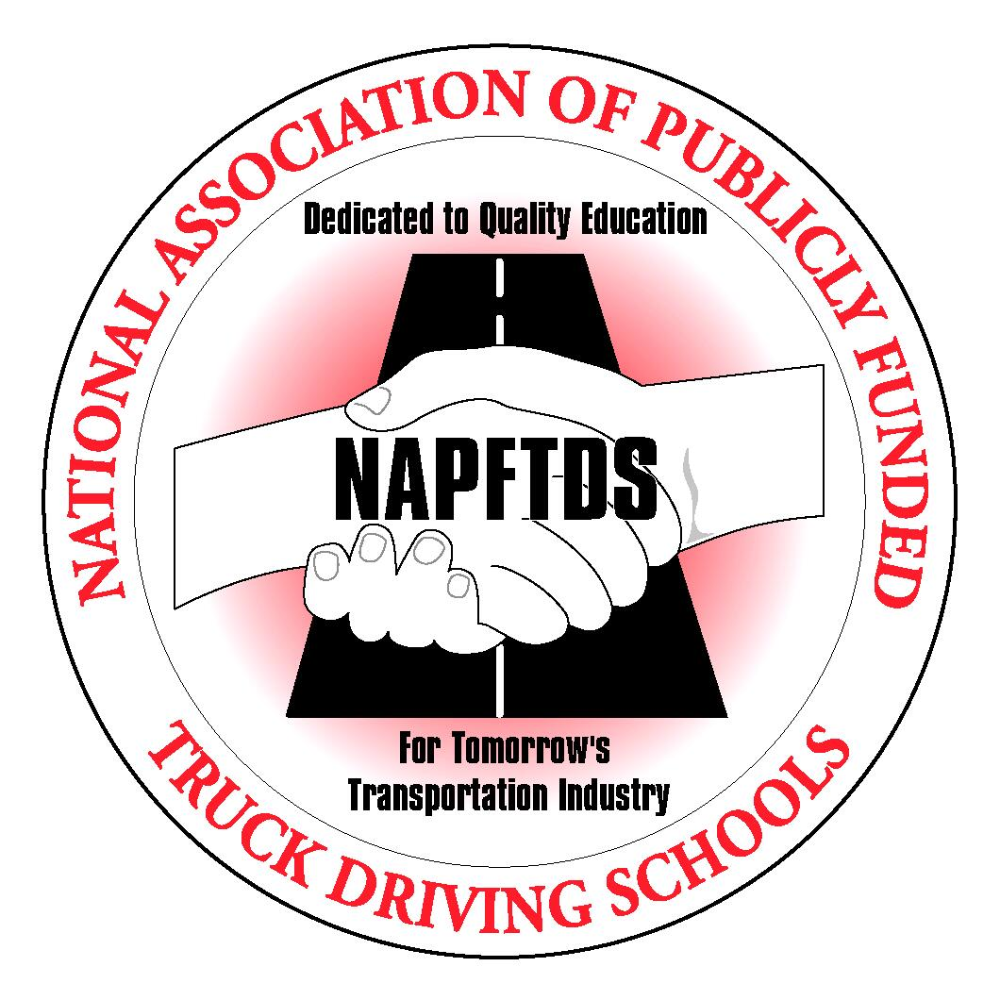

**National Association of Publicly Funded Truck Driving Schools**

Federal Motor Carrier Safety Administration Submitted via Public Listening Session

Re: National Association of Publicly Funded Truck Driving Schools comments on Notice of Proposed Rule: Part VI Department of Transportation, FMCSA, 49 CFR Parts 380, 383, and 384, Minimum Training requirements for Entry-Level Commercial Motor Vehicle Operators, Docket Number FMCSA-2007-27748, December 26, 2007.

Pursuant to the Federal Motor Carrier Safety Administration’s request for comments on the above referenced Notice of Proposed Rule Making, the National Association of Publicly Funded Truck Driving Schools (NAPFTDS) herby submits comments in accordance with FMCSA’s request published in the December 20, 2012 Federal Register notices.:

The National Association of Publicly Funded Truck Driving Schools is a trade organization of public schools; Community Colleges, Technical Schools and Vo-Tech schools, established in 1991. Our current membership also consists of trucking companies and industry vendors. Current membership is over 100 public schools offering entry-level truck driver training. Our member schools have programs ranging from 3 weeks, 160 hours; to some with programs over 10 weeks 400 hours in length. Our average programs are 7 weeks with about 330 hours in their courses. Average cost of tuition at a public school is about $2900. Again, this will range from about $400 to over $4,000 for tuition. The majority of our schools have accreditation from a recognized agency by the Department of Education. There are about 18 of our member schools that offer PTDI certified courses. The purpose of our Association is to promote high standards and to share with each other best practices and ideals on improving the quality of training and how to best serve our students.

While we have different types and lengths of programs, we believe that the majority of our schools have developed their programs using the Model Curriculum for Training Tractor-Trailer Drivers as a base for their training.

We believe that the intent of FMCSA’s NPRM is to improve the safety of operation of entry-level trainees who operate large commercial vehicles by ensuring that they have received the appropriate training before being employed in the industry. To this extent, we applaud FMCSA and offer the following comments and suggestions:

**1. Comments on the content and extent of proposed training for Class A and Class B/C applicants.**

While there are some associations and groups calling this an “Hours Based” proposal, we should point out that according to Part 380.611 Driver Testing in the proposed rule; “To successfully complete the CMV driver training program set forth in this subpart, and entry-level driver-student must pass knowledge and skills tests in accordance with the following requirements.” Paragraph (b) of this section addresses proficiency determination stating that; “The driver student must meet the following conditions to be certified as having successfully completed training under this subpart” (b)(2) states that the driver-student must demonstrate that he/she can successfully perform all of the skills addressed in paragraph (a)(6) of this section. Under Part 380.611 we believe this to address the proficiency development of each student and therefore believe this to be a Performance/Hours Based regulation.

NAPFTDS supports the proposed regulation requiring performance and hours based training. A combination of both would allow schools the opportunity to produce the quality of entry-level drivers demanded by the trucking industry and the general public.

**2. Comments and data on the correlation between hours and content of training and the driving records of persons completing such training.**

The Model Curriculum, as mentioned in the NPRM, was completed in the mid-1980s with course content and hours-of-training recommendations of 320 hours which included the classroom portion and 53 hours behind-the-wheel for each student. Later a group of industry leaders from trucking companies, training schools and insurance companies began meetings to determine entry-level training standards. During those meetings the group adopted many of the Model Curriculum recommendations and revised the hours by recommending 44 as the minimum required for behind-the-wheel training. Also adopted were a set of knowledge and performance standards to insure student proficiency in knowledge and skills. The result of these revisions let to the current PTDI standards for entry-level training. We believe these standards have been the foundation for most training programs since that time. We also believe that without minimum hours and proficiency testing there can be no adequate measure to determine compliance with this proposed regulation.

**4. Comments regarding the appropriateness of accreditation as a means of maintaining quality control over the training provided, the ability of existing entry-level training facilities to acquire accreditation and the necessity of acknowledging CHEA in addition to Dept of ED as an entity that may recognize accrediting agencies. Comments are also sought regarding any possible alternatives to accreditation that would accomplish similar objectives.**

Accreditation primarily deals with institutional issues and is not content or course specific. NAPFTDS believes that a viable alternative for accreditation could be certification. Certification of a program or course is content specific. Certification is industry specific and the process would use industry professionals to certify that a course meets all federal regulations. To ensure training providers are meeting the minimum requirement, we do recommend the use of either accreditation or certification of a program or course. We firmly believe accreditation and/or certification is essential because, among many other known positive aspects, it could serve as a preventive to the abuses and fraudulent practices that exist within the truck driver training industry. Accreditation and/or certification would also allow States and FMCSA to more effectively monitor school compliance with the proposed regulation.

**7. Additional comments on the correlation between hours and content of training.**

In the NPRM, Table 1. Minimum Hours of Training Required by Part 380 Appendix B, all training hours are broken down for each of the 5 sections of training. Our Association does not feel it appropriate to assign specific hours for each section of classroom and BTW training. There are certain factors relating to how much time is needed to cover each section. The size of the class, what type of lecture in the classroom, the availability of equipment or instructor could all determine how much time is needed to complete the task. NAPFTDS believes that all topics should be covered, but there can be some flexibility related to the exact time allowed for each subject. There need not be a specific time requirement for each topic in the classroom portion. However we do believe that the required 76 hours of classroom and 44 hours of BTW is appropriate. Allowing flexibility in hours will allow programs to determine how much time is allotted in each task.

In consideration of the BTW phase of training, we believe that the proposed minimum 44 hours for a Class A license and 32 hours for a Class B license should be the minimum standard as outlined in the NPRM. It should be noted that the total length of a program would actually be determined by the ratio of students per truck. The proposed 120 hours of training is based on a one-to-one ratio. However, there are few if any programs offering such a ratio. The industry average would be more of a four-to-one ratio of students per truck. With a four-to-one ratio and in order to provide 44 hours BTW per student the total length of a program would be 252 hours of training (44BTW x 4 students =176hours+76 classroom hours = 252 program hours).

We also feel that proper proficiency testing should be part of the entire training program.

In summary, NAPFTDS recognizes the value of the proposed total minimum 120 hours for a Class A license, which includes the classroom portion, a minimum 44 hours BTW phase, and proficiency testing in both of these portions. (Class B license includes a total minimum 90 hours with a minimum 32 hours BTW.) However, we believe that the school could gain some flexibility in training students if the classroom portion and BTW of training would not specify time requirements for topic areas. We feel that, not only would this enhance flexibility, it would also be in keeping with the regulation.

Robert W McClanahan

Executive Director, NAPFTD

[Robert-mcclanahan@att.net](mailto:Robert-mcclanahan@att.net)

918-770-6446