FMCSA Distracted Driving: Stakeholder Social Media Editorial Calendar

The Federal Motor Carrier Safety Administration (FMCSA) has developed the sample social media editorial calendar below to raise awareness about the critical importance of eliminating distracted driving behaviors.

Help end distracted driving by sharing safety messages and resources on your communication platforms, or share FMCSA’s posts from the Our Roads, Our Safety® Facebook page.

April 1-4, 2025 Social Messages | Post Asset(s)
April is Distracted Driving Awareness Month. Together, we can help make #OurRoads safer by staying focused behind the wheel.  Learn more about FMCSA’s efforts and access shareable materials: https://www.fmcsa.dot.gov/ourroads/distracted-driving-campaign  #distracteddriving #justdrive | 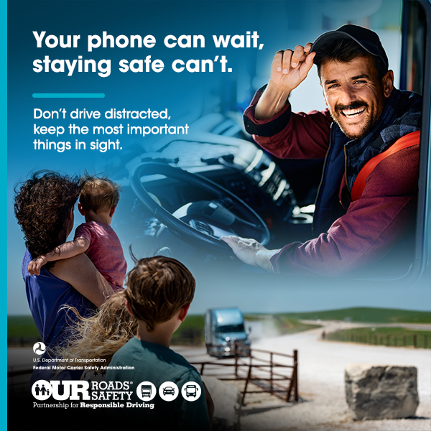
Looking at your phone while on the road can distract you from what’s most important: getting to your destination safely.  Stay screen-free and #justdrive.  Learn more from FMCSA about distracted driving: https://www.fmcsa.dot.gov/ourroads/distracted-driving-campaign  #OurRoads #distracteddriving | 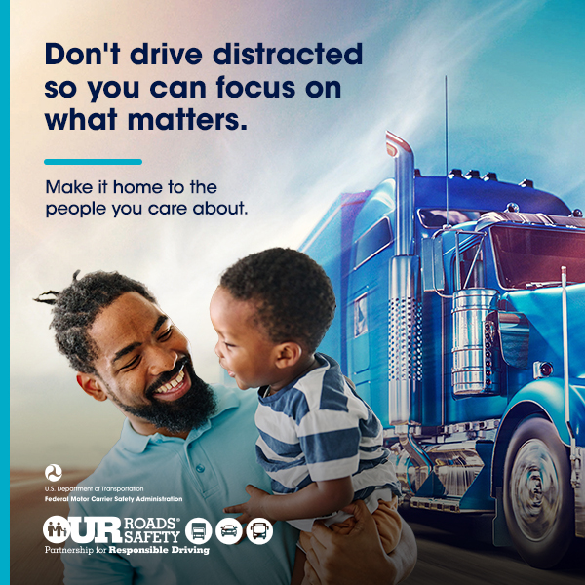
April 7-11, 2025 Social Messages | Post Asset(s)
Stay focused and stay safe! Set the GPS before you head out so you can drive distraction-free.  Learn more from FMCSA: https://www.fmcsa.dot.gov/ourroads/distracted-driving-campaign  #OurRoads #distracteddriving #justdrive | 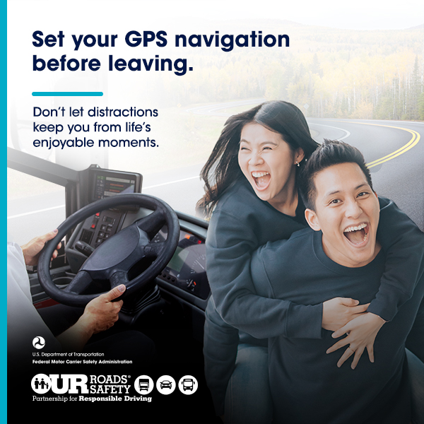
Driving distracted is risky and reckless. Make safety the top priority during National Distracted Driving Awareness Month and throughout the year.

Share safety tips from FMCSA: https://www.fmcsa.dot.gov/ourroads/distracted-driving-campaign

#OurRoads #distracteddriving #justdrive

Keep safety top of mind with these tips to help you drive distraction-free on #OurRoads:

📵 Put your phone away
🛣 Set your GPS before hitting the road
😴 Get a good night sleep before a long traveling day.

Get more safety tips: https://www.fmcsa.dot.gov/ourroads/distracted-driving-campaign

#distracteddriving #justdrive

April 14-18, 2025 Social Messages | Post Asset(s)
🚛 Getting ready to hit the road? Make sure to get a good night’s rest and set the GPS route ahead of time to prevent driving distracted.

Learn more from FMCSA: https://www.fmcsa.dot.gov/ourroads/distracted-driving-campaign

#OurRoads #distracteddriving #justdrive

It’s not just about getting to your destination, it's about getting there safely.

Learn how you can help reduce distracted driving, and share safety materials with your community: https://www.fmcsa.dot.gov/ourroads/distracted-driving-campaign

#OurRoads #distracteddriving #justdrive
📵Staying focused on the road starts with putting your phone away and silencing notifications. Keeping your eyes on the road is crucial for everyone’s safety.

Explore more tips to avoid distracted driving:
https://www.fmcsa.dot.gov/ourroads/distracted-driving-campaign

#OurRoads #distracteddriving #justdrive

April 21-25, 2025 Social Messages | Post Asset(s)
Start each journey with a commitment to safety. No calls, no texts and no distractions while on the road.

As Distracted Driving Awareness Month comes to an end, stay committed to driving distraction-free and share FMCSA’s safety materials: https://www.fmcsa.dot.gov/ourroads/distracted-driving-campaign

#OurRoads #distracteddriving #justdrive

Whether it’s setting your GPS route or peeking at your phone, distracted driving is risky for everyone on the road. Drive distraction-free and make it to your destination safely.

Learn more about sharing the road safely: https://www.fmcsa.dot.gov/ourroads/distracted-driving-campaign

#OurRoads #distracteddriving #justdrive

If you get behind the wheel without getting a good night’s sleep, you can be distracted on the road. When driving has your full attention, you help make #OurRoads safer.

Learn more tips on how to avoid driving distracted: https://www.fmcsa.dot.gov/ourroads/distracted-driving-campaign

#distracteddriving #justdrive
April 28-30, 2025 Social Messages | Post Asset(s)
Staying focused and phone-free on the road is what will help you arrive at your destinations safely.

Though Distracted Driving Awareness Month is coming to an end, FMCSA reminds you to stay focused on #OurRoads all year long: https://www.fmcsa.dot.gov/ourroads/distracted-driving-campaign

#distracteddriving #justdrive

