FMCSA Distracted Driving: Stakeholder Social Media Editorial Calendar

The Federal Motor Carrier Safety Administration (FMCSA) has developed a Social Media Editorial Calendar aimed at raising awareness about the critical importance of eliminating distracted driving behaviors. These messages highlight FMCSA’s efforts to encourage safe driving practices among commercial motor vehicle (CMV) drivers and all road users to reduce the number of road fatalities. Help end distracted driving by sharing safety messages and resources on your communication platforms to your community or share FMCSA’s posts from the Our Roads, Our Safety® Facebook page.

April 1-5, 2024 Facebook Messages | Post Asset(s)
It’s Distracted Driving Awareness Month! Keep safety top of mind and remain focused behind the wheel. Learn more about FMCSA’s efforts to reduce distracted driving and access shareable materials: https://bit.ly/49fg9IJ #justdrive #distracteddriving #OurRoads | 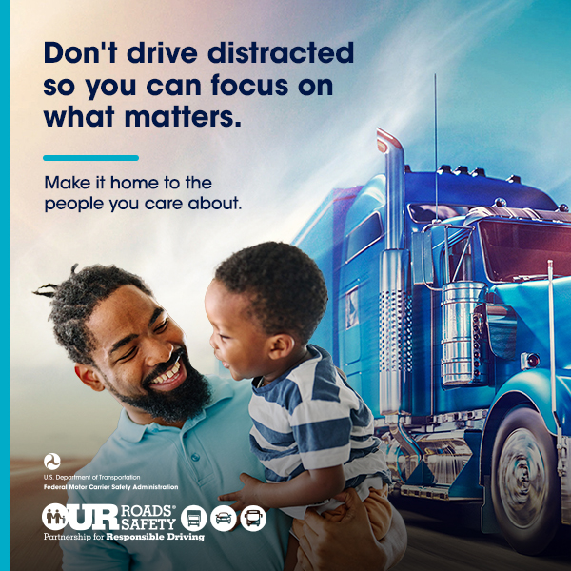
Distractions can lead to disasters. Put your phone away, notifications on silent, and stay focused. Discover tips to avoid driving distracted from FMCSA: https://bit.ly/3x652Ee #justdrive #distracteddriving #OurRoads | 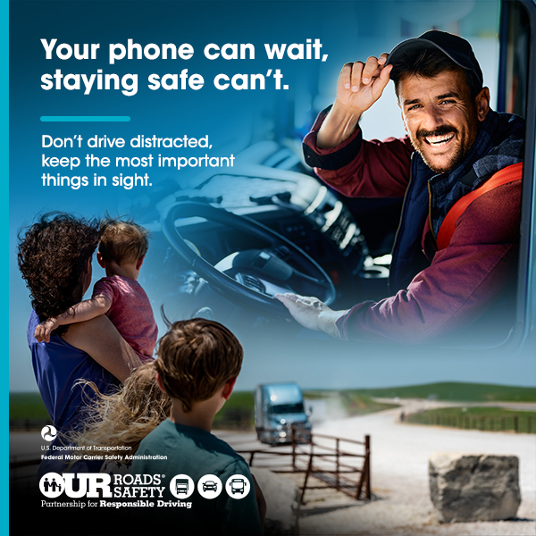
April 8-12, 2024 Facebook Message | Post Asset(s)
Remember to keep your eyes on the road. Your phone can wait. Share the road safely by staying focused and avoiding distractions while driving. Share tips from FMCSA to prevent distracted driving: https://bit.ly/49fg9IJ #justdrive #distracteddriving #OurRoads

Distracted driving isn't just risky, it's reckless. Let's make safety our top priority by setting the GPS before we start driving. Learn more about distracted driving from our safety partners at FMCSA: https://bit.ly/3x652Ee #justdrive #distracteddriving #OurRoads | 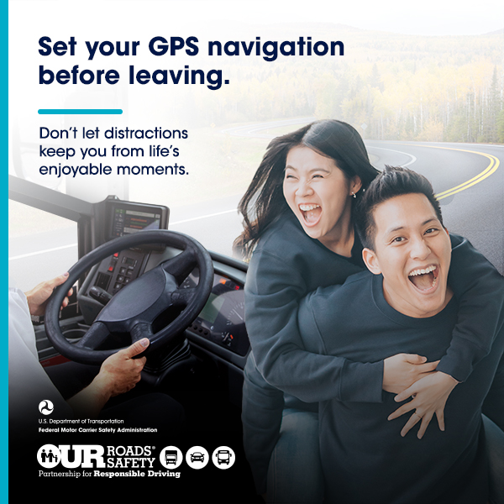
As a road user, your priority is clear: safety above all else. Share these materials with your network to make sure others know not to drive distracted: https://bit.ly/49fg9IJ #justdrive #distracteddriving #OurRoads
April 15-19, 2024 Facebook Message | Post Asset(s)
Distractions can cause a problem anywhere on the road, but especially in work zones. Do your part, set your route ahead, and always stay focused. Learn more about distracted driving from FMCSA https://bit.ly/3x652Ee #justdrive #distracteddriving #NWZAW #OurRoads

No text, call, or notification is worth risking lives on the road. Drive distraction-free. Learn more about how to help FMCSA reduce distracted driving on our roads: https://bit.ly/49fg9IJ #justdrive #distracteddriving #OurRoads

April 22-26, 2024 Facebook Message | Post Asset(s)
Every journey starts with a commitment to safety. Keep our roads safe by putting away your phone and setting your GPS before driving. As Distracted Driving Awareness Month comes to an end, continue to share FMCSA’s materials to show your commitment to driving distraction-free: https://bit.ly/49fg9IJ #justdrive #distracteddriving #OurRoads

FMCSA encourages you to put your phone away while driving. Remember that no call or message is as important as arriving safely. Drive without distractions. Learn more about distracted driving: https://bit.ly/3x652Ee #justdrive #distracteddriving #OurRoads

April 29-30, 2024 Facebook Message | Post Asset(s)
Your loved ones are waiting for you to come home safely. Drive distraction-free, and get to your destination in one piece. Learn more about how to share the road safely: https://bit.ly/3x652Ee #justdrive #distracteddriving #OurRoads

