

**STATE OF WYOMING EXECUTIVE DEPARTMENT EXECUTIVE ORDER**

**Order 2022-06**

**EMERGENCY EXEMPTION FROM PERMISSIBLE OPERATING TIME REGULATIONS**

**WHEREAS,** the people of the State of Wyoming are faced with low supplies of propane with which to heat their homes and businesses, and to carry out commerce due to reduced propane production and availability at refineries; and

**WHEREAS,** it is necessary for propane customers throughout the State of Wyoming to timely receive deliveries in an environment where propane transportation and delivery companies are forced to drive further and wait longer at terminals to secure propane; and

**WHEREAS,** regulatory impediments to the expeditious delivery of propane to customers throughout Wyoming threaten to endanger the health and welfare of the people; and

**WHEREAS,** drivers of propane delivery vehicles are required to deliver supplies of this product in order to meet the demand for the product; and

**WHEREAS,** the State of Wyoming has the ability, through an executive order, to make emergency changes in regulations so that the prompt delivery of propane to customers throughout the state is not impeded by restrictions to the hours that can be worked by qualified drivers; and

**WHEREAS,** in the interest of public safety, the Wyoming Legislature, in Wyo. Stat. Ann. § 31- 18-303(a), has mandated that the Wyoming Department of Transportation adopt rules and regulations prescribing the permissible operating time and other requirements of motor carrier drivers, and the Department has complied with this mandate by adopting its own rules of motor carriers, chapter 1, § 9, which requires compliance with various federal regulations, including 49 CFR 390 and 49 CFR 395 of the United States Department of Transportation Motor Carrier Safety Regulations; and

**WHEREAS,** 49 CFR 390.23 permits a state official authorized to declare an emergency, such as the Governor of the State of Wyoming, in the event of such declaration, to exempt motor carrier drivers from certain regulations, including operating time requirements.

EO 2022-6 EMERGENCY EXEMPTION FROM PERMISSIBLE OPERATING TIME REGULATIONS

December 15, 2022

Page 2

**NOW, THEREFORE,** pursuant to the authority vested in me by the Constitution and by the laws of the State of Wyoming, I, Mark Gordon, do hereby order and direct:

1. A state of emergency exists in Wyoming, and I hereby declare such an emergency. The emergency requires that the transportation and delivery of propane into and within the State of Wyoming shall be exempt from 49 CFR 395.3.
2. Nothing contained in this Order shall be construed as an exemption from the controlled substances, alcohol use, and testing requirements (49 CFR 382), the commercial driver's license requirements (49 CFR 383), the financial responsibility requirements (49 CFR 387), applicable size and weight requirements, or any other portion of the regulations not specifically identified in this Order.
3. Propane transportation or delivery companies, while under this Order, shall not require or allow any fatigued driver to operate a propane delivery vehicle. A driver who informs a carrier that he/she needs immediate rest shall be given adequate rest before the driver is required to return to service.

Be it further ordered, this Executive Order is effective immediately and shall expire upon the conclusion of the emergency, but no later than midnight, January 14, 2023.

This Executive Order is effective December 15, 2022.

Given under my hand and the Executive Seal of the State of Wyoming this 15th day of December, 2022.

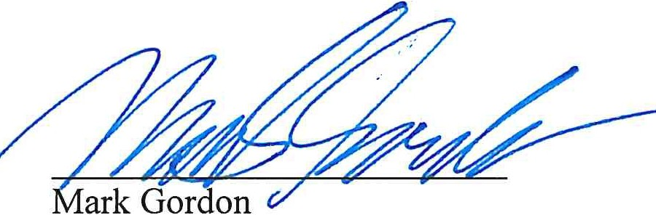

Governor