FMCSA-HOS-ELD-TECH-395-FAQ64(2017-11-07)-CORR1

Question: What information must be displayed on the electronic logging device (ELD) or provided on the ELD printout?

**Answer:** The ELD must show the following information via the display of the ELD or printout:

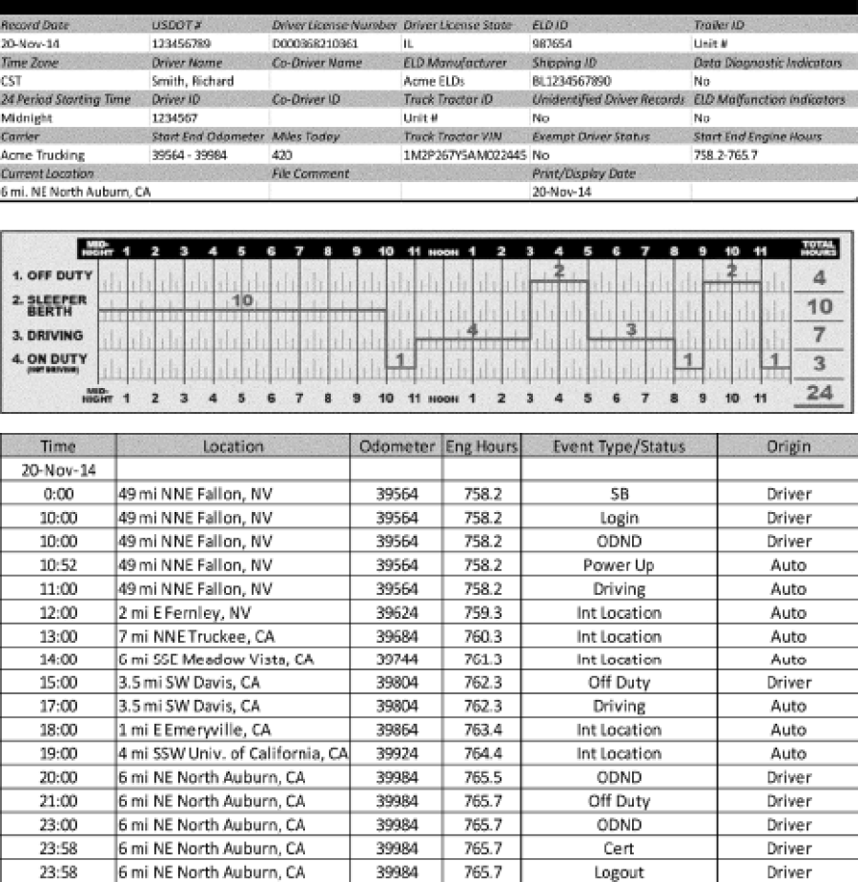

**Contact Info:** FMCSA ELD Information, 1-800-832-5660 or [ELD@dot.gov](mailto:ELD@dot.gov).

________________________

*Note: This guidance document does not have the force and effect of law and is not meant to bind the public in any way.  It is intended only to provide information and clarity regarding existing requirements under the law or agency policies.*

**Regulatory Topic: ELD Guidance**

**Effective Date:** Thursday, November 7, 2019

**Issued Date:** Thursday, November 7, 2019