ELD guidance

**Electronic Logging Devices and Hours of Service Supporting Documents: Frequently Asked Questions.**

## Guidance

**Agriculture Exemption Diagrams**

The diagrams in this document illustrate, but do not modify, the guidance provided in the Federal Register Notice “Hours of Service of Drivers of Commercial Motor Vehicles; Regulatory Guidance Concerning the Transportation of Agricultural Commodities,” 83 Fed. Reg. 26374 (June 7, 2018).

***NOTE:*** *These diagrams address the transportation of any type of “agricultural commodity,” as defined in 49 CFR § 395.2. However, Congress has prohibited FMCSA or its State partners from using Federal funds to enforce the requirement that commercial motor vehicle operators use electronic logging devices (ELDs) to track their hours of service (HOS) while transporting either livestock, as defined under 7 U.S.C. § 1471, or insects, through September 30, 2019.*

**En Route Empty to Source**

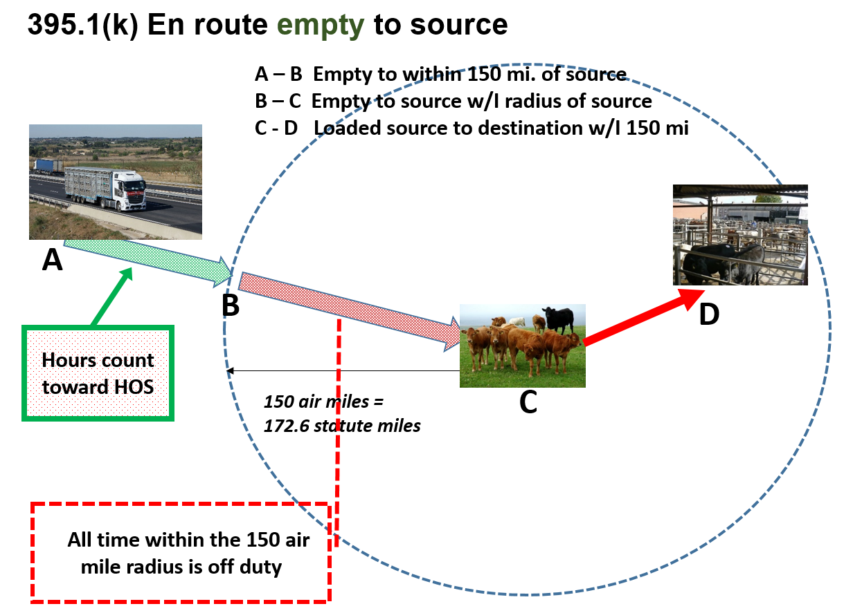

The letter “A” represents the start of trip.

The letter “B” represents the 150 air-mile radius boundary from the source.

The letter “C” represents the location of the source of the commodity.

The letter “D” represents the destination of the commodity.

In the “En Route Empty to Source” scenario, provided that the trip does not involve transporting any non-agricultural cargo and the sole purpose of the trip is to make a pick-up of agricultural commodities, the hours-of-service (HOS) rules do not apply while driving unloaded within 150 air miles of the place where an agricultural commodity will be loaded. Nor would the HOS rules apply during that portion of an unloaded return trip which occurs within a 150 air-mile radius of the place where the agricultural commodity was loaded. The driver is subject to the HOS rules while driving outside the 150 air-mile radius from the source.

**Agricultural Commodities to Market**

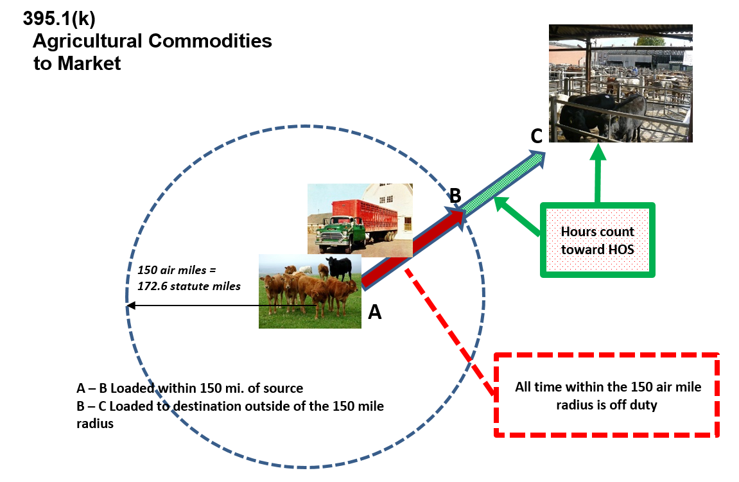

The letter “A” represents the source of the commodity.

The letter “B” represents the 150-air mile radius boundary.

The letter “C” represents the destination of the commodity.

In the “Agricultural Commodities to Market” scenario, the hours-of-service (HOS) rules do not apply to transportation within the initial 150 air miles from the source of the commodity. However, once the destination of the commodity is beyond the 150 air-mile boundary, the driver is subject to the HOS rules and must record those hours in compliance with the HOS rules.

**Return Empty from Delivery**

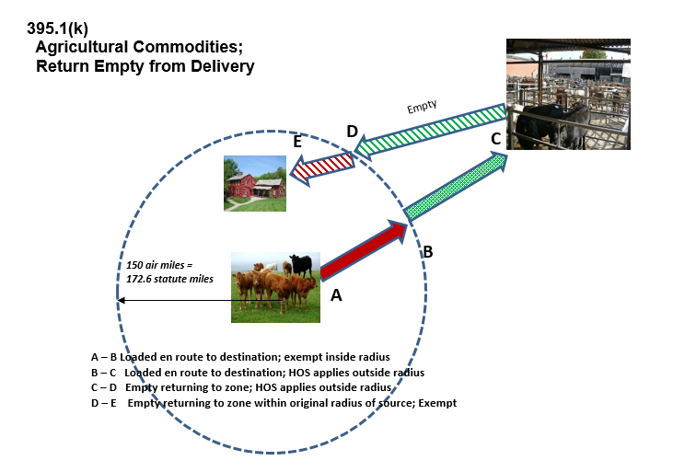

The letter “A” represents the source of the commodity.

The letter “B” represents the 150 air mile radius boundary.

The letter “C” represents the destination of the commodity.

The letter “D” represents the 150 air mile radius boundary.

The letter “E” represents the source of the commodity.

In the “Agricultural Commodities Return Empty from Delivery” scenario, when returning empty, the hours-of-service (HOS) rules apply while the driver operates beyond the 150 air-mile radius of the source, until the driver is within 150 air miles of the original source. The HOS rules do not apply when the driver crosses back into the area within 150 air miles of the original source of the commodities.

**Starting a New Trip Without Returning to Original Source**

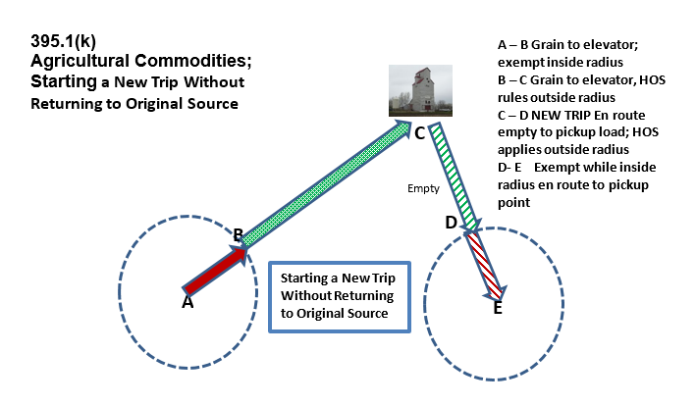

The letter “A” represents the location of the source of the commodity.

The letter “B” represents the 150 air-mile radius boundary.

The letter “C” represents the destination of the commodity, and the beginning of a new trip.

The letter “D” represents the boundary of location of the new source of the commodity.

The letter “E” represents the location of the new source of the commodity.

In the “Agricultural Commodities; Starting a New Trip Without Returning to the Original Source” scenario, a commodity is picked up at point A and delivered to the elevator at point C. A new trip starts unladen toward a new source of a commodity at point E. The hours-of-service rules do not apply on segments A to B or D to E, since they are within the 150 air-mile radius of each source.

**Agricultural Commodities to Market (Multiple Sources)**

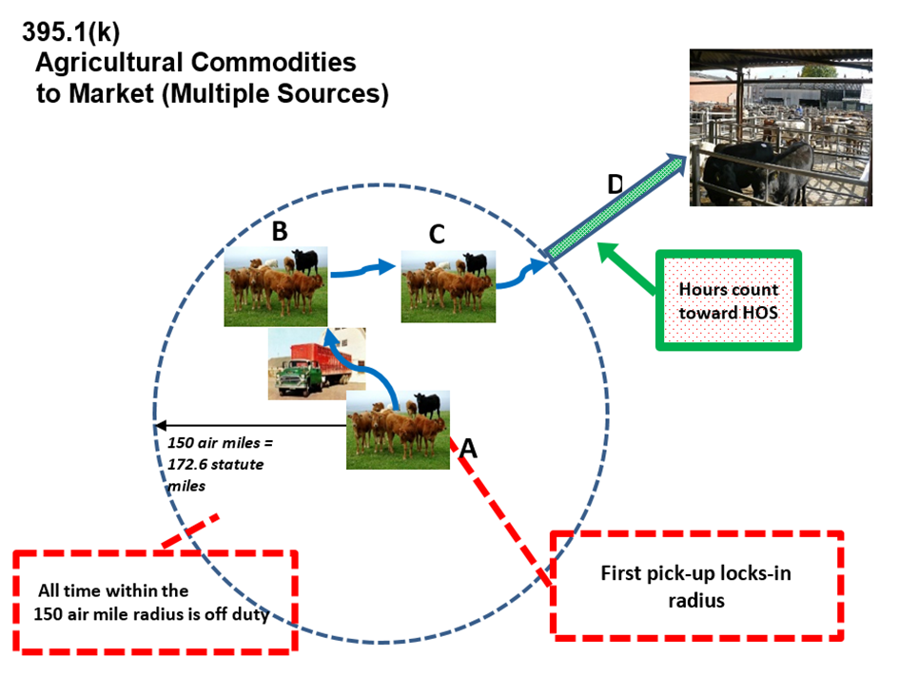

The letter “A” represents the first location of the source of the commodity.

The letter “B” represents the second location of the source of the commodity.

The letter “C” represents the third location of the source of the commodity.

The letter “D” represents the destination for the entire load.

In the “Agricultural Commodities to Market (Multiple Sources)” scenario, the first place where the commodity was loaded is the measuring point for the 150 air-mile radius. Transportation within 150 air miles from location “A” is not subject to the hours-of-service (HOS) rules. Therefore, the HOS rules do not apply when a driver makes multiple pick-ups of agricultural commodities within the 150 air-mile radius from location “A,” such as location “B” and location “C.” The HOS rules apply to transportation beyond 150 air miles from location “A.”