# Behind The Wheel Training

|  |  |  |
| --- | --- | --- |
| Bus Driver Image | Bus Image | Bus Driving |

**Purpose:**

The purpose of this training module is to provide student drivers with off- and on-road practice with motorcoaches they will be operating. Off-road practice will focus on skill maneuvering and learning motorcoach vehicle dynamics. On-road practice will focus on maneuvering motorcoaches in various real-world situations and assessing existing and potential hazards in a variety of environments.

**Module Overview:**

The training module contains two classroom lessons and on-vehicle exercises. The classroom lessons are very brief and designed to prepare student drivers for the on-vehicle exercises that follow. The first lesson provides an overview of skill maneuvers that student drivers may be subject to during closed course/off-road skill course exercises. The second lesson provides instruction on expectations of student drivers while they are operating the coach during on-road practice in real world environments.

Lesson 1: Skill Course Maneuvering

Lesson 2: On-Road Practice

LESSON 1

SKILL COURSE MANEUVERING

**Lesson Objectives:**

By the end of this lesson, you will be knowledgeable about standard skill course maneuvers you may be attempting while practicing operating motorcoaches on the off-road skills course. You will have a basic understanding of the critical hazards of each skill maneuver so that you can concentrate on these areas as you learn the operational dynamics of the motorcoach(es).

**Instructional Methods**:

Classroom lecture introduction and behind the wheel exercises.

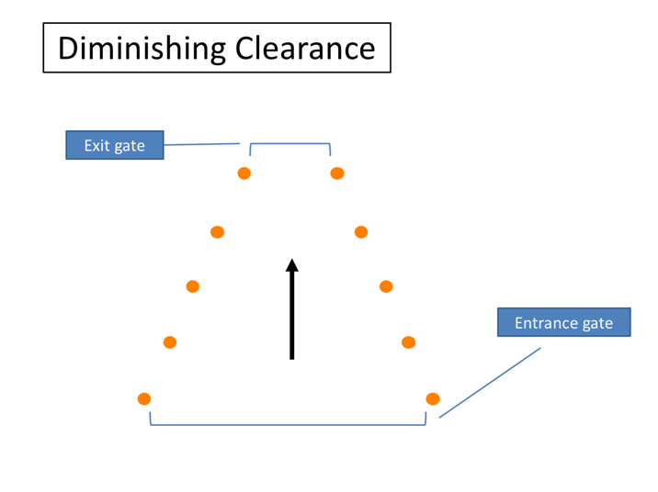

# DIMINISHING CLEARANCE

This skill maneuver is known as “Diminishing Clearance” or “Straight Line”. It’s pretty straightforward and designed to help you understand the overall width of the motorcoach. As you proceed through the lane, the width of the lane will narrow, meaning the “exit gate” could be much tighter than the “entrance gate”.

Besides fitting through the width of the exit gate, there are no significant clearance issues, unless the course is set up to make you turn sharply shortly after exiting this maneuver. In that case, the exit gate cones could become pivot and rear clearance/overhang hazards.

Sometimes instructors will use a similar setup as this maneuver to help assist drivers with the concept of where the motorcoach tires track relative to the side of the coach and their seat. Instead of fitting the entire coach through the diminishing clearance, they ask drivers to roll their right or left side tires through it!

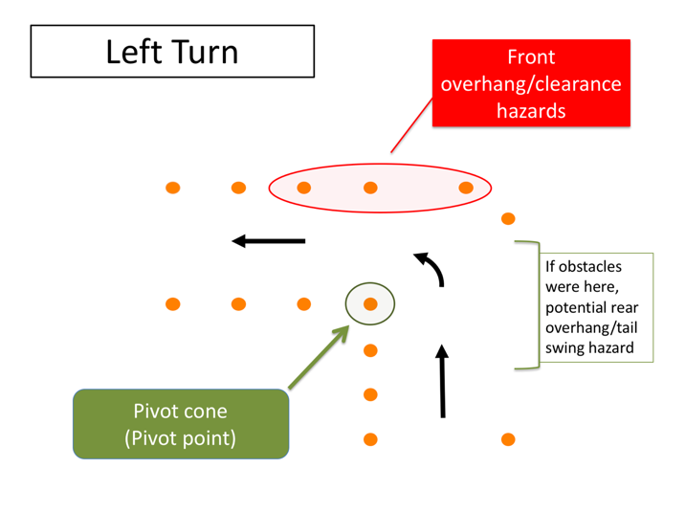

# LEFT TURN

The most basic of maneuvers is the left and right turn. While basic, they are much trickier in a motorcoach than in a regular passenger car. The large wheelbase means that you must account for the off-tracking during turn maneuvers. You also must be aware of the front and rear overhangs and their clearances when negotiating a turn.

To know when you can turn without striking or running over an object with your rear axles, you must know where the pivot point is on the coach. The pivot point can vary depending on whether a tag axle is present, and whether the tag axle is raised or lowered.

As you can see from the diagram, during this skill maneuver you will be making a left (or right) turn. The amount of “extra space” you have to make the turn can be adjusted to simulate varying, real-life scenarios on how “tight” a turn may be. The narrower the approach and exit lanes, the tighter you will need to make the turn around the pivot cone.

**LEFT TURN (continued)**

Your pivot cone is marked on the diagram – when you are on the course, you can imagine this is a curb or the centerline of the roadway. You must locate your vehicle’s pivot point properly relative to this pivot cone or you will strike it (and perhaps others if you turn way too early or too late).

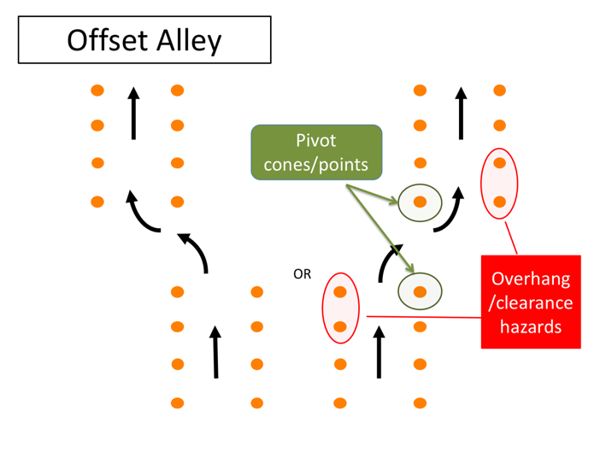

# OFFSET ALLEY

This skill maneuver is called the “Offset Alley”. As you can see, you will enter a straight alley and offset to the left or right, continuing through a second alley.

This skill maneuver will help you understand and realize turning maneuverability as well as front and rear overhang clearances. You’ll be moving laterally an entire width of the coach (8.5’) during the offset. The maneuver becomes more difficult the narrower the alleys and the closer they are together.

There are literally two pivots cones in this maneuver and several cones that will serve as potential overhang clearance hazards as you maneuver out of the first alley and into the second alley.

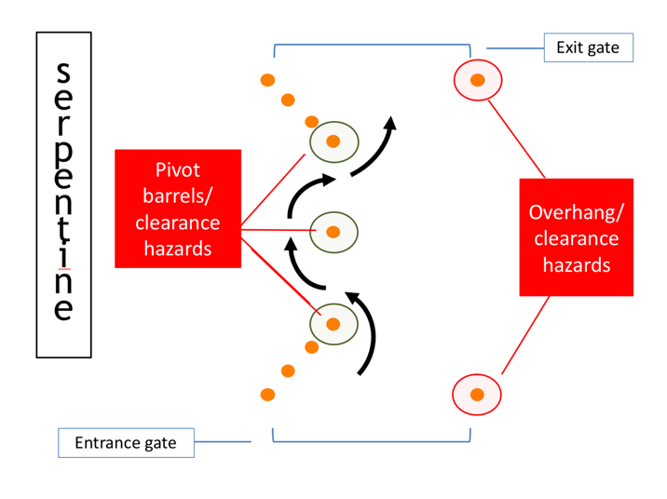

# SERPENTINE

The Serpentine is a difficult skill maneuver that will also help you understand turn radius, pivot points and overhang clearances (you should be noting a theme by now – knowing and understanding these items are key to being able to maneuver without incident). In this maneuver, your pivot cones (barrels) and clearance hazards are one and the same.

Difficulty level will depend on the spacing between the center obstacle and the last/first cones on the entrance/exit gates and the width of the entrance/exit gates.

Experienced and skilled professionals are known to not only drive forward through the serpentine, but also backward!

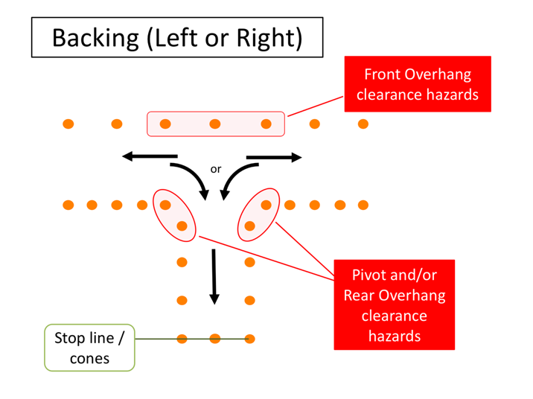

# BACKING (LEFT OR RIGHT)

Alley backing is another tough skill maneuver, and hopefully one you won’t have to physically do very often at all. In fact, remember – it’s best to avoid backing whenever possible since backing incidents are common in the motorcoach business. This skill maneuver will test much the same as the previous: both pivot points and overhang clearances will come into play during the maneuver - but in a different direction!

Difficulty level will depend in part on what side you are backing from - you may be asked during this maneuver to back from the left or right of the alley. Essentially, you’ll pull down the lane in one direction until you pass the alley, then back 90 degrees into the alley. You’ll first start backing to the driver side since your vision field is much better than right or “blind” side backing. Once in the alley, the goal is usually to stop with your rear bumper as close as possible to the rear stop line without going over it.

The width of the lane and the alley, which will dictate clearances for rear and front overhangs, will set the difficulty level.

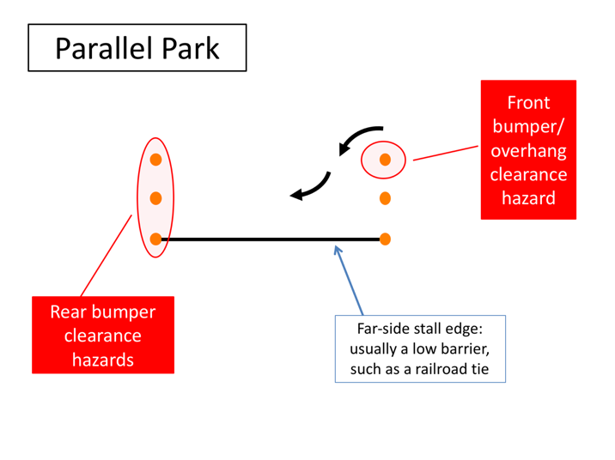

# PARALLEL PARK

The “Parallel Park” maneuver is another backing exercise to help drivers understand clearances and sight issues when they are backing. For this maneuver, you will drive parallel past the “parking” stall and then be asked to back into the parking stall. Much like the Alley Backing, you will be asked to back in both directions, meaning you may back to your driver or passenger side when entering the stall.

Once in the stall, your goal is to come as close to the far-side stall edge line as possible without striking cones at the front or rear end of the stall. The far side stall edge is usually a block of wood or something similar to a curb – this allows you to swing your rear overhang over it during the maneuver without striking a barrier. A point on the coach will be designated from which they will judge distance to the stall edge (for example, rear drive axle).

Your largest hazards are the rear stall cones/barrels that you could strike with the rear bumper if you back to far into the stall. The front corner cone is also a hazard for the front overhang and/or bumper clearance – both on the way into the stall and on the way out.

The difficulty of this skill maneuver is generally dictated by the length of the stall.

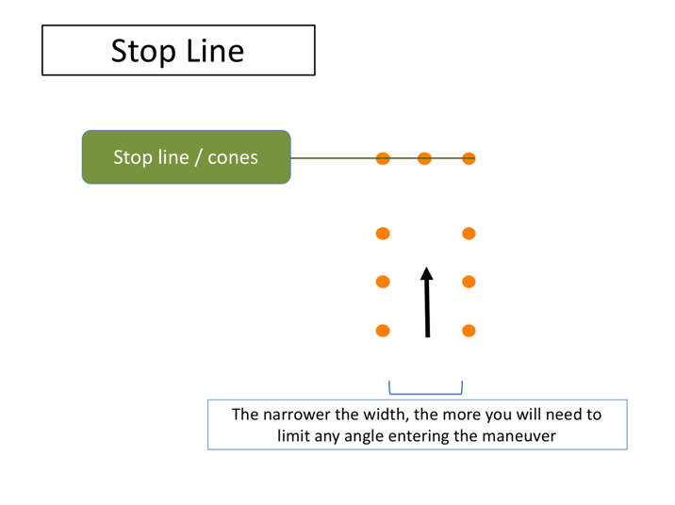

# STOP LINE

Finally, there’s the “Stop Line”. This maneuver will help you judge the location of the front of the motorcoach relative to your seated position.

The general goal is to stop the coach in the stall with the front bumper as close as possible to the end cones (or line). The width of the alley can be adjusted to make it a tighter “fit” as you pull toward the stop line; the narrower it is, the more you may have to adjust prior to entering (may have to enter virtually straight on).

LESSON 2

ON-ROAD PRACTICE

**Lesson Objectives:**

By the end of this lesson, you will understand how to provide commentary related to hazard identification while driving. You will learn to “talk-through” what you see and what your intentions are while you are behind-the-wheel during on-road practice. On-road practice will expose you to a variety of operating environments with a focus on environments you are most likely to operate in for the company.

**Instructional Methods**:

Classroom lecture introduction and behind the wheel exercises.

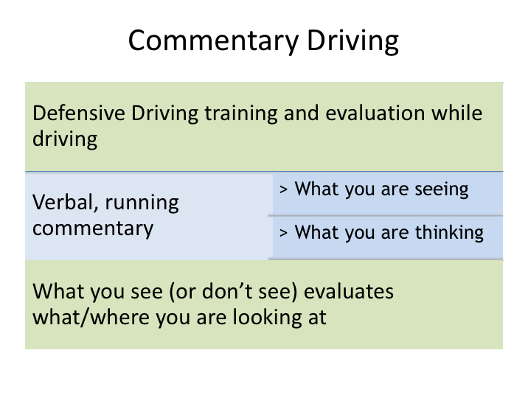

# COMMENTARY DRIVING

Driving defensively means being alert to what is happening around your vehicle and being prepared to respond to emergencies if necessary. Though the basics of defensive driving can be taught in the classroom, it may be difficult for an instructor to truly understand if a student can employ the defensive driving concept in real-world scenarios. “Commentary driving” is a method which takes defensive driving learning outside the classroom and into the cockpit of the motorcoach, allowing for real-world assessment and teaching of defensive driving mindset and skills.

Commentary driving is simply giving a verbal, running commentary while driving. The verbal commentary includes what you see, what you are planning and what you are thinking. The commentary allows an experienced driver/instructor to evaluate where you are looking, what you are seeing, and what you are thinking.

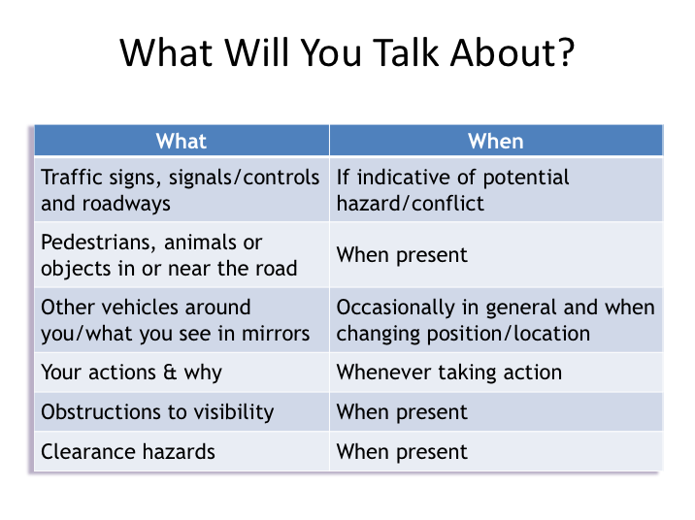

# WHAT WILL YOU TALK ABOUT

Commentary driving is talking it through – it’s thinking out loud as you drive. It keeps your mind alert and focused on the job of driving. You will be applying the hazard-detection methods you have been taught and learning a way of thinking about driving that will serve you well in your driving career, even though you may never talk it through after this training course is over.

Driving evaluators will benefit because he/she can tell you what you are doing right, and can give you guidance or warnings if you fail to notice something important.

**WHAT WILL YOU TALK ABOUT (continued)**

Here are the general types of things you should talk about when you are behind-the-wheel during the on-road exercises:

* Traffic signs, signals, and intersecting roadways
* Pedestrians, objects or animals in or near the road
* Vehicles around you (in front, beside and behind)
* What you see in your mirrors (vehicles gaining, vehicle passing, vehicles changing lanes)
* Your actions & why taken (ex. – left turn signal on to change lanes)
* Clearance hazards (ex. – “overpass ahead, clearance okay”)
* Visibility obstructions
* Your gauges occasionally (ex. – speed)
* Road surface and weather conditions (if applicable)

If you are a quiet person and perhaps a bit shy, you may struggle to speak out-loud in front of someone while driving and the process may itself cause you to concentrate less on your driving.  The fact is, it will be unnatural for all student drivers at first.  Commentary driving is a learning process itself and takes practice. So, don't go thinking you need to start verbally communicating everything you see right away. Start off slowly just by mentioning significant things and build from there. 

How do you go about talking it through?  What should you say and how should you say it?  What shouldn't you say?
 


# HOW TO COMMENT

If you are a quiet person and perhaps a bit shy, you may struggle to speak out-loud in front of someone while driving and the process may itself cause you to concentrate less on your driving. The fact is, it will be unnatural for all student drivers at first. Commentary driving is a learning process itself and takes practice. So, don't go thinking you need to start verbally communicating everything you see right away. Start off slowly just by mentioning significant things and build from there.

How do you go about talking it through? What should you say and how should you say it? What shouldn't you say?

**HOW TO COMMENT (continued)**

Here are a few do's and don'ts to guide you in talking it through:

* **Keep comments short - just a few words**. Say things like "stop sign ahead" or "car tailgating" or "car waiting to pull out."
* **Identify only the most critical hazards**. You can't identify every possible hazard. Concentrate on the ones you think are important. If your instructor disagrees or mentions a hazard you missed, that's okay. This is

supposed to be a learning experience, for you and any other students who will be observing.

* **Identify both actual and potential**. This means that you should mention both *actual hazards* - the ones that you *are* going to react to - and *potential hazards* - the ones you *may* have to react to.
* **Announce "Clear path" for no hazards**. Once in a while - not all of the time – let your instructor know that you don't see any important hazards by saying "clear path."
* **Identify, don't explain**. Mentioning the hazard is enough - you don't have to explain what you are going to do - you'll probably be doing it soon enough!
* **Don't look at the instructor.** Keep focus on the roadway, gauges and mirrors.
* **If you can't talk and drive, don't talk.** This is critical. If things get busy enough behind the wheel that you need to concentrate on driving rather than talking it through, stop talking and do it! Your first responsibility is to drive safely.

Your instructor will demonstrate some commentary driving first so you can see how to talk it through.

Let's go over some examples of specific observations you should comment on.  For example, with regard to other vehicles you should mention:
 
• Vehicles you are overtaking
 
• Vehicles pulling out
 
• Vehicles signaling for a turn
 
• Vehicles tailgating the coach
 
• Vehicles entering from ramps 

By mentioning these, you’re indicating actions you are initiating that require close attention (example:  initiating pass – car passing could move into lane), and actions of others that you recognize and are paying attention to (examples: vehicles pulling out, signaling turns, tailgating and merging from ramps).


# EXAMPLE COMMENTARY

Let's go over some examples of specific observations you should comment on. For example, with regard to other vehicles you should mention:

* Vehicles you are overtaking

* Vehicles pulling out

* Vehicles signaling for a turn

* Vehicles tailgating the coach

* Vehicles entering from ramps

By mentioning these, you’re indicating actions you are initiating that require close attention (example: initiating pass – car passing could move into lane), and actions of others that you recognize and are paying attention to (examples: vehicles pulling out, signaling turns, tailgating and merging from ramps).

**EXAMPLE COMMENTARY (continued)**

The table on this slide gives some more examples of short commentary related to occurrences. Even if you really don't like the thought of commentary driving

and miss some hazards at the beginning, you’ll eventually get better at it, which is the point – just like improving in executing skill course maneuvers. And, as a result of both your commentary driving, that of other student drivers that you observe, and feedback from the instructor, you’ll become a better defensive driver.