# Behind-The-Wheel Training

|  |  |  |
| --- | --- | --- |
| Bus Driver | Bus | Bus Driving |

**Purpose:**

The purpose of this training module is to provide student drivers with off- and on-road practice with motorcoaches they will be operating. Off-road practice will focus on skill maneuvering and learning motorcoach vehicle dynamics. On-road practice will focus on maneuvering motorcoaches in various real-world situations and assessing existing and potential hazards in a variety of environments.

**Module Overview:**

The training module contains two classroom lessons and on-vehicle exercises. The classroom lessons are very brief and designed to prepare student drivers for the on-vehicle exercises that follow. The first lesson provides an overview of skill maneuvers that student drivers may be subject to during closed course/off-road skill course exercises. The second lesson provides instruction on expectations of student drivers while they are operating the coach during on-road practice in real world environments.

Lesson 1: Skill Course Maneuvering

Lesson 2: On-Road Practice

LESSON 1

SKILL COURSE MANEUVERING

**Lesson Objectives:**

By the end of this lesson, the students will be knowledgeable about standard skill course maneuvers they will be attempting while practicing operating motorcoaches on the off-road skills course. They will have a basic understanding of the critical hazards of each skill maneuver so that they can concentrate on these areas as they learn the operational dynamics of the motorcoach(es).

**Instructional Methods**:

Classroom lecture introduction and behind-the-wheel exercises.

**Approach:**

Utilizing the PowerPoint slides, review the skill course maneuvers you will utilize with student drivers. Review the specifics of each skill maneuver and theory for executing each correctly, detailing hazard areas for each skill maneuver.

**Instructor Note –**

Review the *Instructor Skill Course Suggestions* in the Instructor Guide Appendix that follows this module for helpful ideas to maximize and reinforce on-course learning of key concepts.

**NARRATIVE**

*Student Guide reference here*

Being able to operate a motorcoach safely is largely dependent on two concepts – knowing the dynamics of the coach and how they affect real-world operation and being able to identify existing and potential hazards around the coach while driving.

While anyone can study and “know” coach operation and dynamics, experiencing them in real life provides much better understanding. We will be spending a significant amount of time during behind-the-wheel training where each of you will gain plenty of experience in both of these areas.

You’ll first gain an appreciation for the motorcoach dynamics in a low-stress environment, where you can concentrate on understanding coach operations - from starting the coach to maneuvering it through a skill course. This closed-course practice will help you visually understand the capabilities and limitations of the motorcoach in operation. If you make a mistake on the skill course you’ll only be hitting a cone, barrel, or ball. But, in the real world, you could be striking a fixed object or, worse yet, a pedestrian.

The slides in this lesson will familiarize you with some of the skill maneuvers you may see on the closed course, though you will likely not see them in this order and may not see some of them at all, dependent upon space limitations.

*Display PowerPoint slide.*

A diagram showing the diminish cleareance skill manevaur.
For a full explation of this slide, please see the text directly below this image.

# DIMINISHING CLEARANCE NARRATIVE

This skill maneuver is known as “Diminishing Clearance” or “Straight Line”. It’s pretty straightforward and designed to help you understand the overall width of the motorcoach. As you proceed through the lane, the width of the lane will narrow, meaning the “exit gate” could be much tighter than the “entrance gate”.

Besides fitting through the width of the exit gate, there are no significant clearance issues, unless the course is set up to make you turn sharply shortly after exiting this maneuver. In that case, the exit gate cones could become pivot and rear clearance/overhang hazards.

Sometimes instructors will use a similar setup as this maneuver to help assist drivers with the concept of where the motorcoach tires track relative to the side of the coach and their seat. Instead of fitting the entire coach through the diminishing clearance, they ask drivers to roll their right or left side tires through it!

*Display PowerPoint slide.*

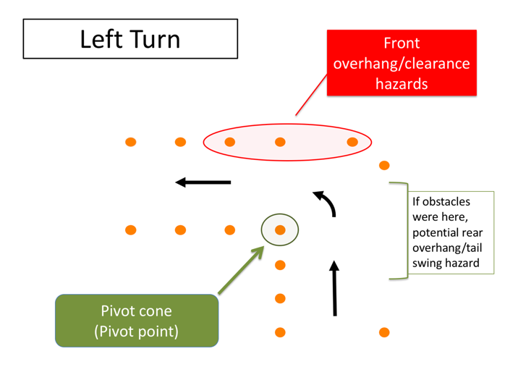

# LEFT TURN NARRATIVE

The most basic of maneuvers is the left and right turn. While basic, they are much trickier in a motorcoach than in a regular passenger car. The large wheelbase means that you must account for the off-tracking during turn maneuvers. You also must be aware of the front and rear overhangs and their clearances when negotiating a turn.

To know when you can turn without striking or running over an object with your rear axles, you must know where the pivot point is on the coach. The pivot point can vary depending on whether a tag axle is present, and whether the tag axle is raised or lowered.

As you can see from the diagram, during this skill maneuver you will be making a left (or right) turn. The amount of “extra space” you have to make the turn can be adjusted to simulate varying, real-life scenarios on how “tight” a turn may be. The narrower the approach and exit lanes, the tighter you will need to make the turn around the pivot cone.

**LEFT TURN NARRATIVE (continued)**

Your pivot cone is marked on the diagram – when you are on the course, you can imagine this is a curb or the centerline of the roadway. You must locate your vehicle’s pivot point properly relative to this pivot cone or you will strike it (and perhaps others if you turn way too early or too late).

*Display PowerPoint slide.*

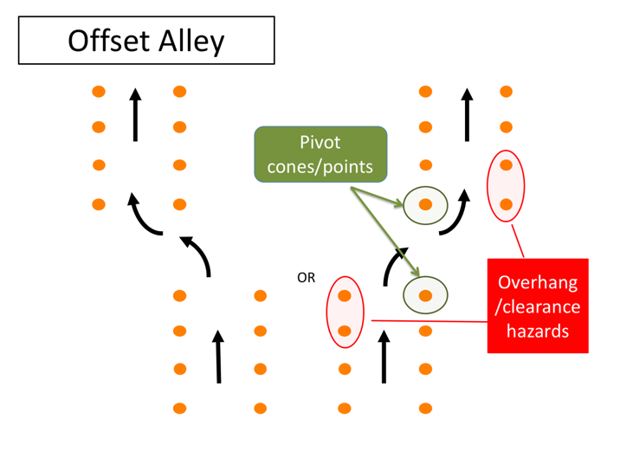

# OFFSET ALLEY NARRATIVE

This skill maneuver is called the Offset Alley. As you can see, you will enter a straight alley and offset to the left or right, continuing through a second alley.

This skill maneuver will help you understand and realize turning maneuverability as well as front and rear overhang clearances. You’ll be moving laterally an entire width of the coach (8.5’) during the offset. The maneuver becomes more difficult the narrower the alleys and the closer they are together.

There are literally two pivots cones in this maneuver and several cones that will serve as potential overhang clearance hazards as you maneuver out of the first alley and into the second alley

*Display PowerPoint slide.*

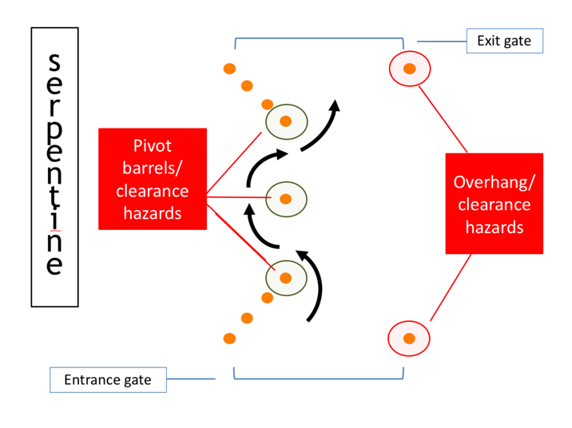

# SERPENTINE NARRATIVE

The Serpentine is a difficult skill maneuver that will also help you understand turn radius, pivot points and overhang clearances (you should be noting a theme by now – knowing and understanding these items are key to being able to maneuver without incident). In this maneuver, your pivot cones (barrels) and clearance hazards are one and the same.

Difficulty level will depend on the spacing between the center obstacle and the last/first cones on the entrance/exit gates and the width of the entrance/exit gates.

Experienced and skilled professionals are known to not only drive forward through the serpentine, but also backward!

*Display PowerPoint slide.*

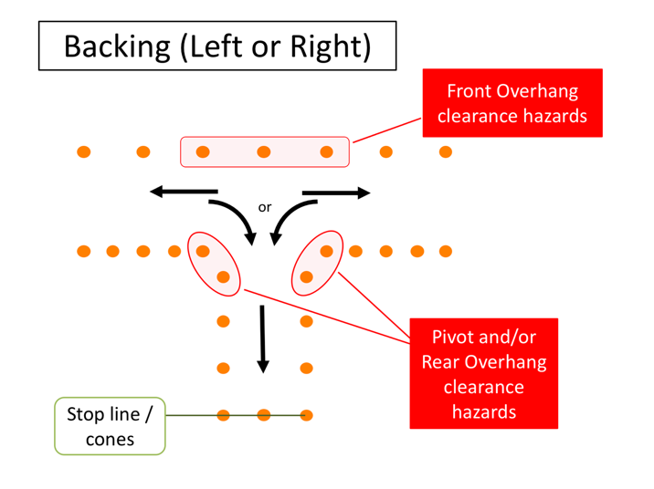

# BACKING (LEFT OR RIGHT) NARRATIVE

Alley backing is another tough skill maneuver, and hopefully one you won’t have to physically do very often at all. In fact, remember – it’s best to avoid backing whenever possible since backing incidents are common in the motorcoach business. This skill maneuver will test much the same as the previous: both pivot points and overhang clearances will come into play during the maneuver - but in a different direction!

Difficulty level will depend in part on what side you are backing from - you may be asked during this maneuver to back from the left or right of the alley. Essentially, you’ll pull down the lane in one direction until you pass the alley, then back 90 degrees into the alley. You’ll first start backing to the driver side since your vision field is much better than right or “blind” side backing. Once in the alley, the goal is usually to stop with your rear bumper as close as possible to the rear stop line without going over it.

The width of the lane and the alley, which will dictate clearances for rear and front overhangs, will set the difficulty level.

*Display PowerPoint slide.*

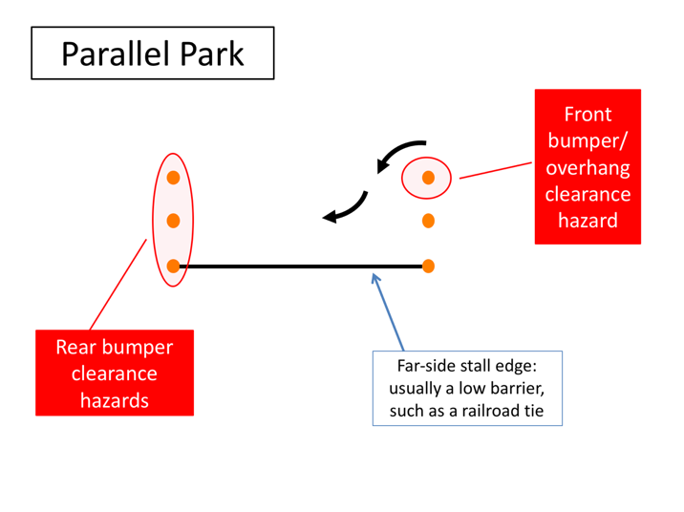

# PARALLEL PARK NARRATIVE

The “Parallel Park” maneuver is another backing exercise to help drivers understand clearances and sight issues when they are backing. For this maneuver, you will drive parallel past the “parking” stall and then be asked to back into the parking stall. Much like the Alley Backing, you will be asked to back in both directions, meaning you may back to your driver or passenger side when entering the stall.

Once in the stall, your goal is to come as close to the far-side stall edge line as possible without striking cones at the front or rear end of the stall. The far side stall edge is usually a block of wood or something similar to a curb – this allows you to swing your rear overhang over it during the maneuver without striking a barrier. A point on the coach will be designated from which they will judge distance to the stall edge (for example, rear drive axle).

Your largest hazards are the rear stall cones/barrels that you could strike with the rear bumper if you back to far into the stall. The front corner cone is also a

**PARALLEL PARK NARRATIVE (continued)**

hazard for the front overhang and/or bumper clearance – both on the way into the stall and on the way out.

The difficulty of this skill maneuver is generally dictated by the length of the stall.

*Display PowerPoint slide.*

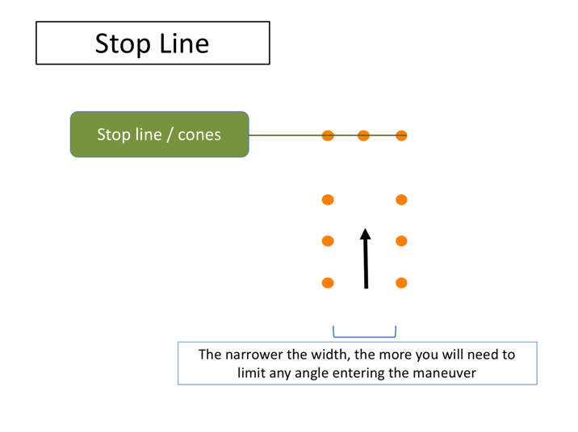

# STOP LINE NARRATIVE

Finally, there’s the “Stop Line”. This maneuver will help you judge the location of the front of the motorcoach relative to your seated position.

The general goal is to stop the coach in the stall with the front bumper as close as possible to the end cones (or line). The width of the alley can be adjusted to make it a tighter “fit” as you pull toward the stop line; the narrower it is, the more you may have to adjust prior to entering (may have to enter virtually straight on).

LESSON 2

ON-ROAD PRACTICE

**Lesson Objectives:**

By the end of this lesson, the students will understand how to provide commentary related to hazard identification while driving. They’ll learn to “talk-through” what they see and what their intentions are while they are behind-the-wheel during on-road practice. On-road practice should expose the student drivers to a variety of operating environments with a focus on environments they are most likely to operate in for the company.

**Instructional Methods**:

Classroom lecture introduction and behind the wheel exercises.

**Approach:**

Utilizing the PowerPoint slides, review the concept of “Commentary Driving.” Following classroom lecture and introduction, schedule drivers for on-road behind-the-wheel training.

Demonstrate commentary driving to the student drivers and then have them provide commentary when they are behind-the-wheel. Subject drivers to as many operating environments that they will be driving in as possible and evaluate their ability to apply safe operating concepts throughout the on-road practice.

**Instructor Note –**

Review the *On-road Practice Suggestions* in the Instructor Guide Appendix that follows this module for helpful ideas to maximize and reinforce necessary over the road driving experience.

Review the *Instructor On-Road Suggestions* that follow the classroom presentation in this Instructor Guide for helpful ideas to maximize and reinforce on-course learning of key concepts.

Review the *Instructor Skill Course Suggestions* in the Instructor Guide Appendix that follows this module for helpful ideas to maximize and reinforce on-course learning of key concepts.

**NARRATIVE**

*Student Guide reference here*

With a good understanding of coach maneuvering dynamics, capabilities and limitations, it’s time to devote attention to the second core element of safe operations – putting your coach operational skills to the test in dynamic and changing real-world roadway environments. While the complexity of the skill maneuvers won’t be any more difficult, constantly changing stimuli will present distractions to the unlimited attention to task you’ve been afforded on the closed skill course.

You will also need to be assessing the changing environment for existing and potential hazards – in other words, driving defensively. You will be exposed to a wide range of operating environments to test your skill, ability, and hazard assessment capabilities. Since skill maneuver capabilities have been established and demonstrated on the closed course, much attention will be focused on the ability to operate the coach properly from a situational/environmental perspective, which includes the necessity to assess the operating environment for existing and potential hazards.

*Display PowerPoint slide.*

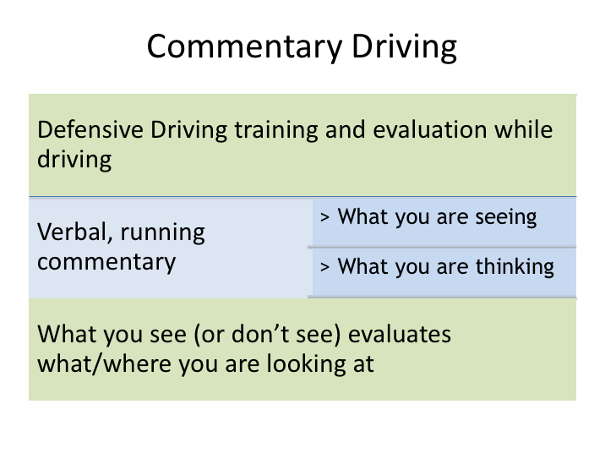

# COMMENTARY DRIVING NARRATIVE

Driving defensively means being alert to what is happening around your vehicle and being prepared to respond to emergencies if necessary. Though the basics of defensive driving can be taught in the classroom, it may be difficult for an instructor to truly understand if a student can employ the defensive driving concept in real-world scenarios. “Commentary driving” is a method which takes defensive driving learning outside the classroom and into the cockpit of the motorcoach, allowing for real-world assessment and teaching of defensive driving mindset and skills.

Commentary driving is simply giving a verbal, running commentary while driving. The verbal commentary includes what you see, what you are planning and what you are thinking. The commentary allows an experienced driver/instructor to evaluate where you are looking, what you are seeing, and what you are thinking.

*Display PowerPoint slide.*

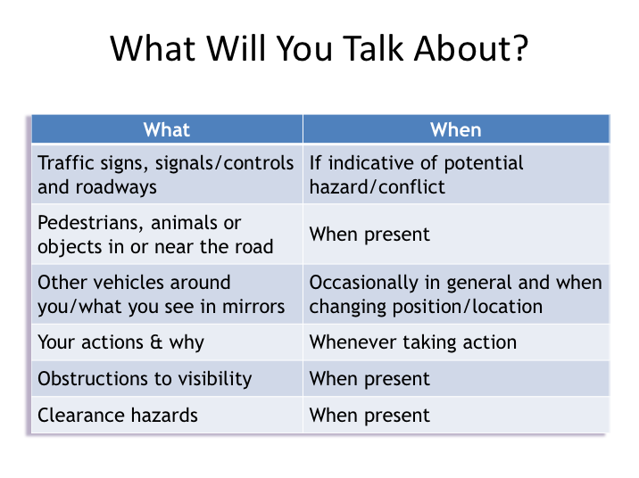

# WHAT WILL YOU TALK ABOUT NARRATIVE

Commentary driving is talking it through – it’s thinking out loud as you drive. It keeps your mind alert and focused on the job of driving. You will be applying the hazard-detection methods you have been taught and learning a way of thinking about driving that will serve you well in your driving career, even though you may never talk it through after this training course is over.

Driving evaluators will benefit because he/she can tell you what you are doing right, and can give you guidance or warnings if you fail to notice something important.

**WHAT WILL YOU TALK ABOUT NARRATIVE (continued)**

Here are the general types of things you should talk about when you are behind-the-wheel during the on-road exercises:

* Traffic signs, signals, and intersecting roadways
* Pedestrians, objects or animals in or near the road
* Vehicles around you (in front, beside and behind)
* What you see in your mirrors (vehicles gaining, vehicle passing, vehicles changing lanes)
* Your actions & why taken (ex. – left turn signal on to change lanes)
* Clearance hazards (ex. – “overpass ahead, clearance OK”)
* Visibility obstructions
* Your gauges occasionally (ex. – speed)
* Road surface and weather conditions (if applicable)

*Display PowerPoint slide.*

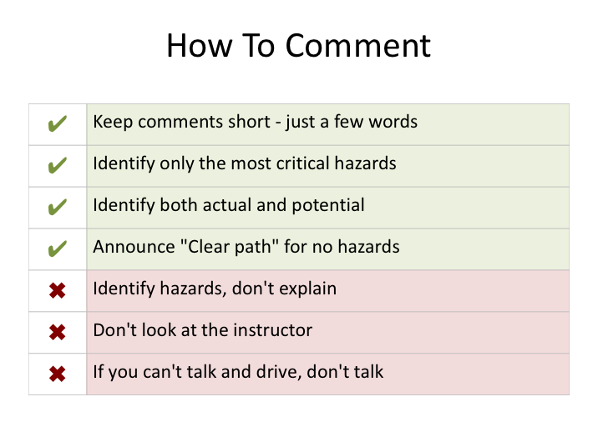

# HOW TO COMMENT NARRATIVE

If you are a quiet person and perhaps a bit shy, you may struggle to speak out-loud in front of someone while driving and the process may itself cause you to concentrate less on your driving. The fact is, it will be unnatural for all student drivers at first. Commentary driving is a learning process itself and takes practice. So, don't go thinking you need to start verbally communicating everything you see right away. Start off slowly just by mentioning significant things and build from there.

How do you go about talking it through? What should you say and how should you say it? What shouldn't you say?

**HOW TO COMMENT NARRATIVE (continued)**

Here are a few do's and don't to guide you in talking it through:

* **Keep comments short - just a few words**. Say things like "stop sign ahead" or "car tailgating" or "car waiting to pull out."
* **Identify only the most critical hazards**. You can't identify every possible hazard. Concentrate on the ones you think are important. If your instructor disagrees or mentions a hazard you missed, that's okay. This is

supposed to be a learning experience, for you and any other students who will be observing.

* **Identify both actual and potential**. This means that you should mention both *actual hazards* - the ones that you *are* going to react to - and *potential hazards* - the ones you *may* have to react to.
* **Announce "Clear path" for no hazards**. Once in a while - not all of the time – let your instructor know that you don't see any important hazards by saying "clear path."
* **Identify, don't explain**. Mentioning the hazard is enough - you don't have to explain what you are going to do - you'll probably be doing it soon enough!
* **Don't look at the instructor.** Keep focus on the roadway, gauges and mirrors.
* **If you can't talk and drive, don't talk.** This is critical. If things get busy enough behind the wheel that you need to concentrate on driving rather than talking it through, stop talking and do it! Your first responsibility is to drive safely.

Your instructor will demonstrate some commentary driving first so you can see how to talk it through.

*Display PowerPoint slide.*

Let's go over some examples of specific observations you should comment on.  For example, with regard to other vehicles you should mention:
 
• Vehicles you are overtaking
 
• Vehicles pulling out
 
• Vehicles signaling for a turn
 
• Vehicles tailgating the coach
 
• Vehicles entering from ramps 

By mentioning these, you’re indicating actions you are initiating that require close attention (example: initiating pass – car passing could move into lane), and actions of others that you recognize and are paying attention to (examples: vehicles pulling out, signaling turns, tailgating and merging from ramps).


# EXAMPLE COMMENTARY NARRATIVE

Let's go over some examples of specific observations you should comment on. For example, with regard to other vehicles you should mention:

* Vehicles you are overtaking

* Vehicles pulling out

* Vehicles signaling for a turn

* Vehicles tailgating the coach

* Vehicles entering from ramps

By mentioning these, you’re indicating actions you are initiating that require close attention (example: initiating pass – car passing could move into lane), and actions of others that you recognize and are paying attention to (examples: vehicles pulling out, signaling turns, tailgating and merging from ramps).

**EXAMPLE COMMENTARY NARRATIVE (continued)**

The table on this slide gives some more examples of short commentary related to occurrences. Even if you really don't like the thought of commentary driving and miss some hazards at the beginning, you’ll eventually get better at it, which is the point – just like improving in executing skill course maneuvers. And, as a result of both your commentary driving, that of other student drivers that you observe, and feedback from the instructor, you’ll become a better defensive driver.

# Instructor Guide Appendix

## Behind The Wheel Training

This Appendix includes Instructor suggestions for both off-road/skill course practice and on-road training.

At this point, the students should be treated as drivers and required to do everything they’ve been taught that drivers must do – this will help set the tone and give them plenty of practice with paperwork and expected processes. Below are some suggestions that apply to both off- and on-road practice.

* Students should conduct a pre-trip inspection every day. You may consider placing fictitious and varying post-trip inspection reports so that they can demonstrate they know what to look for and do in various situations when reviewing the previous driver’s report. You may also want to consider “planting” defect cards or security-related concerns in appropriate places to verify that students are doing thorough pre-trips and identifying any issues.
* Students should log every day, whether electronically or on paper. You may have had them doing this already throughout classroom training but if not, now is the time to start. They also You should review logs at the completion of the days to insure they logged correctly and provide feedback as necessary.
* Students should compete a Vehicle Inspection Report (VIR) at the end of each day. Review them for completeness with their logs and provide guidance as necessary.
* Each time a student gets behind the wheel and assumes control of the motorcoach, you should insure they are adjusting the seat and mirrors as necessary and proper.
* Practice lots of turns, lane changes, and backing scenarios. These are common actions that result in incidents, so the student drivers should be very comfortable with these actions (and skilled!). When reviewing backing, teach the Get Out and Look (GOAL) method to ensure open space behind the coach (both low and high).
* Have student drivers take turns providing manual passenger safety briefings, even if automated/recorded briefings are generally used. Use the on-road practice to provide differing scenarios to students to test their understanding of when safety briefings should be provided.
* Ensure that accessible bus lift and ramp deployment and usage is practiced as applicable, especially during on-road exercises so that pretend pickup spots can be provided to allow student drivers to choose areas for ramp/lift deployment.
* Practice simulated coach evacuations and emergencies. For instance, while driving, you should tell the student driver that there is a smoke smell in the back of the coach to see how they respond. Escalate the situation to a simulated fire to test their reaction and reinforce training in coach evacuation and passenger management.
* Include fueling and lavatory dumping exercises (using proper protective equipment) to the extent possible if drivers will be expected to perform these functions.

You should consider reviewing each of these processes to refresh students’ memories before beginning to have them complete these tasks during behind-the-wheel training.

Behind-the-wheel practice is critical to student driver development. Now that you’ve spent time teaching them theory in the classroom, they must have enough opportunity to get used to being at the wheel and controls of a motorcoach and learning the operational capabilities and limitations through trial and error. This is certainly best accomplished in an off-road, closed course setting.

Few motorcoach companies will have the space necessary for closed course maneuvering, so you’ll likely have to find a facility large enough. It’s best to have multiple (if not all) maneuvers set up at the same time, though not truly necessary if there are legitimate space or course materials issues. Many companies find a local warehouse, stadium, school, mall or other facility and obtain permission to use the facility for training purposes. The more room you have, the more skill problems you can lay out. With enough room, you can lay out an entire course where students transition from one skill maneuver to the next.

You will need specific supplies to construct the skill course.

* Two tape measures (25’ and 100’)
* A square or other tool to determine right angles
* Marking crayons (temporary) or marking paint (permanent)
* 71 traffic cones
* 3 construction barrels
* Either 18 more barrels (preferred) or 18 more traffic cones
* 10 tennis balls
* 10 large, steel flat washers (the tennis balls will sit on top of these washers)

Ask for old cone and construction barrel donations from your local municipality or state DOT if you are having trouble locating them on your own. The numbers of cones and barrels above would allow for establishing all skill maneuvers at once; independent counts for each skill maneuver are included when detailing maneuver suggestions later in this document. Invariably you will need some spare cones as its likely one or more may be damaged beyond function over time during the skill maneuvers.

If you have multiple makes and models of motorcoaches, you should allow students to gain experience in each, especially when overall length, turning sweep/radius and overhangs vary significantly. Where significant differences do exist, you will need to adjust course dimensions if trying to make the maneuver possible and/or challenging. Some sample dimensions for various coaches are provided for each skill problem – these should be good starting points for you to set up a course and check to see it meets your intended needs. Use the chalk or paint to mark cone locations so that you don’t have to re-measure and mark the course every time you set it up; marking crayons will often hold up for some time, even over light rains (these can be purchased online or at a home improvement store; yellow crayons tend to contrast best with asphalt surfaces).

There are other items you should review during off-road training in addition to skill maneuvering. These include:

* Starting up/shutting down each coach (gear selection, parking brake release/engage, master control switch, start button, fast idle switch, etc.)
* Raising/lowering/locking tag axle
* Audio/video and other entertainment system operation
* Communication system operations, including emergency/panic notifications
* DPF/exhaust regeneration
* Manual deployment of various vehicle-based technologies and safety equipment, such as fire suppression systems, on-board event cameras, etc.

***It is recommended you draft specific instructions relative to each model and/or system with regard to these items and provide to students as notes to keep with their study guides.*** There likely are other systems/processes where details are necessary that were not covered in the classroom due to the variation in coaches – this is where your experience and knowledge of your fleet comes into play to ensure that the students are well prepared.

In addition to skill course maneuvering, you should use the skill course to have drivers demonstrate familiarity with coach operational controls. While stationary or driving have them operate various controls of the coach on your command, such as HVAC controls, interior lighting, etc.

You may also be able to use an off-road facility to train students on situations we hope they don’t encounter – such as sliding on snow or very wet roadways. These scenarios may also allow a student to feel and get used to any anti-lock brake systems at work. If you do attempt this type of training, you should ensure there is more than plenty of room and no obstacles (such as light poles) or pavement height variations in the area (such as curbs or drainage grates/ditches).

As student drivers navigate skill maneuvers, tell them to do everything they would normally do if they were actually operating on a public roadway. This means using turn signals during turn maneuvers, horns when they are backing up, and utilizing proper steering wheel turn mechanics. You should be evaluating them for these basic operating principles as they navigate the off-road training.

Finally, it is important to focus on learning vehicle dynamics and operation during this phase of the behind-the-wheel training. You don’t want driver students unsure of coach capabilities or trying to figure out how to work something on the coach when in a real-world roadway environment; they will need to be focus on hazard detection and observation when that time comes.

Let them make and see mistakes. Encourage them to try maneuvers they are unsure they can make so that they learn capabilities and limitations. Remind them this is a controlled environment and there is no need to panic; to just practice and learn. This is the only time they will live in a “mistakes are okay” world.

On the following pages are diagrams of the skill curse maneuvers with details on materials needed and suggested/ranges of dimensions. You’ll want to start with the skill maneuvers set to be relatively easy, so they learn to navigate them and can then “tighten” the course as they progress. It will be helpful if you or a helper observes maneuvers from outside the coach, so you can comment on cones/obstacles struck and even each student’s general approach to maneuvers.

As you change dimensions of skill maneuvers, let them know what the dimensions are. If they can learn to visually recognize tight maneuvers, then they will hopefully make better decisions on their own with regard to trying to squeeze where they may not be able to go.

You may also consider making students part of the process of setting up the cones and/or barrels, and talking them through the hazard areas and dimensions as each skill maneuver is erected.

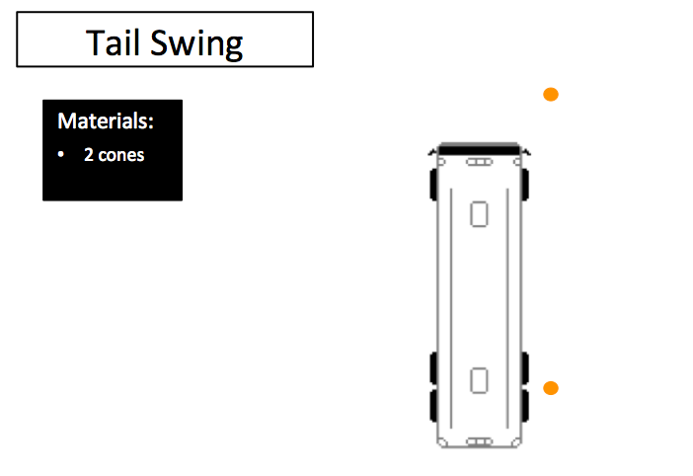

Not shown in the classroom instruction, this demonstration will visually identify tail swing to the student drivers. It should be done first and will help them tremendously as they approach the skill maneuvers and evaluate hazards and how to complete them.

You can visually demonstrate tail swing in two ways – both are done to show how much the tail swings out from a stopped position during a hard turn.

1. Place a cone within 12” of the right side of the coach at the pivot point. Place another cone parallel to the first, but in front of the coach – so it is visible to the driver. Ask the driver to turn the wheel full left and turn until the coach has turned 90 degrees. The cone at the right rear will be struck by the tail swing. The driver will have been able to get a visual reference of the distance of the cone struck from t he side of the coach – both by looking at the cone in the side mirror prior to turning, and also by having the reference cone forward of the front of the coach.

Repeat this step, moving the cones further away at 1’ intervals until the coach is able to make the turn without striking the rear cone. Then, measure the rear overhang of the coach and provide it to the students, along with the most recent distance of the cone from the side of the coach – where the coach made the turn without striking it.

Have each student driver go through this exercise while behind the wheel. When not behind the wheel, all student drivers should be observing this from behind the coach at the right side.

1. The second way to demonstrate tail swing is to simply park the coach with its right side along a painted/marked straight line. With the students standing to the rear of the coach on the right side, have a helper turn the coach full/hard left until the coach has turned 90 degrees. Have the helper park the coach in this position. Measure the distance the rear is over the line - this distance indicates the side clearance necessary to make a hard/full turn without striking an object with the tail swing.

Similar tactics as outlined above can be used to also demonstrate front overhang issues.

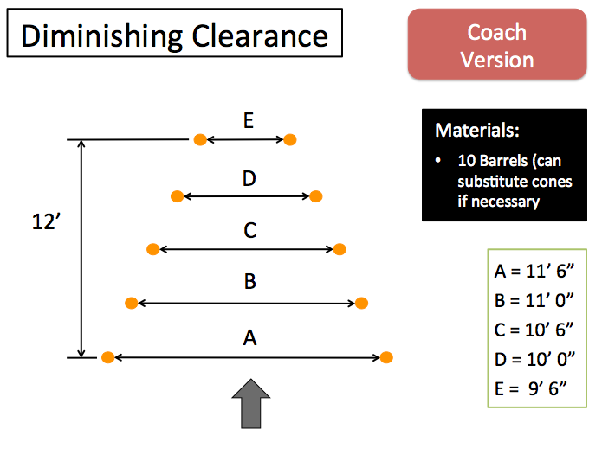

Almost every modern motorcoach is 8’ 6” wide, so the measurements detailed should work accordingly. The clearance will start at approximately 3’ wider than the motorcoach (A), narrowing to only 1’ wider at the exit (E)

As with all the skill problems, you should consider beginning with the barrels farther apart to make the skill maneuver easier, especially for new drivers. Making any skill maneuver too difficult initially can discourage student drivers, while accomplishing one successfully will build their confidence. Also, you should make sure the maneuver is possible by navigating it yourself after you have set it up.

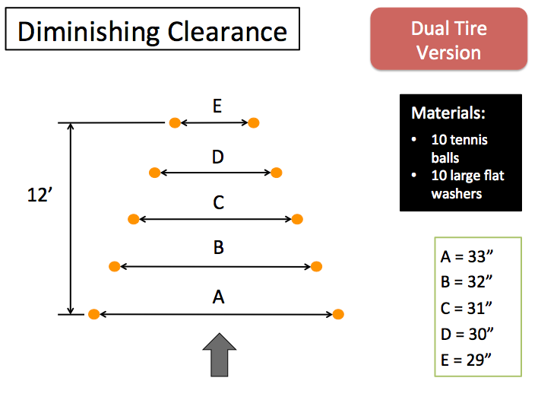

This is a variation that should be considered only after drivers have gained experience on other skill maneuvers. In this variation, the goal is to pass either the left or ride side steer, drive and tag wheels in between the tennis balls that are sitting on the flat washers. The dimensions provided here should provide approximately 2 inches extra beyond the width of the drive wheels.

As with all the skill problems, you should consider beginning with the tennis balls farther apart to make the skill maneuver easier, especially for new drivers. Making any skill maneuver too difficult initially can discourage student drivers, while accomplishing one successfully will build their confidence. Also, you should make sure the maneuver is possible by navigating it yourself after you have set it up.

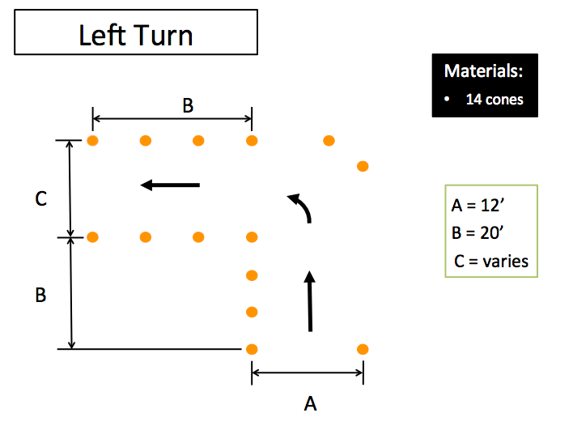

**Variable Measurement:**

**You will have to do some trial and error with the coach(es) you will be using to find the range of dimensions you’ll want to work with for the “turn alleys” (measurement C). This measurement will change depending on the make & model of the coach you are using at the time. For a 45’ motorcoach, a challenging width for the turn alley will range from 39 – 43 feet. Generally, the shorter the wheelbase, the less space needed to make the turn successfully. Other factors, such as steering tag axles and whether the tag axle is raised or lowered will affect turning ability.**

One of the most hazardous maneuvers drivers will continuously face is making left and right turns, so considerable time should be spent making these maneuvers under various dimensions. While the left turn maneuver is pictured, the right turn skill maneuver is set up exactly the same - just opposite so that the turn goes to the right.

When beginning these maneuvers you should consider using another experienced driver to help show and demonstrate concepts to driver students watching from inside the turn. Have the helper driver turn too early (before pivot point reaches pivot cone) to show the off-tracking dangers. And show the variations of partial turns that can be made before the pivot point fully reaches the pivot cone. You might also consider placing some cones to the outside of the entrance lane to show potential tail swing issues.

As student drivers become experienced in the turn maneuver, a variation that can be used to have drivers compete against one another is to tell drivers to pivot as close as possible around the pivot cone with their drive tire, with the closest ones (without striking the cone obviously) the “winners”. To use this, make incremental lines every 3” at a 45-degree angle from the top right corner of the cone, so a visual measurement can be recorded as the drive tire rolls past.

As with all of the skill problems, you should consider beginning with a wider turn alley to make the skill maneuver easier - especially for new drivers. Making any skill maneuver too difficult initially can discourage student drivers, while accomplishing one successfully will build their confidence. Also, you should make sure the maneuver is possible by navigating it yourself after you have set it up.

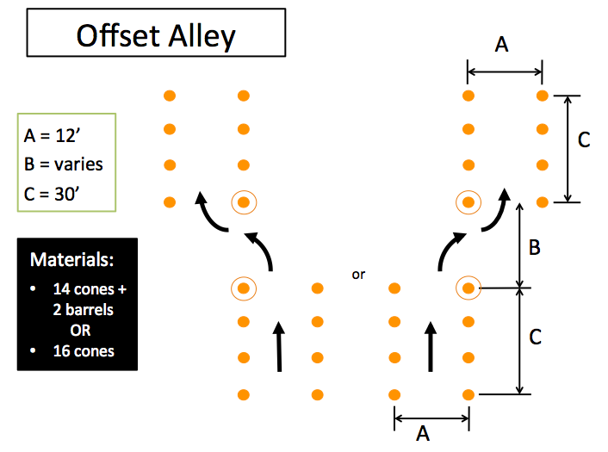

If you have the two (optional) barrels, you will locate them at the circled positions.

**Variable Measurement:**

**You will have to do some trial and error with the coach(es) you will be using to find the range of dimensions you’ll want to work with for the “offset distance” (measurement B). This measurement will change depending on the make & model of the coach you are using at the time. For a 45’ motorcoach, a challenging length for the offset distance will range from 40 – 45 feet. Generally, the shorter the wheelbase, the less space needed to make the offset maneuver between alleys successfully. Other factors, such as steering tag axles and whether the tag axle is raised or lowered will affect the distance necessary to make the offset maneuver.**

This skill maneuver will help student drivers understand motorcoach maneuverability in tight spaces.

As with all the skill problems, you should consider beginning with a longer offset distance to make the skill maneuver easier, especially for new drivers. Making any skill maneuver too difficult initially can discourage student drivers, while accomplishing one successfully will build their confidence. Also, you should make sure the maneuver is possible by navigating it yourself after you have set it up.

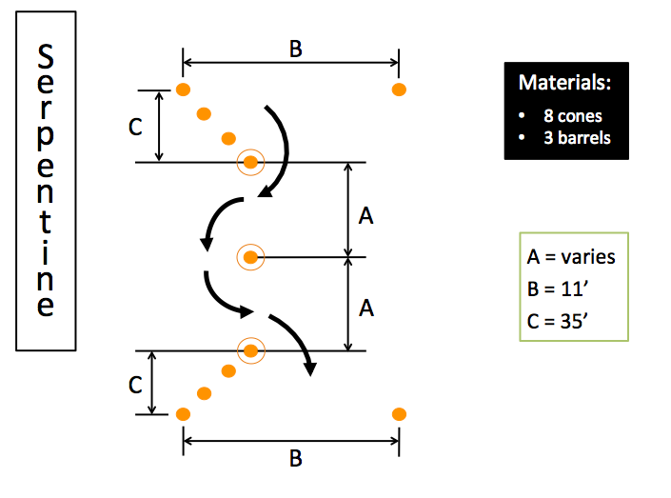

Barrels to be located at the circled positions.

**Variable Measurement:**

**You will have to do some trial and error with the coach(es) you will be using to find the range of dimensions you’ll want to work with for the distance between barrels (measurement A) in the Serpentine. This measurement will change depending on the make & model of the coach you are using at the time. For a 45’ motorcoach, a challenging length for the distance between barrels will range from 38 – 45 feet. Generally, the shorter the wheelbase and turning radius, the less space needed between the barrels to maneuver around them successfully. Other factors, such as steering tag axles and whether the tag axle is raised or lowered will affect the distance necessary to make the offset maneuver.**

The Serpentine will be one of the more challenging maneuvers for student drivers. It will teach them coach maneuverability in tight spaces. Considering that many motorcoach incidents involve striking fixed objects, understanding maneuverability is critical.

You may find yourself in a situation where you have an overly confident student driver that has some motorcoach experience – this skill maneuver, when set up aggressively, may be a good exercise to ground any over-confidence.

As with all the skill problems, you should consider beginning with the barrels farther apart to make the skill maneuver easier, especially for new drivers. Making any skill maneuver too difficult initially can discourage student drivers, while accomplishing one successfully will build their confidence. Also, you should make sure the maneuver is possible by navigating it yourself after you have set it up.

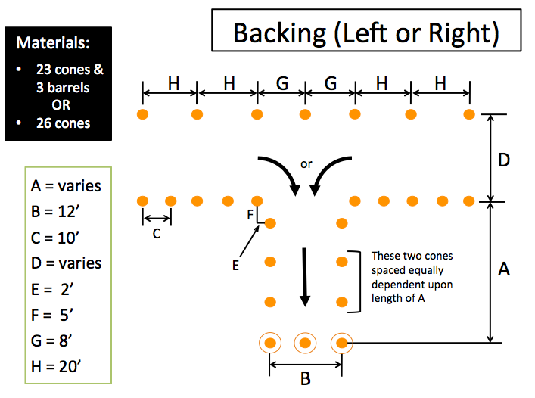

If you have the three (optional) barrels, you will locate them at the circled positions. Alternately, you could use some other straight line barrier at the rear of the backing alley.

**Variable Measurement(s):**

**There are two variables for this skill maneuver. For the depth of the backing stall (measurement A), you will want to use a distance that is five feet shorter than the overall length of the coach you are using (example – A=40’ for a 45’ motorcoach).**

**You will have to do some trial and error with the coach(es) you will be using to find the range of dimensions you’ll want to work with for the width of the approach (measurement D). This measurement will change depending on the make & model of the coach you are using at the time. For a 45’ motorcoach, a challenging approach lane width will range from 38 – 43 feet.**

Backing should be a maneuver of last resort, but drivers must be able to do it capably anyway. If your vehicles are equipped with back up cameras, you will want to cover any monitor visible to the driver so that they demonstrate they can back without the help of camera technology (which could malfunction during a trip).

This skill maneuver will help student drivers judge where the rear of the coach is tracking and learn to use their pivot point in a backward maneuver. Since it’s easier to see, start with drivers backing to the driver side. As they demonstrate ability in confidence in backing to the driver side, switch so that they are backing to the passenger, or “blind” side.

As student drivers become experienced in the backing maneuver, you can add measurements from the back obstacle to the rear bumper as a competition tool – the driver who gets closest (without striking the rear barrier obviously) is the winner. To do this, you’ll simply need a yardstick or similar tool to take the measurement.

As with all the skill problems, you should consider beginning with a wider approach lane to make the skill maneuver easier, especially for new drivers; you also could widen the backing alley to make it easier if desired. Making any skill maneuver too difficult initially can discourage student drivers, while accomplishing one successfully will build their confidence. Also, you should make sure the maneuver is possible by navigating it yourself after you have set it up.

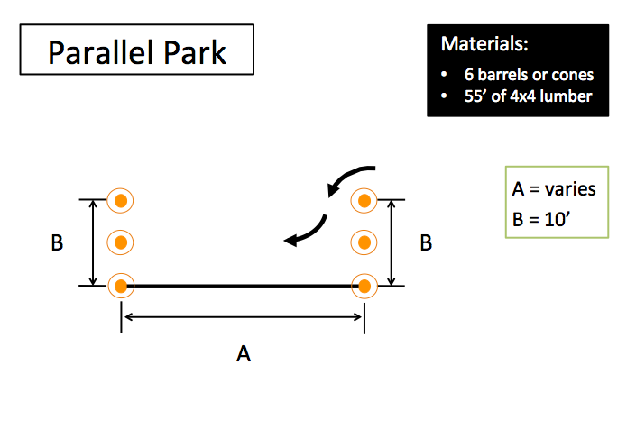

Barrels or cones can be used for the ends of the parallel stall; you can also use any other suitable straight barriers.

Ideally, this skill maneuver would incorporate an existing straight curb for the length of the stall (A). If a curb is not available, 4x4 lumber pieces can be placed end to end to reach a desired length (old railroad ties work well). If nothing similar is available, you can simply use a thick chalk or paint line for the edge of the stall – you’ll want this line to be visible to drivers in their side mirror.

**Variable Measurement:**

**The variable measurement for this skill maneuver is the overall length of the parallel park stall (measurement A), though it’s easy to determine a challenging measurement. Setting the stall at a length that is 10’ greater than the overall length of the motorcoach will make this skill maneuver challenging (example – A = 55’ for a 45’ motorcoach).**

Parallel parking (hopefully) will not be necessary often, but drivers will have to be able to maneuver similarly in other situations as well. Backing of any sort should be a maneuver of last resort. If your vehicles are equipped with back up

cameras, you will want to cover any monitor visible to the driver so that they demonstrate they can back without the help of camera technology (which could malfunction during a trip).

This skill maneuver will help student drivers judge where the rear of the coach is tracking as they back up and swing into a spot; it’s almost like a reverse offset alley. As with the backing skill maneuver, have student drivers start by backing to the driver side since it’s easier to see. As they demonstrate ability in confidence in backing to the driver side, switch so that they are backing to the passenger or “blind” side.

As student drivers become experienced in the parallel park maneuver, you can add measurements from the side (curb) obstacle to a fixed point on the side of the coach (ex., drive tire) as a competition tool – the driver who gets closest to the curb line (without striking any other barrier obviously) is the winner. To do this, you’ll simply need a yardstick or similar tool to take the measurement.

As with all the skill problems, you should consider beginning with a longer parking stall to make the skill maneuver easier, especially for new drivers. Making any skill maneuver too difficult initially can discourage student drivers, while accomplishing one successfully will build their confidence. Also, you should make sure the maneuver is possible by navigating it yourself after you have set it up.

One other concept can be taught using this skill maneuver without any adjustment. Drivers may often find themselves in tight traffic conditions where they may have cars all around them, such as at an airport departure or pickup area. In these situations, they may need to judge if they can maneuver around a car close to the front of them without backing up. Using this skill maneuver, and after they have attempted the parallel park, ask student drivers to pull as far forward along the curb line as they think they can before turning the wheel to exit the stall without hitting the barrels or cones at the front of the stall. This exercise will help them judge and visually see front clearance distances necessary if they find themselves in this situation in real life driving. To make this secondary exercise/maneuver even more difficult, you can introduce tail swing hazards along the side of the coach that could be a conflict with a sharp turn.

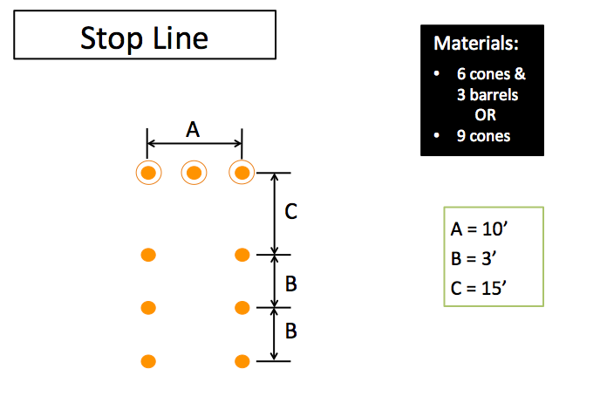

If you have the three (optional) barrels, you will locate them at the circled positions. You could also use any other suitable straight barrier.

This is similar to the diminishing clearance, except that the width of the stop alley is a constant with approximately 1.5’ to spare. Because of the narrowness, student drivers will have to approach this skill maneuver almost straight-on, so keep this in mind when you setup this maneuver.

This exercise will teach side clearance and help student drivers judge the location of the front of the motorcoach when they stop. Instruct drivers to pull into the lane and stop as close as possible to the front cone/barrel barriers. Once entering the cones, they may only stop once – no “creeping”.

You can introduce some competitiveness by measuring from the center barrier/cone/obstacle to the center of the front bumper and ranking student drivers by how close they stop to the front come line without striking any barrier.

You can also use this skill maneuver to practice some very narrow straight-line backing.

**General**

This portion of training will provide an opportunity to evaluate whether a student driver is truly ready and equipped to operate in the real world. It will test their retention of information learned in the classroom and their ability to operate and maneuver safely without the isolation and safety of the closed course environment. This real-life, on-road training component is perhaps the most critical to successfully preparing a motorcoach driver for safe operations. The importance of your knowledge of likely hazards, operational areas, and your thinking, planning, and dedication to this step cannot be overstated.

This portion of the training will require significant planning by you, the instructor. You will need to evaluate where and when over-the-road training will occur, with the goal being to expose the student drivers (in a progressive way) to as many of the situations and environments that they will find themselves operating in as possible.

Depending on your class size, the student drivers may have to be divided into groups – you’ll want to minimize the number of students training on one bus so that engagement and learning is maximized (a group of no more than four is suggested).

Before hitting the road, you might consider a quick review of the “Safe Driving Principles” module with students if you feel that a review of driving principles and operational hazards would be beneficial.

To keep all student drivers engaged, you should limit student driving time behind the wheel before switching to the next student - 30 minutes is a good interval to consider. Students not driving should be seated up front in aisle seat so they can see out the front of the motorcoach. They should watch the road environment just as if they were driving and pay close attention to what the driver is saying while "talking it through." They should be asking themselves whether they saw hazards mentioned and listen closely to your feedback. They should remain quiet, but can offer hazards they saw that were not reported during post-drive discussions. Each student should receive as much behind-the-wheel practice as necessary – some students are likely to require more before you feel satisfied with their proficiency.

Finally, completing driving evaluations of student drivers at various intervals throughout the on-road training will be helpful in identifying areas where students need to improve and reach proficiency. These evaluations can also help instructors by allowing you to focus on-road training in areas of necessity as student drivers’ progress.

**How**

When driving have the students use the "commentary driving" technique they learned in the classroom – especially at the beginning of the on-road exercises. You’ll want to have them do this throughout the training, but it is not necessary to do every time they are behind the wheel. As the on-road training progresses, navigation instructions will likely become more complex in urban areas and having them trying to provide commentary during your instructions may be confusing or difficult. However, starting with significant focus on commentary driving is recommended so that you can assess student hazard scanning and perception.

The primary factors to be evaluated include:

* Distance scanning and early detection of potential hazards.
* Normal frequency of mirror usage and mirror usage associated with specific maneuvers such as turning.
* Roadside scanning to detect signs, signals, and any pedestrians/animals that may encroach on the motorcoach's path.
* Search of the turn path and detection of all vehicles, pedestrians, or animals that could potentially obstruct that turn path.

Within a driving session, you should avoid talking to the student driver, unless necessary for safety reasons (other than giving brief navigation instructions). Issue route directions well ahead of the time they need to be acted upon.

If you feel that cor­rective feedback needs to be provided to the student before the driving session is over, direct the student into a safe location and have him/her stop the coach. At the end of each driving session, the instructor, the driver, and the student observers should spend a few minutes discussing the pre­vious dri­ver's search patterns and driving performance.

Although the focus of commentary driving is the detection and recognition of hazards, any driving-related topic can discussed during these feedback sessions (for example, setup for turns). Be sure to recognize and compliment good practices as well as areas of concern. If you are uncertain of performance relative to a specific hazard, ask questions to determine whether the student driver failed to see a potential hazard or failed to respond to a perceived potential hazard. Be sure to include other student drivers on-board in these discussions, so that they can learn not only from their own time behind the wheel, but also from the experiences and coaching of the other student drivers as well.

**When**

During on-road practice, the protective environment of off-road/skill course maneuvering changes to the dynamic environment that student drivers will actually be operating in during their career. You need to consider their experience level, anxiousness and potential nervousness when beginning on-road practice. You’ll want to ease them into the real world of driving by starting this portion of the training at certain times and in certain environments.

Start behind the wheel training during the day in controlled environments with low to moderate traffic – these will present the least amount of hazards to deal with initially. An example is a controlled-access interstate, where hazards are limited to vehicles sharing the road or hazards/objects on the shoulder. Rural highways with limited intersections and intersecting businesses/driveways are another example of starting off slow and simple. As the student drivers gain confidence and get more comfortable operating in the real world, you can introduce different and more challenging environments.

Ultimately, you’ll want the student drivers to have driving experience at various times of the day, including rush hours. You also should ensure that driving at night and, to the extent possible, in inclement weather, is included in the on-road training. Student drivers need experience operating in these environments; evaluation of their performance and feedback for operating in these environments is critical to their development. It’s relatively easy to drive mid-afternoon on an interstate highway, but driving in a busy urban environment at night and in the rain will really help you understand how prepared any student driver is to face reality on their own.

**Where**

A lot of thought and planning needs to go into where to travel at various stages of the on-road training. The students should experience a variety of environments – most of them multiple times if they are common environments in which they will eventually be operating alone. You’ll also want to progressively and repeatedly expose them to known operational hazards so they become used to driving in those situations and you can be satisfied they are able to recognize, evaluate, and process the hazards appropriately.

An excellent method to determine operating environments and locations is to review trip/charter orders for last few months – note common locations traveled to/served, such as schools, convention centers and convention hotels, airports, prominent hotels, and popular attractions, such as sports and amusement parks. You’ll want to incorporate these locations into your on-road training travels so drivers become familiar with them and any nuances can be explained and learned. Also, incorporate simulated stops so that drivers have to pull up to curbs and/or determine where the best place to stop the coach is for loading unloading at various locations and rest stops, including a simulated accessible stop and loading scenario.

Think about areas where incidents have happened or difficulties are often encountered by you or the company – it could a complicated intersection, unusual merge or exit ramp, unusual traffic pattern, or especially difficult maneuver areas - you’ll want to incorporate these into the on-road training routes also.

Consider roadway terrain also, including hills and sharp turns. Exposing student drivers to mountain driving and ensuring proper gear selection and retarder use is critical if they can expect to encounter these environments.

Review the Safe Driving Principles module and make sure you incorporate these principles and operational hazards into the routes you plan. Lane changes, merging & exiting, and alot of various types of turns (single and multiple turn lanes; tight turns, etc.) should be staples that a student driver must negotiate every day they are behind the wheel. Look for opportunities to include low clearance hazards, railroad crossings, roadways and turns from roadways that have bike lanes, etc.

As the students progress you should consider challenging their decision-making and alertness through routing. Ask them to travel a route that has a turn that is too tight, or not possible at all, to see if they plan to attempt it (make sure this is not in a very busy area and there is an alternate other than backing up to circumvent the turn, such as simply going to the next block). If, upon approach, they seem to plan to actually attempt the turn, stop them and counsel them on how they should have handled the situation. You may also want to route them on an illegal route (restricted bridge or roadway) to see if they notice the signage and attempt to adjust appropriately, or if they continue to blindly follow the designated route. Again, make sure there acceptable alternate paths in the area where they should be recognizing that they cannot travel the designated route. Consider a route where there is insufficient clearance to see if they pick up on the hazard (obviously stop them well before reaching the hazard if they do not).

Toward the end of training, provide the student drivers with various itineraries and ask them to determine the routing (even if your company routinely provides drivers with route directions). Review and discuss proposed routes, then have them operate the run, switching off at various stops. You might also consider enlisting a senior driver or other helper to run a second motorcoach and simulate a multi-coach move with one of the itineraries.