**Enforcement & Police Interactions**

|  |  |  |
| --- | --- | --- |
| Man replacing tire image | Screen Shot 2015-02-26 at 10.57.29 AM.png | Safety Measurement System |

**Purpose:**

The purpose of this training module is to provide you with some information and background on interactions you can expect with enforcement officials. You will learn why inspections occur, the different types, basic procedures, and even interaction with non-enforcement responders.

**Module Overview:**

The training module contains three classroom lessons. The first lesson discusses why inspections occur and what inspectors are evaluating in the process. The second lesson details inspection points for various levels of inspections and the general step-by-step procedures used during the inspection process. The third lesson reviews engagement with non-enforcement personnel, specifically following collisions and incidents.

The lessons are:

Lesson 1: Inspections: Substance

Lesson 2: Inspections: Process

Lesson 3: Collisions & Incidents

LESSON 1

INSPECTIONS: SUBSTANCE

**Lesson Objectives:**

By the completion of this lesson, you will have a good understanding of the enforcement agencies who are responsible for safety regulation compliance and the general areas they will review during various inspections.

**Instructional Methods**: Classroom

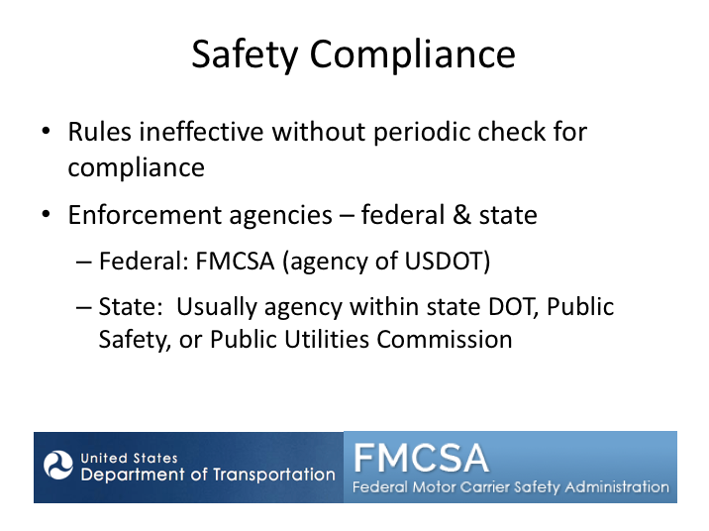

**SAFETY COMPLIANCE**

Federal and/or state commercial carrier safety regulations have been developed to ensure certain standards are met with regard to operation of commercial vehicles on public roadways. Of course, having rules without anyone checking that they are being followed would likely result in a wide range of states of compliance from those who the rules apply to. To prevent this, state and federal enforcement personnel routinely check companies, drivers, and vehicles for compliance with safety regulations.

These enforcement personnel go to work every day to find unsafe companies, drivers and vehicles. The majority of commercial vehicle enforcement efforts go toward truck operations – simply because the truck population greatly outnumbers the number of motorcoaches on the road. However, this doesn’t mean that passenger transportation operations get off easy. The nature of passenger operations and potential for catastrophic crashes demands enforcement attention. In fact, the FMCSA has a special division dedicated to passenger carriers and some states also have teams of inspection personnel dedicated to passenger transportation operations. Depending on the state, enforcement personnel may be a part of the State’s Department of Transportation, Department of Public Safety, or Public Utilities Commission.

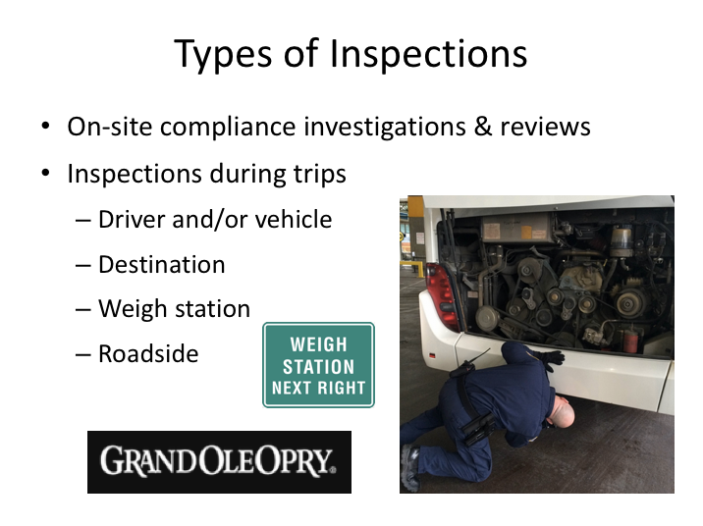

**TYPES OF INSPECTIONS**

Commercial vehicle passenger operations are generally inspected in one of two ways – on-site at companies or during on-the-road operations. During on-site compliance investigations and reviews, enforcement personnel visit a company in person and review records maintained to verify compliance. This type of inspection process occurs at differing intervals based on a variety of factors. More often, compliance with certain driver and vehicle-based regulations is investigated during an actual trip. As a motorcoach driver, you can expect to undergo inspections of this type.

During an over-the-road inspection, enforcement personnel may check the driver, the vehicle, or both for compliance with safety regulations. For passenger transportation operations, these inspections will typically occur at a destination point, or at curbside for line-haul operations with curbside only passenger service.

Fixing America’s Surface Transportation (FAST) Act of 2015 removed authority to perform any inspections at weigh stations with passengers on board. However, at other locations, and at weigh stations when there are no passengers on board, the inspector may do any inspection, including a level I or II inspection.

**TYPES OF INSPECTIONS (continued)**

Personnel may stop a motorcoach with passengers at any time and location if a driver is observed violating driving laws or if they observe a serious defect with the vehicle that is likely to cause a crash.

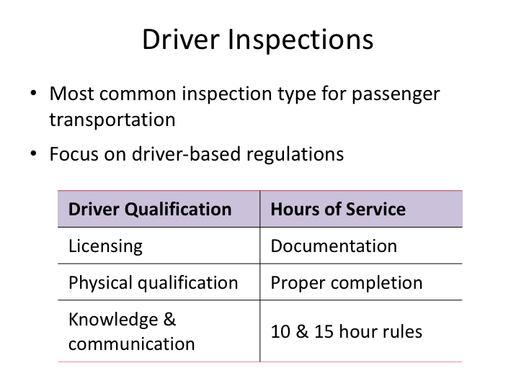

**DRIVER INSPECTIONS**

Between the three types of inspections (driver, vehicle, or a combination), motorcoach drivers historically are most frequently subject to a driver-only inspection. (The types of inspections are defined later in this module.) These inspections can be done relatively quickly, with minimal interruption to trip schedules. During this inspection, the enforcement officer will review compliance with driver-based regulations such as proper licensing for the vehicle being operated, medical certification status, hours of service compliance, and the driver’s understanding of the regulations.

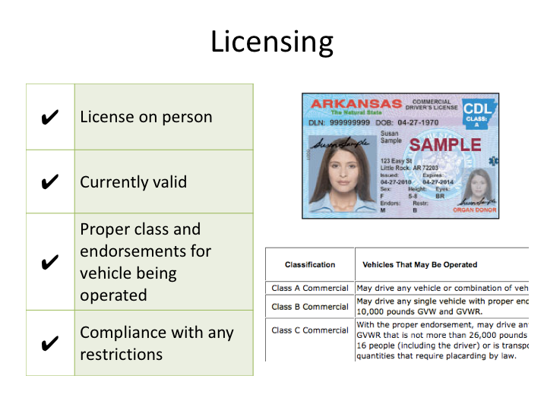

**LICENSING**

More specific to the license check, the enforcement official will be looking for the following:

* Presence of a state-issued commercial driver license.
* That the license is the proper class of commercial driver license for the vehicle being operated. They will also be looking to ensure that the passenger endorsement is present when necessary.
* That the license is currently valid, and not suspended or revoked - regardless of the expiration date listed on the license itself.
* That the driver is meeting any restrictions listed on the license such as wearing eyeglasses and that there is no airbrake restriction (assuming of course the vehicle being operated has airbrakes).

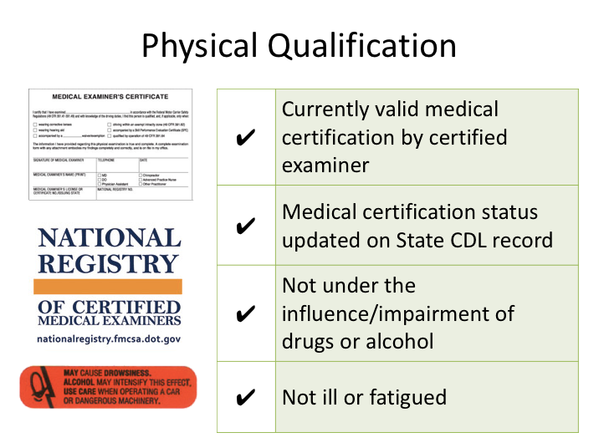

**PHYSICAL QUALIFICATION**

Specific to physical qualification, inspectors will ensure that a driver has a currently valid medical certification and is not operating outside of any restrictions, such as intrastate only certification. The medical certification must have been performed by a medical professional registered on the National Registry of Certified Medical Examiners (NRCME). The enforcement official will be checking the driver’s motor vehicle record through the state that issued the CDL. If the medical certification is not listed on the driver's motor vehicle record, the officer may assume there is not a valid medical certification.

The officer will also verify that the driver is not noticeably impaired, ill or fatigued, or under the influence of controlled substances or alcohol.

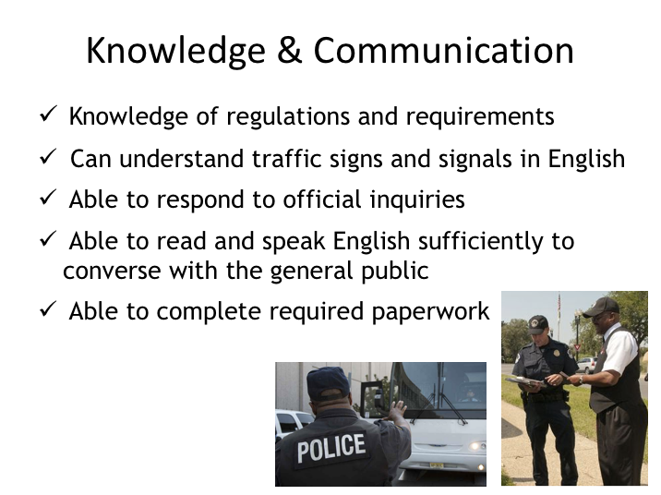

**KNOWLEDGE & COMMUNICATION**

Enforcement officers will usually test driver knowledge and communication ability in the normal course of interaction during an inspection.

To assess regulatory knowledge, an inspector may quiz a driver on topics such as vehicle inspection processes and hours of service limitations. They will verify a driver’s ability to respond to inquiries in the forms of questions during the driver interview as well as directions given during any vehicle inspection process. During the interview process, they will examine paperwork to assess the driver’s ability to complete it as required and, as a result of the entire interaction, will determine a driver’s ability to read and speak English sufficiently and converse with the general public.

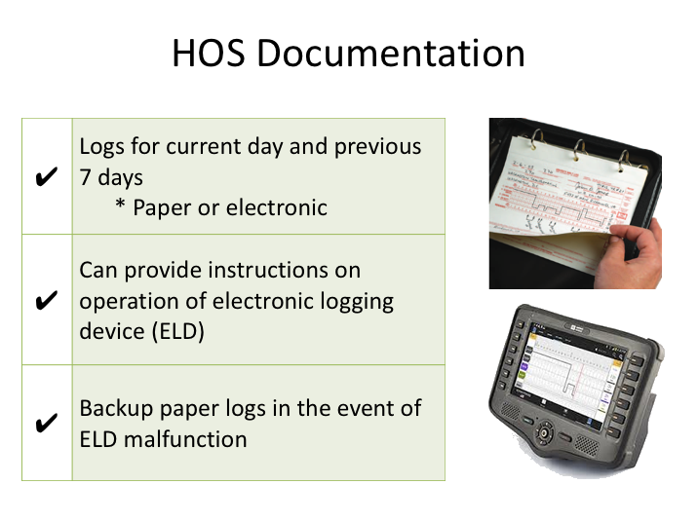

**HOS DOCUMENTATION**

When it comes to hours of service documentation, the enforcement officer will check to see that driver logs are present as required. When required, they will be checking for the presence of the current day’s log, as well as the previous seven days. If a driver claims that he or she is operating locally within the air-mile radius exemption and are excepted from completing driver logs, the officer will verify the distance of the location from the location of dispatch.

If a carrier and driver is using an electronic logging device (ELD), the enforcement officer may ask to review the current and previous days’ logs on the device or may ask a driver to initiate transfer of an eRODS file. A user’s manual describing how to operate the ELD including step- by-step instructions for a driver to produce and transfer the ELD records to an authorized safety official and Summary description of ELD malfunctions must be available on board the CMV and provided to the safety official.

Also, for those utilizing electronic logs, back up paper logs must be readily available if there is a malfunction with the ELD.

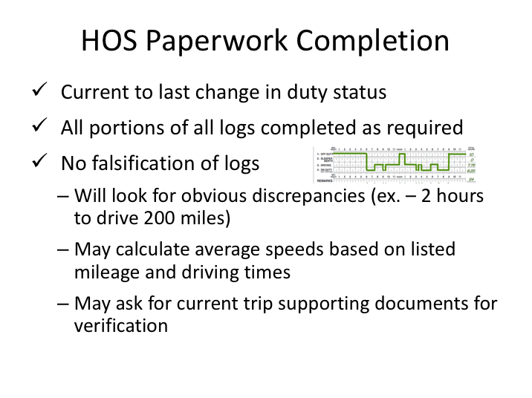

**HOS PAPERWORK COMPLETION**

When reviewing paper logs, enforcement officials will check to see that the log is current to the last change in duty status. They will review current and previous logs for proper completion, checking to be sure that all required areas of the logs are completed. And finally, they will look for evidence of falsification during their log paperwork review. This review may include obvious errors, such as too short a time listed for the distance of a known city pair, calculating average speeds from information contained on driver logs, and verifying log information with supporting documents available from the current trip.

Note: 395.11(g) requires the driver to provide any supporting documentation in their possession during a roadside inspection when requested by the safety official.

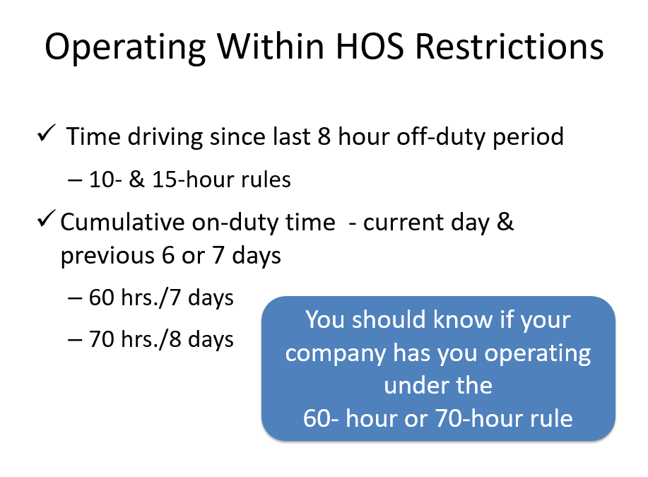

**OPERATING WITHIN HOS RESTRICTIONS**

Enforcement personnel will of course be reviewing driver logs to ensure that the driver and carrier is operating within the hours of service limitations. They’ll be looking for compliance with both the 10-hour and 15-hour rules, as well as compliance with the cumulative on-duty rules over the past seven or eight days (including the current day). Companies may have drivers that operate differently. Therefore, a driver should know whether they are operating under the 60 hour or 70 hour rule limitation – this is almost certain to be asked during the driver interview process of an inspection.

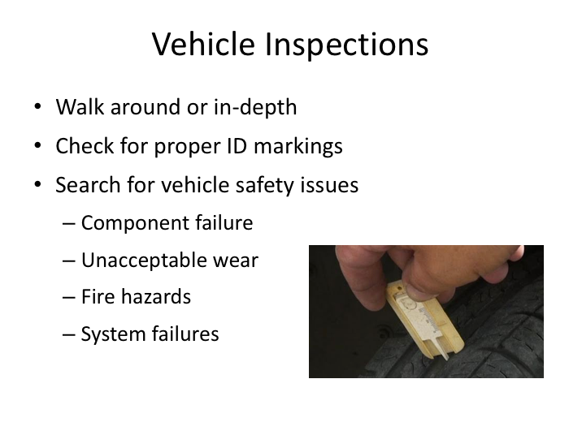

**VEHICLE INSPECTIONS**

Vehicle inspections, when part of an enforcement inspection, can vary in length depending upon whether it is a walk around or more thorough vehicle inspection. Enforcement officers may ask for driver assistance when checking certain components during a vehicle inspection, such as signal and light operation, windshield wiper operation, and brake applications. The vehicle inspection procedure is designed to identify vehicle safety concerns such as component failures, unacceptable wear, fire hazards and system failures. Examples include a broken suspension spring, tire tread depth issues, chafed or unsecured wiring, and airbrake or ABS system failures. And, while inspecting the vehicle enforcement officials will be checking to ensure that the vehicle is properly marked with all required identification information.

LESSON 2

INSPECTIONS: PROCESS

**Lesson Objectives:**

By the completion of this lesson, you will have a good understanding of the types of inspections you may be subject to as well as the compliance areas reviewed during these inspections. You’ll know what the expectations (and requirements) are with regard to participation in the inspection process.

You’ll learn what to do following an inspection and also understand some of the potential consequences of performing poorly during inspections and not following safety regulations.

**Instructional Methods**: Classroom

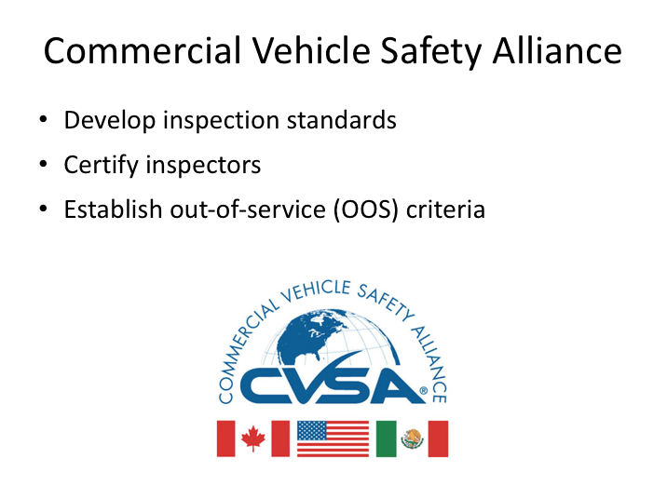

**COMMERCIAL VEHICLE SAFETY ALLIANCE**

As a motorcoach driver, you can expect to undergo compliance inspections on occasion, so it’s therefore important for you to understand the process and also information on making them go as smooth as possible. But before we get to the process, let’s go over some background information on protocols.

The vast majority of commercial vehicle inspections in North America occur under the guidance of the Commercial Vehicle Safety Alliance (CVSA). CVSA was established in the 1980s and today is comprised of local, state, provincial, territorial and federal motor carrier safety officials and industry representatives from the United States, Canada, and Mexico.

The alliance is guided by several principles, the foremost of which is to ensure uniform and reciprocal application of North American inspection procedures and out-of-service criteria. CVSA establishes the out-of-service criteria – these are regulatory and safety violations deemed so serious that a vehicle, driver, or both, are prohibited from further operation until a remedy is affected.

Inspections done under CVSA’s program must be conducted by certified inspectors that have successfully completed a training program approved by the Alliance and met in-service inspection requirements.

Table showing the eight different levels of CVSA inspection levels.
A full explanation of this slide can be found directly below this image.

**CVSA INSPECTION LEVELS**

There are currently seven “levels” of inspections, denoted by numbers – officially by roman numerals. Each inspection level represents a different type of inspection. Levels I through III and Level V inspections are fairly standard and typical inspections that are completed on a daily basis throughout North America.

Level IV inspections are inspections that fall outside of the regular inspections, and are usually in support of a certain target or information gathering. For example, each year, Operation Airbrake is conducted – a several day blitz across North America targeting air brake inspections. During these inspections, typical inspection procedures may be altered to shorten inspections and maximize the amount of vehicles inspected.

Level VII inspections are somewhat similar to Level IV inspections. These are jurisdictionally-mandated inspections that do not meet the requirements of any other level of inspection and there is more flexibility in inspection personnel.

**CVSA INSPECTION LEVELS (continued)**

Level VIII inspections are the newest type of inspection – a completely electronic inspection. The North American Standard Electronic Inspection is an inspection conducted electronically or wirelessly while a vehicle is in motion without direct interaction with an enforcement officer. These inspections are still in development and are not yet common.

Level VI inspections pertain to radioactive hazardous material commodities that are not legal on motorcoaches, and thus you will hopefully never encounter on a motorcoach – transuranic waste (e.g., wastes having atomic numbers higher than uranium) and radioactive material!

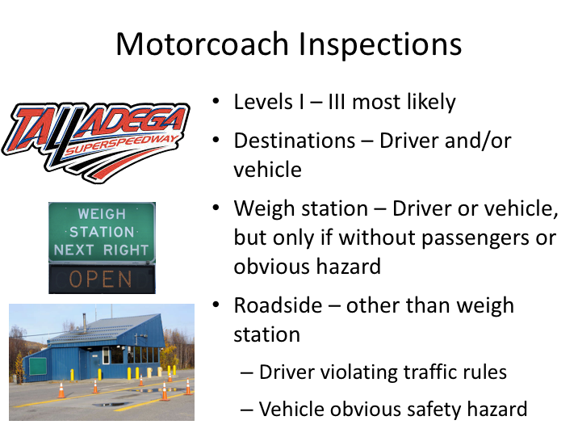

**MOTORCOACH INSPECTIONS**

As a driver on a dispatched trip, the types of inspections you are most likely to experience are a Level I, II or III inspection. Before we review these types of inspections in a little more detail, let’s look at when, and where, you might reasonably expect to be inspected.

Probably the most common situation when you will experience an inspection is upon arrival at a destination, such as an amusement park or sporting event. Another possibility is curbside, for companies that provide line run services with only curbside stops. Inspections at these locations can include driver and/or vehicle inspections. Because these types of locations and layovers typically do not have passengers present at the time of inspection, they tend to include vehicle inspections more often (either a Level I or II).

Increasingly, states are requiring motorcoaches and passenger vehicles to stop at roadside weigh stations. Inspections may only be conducted at a roadside facility, such as a weigh station, if there are no passengers on the

motorcoach or an imminent safety concern is observed.

**MOTORCOACH INSPECTIONS (continued)**

Other similar potential inspection locations are a highway rest area, terminal, border crossing maintenance facility, passenger pickup locations (curbside, shopping centers, etc.).

Roadside (other than weigh station) – An inspection may be conducted en-route when an imminent or obvious safety hazard is observed. An example of imminent or obvious safety hazard would be a vehicle emitting excessive smoke from the engine compartment, smoke from any other part of the vehicle, and any condition that would indicate a potential or present danger from fire. Also, any observed violation which would cause a CMV transporting passengers to be placed out-of-service under the North American Standard OOS Criteria will subject the vehicle to an en-route inspection. Other than an imminent or obvious safety hazard, the only reason you would generally be pulled over while traveling along the roadway is if you were violating a traffic rule.

There is always the possibility a violation could result in the driver or vehicle being placed out-of-service. In such a case, you need to know the company policies for notifying them of the situation, so decisions can be made on how to proceed.

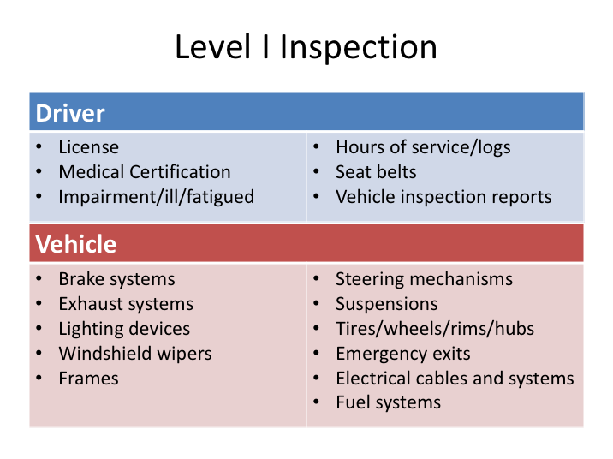

**LEVEL I INSPECTION**

A Level I inspection is the granddaddy of them all - the most thorough, and the most time consuming. We discussed in varying detail what enforcement inspectors will be looking at during driver and vehicle inspections; a Level I inspection is a combination of the two.

From the driver aspect, the inspection will include an examination of your driver license; medical examiner’s certification status; alcohol and drugs; driver’s records of duty status as require/hours of service; and seat belt.

On the vehicle side, they will inspect vehicle inspection report (as applicable); brake systems; exhaust systems; frames; fuel systems; lighting devices (headlamps, tail lamps, stop lamps, turn signals); steering mechanisms; suspensions; tires; wheels, rims and hubs; windshield wipers; emergency exits; electrical cables and systems in engine and battery compartments, and maybe even securement of cargo in luggage bays (as required).

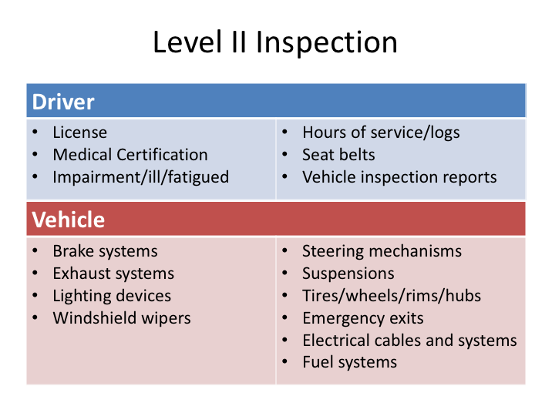

**LEVEL II INSPECTION**

A Level II inspection is similar to a Level I inspection. The largest difference is in the vehicle inspection portion– for a Level II, this will include only those components or portions of systems that can be inspected without physically getting under the vehicle. There is no change in the driver inspection portion from a Level I.

- License
- Medical Certification Status
- Impairment/ill/fatigued
- Hours of Service
- Seat Belt
- Vehicle Inspection Reports (as applicable)

**LEVEL III INSPECTION**

A Level III inspection is focused solely on driver credentials and is the quickest inspection type. It will focus on driver-only concerns as illustrated here.

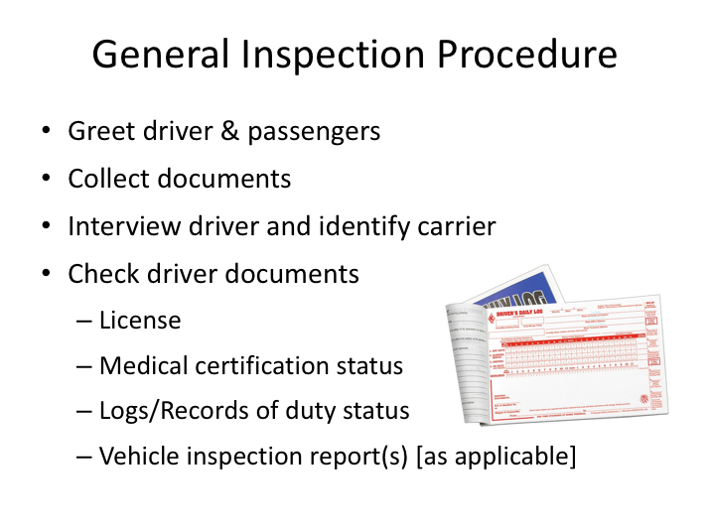

**GENERAL INSPECTION PROCEDURE**

Thanks to training provided to inspectors and the uniform standards established by CVSA, you can expect similar procedures regardless of where you are selected for inspection. Obviously, the procedures will vary depending upon the inspection level and how many enforcement personnel are conducting the inspection. For driver only inspections, there may only be one enforcement official; for inspections that include a check of the vehicle there may be multiple inspectors working as a team.

The inspector will usually start by greeting you and any passengers on-board. He or she may ask strictly for driver-related documents or may also want to see company and vehicle related documents. Many coach companies keep insurance and other registration documents on the coach in a specific location - you should know where this is kept on your coach and should even verify its presence during your pre-trip inspection.

The inspector will interview you about your trip and the company you work for. As indicated earlier, during this interview he or she will be probing your knowledge of the regulations and also assessing your ability to communicate sufficiently and complete paperwork as required.

**GENERAL INSPECTION PROCEDURE (continued)**

Following the interview, the inspector will review the documentation collected, including your license and logs. He or she will verify your medical certification status and may ask to see vehicle inspection reports if you are on a multi-day trip and therefore would be expected to have them on the vehicle.

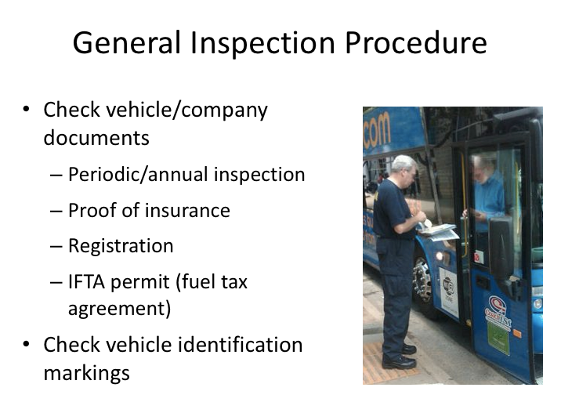

**GENERAL INSPECTION PROCEDURE (continued)**

If the inspector has collected vehicle and company documents, they will review these to ensure that certain items are present. They will look to ensure that the vehicle has undergone a periodic inspection as required by the DOT, that it is properly registered, there is proof of insurance, and that is properly permitted for fuel tax purposes. They may also verify that the proper identification markings are on the outside of the vehicle according to the documents reviewed and the answers you’ve provided.

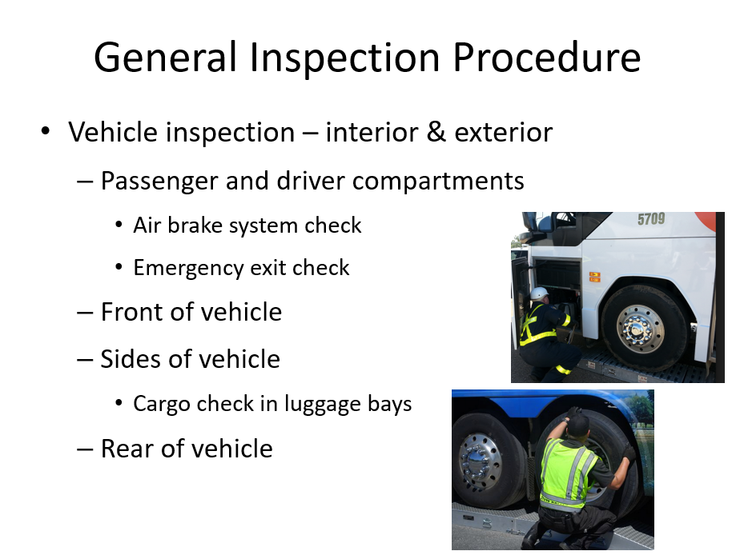

**GENERAL INSPECTION PROCEDURE (continued)**

If it is a Level I or II inspection, the inspector(s) will then check the vehicle. Usually they will begin the interior inspection with the driver compartment including a check of the air brake system to ensure that all features are working properly such as ABS and low air warnings. They will continue the interior inspection with the passenger area verifying emergency egress availability, functionality and labeling. An inspector will ask the driver to open each side emergency window exit and roof exits. Exits are required to open and close as designed. Ensure students know how to operate the emergency window and roof exits in the type coach they are operating as they may be equipped with different releases. Failure to open or close an exit may result in an out-of-service violation.

This will be followed by an inspection of the front of the motor coach, then the sides and rear of the vehicle including the engine compartment. During this process, they will be checking all visible components including lighting, tires and wheels, windshield wipers, etc. It’s also possible that they may check in the luggage space for proper securement of any necessary materials and ensure that no prohibited cargo is being stored. The engine compartment will be checked for fluid leaks, belt condition and frame integrity.

SAFETY NOTE: Never start the engine of a motorcoach during an inspection with the engine door open and the location of all inspectors is unknown. Motorcoach inspections are generally conducted in teams with one completing the interior inspection and the others conducting the exterior inspection including the engine compartment. Inspectors receive safety training in this area however, the driver should always be attentive to the dangers possible while the engine door is open.

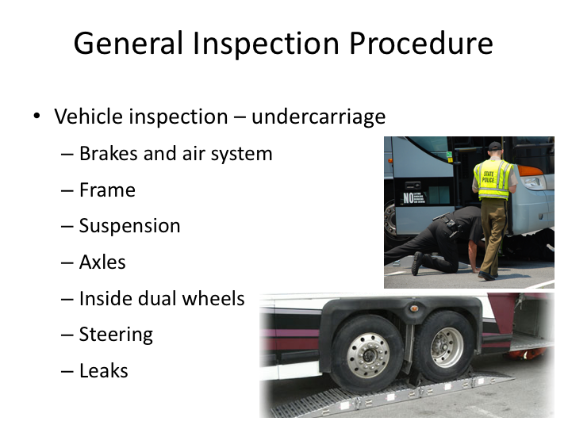

**GENERAL INSPECTION PROCEDURE (continued)**

During a Level I inspection, an undercarriage inspection will follow the exterior inspection. In almost all cases, this will require maneuvering the coach onto wheel ramps so that the inspectors can more easily maneuver around underneath the vehicle – without them, Level I inspection just aren’t feasible outside of a maintenance facility with lifts or service pits. While inspecting the undercarriage, they will look for issues with various components such as suspension, steering, airbrake system, and also inspect the axles and frame.

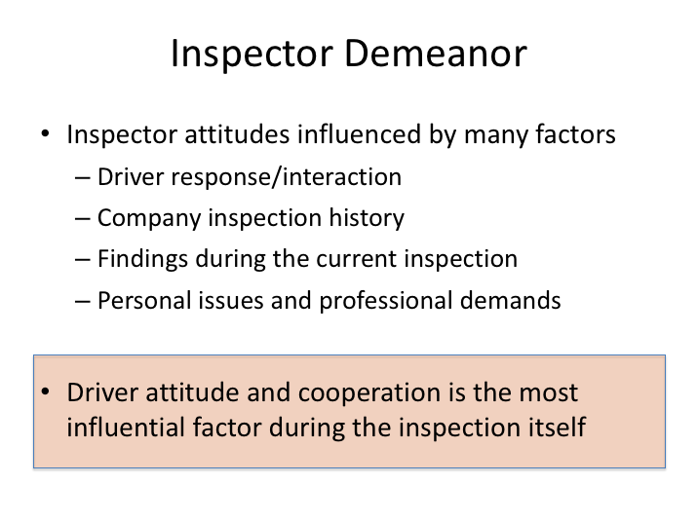

**INSPECTOR DEMEANOR**

There’s no doubt you will come across a variety of demeanors when it comes to the inspectors themselves. Just like with passengers and tour leaders, some will be easier to get along with than others. Some inspectors will be friendlier, while others may project the image of total business. One thing is for certain however – your response to, and interaction with, any inspector will dictate the tone of the continued interaction.

When you are approached by a commercial vehicle enforcement officer, remember to conduct yourself in a courteous and professional manner. An agreeable and cooperative demeanor tells the officer that you have nothing to hide and they may then choose to perform only a cursory inspection or even decide to defer your inspection for another, “more deserving” candidate. Remember that enforcement officers have a lot of historical inspection data at their fingertips with regard to carriers. In fact, past performance of the company you drive for can also positively or negatively influence the demeanor of the inspector from the get-go. But, no matter what, if a driver is uncooperative, appears nervous, unknowledgeable or evasive, the inspectors will dig in and the intensity will rise. The fact is that most inspectors are true professionals that understand and respect the job that professional drivers do more than most.

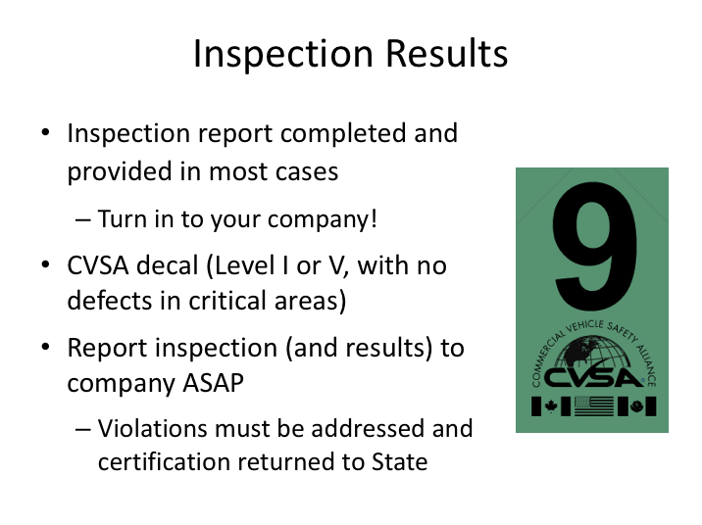

**INSPECTION RESULTS**

In most cases, the driver will be presented with official inspection results via an inspection report. However, some cursory driver-only inspections may not be recorded on an inspection report. If you receive an inspection report that includes violations, you will be instructed by the officer to have a company official sign and return a copy to their state office. Violations that are not deemed safety critical must be remedied and the company must verify these have been addressed within 15 days of the report, so it’s critical you get the report to your company.

If the vehicle has been thoroughly inspected during a Level I inspection and there were no defects found in critical safety areas, the officer should issue a CVSA decal, which he/she will place on the vehicle. This decal denotes that the vehicle has successfully passed a CVSA-level inspection. After receiving a CVSA decal, a vehicle is unlikely to be inspected by another enforcement official for at least the next 90 days. CVSA decals vary in color to identify the quarter in which they were issued and universally-recognized modifications to the decal signify the month during the quarter that the inspection occurred.

In all cases, you will also want to notify your company of any inspection and the results as soon as possible following the inspection.

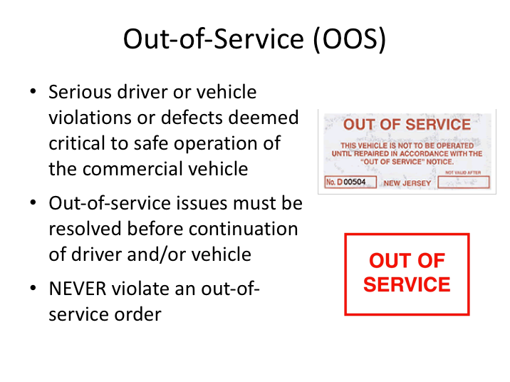

**OUT-OF-SERVICE (OOS)**

All defects and violations will be written up on an inspection report. The majority of possible defects or regulatory violations do not call for immediate enforcement activity. However, serious driver or vehicle defects discovered that are deemed critical to safe operation of the commercial vehicle will result in immediate enforcement action and probable “out-of-service” status. If any on-the-spot enforcement action is necessary, the inspectors will take it and notify you of any options.

If you are placed out-of-service due to regulatory violations, the inspector will let you know what must be done before you can re-enter service. In most cases, this will be the result of an hours of service violation and the remedy is generally a consecutive eight hour off-duty period to restart your 10- and 15-hour rule.

If the vehicle is placed out-of-service, the defect(s) responsible for the out-of-service status must be fixed before the vehicle can continue. **Never violate an out-of-service order**. Violation of out-of-service orders can result in disqualification of your commercial driver license, as well as substantial fines to you and your company.

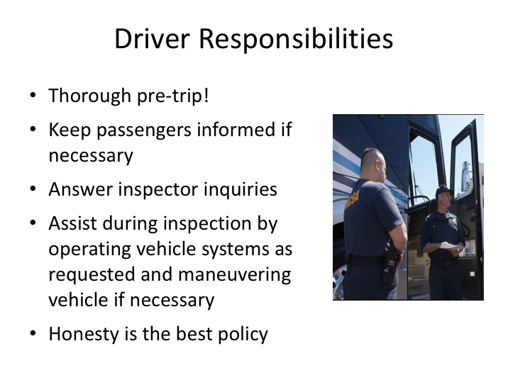

**DRIVER RESPONSIBILITIES**

As it pertains to the inspection process, your responsibilities as a driver will vary depending upon the inspection level. First and foremost, properly conducting one of your other job responsibilities – a thorough pre-trip inspection of the vehicle – will go a long way in limiting potential issues during an inspection. Identifying and addressing visible vehicle defects, verifying repair of previous driver vehicle inspection report write-ups, and ensuring that you have all necessary paperwork before you leave on a trip helps limit issues during an enforcement inspection.

In the event that you have passengers on board, and the enforcement officials have not addressed the passengers, you should inform the passengers with regard to what is taking place. Generally, letting them know that you and/or the vehicle has been selected for a random safety inspection is a good way to communicate what will occur.

You should answer any of the inspector’s questions as they interview you and provide them with requested documents if available. During the inspection process itself, the enforcement officials will ask for your assistance in operating certain vehicle systems as they inspect them, and may ask you to maneuver the vehicle on and off of inspection ramps. You should comply with these requests.

**DRIVER RESPONSIBILITIES (continued)**

Finally, you should know that commercial vehicle safety inspectors conduct these safety inspections daily. They often are able to tell if a driver is not being truthful and have experience in uncovering dishonesty. You will gain respect by being truthful and invite increased scrutiny for being dishonest or pretending to know something you don’t.

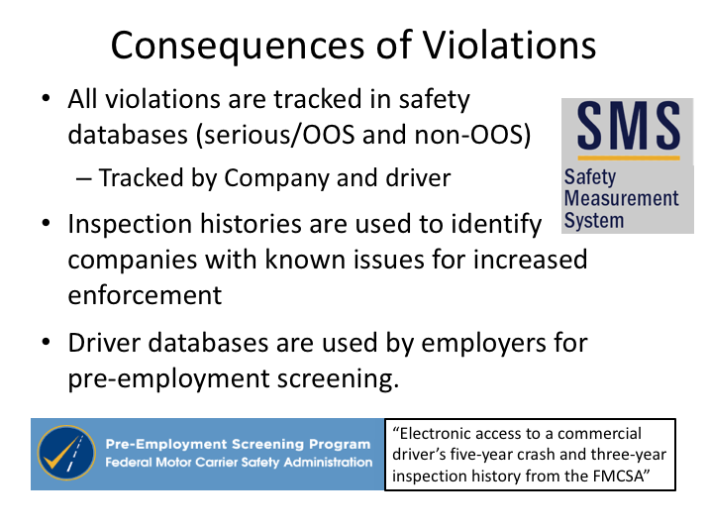

**CONSEQUENCES OF VIOLATIONS**

We’ve discussed the seriousness of out-of-service violations and the consequences that can be incurred from conviction of a citation for violating an out-of-service order. However, this does not mean that non-out-of-service violations do not have any real consequences. Inspection violation databases are maintained on both companies and drivers. In fact, these databases maintained on companies help identify problem companies that enforcement targets due to previous history/results.

For drivers, the (current) consequence is in potential employment opportunities. Commercial vehicle operators are permitted to query these inspection databases for driver applicant violations and crashes they were involved in. Since previous performance is generally a good indicator of future performance, many employers are weary of hiring applicant drivers who have had previous violations attributed to them and their vehicle. FMCSA also has the ability to take direct enforcement action against drivers and has even restricted authorization to operate commercial vehicles by declaring a driver an imminent hazard based on repeat violations of serious safety regulations. Keep in mind that, because of the cargo, passenger operations are more likely to bring about such an action against a driver than are freight operations.

.

LESSON 3

COLLISIONS & INCIDENTS

**Lesson Objectives:**

By the completion of this lesson, you’ll understand your basic responsibilities following a collision or incident, including typical interaction with emergency responders and what aspects of the collision to discuss with whom.

Instructors will use this opportunity to review expectations of information and other documentation to gather following a collision.

**Instructional Methods**: Classroom

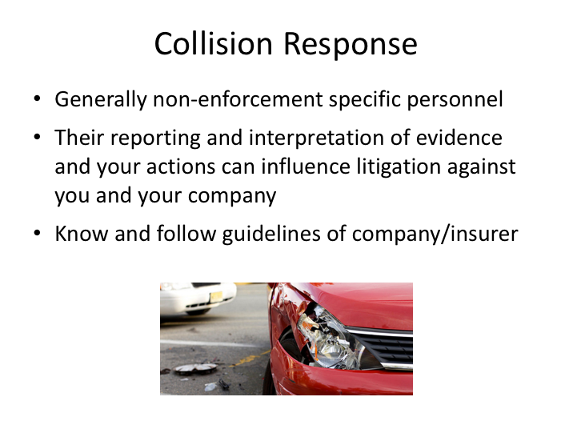

**COLLISION RESPONSE**

Besides inspections, your next most likely occasion to interact with enforcement personnel is probably following a collision incident. Collision incidents vary so greatly in type and severity, as do responses by police and enforcement agencies, that there is no way to lay out any typical scenario.

Until now we’ve talked strictly enforcement personnel – those charged principally with enforcing commercial vehicle regulations and promoting safe commercial vehicle operations. While these type of enforcement personnel may respond to a very serious crash, they are not likely to respond to a more common, less serious incident. Nonetheless, the non-enforcement responders will be engaging you, in an attempt to determine the facts of the crash. How you interact with them, especially in a difficult situation, can be very important down the road depending upon any fallout from a collision. Their ultimate reporting and interpretation of facts and evidence can influence litigation against you and your company.

Your company and its insurance carrier may have a kit of materials and forms to be used in case of a crash – usually these are located on the bus, though sometimes they can be issued individually to drivers. You should read these materials and know what this kit contains before you are involved in a crash.

**COLLISION RESPONSE (continued)**

Remember that these kits often contain a set of specific guidelines to follow that can be a valuable refresher in a stressful situation such as a collision.

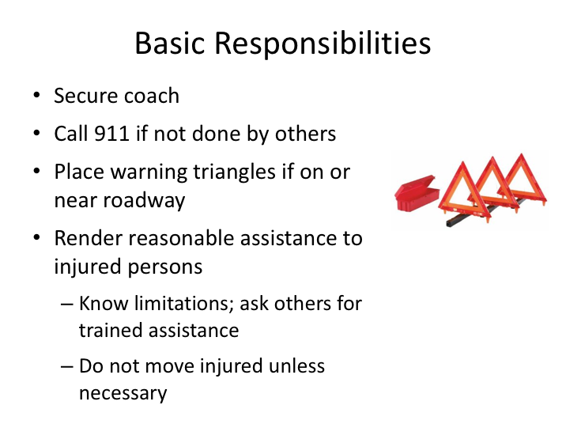

**BASIC RESPONSIBILITIES**

Let’s review the basic responsibilities of a driver in the event of a collision. First, you should try to ensure continued safety of passengers and other motorists. Secure the coach with the parking brake. If your coach is on or near the roadway, you will need to put out the reflective triangles to warn oncoming traffic of the incident and any dangers while protecting any passengers from additional collision events.

You should render all reasonable assistance to any injured persons. Keep injured persons warm and comfortable. At the same time, be aware of your own first-aid abilities and limitations so that you do not do more harm than good. You can always check to see if any of your able and willing passengers are trained in first aid and can assist until responders arrive. You should not move injured persons at the scene if moving them is likely to cause further injury.

Beyond these basic responsibilities, there is additional information to be collected such as passenger contact information, seating positions, witnesses, etc. Refer to company guidance.

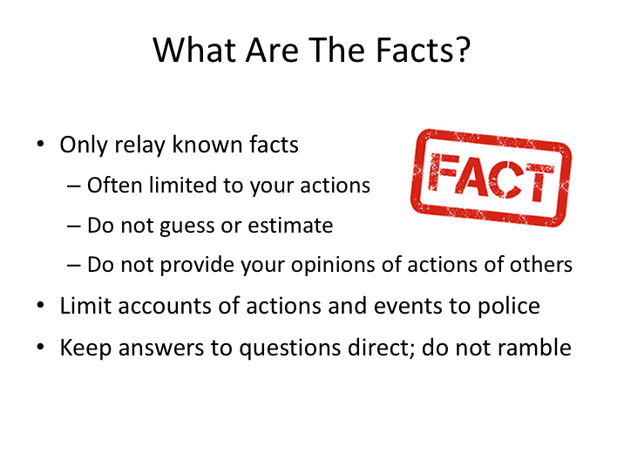

**WHAT ARE THE FACTS**

Remember that what you say can affect your personal liability and your company's liability, as well as its reputation through the media. You should cooperate with the police, but you should not discuss the causes of the crash with anyone except company representatives.

Be aware that you may be asked by several officers of your account of the crash. You will be asked similar questions in the days following by numerous other interested personnel. The principle to remember is only to provide facts that you know - not what you think happened, not what you heard happened, or anything else beyond what you know to be true.

Keep interactions with authorities simple and to the point. The more you talk, the more likely you are to introduce opinions and guesses as to what occurred.

Finally, do not discuss the events of the crash with anyone except police personnel and company representatives.

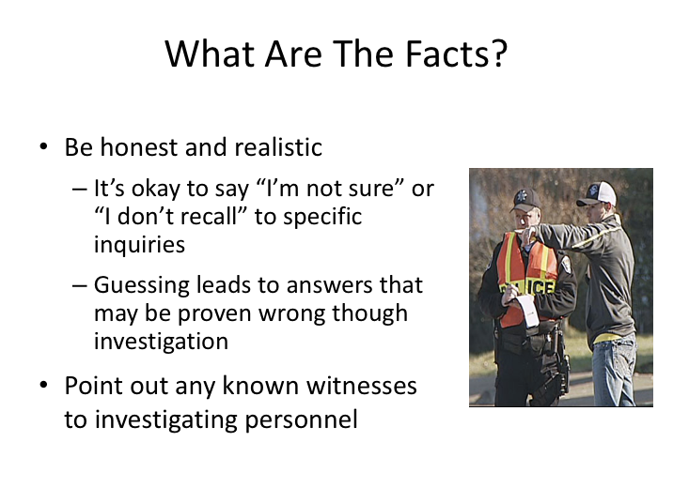

**WHAT ARE THE FACTS (continued)**

Be honest and realistic in any answers that you provide. Remember that any answers you provide are likely to be verified with additional information and investigation. For example, your speed may be recorded on vehicle systems that are retrievable or may be determined through analysis. If you cannot provide precise or reasonably reliable answers, remember that it’s okay to say, “I’m not sure” and “I don’t recall.” These answers may be appropriate when asked about your speed, whether or not you braked prior to any collision, etc. They would likely not be appropriate for questions such as the lane you were traveling in.

Point out any known witnesses to enforcement personnel. The information they provide will be vetted, like your information provided, in varying detail depending upon the outcomes of the collision incident.

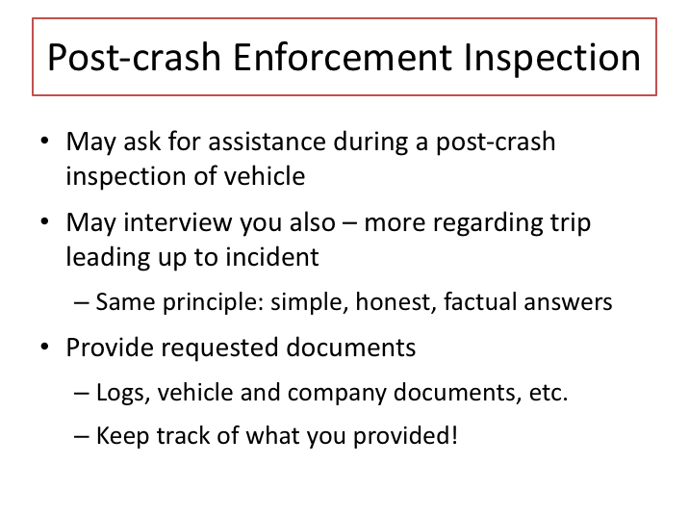

**POST-CRASH ENFORCEMENT INSPECTION**

In the event of a serious collision, commercial vehicle enforcement personnel may be on scene to investigate regulatory aspects of the collision. As with other investigators, you should respond to their requests. Requests will likely include trip documentation, such as logs and vehicle inspection reports, as well as vehicle and company documentation, such as annual/periodic DOT inspections and insurance information. They may also ask for assistance in conducting a post-crash inspection of your vehicle.

They may interview you (much like a regular inspection) and will then compare your responses to trip documents they review. So, the same rules apply – keep answers honest, simple, and let them know if you’re not sure. You should keep track of what you provide investigators – especially required documentation such as driver logs. It is necessary to track where any required, paper-based documents went to protect your and your company’s interests. For example, after collisions, allegations are often made that required documents were not present, though they may have been collected by investigators at the scene, but not preserved.

**ENFORCEMENT & POLICE INTERACTIONS**

**QUIZ**

1. Passenger carrier operations are generally inspected in one of two ways: on-site and at destinations.
   1. True
   2. False
2. During a license check, the enforcement official will be looking for the following:
   1. Presence of a state-issued commercial driver’s license
   2. Proper class of commercial driver’s license for the vehicle being operated as well as the passenger endorsement when necessary
   3. Currently valid license
   4. The driver is meeting the restrictions listed on the license
   5. All of the above
3. To be properly physically qualified, a certified medical professional on the National Registry of Certified Medical Examiners (NRCME) must conduct the driver’s medical certification.
   1. True
   2. False
4. Enforcement driver and/or vehicle-related violations are company issues and have little effect on the driver.
   1. True
   2. False
5. When reviewing paper logs, enforcement officials will check to see that the log is current to the last change of duty status.
   1. True
   2. False
6. When utilizing an electronic log system, having backup paper logs readily available is not required.
   1. True
   2. False
7. Certified inspectors must conduct inspections done under CSVA’s protocol.
   1. True
   2. False
8. As a driver on a dispatched trip, the most likely type of inspection you are likely to experience is:
   1. Level I, II and III
   2. Level IV
   3. Level V
   4. Level VI
   5. Level VII
9. A level I or II inspection will include a vehicle inspection of both the interior and exterior of the vehicle.
   1. True
   2. False
10. Some cursory driver-only inspections may not be recorded on an inspection report.
    1. True
    2. False
11. Driver violations, in addition to company violations, are tracked by driver in federal safety/statistical databases.
    1. True
    2. False
12. If the vehicle is placed out-of-service, the defect(s) responsible for the out-of-service status must be fixed before the vehicle can continue.
    1. True
    2. False
13. Potential motor carrier employers can review three years of any commercial driver’s inspection violations (and crash data) when they are considering a potential applicant for hire.
    1. True
    2. False
14. When discussing the collision with officers, you should tell them what you think happened.
    1. True
    2. False
15. When discussing the collision, it is okay to say “I’m not sure” or “I don’t recall” to specific inquiries.
    1. True
    2. False