# Enforcement & Police Interactions

|  |  |  |
| --- | --- | --- |
| Fixing Tire | Screen Shot 2015-02-26 at 10.57.29 AM.png | Safety Measurement Systemn |

**Purpose:**

The purpose of this training module is to provide students with some information and background on interactions they can expect with enforcement officials. They will learn why inspections occur, the different types, general basic procedures, and even about interaction with non-enforcement responders.

**Module Overview:**

The training module contains three classroom lessons. The first lesson discusses why inspections occur and what inspectors are evaluating in the process. The second lesson details inspection areas, for varying levels of inspections and the general step-by-step procedures used during the inspection process. The third lesson reviews engagement with non-enforcement personnel, specifically following collisions and incidents.

Lesson 1: Inspections: Substance

Lesson 2: Inspections: Process

Lesson 3: Collisions & Incidents

LESSON 1

INSPECTIONS: SUBSTANCE

**Lesson Objectives:**

By the completion of this lesson, students will have a good understanding of the types of inspections they may be subject to, as well as the compliance areas reviewed during these inspections.

**Instructional Methods**: Classroom

**Approach:**

Utilizing the PowerPoint slides, review the enforcement oversight practices, types of inspections a driver may be involved in, and the areas of compliance evaluated during these inspection processes.

**Instructor Tip –**

Detailing personal and/or company experiences pertaining to the subject material will help students identify with the content and enhance the learning experience.

**LESSON INTRODUCTORY NARRATIVE**

*Student Guide reference here*

To encourage and promote compliance with enacted safety laws and regulations, regulators have established enforcement mechanisms to hold companies and drivers accountable for complying with the safety rules. Enforcement comes from within various levels of government, including Federal, State, and even local in some instances.

Drivers are most likely to experience state-level enforcement personnel. Every state has a commercial vehicle enforcement agency whose responsibility is to check company and driver adherence to safety regulations. Many times enforcement personnel are a special division of a larger safety agency, such as the State Police.

There are also Federal investigators/enforcement personnel – these are less likely to be seen by a driver as they focus more on company compliance and conduct varying levels of inspections at company operations.

No matter which enforcement agency a driver encounters, the potential information, paperwork and vehicle components they will be inspecting will be the same since they will be assessing compliance with the safety regulations. Knowing what they will be reviewing is important in understanding why keeping all of your licenses, certifications and paperwork up to date is critical.

*Display PowerPoint slide.*

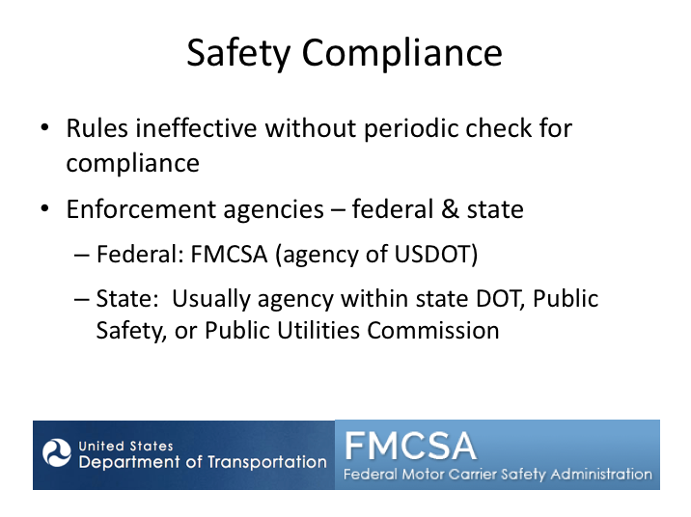

# SAFETY COMPLIANCE NARRATIVE

Federal and/or State commercial carrier safety regulations have been developed to ensure certain standards are met with regard to operation of commercial vehicles on public roadways. Of course having rules without anyone checking that they are being followed would likely result in a wide range of states of compliance from those who the rules apply to. To prevent this, State and Federal enforcement personnel routinely check companies, drivers, and vehicles for compliance with safety regulations.

These enforcement personnel work every day to find unsafe companies, drivers and vehicles. The majority of commercial vehicle enforcement efforts go toward truck operations – simply because the truck population greatly outnumbers the number of motorcoaches on the road. However, this doesn’t mean that passenger transportation operations get off easy. The nature of passenger operations and potential for catastrophic crashes demands enforcement attention. In fact, the FMCSA has a special division dedicated to passenger carriers and some states also have teams of inspection personnel dedicated to

**SAFETY COMPLIANCE NARRATIVE (continued)**

passenger transportation operations. Depending on the State, enforcement personnel may be a part of the State’s Department of Transportation, Department of Public Safety, or Public Utilities Commission.

*Display PowerPoint slide.*

A full explanation of this slide can be found directly below this image.


# TYPES OF INSPECTIONS NARRATIVE

Commercial vehicle passenger operations are generally inspected in one of two ways – on-site at companies or during on-the-road operations. During on-site compliance investigations and reviews, enforcement personnel visit a company in person and review records maintained to verify compliance. This type of inspection process occurs at differing intervals based on a variety of factors. More often, compliance with certain driver and vehicle-based regulations is investigated during an actual trip. As a motorcoach driver, you can expect to undergo inspections of this type.

During an over-the-road inspection, enforcement personnel may check the driver, the vehicle, or both for compliance with safety regulations. For passenger transportation operations, these inspections will typically occur at a destination point, or for line-haul operations with curbside passenger pickup, perhaps at curbside. Enforcement personnel may no longer stop a motorcoach full of passengers at a weigh station. However they can stop an empty motorcoach at a weigh station. Plus, in States that use rest stops as inspection locations, they

**TYPES OF INSPECTIONS NARRATIVE (continued)**

may require a motorcoach with passengers to be inspected. They may stop a motorcoach with passengers if a driver is observed violating driving laws or if they observe a serious defect with the vehicle.

*Display PowerPoint slide.*

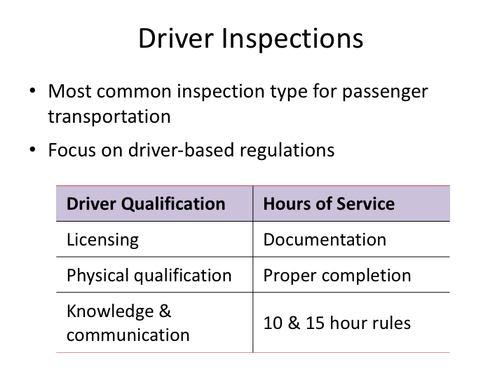

# DRIVER INSPECTIONS NARRATIVE

Between the three types of inspections (driver, vehicle, or a combination), motorcoach drivers historically were most frequently subject to a level III, driver-only inspection. (The types of inspections are defined later in this module.) Driver inspections can be done relatively quickly, with minimal interruption to trip schedules. During this inspection, the enforcement officer will review compliance with driver-based regulations such as proper licensing for the vehicle being operated, medical certification status, hours of service paperwork, and the driver’s understanding of the regulations.

However, the Fixing America’s Surface Transportation (FAST) Act of 2015 removed authority to perform any inspections at weigh stations with passengers on board. However, at other locations, and at weigh stations when there are no passenger on board, the inspector may do any inspection, including a level I or II inspection.

*Display PowerPoint slide.*

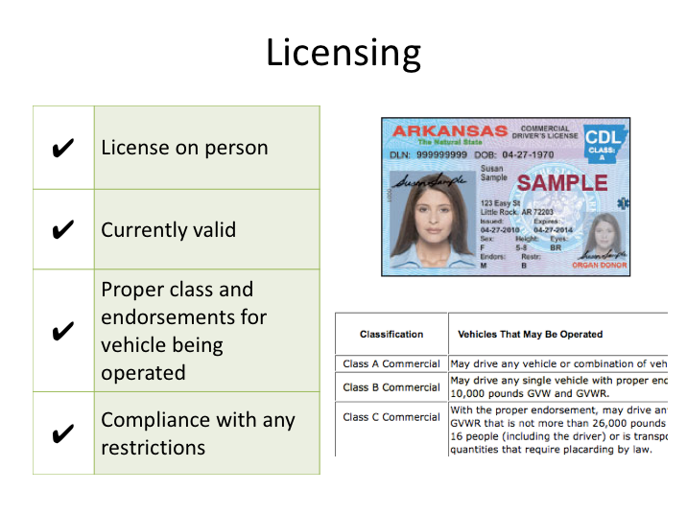

# LICENSING NARRATIVE

More specific to the license check, the enforcement official will be looking for the following:

* Presence of a state-issued commercial driver license.
* That the license is the proper class of commercial driver license for the vehicle being operated. They will also be looking to ensure that the passenger endorsement is present when necessary.
* That the license is currently valid, and not suspended or revoked - regardless of the expiration date listed on the license itself.
* That the driver is meeting any restrictions listed on the license such as wearing eyeglasses and that there is no airbrake restriction (assuming of course the vehicle being operated has airbrakes).

*Display PowerPoint slide.*

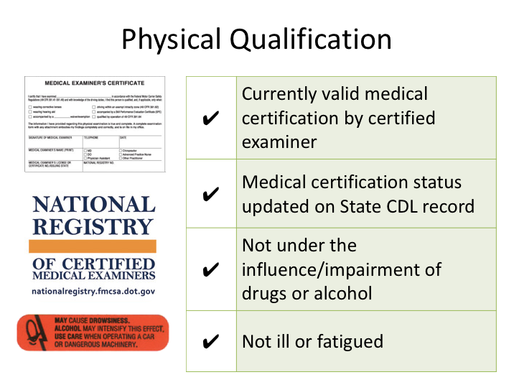

# PHYSICAL QUALIFICATION NARRATIVE

Specific to physical qualification, inspectors will ensure that a driver has a currently valid medical certification and is not operating outside of any restrictions, such as intrastate only certification. The medical certification must have been performed by a medical professional registered on the National Registry of Certified Medical Examiners (NRCME). The enforcement official will be checking the driver’s motor vehicle record through the state that issued the CDL. If the medical certification is not listed on the drivers motor vehicle record, the officer may assume there is not a valid medical certification.

The officer will also verify that the driver is not noticeably impaired, ill or fatigued, or under the influence of controlled substances or alcohol.

*Display PowerPoint slide.*

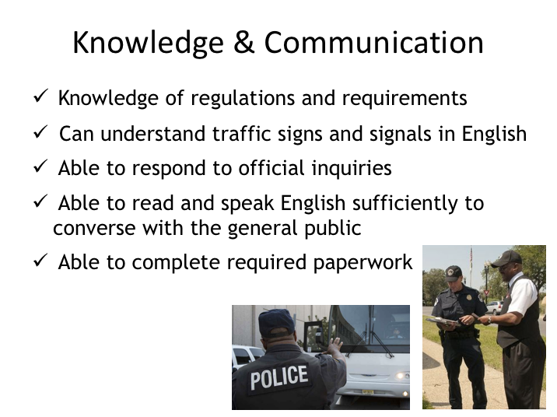

# KNOWLEDGE & COMMUNICATION NARRATIVE

Enforcement officers will usually test driver knowledge and communication ability in the normal course of interaction during an inspection.

To assess regulatory knowledge, an inspector may quiz a driver on topics such as vehicle inspection processes and hours of service limitations. They will verify a driver’s ability to respond to inquiries in the forms of questions during the driver interview as well as directions given during any vehicle inspection process. During the interview process, they will examine paperwork to assess the driver’s ability to complete it as required and, as a result of the entire interaction, will determine a driver’s ability to read and speak English sufficiently and converse with the general public.

*Display PowerPoint slide.*

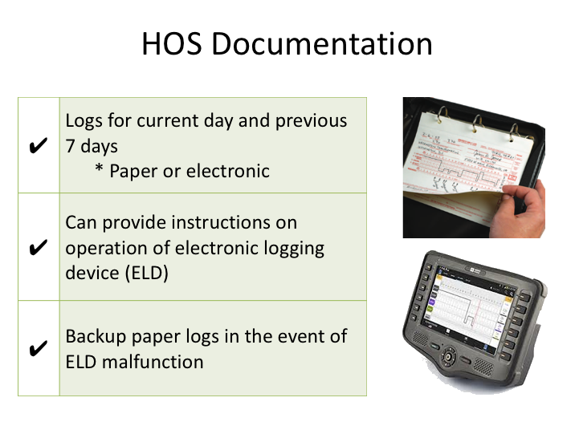

# HOS DOCUMENTATION NARRATIVE

When it comes to hours of service documentation, the enforcement officer will check to see that driver logs are present as required. When required, they will be checking for the presence of the current day’s log, as well as the previous seven days. If a driver claims that he or she is operating locally within the air-mile radius exemption and are excepted from completing driver logs, the officer will verify the distance of the location from the location of dispatch.

If a carrier and driver is using an electronic logging device (ELD), the enforcement officer may ask to review the current and previous days’ logs on the device. A user’s manual describing how to operate the ELD including step- by-step instructions for a driver to produce and transfer the ELD records to an authorized safety official and Summary description of ELD malfunctions must be available on board the CMV and provided to the safety official. Because this may be in electronic form, make sure students understand how to provide this information with your system. Also, for those utilizing electronic logs, back up paper logs must be readily available if there is a malfunction with the ELD.

*Display PowerPoint slide.*

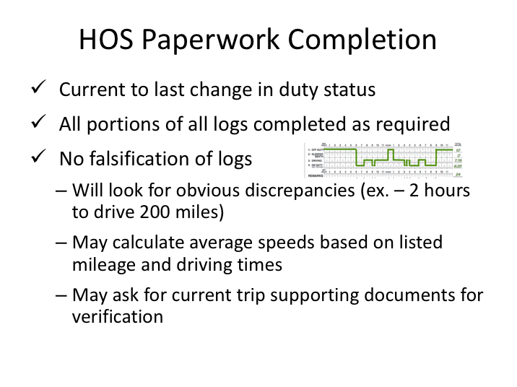

# HOS PAPERWORK COMPLETION NARRATIVE

When reviewing paper logs, enforcement officials will check to see that the log is current to the last change in duty status. They will review current and previous logs for proper completion, checking to be sure that all required areas of the logs are completed. And finally, they will look for evidence of falsification during their log paperwork review. This review may include obvious errors, such as too short a time listed for the distance of a known city pair, calculating average speeds from information contained on driver logs, and verifying log information with supporting documents available from the current trip.

Note: 395.11(g) requires the driver to provide any supporting documentation in their possession during a roadside inspection when requested by the safety official.

*Display PowerPoint slide.*

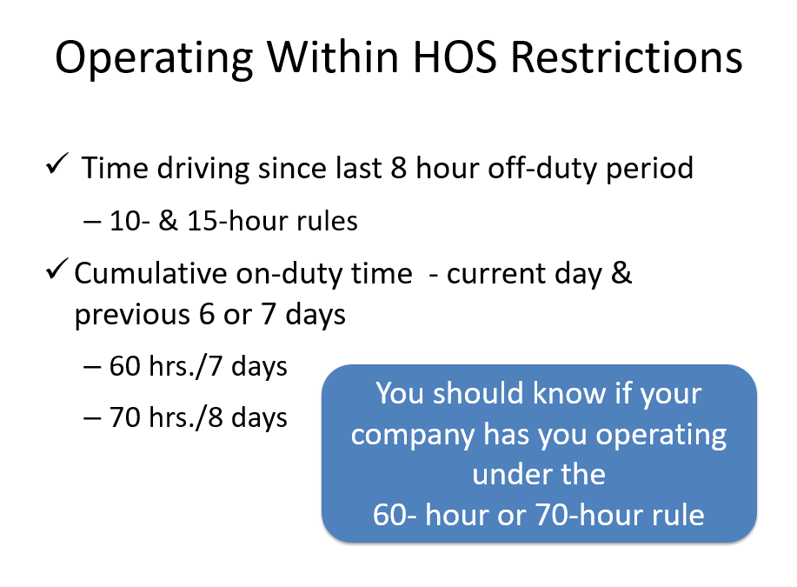

# OPERATING WITHIN HOS RESTRICTIONS NARRATIVE

Enforcement personnel will of course be reviewing driver logs to ensure that the driver and carrier is operating within the hours of service limitations. They’ll be looking for compliance with both the 10 hour and 15 hour rules, as well as compliance with the cumulative on-duty rules over the past seven or eight days (including the current day). Companies may have drivers that operate differently. Therefore, a driver should know whether they are operating under the 60 hour or 70 hour rule limitation – this is almost certain to be asked during the driver interview process of an inspection.

*Display PowerPoint slide.*

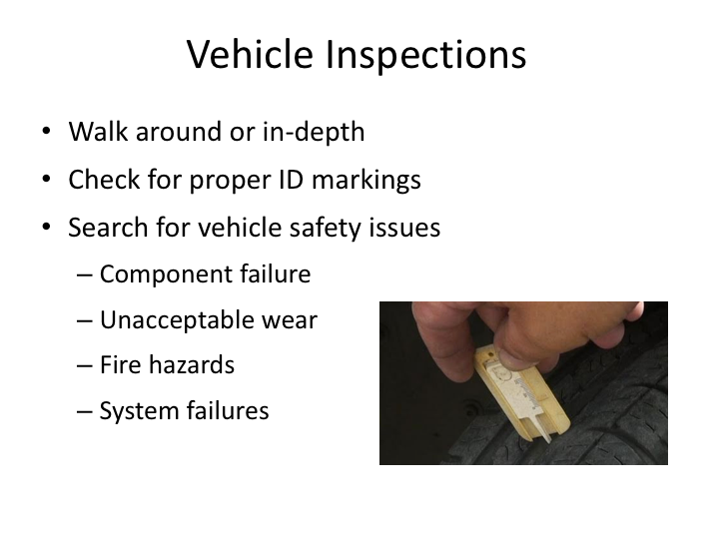

# VEHICLE INSPECTIONS NARRATIVE

Vehicle inspections, when part of an enforcement inspection, can vary in length depending upon whether it is a walk around or more thorough vehicle inspection. Enforcement officers may ask for driver assistance when checking certain components during a vehicle inspection, such as signal and light operation, windshield wiper operation, and brake applications. The vehicle inspection procedure is designed to identify vehicle safety concerns such as component failures, unacceptable wear, fire hazards and system failures. Examples include a broken suspension spring, tire tread depth issues, chafed or unsecured wiring, and airbrake or ABS system failures. And, while inspecting the vehicle enforcement officials will be checking to ensure that the vehicle is properly marked with all required identification information.

LESSON 2

INSPECTIONS: PROCESS

**Lesson Objectives:**

By the completion of this lesson, students will have a basic understanding of the various types of enforcement inspections they could experience as a motorcoach driver, where they may occur, the procedural aspects of these inspections, and the consequences of operating in violation of safety regulations.

**Instructional Methods**: Classroom

**Approach:**

Utilizing the PowerPoint slides, review inspections standards, various levels/types of inspections, the general inspection process, and where motorcoach drivers are likely to be subject to an enforcement inspection. Discuss the consequences of violations, both to the company and the driver.

**Instructor Tip –**

Instructors are encouraged to incorporate any company-specific practices related to inspections as appropriate (for example – where to submit inspection reports). Detail inspection of internal electronic logging systems during an inspection process as well as where instructions for such systems are kept on the motorcoach.

Discuss company policies regarding driver and/or vehicle violations that are attributed to drivers violating company policy and/or safety regulations (if any).

As with any module, relating actual experiences pertaining to material being taught will help students identify with the content.

**LESSON INTRODUCTORY NARRATIVE**

*Student Guide reference here*

Being prepared for an inspection by knowing the general process and even when it’s likely to occur should take away some of the nervousness and uncertainty when one does occur, especially if the driver is confident in his/her state of compliance with the rules and regulations.

It is important to understand that enforcement inspections are a routine part of operating commercial vehicles – you are not being picked on as a driver, and it is unlikely that the company you are driving for is being targeted (though this is possible for companies with history and patterns of violations).

Motorcoach inspections are not likely to occur with passengers on-board, though if it does, you should know how to address the situation with your passengers. Also critical is knowing what to do after an inspection. If there are no violations, there will be little to do beyond giving a copy of the inspection to the company, but more actions may be necessary if violations are discovered.

Drivers who understand and comply with safety regulations and take their job duties seriously should have minimal consequences from inspections. For these drivers, violations should be few, and those discovered may be vehicle issues that a driver could not have reasonable known about. However for drivers – and companies – who violate regulations intentionally or not, there are consequences for non-compliance. In instances where patterns of non-compliance exits, a company’s right to operate could be affected, not to mention their image. For drivers, history of failing to comply can certainly affect current and future employment as a commercial vehicle driver, since motor carriers can investigate driver violation history when considering new applicants.

*Display PowerPoint slide.*

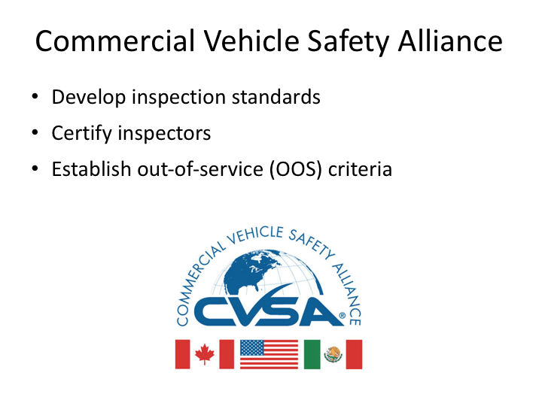

# COMMERCIAL VEHICLE SAFETY ALLIANCE NARRATIVE

As a motorcoach driver, you can expect to undergo these inspections on occasion, so it’s therefore important for you to understand the process and also information on making them go as smooth as possible. But before we get to the process, let’s go over some background information on protocols.

The vast majority of commercial vehicle inspections in North America occur under the guidance of the Commercial Vehicles Safety Alliance (CVSA). CVSA was established in the 1980s and today is comprised of local, state, provincial, territorial and federal motor carrier safety officials and industry representatives from the United States, Canada, and Mexico.

The alliance is guided by several principles, the foremost of which is to ensure uniform and reciprocal application of North American inspection procedures and out-of-service criteria. CVSA establishes the out-of-service criteria – these are regulatory and safety violations deemed so serious that a vehicle, driver, or both, are prohibited from further operation until a remedy is affected.

**COMMERCIAL VEHICLE SAFETY ALLIANCE NARRATIVE (continued)**

Inspections conducted under CVSA’s program must be conducted by certified inspectors that have successfully completed a training program approved by the Alliance and met in-service inspection requirements.

*Display PowerPoint slide.*

Chart contaiing the 8 different levels of CVSA Inspections. 
A full explanation of this slide can be found directly below this image.

# CVSA INSPECTION LEVELS NARRATIVE

There are currently seven “levels” of inspections, denoted by numbers – officially by roman numerals. Each inspection level represents a different type of inspection. Levels I through III and Level V inspections are fairly standard and typical inspections that are completed on a daily basis throughout North America.

Level IV inspections are inspections that fall outside of the regular inspections, and are usually in support of a certain target or information gathering. For example, each year, Operation Airbrake is conducted – a several day blitz across North America targeting air brake inspections. During these inspections, typical inspection procedures may be altered to shorten inspections and maximize the amount of vehicles inspected.

Level VII inspections are somewhat similar to Level IV inspections. These are jurisdictionally-mandated inspections that do not meet the requirements of any other level of inspection and there is more flexibility in inspection personnel.

**CVSA INSPECTION LEVELS NARRATIVE (continued)**

Level VI inspections pertain to radioactive hazardous material commodities that are not legal on motorcoaches, and thus you will hopefully never encounter on a motorcoach – transuranic waste (e.g., wastes having atomic numbers higher than uranium) and radioactive material!

*Display PowerPoint slide.*

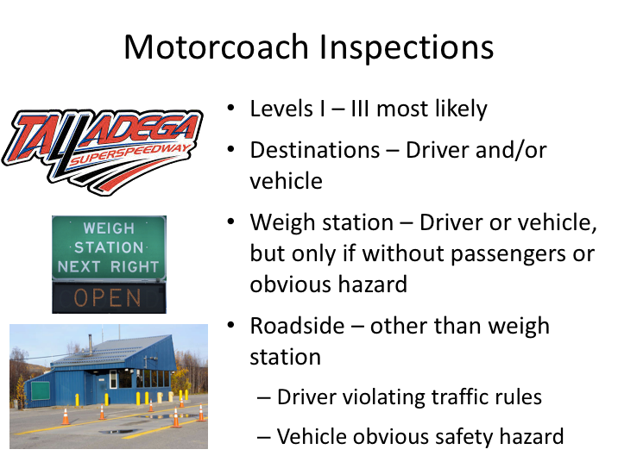

# MOTORCOACH INSPECTIONS NARRATIVE

As the driver on a dispatched trip, the most likely types of inspections you are likely to experience are a Level I, II or III inspection. Before we review these types of inspections in a little more detail, let’s look at when and where you might reasonably expect to be inspected.

Probably the most common situation when you will experience an inspection is upon arrival at a destination, such as an amusement park or sporting event. Another possibility is curbside, for companies that provide line run services with passenger pickup at curbside. Inspections at these locations can include driver and/or vehicle inspections. Because these types of locations and layovers do not have passengers present at the time of inspection, they tend to include vehicle inspections more often (either a Level I or II).

Increasingly, states were requiring motorcoaches and passenger vehicles to stop at roadside weigh stations. According to the Fixing America’s Surface Transportation (FAST) Act of 2015, an inspection may only be conducted at a roadside facility such as a weigh station, if there are no passengers on the **MOTORCOACH INSPECTIONS NARRATIVE (continued)**

motorcoach. Other similar potential inspection locations are a highway rest area, terminal, border crossing maintenance facility, passenger pickup locations (curbside, shopping centers, etc.).

Roadside (other than weigh station) – An inspection may be conducted en-route when an imminent or obvious safety hazard is observed. An example of imminent or obvious safety hazard would be a vehicle emitting excessive smoke from the engine compartment, smoke from any other part of the vehicle, and any condition that would indicate a potential or present danger from fire. Also, any observed violation which would cause a CMV transporting passengers to be placed out-of-service under the North American Standard OOS Criteria will subject the vehicle to an en-route inspection. Other than an imminent or obvious safety hazard, the only reason you would generally be pulled over while traveling along the roadway is if you were violating a traffic rule.

There is always the possibility a violation could result in the driver or vehicle being placed out-of-service. In such a case, you need to know the company policies for notifying them of the situation, so decisions can be made on how to proceed.

*Display PowerPoint slide.*

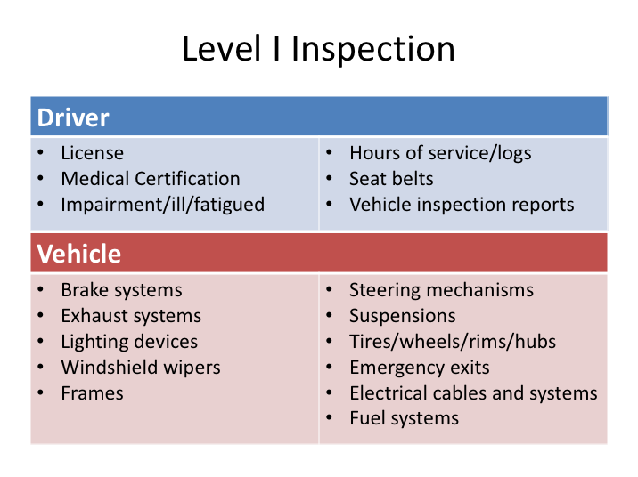

# LEVEL I INSPECTION NARRATIVE

A Level I inspection is the granddaddy of them all - the most thorough, and the most time consuming. We illustrated in varying detail in the slide above what enforcement inspectors will be looking at during driver and vehicle inspections; a Level I inspection is a combination of both the driver and vehicle.

From the driver aspect, the inspection will include an examination of your driver license; medical examiner’s certification status; alcohol and drugs; driver’s record of duty status as required; hours of service and seat belt.

On the vehicle side, they will inspect vehicle inspection report (as applicable); brake systems; exhaust systems; frames; fuel systems; lighting devices (headlamps, tail lamps, stop lamps, turn signals); steering mechanisms; suspensions; tires; wheels, rims and hubs; windshield wipers; emergency exits; electrical cables and systems in engine and battery compartments, and maybe even securement of cargo in luggage bays (as required).

*Display PowerPoint slide.*

Table looks the same as Level I Inspections.
A full explanation of this slide can be found directly below this image.

# LEVEL II INSPECTION NARRATIVE

A Level II inspection is similar to a Level I inspection. The largest difference is in the vehicle inspection portion– for a Level II, this will include only those components or portions of systems that can be inspected without physically getting under the vehicle. There is no change in the driver inspection portion from a Level I.

*Display PowerPoint slide.*

Driver Only:
- License
- Medical Certification Status
- Impairment/ill/fatigued
- Hours of Service
- Seat Belt
- Vehicle Inspection Reports (as applicable).

# LEVEL III INSPECTION NARRATIVE

A Level III inspection is focused solely on driver credentials, and is the quickest inspection type.

*Display PowerPoint slide.*

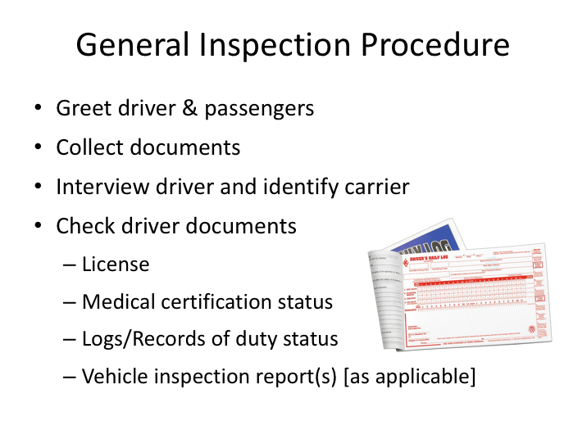

# GENERAL INSPECTION PROCEDURE NARRATIVE

Thanks to training provided to inspectors and the uniform standards established by CVSA, you can expect similar procedures if you are selected for inspection. Obviously, the procedures will vary depending upon the inspection level and how many enforcement personnel are conducting the inspection. For driver only inspections, there may only be one enforcement official; for inspections that include a check of the vehicle there may be multiple inspectors working as a team.

The inspector will usually start by greeting you and any passengers on-board. He or she may ask strictly for driver-related documents or may also want to see company and vehicle related documents. Many coach companies keep insurance and other registration documents on the coach in a specific location - you should know where this is kept on your coach and should even verify its presence during your pre-trip inspection.

**GENERAL INSPECTION PROCEDURE NARRATIVE (continued)**

The inspector will interview you about your trip and the company you work for. As indicated earlier, during this interview he or she will be probing your knowledge of the regulations and also assessing your ability to communicate sufficiently and complete paperwork as required.

Following the interview, the inspector will review the documents collected, including your license and logs. He or she will verify your medical certification status, and may ask to see vehicle inspection reports if you are on a multi-day trip and therefore would be expected to have them on the vehicle.

*Display PowerPoint slide.*

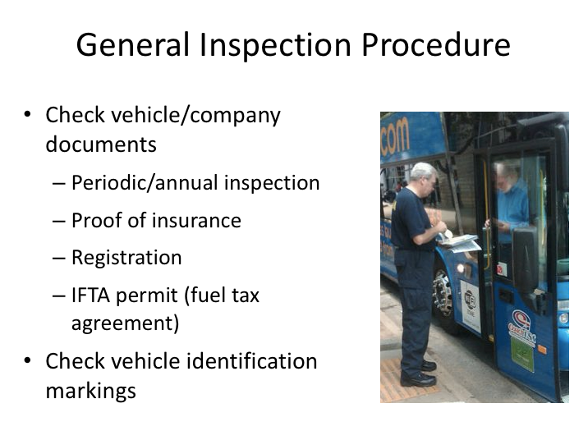

**GENERAL INSPECTION PROCEDURE NARRATIVE (continued)**

If the inspector has collected vehicle and company documents, they will review these to ensure that certain items are present. They will look to ensure that the vehicle has undergone a periodic inspection as required by the DOT, that it is properly registered, there is proof of insurance as well as that is properly permitted for fuel tax purposes. They may also verify that the proper identification markings are on the outside of the vehicle according to the documents reviewed and the answers you’ve provided.

*Display PowerPoint slide.*

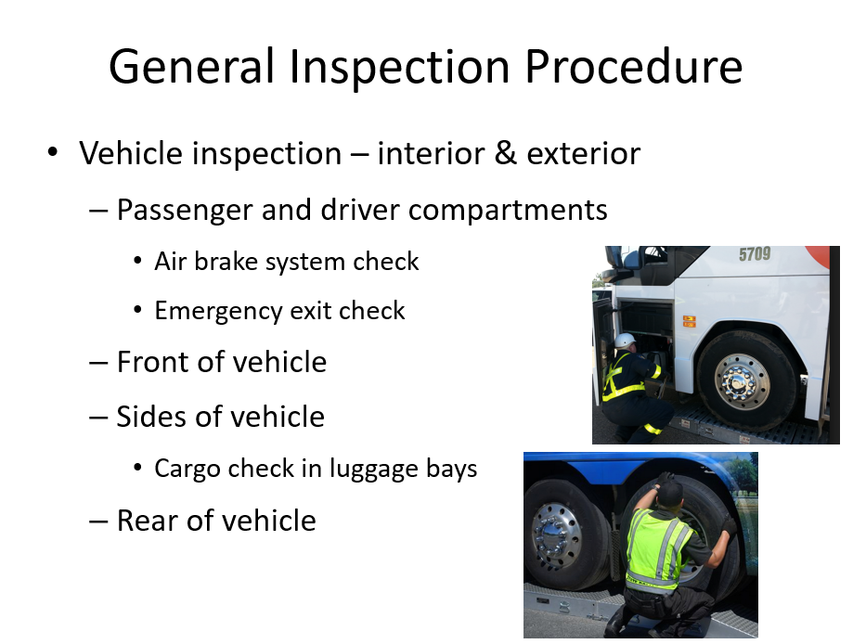

**GENERAL INSPECTION PROCEDURE NARRATIVE (continued)**

If it is a Level I or II inspection, the inspector(s) will then check the vehicle. Usually they will begin the interior inspection with the driver compartment including a check of the air brake system to ensure that all features are working properly such as ABS and low air warnings. They will continue the interior inspection with the passenger area verifying emergency egress availability, functionality and labeling. An inspector will ask the driver to open each side emergency window exit and roof exits. Exits are required to open and close as designed. Ensure students know how to operate the emergency window and roof exits in the type coach they are operating as they may be equipped with different releases. Failure to open or close an exit may result in an out-of-service violation.

This will be followed by an inspection of the front of the motor coach, then the sides and rear of the vehicle including the engine compartment. During this process, they will be checking all visible components including lighting, tires and wheels, windshield wipers, etc. It’s also possible that they may check in the luggage space for proper securement of any necessary materials and ensure that no prohibited cargo is being stored. The engine compartment will be checked for fluid leaks, belt condition and frame integrity.

SAFETY NOTE: Never start the engine of a motorcoach during an inspection with the engine door open and the location of all inspectors is unknown. Motorcoach inspections are generally conducted in teams with one completing the interior inspection and the others conducting the exterior inspection including the engine compartment. Inspectors receive safety training in this area however, the driver should always be attentive to the dangers possible while the engine door is open.

*Display PowerPoint slide.*

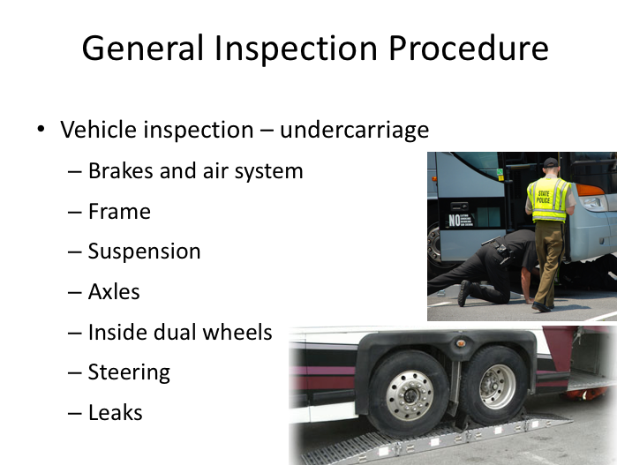

**GENERAL INSPECTION PROCEDURE NARRATIVE (continued)**

During a Level I inspection, an undercarriage inspection will follow the exterior inspection. In almost all cases, this will require maneuvering the coach onto wheel ramps so that the inspectors can more easily maneuver around underneath the vehicle – without them, Level I inspection just aren’t feasible outside of a maintenance facility with lifts or service pits. While inspecting the undercarriage, they will look for issues with various components such as suspension, steering, airbrake system, and also inspect the axles and frame.

*Display PowerPoint slide.*

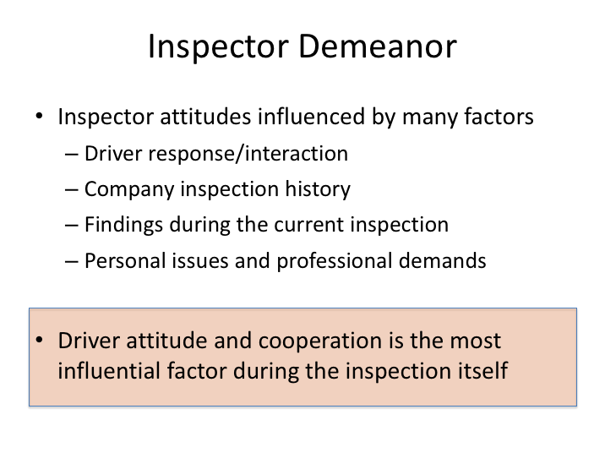

# INSPECTOR DEMEANOR NARRATIVE

There’s no doubt you will come across a variety of demeanors when it comes to the inspectors themselves. As with passengers and toward leaders, some will be easier to get along with than others. Some inspectors will be friendlier, while others may project the image of total business. One thing is for certain however – your response to, and interaction with, to any inspector will dictate the tone of the continued interaction.

When you are approached by a commercial vehicle enforcement officer, remember to conduct yourself in a courteous and professional manner. An agreeable and cooperative demeanor tells the officer that you have nothing to hide and they may then choose to perform only a cursory inspection or even decide to defer your inspection for another, “more deserving” candidate. Remember that enforcement officers have a lot of historical inspection data at their fingertips with regard to carriers. In fact, past performance of the company you drive for can also positively or negatively influence the demeanor of the inspector from the get-go. But, no matter what, if a driver is uncooperative,

**INSPECTOR DEMEANOR NARRATIVE (continued)**

appears nervous, unknowledgeable or evasive, the inspectors will dig in and the intensity will rise. The fact is that most inspectors are true professionals that understand and respect the job that professional drivers do more than most.

*Display PowerPoint slide.*

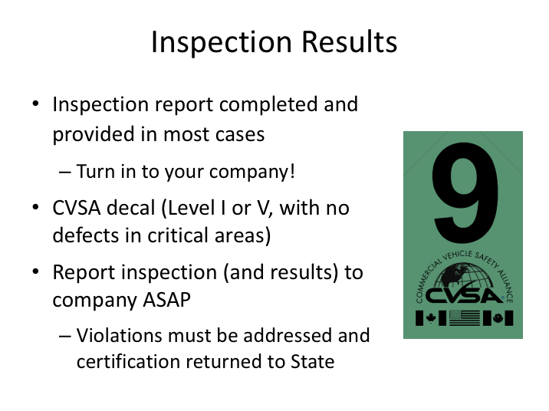

# INSPECTION RESULTS NARRATIVE

In most cases, the driver will be presented with official inspection results via an inspection report. However, some cursory driver-only inspections may not be recorded on an inspection report. If you receive an inspection report, you will be instructed by the officer to have a company official sign and return a copy to their state office. Violations that are not deemed safety critical must be remedied and the company must verify these have been addressed within 15 days of the report, so it’s critical you get the report to your company.

If the vehicle has been thoroughly inspected during a Level I inspection and there were no defects found in critical safety areas, the officer should issue a CVSA decal, which he/she will place on the vehicle. This decal denotes that the vehicle has successfully passed a CVSA-level inspection. After receiving a CVSA decal, a vehicle is unlikely to be inspected by another enforcement official for at least the next 90 days. CVSA decals vary in color to identify the quarter in which they were issued and universally recognized modifications to the decal signify the month during the quarter that the inspection occurred.

**INSPECTION RESULTS NARRATIVE (continued)**

In all cases, you will also want to notify your company of any inspection and the results as soon as possible following the inspection.

*Display PowerPoint slide.*

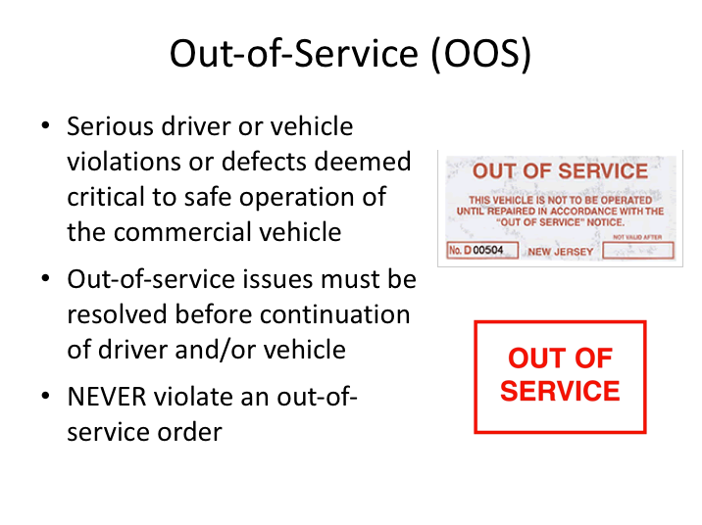

# OUT OF SERVICE (OOS) NARRATIVE

All defects and violations will be written up on an inspection report. The majority of possible defects or regulatory violations do not call for immediate enforcement activity. However, serious driver or vehicle defects discovered that are deemed critical to safe operation of the commercial vehicle will result in immediate enforcement action and probable “out of service” status. If any on-the-spot enforcement action is necessary, the inspectors will take it and notify you of any options.

If you are placed out of service due to regulatory violations, the inspector will let you know what must be done before you can re-enter service. In most cases, this will be the result of a hours-of-service violation and the remedy is generally a consecutive eight hour off-duty period to restart your 10 and 15 hour rule.

If the vehicle is placed out of service, the defect(s) responsible for the out of service status must be fixed before the vehicle can continue. Never violate an out-of-service order. Violation of out-of-service orders can result in a citation for

**OUT OF SERVICE (OOS) NARRATIVE (continued)**

that violation, that if you are found guilty in court can lead to disqualification of your commercial driver license, which gets worse for subsequent such convictions, as well as substantial fines to you and your company.

*Display PowerPoint slide.*

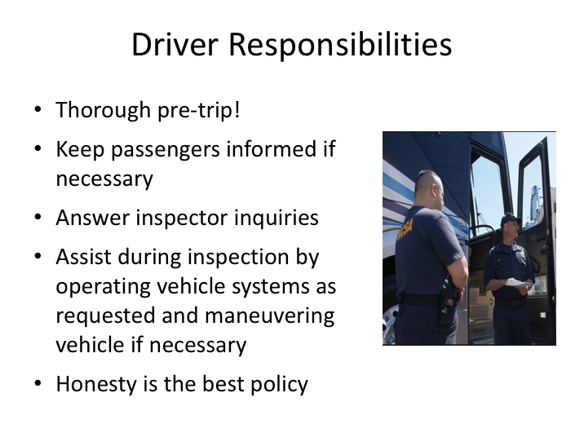

# DRIVER RESPONSIBILITIES NARRATIVE

As it pertains to the inspection process, your responsibilities as a driver will vary depending upon the inspection level. First and foremost, properly conducting one of your other job responsibilities – a thorough pre-trip inspection of the vehicle – will go a long way in limiting potential issues during an inspection. Identifying and addressing visible vehicle defects, verifying repair of previous driver vehicle inspection report write-ups, and ensuring that you have all necessary paperwork before you leave on a trip helps limit issues during an enforcement inspection.

In the event that you have passengers on board, and the enforcement officials have not addressed the passengers, you should inform the passengers with regard to what is taking place. Generally, letting them know that you and/or the vehicle has been selected for a random safety inspection is a good way to communicate what will occur.

You should answer any of the inspector’s questions as they interview you and provide them with requested documents if available. During the inspection

**DRIVER RESPONSIBILITIES NARRATIVE (continued)**

process itself, the enforcement officials will ask for your assistance in operating certain vehicle systems as they inspect them, and may ask you to maneuver the vehicle on and off of inspection ramps. You should comply with these requests.

Finally, you should know that commercial vehicle safety inspectors conduct these safety inspections daily. They often are able to tell if a driver is not being truthful and have experience in uncovering dishonesty. You will gain respect by being truthful and invite increased scrutiny for being dishonest or pretending to know something you don’t.

*Display PowerPoint slide.*

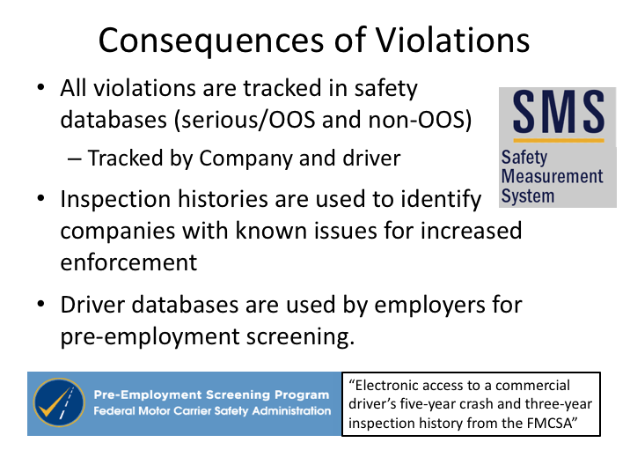

# CONSEQUENCES OF VIOLATIONS NARRATIVE

We’ve discussed the seriousness of out-of-service violations and the consequences that can be incurred from conviction of a citation for violating an out-of-service order. However, this does not mean that non out-of-service violations do not have any real consequences. Inspection violation databases are maintained on both companies and drivers. In fact, these databases maintained on companies help identify problem companies that enforcement targets due to previous known history.

Currently, for drivers, the consequence is in potential employment opportunities. Commercial vehicle operators are permitted to query these inspection databases for driver applicant violations and crashes they were involved in. Since previous performance is generally a good indicator of future performance, many employers are weary of hiring applicant drivers who have had previous violations attributed to them and their vehicle. FMCSA also has the ability to take direct enforcement action against drivers, and has even restricted authorization to operate commercial vehicles by declaring the driver an imminent hazard, based

**CONSEQUENCES OF VIOLATIONS NARRATIVE (continued)**

on serious repeat violations of safety regulations. Keep in mind that, because of the cargo, passenger operations are more likely to bring about such an action against a driver than are freight operations.

LESSON 3

COLLISIONS & INCIDENTS

**Lesson Objectives:**

By the completion of this lesson, drivers will understand their basic responsibilities following a collision incident, including interacting with emergency responder personnel who may, or may not, include commercial vehicle safety enforcement personnel.

**Instructional Methods**: Classroom

**Approach:**

Utilizing the PowerPoint slides, review driver’s responsibilities at the scene of a collision or incident. Include the scope of the information they should provide and to whom, and what information they should collect on behalf of the company. Detail the difference between emergency responders and enforcement personnel.

**Instructor Tip –**

Detailing personal and/or company experiences pertaining to the subject material will help students identify with the content and enhance the learning experience.

**LESSON INTRODUCTORY NARRATIVE**

*Student Guide reference here*

Unfortunately, collisions and incidents are a part of operating commercial vehicles – even for the most careful drivers. While we’ve covered collisions previously, this will serve as a review of what information you are expected to gather/document for your company.

It is important to understand that interacting with responding police personnel following an incident is slightly different than interacting with enforcement personnel, as we've been discussing. Knowing what to discuss with whom is important for you and your company. Being cooperative is important, and so is differentiating what you *know* happened from what you *think* happened.

*Display PowerPoint slide.*

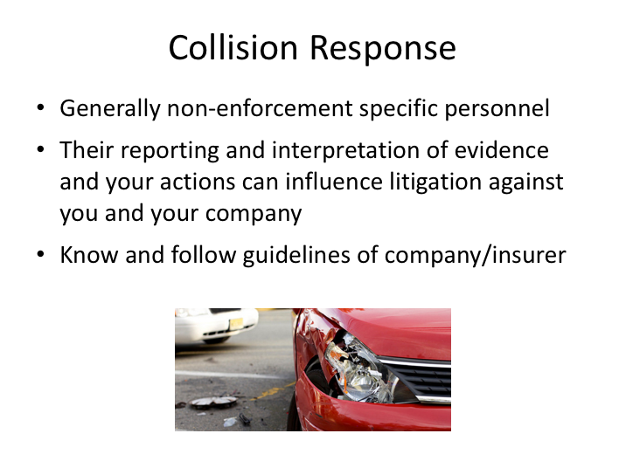

# COLLISION RESPONSE NARRATIVE

Besides inspections, your next most likely occasion to interact with enforcement personnel is probably following a collision incident. Collision incidents vary so greatly in type and severity, as do responses by police and enforcement agencies, that there is no way to lie out any typical scenario.

Until now we’ve talked strictly enforcement personnel – those charged principally with enforcing commercial vehicle regulations and promoting safe commercial vehicle operations. While these type of enforcement personnel may respond to a very serious crash, they are not likely to respond to a more common, less serious incident. Nonetheless, the non-enforcement responders will be engaging you, in an attempt to determine the facts of the crash. How you interact with them, especially in a difficult situation, can be very important down the road depending upon any fallout from a collision. Their ultimate reporting and interpretation of facts and evidence can influence litigation against you and your company.

**COLLISION RESPONSE NARRATIVE (continued)**

Your company and its insurance carrier may have a kit of materials and forms to be used in case of a crash – usually these are located on the bus, though sometimes they can be issued individually to drivers. You should read these materials and know what this kit contains before you are involved in a crash. Remember that these kits often contain a set of specific guidelines to follow that can be a valuable refresher in a stressful situation such as a collision.

**Instructor Tip –**

Review your company’s “collision packet/kit” (assuming one exists). Review the contents and instructions for use at the scene of a collision.

*Display PowerPoint slide.*

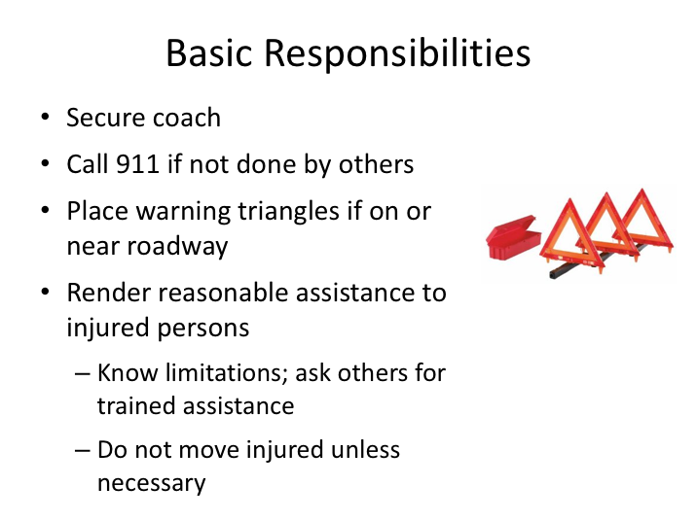

# BASIC RESPONSIBILITIES NARRATIVE

It’s always good to be aware of the basic responsibilities of a driver in the event of a collision. First, you should try to ensure continued safety of passengers and other motorists. Secure the coach with parking brakes. If your coach is on or near the roadway, you will need to put out the reflective triangles to warn oncoming traffic of the incident and any dangers while protecting any passengers from additional collision events.

You should render all reasonable assistance to any injured persons. Keep injured persons warm and comfortable. At the same time, be aware of your own first-aid abilities and limitations so that you do not do more harm than good. You can always check to see if any of your able and willing passengers are trained in first aid and can assist until responders arrive. You should not move injured persons at the scene if moving them is likely to cause further injury.

Beyond these basic responsibilities, there is additional information to be collected such as passenger contact information, seating positions, witnesses, etc. Refer to company guidance.

*Display PowerPoint slide.*

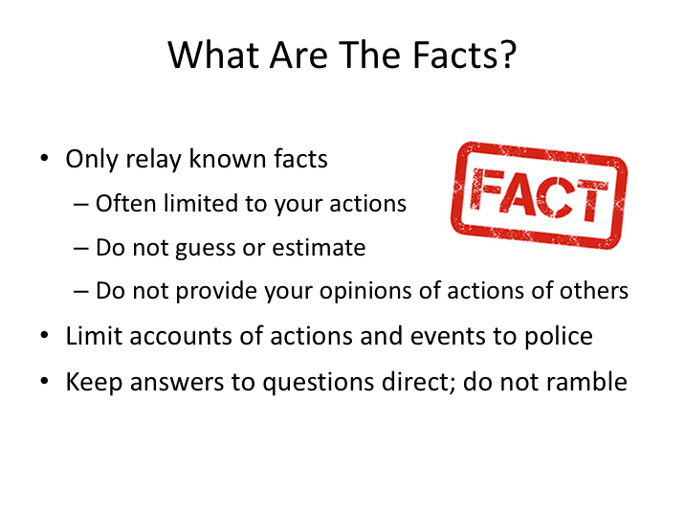

# WHAT ARE THE FACTS NARRATIVE

Remember that what you say can affect your personal liability and your company's liability and its reputation in the media. You should cooperate with the police, but you should not discuss the causes of the crash with anyone except company representatives.

Remember that what you say can affect your own company's liability and its reputation in the media. You should cooperate with the police, but you should not discuss the causes of the crash with anyone except company representatives.

Be aware that you may be asked by several officers of your account of the crash. You will be asked similar questions in the days following by numerous other interested personnel. The principle to remember is only to provide facts that you know - not what you think happened, not what you heard happened, or anything else beyond what you know to be true.

**WHAT ARE THE FACTS NARRATIVE (continued)**

Keep interactions with authorities simple and to the point. The more you talk, the more likely you are to introduce opinions and guesses as to what occurred.

Finally, do not discuss the events of the crash with anyone except police personnel and company representatives.

*Display PowerPoint slide.*

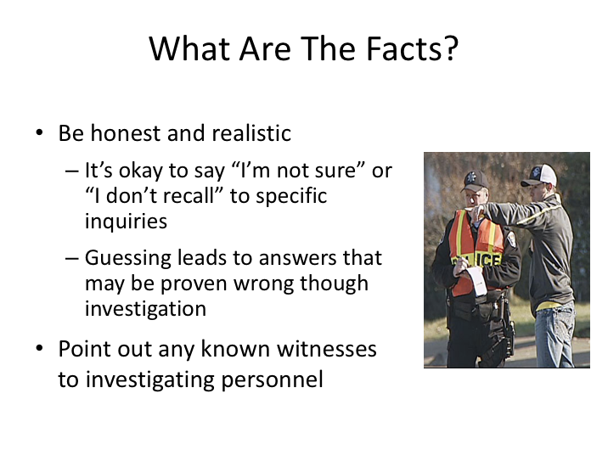

**WHAT ARE THE FACTS NARRATIVE (continued)**

Be honest and realistic in any answers that you provide. Remember that any answers you provide are likely to be verified with additional information and investigation. For example, your speed may be recorded on vehicle systems that are retrievable or may be determined through analysis. If you cannot provide precise or reasonably reliable answers, remember that it’s okay to say, “I’m not sure” and “I don’t recall.” These answers may be appropriate when asked about your speed, whether or not you braked prior to any collision, etc. They would likely not be appropriate for questions such as the lane you were traveling in.

Point out any known witnesses to enforcement personnel. The information they provide will be vetted, like your information provided, in varying detail depending upon the outcomes of the collision incident.

*Display PowerPoint slide.*

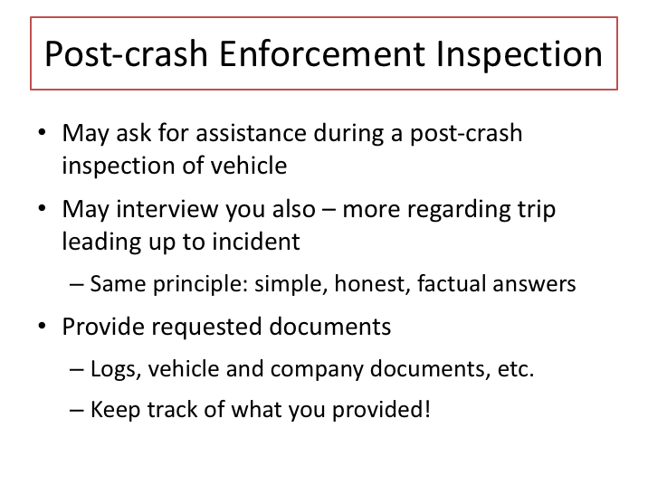

# POST-CRASH ENFORCEMENT INSPECTION NARRATIVE

In the event of a serious collision, commercial vehicle enforcement personnel may be on scene to investigate regulatory aspects of the collision. As with other investigators, you should respond to their requests. Request will likely include trip documentation, such as logs and vehicle inspection reports, as well as vehicle and company documentation, such as annual/periodic DOT inspections and insurance information. They may also ask for assistance in conducting a post-crash inspection of your vehicle.

They may interview you much like a regular inspection and they will then compare your responses to trip documents they review. So, the same rules apply – keep answers honest, simple, and let them know if you’re not sure. You should keep track of what you provide investigators – especially required documentation such as driver logs. This is necessary to track where any required documents went. For example, after collisions, allegations are often made that logbooks were not present, though they may have been collected by investigators at the scene and not preserved.

**ENFORCEMENT & POLICE INTERACTIONS**

**QUIZ**

*Instructor’s Note – Corrected answers are highlighted*

1. Commercial vehicle passenger operations are generally inspected in one of two ways: on-site and at destinations.
   1. **True**
   2. False
2. During a license check, the enforcement official will be looking for the following:
   1. Presence of a state-issued commercial driver’s license
   2. Proper class of commercial driver’s license for the vehicle being operated as well as the passenger endorsement when necessary
   3. Currently valid license
   4. The driver is meeting the restrictions listed on the license
   5. **All of the above**
3. To be properly physically qualified, a certified medical professional on the National Registry of Certified Medical Examiners (NRCME) must conduct the driver’s medical certification.
   1. **True**
   2. False
4. Enforcement driver and/or vehicle-related violations are company issues and have little effect on the driver.
   1. True
   2. **False**
5. When reviewing paper logs, enforcement officials will check to see that the log is current to the last change of duty status.
   1. **True**
   2. False
6. When utilizing an electronic log system, having backup paper logs readily available is not required.
   1. True
   2. **False**
7. Certified inspectors must conduct inspections done under CSVA’s protocol.
   1. **True**
   2. False
8. As a driver on a dispatched trip, the most likely type of inspection you are likely to experience is:
   1. **Level I, II and III**
   2. Level IV
   3. Level V
   4. Level VI
   5. Level VII
9. A level I or II inspection will include a vehicle inspection of both the interior and exterior of the vehicle.
   1. **True**
   2. False
10. Some cursory driver-only inspections may not be recorded on an inspection report.
    1. **True**
    2. False
11. Driver violations, in addition to company violations, are tracked by driver in federal safety/statistical databases.
    1. True
    2. **False**
12. If the vehicle is placed out of service, the defect(s) responsible for the out of service status must be fixed before the vehicle can continue?
    1. **True**
    2. False
13. Potential motor carrier employers can review three years of any commercial driver’s inspection violations (and crash data) when they are considering a potential applicant for hire.
    1. **True**
    2. False
14. When discussing the collision with officers, you should tell them what you think happened.
    1. True
    2. **False**
15. When discussing the collision, it is okay to say “I’m not sure” or “I don’t recall” to specific inquiries?
    1. **True**
    2. False