# Emergency Situations

|  |  |  |
| --- | --- | --- |
| Traffic Cone | Bus on Fire | Flat Tire |

**Purpose:**

The purpose of this module is to prepare you for emergency situations that you may encounter while operating a motorcoach. You will learn how to handle situations ranging from the most common type of emergency - a breakdown - to uncommon situations that you may never experience personally, such as a threatening or disruptive passenger.

**Module Overview:**

This module contains one classroom lesson concerning various emergency situations including breakdowns, crashes, and passenger evacuation.

Lesson 1: Emergencies

LESSON 1

EMERGENCIES

**Lesson Objectives:**

By the end of this lesson, you will be familiar with potential emergency situations you might face when operating a motorcoach. These situations include: breakdowns; crashes; skids; tire blowouts; aggressive behaviors; bus fires; and passenger evacuation.

**Instructional Methods**: Classroom

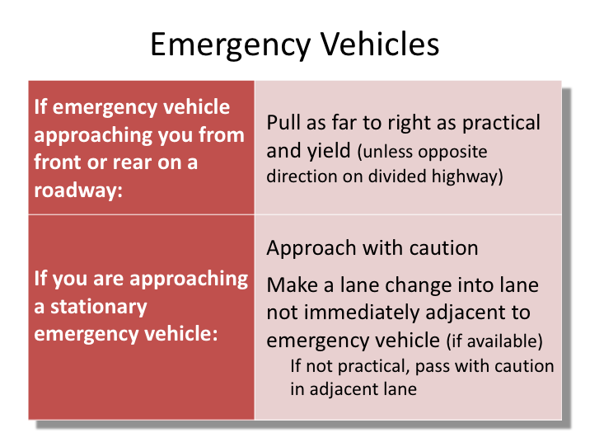

# EMERGENCY VEHICLES

Laws pertaining to commercial vehicles with regard to emergency vehicles along the roadway are no different than the laws pertaining to passenger vehicles with regard to the same. While each state has their own specific laws with how motorists are to respond to the presence of an emergency vehicle, they all are somewhat similar in nature. Basically you must always yield, and, if you must pass a stationary emergency vehicle, you should move as far away from it as possible and pass with caution.

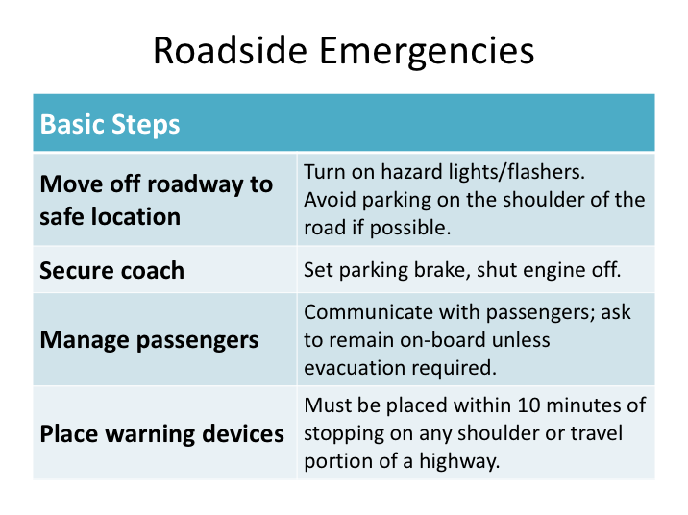

# ROADSIDE EMERGENCIES

There are a number of emergency situations within this module which could find the driver, coach, and passengers on the side of a roadway. Anytime a commercial vehicle is stopped on the side of the roadway, there are steps and procedures that should be followed to comply with Federal Motor Carrier Safety Regulations (FMCSRs). Additionally, steps must be taken to manage passengers and ensure safety in these situations. Rather than repeat these steps and processes for each emergency situation to which they could apply, we’ll detail the procedures to follow here once.

Whenever there is an emergency along the roadway, you must find a safe place to park, turn on your hazards/4-way flashers, and place your reflective warning devices/triangles. Certain emergency situations, such as a fire, may preclude placement of the reflective warning devices/triangles. Some emergencies are more time sensitive than others. In any emergency, you must remember to consider other traffic around you as you move to a safe location off the roadway.

**ROADSIDE EMERGENCIES (continued)**

**Move off the roadway to safe location.** Pull off the roadway and stop. The circumstances of the emergency will dictate how much time you have and options available in finding a location to stop the coach. Turn on your four-way flashers, and try to avoid abrupt changes in speed and direction that could make you a hazard to other vehicles on the roadway.

Avoid parking on the shoulder if possible. Try and find a rest area, parking lot, or other location well off the roadway that will accommodate the coach. Make sure the area chosen will support the weight of the coach. However, don’t risk additional danger if there is no other suitable alternative.

If you must park on the shoulder of the road, try to find a location wide enough so that you can pull completely off the travel lanes of the roadway. Avoid soft shoulders which may not support the weight of the coach.

Stopping within the traffic lanes should be a last resort. If you must do this, plan to park as far to the right as you can.

**Secure the coach.** Once the coach is stopped, set the parking brake, place the transmission in neutral or park, and shut the engine off. This may sound like an obvious step, but stressful situations sometimes cause drivers to miss the obvious, since you’ll be thinking ahead to the next steps. Leave the 4-way flashers/hazards on.

**Manage passengers.** If you have passengers on-board, you should briefly and quickly communicate with them what is happening and what the next steps are. If the situation does not require passenger evacuation, ask them to stay seated on-board.

**Place warning devices.** FMCSRs require that warning devices be displayed whenever you are stopped on the shoulder or travel portion of a highway for any reason other than normal traffic stops. The warning devices must be placed within 10 minutes of stopping. Specified locations of the placement of the warning devices depend upon the type of roadway the motorcoach is stopped on.

Always place 3 warning devices.
For a complete explanation of this slide, please view the text directly below the image.

# WARNING DEVICE PLACEMENT

Whenever you park on the roadway or shoulder, regulations require you to place warning devices in specific locations within 10 minutes. These required warning devices are more commonly referred to by drivers and companies as “emergency triangles”, or simply “triangles”. These warning devices, or a suitable alternative, are required by safety regulations to be carried on-board every commercial vehicle – you should verify their presence during the pre-trip inspection.

Specific placement of these warning devices is also detailed in the safety regulations. Placement in relation to the stopped commercial vehicle is dependent upon the type of roadway the vehicle is stopped on.

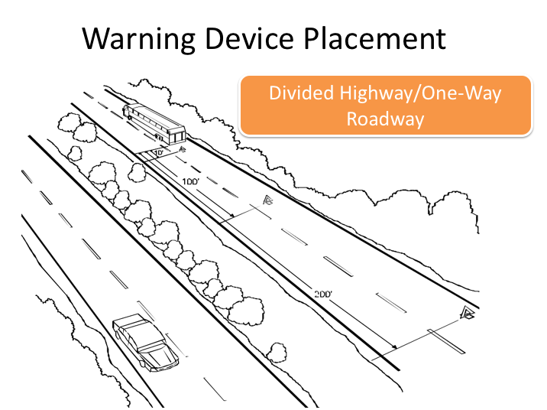

**WARNING DEVICE PLACEMENT (continued)**

*DIVIDED HIGHWAY/ONE-WAY ROADWAY*

On a divided highway or one-way road, place all three triangles behind the motorcoach. Place one triangle 10 feet behind the coach, another 100 feet behind, and the last 200 feet behind. This will give your approaching traffic plenty of warning so they can avoid your disabled vehicle.

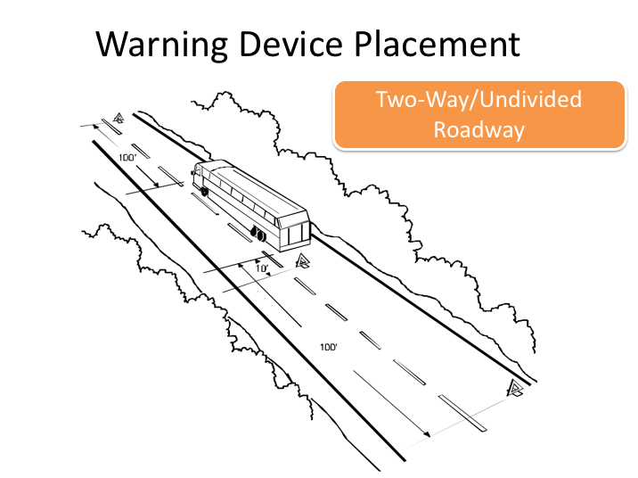

**WARNING DEVICE PLACEMENT (continued)**

*TWO-WAY/UNDIVIDED ROADWAY*

On roads with two-way traffic, place one triangle in front of the coach and two behind. One should be 100 feet ahead of the coach, a second should be 10 feet behind the coach, and a third should be 100 feet behind. The one ahead of the coach should be placed last. This placement applies to all roads with two-way traffic and no center divider, no matter how many lanes they have.

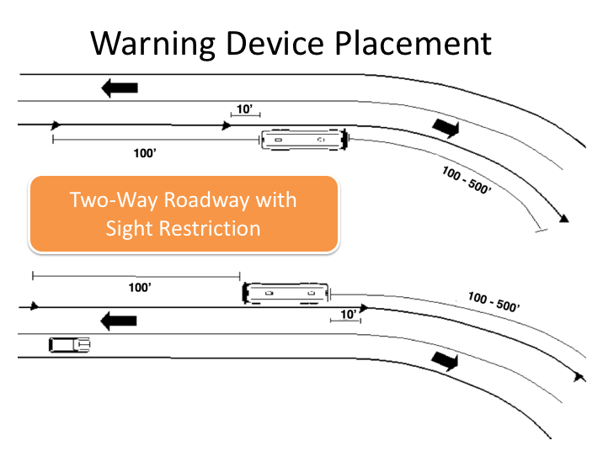

**WARNING DEVICE PLACEMENT (continued)**

*TWO-WAY ROADWAY WITH SIGHT RESTRICTION*

If your motorcoach is stopped within 500 feet of a curve, crest of a hill, or other sight obstruction that would prevent oncoming traffic from seeing your parked coach, the triangle on the side of the obstruction may be placed anywhere between 100 and 500 feet from the coach. In general, the faster the traffic is moving, the further away the triangle should be placed.

Notice that the curve, hill crest, or other sight obstruction may be behind the coach, as well as ahead of it. Either way, you have flexibility in the placement of the triangle that is closest to the obstruction. You may place it between 100 and 500 feet from the coach. The triangle ahead of the coach should be placed last.

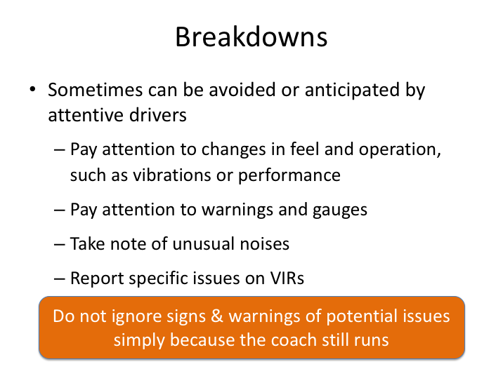

# BREAKDOWNS

Breakdowns can happen at any point during a trip.  Drivers tend to visualize the worse situations – a breakdown along a busy highway.  While this is certainly possible, it’s also possible that you could experience a breakdown at other points along a trip, such as when overnighting at a hotel.  And, while breakdowns do happen, they sometimes can be avoided by attentive drivers.

More important than the breakdown itself are coach symptoms which may indicate a pending issue.  Drivers must pay close attention to any symptoms or indications that the coach is not running normally.  When there are indications that something is wrong with the coach that could lead to a breakdown or safety issue, drivers should resist the temptation to try to “limp’ the bus home for service.

For instance, if you feel vibration or hear an unusual noise, try to localize it from the driver's seat. Then stop the coach in a safe location and inspect the coach to find the source of the problem.  There are many possible sources of vibration and noise, including a flat tire, loose wheel lugs, a failing driveshaft, a failing wheel bearing, or a wheel out of balance. Some of these causes are extremely serious;

**BREAKDOWNS (continued)**

others are easily fixed.  In any case – whether you think you’ve identified the source or were unable to - phone your company for further direction.  Many times, describing the symptoms you observed can help mechanics troubleshoot the problem and determine if it is safe to continue.

As always, drivers should detail specific issues and concerns experienced with the coach on vehicle inspection reports so that proper follow-up can be initiated.  Being as specific as possible is critical to assisting maintenance personnel in identifying potential pending problems and failures.

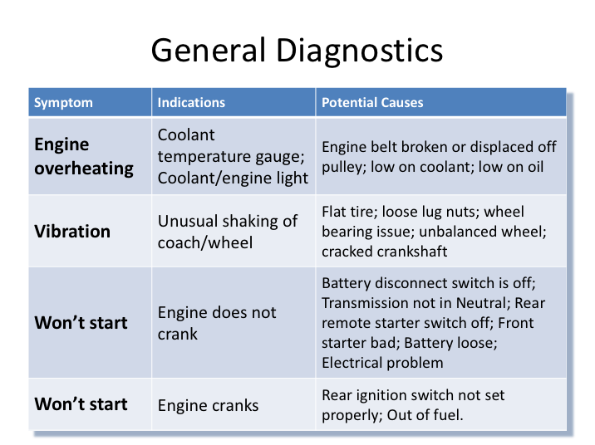

# GENERAL DIAGNOSTICS

Being a commercial motorcoach driver - especially an over-the-road driver - will occasionally morph to being a crude diagnostic mechanic.  Motorcoaches are complex machines, with hundreds of mechanical and electronic systems that occasionally act up, and even fail. You won’t learn to be a master mechanic, but you may learn a few ways to get the coach going again.  This table presents some basic mechanical issues and their potential causes.

 In many cases, you will not be able to determine, let alone fix the problem, and you will have to phone your company for further instructions. Maintenance staff is usually very good at troubleshooting issues over the phone – just remember, the more information you can provide them, the better the chance of them being able to determine the issue.

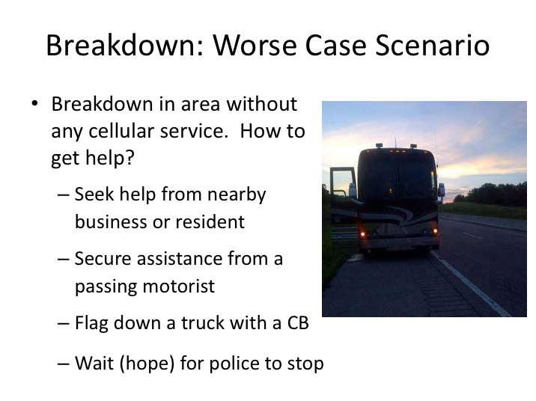

# BREAKDOWN: WORSE CASE SCENARIO

Breakdowns used to be a more complicated process than they are today. Before cell phones and on-board communication mechanisms, breakdowns would mean either you or someone on-board getting to a phone, or finding someone in passing willing to assist in relaying distress messages for you to the company. With today’s technology, those days are almost long gone. There are very few areas of the country where you or someone on board the coach would not have a cellular phone capable of reaching help. Additionally, some companies have systems on-board that provide for communication from the vehicle back to the company, either through cellular or satellite signals. Even better, electronic control systems on many of today’s modern motorcoaches may also have the ability to communicate information back to the mechanics at the shop, including trouble codes and similar diagnostic data that can be helpful in determining issues.

Nonetheless, Murphy’s Law strikes often. There still are potential areas where you could break down and have no cell phone coverage or other outside communication options. So, let’s review another almost-lost art – finding ways to get help, the old-fashioned way:

**BREAKDOWN: WORSE CASE SCENARIO (continued)**

**Seek help from nearby business or resident.** As the driver and company representative, you should always stay with the group and the coach. If there is a tour leader, he or she may be willing to access this help for you. If businesses or residents are not close by, you should move to the next option.

**Secure assistance from a passing motorist.** If you find a motorist willing to help, it’s best to provide them written, specific information to relay to authorities and your company. That information is: Company number to call; Who you are (driver, coach number); Where you are (mile marker, route, distance from town X); Brief indication of the coach issues/symptoms.

**Flag down a truck with a CB.** Standby method – CBs can reach help on dedicated police channels or network with each other to reach help. Additionally, truckers are very likely to want to help out another commercial vehicle driver.

**Wait for police to stop.** Chances are, if you don’t have cell service, just waiting for a police agency to roll by might be a long shot.

|  |
| --- |
| Clipart |

On the current slide, study the picture of a coach with a mechanical issue on the side of the roadway. Do you see anything that the driver could or should have done differently?

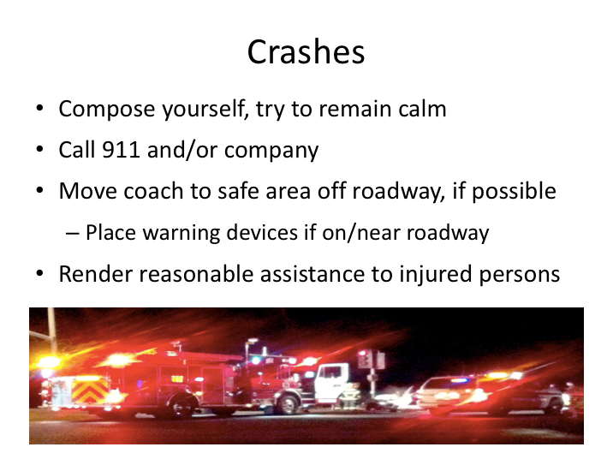

# CRASHES

One common type of emergency situation is a crash. Crashes vary greatly by type and severity, and protocols in various scenarios may differ by company. However, there are a few general guidelines that govern driver responsibilities in the event of a crash:

* Try to keep calm and assess the situation. Contact emergency personnel and/or your company as necessary.
* Be sure that the coach is safely parked and secured from rolling. If your coach is on the roadway and still operable, move it off the roadway and out of harms way. If your coach is on or near the roadway and cannot be moved, put out the reflective triangles to warn other motorists.  If the crash site cannot easily be seen by approaching traffic, it may be necessary to warn them.
* Render reasonable assistance to any injured persons. Keep injured persons warm and comfortable. At the same time, be aware of your own first aid abilities and limitations so that you do not cause more harm than

**CRASHES (continued)**

good. Find out if any of your passengers are trained in first aid. You should not move injured persons at the scene if moving them is likely to cause further injury.

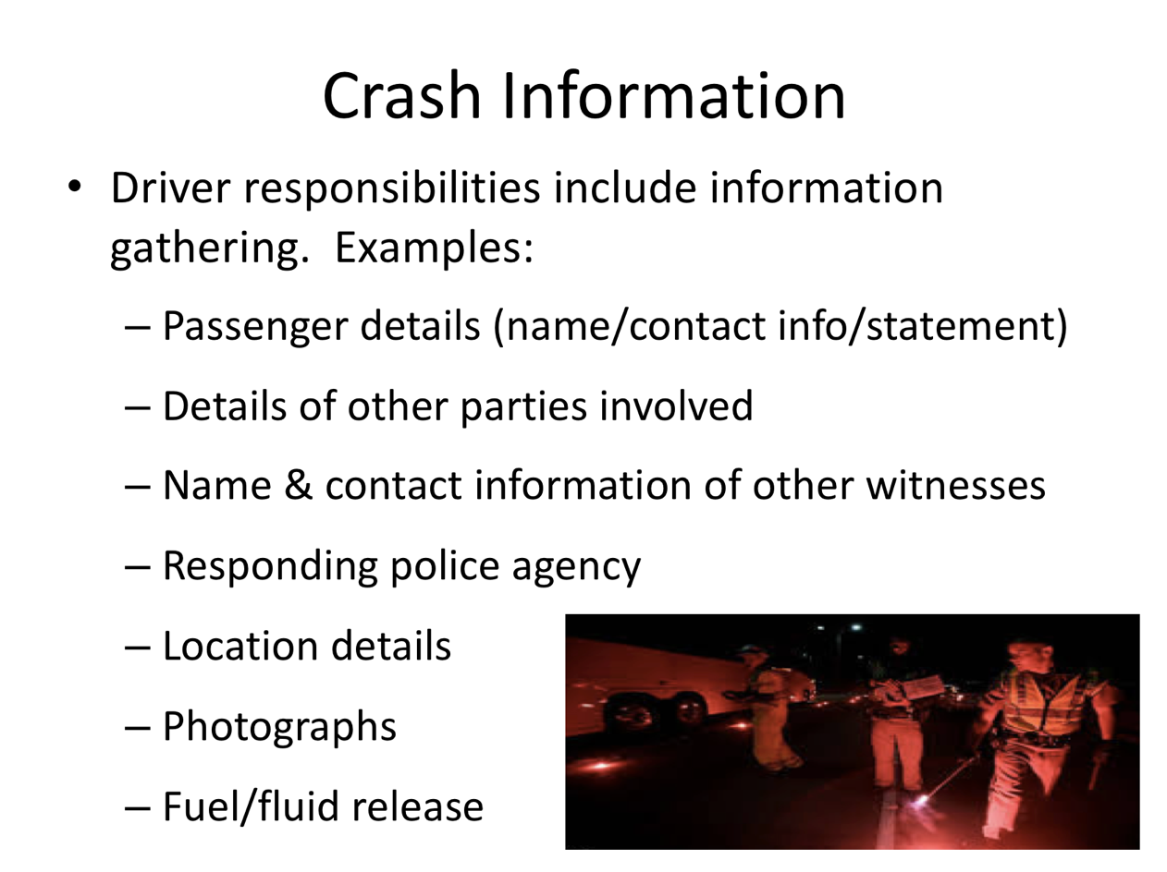

# CRASH INFORMATION

After any crash, your company will require you to provide specific information needed to properly document the incident as well as file an insurance claim, if necessary. While information required to be gathered may vary depending upon the type of incident (and likely the location), the following is an overview of common pertinent information:

* Passenger details – name, contact information, where seated, and statement if witnessed
* Details of other parties involved - the license numbers of all vehicles involved and detail of drivers and passengers
* Independent witness names and contact information
* Names of responding police agency and officers
* Location details – roadway, nearby identifying cross streets or markers
* Photographs – to document damages to vehicles and property, general area of crash and any other evidence (tire marks, debris fields, etc.)

**CRASH INFORMATION (continued)**

* Any environmental impacts/spills – any spill of fuel or other vehicle fluids needs to be contained and addressed. Report to your company with other information.

Remember that what you say can affect your company's (and your) liability. You should cooperate with police, but you should not discuss the crash with anyone else except company representatives. Follow company guidance with respect to any media inquiries.

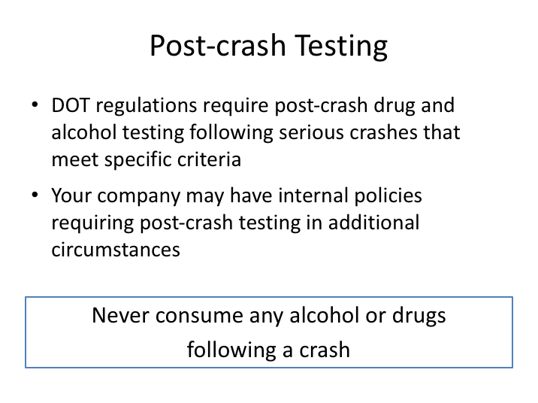

# POST-CRASH TESTING

Federal regulations require post-crash drug and alcohol testing following DOT-recordable crashes that involve a fatality or where a driver is issued a citation in connection with a crash involving injuries treated away from the scene or towing of an involved vehicle.  Additionally, company policies can require post-crash testing in other circumstances.

Remember to never consume any alcohol or drugs following a crash.

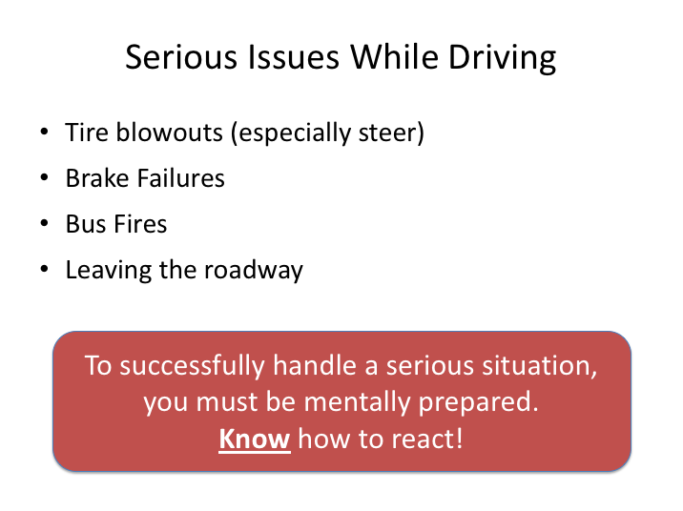

# SERIOUS ISSUES WHILE DRIVING

While any issue encountered on a trip has the potential to be serious, there are several incidents that almost always are. Though rare, you should be mentally prepared to handle even these tough situations.  These include: tire blowouts, brake failures, bus fires, and any condition that may cause you to leave the roadway.

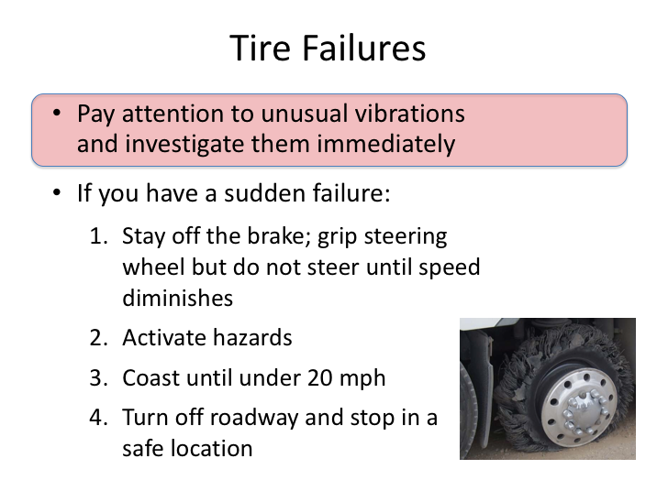

# TIRE FAILURES

Tire failures are rare occurrences when a motorcoach and its tires are properly maintained and inspected. Nevertheless, failures do occur. Tires usually leak air over time after developing a leak – perhaps from a road hazard or faulty valve stem. Many instances of tire failure will be forecasted; tire delaminations (tread separates from tire), and flat tires will typically cause vibrations immediately prior to failure.

However, catastrophic tire failures do occasionally occur. If you hear a loud “pop” while driving, followed by loss of control or vibration, you may have had a tire blow-out.  You should react the same to any suspected blowout.  A rear blowout will be harder to determine – the distant sound won’t be as loud, and the resulting vibration may even be very slight.  On the other hand, there will be little doubt if you have a steer tire blowout.  The sound will be much louder and obvious, as will the vibration and reaction of the coach.  The steering wheel will shake – sometimes violently - and will steer toward the side of the blowout, trying to pull the coach in that direction.

**TIRE FAILURES (continued)**

Your first reaction should be to grip the steering wheel tightly and stay off the brake. Do not try to turn off the roadway immediately - Activate your hazards, and let the coach coast until you are below 20 miles per hour; then, pull off the road and stop in a safe location, using the brake gently.  If you are having serious trouble controlling the coach with a steer tire blowout, accelerate slightly to try to stabilize the position and heading of the blown-out wheel.

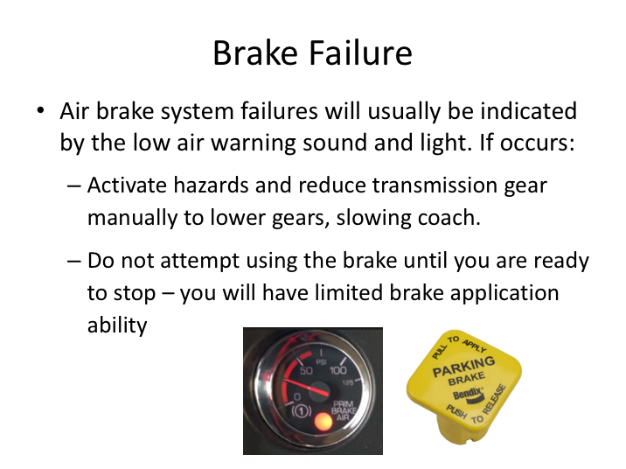

# BRAKE FAILURE

We’ve already covered one instance of brake failure in Module 8 – brakes that got too hot when over-used descending downhill.  But what should you do if your brakes fail under normal operating conditions?

Air brake systems that develop a leak in the air storage system are also designed to give you warning when they are failing.  The low air pressure signal will sound in the cab, and you will see the diminished air pressure reading on the dashboard gauge.  This usually comes on at about 60psi; giving you some time to reduce your speed and get off the roadway.  Here’s what you should remember – once this occurs, you should only brake when you are ready to stop.  The system will usually have air stored near brake chambers that hopefully will remain until you are ready for a brake application.  If you experience air pressure loss, activate your hazards, reduce your speed using manual downshift of the transmission gears. Once your speed is reduced to under 20 mph. move off the roadway if possible and attempt the brake application.

Catastrophic failures of an air brake system are rare. However, if a catastrophic failure of all air pressure in the system occurs, the parking brakes will generally

**BRAKE FAILURE (continued)**

engage, resulting in a very abrupt stopping of the rear wheels.  If this occurs, if possible, steer gently off the roadway, but do not make any abrupt steering inputs.

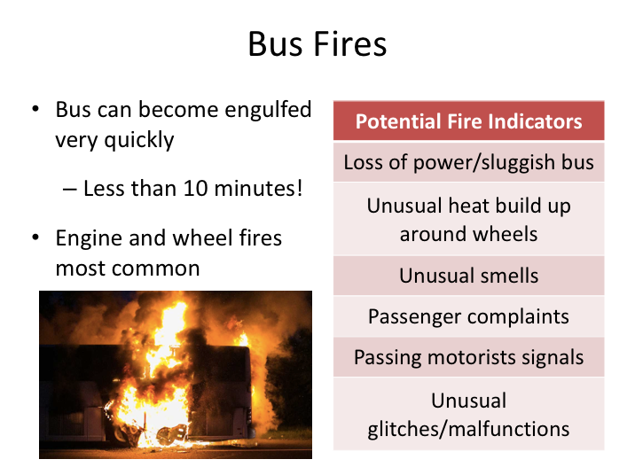

# BUS FIRES

Tire failures are one potential cause of bus fires. Many times, bus fires are not detected until they are out of control. Bus fires can be very dangerous, especially in the event of a fully loaded motorcoach. Drivers need to know bus fire signs and symptoms, pay attention to them, and, if there is a fire, know how to decisively react.

A 45 foot motorcoach can become fully engulfed in flames from a fire in less than 10 minutes. In a fire situation, time is of the essence. Drivers should not be fooled into any sense of security by a fire suppression system, which many modern motorcoaches are equipped with. While these suppressions systems go a long way in detecting and controlling fires in certain areas of the vehicle, they will not prevent a fire, and cannot control one in all instances.

**BUS FIRES (continued)**

There are various causes for bus fires, but the majority of bus fires start in either the engine compartment or at a wheel. Here are some of indications that you may have a potential fire issue:

* Loss of power – engine turbo charger failures have been responsible for many bus fires. When a turbocharger fails, the bus will still run, but will feel sluggish and lack power, especially under load (up hills, etc.)
* Unusual heat around wheels – wheel bearing, brake, or tire-related issues that can result in a wheel fire will be indicated by abnormally high temperatures in the wheel area.
* Unusual smells – localized unusual smells from arcing or burning electrical components, or even burning or smoke-related smells coming through the HVAC system.
* Passenger complaints/alerts – passenger complaints of unusual smells - especially in the rear of the coach, far away from the driver - should never be ignored.
* Passing motorist signals – motorist traveling behind a bus are usually able to observe signals of a fire, or pending fire, long before the driver. If you see passing motorists waving or pointing toward the back of the bus, pull over to investigate.
* Unusual functioning - strange malfunctions, such as loss of cabin heat, or other irregular glitches, may be indication of an electrical or fire issue.

Ironically, pulling over to investigate a potential fire can actually accelerate fire development because stopping the coach removes air movement that may be temporarily keeping the fire from propagating. However, this is no reason to not investigate a potential fire.

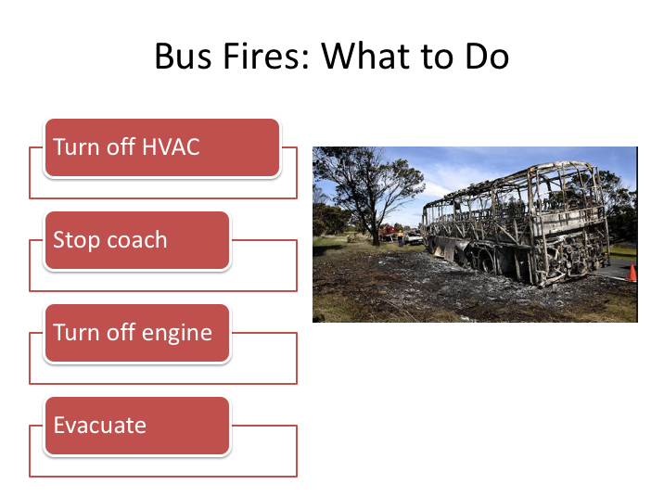

# BUS FIRES: WHAT TO DO

For as catastrophic as they can be, the steps to reacting to a bus fire are very straightforward and simple. **Remember, time is of the essence** and you must be prepared to act quickly.

The order of the first couple steps outlined may vary, depending upon when you realize you have a fire.

1. **Turn off HVAC systems** – this will help limit any unnecessary smoke introduction into the passenger cabin.
2. **Stop coach ASAP** – If you haven’t done this already, this would be a good time. Shutting down the engine can assist in slowing some fires, but you should never do this unless you are safely off the roadway and in a position to evacuate.
3. **Turn off engine ASAP** – fires are fed by a fuel component. If you are experiencing an engine fire, it’s very possible that there is a fluid line leaking/compromise that is fueling the fire. Turning off the engine will reduce fluid circulation, limiting continuity of fuel supply and slowing fire propagation.

**BUS FIRES: WHAT TO DO (continued)**

1. **Evacuate**. Immediate evacuation of passengers on the coach in a fire situation is essential. Principle steps for an evacuation are the same, but urgency is necessary. In the event there are any non-ambulatory passengers on-board, the wheelchair lift may not be operational or may be close to the fire source. Even if available, operation of the lift may take too long. In this situation, ask other passengers to assist you in getting the non-ambulatory passenger(s) off of the coach.

Ensure your passengers move far enough away from the coach and upwind of any smoke after evacuating. Only then should you consider trying to use a fire extinguisher or other manual fire-fighting apparatus to try to control or put out a fire (un-triggered fire suppression systems, if located near the fire, should be deployed manually at first instance of fire).

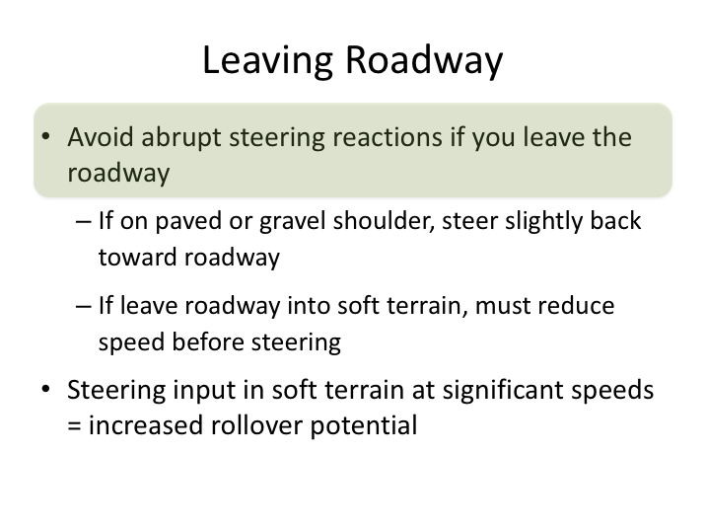

# LEAVING ROADWAY

If, for whatever reason, your coach leaves the roadway, you must be calm in your reaction.  Unexpected movement off the roadway often results in abrupt over-reactions that can cause loss of control and potential overturn.  If you are on a paved or gravel shoulder, steer gradually back toward the roadway.  If you end up in a soft-earth median or shoulder, you should not try to steer back to toward the roadway until you have reduced speed.  Soft terrains are very difficult to steer out of – if you attempt to steer with any significant speed on a soft terrain, there is significant risk of rollover.

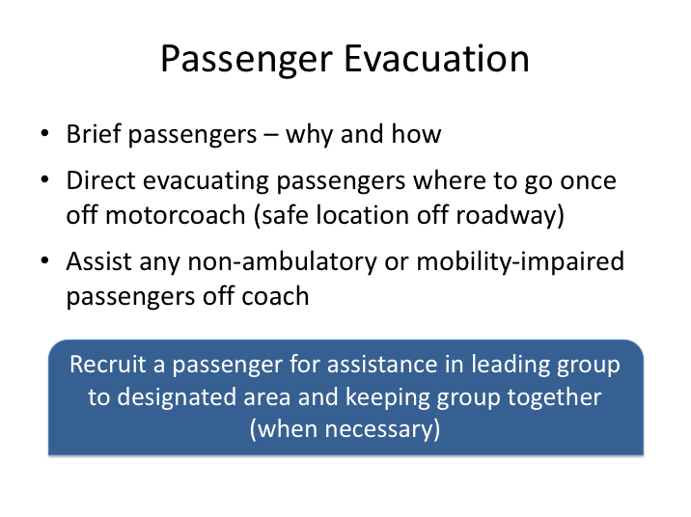

# PASSENGER EVACUATION

Some emergency situations, such as a fire, will require you to evacuate the passengers from the coach. In some cases, speed of evacuation will be important; in other situations, the need will be less urgent. In many situations - especially those where passengers could be exposed to other dangers, such as traffic on the roadway - it is preferable to keep passengers on the bus.

These are the general steps in evacuation of the coach:

* The first step is to brief the passengers. You should tell them the nature of the problem and provide instruction to exit. If exits other than the service door are necessary, provide additional instruction and assistance. Instruct them to stay together in a group.
* Direct passengers where to go once off the motorcoach. Choose a safe location off the roadway. It will be helpful to recruit a passenger(s) to assist you leading passengers to the designated location while you oversee evacuation. You may also wish to take a passenger count so you can keep track of passengers. Direct passengers to stay together.

**PASSENGER EVACUATION (continued)**

* If they must walk along the roadway, advise them to walk single file, as far off the travel lanes as possible.
* Provide assistance to any non-ambulatory or persons with mobility impairments.

|  |
| --- |
| Clipart |

In some emergencies, you may have to use the emergency exits. Besides the marked emergency exits on a motorcoach and the main service door, what is another potential exit?

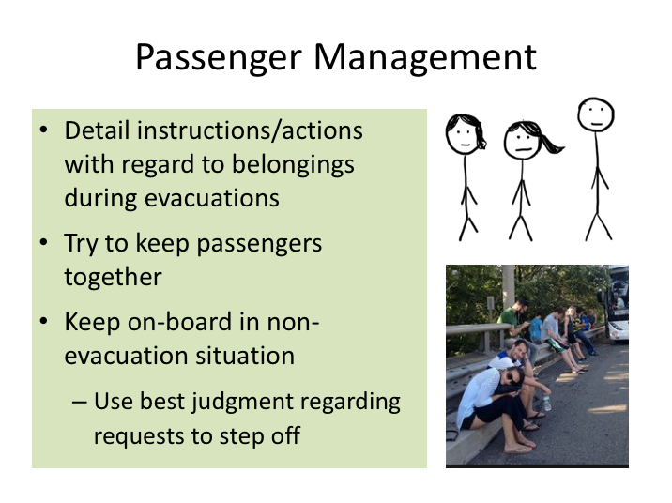

# PASSENGER MANAGEMENT

There are two types of evacuations:

1. Emergency. This is a situation, like a fire on the coach, when it is critical to get everyone off as soon as possible.
2. Controlled. In this situation, there is not an immediate danger to the passengers.

Remember during instructions to detail urgency, and how this relates to passenger belongings. Passengers naturally want to take their belongings with them, even in an emergency. While you can control access to the items underneath the motor coach, the passengers will have access to their other belongings inside the coach. When it is an emergency evacuation, you must specify to leave all belongings. Passengers trying to gather belongings will slow the evacuation process.

In a controlled evacuation, there is less urgency and they may have time to gather some belongings. Even in a controlled evacuation, you may want the

**PASSENGER MANAGEMENT (continued)**

passengers to get off without delay. So, they will be able to take only those items that they can gather quickly. If you have more time - for example, you are evacuating because the coach has become too hot or too cold to wait on-board - the passengers will have time to take off whatever they carried on.

Try to keep an eye on passengers as they move from the coach toward the designated location. It’s desirable to keep them together so that you can continue to account for them until help arrives. This will be much easier if they are on a group charter and know each other than if it is a coach full of unrelated passengers.

Depending on the situation, it may be preferred to delay a controlled evacuation until you place your warning devices/triangles and can concentrate on monitoring the evacuation process.

As stated earlier, the general preference is to keep the passengers on-board unless there is a need to evacuate. That said, there will be times where drivers must make judgment calls with regard to permitting passengers off the vehicle during non-evacuation situations, such as when a relief bus or mechanic will take a significant time to arrive, or if the bus is uncomfortably hot. There is no way to address every situation, so drivers will have to your best judgment in allowing passengers off to smoke, retrieve something from luggage bay, etc.

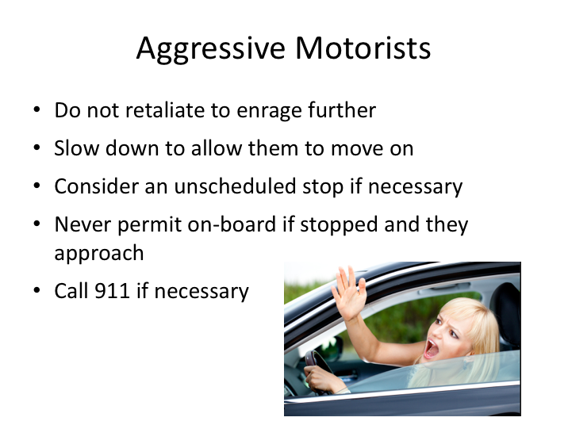

# AGGRESSIVE MOTORISTS

Road rage is a growing problem on our highways. Learning how to deal with road rage can help you sidestep the dangerous nightmare that often follows an aggressive road rage incident.

If you encounter a driver who is enraged about your behavior or actions, slow down to allow them to get by you or move on. Only in the worst cases will an enraged driver want to slow down to continue to show their displeasure. If that happens, and the driver is intent on intimidating you, consider making an unscheduled stop and proceeding to a safe haven, such as a police station or firehouse. Do not try to talk with an enraged motorist.

You must realize that you can't control another driver's behavior, but you can control your own. When another driver cuts you off, how you react will determine what happens next. If you are able to back off, take a deep breath, and remain calm, then you can defuse a potentially violent situation. Never retaliate – it can only make the situation worse and jeopardize your and your passengers’ safety.

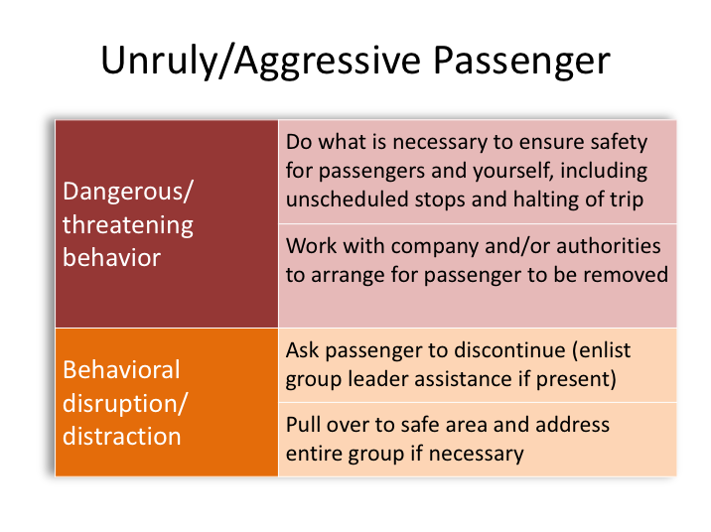

# UNRULY/AGGRESSIVE PASSENGER

Every once in a while, you are faced with a noisy or rowdy passenger who is distractive to the rest of the passengers and to you. Your total attention to the driving task is far too important for repetitive distractions because of one or a few passengers.

There are three categories of these disruptive passengers:

1. Threatening disruption – This passenger is a concern because of the threatening manner in which they are acting toward the driver or other passengers.
2. Behavioral disruption – This passenger’s conduct on the coach and interaction with others is disruptive to your concentration. Examples would include rolling objects down the aisle, jumping around the coach and seats, and throwing things about.
3. Social disruption – This passenger(s) are simply engaging in conversation with you. They are not distractive; they are only trying to be sociable.

**UNRULY/AGGRESSIVE PASSENGER (continued)**

The threatening disruption is the most dangerous, so let’s discuss how to handle it.

For the threatening disruption:

* Work with your company and/or the authorities to have him/her removed from the motorcoach. This passenger could be dangerous – if there are any threats, you should discontinue the trip until he/she is off the coach. Options include arranging for authorities to be present at the next scheduled or unscheduled ‘rest stop’ to remove the passenger.

If there is any type of hijacking or hostage situation, you should do what you can to ensure the safety of passengers and yourself. Use any distress signals that may incorporated into on-board communication systems to alert your company and/or the authorities.

The behavioral disruption can also be a cause of concern because of severe distraction to the driver and required focus on safe driving.

For the behavioral disruption:

* Politely, but firmly, ask the passenger(s) to discontinue whatever it is that is distracting; if this is not effective, ask the group leader (if there is one) to attend to the distracting situation;
* If necessary, pull over to the side of the road to an area that is protected from moving traffic, and address the entire group directly about the distractions and what should be done so that you can continue to drive safely;
* If all else fails, consult with your management and, if in consensus, remove the disruptive/unruly passenger(s) from the motorcoach.

|  |
| --- |
| Clipart |

So, we’ve talked about the dangerous situations and about that socially disruptive passenger. This type of distraction is the most likely to occur. How would you handle that person(s)?

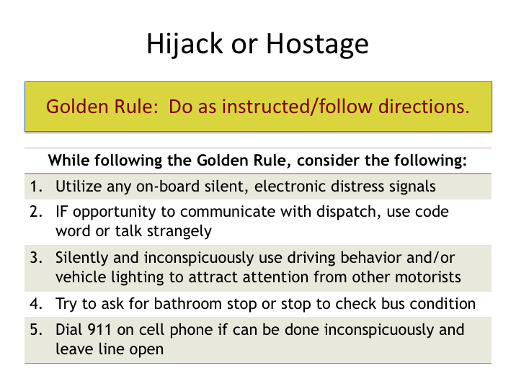

# HIJACK OR HOSTAGE

While the likelihood is extremely remote, there have been instances where a motorcoach has been hijacked or been involved in hostage situations with an armed passenger. In this situation, there is one golden rule: Keep calm & do as instructed. Do not be a hero and jeopardize your safety or the safety of your passengers unnecessarily.

While following the golden rule, there are several ways to try to get help with the situation. If there are other passengers on-board that are not involved in the hijacking or hostage, it’s very likely one of them will discreetly call 911 (if able) on a cell phone to alert authorities. In the meantime, there steps you can take to garner attention and potentially slow down the situation.

1. Utilize any electronic distress signals incorporated into the bus communication systems to alert dispatch of issues. If you have such a system, this should be sufficient to get responders to you.
2. If asked to communicate with dispatch, use any special emergency code word provided to indicate an emergency or talk strangely without being obvious to raise concern with dispatch.

**HIJACK OR HOSTAGE (continued)**

1. Try to silently and inconspicuously garner attention and concern from other motorists or even passing police personnel in the hopes they take some action. Examples include flashing headlights on and off, weaving slightly as if you were intoxicated, or driving unusually slow or fast.
2. If you have a way to dial 911 on a cell phone without the threat noticing, do so even if you can’t talk directly into the phone.
3. Try to find a way to get the threat to allow you to stop the coach – perhaps a personal bathroom break or to investigate a (phony) vehicle issue. Any stop will buy time and allow you or others to potentially alert others of the dangerous situation.

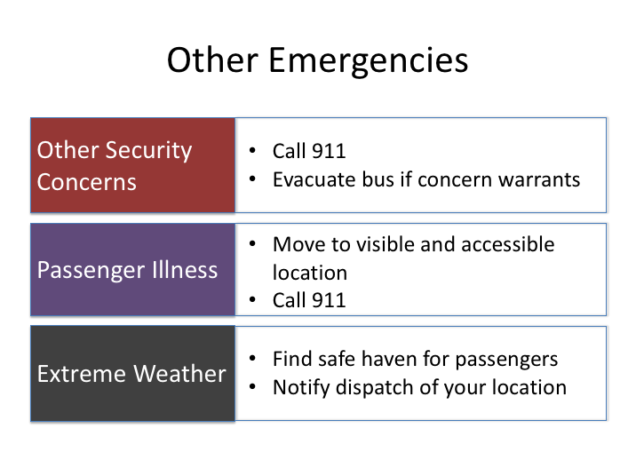

# OTHER EMERGENCIES

There are many other types of emergency situation that can pop up during a trip. Here are a few and steps you should take as a driver.

* **Other Security Concerns**. If you witness a security incident or see something that concerns you, contact 911 and provide details so your concerns can be investigated. If the concern involves your motorcoach, make sure all passengers are evacuated and in a safe location before you call. Do not resume the trip until your concerns with the coach are alleviated.
* **Passenger Illness.** If you have a passenger fall ill, makes sure the bus is in a visible and accessible location for emergency responders and call 911.
* **Extreme Weather.** Hopefully you’ll never be caught off guard by unexpected weather. However, if you experience extreme weather, such as a tornado, find a safe haven for your passengers. These include commercial structures suited for large crowds, such as hotels.

**EMERGENCY SITUATIONS**

**QUIZ**

1. If an emergency vehicle is approaching you from the rear, you should:
2. Stop right where you are
3. Pull into the next available driveway
4. Pull as far to the right as practical and yield
5. Continue driving as normal
6. None of the above
7. Unless otherwise necessary, it is preferable to keep passengers on-board the coach in any breakdown situation.
8. True
9. False
10. Most bus fires start:
11. At the electrical/fuse panel
12. In the engine
13. Near the batteries
14. At a rear wheel
15. Both B & D
16. Both A & B
17. On roads with two-way traffic (undivided roadway), place one triangle in front of the coach and two behind.
18. True
19. False
20. Whenever you park on the roadway or shoulder, regulations require you to place warning devices in specific locations within what time frame:
21. 5 minutes
22. 10 minutes
23. 15 minutes
24. 20 minutes
25. 25 minutes
26. If you breakdown in an area without any cellular service, what are your best options for getting help?
27. Seek help from nearby business or resident
28. A, C & D
29. Secure assistance from a passing motorist
30. Flag down a tractor-trailer
31. Wait for police to come by
32. If a crash does occur, you should cooperate with the police and discuss the crash with anyone else that has questions for you.
33. True
34. False
35. If a tire fails, do not brake immediately.
36. True
37. False
38. A 45-foot motorcoach can become fully engulfed in flames from a fire in less than 10 minutes.
39. True
40. False
41. If a bus fire does occur, you should:
42. Turn off HVAC systems
43. Pull off to side of road and Stop ASAP
44. Turn off engine ASAP
45. Evacuate
46. All of the above