# Special Driving Conditions

|  |  |  |
| --- | --- | --- |
| Caution - Heavy Fog | Traffic | Lights |

**Purpose:**

The purpose of this training module is to review specific driving situations that deserve special attention due to the hazards presented. You will understand the additional hazards posed during these driving situations and learn how you can respond to minimize the chance of collisions and other incidents.

**Module Overview:**

This training module contains two classroom lessons and one optional at-vehicle exercise. The first lesson reviews driving hazards related to adverse weather and may include hands-on following the classroom training. The second lesson provides awareness of additional hazards related to some other specific driving scenarios that motorcoach operators will experience.

Lesson 1: Adverse Weather

Lesson 2: Special Driving Situations

LESSON 1

ADVERSE WEATHER

**Lesson Objectives:**

By the end of this lesson, you will understand additional risks posed by various adverse weather scenarios. A review of the steps to take to help manage additional risk will be provided so that they can be utilized when operating in these environments. You will also learn how to put on tire chains/socks for carriers that operate in areas and climate where these may be required.

**Instructional Methods**: Classroom and at-vehicle exercise (optional)

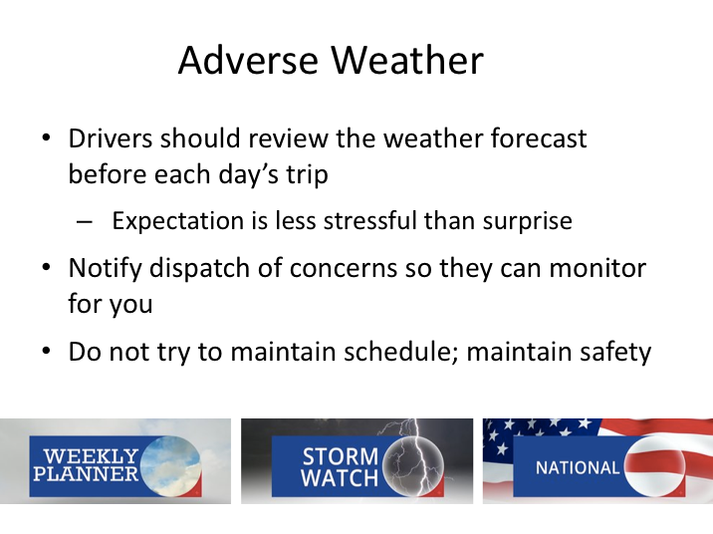

# ADVERSE WEATHER

As a commercial driver, you should be keenly interested in weather and weather patterns because they can affect your trip and safe operation. You should be watching the weather for every trip you operate - whether it’s a short single day trip or transfer, or a multi-day charter or tour. Part of being able to handle stressful situations is being prepared for them ahead of time. Adverse weather can be stressful if you’re not expecting it, but if you are expecting it, you’ll be prepared to take the necessary precautions to drive safely through it.

As indicated in the trip preparation module, weather monitoring should be included in your trip preparation process. There are many ways to monitor weather and roadway conditions in any area of the country. For a local, one-day trip, it’s pretty simple - simply watch the news or check weather content on specialized channels or internet sites, such as the Weather Channel.

For longer, multi-day trips, it’s easiest to review weather forecasts for areas you intend to be operating the following day each night. This will give you the latest, up-to-date forecast. You also may be able to pick up weather information during a trip at intermediate rest stops and passenger pick-up points. If you have

**ADVERSE WEATHER (continued)**

weather concerns, be sure to notify dispatch so they can monitor this for you as well. They can monitor the changing weather conditions in real time, provide you updates as you continue your travels, and even make alternate plans if they see that there is potential for trip disruption.

If you encounter adverse weather, it will likely slow you down. And, while nobody likes to run behind schedule, passengers will mostly appreciate a safe driver and the comfort that your additional caution provides. Remember, slowing down for adverse weather is no different than slowing down for an unexpected crash. Schedules are based on normal weather conditions, speed limits, and traffic. If you are running late because of adverse weather, stay late.

|  |
| --- |
| Clipart |

How many different adverse weather conditions can you think of that would affect your driving behavior?

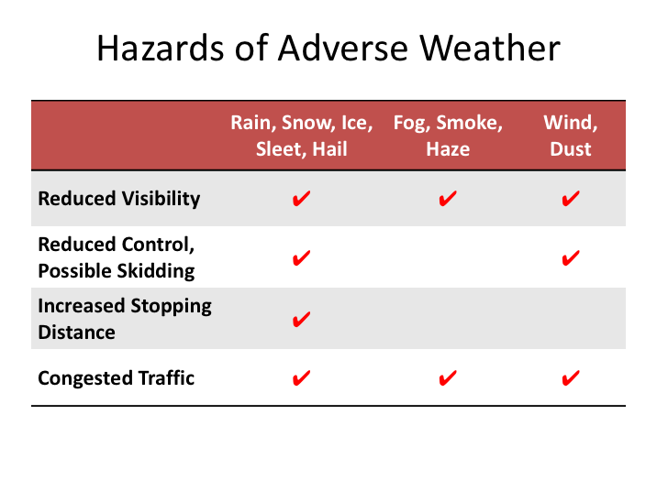

# HAZARDS OF ADVERSE WEATHER

When people think of adverse weather they often think of specific weather conditions – rain, snow, ice, fog, etc. Another way of defining adverse weather is any condition that affects your visibility, your vehicles handling, or both. As if worrying about visibility and vehicle control isn’t enough, there is an additional natural consequence to both of these adverse weather conditions that creates additional hazards - namely congested traffic.

This chart details the most common adverse weather conditions: rain, snow, ice, sleet, hail, fog, smoke, haze, dust, and wind. Notice that two hazards - reduced visibility and congested traffic - are common to all the adverse weather conditions.

Reduced visibility means that we can't see around us as well as we can under normal weather conditions. Congested traffic results from actions and inactions of motorists. In bad weather, most drivers tend to slow down, and some slow down more than others. This often causes vehicles to "bunch up" as faster-moving vehicles catch up with slower moving ones. Other drivers may over- or

under-react and do things they wouldn't otherwise be doing, like slowing suddenly or pulling off the road. They may even lose control of their vehicles and start to skid if they haven’t taken proper precautions or are simply going too fast.

**HAZARDS OF ADVERSE WEATHER (continued)**

While you will be maintaining a safe following interval, some of the other drivers probably will not, and there will definitely be more traffic around you to monitor and be prepared to react to.

In addition to losing visibility during rain, snow, sleet, and hail, once the road is wet, snow covered or icy, you can expect that it will take longer for you to stop. Most drivers don't realize how much effect rain can have on traction. Some drivers who will slow down for snow and ice will maintain their speed up in the rain. This isn't a safe practice. A wet road can reduce traction significantly and increase your stopping distance. Wet roadways not only reduce traction but also can affect braking performance, and water covered roadways are especially dangerous to passenger vehicles whose tires may not be able to displace all the water underneath them, resulting in loss of control (hydroplaning).

Traction loss on wet roadways can be even more pronounced in certain climates. In areas where there is not a lot of rain, oils and other vehicle fluids tend to build up on the roadways as they are deposited from vehicles traveling over the road. When it rains, water is added to these deposits, resulting in a very slippery roadway immediately after the rain commences. If it continues to rain, this slippery condition eventually dissipates as the oily water is washed away. However, if it is a short rainfall, these fluids can remain on the surface of the roadway for longer periods.

Ice and sleet are much worse. Under the best of conditions, ice and sleet will leave you with only 15 percent of your normal traction.

Wet, snowy, and icy roads will also increase the chances of a skid. When your wheels start to slide over the road instead of roll over it, you essentially lose the ability to steer and stop, which is a position you don’t want to find yourself in!

In high winds, you can lose control in a different way. The wind may make it difficult for you to keep the coach in the lane, or otherwise get the coach to go exactly where you want it to. Winds have physically blown over semi-trailers and can exert enough force on large surface vehicles (large side surface areas, like motorcoaches and box trailers) to forcefully move a vehicle off its path.

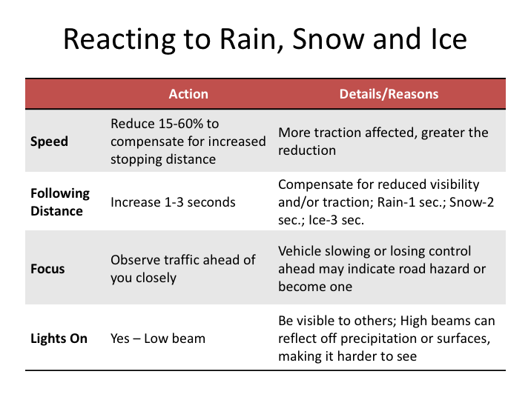

# REACTING TO RAIN, SNOW AND ICE

There are several steps to take to react to rain, snow, and/or ice (ice includes hail or sleet for these purposes). The first step is to reduce your speed to compensate for the increased following distance. The more traction is affected, the greater your reduction in speed should be – guidelines call for reductions of 15 to 60%.

You should increase your following distance due to reductions in visibility and/or increases in stopping distance. The typical following distance at highway speeds in normal conditions is 5 to 6 seconds – you would add at least one second to this for rain conditions, two seconds for snow conditions, and three seconds for ice conditions.

*Remember, these are only guidelines*. If the rain, snow, ice, or sleet is heavy, you will need to reduce you speed even more. In fog, smoke, and dust you would reduce your speed depending upon how far ahead you can see. We'll talk about sight intervals more in a minute.

**REACTING TO RAIN, SNOW AND ICE (continued)**

Rain, snow, ice, and sleet on the road increase your stopping distance by reducing your traction. But there is another way that adverse weather can increase stopping distance. When driving in rain or standing water, your brakes can get wet. When that happens, their stopping power can be greatly reduced, or they may apply unevenly, possibly causing a skid. This is more prevalent in drum brake systems; modern disc brakes tend to dissipate the water better. If you can avoid driving through standing water, do so. If you cannot avoid standing water, your brakes may get wet, resulting in increased stopping distances until they dry.

In all of these conditions, you should observe traffic ahead of you closely. If you see vehicles ahead slowing or losing control, this may indicate the presence of a road hazard (perhaps something in the roadway), an especially dangerous patch of ice, or the vehicles themselves could be turning off or losing control and could become a road hazard to you.

Drive with your low beams on so you can see, and others can see you. While use of your high beams in reduced visibility situations seems logical, it could actually work against you. High beams can reflect off precipitation and wet surfaces, causing glare that can further degrade visibility.

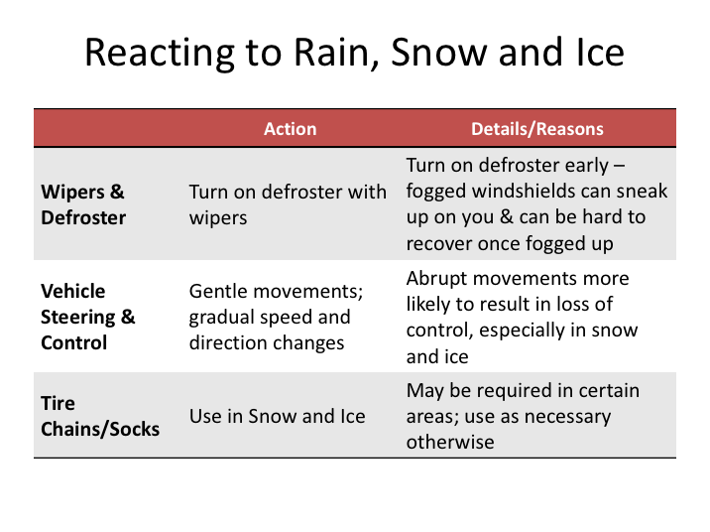

**REACTING TO RAIN, SNOW AND ICE (continued)**

To improve your visibility in the rain, snow, ice, and sleet, you will probably be using your windshield wipers. But also remember to turn on your defroster. Be sure to do this early – a fogged windshield can develop so gradually that you do not notice it until there is a real problem with visibility, and the defroster can take time to clear it up!

Steering inputs, as well as throttle and brake applications, should be gentle in low traction situations. Do not attempt to make quick changes in speed or direction. Speed up, slow down, and turn the steering wheel smoothly and gradually.

For drivers in northern areas and mountainous states, snow is a more common adverse weather condition. Make sure you have tire chains on-board when the weather forecast indicates potential snow. You must carry tire chains at certain times of the year in some states and areas and are required to use them when posted. Utilize chains when required and as necessary depending upon traction. Be sure to also have proper personal outerwear (including headgear, boots, and gloves) that would permit you to install tire chains under adverse conditions.

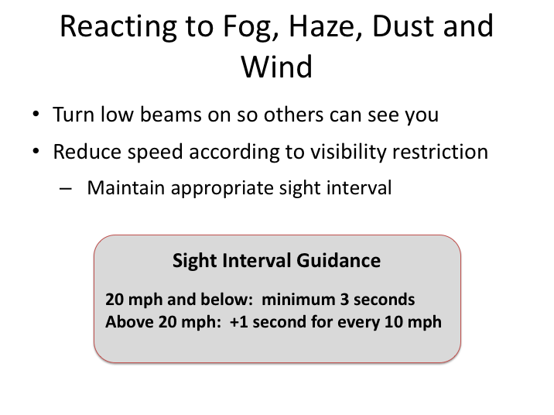

# REACTING TO FOG, HAZE, DUST AND WIND

What if you don’t have reduced traction or stopping ability, but you can’t see quite as well because of fog, haze, smoke, or dust/wind? Of course, you must also increase your following distance whenever weather conditions reduce your visibility. But, the idea of maintaining safe sight intervals is a little different from maintaining safe following distances.

You already know that, to maintain a safe *following distance*, you measure the number of seconds between you and the vehicle ahead. To maintain a safe *sight interval* in poor visibility, you measure the number of seconds it takes you to reach the furthest fixed object you can see along the road. For example, a road sign appears out of the fog and you count the number of seconds until you reach it.

Minimum sight interval guidance when visibility is an issue is detailed on this slide. At 50 mph you should be able to see at least 6 seconds ahead. If you cannot, drop your speed to 40. Can you see 5 seconds ahead at 40 mph? If not, drop your speed further. If you drop your speed to 20 and you cannot see at least 3 seconds ahead, find a safe place to park until visibility improves (if you haven’t decided to do that already).

**REACTING TO FOG, HAZE, DUST AND WIND (continued)**

When you are driving in poor visibility conditions, keep checking to see how many seconds ahead you can see. Then, adjust your speed as needed.

You probably are asking yourself, "What do I do when I'm driving in weather with *both* poor traction and poor visibility?" The answer is this: Follow the guidelines for poor traction and then verify that you have necessary visibility. For example, let's say you were driving in a snow storm. The guidelines say you should allow at least a 7-second following interval. This may be fine, so long as you can *see* a vehicle that is 7 seconds ahead. If it is snowing hard enough that you cannot, slow down until you have a 7-second sight interval.

**EXERCISE**

Depending upon company operations you may learn how to install tire chains.

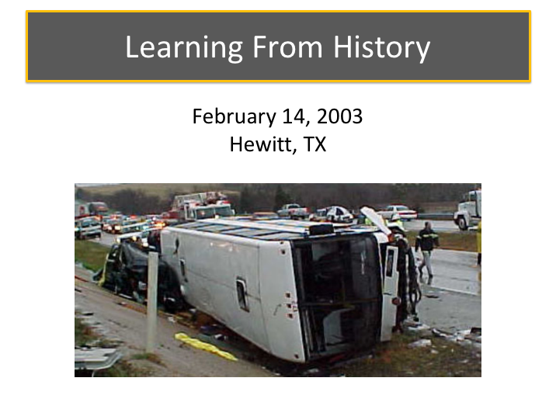

# LEARNING FROM HISTORY

Inclement weather, reduced visibility, and slippery roadways that often result from inclement weather require adaptive driving techniques to maintain safe operation of the motorcoach.

A crash that occurred on February 14, 2003, in Hewitt, TX, illustrates the dangers of reduced visibility and poor conditions without maintaining proper following distances or sight intervals.

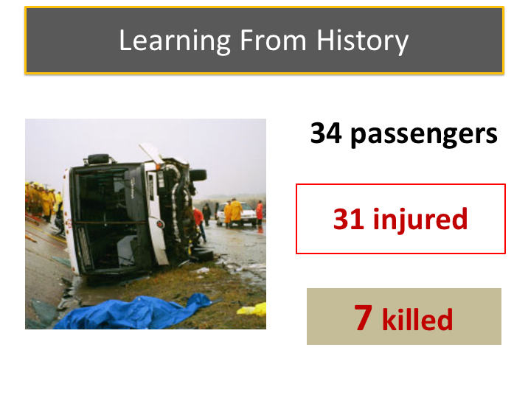

**LEARNING FROM HISTORY (continued)**

On February 14, 2003, about 9:59 a.m., a motorcoach carrying 34 passengers was traveling northbound on Interstate 35 near Hewitt, Texas. The weather was overcast with reduced visibility due to fog, haze, and heavy rain.  As the motorcoach approached the crest of a hill, the bus driver said he observed brake lights ahead of him and began to brake lightly.  He then noticed that traffic ahead was nearly stopped and he moved toward the left lane, which was not backed up as far, so he wouldn’t have to brake as hard.  As he moved from the right lane into the left lane, another vehicle ahead of the bus also moved over, so he braked harder and the rear of the bus skidded. The bus driver was unable to maintain control of the bus as it departed the left side of the roadway, crossed the grassy median, entered the southbound lanes, and collided with a Chevrolet Suburban occupied by a driver and two passengers. The motorcoach then overturned on its right side, rotated, and slid to final rest facing south against a concrete embankment on the side of the road.

Five motorcoach passengers, the Suburban driver, and one Suburban passenger sustained fatal injuries. The bus driver sustained serious injuries and was ejected, along with sixteen other passengers; the remaining passengers on the bus and in the Suburban sustained injuries ranging from minor to serious.

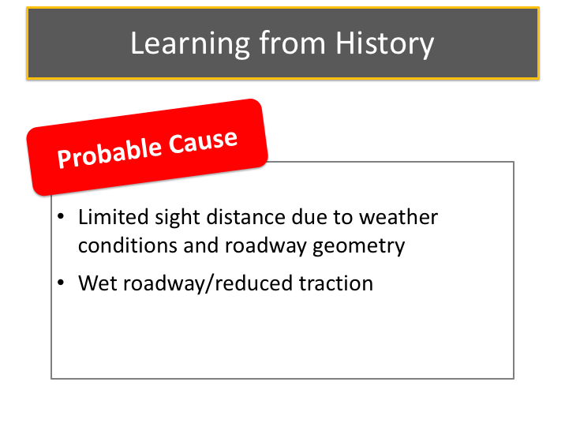

**LEARNING FROM HISTORY NARRATIVE (continued)**

The ensuing National Transportation Safety Board (NTSB) investigation determined that the motorcoach was traveling approximately 60 mph in the 70 mph zone.  Rain was heavy and visibility significantly reduced due to a combination of rain and fog in the area.  A witness traveling through the area just before the accident described the rain as being heavy, with visibility reduced to about 500 feet. Another witness described the rain as being “really hard.” Another accident had occurred about 1.5 miles ahead of the location of this crash; traffic had slowed and backed up due to this other crash.

The NTSB determined that the probable cause of this accident was the roadway’s limited sight distance and its poor conditions in wet weather; as a result, the bus driver was unable to detect the stopped vehicles as he approached the traffic queue and lost control of the motorcoach due to low pavement friction. Exacerbating the poor roadway conditions were the minimum tread depths on the motorcoach’s drive axle tires.

**LEARNING FROM HISTORY NARRATIVE (continued)**

|  |
| --- |
| Clipart |

What could have been done to prevent this crash?

LESSON 2

SPECIAL DRIVING SITUATIONS

**Lesson Objectives:**

By the end of this lesson, you will understand the potential risks of a few specific driving environments and situations. Practical tips on managing these environments will be conveyed to lessen the chance of collisions or incidents within these environments and situations.

**Instructional Methods**: Classroom

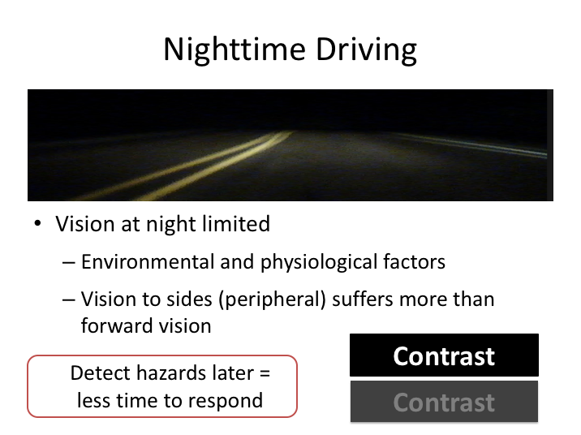

# NIGHTTIME DRIVING

The most fundamental reason why driving at night is more challenging has to do with our physical limitations as drivers. People in general have limited night vision – we just can’t see as well at night as we can during the daytime. Our central vision (forward) is hampered, and our peripheral vision (to the sides) drops off even more. At night, hazards tend to be first detected much closer to the vehicle, and later detection means we have less time to react to the hazard.

Typically, ideal hazard recognition occurs when we look at least 12 to 15 seconds down the highway; this is generally easier to accomplish during daylight, and drivers who practice this are able to recognize hazards and react to them appropriately to avoid them. This kind of defensive driving technique is much harder to apply at night. At night, we rarely drive on highways that are lighted well enough to see vehicles and other objects on the roadway at a distance of 500 feet. We can usually see only as far as our headlights can reach; and they don't show us what hazards are developing outside those narrow beams.

Dusk and dawn are especially dangerous times in night driving because there is less contrast in what we see; the whole scene is shown in shades of grey. Drivers should be aware of this and make an effort to be more alert to hazards during dusk and dawn.

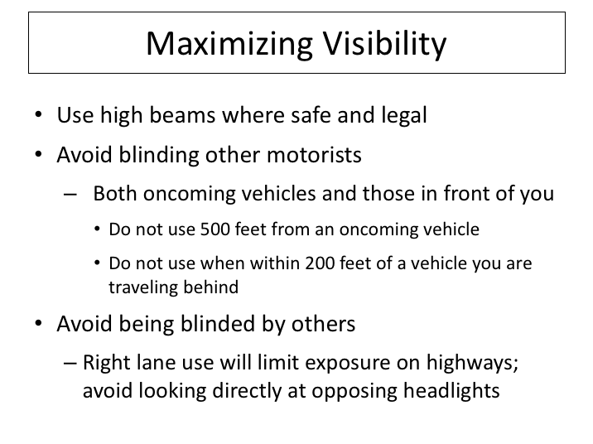

# MAXIMIZING VISIBILITY

One way to improve the situation is to make maximum use of your high beams. You should consider using the high beams whenever it is safe and legal to do so.

However, using high beams at the wrong time can be dangerous, especially if the glare reduces another motorist’s ability to see. Some people are more sensitive to glare than other people. In general, the older a person gets, the more light that person needs for night vision and the longer it takes to recover from glare blindness. You may have had the experience of being temporarily blinded by a camera flash. The same kind of thing can happen on the road when you are blinded by high beams. Some people recover in half a second and others take several seconds. If you are driving at 55 miles per hour, and you take two seconds to recover from glare blindness, you are forced to drive blind for 160 feet (about 4 coach lengths).

**MAXIMIZING VISIBILITY (continued)**

There are two things you can do about headlight glare:

* Avoid blinding others: Dim your lights 500 feet from an approaching vehicle. Dim your lights 200 feet from a vehicle you are overtaking. Drivers can be as easily blinded through their mirrors as through their wind­shields.

* Avoid being blinded yourself: Do not look directly at the high beams of oncoming vehicles. Glance to the right edge of the road to avoid the glare. On multi-lane highways, you are less likely to be blinded when you use the right-hand lane. If you are blinded by an oncoming vehicles high beams, resist any temptation to retaliate with your high beams – it’s simply unprofessional and there could be a very valid reason the other vehicle was using their high beams at the time.

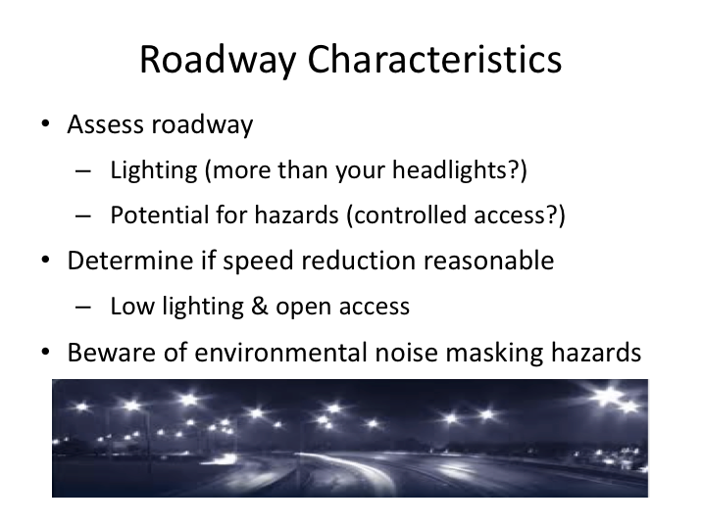

# ROADWAY CHARACTERISTICS

On any type of roadway, in any type of situation, the key to avoiding a hazard is recognition, and there are many factors at play in recognizing a hazard. Available lighting/illumination and driver alertness are two of these factors.

The expectation, presence, and observation of hazards is partly dictated by the type of roadway on which a driver is traveling. Limited access roadways, such as highways, tend to have few hazards beyond the other vehicles on the roadway and the occasional road debris or animals. These types of roadways also tend to be fairly well lit, especially when they are in metropolitan areas. Even when they are not though, the expectation of unforeseen hazards is low due to the controlled access.

Rural areas and roadways can be completely the opposite, and drivers will often have to depend entirely on their headlights to see any hazards. In such situations you should consider reducing speed so that you can have more time to attempt to react to hazards that present themselves in your headlights. It’s pretty difficult to not "overdrive your headlights” on a rural highway (especially low beams), but it is reasonable to be traveling at a speed where you could at least

**ROADWAY CHARACTERISTICS (continued)**

have an opportunity to react to the presence of a typical hazard, such as an animal, once identified in your headlights.

In contrast, metropolitan areas at night can have so much lighting and activity that hazards become hidden, even when they should appear to be identifiable. Various lights and signs can create enough noise that your ability to perceive objects becomes more difficult. For example, a traffic light could be hard to see against a background of lighted signs and shop windows or a pedestrian in varied clothing can blend in with background lighting and objects.

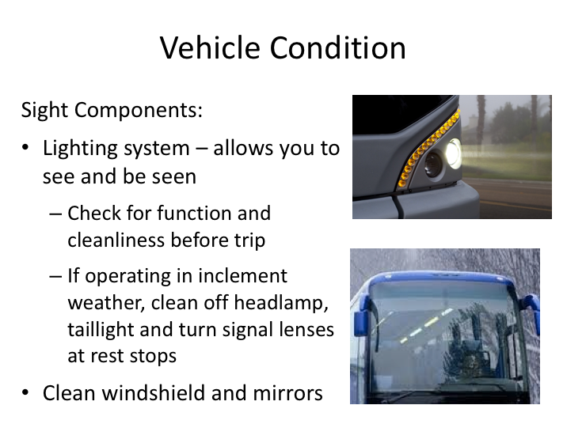

# VEHICLE CONDITION

Another element in night driving is the vehicle. The driver can play a big role in making sure the vehicle is safe for night driving. Focus on the parts of the vehicle that let you see and be seen in the dark – the vehicle lighting system. Make sure your pre-trip check is thorough. Many drivers tend to focus only on the major lights, but forget about their auxiliary lights - a motorcoach is recognizable at night from any direction when all of its lights are working well.

Not only should lighting be working, but it should also be clean. Pay particular attention to headlamp cleanliness as well as function. Not only is the light blocked from coming out of a dirty lamp, but it is also diffused, meaning it is no longer focused into a powerful beam by the reflectors and lenses that are part of the head­lamp. Dirty headlights can cut illumination as much as 50 percent, which means 50% less light for the driver to see potential hazards.

Also pay close attention to turn signals and brake lights - they are your main means of communication with other drivers. When they are covered with dirt, ice, or snow, your crash risk is increased. If you’ve been driving in conditions where there has been a lot of dirty spray, you may need to clean the headlamp, taillight and turn signal lenses at rest stops to maintain optimum performance.

**VEHICLE CONDITION (continued)**

A clean windshield is a must for safe night driving. It should be clean on both the inside and outside. A clean windshield passes 95 percent of the light, but a dirty windshield reflects light, decreasing visibility. Keep a rag and some cleaning solution aboard for cleaning the windshield (don’t forget to clean your mirrors, too!). If your wipers make streaks, they need wiped off or changed. Don't forget to clean your mirrors too.

Finally, when driving at night you should keep the interior lights off or as dim as possible. Darkness dilates the pupils of your eyes, which will allow you to see better. A dim interior also prevents the windshield from reflecting interior lighting that can reduce your ability to see outward.

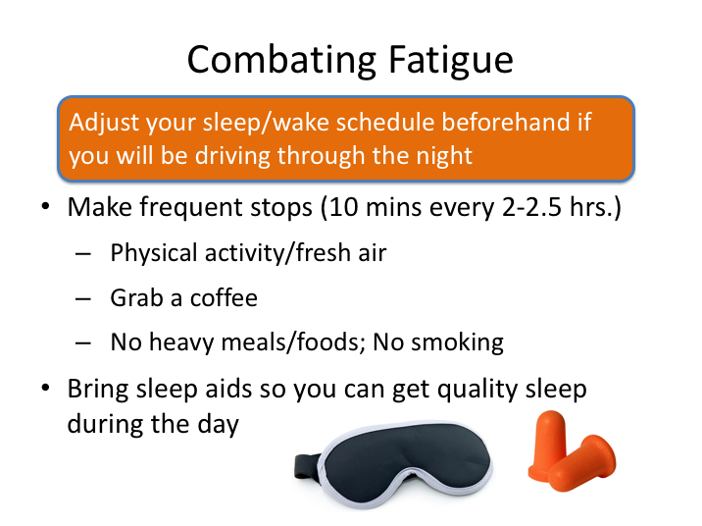

# COMBATING FATIGUE

Fatigue and sleepiness are other important factors that make night driving more dangerous. They can affect visual acuity and alertness, which can hamper hazard recognition. As covered in the trip preparation topics, there are physiological reasons behind early morning sleepiness, so there is more to being ready to drive through the night than just getting a good night’s (day’s) sleep.

When possible, you should adjust your sleep/wake schedule beforehand if you know you’ll be driving during portions of the night.

When driving at nighttime, make frequent stops. Passengers on the bus are often asleep during nighttime operation and more stops are manageable. Walk around to get a little physical activity and fresh air during any stop. Grab a coffee if necessary, but do not eat any heavy meals or smoke. Smoking reduces blood flow to the brain, which is not a good method to counter fatigue.

If you are on a multi-day trip where you will be driving considerable amounts at nighttime, be sure to bring some sleep aids (ear plugs, eye mask, melatonin) so that you can get quality sleep during the day.

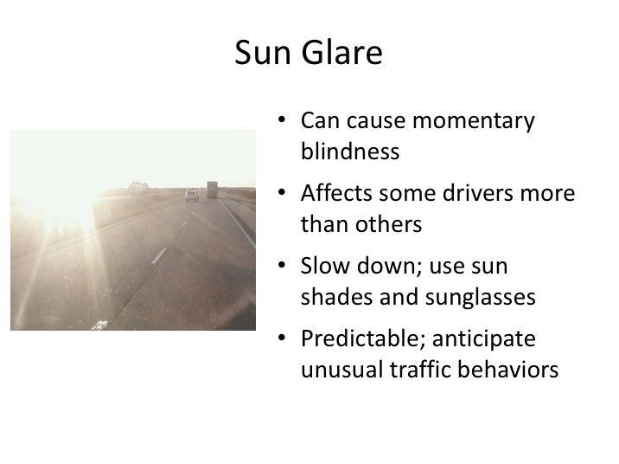

# SUN GLARE

Driving toward the sun when it is rising or setting can present a daytime sight hazard when sun glare occurs.  Sun glare can be uncomfortable and cause depth perception problems.  Driving directly toward the sun can also cause sudden moments of blindness as the sun peeks out from behind surrounding objects.  Sun glare can also cause reflections on the windshield, further complicating the forward vision field.

The effects of sun glare can be enhanced if the windshield is dirty or pitted – another reason to keep a clean windshield.  Some drivers are also more sensitive to glare and thus its effects may be magnified; drivers middle-aged and older tend to be more sensitive to glare than younger drivers because their eyes take longer to adjust to changing light levels and certain other conditions, such as having had vision-correction surgery that affects the corneas, may also increase sensitivity to glare. Tools available to drivers to help manage sun glare include windshield shades on the coach and sunglasses.

Drivers should anticipate traffic slow ups in reaction to glare and anticipate potential unusual behaviors from other drivers. Perhaps the best news about sun

**SUN GLARE (continued)**

glare is that it is both predictable and fleeting.  Sun glare should not surprise anyone, especially the most severe glare - when the sun is just above the horizon.  Learn to anticipate its occurrence and be prepared.  If the glare is especially severe, consider pulling off the roadway in a safe area and waiting a few minutes for the sun to move into a less bothersome position.

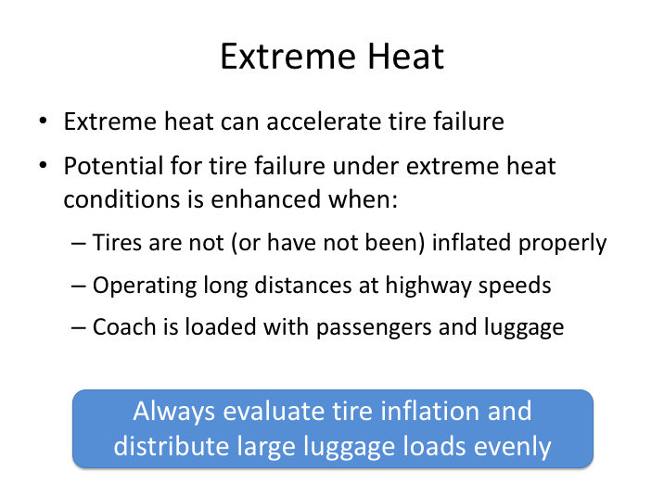

# EXTREME HEAT

Most people don’t think of extreme heat as an adverse weather condition. Though it doesn’t tend to affect vehicle handling or driver vision, extreme heat can accelerate tire failures, especially when tires are not properly inflated, near or over load limits, and operating at high speeds.

When you expect to be traveling for long distances on highways in hot temperatures, be certain that your motorcoaches’ tires are properly inflated.  If you have a significant load of passengers and luggage, make sure that the load is distributed as evenly as possible to avoid any potential issues.

And when you encounter extreme heat during a long over-the-road trip, pay special attention to any vehicle handling issues that may indicate a potential tire failure.

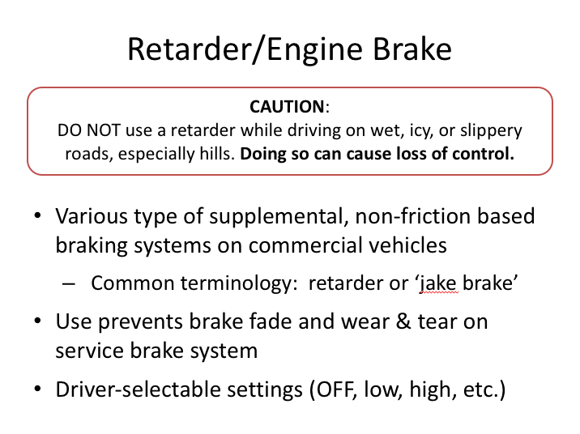

# RETARDER/ENGINE BRAKE

A retarder is a device used to augment or replace some of the functions of primary service brake system. Friction-based braking systems are susceptible to “brake fade” when used extensively for continuous periods, which can be dangerous if braking performance drops below what is required to stop the vehicle. For this reason, motorcoaches and other commercial vehicles are frequently fitted with a supplementary system that is not friction-based. Retarders serve to slow vehicles, or maintain a steady speed on declines, and help prevent the vehicle 'running away' by accelerating down the decline. Retarders are not capable of bringing vehicles to a standstill, as their effectiveness diminishes as vehicle speed lowers. They are designed to assist in slowing vehicles, with the final braking done by the conventional braking system.

Using retarders is the preferred way to keep from losing your brakes on a long, steep descent. Some retarders work on the engine; some on the driveshaft; some on the transmission, and some work between the engine and the transmission. Most modern motorcoaches have a retarder of some type, and it will generally have driver selectable settings (e.g., low, medium, high). A retarder will save wear on both the engine and the brakes on long declines and can also save lives.

**RETARDER/ENGINE BRAKE (continued)**

**Use it if you have it, with one caveat:**  Retarders should not be used on wet, icy or slippery roads, especially hills.  Using retarders when roadway friction is low can result in loss of control of the motorcoach.

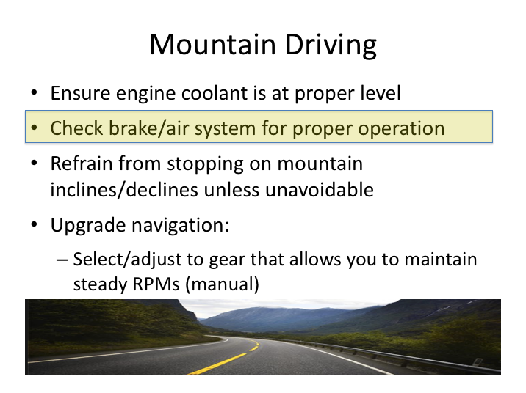

# MOUNTAIN DRIVING

When you’re driving in the mountains, you are fighting gravity. When you’re going uphill, gravity makes your engine run harder and hotter. When going downhill, gravity acts opposite your brakes, causing them to get hot and potentially fade. If bakes get too hot, they can fail and result in a runaway motorcoach. Any driver operating in mountainous terrain should pay extra special attention to engine coolant levels and air brake system tests during vehicle inspections to guard against engine overheating and to ensure that the brake system is operating as designed.

Stopping on a mountain road can be a problem. Mountain roads sometimes do not have shoulders or turnoffs where you can safely stop and park. If you must stop on the roadway, make sure it is at a point where you can be seen from a distance by the traffic behind you and set out your red reflective triangles as soon as you can.

**MOUNTAIN DRIVING (continued)**

*Upgrade Driving.*  The main key to keeping your engine from overheating when driving uphill is to select the correct gear (or gear range). In a manual transmission, if your engine starts to lug or strain, or if your engine’s RPMs go down as the grade increases, you would shift down until you find a gear at which you can maintain a steady RPM. Obviously, a motorcoach equipped with an automatic transmission will select the appropriate gear for you, but if you feel there are issues in proper gear selection, manual adjustment of the gear is possible and suggested.

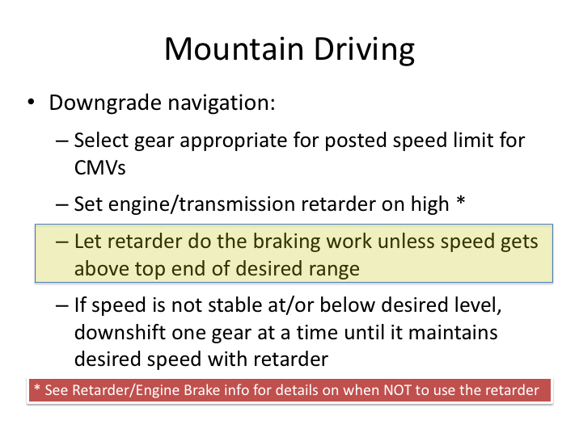

**MOUNTAIN DRIVING (continued)**

*Downgrade Driving.* You should always stop at the crest of any significant decline to test and assess your brakes – this is even a requirement in some states.

The rule of thumb for selecting your downhill gear is to use the same gear going down that the vehicle used going up. Depending upon your transmission, you may not know what gear the vehicle was in. In all cases, there will be a posted speed limit for commercial vehicles at the top of the hill. You should use this speed limit as the top end of your speed range while going down the mountain.

Your retarder should be doing most of the braking work as you travel down the mountain. If the motorcoach speed is not stable at or below the top end of your speed range, downshift one gear.

In an automatic transmission, each of the gears has an RPM operating range. When engine speed hits the top of that range, the transmission shifts up (to the next higher gear). This reduces the braking effect of the engine. You should use your brakes and retarder to stay within the speed range for the gear selected, otherwise, the transmission may shift up a gear. If you find it difficult to maintain a desired gear on an automatic transmission, it may be beneficial to manually select the gear you want.

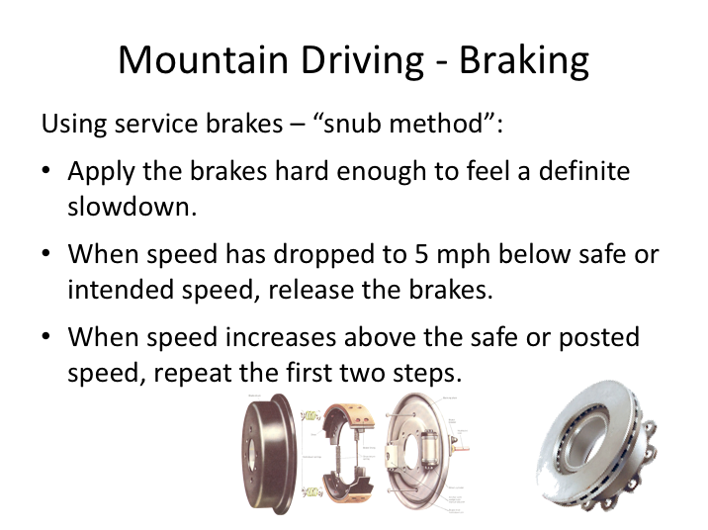

# MOUNTAIN DRIVING – BRAKING

Even with a properly functioning retarder and transmission, you will likely need to apply brakes when going downhill to adjust to your desired speed range and gear. Disc brakes on modern motorcoaches run cooler and are harder to heat to the point of brake fade, however many motorcoaches still have drum brakes which are more susceptible to heat/brake fade.

Whether your motorcoach has disc or drum brakes, the point is to use service brakes sparingly while descending steep declines. First of all, you’re either using your service brakes or you’re not. Many myths called for special applications in these types of situations, including fanning or pumping the service brakes (apparently this was to cool them off). The facts are that the amount of heat lost between applications of the brake is negligible, and pumping the brake builds up more heat than braking with steady pressure. Light, steady braking is a problem too. The problem is that brakes are rarely perfectly balanced among the wheels. The brake on one wheel may come on 4 or 5 psi before the brake on another wheel. If this is true of your coach, and if you brake lightly and steadily, one set of brakes may be overheated/ruined while another is still working.

**MOUNTAIN DRIVING – BRAKING (continued)**

Here is the proper manner for using service brakes on mountain declines (snub method):

1. Apply the brakes hard enough to feel a definite slowdown.
2. When speed has dropped to 5-10 mph below safe, desired, or posted speed, release the brakes.
3. When speed increases above the safe or posted speed, repeat the first two steps.

This method helps each brake to do its share of the work despite any imbalance, resulting in more uniform temperatures from brake to brake and from axle to axle.

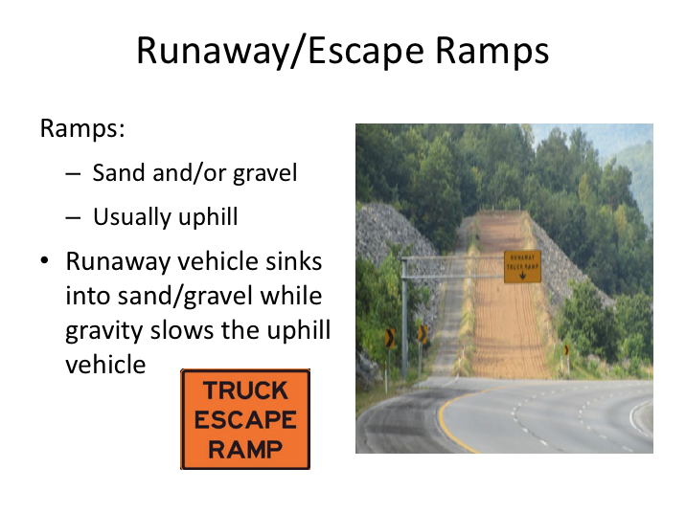

# RUNAWAY/ESCAPE RAMPS

Runaway (or escape) ramps are designed to stop runaway vehicles on steep mountain roads without damaging the vehicle and cargo and minimizing injury to any passengers. Despite often signed a “runaway truck” ramp, these escape ramps will work similarly for any type of vehicle, including a motorcoach. Emergency escape ramps generally utilize gravity and sand or gravel to bring a runaway vehicle to a stop. If a runaway vehicle enters the ramp, it will sink into the sand or gravel while traveling up an incline.

If you are going downhill and you experience braking problems or concerns, you should look for a runaway truck/vehicle ramp. If you think or know you need an escape ramp and you see one, use it. Things will only get worse if you do need it, but opted not to use it - the brakes will get hotter and less effective and the road could get steeper and more winding.

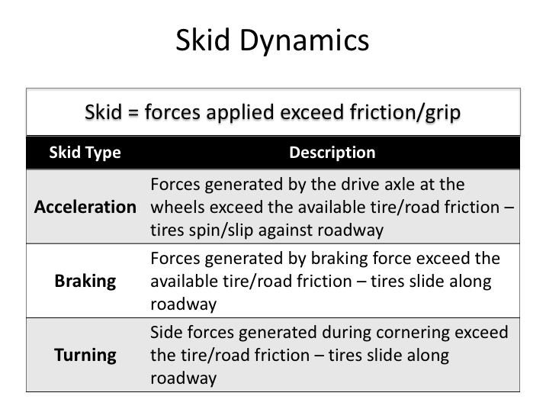

# SKID DYNAMICS

Skidding occurs when the frictional force between a tire and the roadway is exceeded – in other words, they can’t hold onto each other. A skid is very much like your foot sliding on ice, or the same as a box sliding across the floor. In both cases the friction between the object and the surface it was on was exceeded.

If a car slams on the brakes so that the wheels stop rolling, the car theoretically should stop immediately. But if the forces generated exceed the maximum friction between the tire and the road, the tires will slide along the surface until the energy is dissipated and the car stops. During a turn, sideways force is needed to make the car change direction. If the side force generated exceeds the ‘grip’ (friction) between the tires and roadway, the vehicle will slide rather than make the turn.

Traction makes the tires stick to the road and move the vehicle the same speed as the wheels. When the road is dry and the speed is appropriate, traction lets you accel­er­ate, brake, and turn without skidding. When the roadway becomes slippery, that traction is lost at a lower speed than normal and, if you don't slow down, the vehicle goes into a skid. The point is that whenever the forces of motion (i.e., acceleration, braking, turning) overcome the traction of the tires on the road, the vehicle will skid.

**SKID DYNAMICS (continued)**

|  |
| --- |
| Clipart |

So, sometimes a skid occurs, while other times it does not. Knowing that tires don’t change much from day to day, the tire-to-road friction level must change or the forces exerted are too great. Explain some scenarios or conditions that would cause a motorcoach to skid.

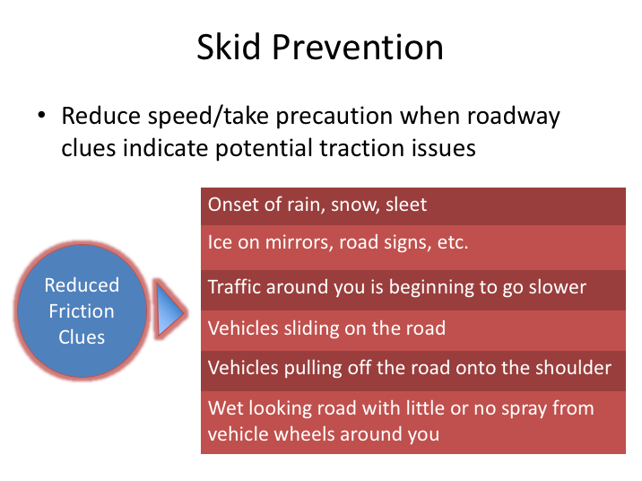

# SKID PREVENTION

The best way to handle skidding is to avoid it altogether. This is accomplished by staying sensitive to the condition of the roadway and slowing down when traction is likely to be impaired (by rain, snow, sleet, ice, loose gravel, leaves).

The primary cause of all skids is too much speed for conditions. The fact is, skidding can nearly always be prevented by slowing down. We say "nearly always" because there are extreme cases when ice prevents you from maintaining any traction or making any headway. But almost all skids can be avoided by adopting a safe speed for the conditions. The slower you travel, the less abruptly/forceful you will have to make changes, and the less chance that any change you make will exceed the friction threshold. For example, under icy conditions, you should reduce your speed significantly. Reducing a 60 mph speed to 30 mph will make control of your coach much easier and less likely to result in skidding.

Your following interval is also important because most skids are started by steering, braking, or acceleration that is too abrupt. If you give yourself a cushion of time and distance, you will be able to drive "gently” and not have to brake or steer as hard. Under slippery conditions, if you have to turn or brake, do no more than is absolutely necessary.

**SKID PREVENTION (continued)**

Curves are especially bad places to have a skid. You could easily skid into oncoming traffic and have a collision, or you could skid off the roadway. The best way to prevent turning skids is to slow down well before entering any curve and accelerate very slowly when coming out of the curve.

By slowing down, allowing an extra margin of following distance, and driving "gently," you can usually avoid a skid.

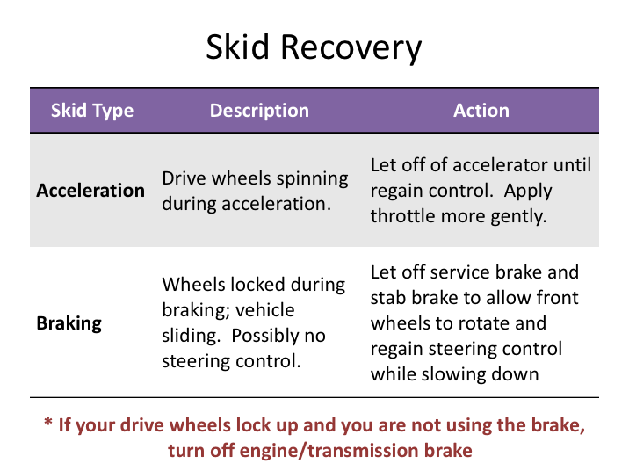

# SKID RECOVERY

While anti-lock braking and traction control technologies have greatly reduced the chances of skidding vehicles, it is still wise to understand how to attempt to recover from various types of skids.

The easiest type of skid to control is the one that occurs during acceleration. It’s also the least likely skid a driver of a motorcoach will experience. When an acceleration skid begins, the wheels may simply spin in place, or the drive wheels may start to slide sideways. Usually, letting up on the accelerator is all that is necessary to regain control and stop the skid.

A braking skid usually means that too much brake force has been applied for the road conditions, and the momentum of your vehicle has overcome the friction between its tires and the road. Another way to start such a skid is through engine braking under slippery conditions, like discussed earlier in mountain driving.

Locking the front/steer tires equates to serious trouble. If a vehicle continues to move while the front wheels are not rotating/turning, that vehicle is out of control because **a skidding vehicle with its front wheels locked cannot be steered.**

**SKID RECOVERY (continued)**

This is an important concept to remember that can help with both braking and turning skids. It means that if you lock your front wheels, your steering wheel remains useless as long as they are locked. You have no control over the direction of travel of your vehicle, and you cannot make maneuvers to evade objects or other vehicles in your path. Required anti-lock braking systems (ABS) have helped limit this situation, but drivers must still understand how to recover in the event that the ABS is malfunctioning, or it is an older coach that is not equipped with ABS.

To recover from a braking skid, you have to get your front wheels rotating before you can regain control. This can be accomplished by letting up on the brake until the wheels start rolling again and then steering into the skid. If you still need to stop or slow down, you begin "stab braking." "Stab braking" means repeatedly applying the brakes until the wheels stop rolling and letting up on the brakes until the wheels start rolling again. This gives you both braking and steering (directional control).

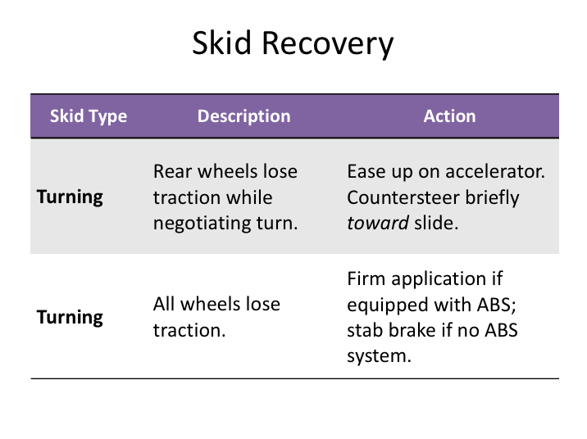

**SKID RECOVERY (continued)**

A turning skid results when the traction at the tire tread is overcome by the tendency of the vehicle to continue moving along its previous path in a straight line. There are two possible ways that a turning skid can happen:

1. The front wheels continue around the intended curve path while the rear wheels begin to lose traction, and the rear of the vehicle starts to slide sideways. This is the more frequent scenario.
2. All wheels lose traction simultaneously. In this scenario, instead of turning, the vehicle continues in the direction it had been traveling.

When you’ve lost traction on the drive wheels only, and the rear of the motorcoach is sliding sideways, even light braking can enhance the skid. Instead, you should ease up on the accelerator and steer briefly in the direction of the skid to regain control.

You’ll have to concentrate to steer in the direction of the skid, because you are not used to doing it. For example, you want to negotiate a left curve, but the rear of your coach slides to the right. If you catch it early, steering briefly to the right

**SKID RECOVERY (continued)**

can bring you out of the skid. As the vehicle resumes the correct course, however, you must countersteer early in order to avoid "overshoot." In the example, steering to the right made the rear of the coach swing back to the left. But it could easily overshoot the correct course unless you countersteer to the left before the rear lines up with the correct course. If you countersteer too late, you could set up an oscillation, or "fishtailing," where the rear swings first to one side and then the other.

If you lose traction on all wheels during a turn, apply your ABS brakes firmly to regain directional control and slow down. If the vehicle does not have anti-lock brakes, you will need to stab brake to re-establish control and slow the coach.

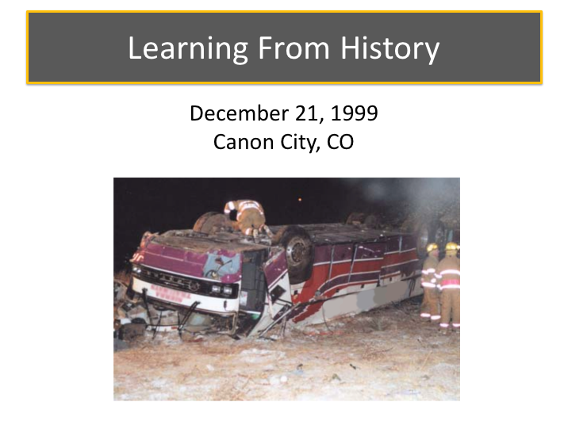

# LEARNING FROM HISTORY

Roadways that have reduced traction due to ice, snow and other precipitation present an increased chance for vehicle skidding and related loss of control.

A crash that occurred on December 21,1999, in Canon City, CO, illustrates the dangers of icy roadways, loss of traction, and the need for drivers to be aware of motorcoach braking systems.

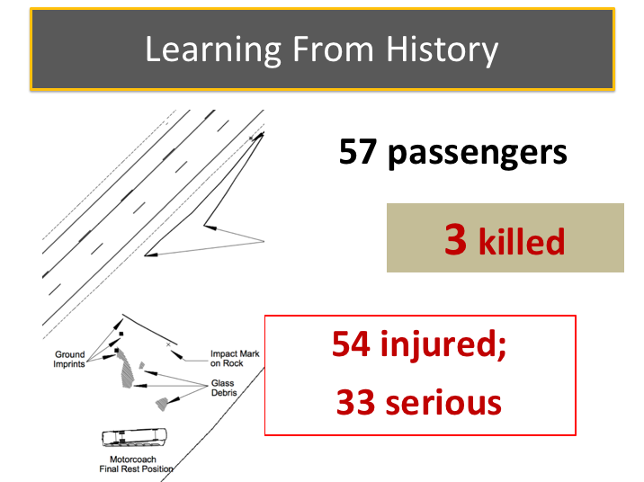

**LEARNING FROM HISTORY (continued)**

About 9:05 p.m. on December 21, 1999, a 59-passenger motorcoach was traveling eastbound on State Highway 50 along a 7-mile-long downgrade west of Canon City, Colorado. The speed limit on the descent was 65 mph, with an advisory speed limit of 55 mph on the curves along this section of the roadway.

The temperature at the time of the accident was in the low 20ºs F with light snow.

While traveling at 63 mph and negotiating a curve, the motorcoach began to fishtail.  The driver regained control.  Approximately 36 seconds later, while traveling about 70 mph, the driver lost control on another curve.  The motorcoach drifted off the right side of the road, returned to the road, rotated clockwise 180 degrees toward the centerline, and departed the north side of the roadway backward. The vehicle rolled at least 1.5 times down a 40-foot-deep embankment and came to rest on its roof.

The driver and two passengers were killed; 33 passengers sustained serious injuries and 24 sustained minor injuries.

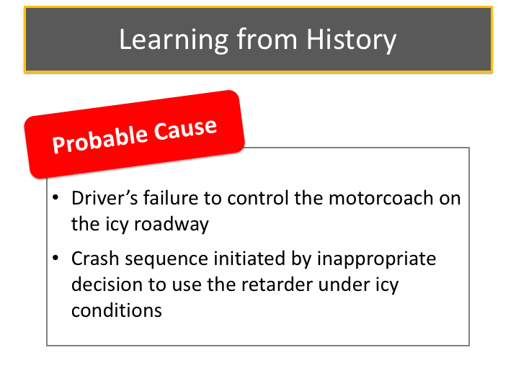

# LEARNING FROM HISTORY (continued)

A Colorado DOT road crew had been salting and sanding the road throughout the day and reported in a post accident interview that parts of the roadway were icy.

The NTSB investigation revealed that the driver of the motorcoach had substantial experience driving various types of commercial vehicles, and had made multiple trips to ski resorts with motorcoaches in the past.  Accident recorder data and results from the motorcoach inspection revealed that the transmission retarder was on its highest setting and activated when the driver initially lost control on the first curve.  After regaining control, the driver switched the transmission to neutral, effectively disengaging the retarder and also any engine/gear braking.  Subsequently, several short applications of the motorcoaches brakes were made (about 1 second each) with little effect.

The National Transportation Safety Board determined that the probable cause of this accident was the motorcoach driver’s inability to control his vehicle under the icy conditions of the roadway; the driver initiated the accident sequence by inappropriately deciding to use the retarder under icy conditions.

**LEARNING FROM HISTORY (continued)**

|  |
| --- |
| Clipart |

What are some more appropriate methods the driver could have used to control the coach?  What else could have been done to prevent this crash?

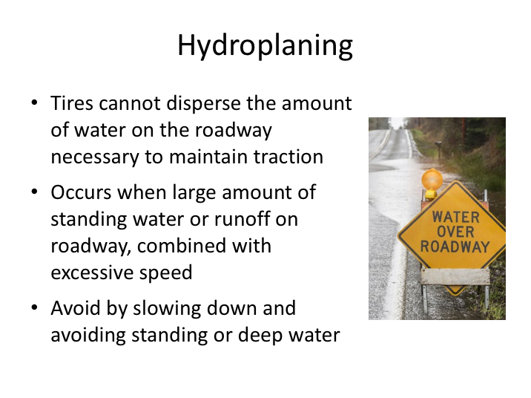

# HYDROPLANING

When it rains heavily, excess runoff or standing water can be on the roadway, creating a situation where hydroplaning is possible. During hydroplaning, the tires lose contact with the road and have little or no traction that can affect steering and braking. Higher speeds increase the chance of hydroplaning, which can happen at speeds as low as 30 mph.

If you think you are hydroplaning, don't use the brakes to slow down until you’ve regained traction. Take your foot off the accelerator and gently steer the wheel in the direction you want the vehicle to go so that you will be aligned with the roadway when traction returns.

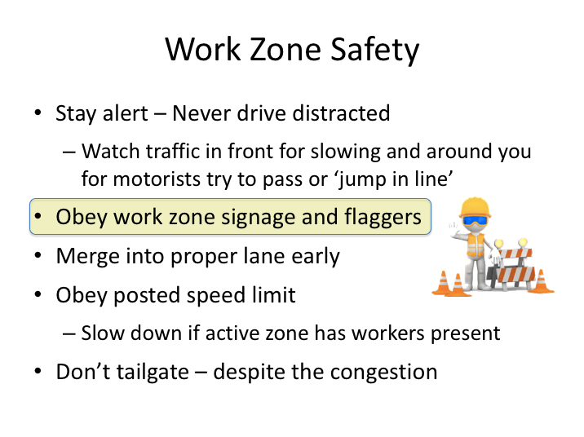

# WORK ZONE SAFETY

Construction zones are a fact of life and necessary to repair and improve our nation’s roadway infrastructure. Despite precautions taken, many collisions occur in work zones. Most work zone fatalities involve motorists, however one-fifth of them involve construction zone workers. In addition to fatalities, more than 40,000 people are injured in work zones each year.

Rear-end crashes are the most common type of work zone crash and fatal work zone crashes occur most often in summer and fall. The majority of fatal work zone crashes occur on roads with speed limits greater than 50 mph.

Whether you are aware of construction along a route ahead of time or not, work zones are usually well marked with sufficient advance notice of their presence and even forthcoming roadway configuration changes.

Safety for motorists, pedestrians, and construction workers can be improved by exercising caution and following good safety practices in highway work zones.

**WORK ZONE SAFETY (continued)**

Here’s some work zone safety tips:

* **Stay alert.** Never drive distracted, work zone or not. Dedicate your full attention to the roadway. Watch vehicles in front of you for slowing, and beware of vehicles around you trying to pass you or jump in front of you when lanes are merging/ending.
* **Obey work zone signage and flaggers**.
* **Merge into the proper lane** well before you reach the lane closure. Be aware that traffic patterns can change daily.
* **Obey the posted speed limit.** Be prepared to slow down further if conditions indicate the need. Extra caution should be taken when it is an active zone with workers present.
* **Don't tailgate**. Increase your following distance.

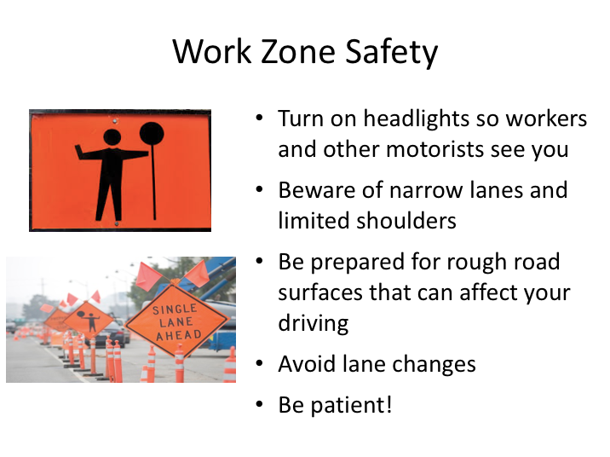

**WORK ZONE SAFETY (continued)**

* **Turn your headlights on** so workers and other drivers can see you.
* **Avoid lane changes.** Change lanes only if necessary and only where pavement markings indicate it is legal to do so.
* **Beware of narrow lanes and limited shoulders.**
* **Be prepared for rough road surfaces that can affect your driving.**
* **Expect the unexpected.** Watch workers, work vehicles, and work equipment in addition to other motorists.
* **Be patient!**

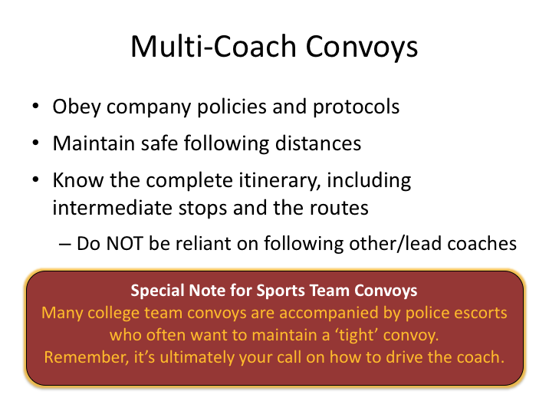

# MULTI-COACH CONVOYS

Multi-coach trips and moves are common in the motorcoach industry. Often, large groups cannot be accommodated by a single motorcoach, and there may be several on a single trip. Examples include military personnel moves, sports team charters (complete with the band!), sporting event ticket package trips, etc.

There are a few images more impressive than a multi-bus convoy of motorcoaches from a company rolling down the highway. While having the coaches very close together - all in a tight formation - is even more impressive, it’s also flirting with disaster. There are few things more embarrassing to drivers and owners if two buses from the same company are involved in an incident with each other during one of these moves. The trip can quickly go from a great public relations coup to a disaster - all because of poor driver judgment.

All too often, drivers in these multi-coach convoys feel they can travel close together because the driver of the coach in front of them is well-trained and will not make any sudden moves. However, every driver also knows that, no matter the skill set of the driver of the motorcoach, other motorists can, and often do, drive unsafely and cause a necessary quick reaction.

**MULTI-COACH CONVOYS (continued)**

Drivers in multi-coach convoys should heed the following:

* Maintain a safe following distance, just as you would with any other commercial vehicle in front of you.
* Ensure you know all destination stops, as well as the route to get there. Do not rely on a lead driver to conduct all of the trip familiarization. If you are reliant on other drivers, you may feel obligated to stay closer to them, which could result in making unwise and unsafe choices.

Special note for sports team convoys: Many college team convoys are accompanied by police escorts who often want to maintain a ‘tight’ convoy. Remember, as the captain of the motorcoach, it’s ultimately your call on how to drive the coach – and the company will still be responsible for any incidents. Do not feel bullied into driving unsafely; the consequences of getting in a crash will far outweigh the consequences of not following close enough.

Many companies have protocols and policies specifically regarding multi-coach moves. These include specific spacing policies when on the highway, as well as trip procedures.

**SPECIAL DRIVING CONDITIONS**

**QUIZ**

1. Your company is required to notify you regarding weather patterns and if it will affect your trip.
2. True
3. False
4. Which two hazards are common to all the adverse weather conditions?
5. Reduced visibility and reduced control
6. Congested traffic and increased stopping distance
7. Reduced visibility and increased stopping distance
8. Reduced control and congested traffic
9. Reduced visibility and congested traffic
10. Ice and sleet can leave you with only 15 percent of your normal traction.
11. True
12. False
13. You should increase your following distance at least how much during poor visibility.
14. 1-3 seconds
15. 2-4 seconds
16. 3-5 seconds
17. 4-6 seconds
18. 5-6 seconds
19. High beams can reflect off precipitation and wet surfaces, making it harder to see.
20. True
21. False
22. If you are traveling at 50 mph and visibility is reduced, you should be able to see at least _________seconds ahead.
23. 2
24. 3
25. 4
26. 5
27. 6
28. How far away should you dim your high beams when approaching an on-coming vehicle?
29. 200 feet
30. 300 feet
31. 400 feet
32. 500 feet
33. 600 feet
34. To maintain lighting functionality, you may need to clean your lights during a trip.
35. True
36. False
37. What percentage can dirty headlights cut illumination?
38. 30%
39. 35%
40. 40%
41. 50%
42. 55%
43. Driving uphill in mountain driving makes your engine run harder and hotter.
44. True
45. False
46. Unless there are signs indicating that you should, it is not a good idea to stop at the crest of any significant decline to test and assess your brakes.
47. True
48. False
49. It’s a good practice to use a retarder while driving on wet, icy and slippery roads, especially hills.
50. True
51. False
52. What can you do to help combat the potential for fatigue when driving overnight?
53. Drink caffeine for short term boost
54. Adjust your sleep schedule prior to the trip if you normally sleep at night
55. Bring sleep aids to get quality sleep if you must sleep during the day on a trip
56. Stop more frequently
57. All of the above
58. In normal conditions you should maximize the retarder and let it do most of your downhill braking on large declines.
59. True
60. False
61. Skidding can nearly always be prevented by slowing down.
62. True
63. False