Safe Driving Principles

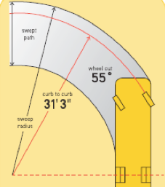 | 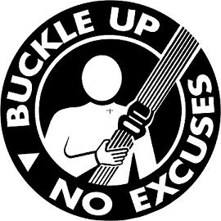 | 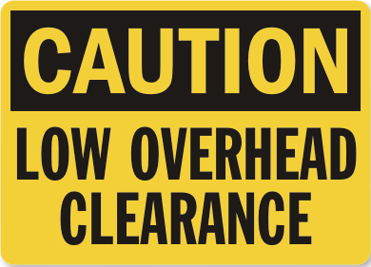

Purpose:

The purpose of this training module is to provide you with knowledge on the concepts of defensive driving and identify known operational hazards that exist specific to driving a motorcoach. You will learn key concepts pertaining to defensive driving so that you can apply them when driving to recognize and avoid hazards. You will also learn specific operating scenarios where issues could result in a collision or incident.

Module Overview:

The training module contains two classroom lessons. The first lesson will review basic defensive driving theory. The second lesson identifies some specific operational hazards known to be present during coach operation.

Lesson 1: Defensive Driving

Lesson 2: Operational Hazards

LESSON 1

DEFENSIVE DRIVING

Lesson Objectives:

By the end of this lesson, you will understand the basic concepts related to early identification of hazards and successfully reacting to them when possible. Techniques to scan for hazards and optimize reaction potential will be presented.

Instructional Method: Classroom

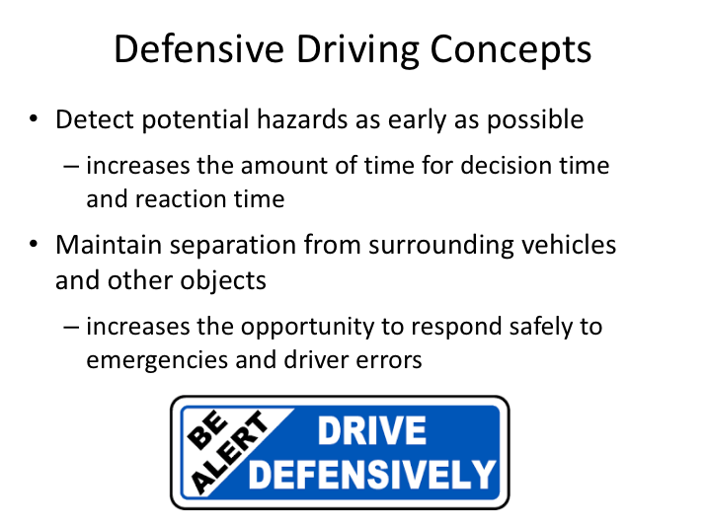

DEFENSIVE DRIVING CONCEPTS

You’ve likely heard about defense driving before - it’s a concept that is presented in many different manners – all with the same underlying fundamentals. Those fundamentals are:

- Understanding potential hazards

- Scanning the roadway for present or developing hazards

- Allowing yourself time to react to hazards

- Understanding your options in reacting to hazards present

When you consistently apply these fundamental concepts, your risk of being involved in preventable collisions will decrease.

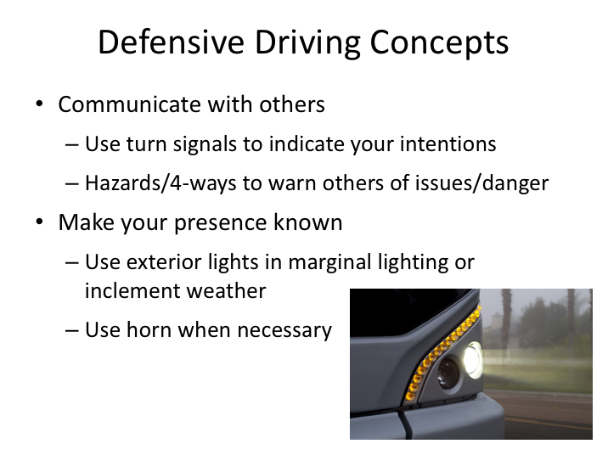

DEFENSIVE DRIVING CONCEPTS (continued)

Other key concepts for defensive driving include communicating with other motorists and pedestrians. Always using your signals and activating them early to communicate intentions is important in helping manage the behavior of other motorists and pedestrians. Similarly, using hazards or four-ways is helpful in communicating potential issues or danger.

Sometimes motorists or pedestrians may not even realize you are there. While we may not think it’s difficult to see a large motorcoach, it certainly does happen. You can enhance your visibility by using exterior lights in any conditions where there is low daylight or inclement weather. Additionally, you may want to occasionally use your horn if necessary to alert others of your presence or an impending movement (for example, before you begin to back up).

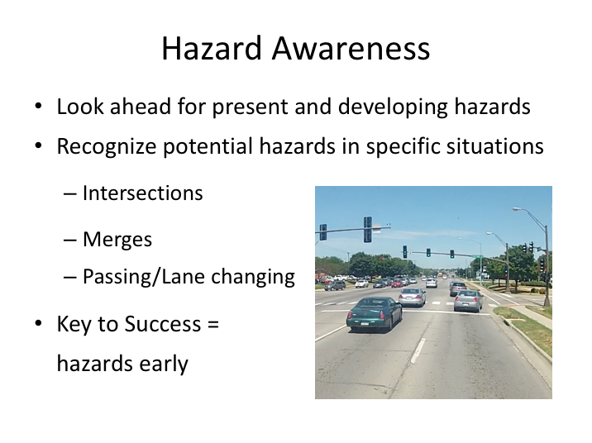

HAZARD AWARENESS

To react to hazards, you need to understand the what and where’s of hazards. What is a current hazard? Where can hazards come from? What could turn into a hazard? And what type of situations breed hazards?

The presence of hazards and manner in which you search for them may vary depending on the environment in which you are driving. For instance, scanning for hazards and hazard expectations while driving on a highway may differ from techniques or expectations used at intersections.

All of the concepts discussed in this section are dependent upon understanding hazards and where they are so that you can identify them and then, hopefully, employ the appropriate response to avoid them. There is a lot of mental and physical activity that goes into reacting to hazards, so the earlier you can spot a problem, the more time you have left for considering the effective solutions and deciding whether you can safely carry out a response. The key to success is to spot the hazards early.


When identifying possible safety hazards, what are some things that a driver has to look at and look for?

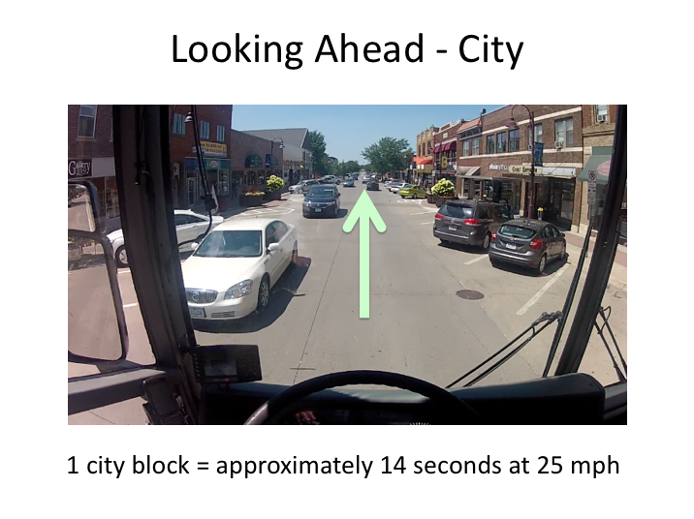

LOOKING AHEAD - CITY

You obviously can’t avoid a hazard if you don’t know it’s there, and knowing a hazard is there does not do you any good unless you can act to avoid it. To put it simply, you must see into the future to avoid existing hazards or those developing down the road.

One way to spot problems early is to look as far ahead as you can. You might say that when you are looking ahead, you are looking into the future. You might be able to spot a potential hazard that won't become an actual emergency for several more seconds. Commercial vehicle drivers already have an advantage over car drivers – your seat height generally provides you a better, unobstructed view into the distance. If you look far ahead, you also have a better view into the future.

In city driving, a good rule of thumb is to look ahead at least one city block. How far into the future is that? To give you an idea, let's consider that you are traveling at a constant rate of 35 mph down a city street that has 10 blocks per mile. Now, if you look ahead one block, you are also looking ahead 10 seconds. If you are going 25 mph, your lead time is about 14 seconds.

LOOKING AHEAD - CITY (continued)

One thing to consider when looking one or more blocks ahead is “stale” traffic lights. Keep track of traffic lights in your search area. If a green light has been green for a long time (if it is a "stale" green light), you should cover the brake with your foot as you approach it because chances are the light will change before you get to the intersection. As a matter of fact, it is good practice to cover the brake when going through any intersection. Covering the brake can save you a lot of reaction time and stopping distance. Of course, if you are already into the intersection when the light turns yellow, you should proceed through the intersection.

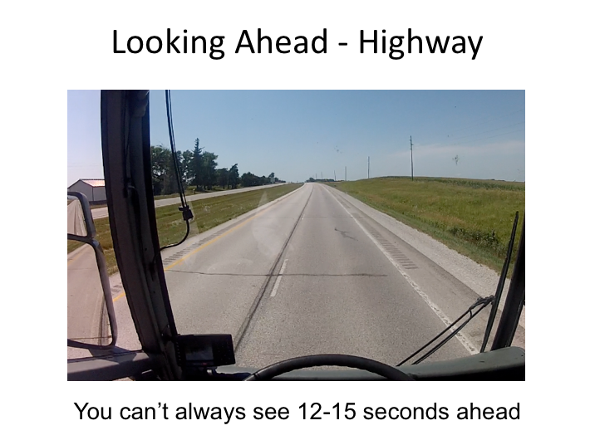

LOOKING AHEAD - HIGHWAY

For highway driving, the rule of thumb is to look at least a quarter of a mile down the road. If you are going 60 mph on an interstate highway, looking ahead a quarter mile is looking 15 seconds into the future.

In some situations, you can see the road ahead for a mile or more; in other situations, the sight distance is only a few yards. If you are thinking that sometimes it won't be possible to look ahead as far as we’d like, you're right. The "one block ahead" view might be obstructed by a big truck. The "quarter of a mile ahead" view could be around a curve or over the next hill.

To summarize:

Try to maintain a 12-15 second eye lead time, depending on circumstances and driving environment.

When you can't see at least 12 seconds ahead, driving conditions are less than perfect. Hazards could develop or present themselves suddenly with a limited response window. You should be extra watchful of the road ahead.

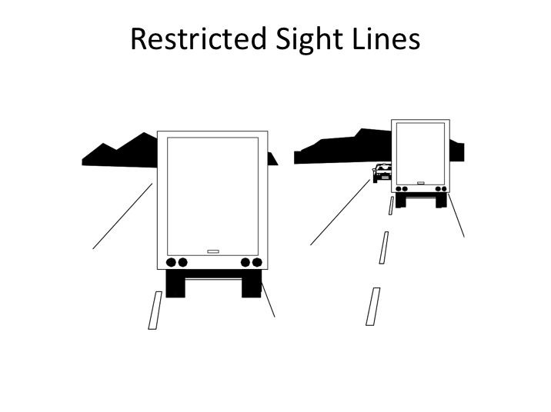

RESTRICTED SIGHT LINES

You may not be able to look as far ahead as you’d like because of objects in front of you. Restricted sight distance is one of the reasons for not following the vehicle in front of you too closely – even in a motorcoach, other large vehicles can restrict your sight line. In fact, this is one reason some people don’t like to travel behind a truck or bus.

Notice in this image how much more you can see when you are further back.

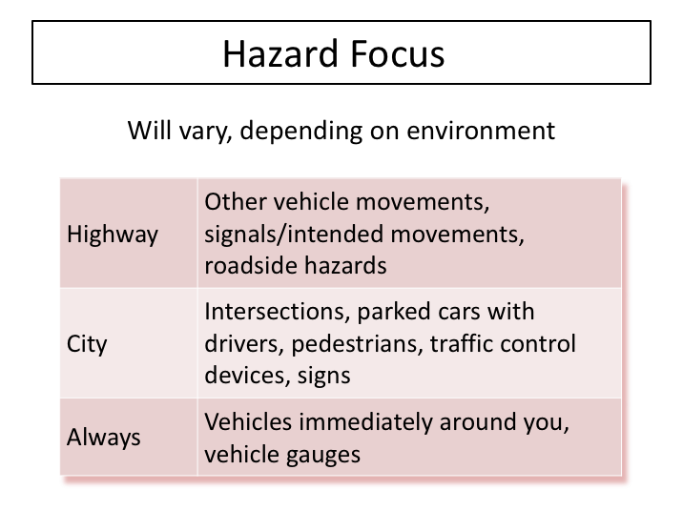

HAZARD FOCUS

The amount of time you spend looking far ahead will vary depending on your driving environment and your intended path.

For highway driving, you’ll spend more time looking down the road, as there will be less near-term hazards and you’ll be able to see the sides of the road as you look ahead. As you look ahead, your eyes will be attracted to activities happening at the sides of the road. In other driving, as your speed decreases, you will spend more time focusing on intersections and closer hazards, or potential hazards; closer objects and activities become more important. In certain environments you might have to move your head as well as your eyes to see all that is necessary. For example, when you are stopped and waiting to pull out, you may need to move your head to keep track of potential hazards.

In all environments, you should also keep track of the presence of vehicles immediately around yours, and occasionally check vehicle gauges. Checking mirrors for other vehicles around you and vehicle gauges will remove your full focus from the road immediately ahead. While performing these tasks is essential to be the best driver, you should never divert your attention from the road for more than a second or two at a time.

HAZARD FOCUS (continued)

To continuously search for hazards and monitor what’s around you, you’ll find that your eyes will be constantly moving to feed necessary information to your brain. You should not be simply staring down the road - if you do, you could easily miss a sign of trouble that you could have spotted if you had kept your eyes moving.

You should look at your mirrors several times a minute on the highway and more often in congested environments – it’s important for you to continually monitor the traffic around your vehicle so you can be aware that a vehicle may have entered one of your blind spots.

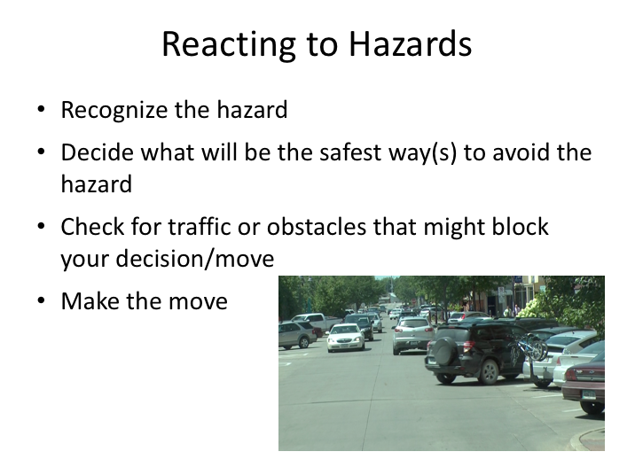

REACTING TO HAZARDS

Once presented with a hazard, a driver must decide how to react and determine whether specific reactions are possible based upon dynamics of the situation. Recognizing the hazard, deciding how to react to it, and then physically reacting naturally takes time. Some of the common reactions are slowing down, stopping, and changing lanes.

Every reaction takes time. It takes time to slow down, come to a complete stop, or to move to another lane. Checking for traffic that may block your reaction decision takes additional time and, if the move is blocked, another decision needs to be picked, taking even more time.

If a crash is to be avoided, the driver needs enough time to do them all. Successful reactions take both time and space – at a minimum, you need space in front of your vehicle, and you may need space around your vehicle. Because the coach is moving while all of this is going on, this time interval translates into a space interval. There is a huge difference between coming to a stop one foot in front of a pedestrian and coming to a stop one foot behind a pedestrian.
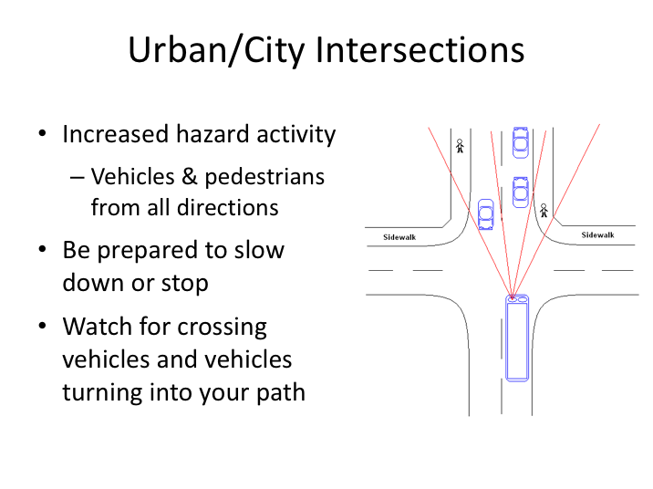

URBAN/CITY INTERSECTIONS

By their nature, intersections present additional hazards to a driver. Instead of only focusing on traffic going in your direction and any coming in the opposite direction, you now have be aware of traffic approaching from one or both sides. Drivers can also expect increased pedestrian activity at intersections. Because of these increased hazards, it’s a good practice to be prepared to slow down and yield or stop when approaching an intersection, even when you have the right of way.

When approaching an intersection, you will need to focus your attention in many directions. It’s important to watch for pedestrians, traffic from side streets, and vehicles that may turn into your path. Widen your scan path to include activities on sidewalks and traffic on the side streets. Watch other vehicles for indications of what they intend to do. Remember that other vehicles won’t always travel in the direction you expect, even when the driver is using a turn signal.

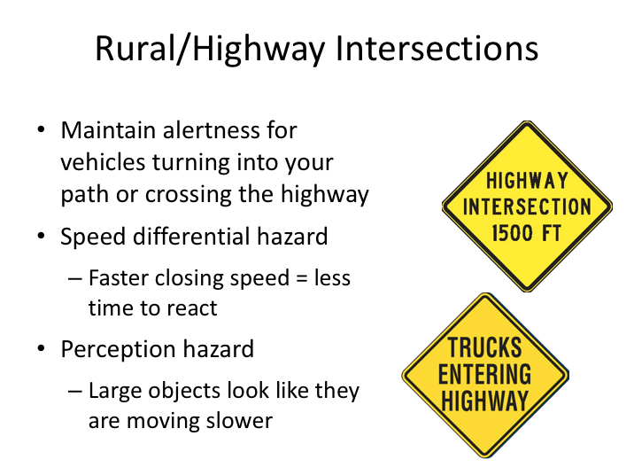

RURAL/HIGHWAY INTERSECTIONS

So far we talked about intersections in busier areas such as cities. As a motorcoach driver, you’ll also encounter intersections along highways and in more rural areas.

The concepts for these types of intersections remain essentially the same, but some hazards are more pronounced than others. The first thing to recognize is the higher speed you will be traveling at on these types of roadways and how it affects your closing speed on slower moving vehicles that may pull out in front of you or across the roadway.

On highways where there is limited access or in areas with less foot traffic, you’re less likely to encounter significant numbers of pedestrians. However, the danger of vehicles pulling into your path, especially from side streets, may actually increase. The size of a motorcoach can cause other drivers to misjudge your speed and distance as you approach highway intersections. Larger vehicles tend to appear to be moving slower than they actually are - trains and airplanes
create a similar optical illusion. For this reason, and because they can move more quickly, drivers of passenger vehicles may pull out in front of you.

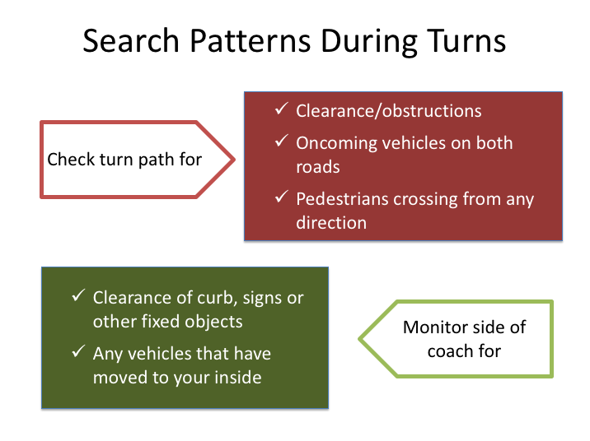

SEARCH PATTERNS DURING TURNS

So far, we’ve focused on where you look as you travel down a roadway. But what about when you are turning? Turning presents unique hazards and requires a different hazard search pattern.

Before making a right or left turn, you should search the turn path for any obstacles to ensure you can complete the turn safely. In addition, you have to search for vehicles or pedestrians that might enter the turn path while you are turning. This includes on-coming traffic on the road you are leaving, pedestrians, and traffic on the road you are entering.
While making the turn, you should again check your mirrors to make sure that you are clear of the curb, signs and any fixed objects along the side of your coach. Also, check that no vehicles have moved to your inside so far during the turn process. Since there is a lot to look for, you may want to stop before making the turn so that you have enough time to make sure you will have a clear turn path. In every case, slow down and proceed slowly through the turn to give yourself enough time to check your mirrors and turn path as necessary.
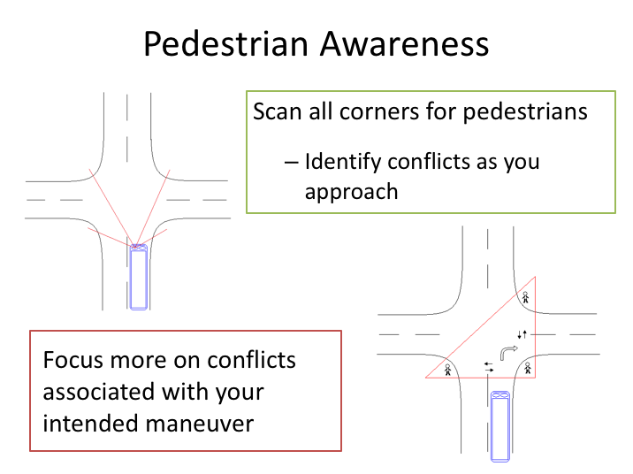

PEDESTRIAN AWARENESS

Pedestrian and bicyclist collisions are devastating for all involved, including the driver. Some of the keys to avoiding these catastrophic crashes are observing the pedestrians and bicyclists, understanding their behavior, and anticipating their movement.

We’ve already talked some about scanning for pedestrians as you navigate intersections. Let’s talk a little more in depth on the type of scans you might conduct, depending upon whether you plan to travel through the intersection, turn at the intersection, or are stopped at the intersection due to a traffic control device.

In any event, you want to scan all four corners as you approach the intersection so you have a concept of where potential pedestrian conflicts exist. After initial identification, you’ll want to focus most on those who potentially conflict with your intended maneuver.

If you’re simply traveling through the intersection, you should focus on pedestrians who are not paying attention or facing in directions opposite (perpendicular to) the direction you’re traveling.

PEDESTRIAN AWARENESS (continued)

If you are making a right turn, you should focus on the identified pedestrians located at both corners of the near side intersection and the right corner of the far side intersection.

If you are stopped at the intersection due to a traffic control device, you should pay attention to all pedestrians, and especially to activity occurring as signals begin to change. Try to determine their intentions, but also understand that pedestrians often try to beat crossing/traffic signals, just like motorists often do.

If there are bike lanes along the roadway you’re traveling, you should also try to keep tabs on any bicycles traveling in your direction or approaching from the rear. Similarly, if you are stopped at a traffic control device, but intend to turn, you should ensure that no bicycles are approaching from the side/rear (in addition to pedestrians) before you make your turn once you receive the right-of-way.

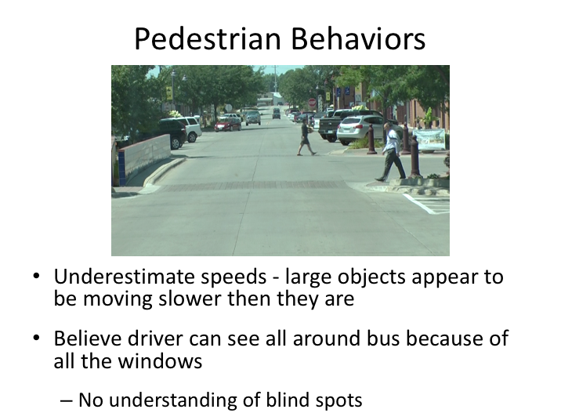

PEDESTRIAN BEHAVIORS

Avoiding pedestrian conflicts necessitates anticipation of pedestrian moves, and this requires an understanding of pedestrian behavior.

Pedestrians often underestimate the speed of larger objects and vehicles, such as motorcoaches. Larger objects appear to be moving slower to them, and they may think they have more time than they really do before you reach them. They also believe that all the windows on motorcoaches mean the driver can see all around the bus, and have no understanding of blind spots. This can lead to conflicts – especially during turns and when they are walking in the vicinity of motorcoaches.

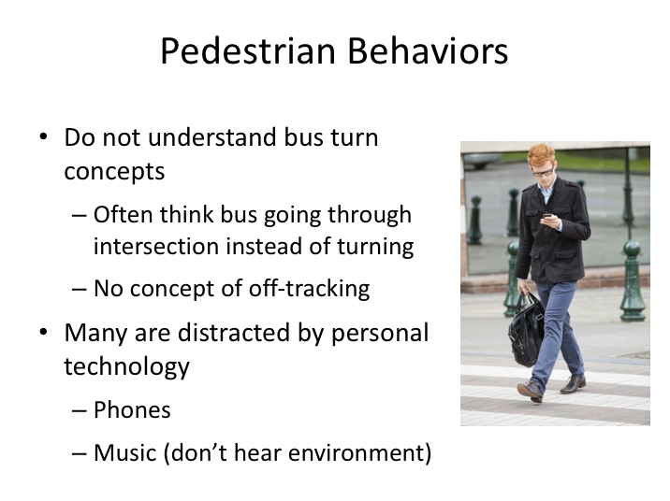

PEDESTRIAN BEHAVIORS (continued)

Pedestrians also do not understand the dynamics of a turning motorcoach. Because of their large wheelbases, motorcoaches generally drive deep into an intersection before actually beginning their turn. To the average pedestrian or bicyclist, it can appear that the coach is proceeding through the intersection instead of turning. Based on that belief, they may move into conflict areas within the turn maneuver.

Also, keep in mind that in today’s environment pedestrians have access to personal technology at their fingertips. Many distractions, such as talking or texting on phones, playing games, or listening to music, all may make the pedestrian blind or deaf to the environment and vehicle dangers around them.

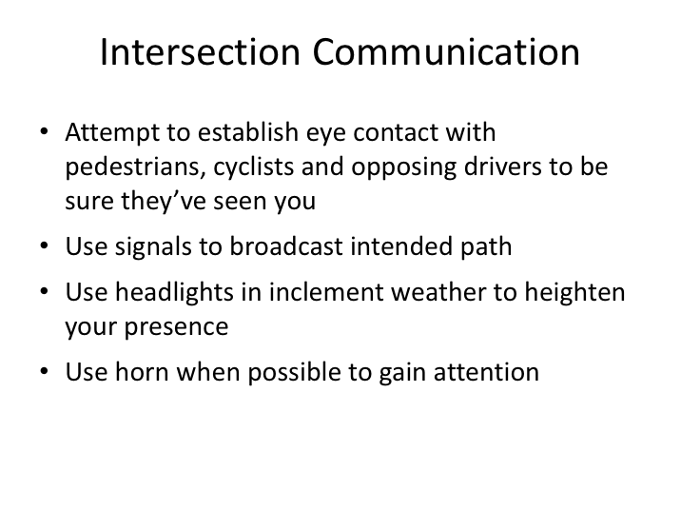

INTERSECTION COMMUNICATION

One of the keys to avoiding hazards at intersections is to make sure that others are aware of you, just like you are aware of them. Unfortunately, with all the distractions nowadays for both drivers and pedestrians, them seeing you is not as simple as it sounds.

One way to understand if they see you is to try to make eye contact with them. Making eye contact with pedestrians, bicyclists, and other motorists is one of the best ways to insure they’ve seen you. Unfortunately, making eye contact is not always possible, so you have to rely on other tactics so others hopefully recognize you and understand your intentions. When turning, always use turn signals to indicate your intended path; Use your lights during daytime inclement weather to enhance your vehicle’s visibility; and, finally, use your horn if necessary to garner attention.

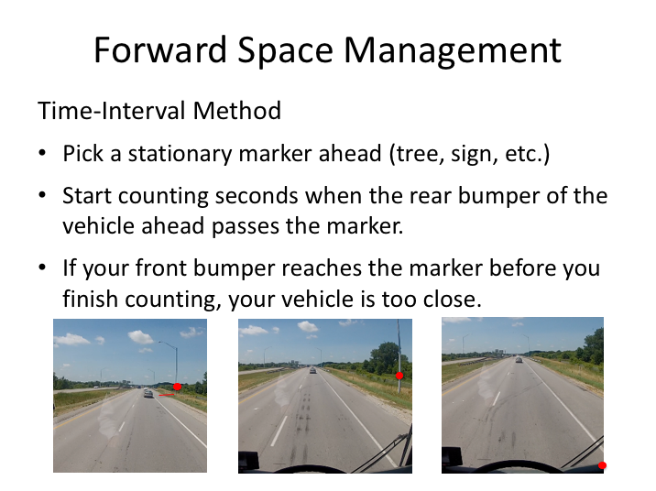

FORWARD SPACE MANAGEMENT

The most critical space to any side of your vehicle in terms of reacting to hazards is the space in front of you. Simply put, you will need space in front of you to react to any recognized hazard. Space cushions in front of a vehicle are established by the driver’s following distance. Following distance, as you may have guessed, is how far a vehicle is traveling behind the vehicle in front of it. While distance is difficult to judge, time is not. And, the further away you are from the vehicle in front of you time-wise, the further away you will be distance-wise.

The minimum following interval for motorcoaches is 4-5 seconds. This interval provides the minimum necessary time to perceive a hazard, decide what to do, and react. While this may seem like a long interval, you must realize that commercial vehicles, motorcoaches included, take longer to stop than cars, in both time and distance.

FORWARD SPACE MANAGEMENT (continued)

Here's how you can determine how far you are traveling behind another vehicle:

- Pick a stationary marker ahead (shadow, tree, sign, etc.).

- Start counting seconds when the rear bumper of the vehicle ahead passes the marker. Count: one thousand one, one thousand two, one thousand three, one thousand four.

- If your front bumper reaches the marker before you finish counting, your vehicle is too close.
In addition to a proper following interval, it is also a good idea to maintain a space interval when you are stopped behind a vehicle. You should allow enough room that you could swing around and pass the vehicle in front, without having to back up first, should the vehicle not be able to move for some reason (stalled, waiting to make a turn, etc.). As always, you should only pass when you have searched all ways and decided that it is safe to do so.

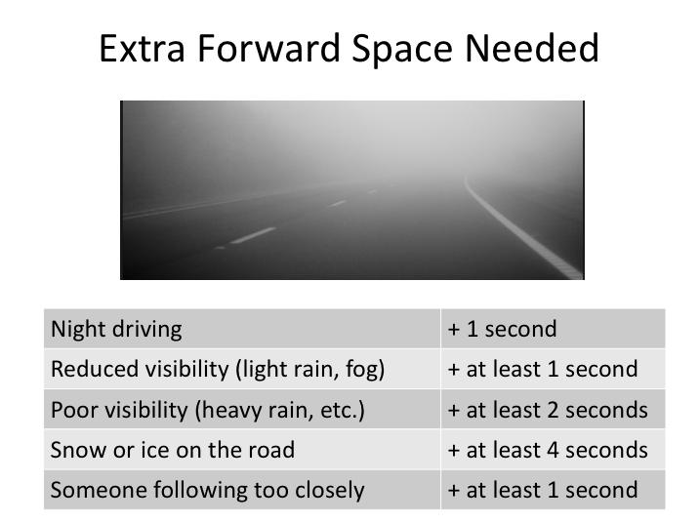

EXTRA FORWARD SPACE NEEDED

Remember that 4-5 seconds is the absolute minimum following interval – applicable under ideal conditions. When conditions are less than perfect, you have to increase the following interval.

Add 1 second for night driving and 1 or more seconds when your vision is restricted by weather conditions. How much you add will depend on how bad the weather is. At one extreme, rain, snow, and fog can be so heavy that visibility is near zero, and you should pull off the road in a safe spot and wait out the storm. At the other extreme, they can be so light that you would just add 1 second to your following interval.

When snow or ice might affect your traction, you should add at least 4 seconds to your following interval.

Notice that you should add one second to the time interval between you and the vehicle in front when you have someone who is following you too closely. Doing this reduces the chances that you will have to stop quickly, causing the vehicle
behind to hit you; it also may encourage the vehicle behind to pass you and get out of your blind spot.

Why is tailgating a bad practice?

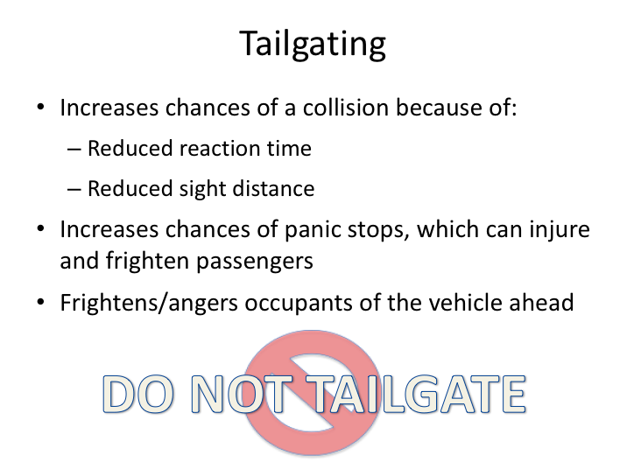

TAILGATING

Probably the most common and extreme example of poor forward space management is tailgating, or unsafe following distance.

Tailgating increases your chances of a collision because it can affect your sight line when looking ahead and it does not permit you enough reaction time.

Tailgating also increases the chances that you will have to stop suddenly, thereby increasing the chances of a sudden stop injury to passengers on board.

Finally, nobody is comfortable when they have a large commercial vehicle right on their tail. Think about when you look in your rearview mirror and see the grill of a truck or bus – what is your first thought about that driver and company?

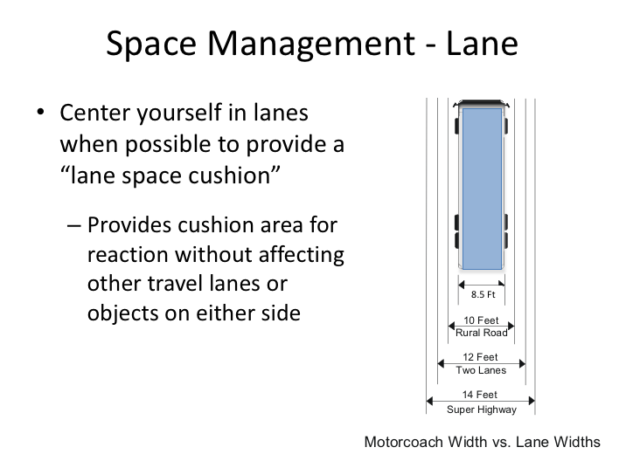

SPACE MANAGEMENT - LANE

We’ve covered looking ahead, following distance, and scan methods so that hazards can be spotted early. Now we’ll focus on creating the space necessary to react to the early-spotted hazard.

Another area of “space” you can manage is the space within the lane you are traveling. Depending upon the type of road you are on, you will have varying amounts of excess lane width beyond what is necessary to accommodate your coach. By centering your coach in the lane, you provide “lane space cushions” on both sides of your coach. These small cushions will allow you room to make small maneuvers without affecting other traffic or otherwise changing your course if someone drifts momentarily into your lane. They also provide you with a small cushion without encroaching into adjacent lanes in the event you drift to one side for any reason.

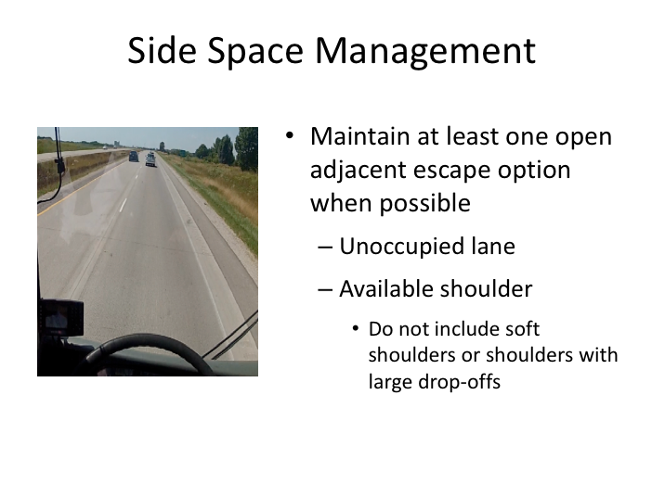

SIDE SPACE MANAGEMENT

For some successful reactions to identified hazards you will need to steer around the hazard, which may cause you to encroach into an adjacent lane or change lanes completely. Obviously, it’s difficult to do this if there are vehicles or objects in adjacent lanes.

In order to provide yourself with the most options for reacting to hazards, you should attempt to maintain at least one open “escape route” to either side of your coach. This typically would be an unoccupied adjacent lane, or an unoccupied roadway shoulder. When possible, don’t allow yourself to be boxed in with vehicles on both sides. If you are relying on a shoulder, make sure it is suitable for travel. If it is soft or has a large drop-off that could upset the coach, do not plan to utilize the shoulder as an escape route.

If you are on a roadway with only one lane in your travel direction and no suitable shoulder for escape, you should compensate with additional following distance.

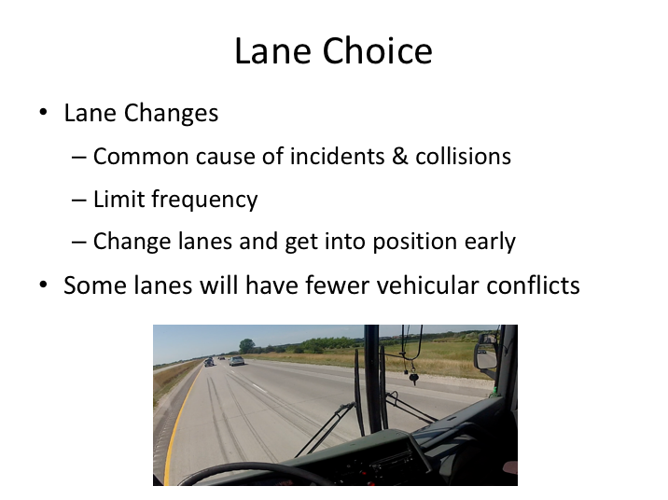

LANE CHOICE

Collisions and incidents related to lane changing are common in the motorcoach industry. We’ll discuss the mechanics of lane changing in the next lesson, but suffice to say that the best defense against incidents involving these maneuvers is to limit them to the extent possible.

On highways, choose a lane and stay in it as much as possible. On controlled access roadways, the right-most lane will have a lot of conflict traffic – traffic that is either entering or leaving the highway. The left-most lane is often where faster vehicles travel – traveling in it at the posted speed is perfectly fine, but be especially aware that you are likely to have fast-moving vehicles passing you on the right and that some of them may get angry for having to move around you in their “fast lane”. On multi-lane highways, lanes in between the left-most and the right-most lane may be the best choice to avoid traffic conflicts. Keep in mind that some states designate the left-most highway lane for passing only; and that sometimes restrictions for commercial vehicle traffic may be in place in specified lanes.

LANE CHOICE (continued)

On highways with congested traffic patterns, there may be high-occupancy vehicle (HOV) lanes – usually the left-most lane. For these roadways, this lane
may be your best choice because it will be less congested and traffic traveling behind you will be less likely to move around you due to congestion in the lanes to the right.

Whenever you know you must be in a specific lane – either to turn, exit, or merge onto a controlled access roadway, you should get in the necessary lane well in advance. Waiting to change lanes until you are too close to the turn will pressure you to change lanes quicker, and increase your chance of being involved in an incident.

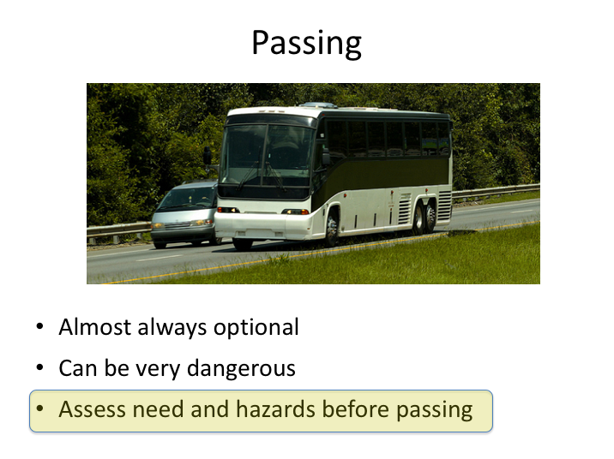

PASSING

Passing is almost always an optional maneuver. The dangers of passing vary, depending on the type of roadway you are traveling on and its characteristics. Passing which necessitates encroaching into the travel lanes of oncoming traffic, especially on hilly and curvy roadways, can be exceptionally dangerous and result in very serious collisions.

When you think you might want to pass, think again. Even in the least dangerous circumstances, passing will require you to change lanes at least once. Ask yourself if the pass is necessary. Is the vehicle ahead really going that much slower than you? Could there be a reason it is going slowly – perhaps it’s waiting for a vehicle to pass to change lanes itself or getting ready to turn?

Think about the risks and hazards associated with passing in the present situation, and assess how much you might gain by passing. The passengers' safety and comfort should always come first.

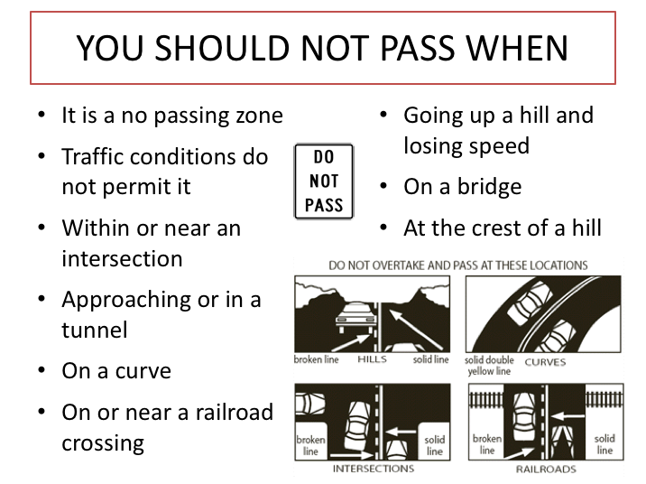

YOU SHOULD NOT PASS WHEN

There are specific instances when passing, no matter the roadway, will be more dangerous than at other times.

Obviously, you should not pass when it is not legal or if traffic conditions do not permit a safe pass. Passing near an intersection is especially hazardous because of the potential for conflict traffic which may not have been observed or present prior to the passing maneuver.

Passing in areas where sightlines are restricted, even if not strictly prohibited, is not advised. These include roadways with curves or hills which prevent the necessary sight line. Passing when going up significant inclines is also not advised – it may be difficult to maintain necessary momentum to complete a pass in this situation.

And finally, passes should not be made in particularly hazardous stretches of roadway, such as on bridges, near or in tunnels, and on or near railroad crossings.

YOU SHOULD NOT PASS WHEN (continued)

Narrowed or non-existent shoulders, acute hazards, and the potential significant increased consequences of collisions in these areas are simply not worth the risk and, in general, not legal.

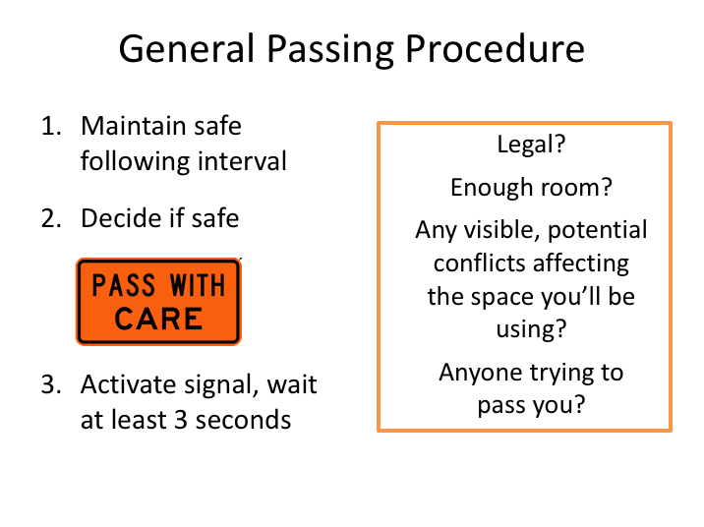

GENERAL PASSING PROCEDURE

To successfully pass in any situation, you should meet several conditions:

- Decide if the pass will be safe. First, make sure it’s legal. Ensure there is enough space to initiate and complete the pass without vehicle or pedestrian conflicts in the space you’ll be using. Also, keep in mind that if you are contemplating passing, there likely may be other vehicles behind you also contemplating the same. With this in mind, you should always be cautious of vehicles at, or approaching from, your rear attempting to pass you at the same time you may be contemplating and trying to pass the vehicle in front of you. Remember, they may not be able to see around you and realize that you are not the one impeding traffic!

- Once you’ve decided it’s safe to pass, activate your turn signal and wait at least 3 seconds before moving into the adjacent lane. Remember, do not assume that your signal will discourage vehicles attempting to pass you or move into your intended area. Your signal is only for information – and
many times, other vehicles may interpret that information as a sign to try to beat you to that area and get in front of you.
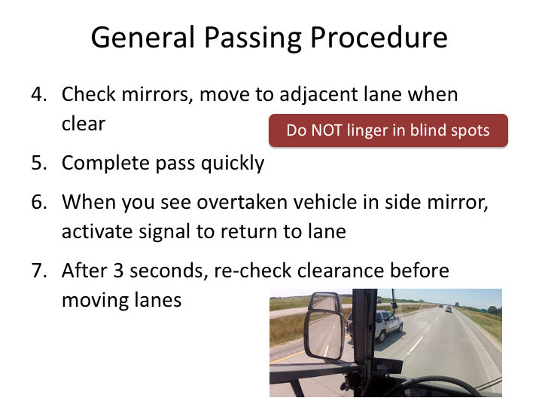

GENERAL PASSING PROCEDURE (continued)

After sufficiently communicating your intentions, re-check your mirrors for clearance and move to the adjacent lane when possible.

Once you begin your pass, complete it as quickly as possible. Do not linger in the blind spots of other vehicles, especially other commercial vehicles. Continue until the headlights of the vehicle you are overtaking appear in your flat mirror – this should indicate sufficient clearance to contemplate returning to your original lane. Remember, do not rely upon your convex mirror in this situation as it can be deceptive in assessing distances between vehicles.

Activate your signal for several seconds and re-check clearance before completing your move back into your original lane.

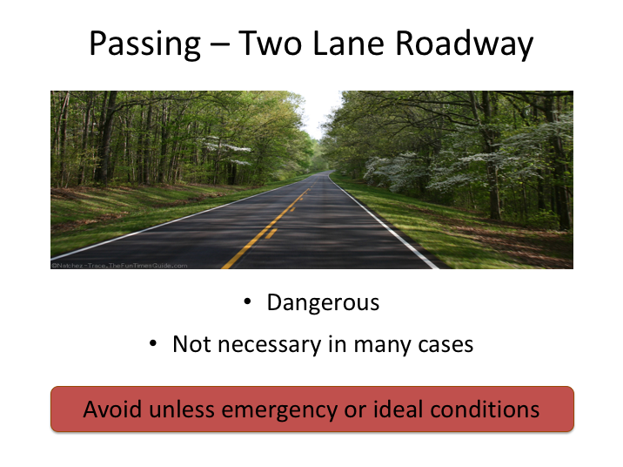

PASSING - TWO-LANE ROADWAY

The most dangerous type of road to pass on is a two-lane road—with one lane of traffic moving in each direction. An error in judgment, timing, or speed can be disastrous.

Because passing on a two-lane road can be a very dangerous maneuver, it should be done sparingly. In fact, it should be largely avoided unless the pass is necessary to avoid or maneuver around an object in the roadway or an unusually slow moving vehicle. Even then, you must wait for an appropriate opportunity given the environment. Remember, motorcoaches cannot accelerate as fast as most vehicles and, because they are longer, coaches have to stay exposed in the passing lane for a longer period of time. Compounding the danger is the unknown mindset of oncoming traffic who may panic and not react appropriately if they see an oncoming vehicle in their lane – especially a large one!

Because of these dangers, passing on two-lane roadways should be avoided unless it is legal and there are ideal conditions – good visibility, a long, unobstructed sight line, and of course, no oncoming traffic.

When passing on a two-lane roadway (one lane of traffic moving in each direction), what are some of the risks and hazards of passing? What can go wrong during the pass?

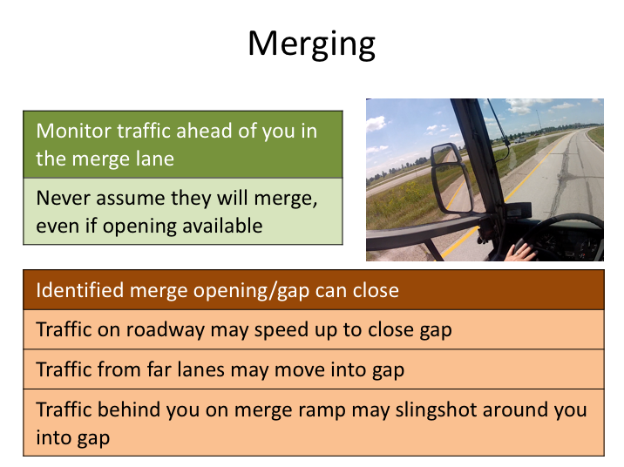

MERGING

Merging seems pretty straightforward, but there are plenty of hazards involved and it can be a very tense and dangerous maneuver. Hazards can change depending upon the scenario and roadway configuration, but can include little or limited merge lanes, congested traffic, and even backed up merge ramps.

When merging onto an expressway or other roadway, you need to be cognizant of traffic in the lane you are attempting to merge into, as well as traffic ahead and behind you in the merge lane. You must be aware of traffic ahead of you in the merge lane; don’t get so absorbed by your mirrors that you fail to notice that the vehicle ahead of you has stopped. This is a major cause of crashes on access ramps. If necessary, hang back (slow down) to give them time to merge. This reduces the chance that you will have to stop on the entrance ramp.

Activate your turn signal; your signal will communicate your intention to merge. Use the flat mirror to observe gaps in oncoming traffic (not the convex mirror – it’s bad for judging distance!). Go slow on the entrance ramp and acceleration lane until you spot an appropriate opening/gap. Once you spot an opening, use the acceleration lane to build up your speed to match the speed of the traffic flow (assuming, of course, any traffic ahead has merged).

MERGING (continued)

Never assume that oncoming traffic will let you in, even if you see a large enough gap. They may slow down a bit, or even change lanes to let you in. However, they may also not let you in by speeding up. Glance over your left shoulder to check for vehicles in the far lanes moving into the gap, and for vehicles behind you merging before you do.

If traffic is heavy and you cannot see a gap, you will have to yield to the traffic and stop. Stop smoothly so that drivers behind you will have time to react. Try to leave yourself a good bit of the acceleration lane so you can pick up speed and merge smoothly once an opening is identified. Once you have stopped, you must wait for a large gap before merging - an entrance at a slow speed can cause a crash if there is not a large gap.

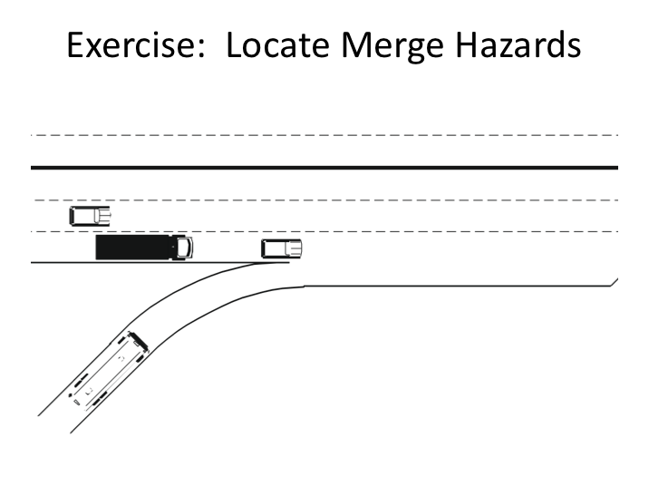

EXERCISE

Instructions: In this study guide, identify the location of all potential merge hazards on this merge diagram with a pencil.

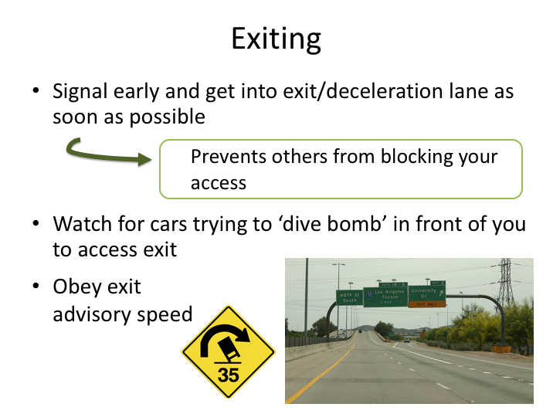

EXITING

Merging onto a controlled access roadway is not the only time you’ll need to be cautious – you also need to be careful when exiting.

If you’ve planned ahead and know your route, you’ll know when you’re approaching an exit you need to take from a controlled access roadway. Make sure you position yourself in the proper lane to exit well in advance; you may have to start maneuvering across the roadway to get into position far ahead of the exit if there is congested traffic.

As you approach your exit ramp, these are the steps to follow:

- Activate your turn signal at least 4 seconds before you reach the exit lane/ramp. An early signal will prevent drivers behind you from attempting an unnecessary pass. It will also warn the drivers behind that you might have to slow down if the exiting traffic is congested. However, do not slow down on the main road unless the traffic in front of you slows.

EXITING (continued)

- Enter the deceleration lane as early as you can, so you can gradually slow down. This will also prevent others from moving in to the lane before you and potentially blocking your access to it if they pull alongside your coach. If there is more than one exit lane, maneuver into the one you will need to be in at the end of the ramp as soon as possible. As you approach the actual ramp, be on the lookout for cars which are trying to cut in front of you into the lane to exit.

- Many ramps have posted advisory speeds because of sudden changes in direction or sharp curves - be sure to heed them. Slow down to at least the advisory speed and avoid carrying too much speed into the curved exit ramp. Going too fast can affect your control of the coach and make passengers uneasy.

LESSON 2

OPERATIONAL HAZARDS

Lesson Objectives:

By the end of this lesson, you will have an understanding of operational hazards related to operating large vehicles, including motorcoaches in particular. Knowledge of these concepts and hazards is critical to safe operation. Understanding these concepts, and incorporating them into your driving practices, will limit incident and collision potential.

Instructional Method: Classroom

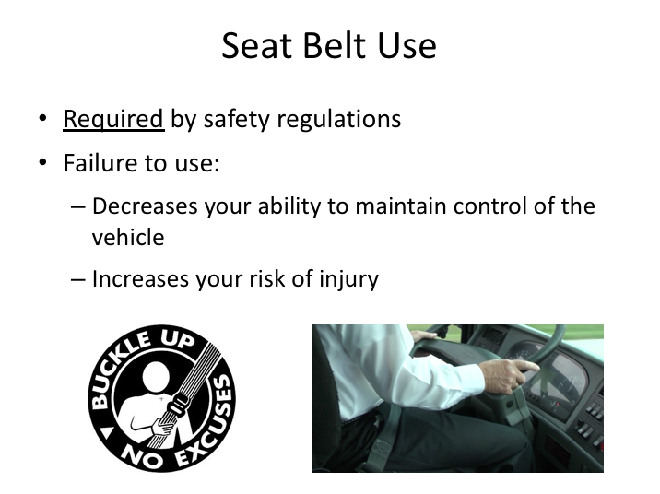

SEAT BELT USE

You may be thinking to yourself, “How is seat belt use a hazard?”. And you’re right, it’s not. But, deciding not to use your seat belt is a significant operational hazard – especially when operating a motorcoach.

Federal Motor Carrier Safety Regulations (FMCSRs) require the use of the driver seat belt in commercial vehicles. In addition, every state has state laws requiring seat belt use. Here’s why it’s critical for you to wear your seat belt:

- Without a seat belt holding you in place, you may be displaced from your normal seated position - even in small incidents or collisions. And once you’re out of position, you’re as much a passenger as anyone else. Utilizing your seat belt will allow you to maintain a position to control the vehicle.

- Another reason to always wear your seatbelt is to protect yourself from injury. In the event of an emergency, your passengers will be relying on you to provide them with instruction on what to do and where to go. Minimizing your chance of injury will allow you the best opportunity to serve your passengers when they may need you the most.

SEAT BELT USE (continued)

Plus, if you aren’t using your seat belt, you can be cited and/or fined by enforcement personnel.

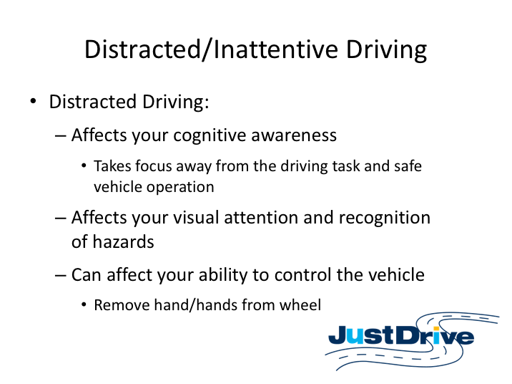

DISTRACTED/INATTENTIVE DRIVING

As you can tell from the previous video, distracted driving has been around a long time. While the concept is not new, the reality is that today, distracted driving is a contributing factor to many vehicle accidents and collisions. The dangers are real – injuries and fatalities attributed to distracted driving have been increasing. Studies show that driving while distracted is just as, if not more, dangerous than driving while intoxicated, under the influence of controlled substances, or driving fatigued.

Multi-tasking while driving affects your cognitive awareness to the driving task, resulting in loss of focus from safe operation of the vehicle – even if you are still looking at the road ahead. Some tasks will divert your attention from the roadway, which is like driving blindfolded, while others may require you to jeopardize control of the vehicle by the taking your hand – or hands – off the wheel.

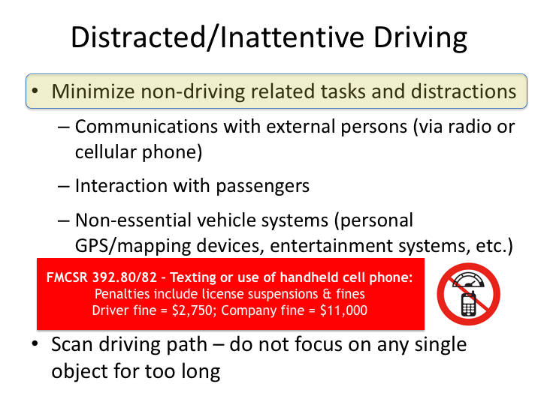

DISTRACTED/INATTENTIVE DRIVING (continued)

Distracted driving is a contributing factor to many vehicle crashes and collisions. The dangers are real – injuries and fatalities attributed to distracted driving have been increasing. Studies show that driving while distracted is just as, if not more, dangerous than driving while intoxicated, under the influence of controlled substances, or driving fatigued.

Mobile communications technology is perhaps the greatest culprit for the increase in distracted driving. Cellular telephones have become the norm, as has expectations of immediate communication or response. The dangers of this omnipresent distraction resulted in safety regulations which prohibit texting and limit cellular voice communication while driving a commercial vehicle. In fact, drivers can lose their license and be fined – up to $2,750 – for violating these federal safety regulations. And, if a driver is caught, his or her company could also be fined – up to $11,000!

DISTRACTED/INATTENTIVE DRIVING (continued)

There are more distractions however then just cellular communication devices. Simply put, focusing on anything other than driving-related tasks is a distraction. Examples include excessive interaction with passengers, operation of non-essential vehicle systems, such as entertainment systems or GPS/mapping devices, and even excessive communication with dispatch via non-cellular technologies. To be the safest driver possible, you must focus on operation of the vehicle, scanning you’re driving path, and monitoring essential vehicle systems and controls.

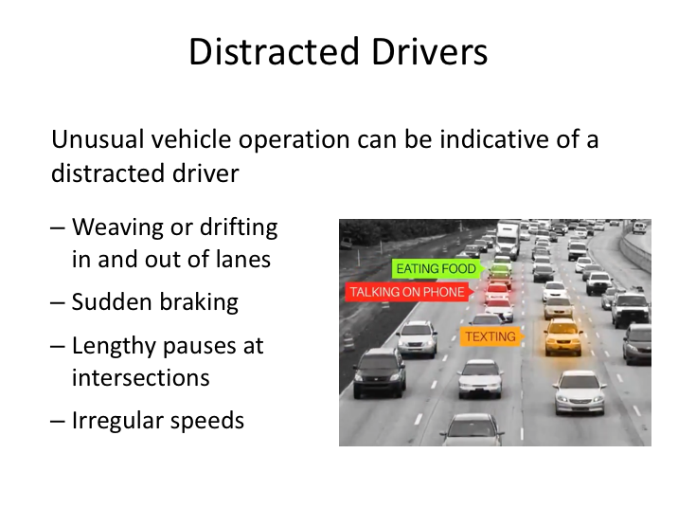

DISTRACTED DRIVERS NARRATIVE

Distracted drivers are among the most dangerous hazards on the road – to themselves as well as others. It’s not difficult to tell if a driver is distracted – even if you’re not looking at them in their vehicle. Vehicle movements and behaviors once associated with drunk driving are now more prevalent and also more likely to indicate a distracted driver.

Vehicles veering left or right within their lane or between lanes without signaling, vehicles braking late or suddenly, ones pausing for lengthy periods at intersections, and those traveling at unusual speeds can all be indications of a potentially distracted driver. When you observe a distracted driver, your best bet is to steer clear of their vehicle so you don’t become a victim of their distraction.

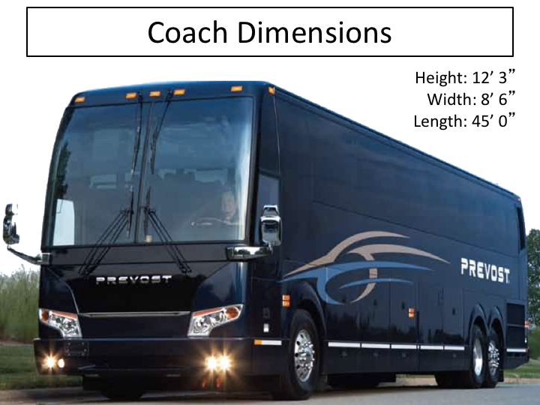

COACH DIMENSIONS

Imagine yourself navigating through some caves, an ancient structure with narrow door openings and low ceilings, or even going through an obstacle course. To do this without hitting your head or other parts of your body, you must know where you can – and more importantly, where you cannot - fit. Where you can’t fit, you’ll have to duck, turn sideways, or take other action to manipulate your body to allow you to get where you are trying to go. Perhaps because we’ve learned the hard way, we instinctively know what spaces we can fit into – and the ones we can’t. And while we may not run across many restrictions on a daily basis, the same is not true when operating a large commercial vehicle.

There are several key dimensions for a motorcoach: height, width, length, and rear overhang. These dimensions can be different on various makes and models of motorcoaches, and knowing your coach’s exact dimensions is extremely important in navigating without incident, as it can literally come down to inches. Many fleets often have different makes and models of coaches, so it will be important for you to make a mental note of the specifics of the coach you are operating on a daily basis.

COACH DIMENSIONS (continued)

While driving along interstates is often relatively conflict-free, non-interstate highways, rural roads, roads to and through popular destinations, and even parking lots present plenty of conflicts for motorcoaches. The fact is, putting a motorcoach where it doesn’t fit usually causes significant damage and ruins a trip.

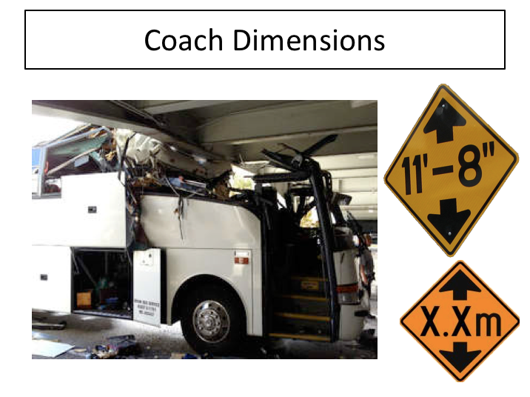

COACH DIMENSIONS (continued)

The most common dimensional conflicts will arise with the height of the motorcoach.

What are some specific things that could be too low for the coach to pass under safely? Can you think of some examples?

COACH DIMENSIONS NARRATIVE (continued)

Common objects that cause avoidable damage to motorcoach roofs are underpasses, tunnels, and canopies, porticos, and other shelter structures, like those found at hotels and service stations. Objects such as these are usually marked with a clearance sign and knowing the height of your coach will help you determine if you can pass underneath without making contact.

However, drivers should also be aware that clearance signs could potentially be incorrect. For example, an underpass clearance sign can be wrong if there is packed snow affecting the clearance height.

Also, some obstacles will not be marked with clearance heights. For example, low hanging tree branches often damage roofs and windows (especially in the winter, when they may be loaded with snow or ice). In these cases, it’s up to the driver to assess the clearance – if you’re not sure you can make it, you should get more information or find another route.

Know the clearance height of your coach before you begin your trip; if you are traveling into Canada, make sure you know your height in meters. While it may be true, it’s best never to assume that your laden coach is riding lower than the specified unloaded height. A good rule of thumb is that any coach, except for a double decker, should fit under obstacles 13’ or higher (double-deckers need over 13’).

In every case, if the clearance is close to the coach height, be careful and proceed very slowly.

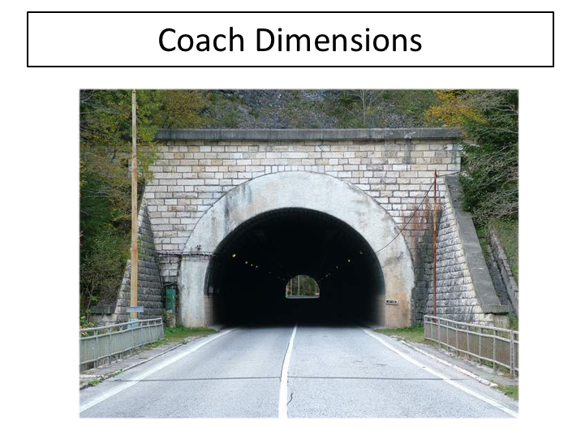

COACH DIMENSIONS (continued)

Be careful when the top of an underpass is curved. A clearance sign may indicate the minimum height over the travel lane, or the maximum height at the center of the arch. A sign in the center should refer to the height at the top of the arch. However, you will be generally driving to one side of the center, and the available clearance where you are driving may be less than the posted clearance.

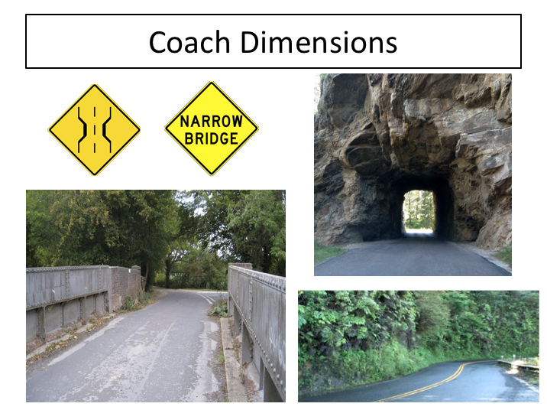

COACH DIMENSIONS (continued)

While height might be the most common clearance conflict, it’s also important to know your coaches width and rear overhang.

While most roadways, tunnels, and attractions can handle the width of a motorcoach without issue, it’s still good to know for the few that are tight, as well as narrow roadways.

Most modern motorcoaches are approximately 8½ feet wide. The lanes of our major highways are 12 to 14 feet wide. You can safely and comfortably drive at the speed limit in the center of such a lane. However, narrow roads do exist and you are likely to encounter them at some point.

When traveling on very narrow roads – ones where passing oncoming large vehicles may not be possible without utilizing portions of the shoulder - proceed slow enough that going onto a soft shoulder would not cause you to lose control.

Also be aware of pavement drop offs at the shoulder – these can upset a motorcoach and cause a crash when tires transition between the uneven surfaces. Soft shoulders and drop-offs can cause a coach to roll over.

COACH DIMENSIONS (continued)

Another key dimension is the rear overhang. This can vary by coach make and model and comes into play when making tight turns. In conjunction with a coach’s turn radius, the rear overhang helps determine when a coach can make a turn without issue. More on how turn radius and rear overhang clearance come into play will be covered later in this lesson.

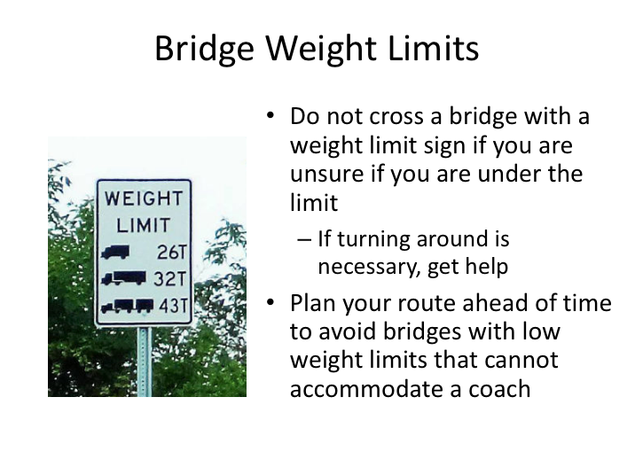

BRIDGE WEIGHT LIMITS

If you find yourself on a road approaching a bridge, and there are signs restricting weight on the bridge, you must think about your loaded weight and decide if it is safe to cross. If the sign is specific to single or combination units, any type of bus, including a motorcoach, would be classified as a single unit.

Weight limits are usually indicated in tons, so remember – 1 ton is equal to 2,000 pounds. In addition to posted restrictions, there are federal axle weight restrictions in place to protect bridges, though the configuration of a typical motorcoach, even when fully loaded to its gross vehicle weight rating, falls within these regulations.

If you cannot navigate a bridge and turning around is necessary, get help so that you can do so safely. Remember, planning your route ahead of time can help you avoid ever having this problem in the first place.

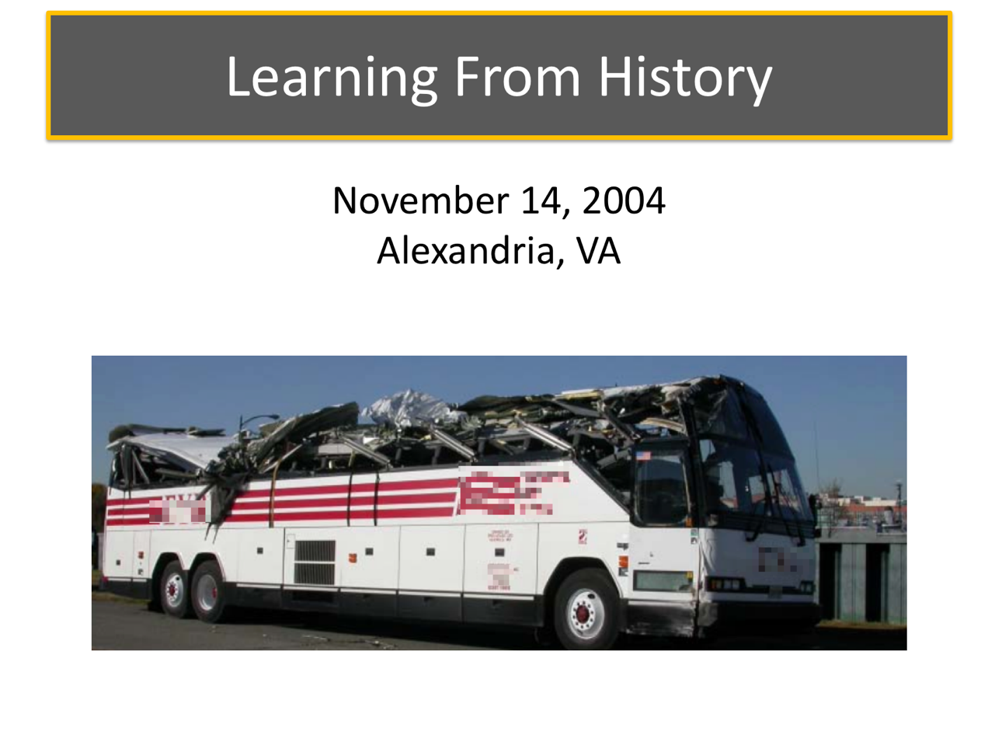

LEARNING FROM HISTORY
The size of a motorcoach, like any large commercial vehicle, is a known operating hazard. The vehicle is just sometimes just too big to go where you and your group wants to take it. Distracted driving is another known operating hazard - without full attention to the driving task, the chances of mistakes increase.
The incident that occurred on November 14, 2004 in Alexandria, VA highlights a dangerous combination of these hazards.

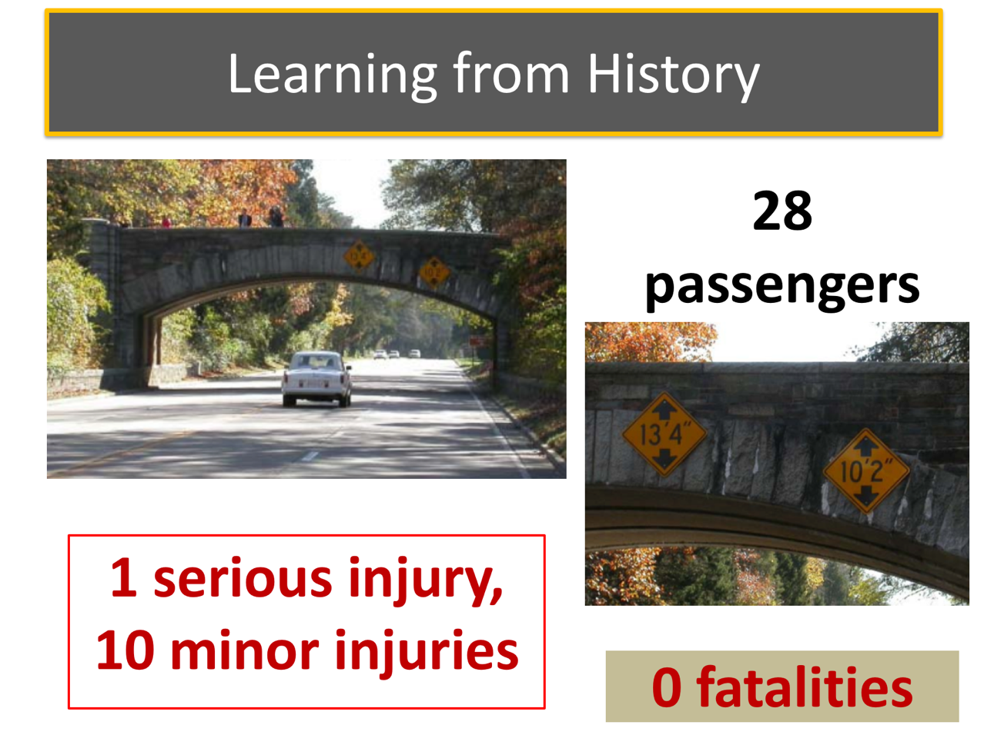

LEARNING FROM HISTORY (continued)
On November 14, 2004, about 9:30 a.m. a 44-year-old bus driver departed the Baltimore/Washington International Thurgood Marshall Airport, in a 58-passenger motorcoach for an approximately 60-mile trip to Mount Vernon, Virginia. Vehicle occupants were the bus driver, an adult chaperone, and 27 high school students. This vehicle was the second of a two-bus team traveling to Mount Vernon.
About 10:40 a.m., the bus was traveling southbound in the right lane of the George Washington Memorial Parkway in Alexandria, Virginia, at a recorded speed of approximately 46 mph. As the bus approached the Alexandria Avenue bridge, the bus driver passed warning signs indicating that the bridge had a 10-foot, 2-inch clearance in the right lane. Nonetheless, the driver remained in the right lane and drove the 12-foot-high bus under the bridge, colliding with the underside and side of the overpass. At the time of the accident, the 13-foot, 4-inch-high left lane was available to the bus, and the lead bus was in the left lane ahead of the accident bus. The accident bus came to a final stop in the right lane about 470 feet beyond the bridge.
Of the 27 student passengers, ten received minor injuries and one sustained serious injuries. The bus driver and chaperone were uninjured. The bus's roof was destroyed.
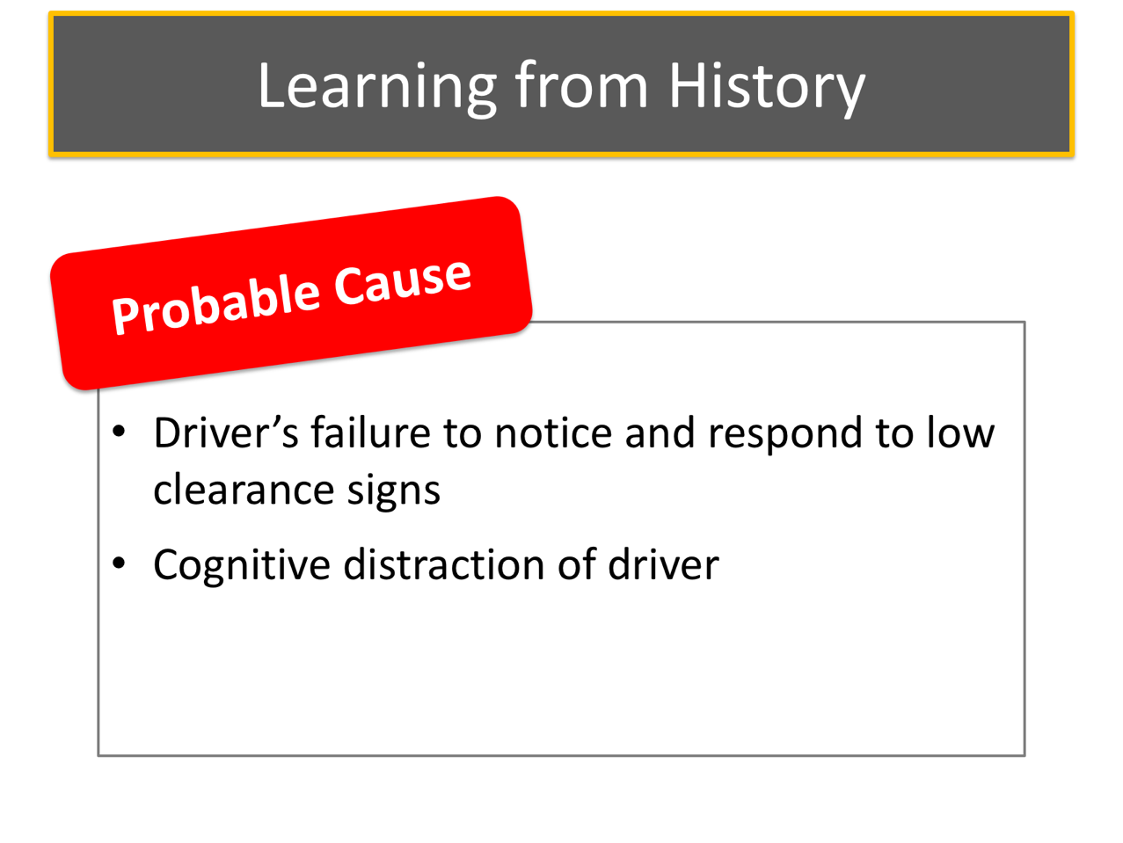

LEARNING FROM HISTORY (continued)

The National Transportation Safety Board investigation revealed that the carrier operated trips on this roadway frequently, and the accident bus driver had driven this route just 9 days earlier. Witnesses, and the bus driver himself, reported that the bus driver was talking on a hands-free cellular telephone at the time of the accident.

The NTSB determined that the probable cause of this accident was the bus driver's failure to notice and respond to posted low-clearance warning signs and to the bridge itself due to cognitive distraction resulting from conversing on a hands-free cellular telephone while driving.

LEARNING FROM HISTORY (continued)

The results of this crash could have been much worse. How many clues did the driver miss?

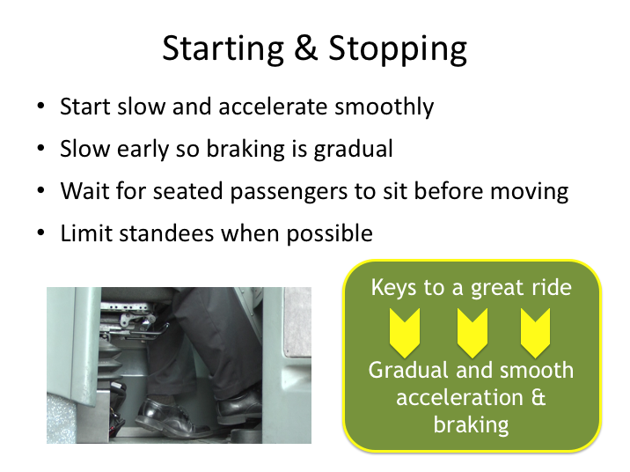

STARTING & STOPPING

The greatest chances for passenger injuries while on-board are collisions and sudden movement of the coach.

We tend to think of sudden movements of the coach as swerves or sudden stops, but it could be any sudden motion – especially if unexpected. Avoid “jack rabbit” starts by easing into any movement from a stopped position and anticipate stopping well in advance when possible. By anticipating when you may be stopping, you can begin to slow by simply stopping active acceleration and eventually brake gently to a controlled stop. Avoiding fast starts and short stops will also limit wear and tear on coach components.

Sudden starts are most likely to injure passengers who are standing, so it is always a good practice when practical to wait until passengers are seated before moving the coach.

When a moving coach has standees out of necessity or choice, the chances of sudden stop injuries will increase. Remind passengers to limit movement about the coach while it is in motion, especially in congested traffic areas.

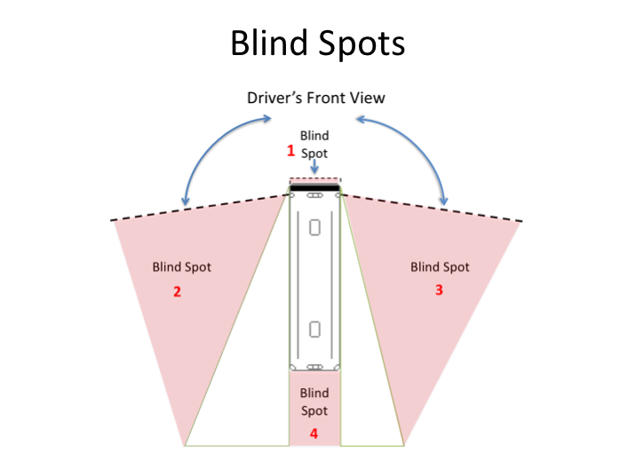

BLIND SPOTS

Blind spots are areas around a coach where you may not be able to see other vehicles. For instance, the largest blind spot is directly behind the coach. Using your side view mirrors, you can see objects some distance behind the coach, but you would not see a small vehicle directly behind the coach. If you have been monitoring a vehicle approaching from the rear that is suddenly not visible in your mirror, the vehicle may have turned off. But, it could also be behind you in the blind spot.

Or, the vehicle could be beside you in one of your other blind spots. There is a blind spot on each side of the coach; depending on the mirrors available and their setting, you can minimize these blind spots, but not eliminate them.

You should always be aware of what vehicles are beside you so that you know when it is safe to make a lane change. You never know when an emergency will make you consider changing lanes. If you frequently monitor whether the lanes next to you are free, you can act quicker in an emergency.

Even when you constantly monitor your mirrors, it is good practice to turn your head slightly and check those blind spots before changing lanes.

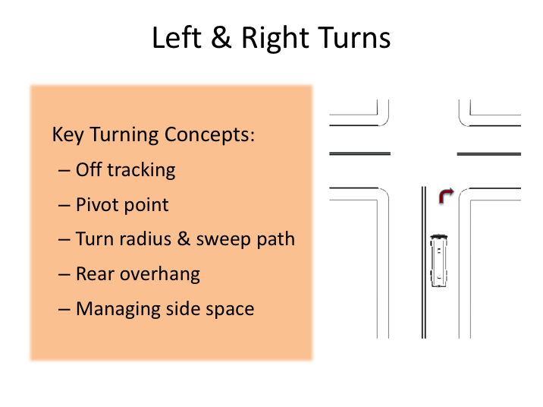

LEFT & RIGHT TURNS

While the concept of left and right turns at intersections seems straightforward, the truth is that turns can often be difficult maneuvers in a large motorcoach. Turns usually occur at intersections where there may be traffic traveling in opposite directions and where stopped vehicles turn into fixed object hazards. Potential pedestrian conflicts increase at intersections, and fixed object hazards such as light poles and signs are often present on intersection corners. Even traffic approaching from the rear can present dangers to executing a turn without incident. These factors can be complicated even further depending upon whether traffic control devices are present at any given intersection.

In order to overcome these obstacles to safety, you must have a good understanding of key concepts related to turns. These are:

- Off tracking
- Pivot point
- Turn radius and sweep path
- Rear overhang
- Managing side space

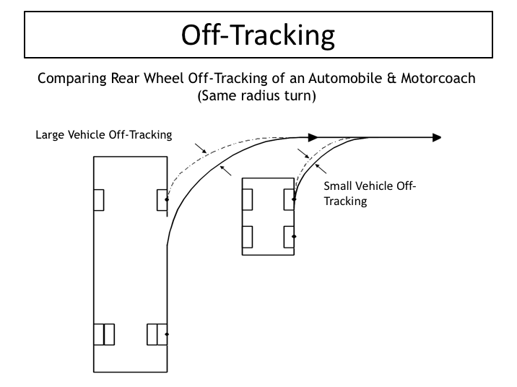

OFF-TRACKING

The first thing you need to understand is off-tracking. This is the main characteristic that makes turns difficult when you are in a long vehicle.

Let’s assume that you are just starting into an intersection with your coach and want to make a right turn. What do you think would happen if you started to turn the wheel immediately, like you do in your car?

Off-tracking refers to the fact that, when making a turn, the rear wheels of the vehicle will track inside the front wheels. The longer the vehicle - as in the case of a motorcoach - the greater the off-tracking. Cars also have off-tracking to some degree, but it's so slight in cars that the drivers usually don't have to think about it when making a turn. If they do think about it, it is when they park. Many drivers don't even know it happens. On the other hand, motorcoach drivers typically have to think about off-tracking whenever they are behind the wheel.
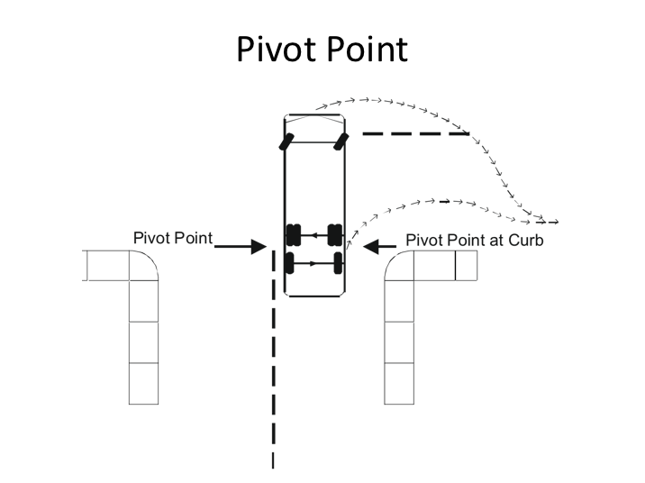

PIVOT POINT

In order to compensate for the exaggerated off-tracking of a larger vehicle, you’ll need to understand the pivot point concept. Just as it sounds, the pivot point is the point around which the rest of the vehicle turns. It doesn't actually stand still while the rest of the vehicle moves around it, but it's the point that moves the least.

Actually, a motorcoach has two pivot points: one on the right, and one on the left. If you have one rear axle, the pivot point is at that axle; if you have two rear axles and the tag axle (the rear-most) is in contact with the road, it is between them. When a tag axle is raised off the ground (possible with some coaches), the pivot point moves back to the single axle in contact with the road.

In making a right turn, if you were to pull straight out into an intersection until the curb of the street you're turning into is even with the pivot point, you could turn your steering wheel all the way to the right and make the turn without worrying about running over the curb at the corner. If you are in the left part of your lane as you approach the corner, you could start the turn a little earlier.

PIVOT POINT (continued)

For example, you might start turning when the curb line of the intersecting street is about at the second baggage door. But no matter where you start your turn, you should understand your pivot point, and monitor objects near it during the maneuver.

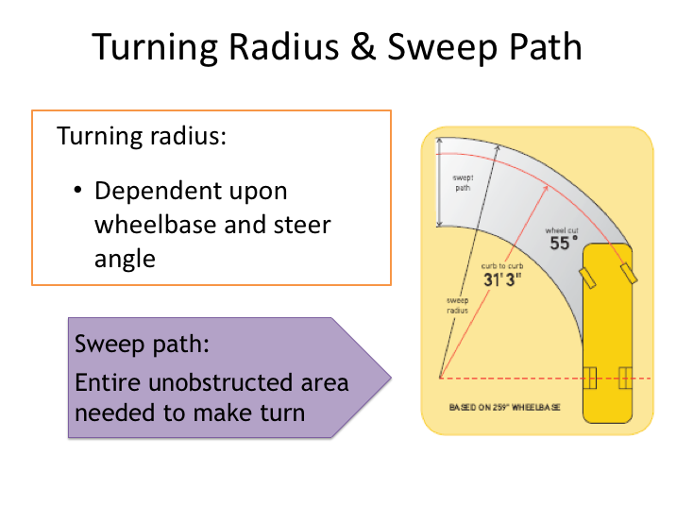

TURNING RADIUS & SWEEP PATH

Turning radius is a term that is often used to describe how sharp a vehicle can turn and the space necessary for a vehicle to make a turn. While conceptually correct, the space necessary for an unobstructed turn will be greater than a vehicle’s turning radius.

The turning radius usually considers the path of a vehicle’s tires and does not account for the path of the body of the vehicle through the turn.

The largest determining factor of turning radius is a vehicle’s wheelbase. This being the case, one might assume that the turning radius of all similarly configured motorcoaches is about equal, though this is not true. Just as with vehicle clearances, turning capabilities of various makes and models of motorcoaches can vary considerably. This is because steer angle, sometimes referred to as wheel cut, is a secondary determining factor for turning radius. Some coaches simply have greater steering angle capabilities, which will shorten turn radius.

There are other features on certain motorcoaches that can be employed to make sharper turns. Some motor coaches are equipped with steering tag axles.

TURNING RADIUS & SWEEP PATH (continued)

These axles actually turn in conjunction with the front wheels, effectively decreasing the turning radius. Some motorcoaches also have tag axles that can be raised, which effectively decreases the wheelbase of the motorcoach, allowing it to turn along a shorter path.

While turning radius is a widely published vehicle specification, what really is of concern to a driver is the vehicle sweep path. The sweep path is the unobstructed area needed to make a turn without striking any object with any portion of the vehicle. While minimal body overhangs on most cars make the vehicle sweep path similar to its turn radius, the larger body overhangs on commercial vehicles can make the sweep path substantially larger than the turn radius.

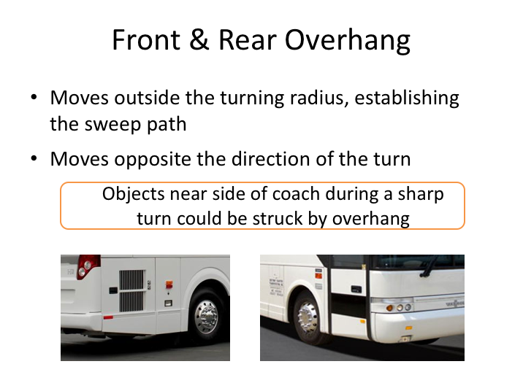

FRONT & REAR OVERHANG

“Overhangs” are the amount of body between the bumper of the vehicle and the front or rear axle. The front overhang is from the front bumper to the center of the steer axle. The rear overhang is from the rear axle to the back bumper.

The length of both of these overhangs determine the vehicle sweep path. As just discussed, wheelbase is the main determining factor in vehicle turning radius and maneuverability. Manufactures of motorcoaches and other large vehicles naturally want to shorten the wheelbase as much as practical so that the vehicle is more maneuverable. Minimizing the wheelbase tends to result in large rear overhangs on some buses.

When operating a motorcoach, it's very important to understand the size of overhangs and the effect overhang extensions will have when turning the coach. In any turn, the rear overhang moves initially opposite the turn. The front overhang may also infringe upon the area opposite the turn and must be considered when turning. Drivers should take note of objects close to the side of their vehicle, especially when making sharp turns.

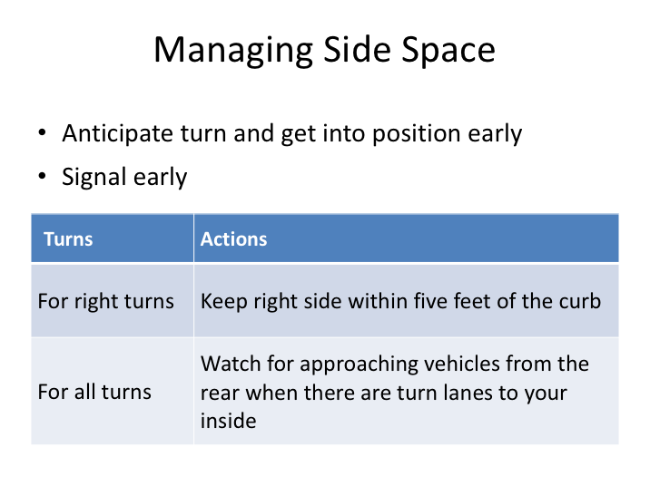

MANAGING SIDE SPACE

When making any turn, you need to be aware what is immediately beside you while negotiating the turn. Collisions frequently occur when other vehicles squeeze into the area along the side of your vehicle during a turn. The other vehicle may be attempting to pass on the right or may also be making a turn to the inside of your motorcoach. This scenario occurs most often during right turns and is so common historically that it has its own terminology in safety circles – it’s called the right turn squeeze.
What causes the problem? Generally, it’s the other driver who is in a hurry, not paying attention, or desperate to get around or in front of your motorcoach. However, drivers can encourage the opportunity by setting up for the turn incorrectly, swinging too wide when making a right turn, not signaling at all, or not signaling early enough.

MANAGING SIDE SPACE (continued)

To avoid this problem, it’s important to manage your side space:

- Anticipate the turn and get into position in the necessary lane early.

- Signal early so that others behind you know you are turning.

- For right turns, position the bus to the right edge of the traffic lane no more than five feet from the curb. The bus should not be far enough away from the curb to allow a vehicle to pass on the right between the bus and the curb.

- For left or right turns where there are additional turn lanes inside of yours, watch for traffic approaching from the rear that is attempting to turn in the inside turn lane.

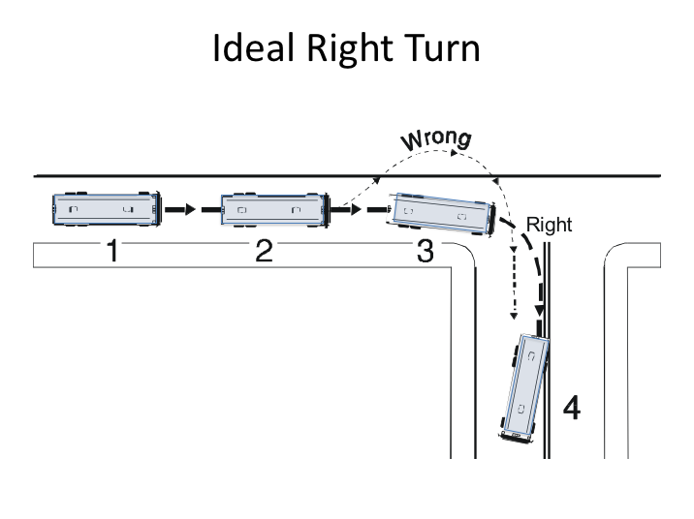

IDEAL RIGHT TURN

Let’s review a proper right turn, taking into account off-tracking, sweep path, overhangs, and side space. A right turn tends to be harder to do than a left turn because you have to change direction faster, and because you can't see as well what is happening to your right. Left turns tend to be more gradual.

This graphic shows you the right and wrong way of making a right turn:

- Prepare for a right turn by switching on the turn signal and moving a little to the left within your lane. However, do not leave more than 5 feet between the coach and the curb. This gives you a little maneuverability in making the turn, but you're not so far to the left that another vehicle could try to pass you on the right. Even when executing this properly, remember that the squeeze play can also involve motorcycles and bicycles; even pedestrians may step out into the space you leave when you swing left to make a right turn.

- When you get to the corner, check for a clear turn path. Look for traffic signals, signs, pedestrians, and vehicles.
IDEAL RIGHT TURN (continued)

- Pull out into the intersection until your pivot point is even with the curb of the street you are turning into (ideally). This guarantees that you will not run over the curb.

- Turn the steering wheel full right. As you continue into the turn, steer the wheels back into position.

Most coach drivers develop their own slight variations on this process, but the theory here is correct. They may start turning a little before the pivot point is aligned with the curb. The way you turn is also influenced by the traffic conditions you encounter. Notice that the ideal path may take you into the oncoming lane of the road you're turning into, especially the front overhang. That's okay - it just means you may have to wait until that lane is clear.

The path that is marked "wrong" in this picture is called a “jug handle” or "buttonhook." It is wrong for several reasons - it encourages other drivers to pass you on the right, and the buttonhook may encroach into other traffic lanes and leaves the driver blind to what is approaching from the rear once the coach swings left.

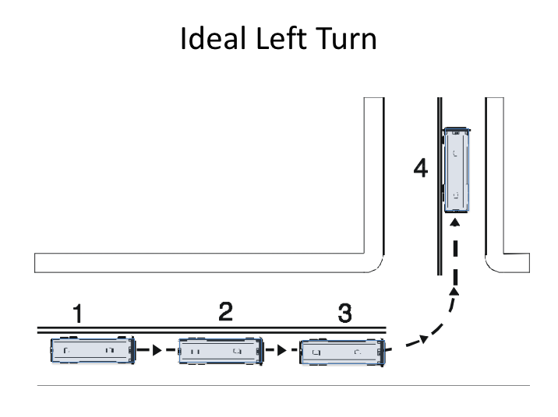

IDEAL LEFT TURN

The left turn is usually a little simpler, although if you were turning left from a one-way street to another one-way street, it might be just as difficult as a right turn. Here's the general procedure for a typical left turn:

- Prepare for a left turn by switching on the turn signal and moving into the proper lane. You should stay in the center of that lane.

- When you get to the corner, check for a clear turn path. Look for traffic signals, signs, pedestrians, and vehicles.

- If you need to stop until you can make the turn safely, it is important to keep the front wheels straight and the brake pedal depressed. This prevents drifting and activates the stop lights. It also prevents the coach being shoved into oncoming traffic in the unlikely event it is struck from the rear.

- When your pivot point reaches the centerline of the roadway you are turning onto, turn the steering wheel full left. As you continue into the turn, steer the wheels back into position.

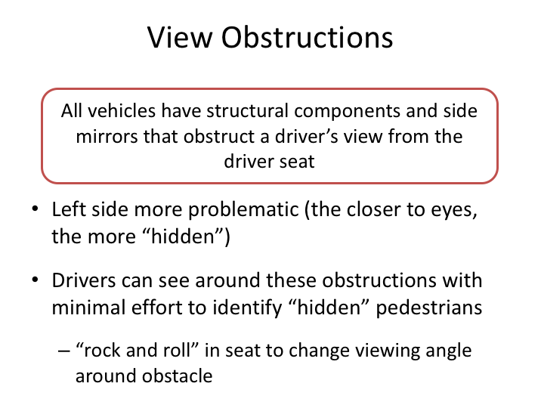

VIEW OBSTRUCTIONS

Pedestrians and bicyclists can be difficult to see due to their size and profile relative to the profile of a car or other vehicle. Their identification and observation tends to increase in areas where their presence is expected, such as busy intersections. However, sometimes, even at busy intersections, drivers fail to see or recognize pedestrians – even when they are scanning for them.

A driver’s area of recognition is only as big as the area he or she can see. Unfortunately, regardless of the design, there are features of vehicles which can impede sightlines and observance of pedestrians. The realities of vision are that opaque objects closest to the viewers’ eyes present the greatest obstruction of vision. This is a concept that is true for any vehicle, including a motorcoach, and must be understood by the driver.

The structure of almost every vehicle on the roadway requires pillar supports for roofs, doors and/or other components. The two most forward structural supports – those that encase the side of windshields – are known as the “A” pillar. The A
pillar of a motorcoach, just like A pillars on passenger vehicles, presents the driver with a view obstruction.

VIEW OBSTRUCTIONS (continued)

Other fixed location view obstructions for motorcoaches are the side view mirrors. The view obstructions presented by A pillars and side view mirrors vary by vehicle and driver position, but are more acute at the left side of the coach because they are closer to the driver’s seated position.

In order to properly observe and locate all pedestrians and bicyclists at intersections, drivers must move within their seat to be able to look around these view obstructions. “Rocking and rolling,” as it’s commonly termed, allows a driver to see around these obstacles by moving their vantage point from within their area of the coach. The view obstructions posed by these objects are not large enough to require anything other than effort from the driver to move their vantage point so they can see “around” these obstacles.

This concept is especially important if you are stopped at an intersection. While you are stopped, you should be moving about your seat to see around any natural vehicle component view obstructions and identify potential pedestrian conflicts so they can be tracked when resuming movement.

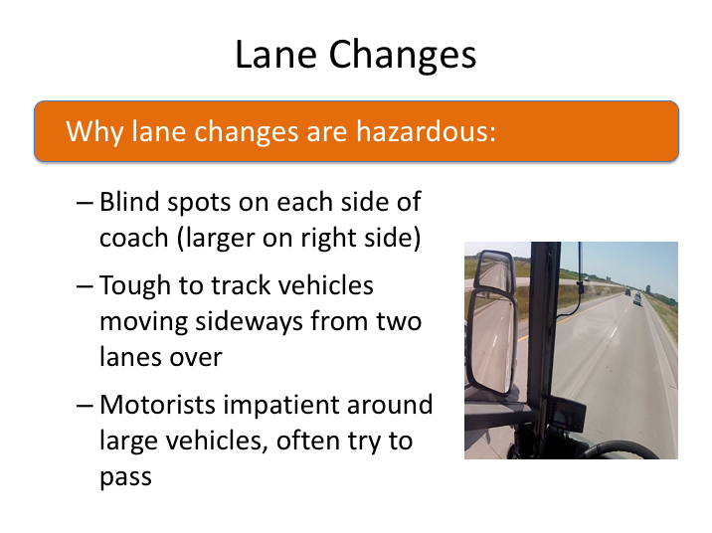

LANE CHANGES

Few think of lane changes as challenging maneuvers that can result in frequent collisions. As you’ve learned, there are blind spots on each side of the motorcoach; mirror configuration and proper mirror adjustment and use can minimize these blind spots, but not eliminate them (the blind spot on the right side of the coach is larger).

These blind spots, coupled with aggressive driving by other motorists and general impatience when following large vehicles, mean that there may often be someone alongside of your coach when you attempt to change lanes. Utilizing defensive driving principles can help you be more aware of where vehicles are around your coach – and when they may have moved into a blind spot.

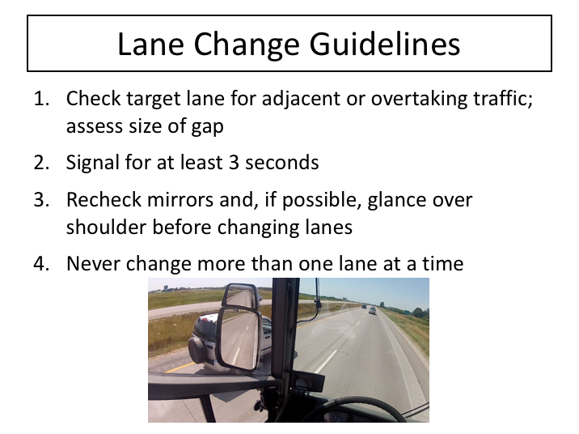

LANE CHANGE GUIDELINES

The easiest way to avoid lane change incidents is to obviously limit the number of times you change lanes. However, there are plenty of times a lane change is necessary or preferred, such as positioning for an upcoming turn or exit, or moving over when there are emergency vehicles on the shoulder. Here are some guidelines for carrying out a successful lane change:

- Check the side mirrors on the side toward which you plan to move. This is a preliminary check to make sure that there is no adjacent or overtaking traffic in the lane you want to enter.

- Assess the size of the gap. Look to see that the gap is big enough to accommodate your motorcoach. Don't decide to move until the gap is big enough.

- Activate your turn signal. Signal early enough that any vehicle that might move into your blind spot would have time to see it and decide against passing your coach. Never start a lane change without having waited for at least three signal flashes.

LANE CHANGE GUIDELINES (continued)

- Recheck your mirrors just before starting the lane change to make sure that an adequate gap is still available.

- When there is an adequate gap in the adjacent lane, merge smoothly into the center of the target lane, and cancel your turn signal.

Finally, never change more than one lane at a time – it’s too difficult to maintain proper forward focus and try to monitor activity in several adjacent lanes.
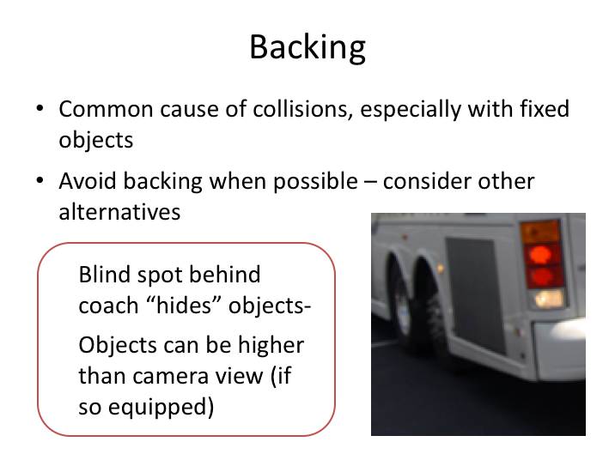

BACKING

Backing a motorcoach safely is difficult task. In fact, backing is responsible for many motorcoach collisions, especially with fixed objects. The reason is that it is difficult - if not impossible - to see hazards behind the coach.

As you have learned, there is a large blind spot behind the coach. Cars, pedestrians, other objects or animals can be in the path of the coach and you would not be able to see them. Some motorcoaches are equipped with backup cameras – even with a camera, you may not be able to see hazards out of the camera’s view, such as low hanging tree limbs.

For these reasons, backing should be avoided whenever possible. For example, if you find that you have passed a destination on a city street, it is often better to go around the block than to back up to it or turn around by backing.

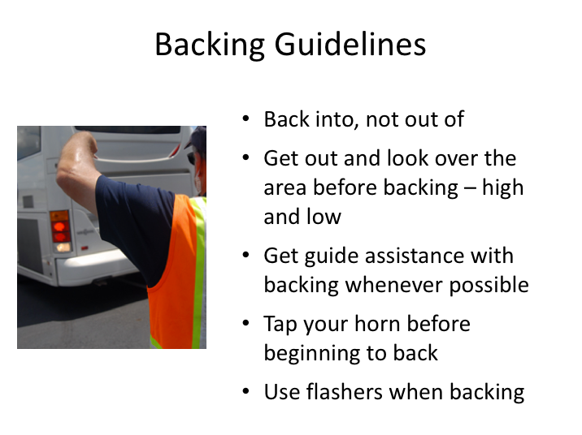

BACKING GUIDELINES

There will be times when it is necessary to back the coach. When it is absolutely necessary, you should utilize the following guidelines:

- Back into, not out of. This means always back into the area with the lower risk of hitting something. For example, you would back into a driveway and pull forward onto the street, rather than pulling into the driveway and backing out onto the street. This assumes you have determined that the driveway is free of obstacles and traffic.

- Get out and look over the area before backing. Look for obstacles low and high (i.e., overhead). Be sure you have clearance on both sides. Repeat this if you need to.

- Get assistance with backing whenever possible.

- Tap your horn as you back and use your flashers.

BACKING GUIDELINES (continued)

- When backing, make sure you back slowly and, whenever possible, in a straight line. When a backing turn is necessary, always try to back to the driver’s side – it’s easier to see. Use both mirrors, constantly checking them as you back up. And finally, use a guide whenever possible to act as your second set of eyes outside the motorcoach.

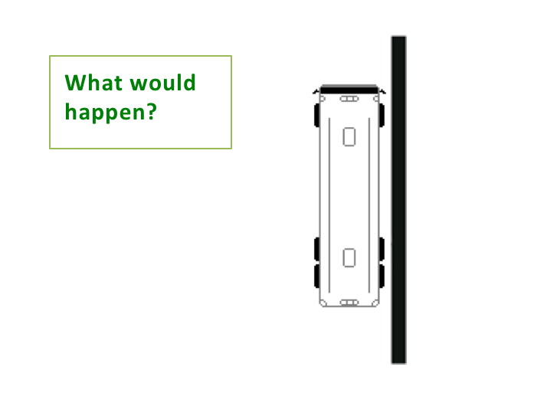

A coach is sitting about 12 inches away from a wall on the right. Let’s assume there are vehicles ahead of and behind the coach. What do you think would happen if the driver of this coach turned the steering wheel all the way to the left and then pulled out?

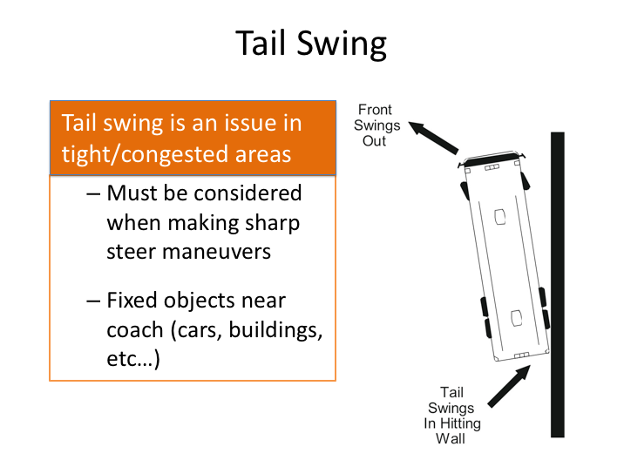

TAIL SWING

The large rear overhang on a motorcoach doesn’t only pose trouble during intersection turns, but also can causes issues when you are entering or leaving congested spaces where your coach is close to vehicles, walls, or other objects.

Imagine a coach’s side is close to a wall and has vehicles both ahead of it and behind it. To leave, you would have to steer sharply to the left because you are pinned in by the vehicles in front and behind you. However, if the rear overhang is longer than the distance from the side of the coach to the wall, you may have a tail swing issue.

When the front of the coach swings sharply in either direction, the rear of the coach swings sharply to the opposite direction. This is called a "tail swing,” and it can result in striking objects next to you – whether they are cars, walls, or even pedestrians or other fixed objects on an adjacent sidewalk. Sometimes, vehicles
move into this position and you may not even be aware of their presence, such as at a congested airport departure area.

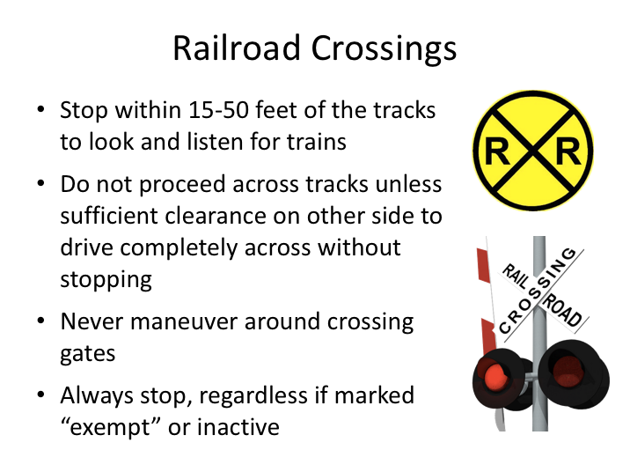

RAILROAD CROSSINGS

Collisions involving trains and motorcoaches are very uncommon. However, train collisions are extremely violent and represent a significant hazard in terms of mass injuries and fatalities for passengers. For this reason, Federal and State safety regulations require buses to stop at most railroad crossings to check for oncoming trains prior to crossing the tracks. While there may be occasional exceptions to this requirement, your best bet is to play it safe and stop at all railroad crossings as a matter of habit. The few seconds it requires is a good investment in safe operations.

While some tracks have crossing gates and signals, there are many other tracks, especially in rural areas, that may not have these warning devices. Even if you do see crossing gates or signals, you should still follow the same routine and are still required to stop.

Here are steps for crossing railroad tracks safely:

- When approaching, activate 4-way hazard lights.

- Stop between 15 and 50 feet from the nearest rail.

RAILROAD CROSSINGS (continued)

- Look and listen for trains. Turn down/off any noise emitting devices not necessary for operation of the bus and open the main service door if necessary.

- When determined to be clear, check for clearance on the other side of the tracks and proceed across when clear.

- Deactivate four-way hazard lights after crossing track.

If anything causes you to hesitate crossing tracks after looking and listening for oncoming trains, repeat the look and listen process to ensure continued clearance before proceeding across tracks.

Remember this about trains: A train cannot stop quickly as its response is limited by its size, weight and the engineer’s view down the track. A train cannot swerve to avoid a vehicle on the tracks. Also, due to their large size, trains appear to be moving more slowly than their actual speed. Drivers often mistakenly judge that they have enough time to safely cross before the train reaches the crossing. Be aware of this fact and, whenever in doubt, wait for the train to pass.

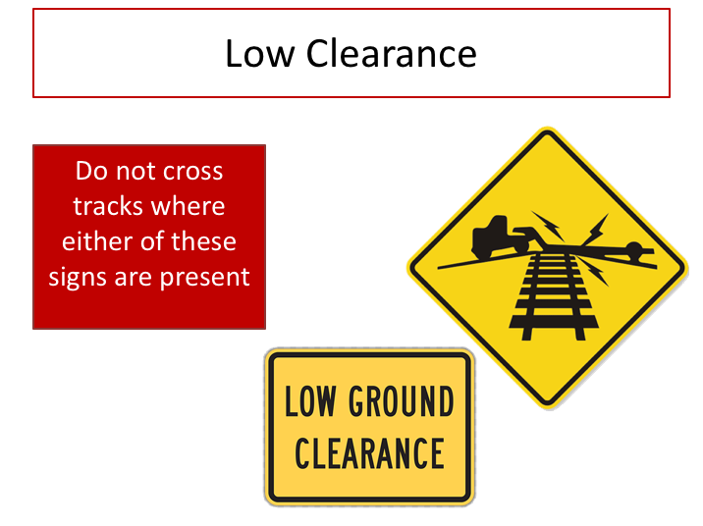

LOW CLEARANCE

If you see signs indicating a a low ground clearance, a high center track, or both, do not maneuver onto or over the tracks. These signs indicate the potential for a longer-wheelbase vehicle, such as a motorcoach, to get stuck on the tracks when the drive wheels lose contact with the ground. Many times this is referred to as high-centering – and it is an extremely serious situation.

If you ever were to become stuck or disabled on a railroad track, you should evacuate your passengers to a safe location away from the tracks and roadway before doing anything else.

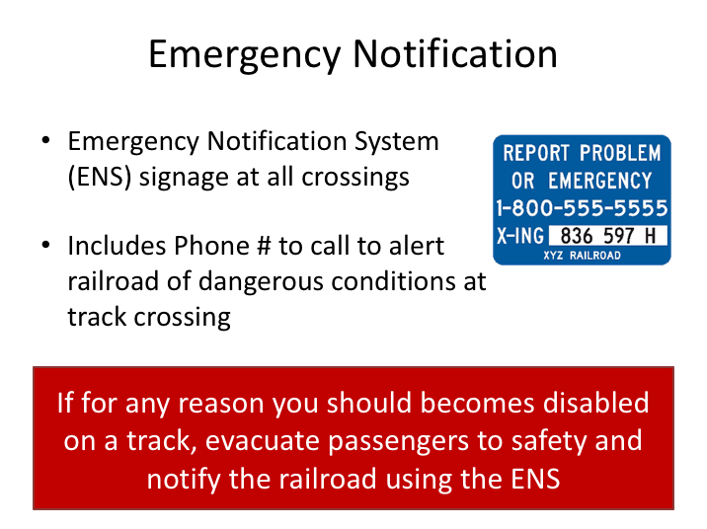

EMERGENCY NOTIFICATION

Effective in 2015, railroads were required to implement an emergency notification system for every active railroad crossing. Requirements include signage to include a telephone number through which they can receive reports of unsafe conditions at crossings. The notification sign will include a crossing number which will identify the crossing to the railroad.

If for any reason you become disabled on a railroad track, immediately evacuate your passengers to safety, finding a safe area away from the tracks and any roadway traffic. Then, notify the railroad of the emergency using the information on the emergency notification signage

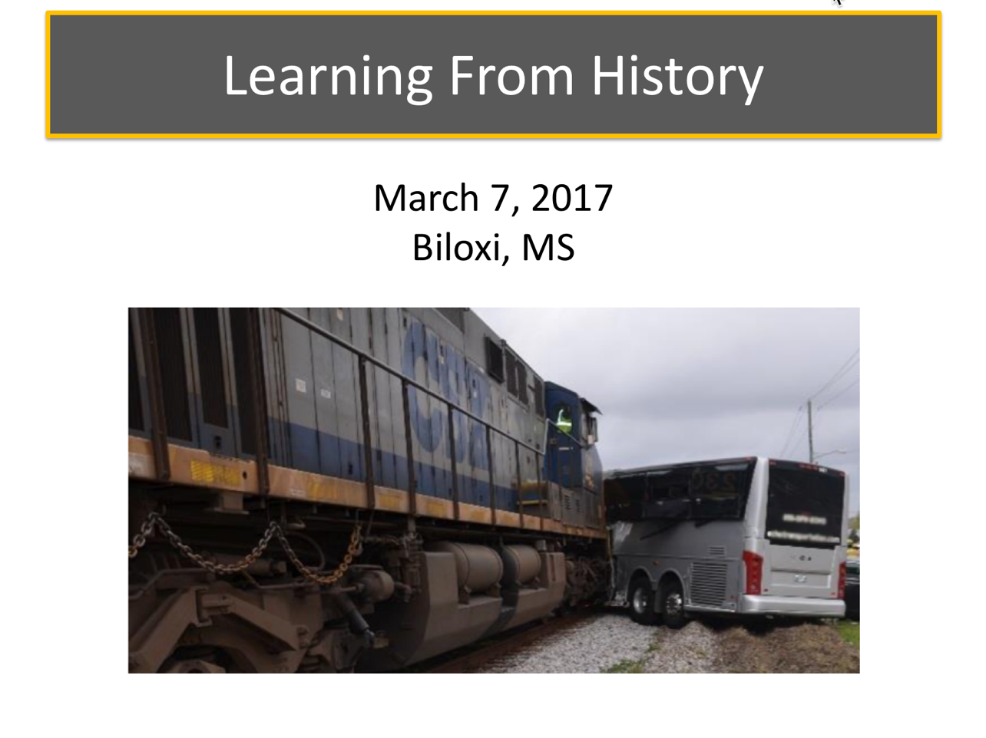

LEARNING FROM HISTORY

Collisions involving trains never turn out good. Many motorists travel across train tracks nonchalantly, paying more attention to signals and gates than looking down or across the tracks, or noticing any other signage.

The train and motorcoach collision that occurred on March 7, 2017 in Biloxi, MS is a good reminder of the dangers of railroad crossings and the vigilant attention and respect that motorcoach drivers should afford them.

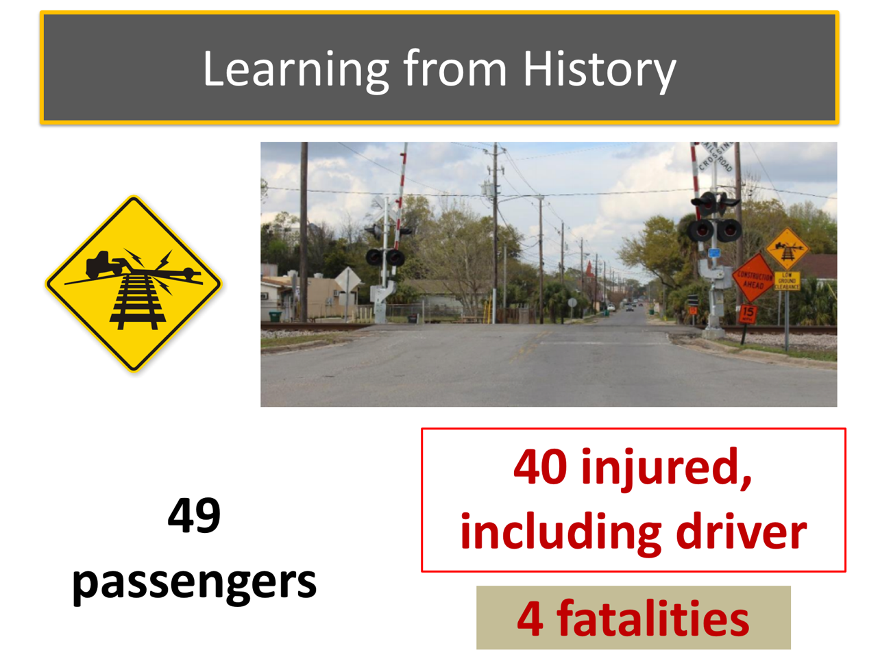

LEARNING FROM HISTORY (continued)

On Tuesday, March 7, 2017 at 2:12 p.m. a motorcoach carrying a group from a Texas senior center on a multi-day casino trip was traveling northbound on Main Street in Biloxi, Harrison County, Mississippi. The motorcoach approached and stopped in advance of a high vertical profile (humped) highway-railroad grade crossing. The crossing was marked with a crossbuck sign, warning lights, a gate, and a low ground clearance grade crossing warning sign with a low ground clearance plaque. The crossing gates were raised, and the warning lights were not activated.

As the motorcoach attempted to traverse the crossing, its frame became lodged on the tracks. The driver attempted to free the motorcoach by trying to move the vehicle backward and forward. At the same time, an eastbound freight train composed of three locomotives, 27 loaded cars, and 25 empty cars was approaching the crossing at a recorded speed of 26 mph. Upon seeing the approaching train, the motorcoach driver opened the entry door and told the passengers to evacuate. The train engineer sounded the train horn and put the train into emergency braking about 510 feet west of the crossing. The train struck the left side of the motorcoach, pushing it about 203 feet before coming to a stop.

LEARNING FROM HISTORY (continued)

As a result of the crash, four passengers died, 39 passengers sustained serious to minor injuries and six passengers were uninjured. The motorcoach driver suffered serious injuries.

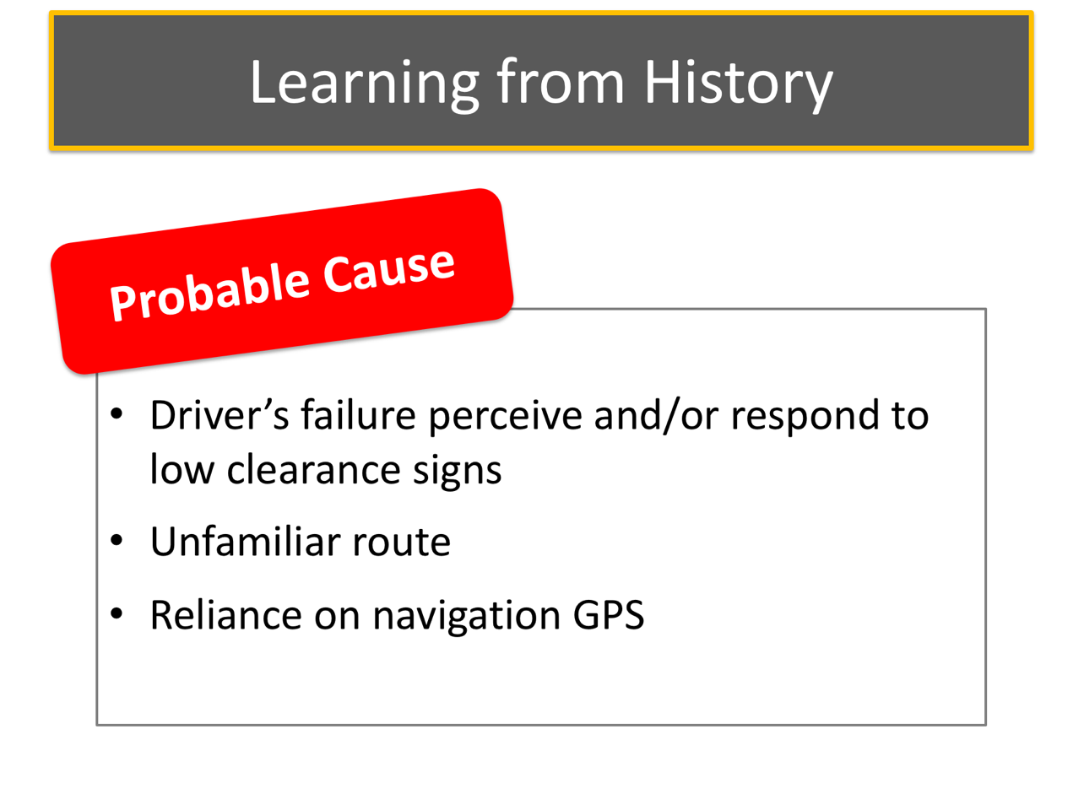

LEARNING FROM HISTORY NARRATIVE (continued)

The National Transportation Safety Board’s investigation of this incident was not complete at the time of this curriculum’s development. However, preliminary data indicates that there had been 16 other crossing accidents at this particular location, including one two months prior to this collision, when a train struck a stranded tractor-trailer, pushing it 70 to 80 feet before stopping.

This tour’s normal trip routing followed a route along Interstate 10. On the day of the crash, the tour operator changed to a more scenic route along the coast, an alternate route that had been used in previous trips. However, the involved coach did not follow the route provided and followed by the other two coaches on the trip. The involved motorcoach driver was using a GPS navigation device set for commercial vehicle use.

LEARNING FROM HISTORY (continued)

What mistakes did the driver make? What did the driver do right? What should the driver have done?

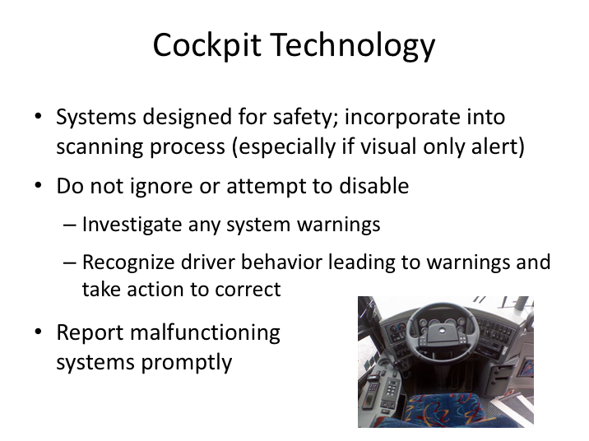

COCKPIT TECHNOLOGY

Efforts to make operating motorcoaches safer has resulted in increased technology within the driver compartment. In the past, all drivers had to do was monitor several gauges and some warning lights. But on today’s motorcoach, there are more sensors and monitoring and alert systems than ever before. Each of these systems has been designed to detect issues with the vehicle before it escalates into a hazardous situation or enhance driver performance and behavior. Examples include tire pressure monitoring systems, lane departure warning systems, electronic stability control systems, radar and adaptive cruise control systems, and blind spot cameras and detection systems.

This increased use of technology means that there are more items for the driver to scan and monitor while driving the coach. Occasionally, the systems may provide false warnings that can be frustrating to a driver. Like the sheep who cried wolf, repeated false warnings tend to de-sensitize a driver to the warning at all. However, drivers must keep in mind that these systems have been installed to maximize safety and should not ever be ignored.

COCKPIT TECHNOLOGY (continued)

Warnings pertaining to driver behavior, such as lane departure warnings, should be embraced and heeded – you should recognize the dangers and take steps to remedy any situation leading to such behavior. Alerts pertaining to vehicle systems, such as tire inflation or temperature alerts should be investigated. Finally, any known defects in these systems should be reported promptly to the company for necessary maintenance.

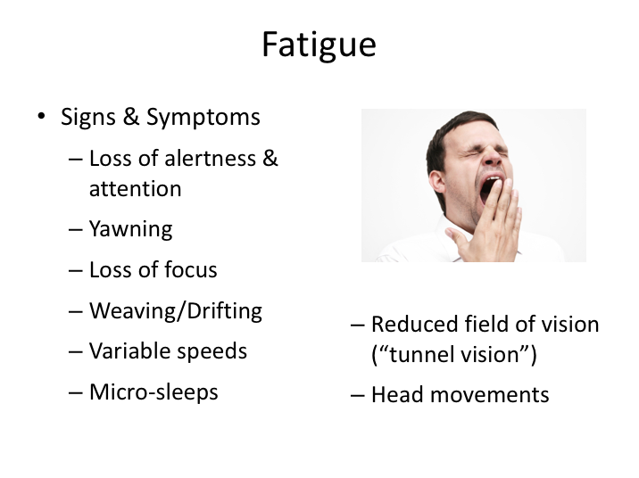

FATIGUE

If you’ve prepared for your trip properly, taken care of yourself, eaten properly, and taken steps to get enough rest during a trip, fatigue likely won’t be an issue. However, as part of your responsibility to operate safely, you also must realize the signs of fatigue and sleepiness and take steps to counter the condition when necessary. The truth is, some of us know when we are fatigued, while others don’t. In one study, 44% of drivers who fell asleep at the wheel reported feeling only slightly drowsy, or not drowsy at all! Though there are large differences in the ability to predict falling asleep, there are some common indicators of fatigue and drowsiness.

Listed here are some of the signs and symptoms of fatigue and sleepiness. If you find yourself yawning excessively, losing focus or alertness, weaving or drifting on the roadway, experiencing tunnel vision, operating at variable speeds unintentionally, and even experiencing micro sleeps, you are experiencing the symptoms of fatigue.

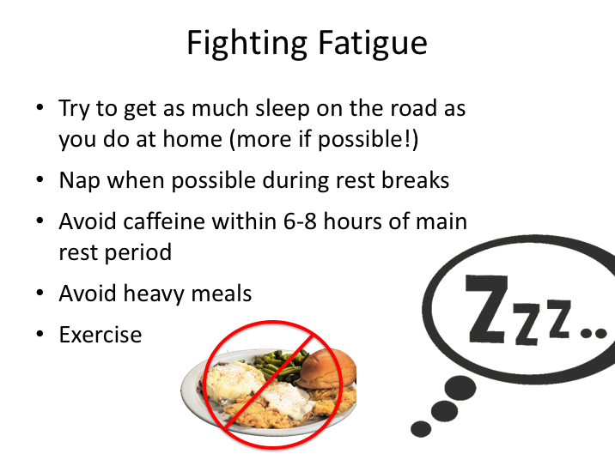

FIGHTING FATIGUE

Combating fatigue while on the road is a two-step process. One involves getting proper rest. Try to maintain regular sleep patterns when home and try to get as much sleep on the road as you do at home – even more if possible. You should also take steps to optimize your sleeping environment, which may include bringing earplugs, eye masks, and other such equipment to facilitate a good sleep environment.

In addition to your main sleep period, short naps during rest breaks are very beneficial, and you’ll find that rest breaks/down times during the day are somewhat common in multi-day trips. Keeping physically active and getting exercise also helps fight fatigue. And when it comes to eating, avoid heavy meals, especially before driving periods, and also avoid caffeine if possible within six to eight hours of your primary rest period.

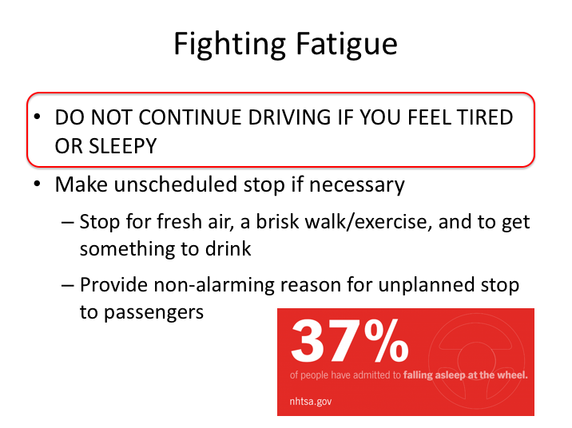

FIGHTING FATIGUE (continued)

No matter if it’s night or day, do not continue driving if you do feel tired or sleepy. Stop to get a drink or just to move around and stretch. If you smoke, refrain from doing so if you’re fatigued and taking a quick break. Smoking reduces oxygen flow to the brain – the opposite of what you need. Of course, if you know a particularly effective solution for you, employ it.

There are plenty of ways to explain an unplanned stop to any passengers if necessary. You could indicate that you are stopping to simply get something to drink, use the restroom – or even to investigate a dashboard light or what could be a slight vibration. Of course, after getting some fresh air and something to drink, you can report that all is okay with the motorcoach.

You should contact dispatch discreetly if the fatigue your experiencing is severe or persists.

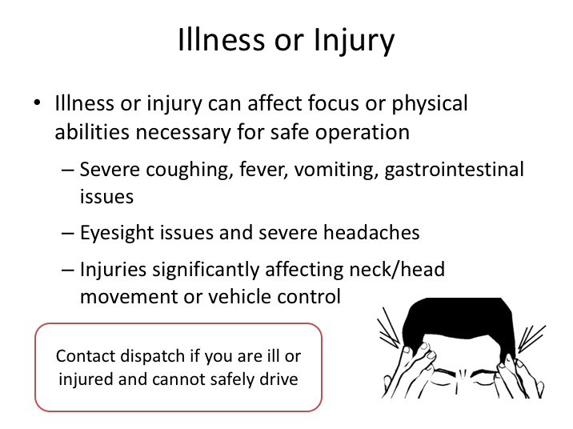

ILLNESS OR INJURY

In addition to fatigue, there are other en-route driver issues that could affect the safety of the passengers and the public. Again, while the temptation to “soldier on” is strong in many drivers, there are times when drivers must realize that they simply should not continue in the interest of safety. If you find yourself very ill, and the illness is affecting your ability to concentrate properly on the driving tasks, you should consider calling dispatch and asking for a replacement. In these uncommon situations, groups are generally very understanding.

Likewise, if you are injured during a trip, and the injury affects your ability to drive safely, you should notify dispatch. Good examples of injuries which could affect safety include eye injuries, injuries to key body parts needed for vehicle control (arms, hands, wrists, legs, feet) or injuries to your neck which preclude you from looking around while driving.

Remember, by being a motorcoach driver you’re already a hero - don’t sacrifice safety for pride.

SAFE DRIVING PRINCIPLES

QUIZ

- If you are traveling at 25 mph, your lead-time for a city block is about _______________.

- 7 seconds
- 10 seconds
- 12 seconds
- 14 seconds
- 16 seconds

- What should you do if you approach a “stale” green light?

- Anticipate that it may change
- Reduce your speed by half
- Cover the brake
- Accelerate up to the speed limit
- Both A & C

- For highway driving, the rule of thumb is to look at least how far down the road?

- 100 feet
- 300 feet
- A quarter mile
- A half mile
- A mile

- A driver should simply look straight ahead to detect road hazards.

- True
- False

- You only need to scan the corner you are turning for pedestrians that might be waiting to cross the street.

- True
- False

- What is the minimum following interval for motorcoaches under normal conditions?

- 1-2 seconds
- 2-3 seconds
- 3-4 seconds
- 4-5 seconds
- 5-6 seconds

- For nighttime driving, you should add _____ second(s) to your minimum following distance?

- 1
- 2
- 3
- 4
- 5

- When snow or ice might affect your traction, you should add at least 4 seconds to your following interval.

- True
- False

- Why is tailgating a bad practice?

- Increases chances of a collision because of reduced reaction time
- Increases chances of a collision because of reduced sight distance
- Increases chances of panic stops
- Frightens/angers occupants of the vehicle ahead
- All of the above

- To help provide a “lane space cushion”, you should always travel along the outside edge of the lane you are traveling in.

- True
- False

- You should maintain at least one open adjacent escape option when possible.

- True
- False

- Some lanes have fewer vehicular conflicts than others.

- True
- False

- You should not pass when:

- In a no passing zone
- At the crest of a hill
- On a curve
- On a bridge
- All of the above

- The most dangerous type of road to pass on is a two-lane road with one lane of traffic moving in each direction.

- True
- False

- When exiting the highway, you should activate your turn signal how many seconds before you reach the exit lane/ramp?

- 2
- 3
- 4
- 5
- 6

- Federal Motor Carrier Safety Regulations require the use of the driver seat belt in commercial vehicles.

- True
- False

- Distracted driving is just as, if not more, dangerous than driving while intoxicated, driving under the influence of controlled substances, or driving fatigued?

- True
- False

- Most modern motorcoaches are approximately how wide?

- 7 feet
- 7 ½ feet
- 8 feet
- 8 ½ feet
- 9 feet

- The greatest chances for passenger injuries while on-board are collisions and sudden movement of the coach.

- True
- False

- What does the term “off-tracking” mean?

____________________________________________________________

____________________________________________________________

- The pivot point is the point around which the rest of the vehicle turns.

- True
- False

- Which turn tends to be more difficult?

- Right turn
- Left turn

- The correct way to perform a right turn is called a “jug handle” or “buttonhook?”

- True
- False

- When it is absolutely necessary to back, you should utilize which guideline(s)?

- Back into, not out of
- Get out and look over the area before backing
- Get assistance with backing whenever possible
- Tap your horn and use flashers when backing
- All of the above

- Blind spots are larger on the right side of the vehicle than on the left side of the vehicle?

- True
- False

- The law requires motorcoach drivers to stop within 15-50 feet of railroad tracks to look and listen for trains.

- True
- False

- As long as the coach is driving normally, it’s okay to ignore any system warnings until you are back as long as you document them on the vehicle inspection report.

- True
- False

- Which of the following is not a good technique for fighting fatigue?

- Exercise
- Eating heavy meals to get your body energy
- Napping when possible during rest breaks
- Drinking coffee just before your main rest period
- Both B and D

- Smoking reduces oxygen flow to the brain and should be avoided if you are fatigued.

- True
- False

- You should notify dispatch if an injury affects your ability to drive safely.

- True
- False

