# Americans With Disabilities

|  |  |  |
| --- | --- | --- |
| Man in a wheelchir | Disability Bus Ramp | Image of 4 different disabilities |

**Purpose:**

The purpose of this training module is to educate you on the requirements of the Americans with Disabilities Act as well as additional duties associated with passengers with disabilities. You will learn background information about the Americans with Disabilities Act (ADA); paperwork requirements; how to communicate and interact with passengers with disabilities; general procedures for motorcoach lift/ramp operation; and securement and/or stowage of mobility aids.

**Module Overview**:

This training module contains three classroom lessons and one on-board exercise. The first lesson discusses the Americans with Disabilities Act and its requirements related to over-the-road bus (motorcoach) transportation. The second lesson provides instruction on communicating and serving persons with disabilities. The third lesson reviews lift operation and mobility aid securement and includes an on-board exercise that should be completed at the end of lesson 3 classroom instruction.

Lesson 1: Americans with Disabilities Act and Motorcoach Operations

Lesson 2: Serving and Communicating with Persons with Disabilities

Lesson 3: Motorcoach Lift/Ramp Operation and Mobility Aid Securement

LESSON 1

AMERICANS WITH DISABILITIES ACT

& MOTORCOACH OPERATIONS

**LESSON 1**

**THE AMERICAN WITH DISABILITIES ACT**

**AND MOTORCOACH OPERATIONS**

**Lesson Objectives**:

This lesson will provide you with background information on the Americans with Disabilities Act (ADA), its requirements pertaining to motorcoach (over-the-road bus) transportation, and operational and service information you should know to maintain compliance with ADA laws.

**Instructional Method:** Classroom

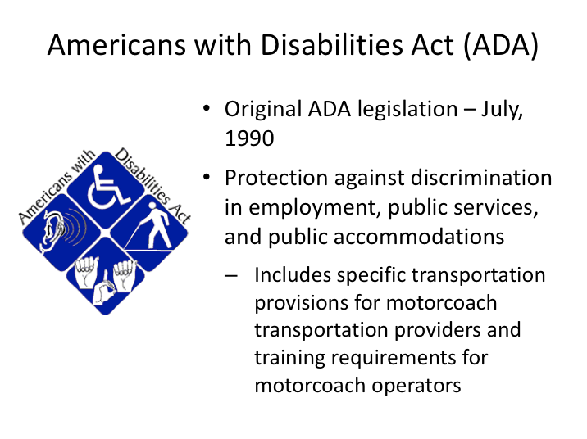

# AMERICANS WITH DISABILITIES ACT (ADA)

The Americans with Disabilities Act was signed into law in 1990 to protect Americans with disabilities from discrimination in a variety of areas; employment, public accommodations, and public services, including transportation.

In addition to public transit, provisions addressed accessible private transportation in specific situations. While many typically think of mobility-based disabilities, the law protects a much wider range of disabilities. Compliance with the regulations requires motorcoach operations – both companies and their drivers - to have basic knowledge of the law’s requirements and proper training to accomplish them.

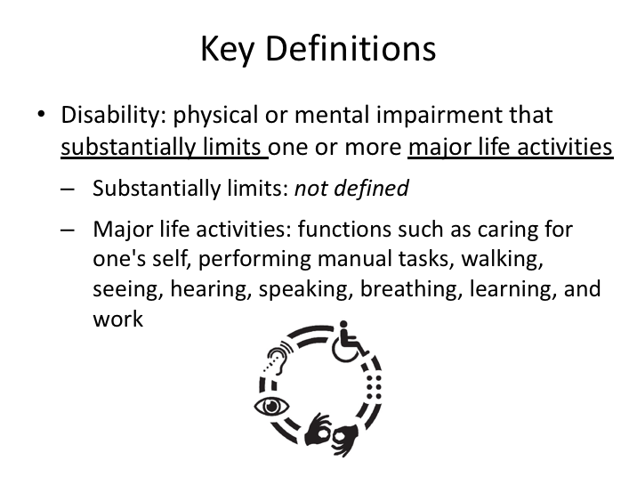

# KEY DEFINITIONS

There are several key definitions in the regulation that a driver should know, including the definition of disability itself. A frequent question from a driver is, “What is considered a disability?” The ADA defines a disability as, “a physical or mental impairment that substantially limits one or more major life activities.” While ‘*substantially limits*’ is not defined, *major life activities* include specified functions such as caring for one’s self, performing manual tasks, walking, seeing, breathing, learning and working.

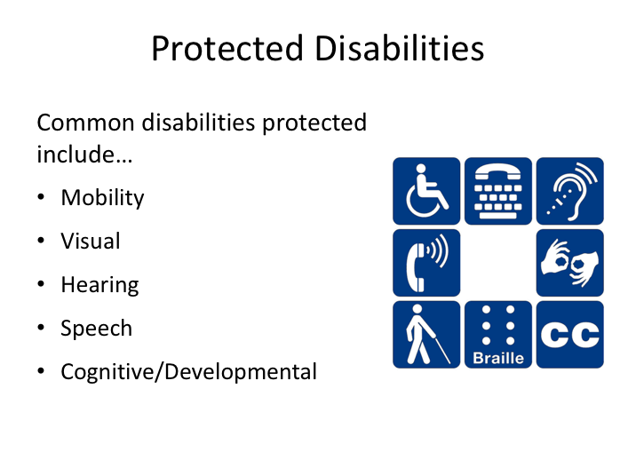

# PROTECTED DISABILITIES

While the regulatory definition leaves open a wide variety of possibilities for what could be considered a disability, there are disabilities that are more common than others and thus specifically mentioned. These include mobility-related impairments, impairments concerning vision, hearing and speech, and cognitive/mental impairment. Some disabilities may be readily observable or recognizable, though there are others that you may not be aware of unless alerted.

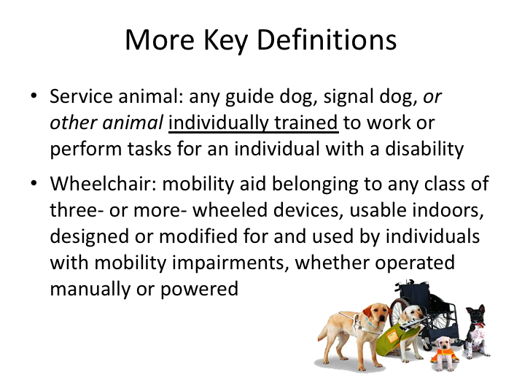

# MORE KEY DEFINITIONS

Persons with disabilities are sometimes aided by a service animal, which raises another definition of interest. The regulations define a service animal as, “any guide dog, signal dog, *or other animal* individually trained to work or perform tasks for an individual with a disability.” Some people tend to think of dogs as the only service animal and, while it’s true that dogs certainly are the most common type of service animal, this definition tells us that other animals can provide assistive service to persons with disabilities.

The term ‘wheelchair’ is still used interchangeably with other terminology to describe certain types of mobility aids. Specifically, wheelchair, as it is used in the regulations, is defined as any three- or more wheeled device usable indoors by an individual with a mobility disability. Common terms include wheelchair, scooter and power chair. The size of wheelchairs is no longer specifically addressed in the law except in the context of wheelchair weight as it relates to lift capabilities and other legitimate safety concerns.

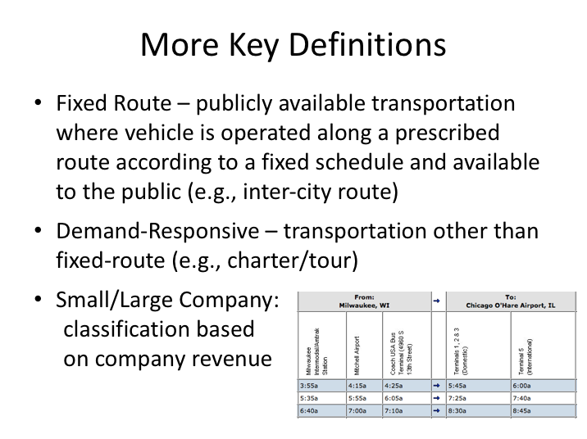

**MORE KEY DEFINITIONS (continued)**

Other key terms in understanding your responsibilities under the ADA include definitions related to the type of transportation service being provided and the size of the company providing the service.  Under the ADA, transportation is differentiated into two categories:  fixed route and demand-responsive.  Fixed route transportation is publicly available service where a vehicle is operated along a prescribed route according to a fixed schedule; a good example of a motorcoach providing fixed route service is an intercity route (Greyhound, Megabus) or scheduled airport service.  Demand responsive transportation is categorized as any transportation other than fixed route.  This transportation is generally private in nature; good examples being a multi-day tour or group-chartered trip/transportation.

In conjunction with these two types of transportation, the size of the company providing the transportation dictates its responsibilities with regard to accessible transportation.  Under the ADA, transportation companies are categorized as either “small” or “large” depending upon a measure of their overall revenue.

**MORE KEY DEFINITIONS NARRATIVE (continued)**

In general, large companies must provide accessible transportation on all fixed routes, while small companies may require a 48-hour advance notice for accessible transportation.

There are some exceptions to these rules for small companies when they are providing service on behalf of a company required to always provide accessible service, and additionally, the law states that, for any type of trip/transportation, any size company must provide accessible service if possible, even if an accessible request is received less than 48 hours prior to transportation.

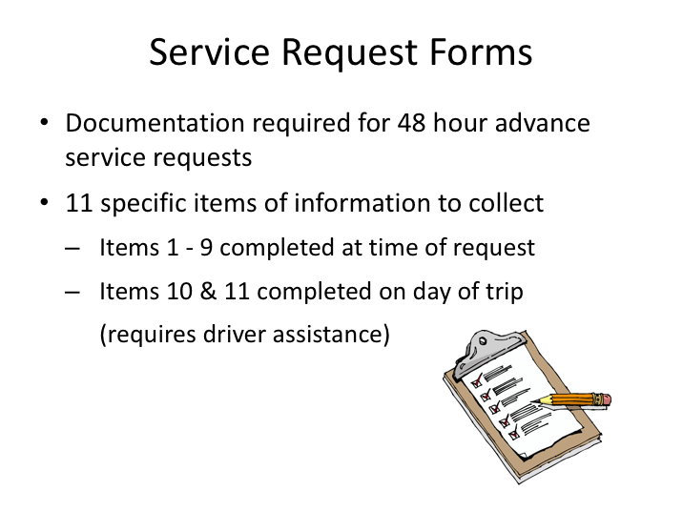

# SERVICE REQUEST FORMS

Motorcoach companies are required to track the number of accessible vehicle requests they receive. Motorcoach companies must complete specific documentation for transportation where advance request/notice is required for accessible service. A “service request form” contains 11 specific items of information that must be collected. Most of this information is collected at the time of the initial request, though there are two items that must be completed on the day of the trip.

Most companies will ask the driver the required information and complete the form themselves, though there may be some instances when the driver may be asked to complete the form and return it to dispatch/management. The two items required to be completed the day of the requested trip are:

1. Was accessible bus or equivalent service provided for trip(s)?
2. If NO (answered above), was there a basis recognized by the USDOT regulations for not providing an accessible bus or equivalent service, as applicable, for the trip(s)?

**SERVICE REQUEST FORMS (continued)**

The first question is self-explanatory, and, absent some unusual exception, should be answered ‘yes’. If accessible service was not provided, a determination must be made as to whether there was an acceptable reason per USDOT guidelines.

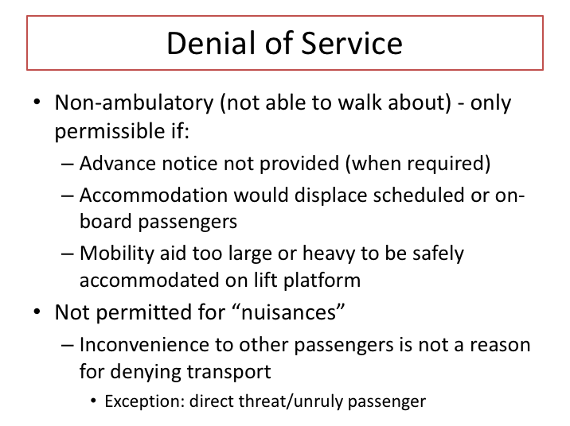

# DENIAL OF SERVICE

There are limited exceptions in the ADA regulation that would permit denial of accessible service to a person with a disability. Most of these exceptions are applicable to non-ambulatory passengers – those who are not able to walk about and thus require use of a lift or ramp equipped motorcoach. The same exceptions could also be applicable to ambulatory passengers who cannot otherwise navigate stairwells and desire to utilize a lift or ramp in boarding and alighting. Permitted exceptions to not providing accessible service are:

1. Sufficient advance notice (at least 48 hours) not provided when required.
2. Accommodation of the non-ambulatory passenger would require displacement of other passengers who have existing reservations.
3. Accommodation of the non-ambulatory passenger would require displacement of other passengers on-board.
4. The mobility chair or device cannot be accommodated safely on the lift platform due to its size or weight (combined weight of chair and passenger exceeds lift capacity rating).

**DENIAL OF SERVICE (continued)**

Out of the scenarios above, the company would likely know scenario #2 without driver involvement, as this situation would generally occur on organized charters/tours where reservations are required and passenger counts are known in advance. As a driver, you are most likely to experience a situation where an accessible vehicle is desired and an accessible request was required and not made. In this instance, you would be unable to board the passenger because you do not have an accessible motorcoach. Another occasion where denial of service may occur is when accommodation of a non-ambulatory passenger and their mobility aid would displace those passengers already on board a fixed-route service. For example: if there were only two seats remaining on the bus, and boarding and securement of the mobility-impaired passenger would require more than the two available seating positions (because seating capacity would decrease to accommodate mobility aid securement), then denial of service would be permitted. If there are enough seats on board, and accommodation would simply require moving existing seated passengers to another open seat, then you must ask the passengers to move and accommodate the mobility-impaired passenger.

Denial of service is NOT permitted for so-called nuisance situations or inconvenience to other passengers. For instance, a passenger allergic to dogs does not permit refusal of service to a disabled person with a service dog. Other nuisance examples include passengers with disabilities who may have hygiene issues or may display characteristics that other passengers may find annoying or unsettling. The only exception to the nuisance rule would be a passenger with a disability who was considered a direct threat or who is otherwise unexplainably unruly. In this instance, if you would have denied transportation to any passenger exhibiting the same characteristics, then denial of service is permissible.

A good rule of thumb - if you encounter any situation where denial of service is, or may be, necessary you should contact dispatch for additional instruction.

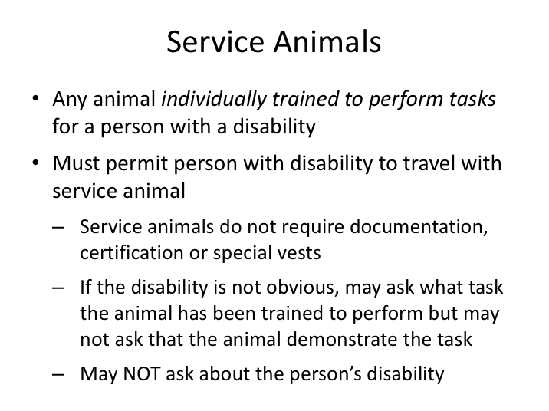

# SERVICE ANIMALS

Service animals perform some of the functions and tasks that the individual with a disability cannot perform for him or herself. Service animals who accompany and perform tasks for persons with disabilities must also be accommodated/ transported. Guide dogs are one type of service animal, used by some individuals who are blind. While this is the type of service animal with which most people are familiar, there are other types of service animals that assist persons with other kinds of disabilities in their day-to-day activities. Some examples include:

* Alerting persons with hearing impairments to sounds.
* Pulling wheelchairs or carrying and picking up things for persons with mobility impairments.
* Assisting persons with mobility impairments with balance.

However, comfort/emotional support animals are not defined as service animals by the ADA.

**SERVICE ANIMALS (continued)**

While dogs are the most common type of service animal, there may be other permissible animals - namely any animal that is individually trained to perform a task for the person with the disability.

Some, but not all, service animals wear special collars and harnesses. Some, but not all, are licensed or certified and have identification papers. However, documentation is not required as a condition for providing transportation to an individual accompanied by a service animal. Although a number of states have programs to certify service animals, you may not insist on proof of state certification before permitting the service animal to accompany the person with a disability.

A service animal is not a pet. If you are not certain that an animal is a service animal, you may ask the person who has the animal if it is a service animal that is required because of a disability and what it has been trained to do, but you may not require the person to disclose their disability and you may not require the animal to perform a specific task. Defer to company policy on how to handle situations involving a pet who you suspect is being presented as a service animal.

As with unruly passengers, you may exclude any animal, including a service animal, from your motorcoach when that animal's behavior poses a direct threat to the health or safety of others. For example, any service animal that displays vicious behavior towards other passengers may be excluded. However, if a service animal is excluded for an allowable reason, service must still be offered to the person should they wish to continue without the animal present.

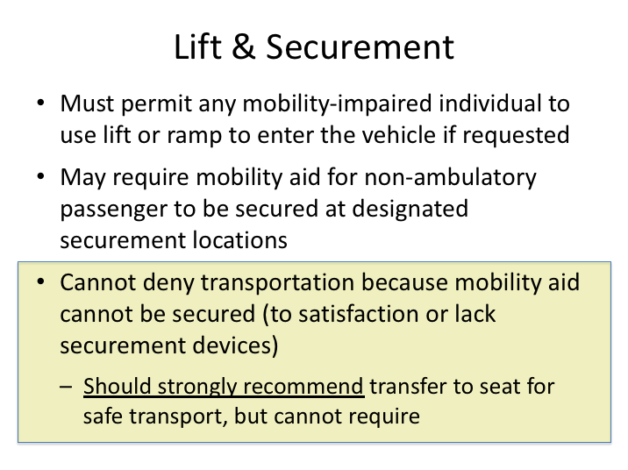

# LIFT & SECUREMENT

Non-ambulatory passengers are usually assisted by a wheelchair, power wheelchair, or scooter-type mobility aid. A wheelchair lift or ramp will be necessary to board these passengers onto the motorcoach. However, remember that mobility-impaired passengers without wheelchair-type mobility aids can request to use the lift or ramp to enter and leave the motorcoach.

Once on-board, it is important for the safety of all passengers to properly secure mobility aids during transport. Mobility aids for ambulatory passengers, such as canes, crutches, and walkers should be stored clear of the aisle way and in luggage bays when necessary – remember to retrieve these items for the passenger at each stop. Mobility aids for non-ambulatory passengers must be secured using the available tie-down system on the motorcoach.

If for some reason you are unable to secure a mobility device, you must still transport the person. However, if this occurs, you should recommend a transfer to a seat for safety purposes. Though a transfer cannot be required as a condition of transportation, it should be strongly recommended for the safety of the passenger. If a non-ambulatory passenger does agree to transfer to a seat, you should provide assistance with the transfer (reviewed in Lesson 3).

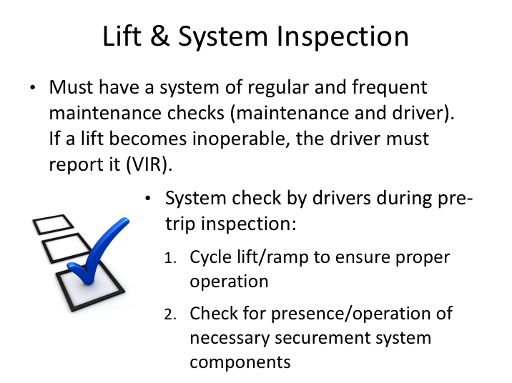

# LIFT & SYSTEM INSPECTION

Drivers operating vehicles to comply with ADA accessibility regulations must include the lift and system inspection into their vehicle inspection routine. However, it’s a good practice to inspect the system at all times – even if you do not anticipate using it during your trip. **The system inspection should include not only a complete cycling of the lift or ramp, but also an inspection of the wheelchair securement devices and areas, including: securement straps and occupant restraint belts, anchors and retracting/ratchet devices, cleanliness of anchor floor tracks, and proper operation of fold away seating.** Ensure that all straps & belts are free of rips and frays, that the anchors secure into the floor tracks, and that the retracting/ratcheting functions on the anchors work properly. Verification of any related equipment, such as belt cutters, should also be incorporated into this inspection process.

Drivers should report system malfunctions or deficiencies on their vehicle inspection report so that the operator can repair the system in a timely manner. If a defect or deficiency is discovered during a pre-trip inspection and you know that accessibility is required for the imminent trip, you should report the defect to dispatch prior to leaving so that appropriate steps can be taken to ensure accessible transportation availability.

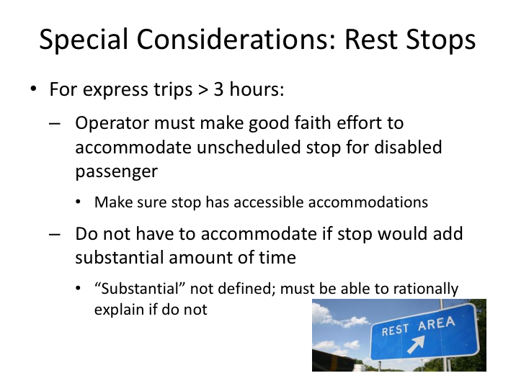

# SPECIAL CONSIDERATIONS: REST STOPS

Whenever a driver has a known passenger with disabilities on-board, he/she must consider the trip itinerary and possible addition of additional rests stops. If the current itinerary includes drive times in excess of three hours that do not have any scheduled stops, the driver must make an effort to accommodate unscheduled stops for the passenger with a disability. In trips of this nature, you should ask the passenger with the disability if they require an unscheduled stop and plan accordingly. In accommodating an unscheduled stop for a passenger with a disability, best efforts should be made to ensure that the stop you intend on using has accessible facilities. Potential stops (if necessary) can be researched and planned ahead if it is known that this situation will arise; for qualifying trips when this occurs without prior knowledge, communication with dispatch (if available) can be beneficial in locating an accessible rest stop.

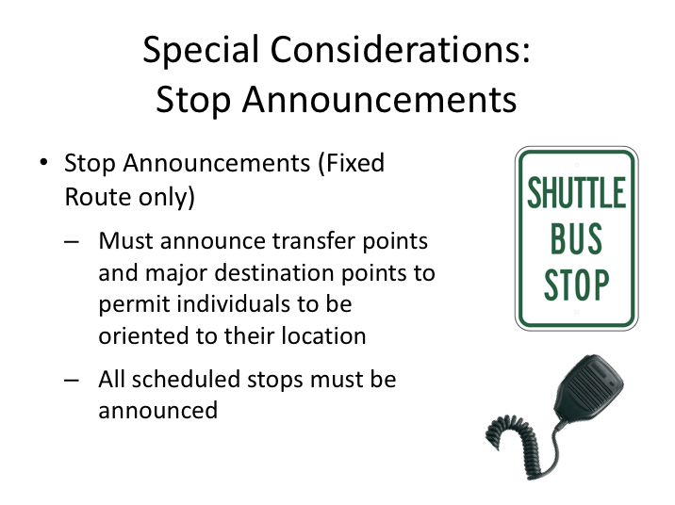

# SPECIAL CONSIDERATIONS: STOP ANNOUNCEMENTS

ADA regulations also require that “stop announcements” are provided to allow persons with disabilities to orient themselves relative to the coach’s location if necessary. For almost all charter and line run operations, this is a standard practice. However, this practice also applies to shuttle operations, where stop announcements are less common. For instance, when shuttling between a convention center and hotels, each hotel stop should be announced. Passengers with disabilities often request this assistance anyway. However, drivers should remember that there might be unknown passengers with disabilities on board who would benefit from these announcements. For known hearing-impaired passengers, you may wish to determine which stop is desired (if applicable), so that you may provide visual or other cues to assist them in determining when the stop is reached.

LESSON 2

SERVING & COMMUNICATING WITH

PERSONS WITH DISABILITIES

**Lesson Objectives**:

This lesson will assist you with understanding how to best communicate with and assist passengers with disabilities. You will learn specific tips for working with disabilities commonly experienced in motorcoach transportation.

**Instructional Method:** Classroom

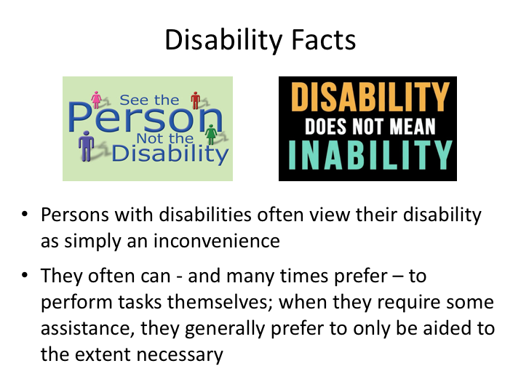

# DISABILITY FACTS

A disability is an inconvenience. People with disabilities carry on their lives just like anyone else. Each person has an individual personality and, as such, each may deal with his or her disability differently.

A disability does not always present a limitation; rather it often only means that a person with a disability will occasionally ask for help — as we all do now and again. But common courtesy and good sense dictate when and where help is needed. Asking the person if you can be of assistance, followed up by asking how (if your offer is accepted), is always appropriate. Most persons with a disability prefer to perform as many tasks on their own as possible.

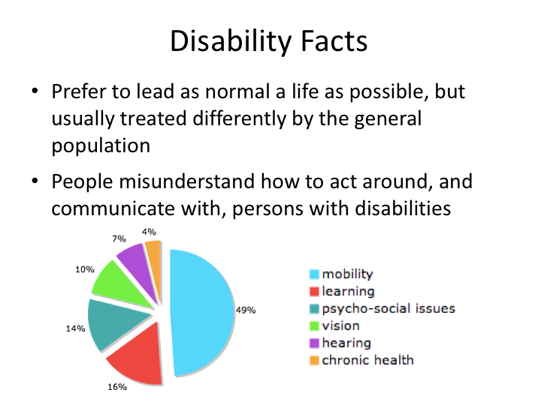

**DISABILITY FACTS (continued)**

Approximately one in ten persons in the US have some type of disability. Usually, the biggest difference they perceive between them and other persons without disabilities is not the disability itself, but instead how the general population treats them. The more obvious and severe a disability, the more prone to abuse and neglect a person may be by the general population.

In many cases, disparate treatment for those with disabilities exists not intentionally, but rather as a result of misunderstandings of how to effectively communicate with and assist the person with the disability. Because of this, sensitivity training is mandated by the ADA rules for transportation providers.

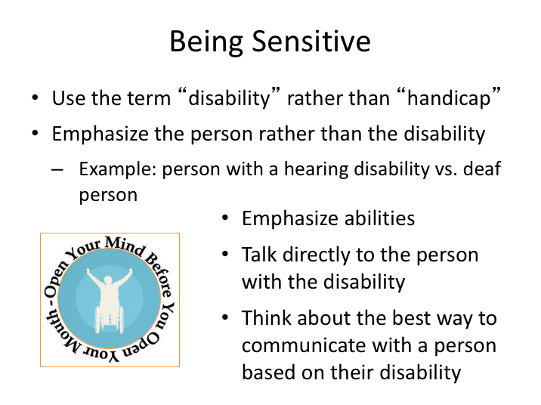

# BEING SENSITIVE

In the past, “Handicap” was a term that was frequently used to describe persons with disabilities. However, this terminology often carries a negative connotation and should be avoided. When interacting, remember to emphasize the positives – the person themselves being the most important aspect of their being, and their disability just a side note. Discuss what they can do rather than what they can’t do, and remember that a disability is a physical restraint and not a disease.

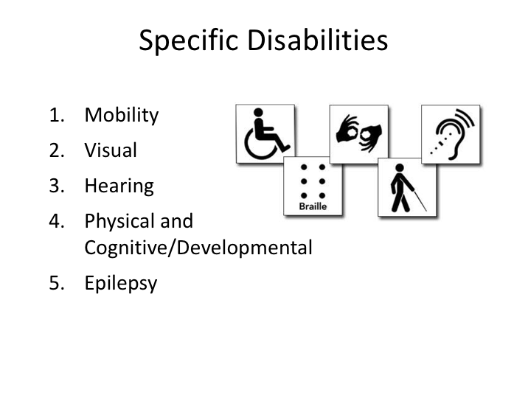

# SPECIFIC DISABILITIES

Let’s review some specific disabilities in more detail. This list highlights some of the more common disabilities you may come to experience while driving a motorcoach. They include mobility–related disabilities, visual and hearing disabilities, physical and cognitive developmental disabilities, and those with epilepsy. Some of these disabilities may not be readily observable, but other passengers or your dispatch may inform you that specific passengers have a disability. Additionally, keep in mind that a person may suffer from multiple disabilities. Proper understanding of these common disabilities and the best ways to communicate with and assist persons affected by them are key to successful interactions.

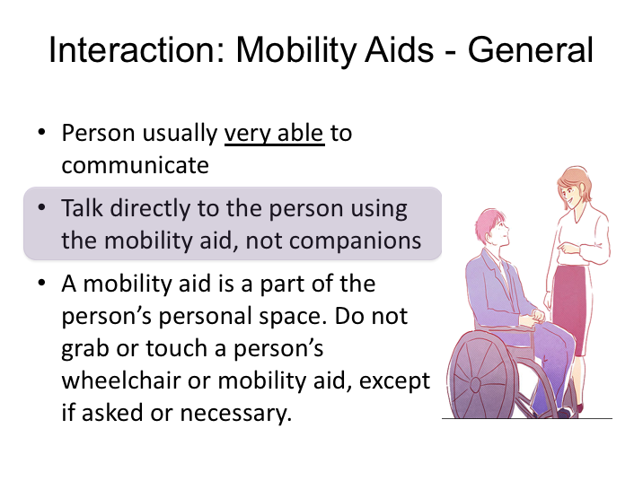

# INTERACTION: MOBILITY AIDS - GENERAL

The most common disability you’re likely to experience is passengers who have mobility limitations and utilize assistive devices to facilitate movement. For passengers using mobility devices, you should ask how they prefer to board – some may prefer to use the lift; others may be able to temporarily forgo their assistive device and navigate the stairs. As with all disabilities, remember to always talk directly to the person with the disability - even if they have one or more traveling companions with them or close by. A person using a mobility aid is usually not helpless or unable to talk.

Keep in mind that the mobility aid they utilize is very personal to them. Don’t ever touch a person’s mobility aid unless necessary, and, when so, detail your intended actions to the passenger. Hanging or leaning on the aid is similar to hanging or leaning on a person sitting in any chair. It is often fine if you are friends, but inappropriate if you are strangers.

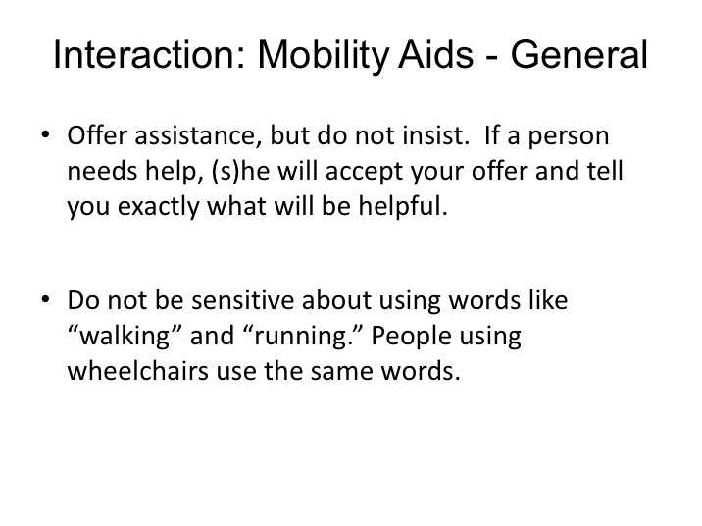

**INTERACTION: MOBILITY AIDS - GENERAL (continued)**

As with any noticeable disability, you should offer assistance to the passenger. Sometimes, the passenger will accept your offer for assistance and other times they will let you know that they can manage on their own. If they do accept your offer of assistance, ask them the best method to assist them if they haven’t told you already. The only time you should insist on specific assistance is to assert control of a chair-type mobility device when you are moving the device on and off a lift platform.

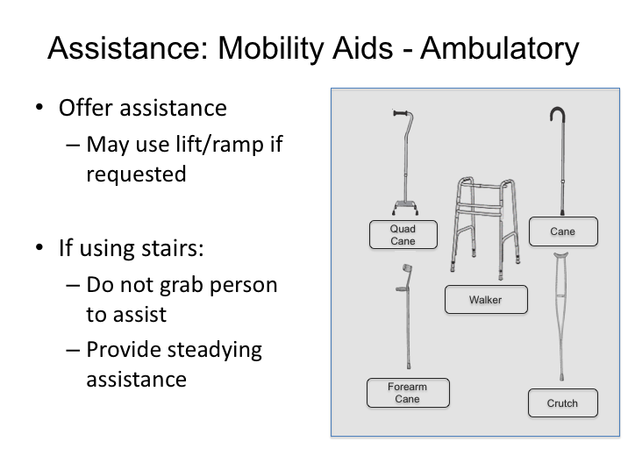

# ASSISTANCE: MOBILITY AIDS - AMBULATORY

This slide shows various types of mobility aids for persons who have difficulty walking or standing. In most cases, assistance provided to them is limited to stairwell navigation, though they may request to use a lift. Many times, their need for assistance arises from balance or unsteadiness issues. While the ADA only requires assistance in using a lift or ramp, it is typical for drivers to provide other steadying assistance when navigating stairwells. Usual practices include extending a firm arm to help steady the person as they descend the stairs, or placing a hand behind the lower back for support as they climb the stairs. Remember to follow their instruction with regard to assistance provided (within reason), and be aware that they may ask you to hold or carry their mobility aid while they are navigating the stairs.

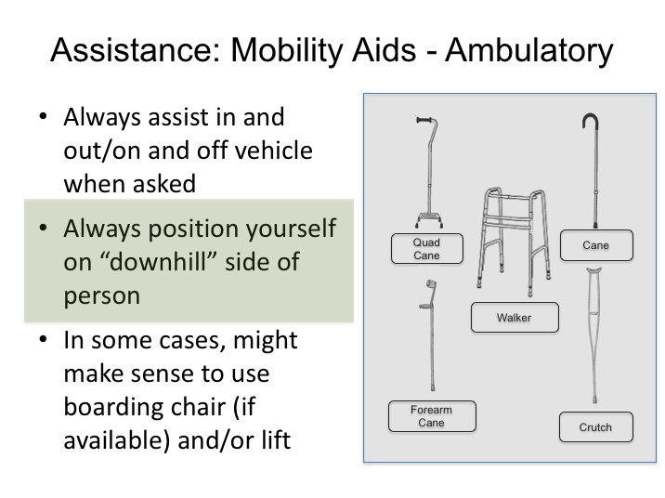

**ASSISTANCE: MOBILITY AIDS - AMBULATORY (continued)**

When assisting passengers up and down the stairwell, always position yourself on the down side of the passenger. This way you serve as a barrier to keep them from falling down the stairwell and out of the bus if they lose balance. Keep an eye on their foot placement to observe if there may be an obvious issue during their stair navigation.

Remember, you must provide assistance when requested. However, the amount of assistance you must provide is limited – do not provide assistance that could injure yourself or that you’re not comfortable providing. For example, you should not be lifting or carrying a person or portions of their body so that they may navigate the stairs. For those extremes, a lift should be used to board and alight the passenger; if your vehicle has a boarding chair, this can be used to help make the lift process safer. Also remember, if they request use of the lift, you must oblige.

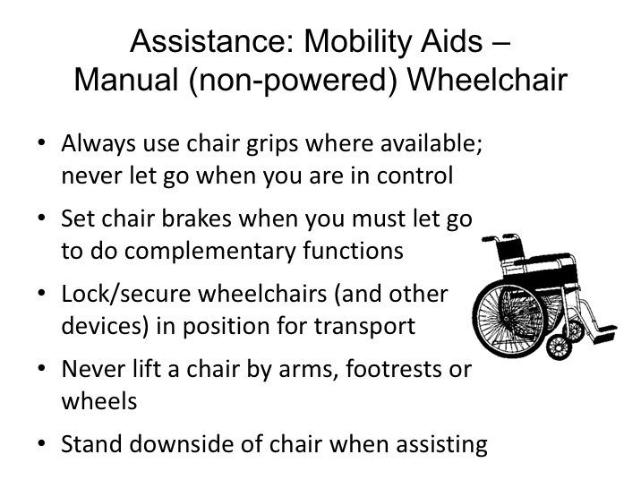

# ASSISTANCE: MOBILITY AIDS - MANUAL WHEELCHAIR

Different assistance is necessary for non-ambulatory passengers with disabilities – those who utilize some type of wheelchair or scooter. With these passengers, assistance will be required when using a lift; possibly also when using a fold out ramp on ramp-equipped, low-floor buses.

You will have more physical control of the device itself when the passenger is utilizing a manual, non-powered wheelchair. Key points to remember when maneuvering this type of wheelchair:

* Always use chair grips when available and never let go when you are controlling the chair.
* Be sure to set wheel brakes when you relinquish control of the aid to conduct complementary functions, such as operating the lift.
* Never lift chairs by the arms, footrests, or wheels.

**ASSISTANCE: MOBILITY AIDS - MANUAL WHEELCHAIR (continued)**

* Secure wheelchairs in position for transport – lift use and securement will be covered in more detail in Lesson 3.

Passengers using powered wheelchairs and mobility aids will maintain control of their aid, though specific steps still need to be followed when boarding/alighting – these will also be covered in Lesson 3.

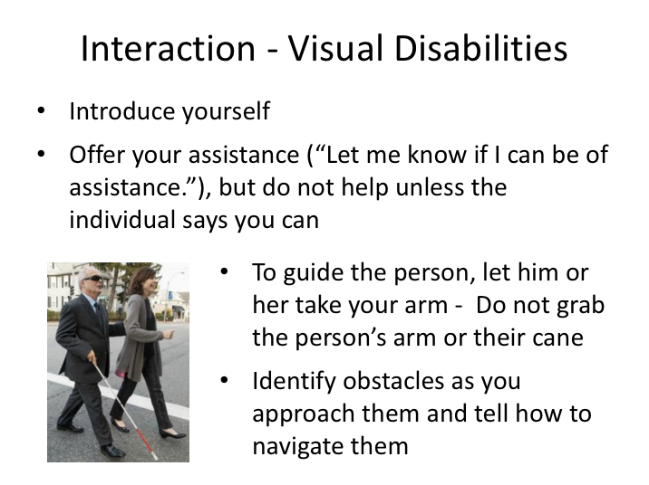

# INTERACTION - VISUAL DISABILITIES

Your first step in assisting persons with visual disabilities is to introduce yourself as the driver. Make them aware that you are there to assist if desired and necessary – always ask before providing any assistance. If they ask for assistance, and you’re not sure what to do, ask them to explain how you can best assist them.

It may be necessary to help guide persons with visuals impairments for the limited distances outside and inside the motorcoach. When guiding, let them take your arm by positioning yourself next to them and telling them where you are located. Do not grab their arm or any mobility aid without their instruction. When walking with you, persons with visual impairments will generally walk about a half step behind you using your body motion to guide them. When navigating obstacles such as curbs or stairs, be sure to identify them and describe the actions the passenger should take to successfully navigate the obstacle.

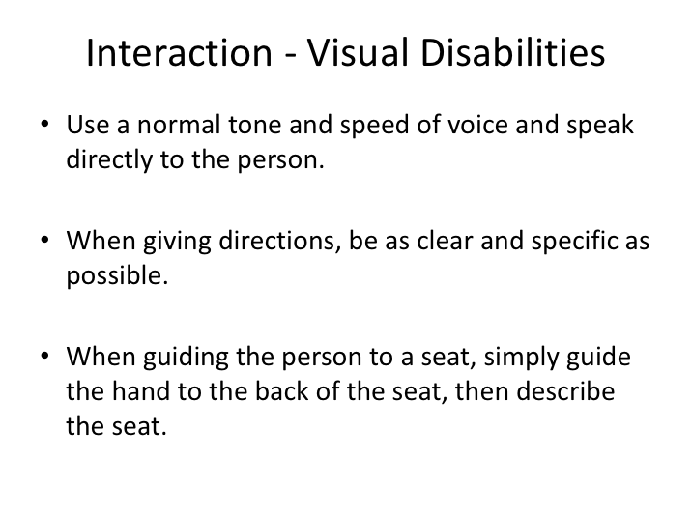

**INTERACTION - VISUAL DISABILITIES (continued)**

When assisting those with visual disabilities, speak directly to them using a normal tone and speed. You do not need to avoid using words like “blind,” “look,” or “see” - persons with visual disabilities use these words too. When giving directions be sure to be clear, specific, and descriptive.

If you are unsure of how to direct a visually impaired person, say something like, “I’d be happy to give you directions.  How should I describe things?”

When guiding them to a seat on the motorcoach, simply guide their hand to the back of the seat and then describe the seat so that they may sit down.

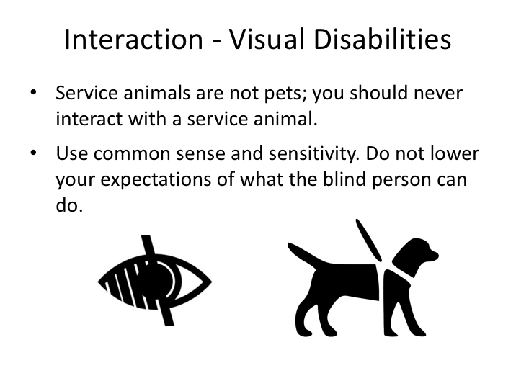

**INTERACTION - VISUAL DISABILITIES** **(continued)**

If you have a passenger that is accompanied by a service animal, understand that the animal is working and is not a pet looking for attention. You should never interact directly with a service animal.

Remember, visually impaired persons can do the same things you can, they just need a little help visualizing the environment.

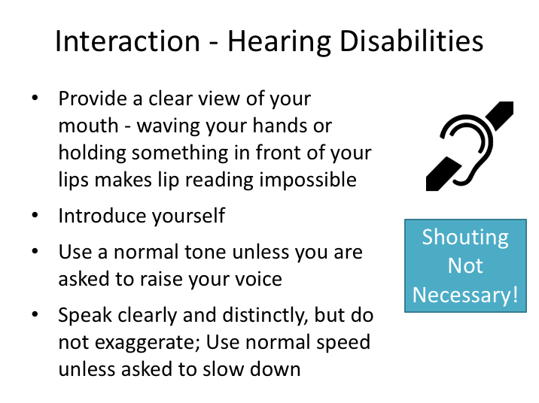

# INTERACTION - HEARING DISABILITIES

Another type of disability you are likely to experience is a passenger with a hearing disability. There are some key points to remember when communicating with persons with hearing disabilities:

* First and foremost, make sure they are looking at you whenever you attempt to speak to them.
* Provide a clear view of your mouth and face; they will be trying to understand you by watching your mouth movement, as well as facial expressions. Lip reading is something of a misno­mer. Under ideal conditions lip readers only catch a percentage of what is being said. The rest of the information is gathered through context, facial expressions, and, if possible, partial hearing.
* Once you have their attention, introduce yourself as the driver.
* Speak clearly and distinctly annunciating your words. You want your mouth and lips to show what you are saying but do not exaggerate.

**INTERACTION - HEARING DISABILITIES (continued)**

* Talk in a normal tone – raising your voice does not help; it only draws attention to their disability.
* Talk at a normal speed unless you are asked to slow down.

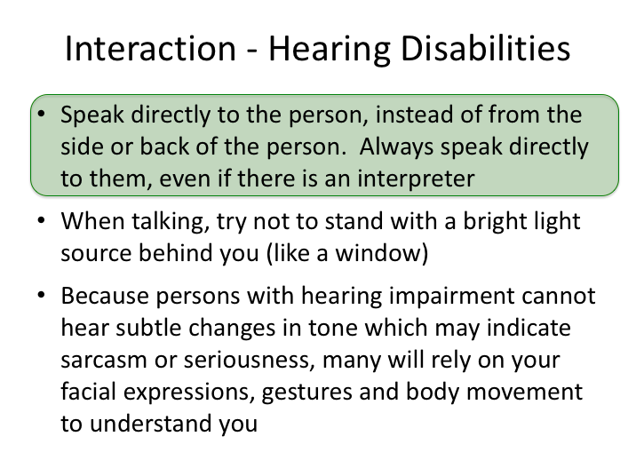

**INTERACTION - HEARING DISABILITIES (continued)**

As with all disabilities, speak directly to the person with the disability; in the case of a person with a hearing disability, do so even if they have an interpreter or hand-signer with them. Also, try to make sure that your face is clearly visible; do not stand in front of bright lights that may silhouette your face and hinder the passengers view. Remember, gestures and expressions play an important role in them understanding what you’re trying to communicate, since they cannot hear changes in vocal tone.

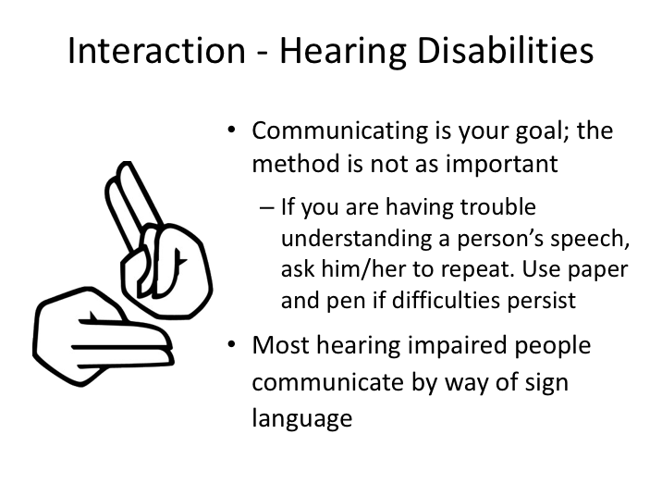

**INTERACTION - HEARING DISABILITIES (continued)**

Passengers with hearing disabilities may try to speak and communicate with you, though sometimes it can be difficult understanding their speech. If you’re having trouble understanding them, ask them to repeat what they said and to slow down if necessary. If you cannot understand what they’re saying after several tries, offer them pen and paper so that they can write what they are trying to communicate to you.

If you know sign language, you can communicate effectively in that manner. You may want to learn some of the basics of finger spelling to facilitate communication, especially if you expect regular interaction with an individual with a hearing disability. Otherwise, it is fine to write notes back and forth.

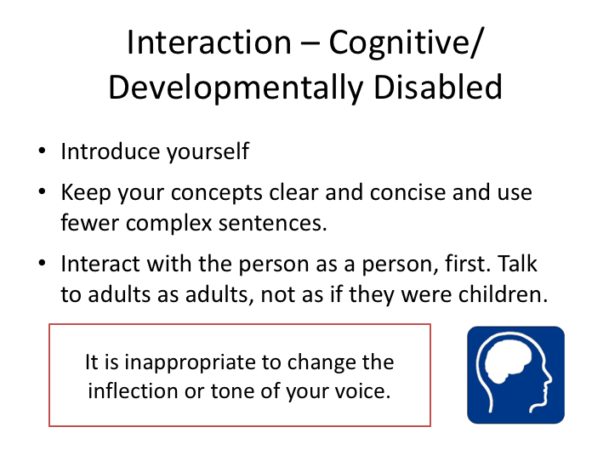

# INTERACTION – COGNITIVE/DEVELOPMENTALLY DISABLED

When communicating with a passenger who is mentally/developmentally disabled, introduce yourself as usual and act normal – for instance, do not act like you’re talking to a child or talk down to them in any manner. To effectively communicate, keep your concepts clear and concise and use non-complex sentences and phrases. People with developmental disabilities deserve the same respect and dignity as all other people.

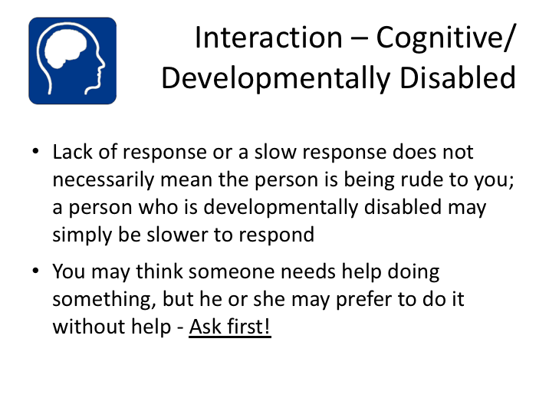

**INTERACTION – COGNITIVE/DEVELOPMENTALLY DISABLED (continued)**

Sometimes, persons with developmental disabilities are slower to react and respond to communication; stay focused on the communication with them, and don’t feel like you are being ignored.

As always, ask if they would like assistance and respond appropriately. Just as the term ‘handicapped’ is no longer commonly used, neither is the term “mentally retarded”.

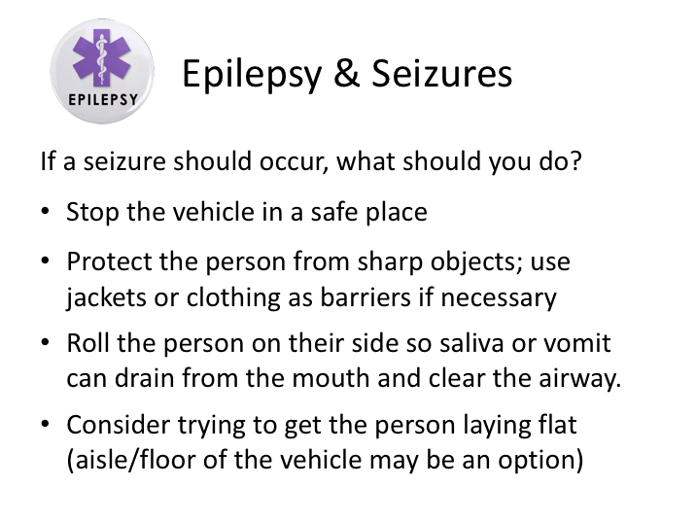

# EPILEPSY & SEIZURES

Perhaps one of the most frightening situations you could encounter as a driver is to witness a passenger having an epileptic or other seizure. Epilepsy is a disability that is marked by unannounced seizures, and seizures sometimes are associated with other disabilities and ailments.

In many cases, there will be traveling companions with the person who know what to do in this situation. However, you should understand some basic steps to take in case the person having a seizure is traveling alone.

* First, stop the vehicle is safe place and notify other passengers what is happening and what you’re going to do.
* Next, protect the person from any sharp or dangerous objects in their immediate vicinity and the side of the bus to the extent possible; place jackets or other types of barriers around them if possible.
* Roll the person on their side so saliva or vomit can drain from their mouth, maintaining a clear airway.
* If necessary, ease them to the aisle of the motorcoach.

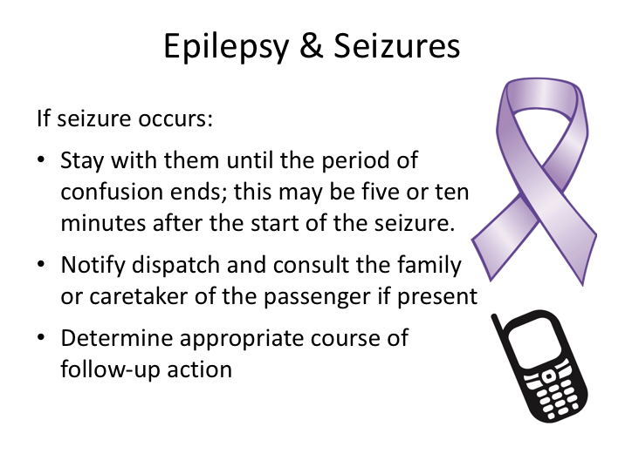

**EPILEPSY & SEIZURES (continued)**

Immediately following seizures, there is often a period of confusion. Stay with the passenger until this period of confusion ends; asking simple questions can help reorient the person and help you ascertain when they are coherent again.

In some cases, it may be necessary to get medical attention for the passenger immediately, but in other cases it may be okay to continue the trip. Notify dispatch and talk with them and the affected passenger to determine a course of action – medical assistance may not be determined to be necessary.

A convulsive seizure is not considered a medical emergency in most cases, though there are exceptions. If the rigid convulsive stage (tonic/clonic stage) lasts longer than five minutes; if the person comes out of one seizure and goes right into another; or if the person requests medical assistance, it should be considered a medical emergency. Also, if consecutive seizures occur, or the period of confusion following a seizure lasts for more than five minutes, medical attention should be summoned.

LESSON 3

MOTORCOACH LIFT/RAMP OPERATION

& MOBILITY AID SECUREMENT

**Lesson Objectives**:

This lesson will provide general information on utilizing lifts and ramps when assisting passengers with mobility devices. You will learn the responsibilities in utilizing the lifts and ramps safely as well as preferred methods for securing mobility aids.

**Instructional Method:** Classroom and On-Board Exercise

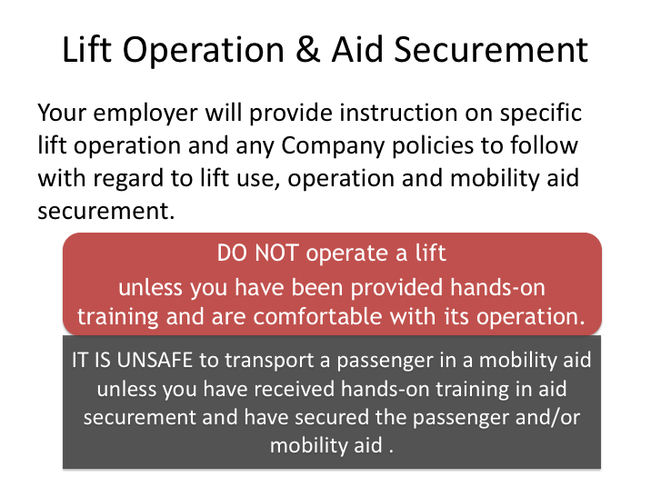

# LIFT OPERATION & AID SECUREMENT

Some persons who require mobility aids will also require use of the vehicle lift to board and alight the bus. Vehicle lifts can be extremely dangerous if they are not operated properly, and different lifts operate in different manners.

Do not operate a lift unless you’ve been provided with hands-on training and are comfortable operating it. Also keep in mind, it is unsafe to transport a person in a mobility aid unless you have received proper training on lift operation and mobility aid securement on the vehicle.

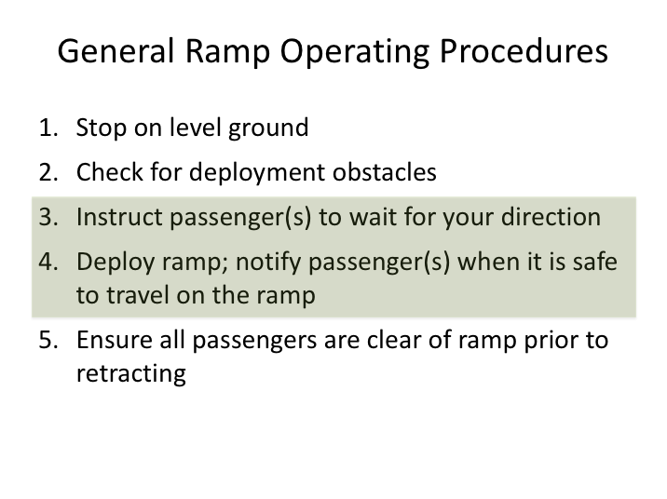

# GENERAL RAMP OPERATING PROCEDURES

Low-floor motorcoaches are generally equipped with ramps that are deployed to assist passengers with mobility disabilities in boarding.

While ramps in general may deploy slightly differently, there are some common rules to follow when utilizing a ramp:

* Instruct the passengers waiting to use the ramp on the procedure.
* Ask them to stay clear of the ramp deployment area and to refrain from navigating onto the ramp until it is fully deployed and you provide them verbal instruction that it is okay to board.

If requested, and or otherwise necessary, you must provide assistance traveling up and down the ramp. You should ensure that all passengers are completely off of, and clear of, the ramp prior to retracting it.

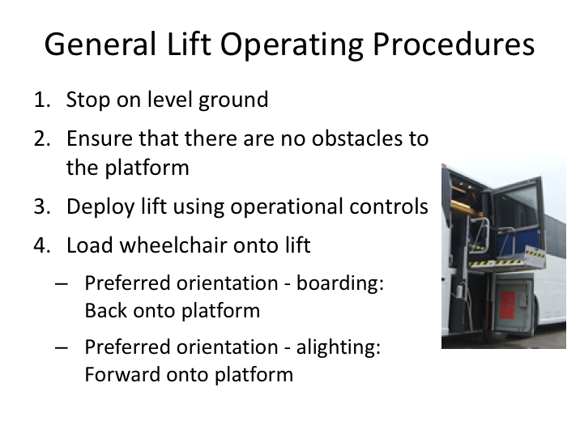

# GENERAL LIFT OPERATING PROCEDURES

While each model and brand of lift operates slightly differently, there are some common rules to follow when utilizing a lift.

You should ensure that the vehicle is stopped on level ground, and that there are no obstacles that would prevent the lift platform from fully deploying.

While the passenger has the choice of which direction they face on the lift, the preferred orientation varies depending on whether you are boarding or alighting and the type of mobility device.

When boarding, it is usually best to back the passenger/mobility aid onto the lift. This is especially true for a manual (non-powered) wheelchair - this way, the grips of the chair are easily accessible from the inside opening of the coach at the top of the lift operation. For powered mobility aids, the preferred loading orientation can depend on the configuration of the coach (location of available securement area), and which direction would facilitate movement to the desired position from the platform at the top of the lift operation.

**GENERAL LIFT OPERATING PROCEDURES (continued)**

During alighting, it is generally best to load onto the lift platform in a forward direction so that the passenger can move forward off the platform at the bottom of the lift maneuver.

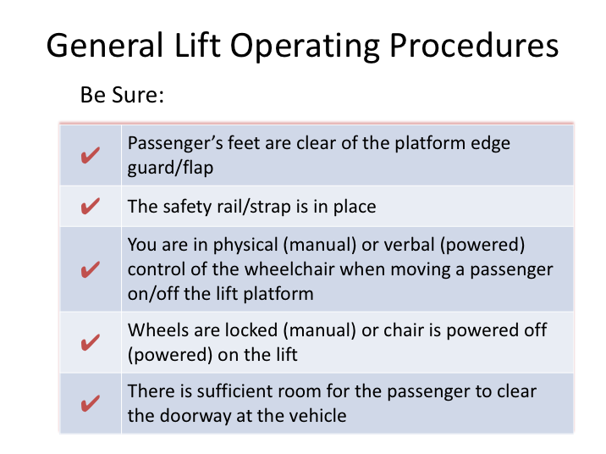

**GENERAL LIFT OPERATING PROCEDURES (continued)**

After loaded onto the lift, **secure the mobility aid by locking the wheels (manual chair) or ensuring the power is OFF (powered chair)**.

Ensure that the passenger’s feet are clear of the edge of the lift and the safety rail is in place. As you begin to raise or lower the lift, the edge guard (outward facing on the lift platform) should raise to prevent any mobility aid from rolling off the exposed edge of the lift. Make sure prior to raising the lift that there are no obstructions on the vehicle immediately inside the doorway area.

Be sure that you announce to the passenger what you are doing and what is going to happen during the entire lift operation process – their sense of security is extremely important.

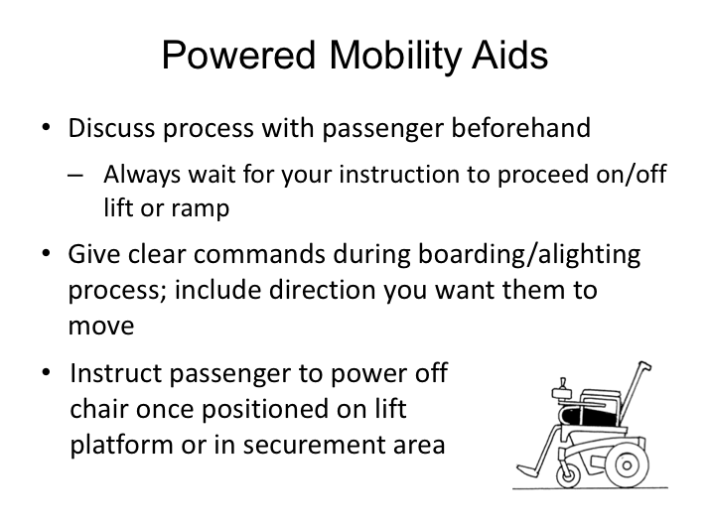

# POWERED MOBILITY AIDS

Powered mobility aids, such as wheelchairs and scooters, present some different challenges even though the boarding/alighting and tie down concepts are the same.

With powered mobility aids, the passenger will maintain control of the aid. However, it is important for you to have a clear protocol with the passenger and that they understand to wait for your instruction during the boarding and alighting process.

After the lift or ramp is in position, instruct them to proceed cautiously onto the lift platform (or up/down the ramp). Once in position on a lift, instruct the passenger to power off their mobility aid, observing and confirming this has been done prior to moving the lift platform. Instruct them to keep the chair powered down until your instruction otherwise. Once the lift maneuver is complete, instruct them to power on their chair and move slowly to the securement area. This same process should be used when alighting. Secure powered mobility aids for transport; aids should be powered down while chair is secured and during transport.

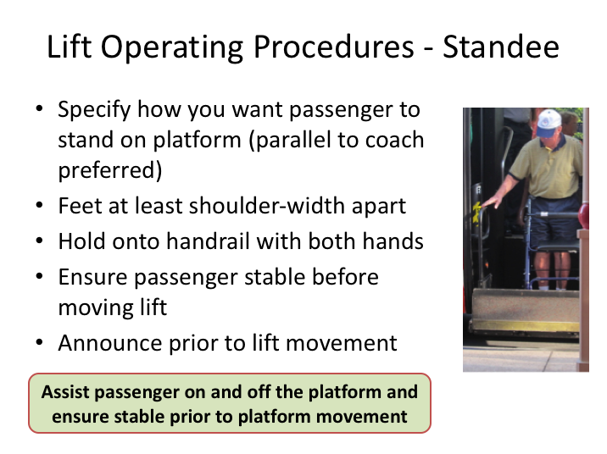

# LIFT OPERATING PROCEDURES - STANDEE

Recall that ADA regulations permit anyone with a mobility disability to use the lift when requested. Thus, you may be in situation when a standee is utilizing the lift. This situation is very dangerous because of the risk of falling – especially if they are significantly unstable. Use of a boarding chair, if one is available, is suggested to reduce the risk of falling. In situations with very unstable passengers, it may be safest for the driver to ride the lift with the passenger, though this is often viewed as a last resort.

ADA regulations permit companies to dictate how standees will stand on a lift, so your assessment and instruction is important if this situation arises. Your company may have internal policies dealing with standee-specific operation, but in general, here are the steps that should be followed:

* After verifying that the passenger desires to use the lift, you must assess the safest manner for the passenger to stand on the platform. The passenger will need to stabilize themselves during lift operation by holding

**LIFT OPERATING PROCEDURES – STANDEE (continued)**

onto the platform side rails – they should not be using or relying upon any unsecured mobility aid, such as a walker, for balance and stability during lift operation.

* + The most stable option is to have the passenger stand on the lift facing a side rail of the platform, grasping the side rail with both hands. While standing in this manner provides the best stability, the passenger will have to turn/pivot from this position to get into the coach from the platform position, and vice-versa.  Be sure to help stabilize and assist the passenger while turning on the lift platform.
* Assist the passenger in getting stabilized when transferring to/from the lift platform.
* Instruct him/her to space their feet at least shoulder width apart for stability.
* Ensure he/she is stable before beginning to raise (or lower) the lift.

*Be sure to announce when you plan to begin the lift operation so the passenger is prepared for the movement and not startled.*

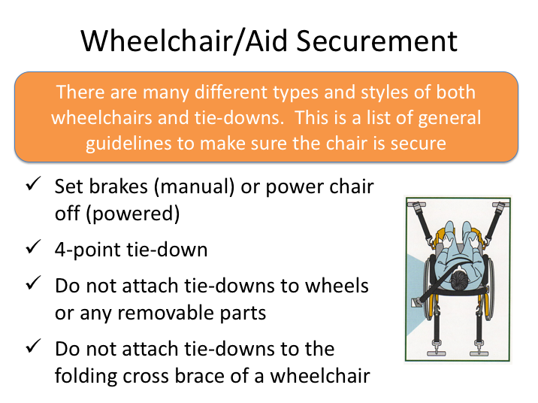

# WHEELCHAIR/AID SECUREMENT

After onboard, the mobility aid must be secured to ensure the safety of the passenger using the aid, as well as other passengers on the vehicle. While there are many different types and styles of non-ambulatory mobility aids and tie down systems, the following guidelines apply to all situations:

* Set the brakes on a manual, non-powered wheelchair. For powered chairs or scooters, ensure the power is OFF.
* Ensure that the mobility aid is secured with a four-point tie down.
* Tie downs should be secured to structural parts of the mobility aid, not wheels or removable parts.
* Never attach tie downs to the folding cross brace of a wheelchair.

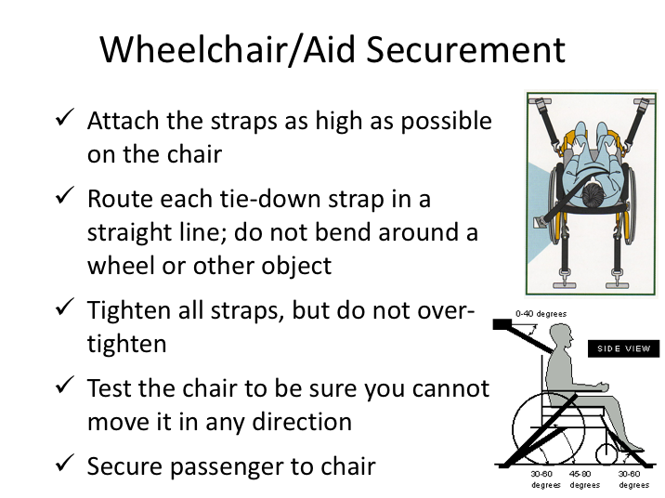

**WHEELCHAIR/AID SECUREMENT (continued)**

Tie down straps should be attached as high as possible on the chair. After secured, each tie down strap should form a straight line between where it is attached on the chair and anchored to the coach, free of curves or bends around other objects. Once the straps are tight, you should test the mobility aid to be sure you cannot move it in any direction.

If available, the passenger should be secured to the mobility device with an internal or external seatbelt. You should ask permission before doing this – passengers are not required by law to utilize either internal or external safety belts in most cases. However, use of these safety devices should be strongly encouraged as seating configuration requirements at tie down locations do not provide similar occupant protection as typical seat configurations. If questions or issues arise during transport of a passenger with a mobility aid, you should contact dispatch for further instruction.

Again, all of these steps related to lift operation and mobility chair securement will be demonstrated during hands-on training.

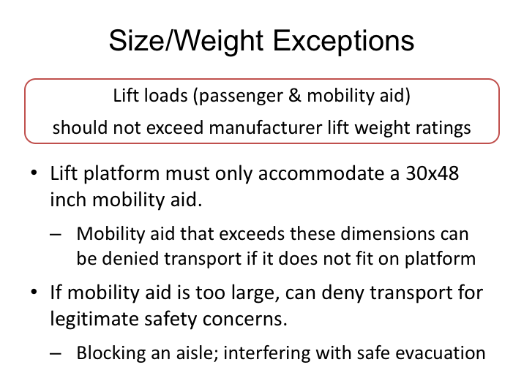

# SIZE/WEIGHT EXCEPTIONS

Lifts are designed by manufacturers to carry specified maximum loads/weights. The ADA regulations require that lifts be capable of handling specified minimum loads; in reality, manufacturers generally design the lifts to be capable of carrying heavier loads than this required minimum. Operators must permit a passenger with a disability, and his/her mobility aid, to utilize the lift as long as they do not exceed the manufacturer’s specified maximum load. If you think the combined weight of a passenger and his/her mobility aid may exceed a lift’s carrying capacity, you should contact dispatch for additional instruction.

Similar to carrying capacity, the minimum physical area of a lift platform is specified. Lift platforms must be able to accommodate a 30x48 inch mobility aid. Manufacturers’ may design platforms larger than this footprint and, as long as a mobility aid fits on the lift, the passenger and mobility aid must be accommodated and transported. The only exception would be mobility aids that are too large to fit in designated areas on board without affecting safety concerns, such as blocking aisles and interfering with vehicle evacuations.

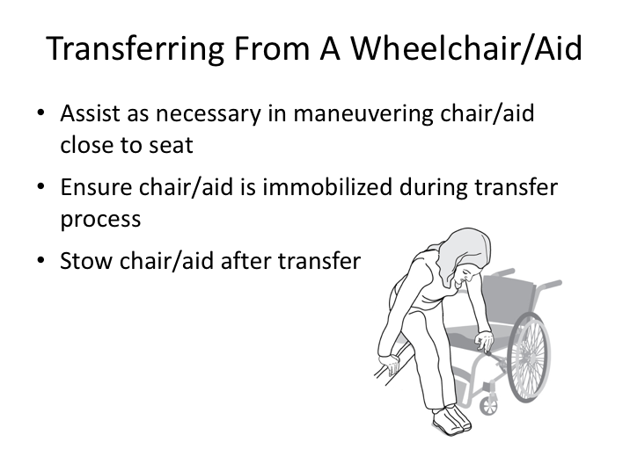

# TRANSFERRING FROM A WHEELCHAIR/AID

Sometimes, non-ambulatory passengers wish to transfer from their mobility chair to a regular seat. Some transportation companies even have a policy that requires the driver to ask them to do so in certain or all cases, such as when a mobility aid cannot be secured in a sufficiently safe manner.

If a passenger is transferring from a mobility aid to a seat, you should assist as necessary in maneuvering the aid next to the seat and ensure that the mobility aid is secured from movement (using wheel brakes, powered aid OFF, etc.) while the passenger transfers to the seat. After a successful transfer, be sure to stow the mobility aid in a secure manner to prevent movement and potential injury to passengers.

**EXERCISE**

This exercise is an on-board exercise.

Vehicle lift operation and mobility aid securement systems vary considerably. Pay close attention to how to properly use the lift and secure mobility aids – your passengers’ safety depends on your knowledge!

**AMERICANS WITH DISABILITIES ACT**

**QUIZ**

1. As a driver, you can deny service to a person with a disability if that person is an inconvenience to other passengers.
2. True
3. False
4. Service dogs are the only acceptable type of service animal.
5. True
6. False
7. You may exclude any animal, including a service animal, from your motorcoach when the animal’s behavior poses a direct threat to the health and safety of others.
8. True
9. False
10. Non-ambulatory passengers are usually assisted by:
11. Manual wheelchair
12. Cane
13. Crutches
14. Powered wheelchair/scooter-type mobility aid
15. Both A and D
16. An accessible motorcoach system inspection should include a cycling of the lift or ramp and:
17. Proper operation of foldaway seating
18. Presence of securement straps and/or securement ratchets/devices
19. Check for occupant restraint belt
20. All of the above
21. Both B & C
22. A driver must announce transfer points, major destinations and scheduled stops during fixed route operations.
23. True
24. False
25. Persons with disabilities lead totally different lives than the rest of us.
26. True
27. False
28. People are generally kinder to people with disabilities than they are to others.
29. True
30. False
31. If a person has a clearly identifiable disability, you should immediately, without question, provide assistance.
32. True
33. False
34. Approximately 1 in _______ persons in the US has some type of disability.
35. 5
36. 7
37. 10
38. 13
39. 15
40. What is the most common passenger disability that you are likely to experience?
41. Visual
42. Hearing
43. Epilepsy
44. Mobility
45. Physical and cognitive/developmental
46. Some negative attitudes toward persons with disabilities arise from fear or simple lack of knowledge about disabilities.
47. True
48. False
49. When interacting with a person using a mobility aid who is with a companion, you should talk to the companion to see if you can assist.
50. True
51. False
52. You need to be sensitive about using words like “walking” and “running” around passengers using wheelchairs.
53. True
54. False
55. When you help guide a person with a sight impairment you should:
56. Hold the person’s hand and pull gently
57. Let him or her take your arm
58. Describe what you are doing/where you are going
59. Both B & C
60. When assisting passengers up and down the stairwell, you should always position yourself on the downhill side of the passenger.
61. True
62. False
63. When speaking to a person with a hearing impairment, you should raise your voice.
64. True
65. False
66. Sometimes, developmentally disabled persons are slower to react and respond to communication.
67. True
68. False
69. Which of the following terms is not appropriate?
70. Blind
71. Handicapped
72. Hearing impaired
73. Disability
74. Epileptic
75. If a passenger has a seizure what should you do?
76. Stop the vehicle in a safe place and explain to the other passengers what is happening
77. Protect the seizing person from sharp objects
78. Try to get the person on a flat surface
79. Roll the person on their side
80. All of the above
81. It is acceptable to operate a lift even if you haven’t had any hands-on training.
82. True
83. False
84. When boarding, it is usually best to back the passenger/mobility aid onto the lift.
85. True
86. False
87. When securing a wheelchair, you should attach the tie-downs to the wheels of the wheelchair.
88. True
89. False
90. If a mobility aid is too large to fit on the lift platform, you can deny transport for legitimate safety concerns.
91. True
92. False
93. If you cannot secure the mobility device because there are no good belt attachment points, you can deny transportation for safety reasons?
94. True
95. False