# Passenger Boarding & Alighting

|  |  |  |
| --- | --- | --- |
| Luggage Bus.png | Image of people entering a bus | Bus Steps.png |

**Purpose:**

The purpose of this training module is to prepare drivers for interaction with passengers and loading passenger luggage. Students will learn how and when to assist passengers during the boarding and exiting process; what to be aware of when screening passengers and luggage; how to load baggage and cargo safely; how to choose stop/unloading points; and how to brief passengers.

**Module Overview**:

This training module contains three classroom lessons and one at-vehicle exercise. The first lesson discusses observation and passenger courtesy and assistance. The second lesson reviews safe loading of luggage, including hazardous materials. Also, the second lesson includes an at-vehicle exercise with hands-on instructions that should be completed at the end of the classroom lesson. The third lesson touches on passenger safety en-route.

Lesson 1: Greeting, Scanning and Assisting Passengers

Lesson 2: Screening, Lifting and Loading Luggage

Lesson 3: Passenger Safety

LESSON 1

GREETING, SCANNING AND ASSISTING PASSENGERS

**Lesson Objectives**:

While every company has their own customer service protocols, they all have some procedures in common – namely greeting & assisting passengers. This lesson will teach students appropriate ways to greet and assist passengers while also screening them to enhance system security.

**Instructional Method:** Classroom

**Approach:**

Utilizing the PowerPoint slides, review the passenger greeting, boarding and alighting processes, including general assistance techniques; Americans with Disabilities Act (ADA) requirements will be covered in a separate module.

**Instructor Tip –**

Instructors are encouraged to incorporate any company-specific customer service protocols into this suggested content. Additional company specific slides can be inserted into the PowerPoint presentation detailing each company specific policies and procedures. It is suggested that these are detailed at the end of the lecture.

As with any module, relating actual experiences pertaining to material being taught will help students identify with the content.

**LESSON INTRODUCTORY NARRATIVE**

*Student Guide reference here*

Motorcoach drivers are the face of the company they work for. Sure, the customer may have talked to some sales agents, but the driver is the one they will be seeing the most, having the most interaction with, and the company representative that will make the most lasting impression. Drivers can expect passengers to ask them questions related to a trip, such as locations of stops, times of departures and arrivals, and other similar information. The amount of interaction a driver will have with passengers will greatly depend upon the type of operation and trip the driver is operating. With proper pre-trip planning and preparation, a driver will be able to handle most of the questions asked by passengers rather easily.

Driver responsibilities include processes related to system safety and security. While we all wish that security was not a potential concern, history has proven otherwise. Drivers who develop consistent processes during the critical times of boarding and alighting passengers can greatly decrease the risk of passenger injury as well as foresee any possible passenger or security issues, thereby ensuring a successful and safe trip for all.

*Display PowerPoint slide.*

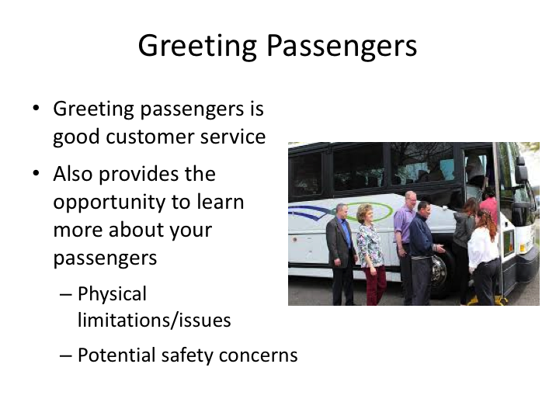

# GREETING PASSENGERS NARRATIVE

Protocols for greeting passengers may be different depending upon the type of trip you’re driving.

**Instructor Tip –**

Detail your company procedures for greeting passengers at the time of boarding.

The most basic customer service practice is greeting passengers as they board your coach. Greet each passenger cheerfully and professionally. Passengers will be looking for someone they feel they can trust to get them safely to their destination, not a jokester or comedian – especially the first time you meet them. On a multiple-day itinerary, you will obviously get to know your passengers better than on a one-day charter or shuttle type of trip.

**GREETING PASSENGERS NARRATIVE (continued)**

In addition to the customer service aspect of this practice, greeting each passenger will also allow you to observe and learn information about them. You'll be able to take note of any passengers who may have difficulty boarding or alighting the bus – for passengers where this will be an obvious issue, you should ask if they would like assistance getting on or off the vehicle and act appropriately (tips on how to assist persons on and off the vehicle will be covered in the Americans with Disabilities module).

*Display PowerPoint slide.*

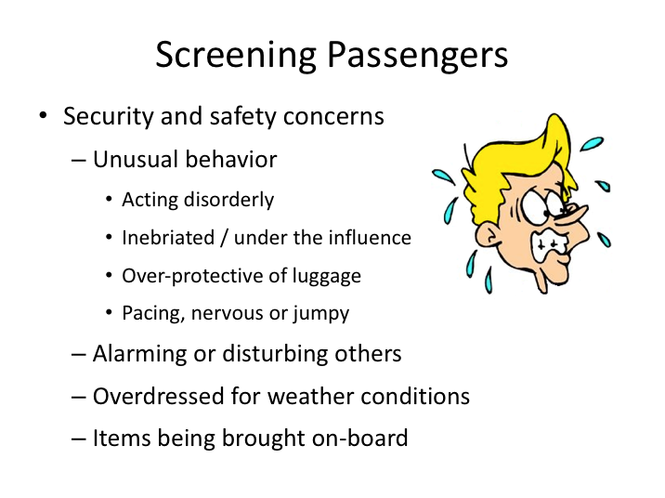

SCREENING PASSENGERS NARRATIVE

You’ll also want to pay attention to passengers as they board for security and safety concerns. Especially on trips where passengers do not know one another, you will want to pay close attention to passenger behavior. Unfortunately, security and terrorism risks have long been associated with motorcoach operations – mostly overseas, though sometimes even here in the United States – this is something that should always be in the back of a drivers mind.

Pay attention to unusual behaviors – it’s impossible to list them all, but you will come to learn what is normal passenger behavior simply because it is how the vast majority of passengers will act and respond to your greeting when boarding the coach. Those that act out of the ordinary are ones you should pay special attention to. Intoxicated and disorderly passengers are potential issues you may have to deal with while driving. Passengers who are nervous or jumpy may be under the influence of controlled substances or could also be a security risk.

**SCREENING PASSENGERS NARRATIVE (continued)**

If there are passengers who are over-protective of their luggage to be stored in the luggage bay, this could be an indication that there is something illegal or unsafe in their luggage (more on luggage loading later). Persons over-dressed for the weather may be hiding something underneath their clothing that could also be a security risk.

Finally, take note of the items passengers are bringing on-board. If there is anything that could not be stowed safely in the passenger compartment, or could be potentially hazardous and is not necessary (e.g., extra canisters of oxygen), you should talk to the passenger about your concerns and stow these items safely in the luggage bay area.

|  |  |
| --- | --- |
| Question……… | Clipart |

**Ask:** If a disorderly or inebriated passenger begins to act out during a trip, what should you do?

Pause and allow students to suggest answers. Accept any reasonable answers.

* *Recognize the emotion of the passenger, politely ask the passenger to remain seated (if applicable), ask the passenger questions while not arguing or escalating the situation, make a decision that will help defuse the situation (ex: finding a safe location to pull over). Assess the amount of risk they pose to you and other passengers. Consider contacting dispatch if necessary.*

*Display PowerPoint slide.*

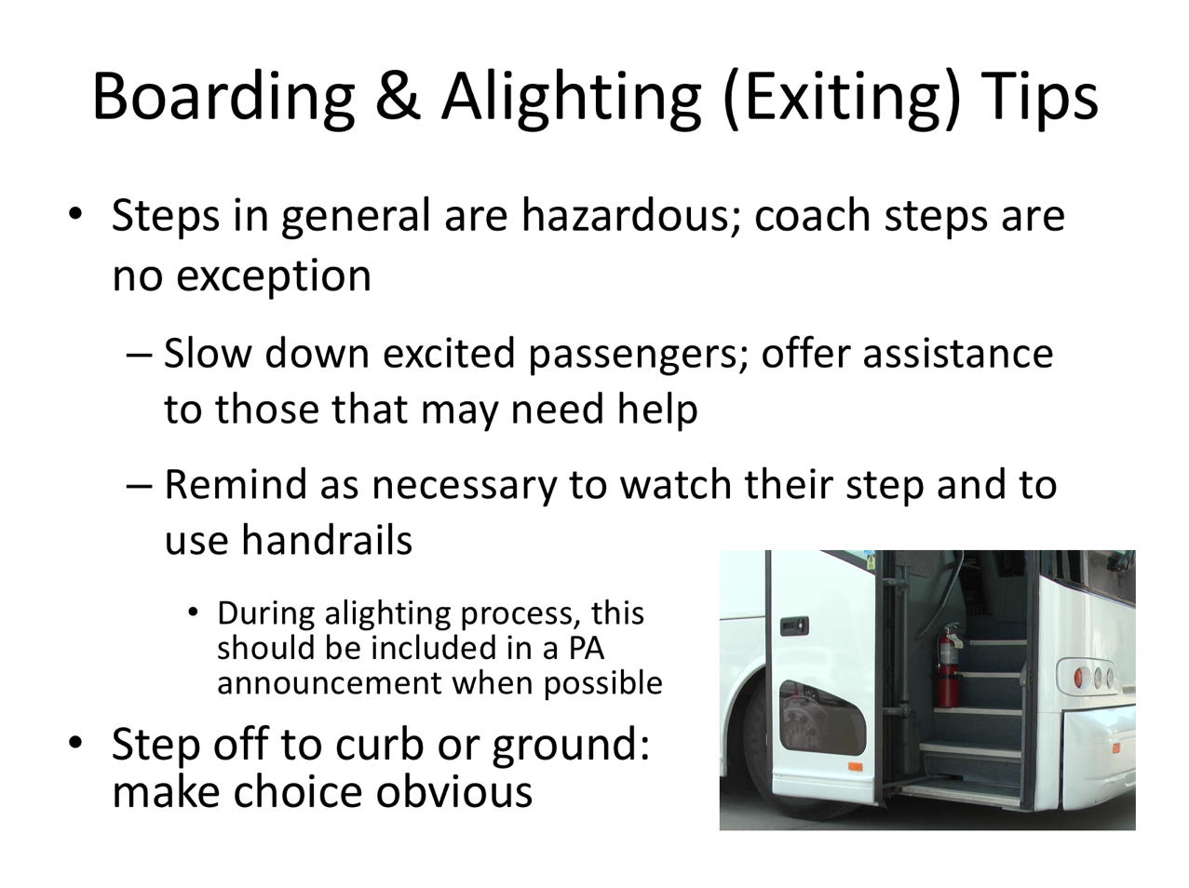

# BOARDING & ALIGHTING (EXITING) TIPS NARRATIVE

Negotiating stairwells and steps is a process that leads to thousands of injuries every year. Motorcoach stairwells are no different. Any time a person is negotiating any stairwell, there is an enhanced potential for injury.

Generally, the step closest to the ground (the first step boarding/last step exiting) will be a larger height/rise from the other steps. If a passenger was to have difficulty physically navigating any step on a motorcoach, this is the most likely one.

Passenger awareness is the best way to prevent a stair fall and injury on a motorcoach. If a passenger is paying attention, using the handrails, and has no physical limitations, they should be able to navigate the stairs safely. If you see a person you believe may need help based upon their physical condition/ appearance, you should ask them if they would like assistance.

**BOARDING & ALIGHTING (EXITING) TIPS NARRATIVE (continued)**

Reminding passengers of stairwell hazards can help raise awareness and prevent unintentional injuries, especially for those who may be rushing or

perhaps carrying too much in their arms to grab a handrail. While it likely won't be possible to instruct every passenger, drivers should remind passengers as appropriate to watch their step and to use the handrails.

When curbs are at exit locations, place the coach in a manner where the passengers exiting are either stepping off onto the curb or down to the ground.  Make the choice obvious – you don’t want passengers trying to overextend themselves to reach a curb or step to the ground and then potentially trip on the curb.  Whether the intention is to step to the curb or the ground, position the coach close enough to, or far enough away from the curb so there is no confusion where they should be stepping down to.

*Display PowerPoint slide.*

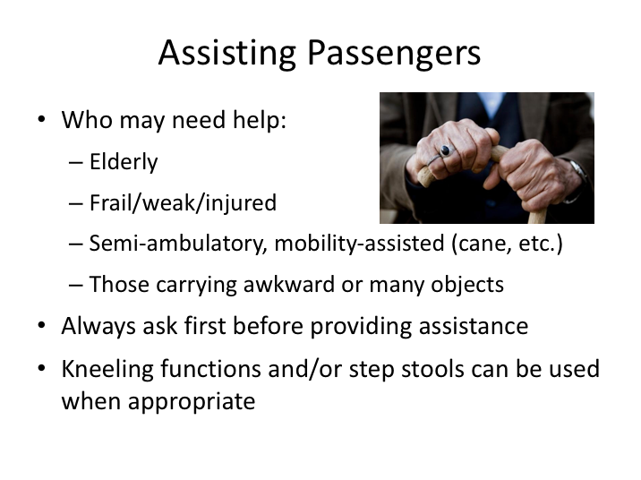

# ASSISTING PASSENGERS NARRATIVE

**Instructor Tip –**

Detail your company procedures and policies for assisting passengers when boarding or exiting the coach.

While boarding assistance is only required to be provided in specific circumstances (for passengers with disabilities), it is typically customary for a driver to provide limited boarding or alighting assistance when asked by a passenger. Passengers may need assistance for a variety of reasons: they may just need help navigating the steps, need help steadying themselves as they navigate stairs, or perhaps need some assistance with some items they are carrying on board.

**ASSISTING PASSENGERS NARRATIVE (continued)**

Aside from the passengers who ask directly for assistance, there may be passengers whose appearance or characteristics indicate that assistance may be beneficial, such as elderly passengers and frail or injured passengers. Despite any appearance of limitation or need, you must always ask first if they would like assistance prior to providing any help.

Drivers should only provide courtesy assistance if they are comfortable in providing the assistance and can do so safely. Kneeling functions of

motorcoaches or step stools can be utilized if available and appropriate to assist in navigation of steps.

*Display PowerPoint slide.*

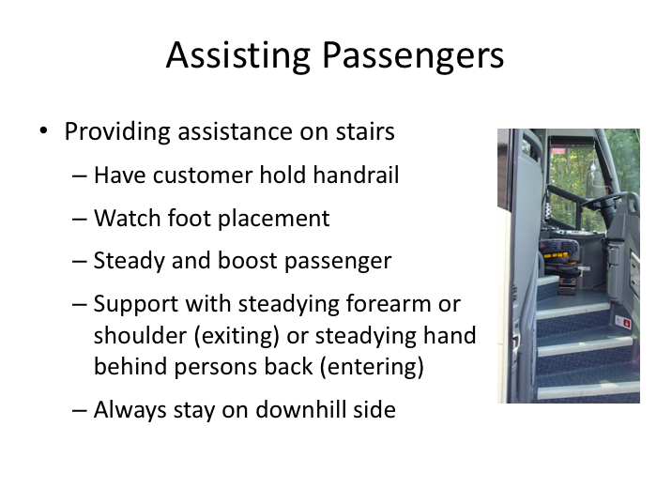

**ASSISTING PASSENGERS NARRATIVE (continued)**

If a passenger proactively asks for assistance, or acknowledges they would like assistance after being asked, you should determine the best method to provide assistance during the boarding or exiting process.  It may be helpful to ask the passenger the best manner in which to assist them. The best method available to you will depend upon the configuration of your motorcoach (whether it is lift-equipped) and the degree of assistance required by the passenger.

Your assistance will most commonly be requested or necessary with passengers boarding or alighting the coach.  While the best method to prevent someone from falling is to support them under one or both arms (armpit area), this type of assistance is not possible when navigating a stairwell.  In this situation, it is more plausible to simply help support and steady them as they climb or descend the stairwell.

**ASSISTING PASSENGERS NARRATIVE (continued)**

In all cases, you should have the passenger you are assisting also use the handrail.  Try to keep an eye on their foot placement to ensure they are squarely on each step prior to transferring weight - if it is not, a problem could be pending.  You can support them when entering the coach by providing steadying support at their lower back with your hand.  If they are descending the stairwell, simply providing a steadying forearm or shoulder in front of them may be sufficient.

When you are assisting a passenger up or down the stairwell, always remain on the downhill side of them; this means if they are getting on the coach you would be on a step behind them, and while exiting, you will be a step in front of them.

simply providing a steadying forearm or shoulder in front of them may be sufficient.

*Display PowerPoint slide.*

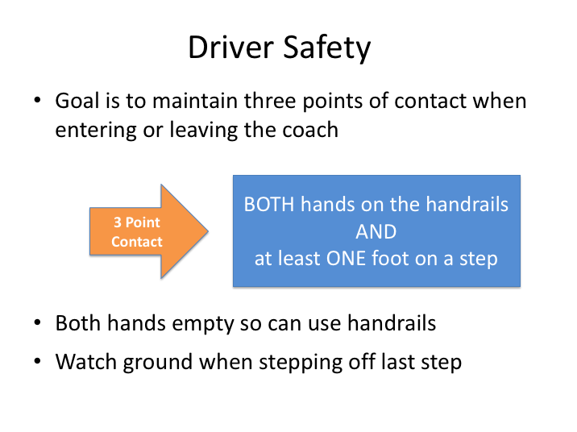

# DRIVER SAFETY NARRATIVE

Though we’ve been talking about passenger safety getting on and off the motorcoach, we also need to talk about driver safety.  A large portion of slip and fall injuries for drivers occur when entering and exiting the bus.  Using the three-point contact procedure is a good method for preventing these types of injuries.  To allow yourself use of both hands on the handrails, you should avoid carrying items and handbags as much as possible. Consider using a bag you can place over your shoulder to carry personal items.  If you must proceed without both hands free, make sure at least hand is, go slow, and watch your footing.

LESSON 2

SCREENING, LIFTING AND LOADING LUGGAGE

**Lesson Objectives**:

This lesson will prepare drivers for trips where passengers have baggage and luggage that must be stowed on the motorcoach. Students will learn how to screen luggage for security concerns, how to safely lift luggage to prevent injury to themselves, how to handle common hazardous materials in transport, and the best manner in which to load luggage to prevent potential vehicle issues associated with tire and axle overloading.

**Instructional Method:** Classroom and At-Vehicle Exercise

**Approach:**

Utilizing the PowerPoint slides, review key concepts related to luggage screening, loading and safe lifting practices.

**Instructor Tip –**

Instructors are encouraged to incorporate any company-specific policies, practices and customer service protocols into this suggested content. Specific slides can be inserted into the PowerPoint presentation provided, detailing your company specific policies and procedures.

The at-vehicle exercise should be used for each type of vehicle operated, detailing luggage compartments and reinforcing classroom-taught techniques.

As with any module, relating actual experiences pertaining to material being taught will help students identify with content.

**LESSON INTRODUCTURY NARRATIVE**

*Student Guide reference here*

On most trips, luggage will be synonymous with passengers. The amount of luggage will range from very light on shuttle and commuter-type trips, to very heavy on multi-day or inter-city transportation.

Even in situations where customer luggage is limited to carry-on bags only, the driver still must be aware of incorrect luggage stowage and any potential for injury or impedance to passengers.

Trips with a lot of luggage usually require significant physical effort from the driver. Lifting, loading and retrieving luggage can result in physical injury if proper handling mechanics are not followed.

As with passengers, there are additional safety and security concerns related to luggage. Drivers must be keen observers while viewing and handling both carry-on and stowed luggage - always on the lookout for suspicious baggage and parcels that could be security concerns.

In addition to security concerns, passenger and luggage capacities of modern motorcoaches push the limits of a vehicle’s axle and tire load capacities, so drivers must understand and recognize the potential for exceeding these mechanical limits and, if necessary, what actions to take to ensure vehicle safety is not compromised.

Finally, there are certain materials that are transported by individuals or groups on a recurring basis that can be dangerous if not handled and stowed properly. Commonly transported hazardous materials will be reviewed and discussed.

Both companies and passengers include safe and courteous luggage and material handling in customer service expectations of drivers. Drivers who understand potential hazards and risks associated with luggage handling can help ensure passenger safety even before they put the motorcoach into gear.

*Display PowerPoint slide.*

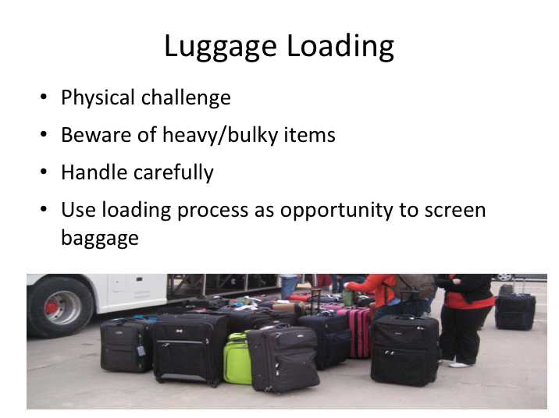

# LUGGAGE LOADING NARRATIVE

While many consider driving a largely mental exercise, luggage handling is a mainly physical activity that is an essential function of a driver’s duties. Drivers unable to repetitively lift, carry, push and pull luggage will be limited in their ability to operate many motorcoach trips.

There are three important concepts drivers must keep in mind with regard to luggage and baggage handling:

1. Motorcoaches have been used in many countries as transport vehicles for explosives and other weapons – either for eventual use or real-time use with the motorcoach as the target/weapon. In addition to the physical task at hand, drivers must be able to recognize potential suspicious packages and baggage.
2. Customers rightly expect courteous and cautious handling of their baggage. Drivers who act as if a parcel is their own typically will handle it in an acceptable manner.

**LUGGAGE LOADING NARRATIVE (continued)**

1. With customer service and cautious handling in mind, as well as overall ability to complete trips without incident, drivers must not be superheroes and try to handle items too heavy or bulky. Asking for assistance when necessary will actually show additional concern and keep a driver from suffering injury that could affect his driving and other job duties.

*Display PowerPoint slide.*

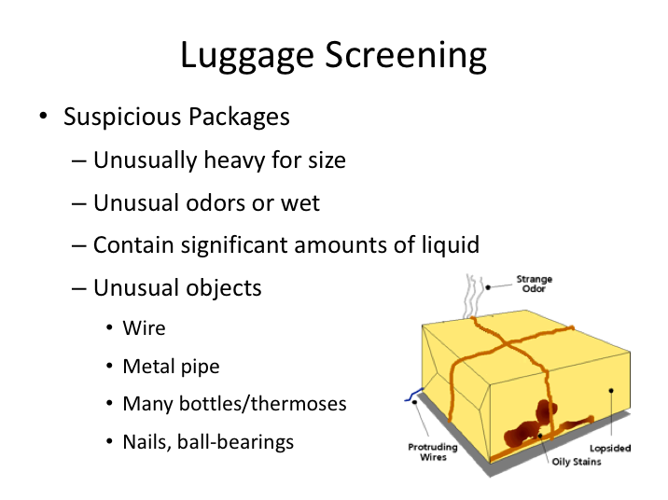

# LUGGAGE SCREENING NARRATIVE

Similar to observing and screening passengers, luggage observation while loading is key to identifying potentially dangerous or suspicious packages a passenger may be attempting to transport on your motorcoach. As with any security-related concern, you will learn what is “ordinary” over the course of being a driver – and recognizing out of the ordinary will become intuitive.

If you observe a passenger who appears to be overly possessive or concerned about his luggage during the passenger boarding process, close attention should be paid to the parcels for any signs of danger. If a customer insists on loading their luggage themselves, drivers may allow them to do so but should check the luggage for suspicious signs after they board the coach. This will require strategic placement and loading of luggage, so it can be readily screened.

For passengers boarding with carry-ons, take note of anything unusual with respect to their carry-ons. For instance, if they are attempting to carry on a full-size suitcase instead of stowing it in the luggage bays, concerns and questioning should ensue.

**LUGGAGE SCREENING NARRATIVE (continued)**

For luggage being stowed in the luggage bays, be cognizant of any of the following signs or concerning characteristics:

* Parcels that are unusually heavy for their size
* Parcels that emit unusual odors
* Parcels that obviously contain large amounts of liquid or are wet
* Parcels containing unusual contents such as metal, pipes, nails or ball bearings (opening parcels for inspections is not advised unless something concerning is obvious or can be felt through soft-sided luggage).

**Instructor Note –**

Detail your company protocol for drivers when situations involving suspicious or dangerous packages occur.

|  |  |
| --- | --- |
| Question……… | Clipart |

**Ask:** As a motorcoach driver, you must always remember to keep security in mind. We’ve discussed identifying potentially dangerous or suspicious packages and recognizing ordinary and out-of-the-ordinary items and behaviors. Can you think of any strange or out of place signs related to the vehicle that we should be on the look-out for as well? Any potential signs of tampering?

Pause and allow students to suggest answers. Accept any reasonable answers.

*Examples:*

* *Unusually clean or dirty components*
* *Open or disturbed compartments and cabinets*
* *Scratches or marks made by prying tools*
* *Things that are out of place*

*Display PowerPoint slide.*

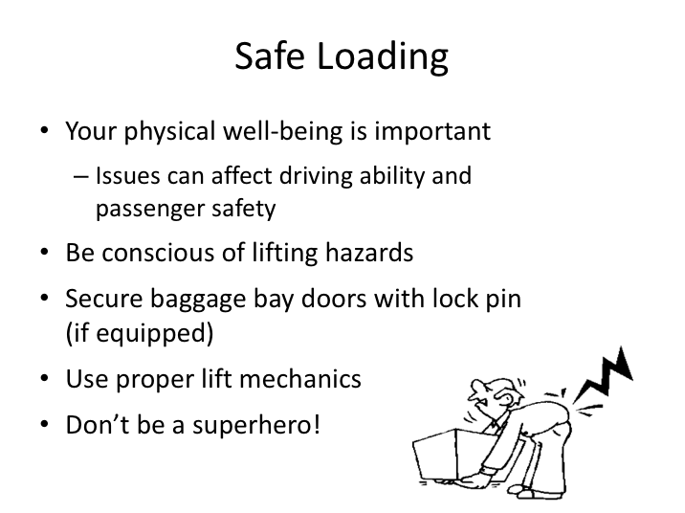

# SAFE LOADING NARRATIVE

Luggage handling is both physical and repetitive and significant injuries can occur when not performed properly. In addition to the potential long-term effects of these injuries, symptoms can present short-term risks and obstacles to safe driving and other driver responsibilities.

Though luggage handling will be a routine task for many drivers, you must always be conscious of the hazards associated with this activity. In doing so, you will be able to focus on utilizing proper techniques to minimize injury to yourself – injuries that otherwise could have long-lasting consequences to your employment, career and family.

**SAFE LOADING NARRATIVE (continued)**

The most common reason drivers suffer injuries during luggage handling tasks is because they do not follow safe practices and/or company procedures. Many companies have policies regarding maximum weights of parcels (though it may be tough to enforce these) as well as when a driver should ask for assistance with heavy or bulky objects. The key for any driver is to be aware of the potential

for injury, secure baggage bay doors open with pins (if equipped), handle luggage properly, and not attempt to handle something that is too heavy or too large.

**Instructor Note –**

Detail your company policies with regard to maximum luggage weights and when and who a driver should ask for assistance if necessary for oversized or overweight parcels.

*Display PowerPoint slide.*

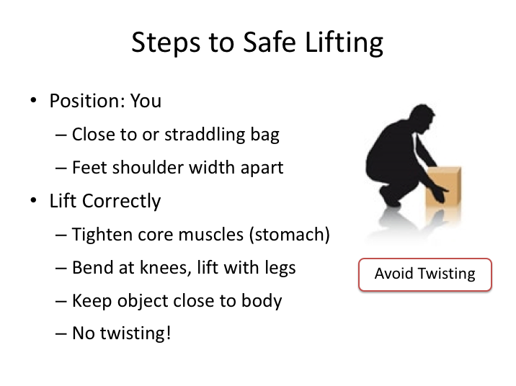

# STEPS TO SAFE LIFTING NARRATIVE

Lifting an object safely is actually an easy task once you understand the proper mechanics and, in particular, what NOT to do to.

Ideally, you want to minimize both the distance an object must be lifted vertically, as well as the distance it must be moved or transported once lifted. You also want to keep the load close to your body when lifting and/or moving. And keep in mind, the higher you must lift an object the more difficult it will become since the muscles doing the lifting will change – even with proper lifting technique.

You want to use your legs as much as possible, hence the saying, “lift with your legs.” Proper technique for lifting a bag would be to position yourself behind or over the bag with your feet shoulder-width apart. Tighten your stomach muscles for stability when you grab the bag in preparation to lift it, and, bending at the knees (not the waist), use your leg muscles to lift the bag up.

**STEPS TO SAFE LIFTING NARRATIVE (continued)**

If you've planned correctly, any bags you are handling will be close to the luggage bay in which you intend to place them - you should not have to walk or carry the luggage any distance. If you do have to carry a parcel after you’ve lifted it, keep the load close to your body while walking. Never twist at the waist while carrying a load.

*Display PowerPoint slide.*

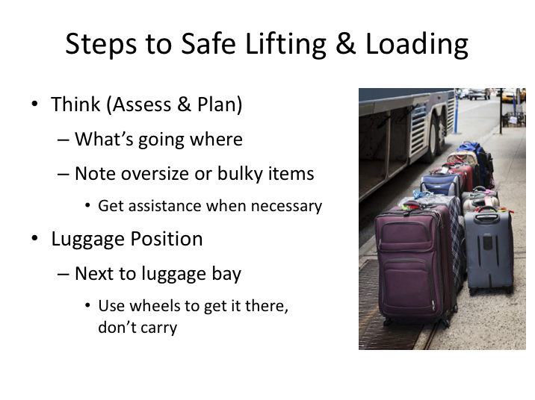

# STEPS TO SAFE LIFTING & LOADING NARRATIVE

When loading luggage on a motorcoach, you will generally be presented with a pile of luggage stacked next to the coach. The first step in determining what you can handle safely (and how you will load the luggage) is to assess what’s there. Arranging the luggage by size and weight categories will be helpful in determining the best manner in which to load the luggage into the luggage bays.

**Driver Tip –**

In order to expedite the planning process, you may wish to ask passengers to place their luggage in areas not immediately next to the luggage bays. This will allow you to move luggage next to the bay you intend to load it into without any obstruction.

**STEPS TO SAFE LIFTING & LOADING NARRATIVE (continued)**

Physically assessing the weight of each parcel will help you determine which are too heavy to handle safely. You can assess a parcel’s weight by simply grasping each parcel and lightly lifting on the handle to assess resistance - a lot of resistance when doing this will indicate a very heavy parcel.

Assessing the weight will also help you determine where you should load each parcel, being careful to distribute the weight across luggage bays of the motor coach and loading the heaviest parcels near the drive and tag axles – these axles are designed to handle more weight than the steer axle.

You should also consider where the heaviest parcels will be placed within the luggage bay. Luggage bays are up to 8 feet across, and you may not want the heaviest objects in the center of the bay where they have to be slid the farthest to get in or out. Instead, lighter objects could be placed toward the center of the bay and heavier objects on the edges to minimize travel while loading and retrieving. If you have a lot of luggage, you may need to stand the larger bags up in the center of the bay and stack the smaller ones toward the edges. It will all depend on the amount of luggage you have and your preference – just remember to keep in mind injury potential as you contemplate your luggage organization.

Prior to physically picking up luggage for loading, you should use integrated luggage wheels and handles to move the luggage immediately next to the area where you plan on loading it in the luggage bay. This will minimize the distance the luggage must be moved once lifted.

Also, since most luggage will be stored horizontally (on its side), rather than vertically (standing tall), you should arrange luggage on its side next to the luggage bay prior to lifting (most bags have both top and side handles). This will allow larger and stronger muscle groups to lift the luggage into the luggage bay.

*Display PowerPoint slide.*

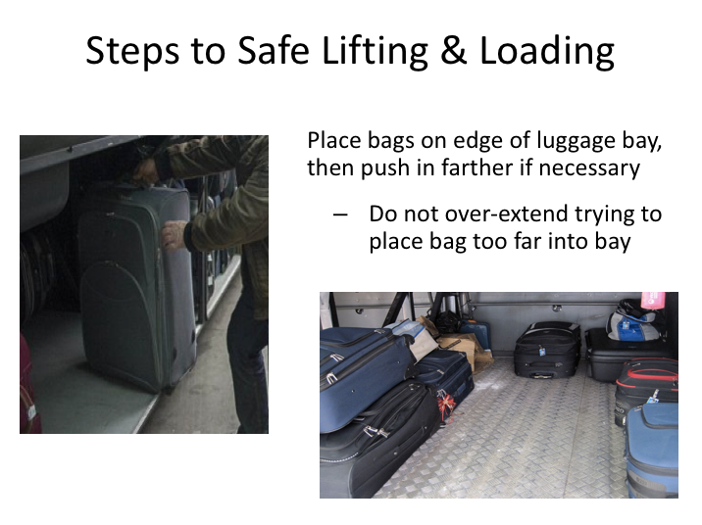

**STEPS TO SAFE LIFTING & LOADING NARRATIVE (continued)**

Once the parcels are loaded on the edge of the luggage bay, you can push them into their final position. Remember to keep them as close to the edge as possible to minimize how far you have to push them in and, when retrieving them, pull them out.

Do not swing your arms once you have lifted the luggage to slide or toss it into the luggage bay.

As long as traffic allows, and it’s safe to do so, you should load the luggage bays from both sides of the coach to prevent from having to push (or pull) any bag across the entire bay.

**Instructor Note –**

Using an empty, light suitcase, demonstrate the lifting process explained. Be sure to include showing them how NOT to bend at the waist, twist at the waist, or swing their arms once a bag is lifted.

*Display PowerPoint slide.*

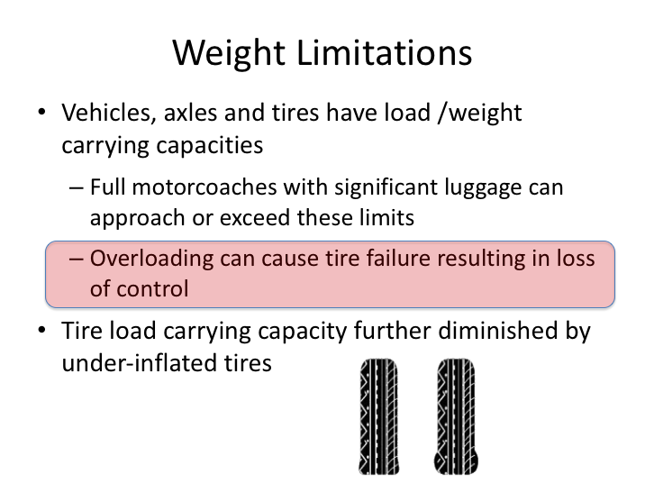

# WEIGHT LIMITATIONS NARRATIVE

Even with its impressive size, a motorcoach has its limits; in fact, any vehicle is only as safe as its weakest link. Vehicles are engineered to safely carry a specific maximum weight (load), assuming the load is properly distributed on weight-bearing axles and tires.

Several motorcoach incidents and crashes have been attributed to tire failures where unintentional overloading may have been a contributing factor. Modern motorcoaches, carrying over 50 passengers and full luggage loads, push the limit on vehicle load carrying capacities.

In addition to a motorcoach’s overall weight capacity, individual axles and tires themselves have limit capacities. Drivers must be cognizant of axle weight-bearing capabilities – heavier loads should be placed near the drive and tag axles.

**WEIGHT LIMITATIONS NARRATIVE (continued)**

Proper tire inflation should be assessed at every vehicle inspection opportunity, as it is critical for many reasons, especially the load capacity of tires: tires that are underinflated have diminished load carrying capacity.

Drivers should also be aware that overloaded tires are even more likely to fail when operated at highway speeds in warm weather.

**Instructor Note –**

Detail company protocol that should be followed if a driver is concerned about potential overloading.

*Display PowerPoint slide.*

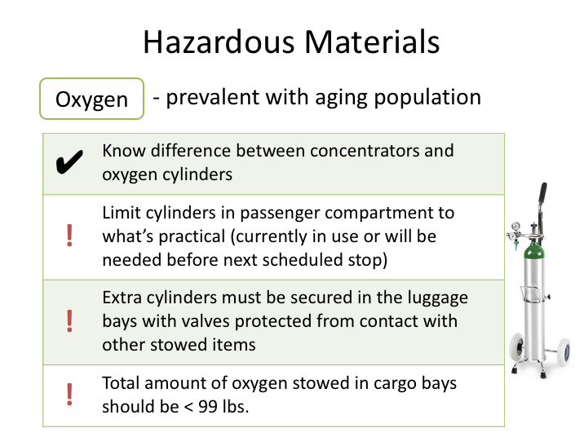

# HAZARDOUS MATERIALS NARRATIVE

Occasional transportation of hazardous materials is commonplace in the motorcoach industry. Motorcoaches hired for transportation to places, events, and activities where passengers need or desire to transport hazardous materials is common. These materials can be transported safely in limited quantities with proper safeguards as long as the driver knows the proper protocols.

The most common potentially hazardous material drivers will see is medical/ personal-use oxygen. Individuals who have been diagnosed with low blood oxygen levels will often be supplied with oxygen concentrators or pure oxygen gas to treat their condition.

Oxygen concentrators are portable devices that concentrate the oxygen from the atmosphere to deliver higher concentrations of oxygen to the user. This type of equipment is small, lightweight and is typically either carried/worn via a strap or hand carried by the user. Oxygen concentrators simply work with existing oxygen in the air and do not contain any hazardous materials; therefore, they do not pose any threats to vehicle or passenger safety.

# HAZARDOUS MATERIALS NARRATIVE (continued)

On the other hand, oxygen tanks contain pure oxygen gas. These tanks are pressurized metal cylinders and will have some type of valve system at the top of the cylinder where the oxygen dispenses. Oxygen tanks are larger than concentrators and are generally carried by the user by either using a bag with a shoulder strap or pulling the cylinder on a cart. Pure oxygen gas can be a risk to passenger and vehicle safety in certain circumstances, thus pure oxygen gas is a classified as a hazardous material.

|  |  |
| --- | --- |
| Question……… | Clipart |

**Ask:**  Can anyone name the three elements of a fire?

Pause and allow students to suggest answers. Accept any reasonable answers.

* *Oxygen*
* *Fuel*
* *Heat (ignition source)*

**Ask:**  (Follow-up question) How could having oxygen tanks on the bus be dangerous?

Pause and allow students to suggest answers. Accept any reasonable answers.

* *Oxygen tanks can cause more deadly and damaging fires. More oxygen introduced to a fire will act as an accelerant and cause fires to burn faster and hotter.*

Oxygen is a component of the fire equation/triangle: oxygen, heat, and fuel. The presence of pure, pressurized oxygen can feed and intensify a fire. Perhaps even more concerning is the hazard potential of a cylinder if the valve system or tank itself is damaged and/or compromised. Because of the pressurization of these tanks, a damaged cylinder or valve system could result in high-pressure release of the gas, which can turn the cylinder itself into a dangerous projectile (similar to a rocket).

# HAZARDOUS MATERIALS NARRATIVE (continued)

Due to these dangers, the presence of oxygen gas cylinders within the passenger compartment of a motorcoach should be limited to only the amount required for immediate use. In almost all circumstances, the current, in-use cylinder should be the only one permitted in the passenger compartment – any spare cylinders should be stowed in the luggage bays under the coach. A single spare cylinder may also be permitted in the passenger compartment in rare instances where there are not anticipated en-route stops that would permit switching of cylinders if necessary. Drivers must ensure that oxygen cylinders in the passenger compartment are not stored in the aisle and that absolutely no smoking is permitted on-board when oxygen cylinders are present.

Inspect any cylinders for damage or leaks. Handle any extra cylinders with care – do not drag or roll them, and do not carry them by the valve. Extra cylinders should be sufficiently secured in the luggage bays to prevent them from movement and stored away from heat sources. Additionally, they should be protected from contact with other unsecured items in the luggage space – protecting the valve area of the cylinder is of critical importance. An ideal situation would be placing the cylinders in a crate or other protective container.

No more than a total of 99 pounds (gross weight of cylinders) of compressed oxygen should be transported in the luggage bays.

**Instructor Note –**

Oxygen is classified as a Division 2.2 hazardous material, with a subsidiary risk of a Division 5.1 Oxidizer.

Regulatory requirements and limitations for the transport of hazardous materials on passenger-carrying vehicles are specified in 49 CFR 177.870. There you can find quantity limitations for the various hazard classes and/or divisions, stowage and securement requirements.

*Display PowerPoint slide.*

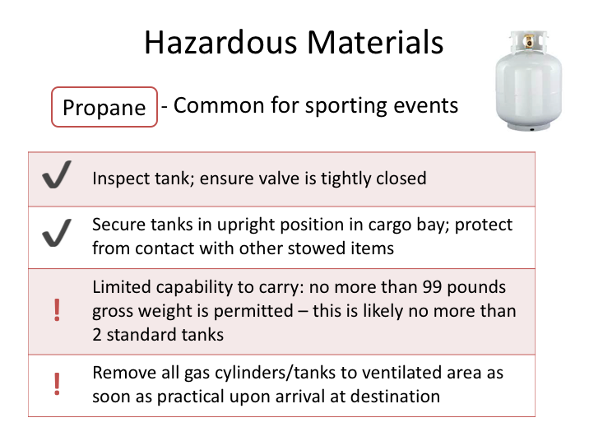

**HAZARDOUS MATERIALS NARRATIVE (continued)**

Propane is another potentially hazardous gas desired to be brought on charter trips, particularly to sporting events.

Propane is a flammable gas that should be transported only in limited quantities, and only in the luggage bay. Similar to oxygen restrictions, no more than 99 pounds (gross weight) is permitted to be transported. Considering that the standard barbeque grill-type tank weighs approximately 15 pounds itself, and holds 20 pounds of propane when full, no more than two full tanks are likely permitted to be transported in the luggage bays (3 full tanks with a total weight of 35+ pounds would exceed the 99 pound limit). The actual weight of the empty tank – referred to as the tare weight, or T.W. - is usually stamped on the collar of the tank.

There are effective ways in dealing with these limitations while still servicing the customer. These include arranging for temporary use of propane tanks at destination venues, purchasing filled tanks once in the area of the destination, or transporting empty tanks and having them filled when arriving at the

**HAZARDOUS MATERIALS NARRATIVE (continued)**

destination. You must be aware however that propane procurement utilizing any of these methods is still subject to the noted limitations of no more than 99 pounds on a motorcoach – even if you don’t have any passengers on-board.

Precautions to take with transporting propane tanks are similar to those described for oxygen cylinders. The first step is to inspect the tank for any damage or leaks, and ensure the valve is closed tight. Secure/immobilize the tanks in their upright position in the luggage bay, protecting them from impact and contact with other stowed articles. Always protect the valves from possible damage.

Because the dangers of hazardous gases are compounded in enclosed spaces, you should remember to remove gas cylinders and tanks from the luggage bay to a well-ventilated area as soon as practical upon arriving at your trip destination.

**Instructor Note –**

Detail any company policies/procedures that apply to hazardous material transportation.

*Display PowerPoint slide.*

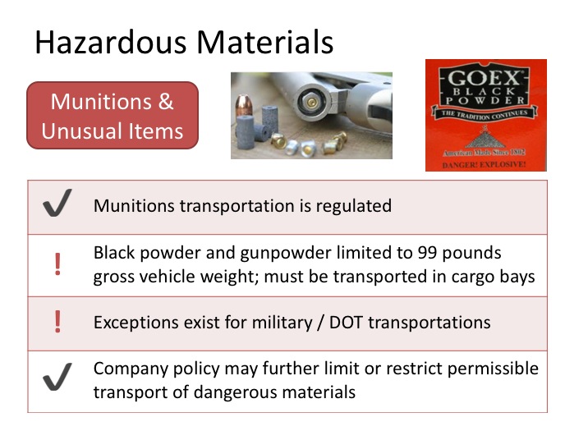

**HAZARDOUS MATERIALS NARRATIVE (continued)**

Much less likely than the transportation of oxygen or propane is the transport of munitions, including small arms ammunition, black and/or gunpowder, and potential military munitions.

Black powder is popular with re-enactments of historical battles from the Civil and Revolutionary Wars; this was the powder used to fire rifles and other weapons of those eras. Similar to oxygen and propane gas, transportation of black powder, and more modern gunpowder, is generally limited to 99 pounds gross weight, and it must be transported in the luggage bays of the coach. There are exceptions to munition transportation limitations for military and troop movements, though even in these cases, munitions are often transported separately if necessary.

It’s safe to say that you should check with dispatch if there are any unusual items or materials offered for transport that you know or feel may be hazardous - especially if not previously advised of the items. Even in cases where hazardous

**HAZARDOUS MATERIALS NARRATIVE (continued)**

materials transportation may be allowable by law (such as small arms ammunition), there may be a company policy which limits transportation of these materials.

**Instructor Note –**

Detail any company policies/procedures that apply to hazardous material transportation.

In the event of multiple types of hazardous materials being transported, the maximum combined gross weight of any combination of designated hazardous materials allowable to be transported on a motorcoach is 496 pounds gross weight.

*Display PowerPoint slide.*

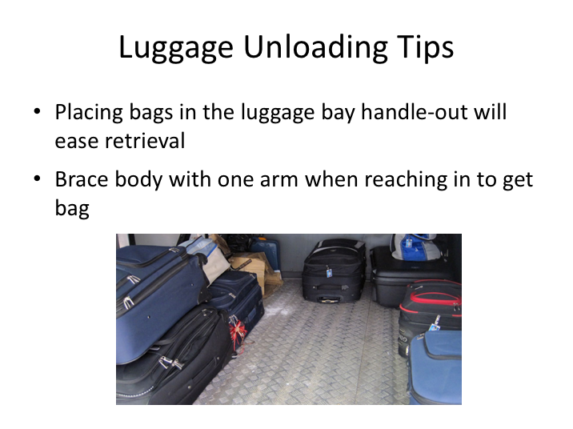

# LUGGAGE UNLOADING TIPS NARRATIVE

We’ve covered loading and transporting luggage, but there are also some practical tips to consider for unloading stowed luggage and articles from a motorcoach.

While many modern suitcases have handles on both the top and the bottom of the bag, there are still many that only have top, and perhaps a side, handle. Taking note of where carry handles are and placing luggage in the motorcoach bay with a handle facing out will greatly ease retrieval of the luggage when it comes time to unload.

Retrieving luggage can be somewhat awkward because of the height of the luggage bays and the potential depth of the luggage within the bay. Drivers should maintain the same vigilance when unloading luggage as they do while loading, being aware of injury potential, especially during removal of parcels in the center of the bay.

**LUGGAGE UNLOADING TIPS NARRATIVE (continued)**

When removing any parcels, remember to try not to twist your back while pulling on the luggage; let your back, shoulder, and arm muscles do most of the work. Many drivers find it helpful to brace their body with one arm against the side of the coach while pulling luggage out with the other arm. Don’t forget – same rules apply if you need to lift and carry luggage when removing from the coach!

**EXERCISE**

Instructional Aides:

1. Motorcoach (one of each manufacturer coach in fleet preferred)
2. Suitcases and duffle bags of various sizes, with various weights marked/indicated (not actual weights – this is simply to represent what a driver may expect)
3. An example of a suspicious package
4. An example of a bulky or oversized item
5. Empty oxygen and/or propane cylinder
6. Crate

To reinforce concepts related to luggage handling and loading, students should be taken out to the motorcoach to participate in hands-on demonstration and training.

Instructors should seek a volunteer student to attempt to assess, plan, and load luggage & parcels into the bays. Instructor should observe and critique process afterwards, indicating what he/she would have done different based on their experience and the classroom instruction in the following areas:

* Assessing and planning luggage loading
* Proper lifting techniques (and improper using a light suitcase)
* Loading/arranging of luggage in bays
* Proper securement and storage of hazardous material cylinders and tanks (if applicable, include any areas these should not be stored in due to any heat concerns from equipment on the coach)

At this time, instructors should also reinforce/demonstrate:

* Axles able to carry heaviest load
* Removal of luggage from bays

Finally, instructors should require each student to demonstrate proper lifting and carrying techniques with various sizes of suitcases and parcels and correct any improper techniques observed.

LESSON 3

PASSENGER SAFETY

**Lesson Objectives**:

This lesson will provide information on en-route passenger safety. Students will learn their responsibilities prior to departure, including providing passenger safety briefings when necessary. Students will also learn concepts related to passenger safety with regard to selecting en-route stop locations.

**Instructional Method:** Classroom

**Approach:**

Utilizing the PowerPoint slides, review key concepts related to passenger safety briefings and en-route stop safety.

**Instructor Tip –**

Instructors are encouraged to incorporate any company-specific policies, practices and customer service protocols into this suggested content. Specific slides can be inserted into the PowerPoint presentation as necessary.

As with any module, relating actual experiences pertaining to material being taught will help students identify with the content.

**LESSON INTRODUCTORY NARRATIVE**

*Student Guide reference here*

Passenger safety is not limited to the driving skills and focus of the operator or the mechanical condition of the motorcoach. Drivers must also be concerned for passenger safety in other circumstances, including en-route stops and also ensuring the passengers are aware of the safety features of the motorcoach.

Motorcoaches have safety attributes and features that are unique and may not be known or understood by passengers on-board. In emergency situations, passengers need to know as much information about the vehicle as possible, especially in the event the driver is incapacitated or not otherwise able to assist.

Similar to airline safety briefings - which are mandated by the Federal Aviation Administration - the Federal Motor Carrier Safety Administration endorses use of passenger safety briefings at specific times during a motorcoach trip.

Doing your best to monitor the motorcoach environment, conducting passenger safety briefings, and choosing intermediate stop locations wisely will help you ensure the safest possible trip for your passengers.

*Display PowerPoint slide.*

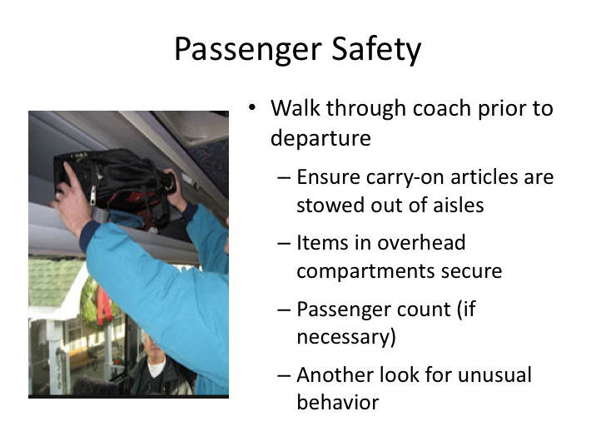

# PASSENGER SAFETY NARRATIVE

After all luggage and passengers have been loaded on the motorcoach, and prior to departure, the driver should walk through the aisle to ensure that aisle way of the coach is free of obstructions and trip hazards.

Drivers can also use this walk-through to ensure any items stowed in overhead bins are securely stowed (bin is closed or, for open bins, items behind retaining mechanism).

This process is also another opportunity for drivers to observe passengers and look for any concerning behavior. Finally, if necessary, drivers can conduct a passenger count at this time.

**Instructor Note –**

Detail any company protocols with regard to passenger counts.

*Display PowerPoint slide.*

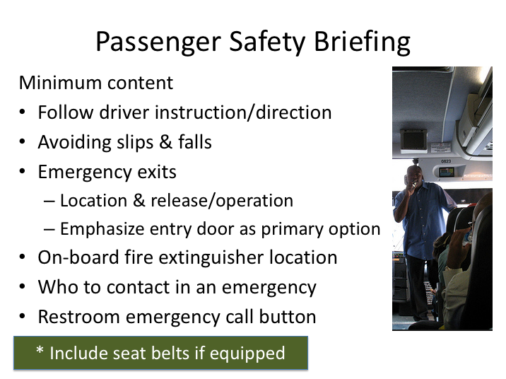

# PASSENGER SAFETY BRIEFING NARRATIVE

Passengers aware of the safety features of the motorcoach they are traveling on may be more likely to utilize features, such as safety belts, while being knowledgeable of emergency features, such as emergency exits, in the event they need to access them.

Guidance from the Federal Motor Carrier Safety Administration details both the minimum content and timing of these passenger safety briefings. The passenger safety briefing should include at least the following:

* Instruction to follow driver direction and instructions in the event of any emergency or safety issue.
* Tips on avoiding passenger injuries due to slips, trips and falls while on the motorcoach. These tips should include: staying seated while the coach is in motion; keeping aisle/walkways clear of obstructions; and methods available to steady and support oneself if moving about the coach while it is in motion.

**PASSENGER SAFETY BRIEFING NARRATIVE (continued)**

* The location and operation of all emergency exits (windows and roof hatches). The service door should be emphasized as the primary exit in any emergency.
* The location of on-board fire extinguishers in the passenger compartment.
* Who the passengers should notify in an emergency (should the driver be incapacitated).
* The presence of the emergency call button located in the restroom.

For motorcoaches equipped with safety belts, drivers should also remind passengers that seatbelts are available, and their use is encouraged.

**Instructor Note –**

Detail any company protocols regarding providing passenger safety briefings via specific media or presentation methods other than driver instruction.

*Display PowerPoint slide.*

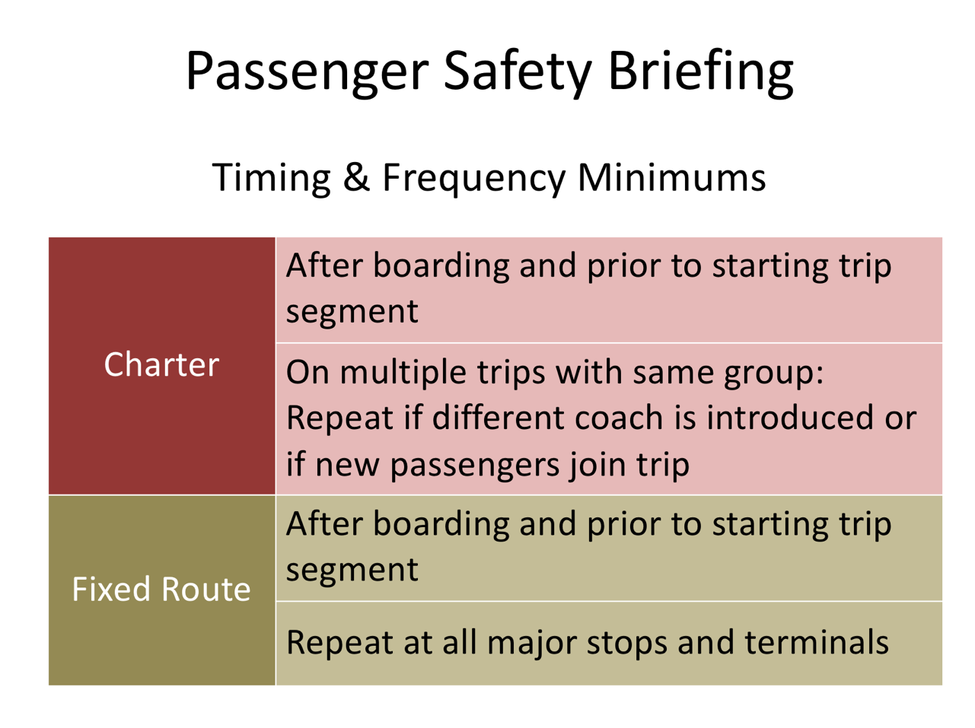

**PASSENGER SAFETY BRIEFING NARRATIVE (continued)**

In addition to safety briefing topics, guidance was also provided on the timing and frequency of passenger safety briefings. When - and how often - these briefings should be provided is dependent upon the type of trip being operated.

For demand responsive trips – charters & tours – the safety briefings should be provided after passenger boarding and prior to beginning the trip. If you are with the same group on a multi-day trip, passenger safety briefings only need to be repeated if a motorcoach change occurs.

For fixed route trips, passenger safety briefings should be provided after boarding and prior to beginning the trip and repeated thereafter at all major stops and terminals.

*Display PowerPoint slide.*

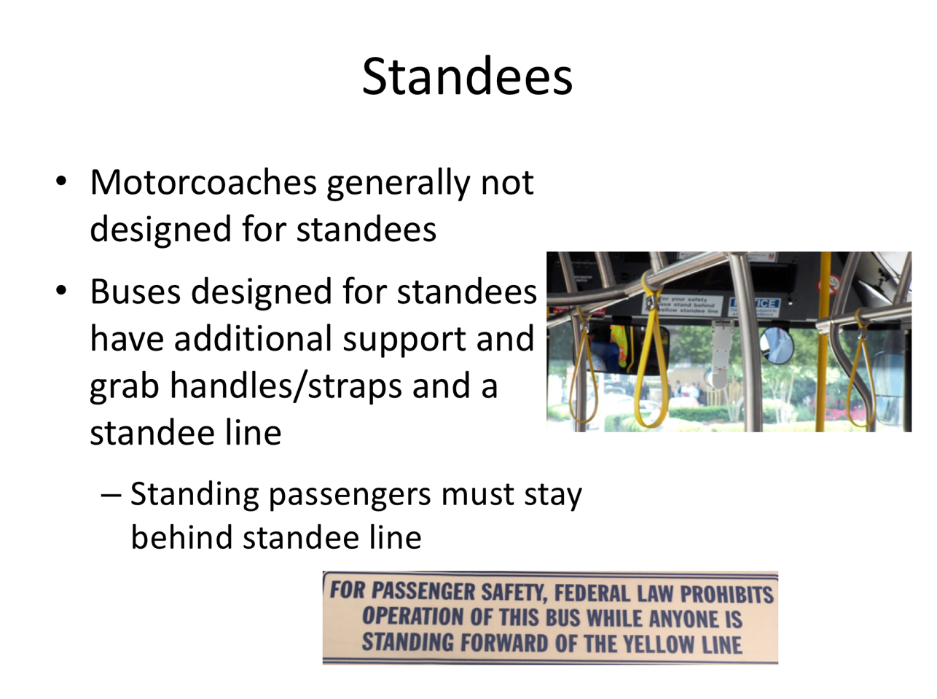

# STANDEES NARRATIVE

There are no federal regulatory prohibitions against standees, though standees are addressed by some state laws. Even when buses are designed to accommodate them it’s not preferable to have unnecessary standees due to the increased potential for falls.

Most motorcoaches are not designed for standee use - the whole point of a motorcoach is to travel in comfort with good views of the passing landscape. Buses that are designed for standee use, like a transit shuttle bus, generally have additional grab rails or hand grabs/straps for standees to use.  Coaches that are designed for standees also usually have a “standee line” – a line near the plane of the driver’s seat that standees must stay rearward of, so as to not interfere with the driver’s ability to see the roadway environment.

*Display PowerPoint slide.*

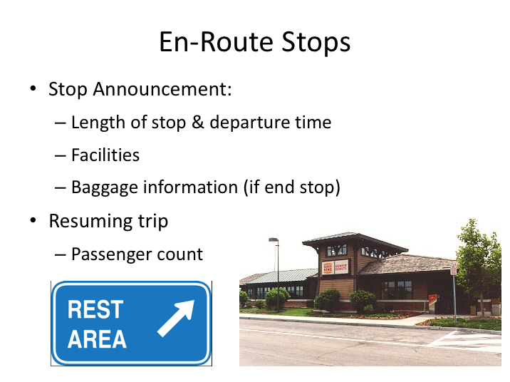

# EN-ROUTE STOPS NARRATIVE

Whether you're operating a fixed route, intercity trip or a charter/tour, you will likely have en-route/intermediate stops that take place between the origin and destination of your trip.

A pre-stop announcement to provide information to passengers will usually accompany each of these stops. This announcement will generally include information such as length of the stop and anticipated departure time, as well as facilities available at the stop location. When doubling as a terminating stop for some passengers, information on baggage retrieval will also be provided.

The stop announcement is also a good opportunity to remind passengers of potential hazards as they exit the coach, including aisle trip hazards and stair navigation.

When resuming a trip from an intermediate stop, it may be necessary – depending on trip protocols - to conduct a passenger count to ensure all passengers have re-boarded the coach prior to departure.

*Display PowerPoint slide.*

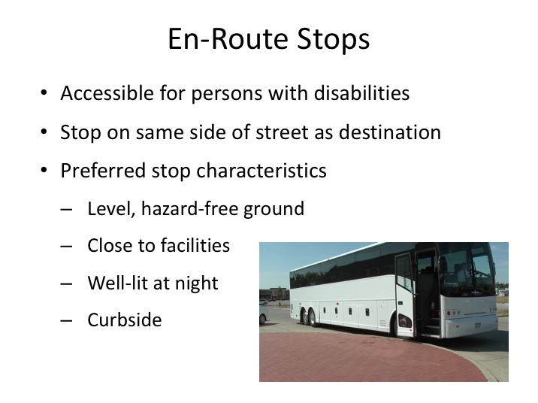

**EN-ROUTE STOPS NARRATIVE (continued)**

When making intermediate stops, drivers should also be cognizant of the physical characteristics of the stop locations. You should try to ensure that all intermediate stops are accessible for persons with disabilities, even if you don’t have any passengers with known mobility impairments on board. Try to stop on the same side of the street as the destination to limit passenger travel distance and exposure to roadway traffic.

On regularly scheduled, fixed route trips, these intermediate stop locations will be preplanned and there will likely be specific instructions on where to park the coach to dispense passengers. On a charter/tour, rest stops may also be predetermined, however the driver is less likely to be familiar with the particulars of the location, or any designated stopping areas.

Ideally, the location where the coach is stopped for passenger alighting should be on level ground with no obvious hazards, as close to the facility as practical, and well-lit if dark outside. When possible, stops should be made curbside to ease navigation of the first/final step on and off the motorcoach.

**EN-ROUTE STOPS NARRATIVE (continued)**

In some instances, designated coach unloading areas or other uncontrollable circumstances may pre-empt driver ability to stop at your preferred location and drivers will have to use their best judgment to choose another parking location at the intermediate stop.

|  |  |
| --- | --- |
| Question……… | Clipart |

**Ask:** When you are at a rest stop, meal stop or any en-route stop, you should do a walk-around inspection of the coach. In an earlier course, we talked about what this en-route inspection should include. Can anyone name the items you should inspect?

Pause and allow students to suggest answers. Accept any reasonable answers.

* *Tires, lights, fluid leaks, all compartments closed, damage to coach, obstacles to pulling out/backing, etc.*

*Display PowerPoint slide.*

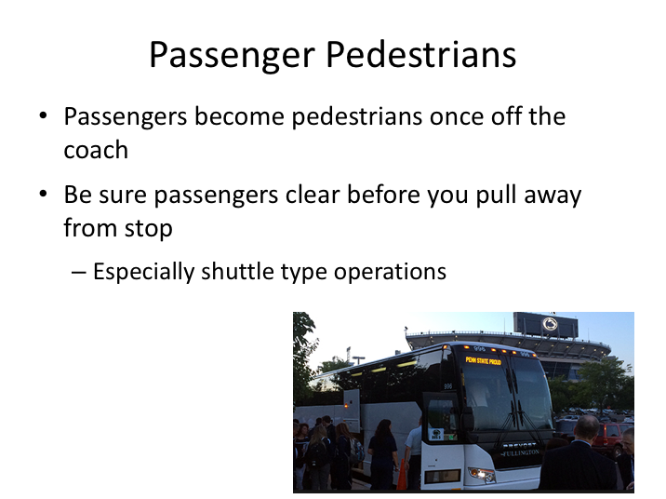

# PASSENGER PEDESTRIANS NARRATIVE

Groups loading and unloading also present special hazards. As groups reach any stop, but in particular their destination, they step off the bus and become excited pedestrians! As passengers exit your bus, try to watch what they do and where they go. Passengers may walk in front of the bus, or even bend down to tie a shoe. Make sure you clear the area around your bus before pulling away.

In most cases, they’ll have cleared away before you even get back in the bus to leave. However, if you’re operating a shuttle type service, it is likely you won’t even leave your seat at every stop, which means you’ll be pulling away sooner. Be careful in these situations of passenger pedestrians, especially when you have children in the mix.

*Display PowerPoint slide.*

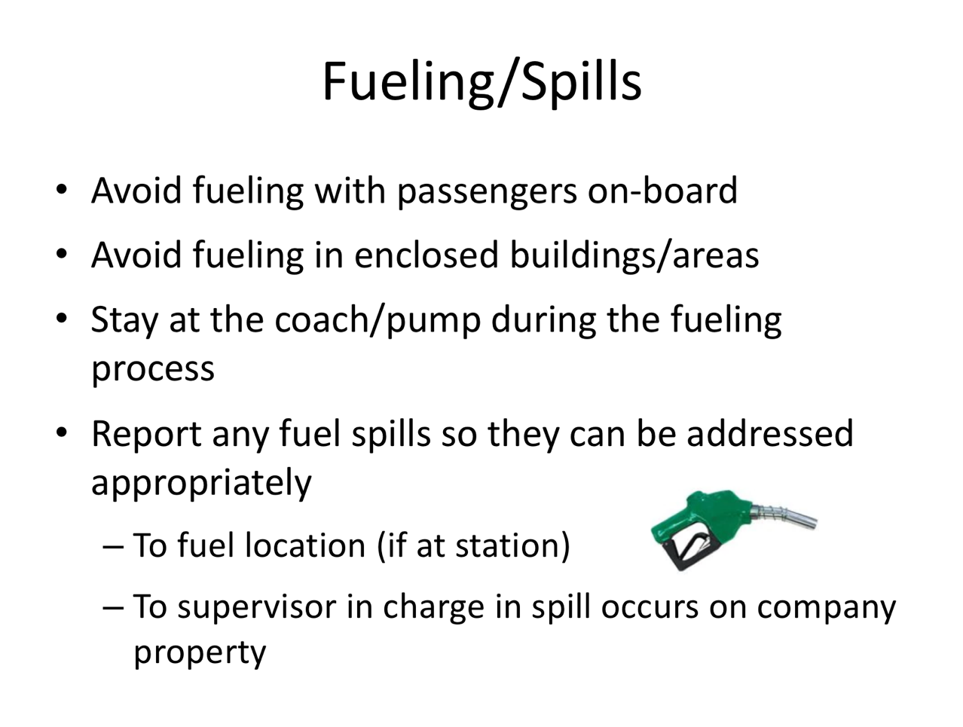

# FUELING/SPILLS NARRATIVE

The responsibility of the driver for regular fueling of a motorcoach varies, depending largely on whether a carrier has on-site fuel storage and dedicated personnel for fueling.  In any case, you will eventually end up fueling a coach - especially if you are out on a multi-day tour with a group.  A few things to remember about fueling:

* Fueling should never occur with passengers on board.  Fuel the coach after stopping and discharging passengers or on off-duty days/periods during long trips.
* Never fuel in enclosed spaces.  You want the environment to absorb/dissipate any fuel fumes, not collect and concentrate them in an enclosed area.
* Guard against fuel spills.  Always stay at fuel pump/coach when fueling.
* Report any fuel spills to fueling station management (off-site) or company management (on-site)

*Display PowerPoint slide.*

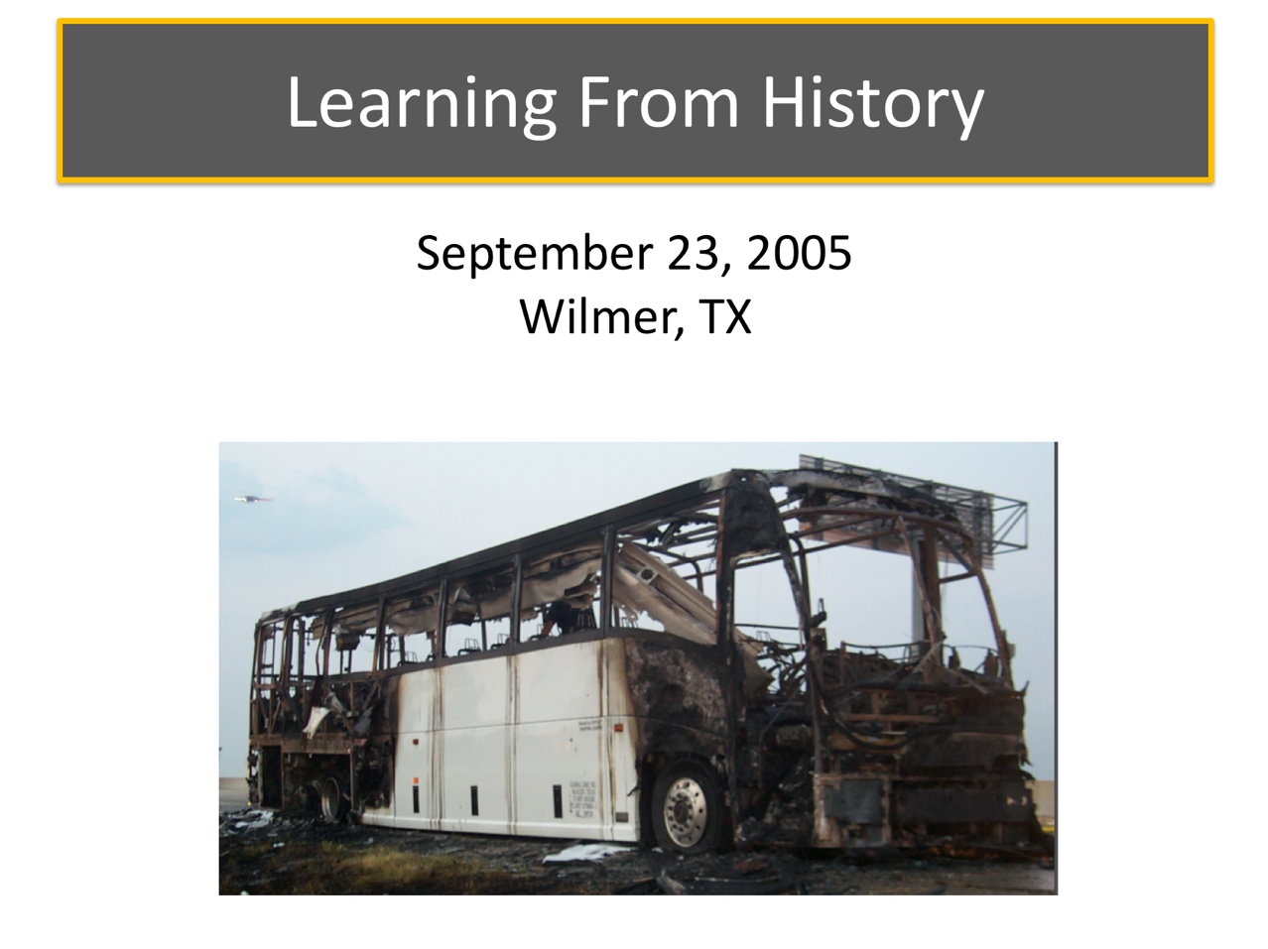

# LEARNING FROM HISTORY NARRATIVE

Drivers sometimes downplay the vehicle inspection process and skirt thorough their vehicle checks – many times because they rarely have vehicle issues, thanks to robust maintenance programs.  However, if there ever was an example of why drivers shouldn’t ever let their guard down, this is it.

An incident that occurred on September 23, 2005 in Wilmer, TX really was a “perfect storm,” and an unforgettable reminder of the importance of understanding and executing practices designed to avoid any incidents, let alone a catastrophe.

*Display PowerPoint slide.*

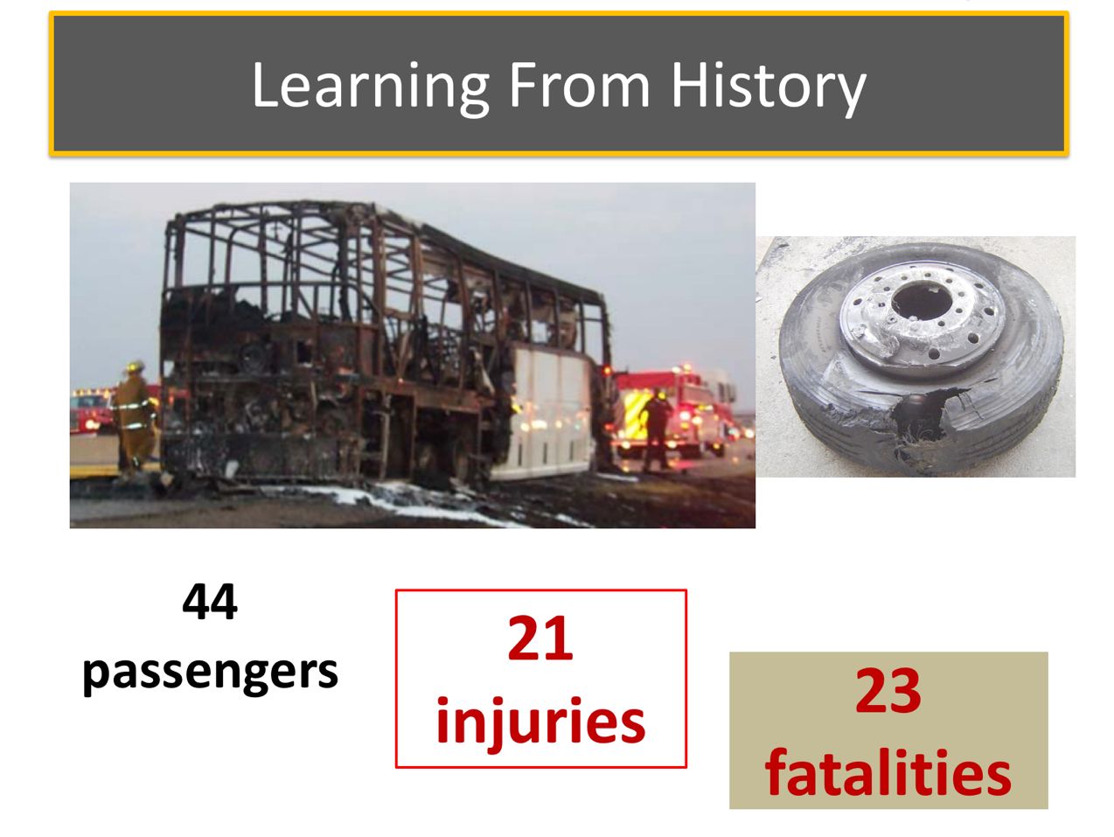

# LEARNING FROM HISTORY NARRATIVE (continued)

In September 2005, Hurricane Rita was approaching Texas and the Governor urged evacuation of coastal areas.  On September 23, 2005, a motorcoach was loaded with 44 evacuees from a nursing home in Galveston, TX.  The evacuees included 22 wheelchair-users, and five persons who used walkers as mobility aids. 18 oxygen cylinders were also loaded onto the coach for use by the evacuees.

The coach left the nursing home at 3 p.m., stopping once at 4 p.m. to retrieve oxygen cylinders from the luggage bay, and again at 7 p.m. to refuel. After returning to the road, the coach stopped shortly thereafter at 7:15 p.m. to retrieve additional oxygen cylinders from the luggage bays. At 3:15 a.m., the right tag axle locked up, and the tire subsequently blew.  The driver stopped, observed the blowout, and drove about 400’ to a location to pull off the roadway.  A tire service was called, arriving at 4:30 a.m. to replace the tire.  The tire was changed very quickly, and the coach returned to the highway.  Within a half-hour, a fellow motorist saw the right rear tire hub glowing red hot, with sparks emanating from the area; this motorist forcibly stopped the coach in the left lane to tell the driver

# LEARNING FROM HISTORY NARRATIVE (continued)

of the problem.  The driver maneuvered the coach across traffic approximately 1/3 of a mile to the right shoulder; when he and nursing staff exited, they observed the right rear tag axle tire on fire.

As they initiated an evacuation of the motorcoach, with assistance from passersby, heavy smoke and fire quickly engulfed the entire vehicle. As the fire propagated, oxygen cylinders were heard exploding in the coach.  Twenty-three passengers were fatally injured. Of the 21 passengers who escaped, 2 were seriously injured and 19 received minor injuries; the motorcoach driver also received minor injuries.

*Display PowerPoint slide.*

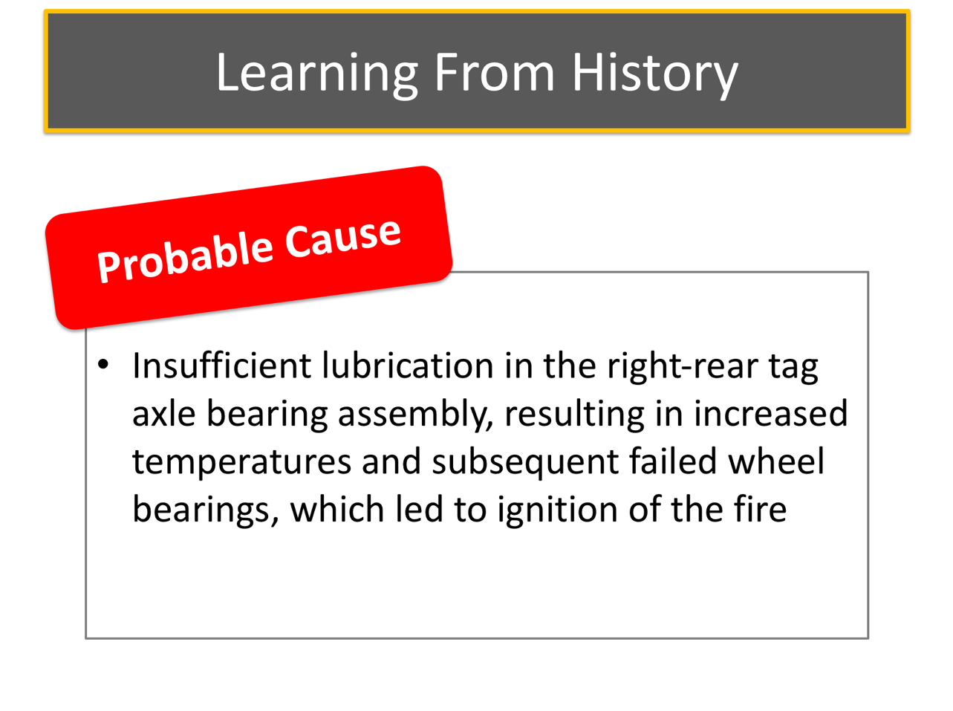

# LEARNING FROM HISTORY NARRATIVE (continued)

The National Transportation Safety Board investigation revealed that the driver had deadheaded for six hours to the nursing home to pick up the evacuees and had been on-duty approximately 24 hours when the fire occurred.  The driver reported a couple of hours rest before they loaded the passengers onto the motorcoach; a process that took 1.5 hours and assistance from the local fire department due to passenger mobility difficulties. Traffic was heavy throughout the trip.  Roadway tire marks indicated that the first tire that was changed (pictured on previous slide) had locked up and been dragged 1500 feet before blowing out (note flat spot on tire and rim). There was also a grass fire in the median approximately three miles prior to the motorcoach fire that began from an ejected bearing from the right tag axle hub assembly.

The NTSB determined that the probable cause of the accident was insufficient lubrication in the right-side tag axle wheel bearing assembly of the motorcoach, resulting in increased temperatures and subsequent failed wheel bearings, which led to ignition of the tire and the catastrophic fire.

|  |  |
| --- | --- |
| Question | Clipart |

**Ask:** What could have prevented this catastrophe?  What other factors complicated this scenario?

*Discuss any answers offered by the students.*

*While the driver was over the hours of service limits, a state of emergency had been declared by the governor.  This declaration removed hours of service limitations for those responding to the emergency, including this company and driver.  While certainly significant, fatigue did not appear to play a major role.*

*The large amount of non-ambulatory and semi-ambulatory passengers contributed significantly to this disaster.  Fellow motorists and nursing home staff attempted to rescue passengers, but smoke propagation within the first few minutes of the fire quickly rendered these efforts fruitless.  The amount of oxygen on the coach was also in violation of regulations, yet also exempted by the state of emergency declaration.*

*The driver never attempted to use the on-board fire extinguisher, though it likely would not have been very effective in addressing this fire. Tire fires are difficult to extinguish.*

*Ultimately, the driver had four en-route opportunities to inspect the coach – two times when they stopped to retrieve additional oxygen cylinders, once when he fueled, and one last time when they replaced the first tire.  A check of the wheels, especially when the first tire blew, would have indicated unusually high temperature at the tag axle with the failing bearing.  Additionally, an observant driver would have noticed the tire drag marks leading to the coach’s stopping point at the time of the tire change and also the flat spot on the tire and rim of the first blowout - these should have been indications of a serious problem.*

Instructor’s Note – Correct answers are highlighted

**PASSENGER BOARDING AND ALIGHTING**

**QUIZ**

1. Greeting passengers is great customer service and can provide insight into safety and/or security concerns.
2. **True**
3. False
4. Which of the following is not a good mannerism or characteristic for greeting passengers?
5. Cheerful
6. Professional
7. **Jokester**
8. Friendly
9. Dependable
10. When you are assisting a passenger up or down the stairwell, always remain on the _______________.
11. Uphill side
12. **Downhill side**
13. Right side
14. Left side
15. Front side
16. The best way to provide support for a passenger is by the forearm, hand or wrist.
17. True
18. **False**
19. Despite any appearance of limitations or need, you must always first ask a passenger if they would like assistance prior to providing help.
20. **True**
21. False
22. When screening passengers, which of the following would you consider an unusual behavior?
23. Acting disorderly
24. Inebriated/under the influence
25. Over-protective of luggage
26. Pacing, nervous or jumpy
27. **All of the above**
28. Generally, the step closest to the ground on a motorcoach is smaller in height than the rest of the steps.
29. True
30. **False**
31. If a boarding or exiting passenger asks for your assistance, you should provide it.
32. **True**
33. False
34. Lifting, loading and retrieving luggage can result in physical injury if proper mechanics are not followed.
35. **True**
36. False
37. Which of the following is a safe lifting technique?
38. Twist only when the load is close to your body
39. Tighten your core muscles
40. Keep luggage close to your body
41. Lift with your back and legs
42. **Both B and C**
43. The heaviest parcels should be loaded near the drive axle.
44. **True**
45. False
46. Full motorcoaches with significant luggage can approach or exceed load/weight limits.
47. **True**
48. False
49. Tires that are _______________ have diminished load carrying capacity.
50. New
51. Old
52. Overinflated
53. **Underinflated**
54. Cold
55. The total amount of oxygen transported in the cargo bays on the motorcoach should be limited to:
56. < 69 lbs.
57. < 79 lbs.
58. < 89 lbs.
59. **< 99 lbs.**
60. < 109 lbs.
61. _______________ are portable devices that concentrate the oxygen from the atmosphere to deliver higher concentrations of oxygen to the user.
62. Oxygen tanks
63. **Oxygen concentrators**
64. Oxygen valve systems
65. Oxygen masks
66. Oxygen dispensers
67. When a company uses an automated/recorded passenger safety briefing, the driver still must know the content necessary and be able to manually provide the briefing.
68. **True**
69. False
70. Prior to departure, the driver should walk through the aisles to:
71. Ensure carry-on articles are stowed out of the aisles and overhead items safety stowed
72. Make sure everyone has their seat belt on
73. Observe passengers for unusual behavior
74. **Both A & C**
75. Not necessary to walk down the aisle
76. The passenger safety briefing should include all of the following except
77. **Tire size and pressure**
78. Avoiding slips and falls
79. Fire extinguisher location
80. Lavatory emergency button
81. Emergency exits
82. An en-route stop announcement will generally include the following information:
83. Length of stop
84. Nearest shopping center location
85. Anticipated departure time
86. Visitor center information
87. **Both A and C**
88. Which of the following is not a preferred en-route stop characteristic?
89. Hazard free ground
90. Close to facility
91. Well-lit at night
92. **On an incline**
93. Curbside