# Vehicle Inspections

|  |  |  |
| --- | --- | --- |
| Engine Compartment.png | DVIR 2.png | Oil Leak.png |

**Purpose:**

The objective of this training module is to teach you the proper method for conducting and documenting various vehicle inspections. You will learn current regulatory requirements in these areas and step-by-step inspection guidelines.

**Module Overview:**

This module consists of two classroom lessons and one on-board exercise. The first lesson will review the pre-trip inspection process, provide guidance for conducting en-route inspections, and give you hands-on experience in conducting a vehicle inspection. The second lesson will review post-trip inspection procedures and documentation.

Lesson 1: Pre-Trip Inspections and En-Route Inspections

Lesson 2: Post-Trip Inspections and Document Preparation

LESSON 1

PRE-TRIP AND EN-ROUTE

INSPECTIONS

**Lesson Objectives:**

By the end of this lesson, you will know how to conduct proper pre-trip and en-route inspections, including reviewing the previous vehicle inspection report. You will also understand what vehicle components you should be inspecting during interim stops during each day.

**Instructional Methods**: Classroom and On-Board Exercise

(On-board exercise in conjunction with Lesson 2)

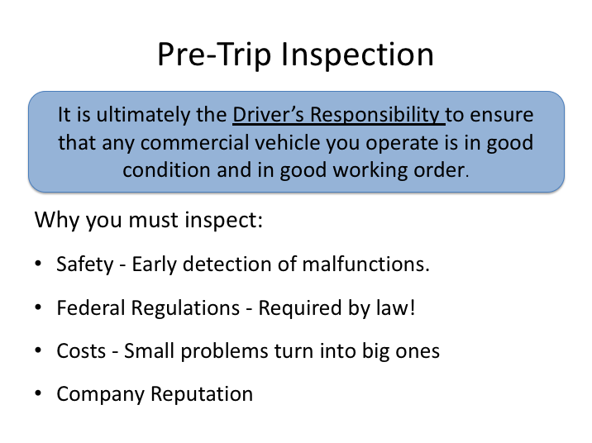

# PRE-TRIP INSPECTION

As a professional driver it is your duty and responsibility to make sure that any vehicle you take out is in safe operating condition and good working order. Federal Motor Carrier Safety Regulations (FMCSRs) requires drivers to conduct vehicle inspections and document deficiencies discovered so the company can address them before the vehicle is next dispatched.

The identification and early detection of vehicle safety issues or deficiencies provide several benefits:

1. Prevents breakdowns, collisions and other unplanned incidents.
2. Ensures compliance with the FMCSRs.
3. Saves on repair and response costs - correcting maintenance problems before they become serious can save a company considerable money.

4. Enhances customer satisfaction & company reputation.

**PRE-TRIP INSPECTION (continued)**

Thorough, consistent inspection procedures will allow a driver to systematically identify safety issues and also spot signs of any potential maintenance problem before it becomes serious and causes a breakdown, incident or collision.

While it’s important for drivers to inspect their vehicle at various times, perhaps the most important inspection is the pre-trip inspection. Regulations and common sense stipulate that a driver should be satisfied that his/her vehicle is in safe operating condition before taking it on the road - this means performing a pre-trip inspection.

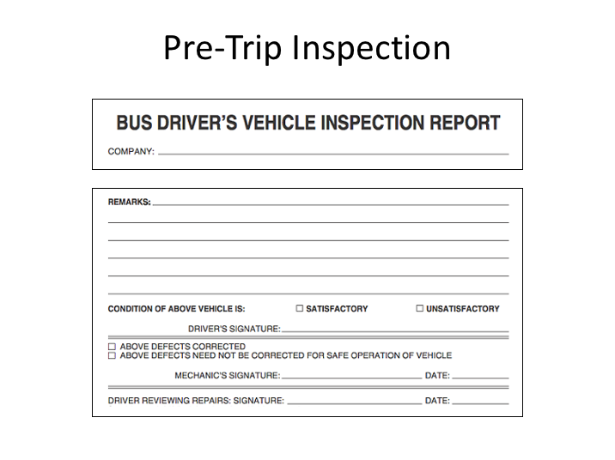

**PRE-TRIP INSPECTION (continued)**

A major component of the pre-trip inspection process involves the last inspection report documented for any vehicle. At the end of the day, for each vehicle operated, a driver must complete an inspection report indicating vehicle deficiencies. At a minimum, the FMCSRs require the driver to report any defects or deficiencies that would affect the safe operation of the vehicle or might result in its mechanical breakdown - this involves performing a post-trip vehicle inspection as well. You will learn about completing these forms later.

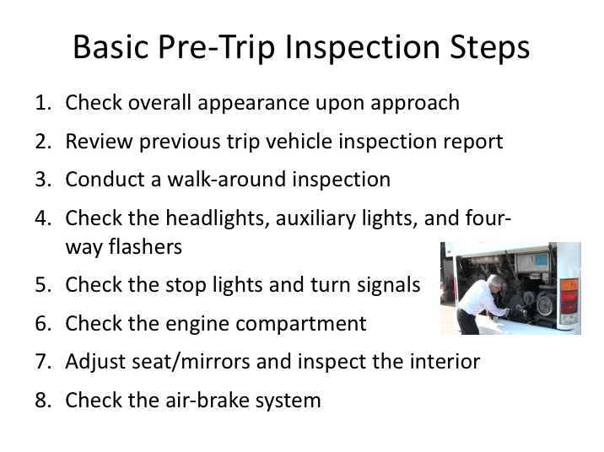

# BASIC PRE-TRIP INSPECTION STEPS

A basic pre-trip inspection can be divided into eight steps:

1. Check the overall appearance of the coach when approaching

2. Review the previous trip vehicle inspection report

3. Conduct a walk-around inspection

4. Check the headlights, auxiliary lights, and four-way flashers

5. Check the stop lights and turn signals

6. Check the engine compartment

7. Adjust the seat/mirrors and inspect the interior compartment

8. Air-brake system check

**BASIC PRE-TRIP INSPECTION STEPS (continued)**

## 1. CHECK THE OVERALL APPEARANCE

As you approach the coach, note its general condition.

* Do you notice any damage?
* Is it leaning to one side?
* Is there anything hanging from underneath?

Look underneath the coach for any fresh fluids. If fresh fluid is observed under the engine area, a leak can be further investigated/confirmed by inspecting the engine compartment. If you see any confirmed leaks or suspicious fresh fluid puddles, try to determine the fluid type and have the leak evaluated by a mechanic or supervisor.

## 2. REVIEW THE PREVIOUS TRIP VEHICLE INSPECTION REPORT (VIR)

Check the previous VIR and make a mental note of any reported defects or issues – you will be checking the status of these during the rest of your inspection. Any safety-related defects must be corrected before the vehicle is used again and any repairs performed should be accompanied by the mechanic’s signature.

After verifying that any safety deficiencies have been repaired, you must sign the appropriate area at the bottom of the VIR (Driver’s Signature).

## 3. CONDUCT A WALK-AROUND INSPECTION

* Enter the coach and unlock all luggage bays. Exit the coach, checking to see that the stairwell is clear of debris. Once outside, check to see that the door(s) opens and closes properly.
* Check to make sure the mirror support brackets are firmly fixed.

**BASIC PRE-TRIP INSPECTION STEPS (continued)**

* As you walk around the coach, check the condition of each tire and wheel. Check each tire to ensure it is not flat. Also check for:
* Loose or missing lug nuts, rust marks, and cracked wheels
* Oil on tires or wheels
* Cuts, bulges, cracks, not enough tread, or uneven tread wear on the tires
* Loose or separated treads
* As you walk around the coach, make sure that all auxiliary lights and reflectors are clean and not broken.
* Check the windshield for cleanliness and damage. The following are allowable conditions:
* Any crack not over 1-inch wide, as long as it’s not intersected by any other crack.
* Any damaged area that can be covered by a quarter, as long as it’s more than three inches from any other damaged area.
* Check the spring tension on the wiper arms and check the wiper blades for damage and signs of age (stiff rubber).
* Check each luggage and service access bay for unusual objects or packages, utilizing door pins or other locking mechanisms when present to ensure the bay doors remain open. Check door operation in the process.
* Check the exterior safety equipment:
* Spare tire
* Tire chains or similar traction aides (if needed)
* Reflective triangles (three) and spare fuses (if not kept inside passenger compartment)

As you walk around the coach, check for damages or missing parts.

If you find a problem during any of the above checks, have the condition checked/fixed if it would affect the safe operation of the coach. You should not use a coach that is not in safe operating condition.

**BASIC PRE-TRIP INSPECTION STEPS (continued)**

## 4. CHECK HEADLIGHTS, AUXILIARY LIGHTS & FOUR-WAY FLASHERS

With the engine off and the parking brake on, turn on your four-way flashers, headlights, and all auxiliary lights (parking, clearance and identification lights). Exit the coach, checking the operation of the stairwell and landing lights. Walk around the coach and check to see operation of all the headlights, tail lamps, four-ways and auxiliary lights. Go back inside and, watching the light patterns in front of the coach, toggle your high beams to ensure they are operational.

## 5. CHECK THE STOP LIGHTS AND TURN SIGNALS

* Enter the coach and turn off all lights.
* Activate the left turn signal and go back outside, checking both the front and rear turn signal for proper operation. Repeat for the right turn signal. If available, you may have a helper assist with the turn signal check as well as a brake light check. If you do not have a helper for a brake light check, attempt to verify proper brake light function by watching light reflections off a close object.

See to it that any defective lights are replaced before starting your trip.

## 6. CHECK THE ENGINE COMPARTMENT

* Check the overall condition of the belts and hoses. Are any of the belts loose or frayed? Are any of the hoses cracked, loose, or rotting?
* Look for signs of leaking fluids in engine compartment and underneath the coach.
* Check the engine bay for unnecessary or unusual buildup of grease, oil, dirt or other materials that could fuel a potential fire. If the engine is equipped with a fire suppression system, check disbursement nozzles for cleanliness and potential obstruction.
* Locate the alternator. Ensure that all battery cables leading to/from the alternator are secured and not chaffed or free to rub against another component.

**BASIC PRE-TRIP INSPECTION STEPS (continued)**

* With the engine off, check the oil level by taking the dipstick out, wiping it with a paper towel, re-inserting it all the way, and examining the dipstick. If the level is low, oil should be added and a close inspection for leaks should be performed before the trip.
* With the engine turned off, check the coolant level using the sight glass or alternate method. If it is low on a pre-trip inspection, have it serviced and inspect closely for any evidence of leaks.
* Turn the engine on. Check the transmission fluid level after letting the engine idle for at least two minutes.

CAUTION: Never remove the radiator cap when the engine is hot or has recently been running. Severe steam burns could result.

## 7. ADJUST SEAT/MIRRORS AND INSPECT THE INTERIOR

* Adjust the seat for yourself and check the seat belt for proper operation.
* After you have adjusted your seat, adjust your mirrors for optimal vision.
* Make sure that the parking brake is on and the gearshift is in "neutral."
* Turn on the master control switch and ensure the engine is running.
* Check the oil pressure. If you have a gauge, you should have pressure immediately; if you have a warning light only, the warning light should go off. If not, shut the engine off; otherwise, leave the engine running. If you have an oil gauge, the oil pressure may not reach its normal level until the engine warms up. Listen for any unusual noises.
* Check the coolant temperature gauge: temperature should begin to climb to the normal operating range. If you only have a coolant temperature warning light, the light should go off.
* Check the voltmeter/battery gauge to see that alternator is charging. If you only have a battery/alternator warning light, the light should go off.
* Check that the air pressure gauge indicates that air pressure is building.

**BASIC PRE-TRIP INSPECTION STEPS (continued)**

* Operate the windshield wipers and washer. Inspect the windshield for damage.
* Check that the coach's heating, air conditioning, defroster and ventilation system is working properly.
* Check the public-address system and adjust as necessary.
* Test your horn.
* Check the play in your steering wheel. As you turn the wheel left and right, you should feel tension after turning the wheel 1 to 2 inches. Listen for unusual noises.
* Check the instrument and other panels for any warning lights, such as anti-lock braking system (ABS), tire pressure monitor, etc.
* Release and re-apply the parking brake.
* Check emergency equipment:
* Check the fire extinguisher for proper mounting and charge.
* Locate emergency triangles and spare fuses (if these are kept in a storage area outside/under the coach, they should be checked during the exterior walk-around).
* Check the passenger seats and seat belts (if equipped) for damage.
* Check that emergency exit windows and roof hatches are marked and releases are functional. Re-secure any unlatched emergency exit windows and hatches.
* Check each overhead rack (if so equipped) and areas under seats for any suspicious objects or packages.
* Check the restroom for damage, cleanliness and supplies, such as toilet tissue and paper towels. Check the restroom door lock and "occupied" sign.

If you find a problem during any of the above checks, have the condition checked/fixed if it would affect the safe operation of the coach. You should not use a coach that is not in safe operating condition.

**BASIC PRE-TRIP INSPECTION STEPS (continued)**

## 8. CHECK THE AIR BRAKE SYSTEM

Brakes are a critical safety component. If any of the following tests are not passed, be sure the condition is corrected before starting your trip.

*When conducting brake system checks, be sure the coach is on a flat surface, as there will be times when no brakes are engaged. If the coach is not or cannot be located on a flat surface, wheel chocks should be used from the beginning of the system check until just prior to the “parking brake test”.*

**Static Leakage Test**

* Place the transmission in neutral, apply the parking brake (if not already applied) and stop the engine. Take note of the air pressure reading and wait for one minute - the air pressure must not drop more than 2 psi during this minute. Now release the parking brake and wait another minute. The air pressure gauge must not drop more than 2 psi in this second minute. Reapply the parking brake.

**Applied Leakage Test**

* With the engine still off and the parking brake released, apply the service brake firmly and hold. The initial drop in air pressure must not be more than 10 psi. After the system settles (needle stops moving) continue to hold the pedal down for one full minute. The pressure should not drop by more than 3 psi in this minute. Re-apply the parking brake.

**Low Air Warning System Test**

The purpose of this test is to be sure that the low-air pressure warning system is functioning properly.

* With the engine still off, release the parking brake, apply and release the service brake repeatedly to reduce the air pressure. When the air pressure gauge reaches 80 psi, turn on the master control switch, but do not turn on the engine. Continue reducing the air pressure until the low air pressure warning light and buzzer come on. This should occur between 75 psi and 55 psi.

**BASIC PRE-TRIP INSPECTION STEPS (continued)**

**Emergency Brake Test**

* Next, continue reducing the air pressure. When the system air pressure reaches about 20 psi, the parking brake knob should "pop out" to indicate that the emergency brake system has activated the spring/parking brake.

**Air Pressure Build-Up Test**

* Start the engine - the air pressure should begin building. Let the air pressure build up until the low air pressure warning buzzer stops. Continue to let the air pressure build. It should not require more than about one minute for the air pressure to go from discharged (5-20 psi) up to between 120 and 130 psi.

**Governor Cut-Out Test**

* When the pressure has climbed to between 120 and 130 psi, the governor should cause the air compressor to cut out. When it cuts out, the compressor sound will stop and the gauge needle will stop moving.

**Governor Cut-In Test**

* Reduce the air pressure by making applications of the service brake. Before the pressure drops below 85 psi, the compressor should cut-in and begin to build air into the system.

**Parking Brake Test**

* With the parking brake still engaged, place the bus into gear and try to move the coach – applied parking brakes should keep the coach from moving.

**Service Brake Test**

* Release the parking brake and drive forward slowly – the coach should move freely with no brake drag.
* Apply the service brake while holding the steering wheel lightly to determine whether the brakes apply without pulling to either side. Drive forward slowly a third time and apply the service brake gradually to check for smoothness (make sure there is no unusual jerkiness when stopping).

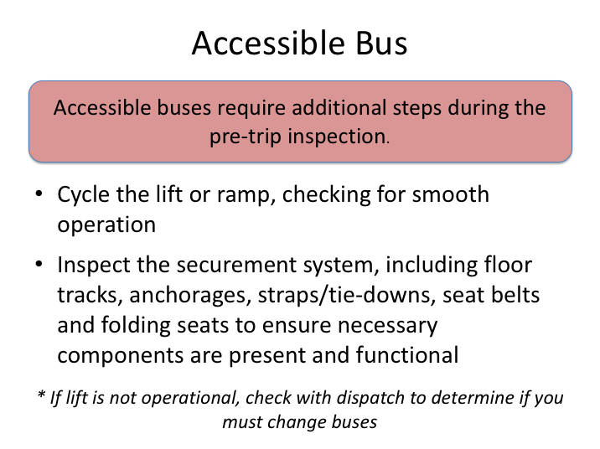

# ACCESSIBLE BUS

If the bus you are inspecting is an accessible bus, there are additional steps that must be taken to ensure it is operational and all necessary accessories are present before embarking on your charter or trip.

This step is important - you may have been assigned an accessible bus because its equipment is necessary for one or more passengers. If the lift is inoperable, or any necessary accessories are not present or functional, you should notify your dispatch immediately so that a decision can be made as whether to assign you another coach or tend to the issues prior to disembarking.

If the lift is not necessary for the assigned trip, and dispatch notifies you to take the bus anyway, you must report the deficiencies found on the vehicle inspection report.

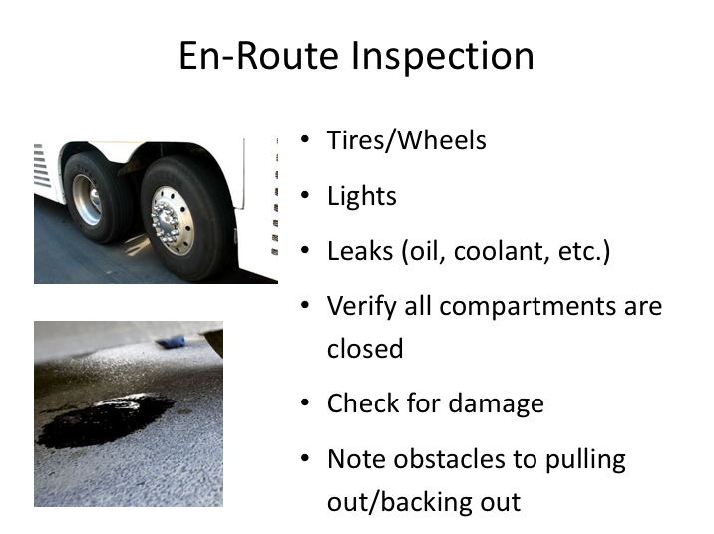

# EN-ROUTE INSPECTION

At the completion of each day’s trip, you must complete a post-trip inspection of the coach, similar to the pre-trip inspection. However, what about any interim stops on the way to the final stop of each day?

Each time you stop en-route to that day’s destination provides another opportunity to check your coach for any obvious issues which could literally lead to trouble down the road. Here is what to look for:

1. Check the tires and wheels. Make sure that there aren’t any flat tires or tires that are low on, or leaking, air. Look for any signs of hub oil on the wheels and check each tire/wheel for excessive heat. Any of these conditions could lead to a tire failure or fire and further investigation is warranted.
2. Check that all lights are working, especially at or near dusk or night. Remember, you rely on lights not only to see, but also to be seen.

**EN-ROUTE INSPECTION (continued)**

1. Check for fluid leaks and any unusual odors, especially at the rear of the coach near the engine area. Fluid leaks in the engine compartment can also lead to fires depending on the source and location of the leak.
2. Be sure that all compartments are closed, especially the baggage bins.
3. Check for any new damage to the outside of the coach.

If you find anything seriously wrong, have it checked at that stop, or call your company and ask for further instructions.

Finally, remember to check for any obstacles around your coach that could give you trouble when leaving your stop, especially if you have to do any backing.

LESSON 2

POST-TRIP INSPECTIONS

AND DOCUMENT PREPARATION

**Lesson Objectives:**

By the end of this lesson, you will know how to conduct a proper post-trip inspection, including completing a vehicle inspection report.

**Instructional Methods**: Classroom and On-Board Exercise

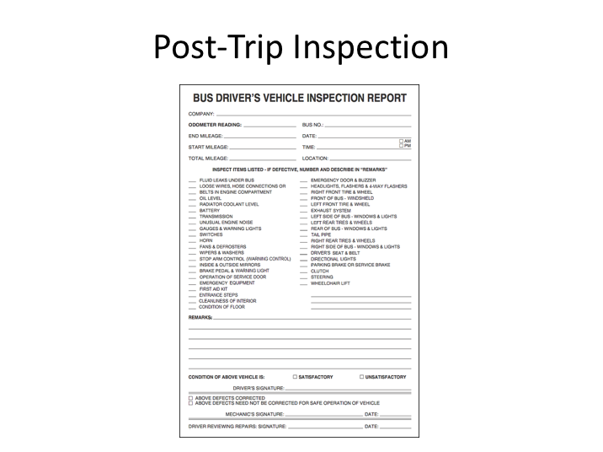

# POST-TRIP INSPECTION AND DRIVER VEHICLE INSPECTION REPORT

The procedures for doing a pre-trip and post-trip inspection are very similar.

After performing a post-trip inspection, at the completion of a driver’s day, you will fill out a form called the Daily Vehicle Inspection Report, sometimes abbreviated and called a ‘DVIR’ or ‘VIR’ (these are the forms reviewed during the pre-trip inspection process). The report must be filled out and signed whether or not any defects or deficiencies are discovered. The daily vehicle inspection report must contain all defects discovered or reported to the driver during the course of the day. Defects discovered during all inspections, pre-trip, en-route and post-trip inspections, as well as any defect reported to the driver by an inspector, is documented on the DVIR.

Vehicle inspection reports differ by company, but there are certain items they are required to have/document. In general, the report must identify the vehicle and list any defect or deficiency discovered by or reported to the driver that would affect the safe operation of the vehicle or result in its mechanical breakdown. Specifically, the condition of the following components must be noted (at a minimum):

* Service Brake
* Parking Brake
* Steering Mechanism
* Lighting Devices & Reflectors
* Tires
* Wheels & Rims
* Mirrors
* Horn
* Windshield Wipers
* Emergency Equipment

In addition to vehicle component condition, drivers should report any unusual occurrences or issues observed while driving, even if they do not know the cause or component affected. For example, experiencing a loss or reduction of power or the vehicle pulling to one side under certain circumstances.

If there are no defects, deficiencies or concerns to report, the report has a location to indicate this. The driver must sign the report.

On two/co-driver trips, only one driver needs to sign the vehicle inspection report, provided both drivers agree as to the defects or deficiencies identified. If a driver drives more than one vehicle, a report must be prepared for each vehicle operated.

**EXERCISE**

Follow your instructor’s direction and complete a VIR.

Pay attention once at the coach during the vehicle inspection – you will be asked to conduct one yourself.

**VEHICLE INSPECTIONS**

**QUIZ**

1. Safety regulations require a vehicle inspection every time a vehicle is used. The inspections are the responsibility of the driver.

1. True
2. False
3. A driver is not required to review the previous trip vehicle inspection report unless notified that there was a defect reported.
4. True
5. False
6. What is the maximum width of a crack in the windshield where the vehicle can still be operated (assuming no intersecting crack)?
7. ½ inch
8. ¾ inch
9. 1 inch
10. 1 ½ inches
11. 2 inches
12. How many reflective triangles (emergency equipment) should you have available?
13. 2
14. 3
15. 4
16. 5
17. 6
18. If you are on a multi-day trip, you only need to complete a vehicle inspection report for the last day (when you return).
19. True
20. False
21. If the mobility lift on an accessible bus is not working properly, and dispatch notifies you to take the bus anyway since the lift is not necessary for the assigned trip, you should report the deficiencies found on the vehicle inspection report.
22. True
23. False
24. When should you complete your vehicle inspection report?
25. When deficiencies are found
26. After the post-trip inspection
27. At the beginning of the trip
28. After the pre-trip inspection
29. During an en route walk-around inspection, you should:
30. Check the tires for unusual heat and proper inflation
31. Check for obstacles to pulling/backing out
32. Check lights and ensure compartments are closed
33. Check for leaks and damage
34. All of the above
35. If you find no defects or deficiencies you do not need to complete or sign a post-inspection report form.
36. True
37. False
38. If you have two/co-driver trips, both drivers need to sign the vehicle inspection report.
39. True
40. False