# Vehicle Inspections

|  |  |  |
| --- | --- | --- |
| Engine Compartment.png | DVIR 2.png | Oil Leak.png |

## Purpose:

The objective of this training module is to teach students the proper method for conducting and documenting various vehicle inspections. Students will learn current regulatory requirements in these areas and step-by-step inspection guidelines.

## Module Overview:

This module consists of two classroom lessons and one on-board exercise. The first lesson will review the pre-trip inspection process and provide guidance for conducting en-route inspections. The second lesson will review post-trip inspection procedures and documentation, and give students hands-on experience in conducting and documenting vehicle inspections.

Lesson 1: Pre-Trip Inspections and En-Route Inspections

Lesson 2: Post-Trip Inspections and Document Preparation

LESSON 1

PRE-TRIP AND EN-ROUTE

INSPECTIONS

## Lesson Objectives:

By the end of this lesson, students will know how to conduct proper pre-trip and en-route inspections, including reviewing the previous vehicle inspection report. Students will also understand what vehicle components they should be inspecting during interim stops during each day.

**Instructional Methods**: Classroom and On-Board Exercise

(On-board exercise in conjunction with Lesson 2)

## Approach:

Using the PowerPoint graphics provided, discuss the process of a pre-trip inspection (including vehicle inspection report review) and en-route inspection. Following classroom discussion and the next lesson, take students out to the vehicle and walk them through the inspection process reviewed in the classroom. As you review stages of the inspection, solicit student involvement in identifying areas to inspect, especially from those who may have previous experience conducting pre-trip and en-route inspections.

**LESSON INTRODUCTORY NARRATIVE**

*Student Guide reference here*

Conducting pre-trip inspections is critical in managing the safe operation of commercial vehicles. The purpose of the pre-trip is two-fold:

1. Be sure that any critical vehicle safety defects indicated by the previous driver have been addressed through evaluation and/or service; and
2. Be comfortable that the motorcoach you are about to operate is safe and in good working condition.

Drivers occasionally believe that a thorough pre-trip inspection is not necessary – especially if they work for a company who has a very good maintenance program and where there are generally few vehicle issues.

However, taking a motorcoach to pick up scores of passengers without doing a thorough pre-trip is simply asking for trouble and embarrassment when an issue occurs that would have been detected during a proper pre-trip.  Not to mention that failing to conduct a pre- trip inspection (or post-trip, for that matter) is against federal safety regulations.

Pre-trip inspections are required to protect you, your passengers, and the public.  Embrace them and always make time for one - not doing one is squandering your first opportunity of operating a successful and safe trip.

En-route inspections are not specifically required except under specific conditions, but experienced drivers know that a lot can happen between the time you start the coach and the end of the day’s trip.  Checking for simple things like unusually hot wheels can help diagnose issues and prevent catastrophic events that could cause injury, death and significant stress for you and your company.

*Display PowerPoint slide.*

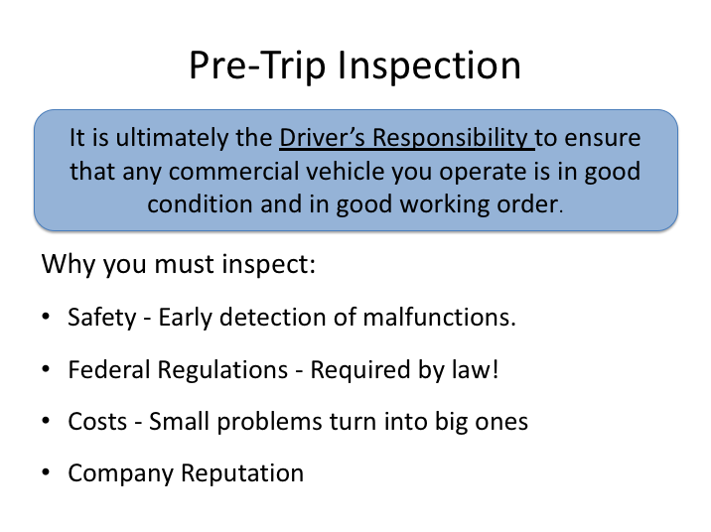

# PRE-TRIP INSPECTION NARRATIVE

As a professional driver it is your duty and responsibility to make sure that any vehicle you take out is in safe operating condition and good working order. Federal Motor Carrier Safety Regulations (FMCSRs) requires drivers to conduct vehicle inspections and document deficiencies discovered so the company can address them before the vehicle is next dispatched.

The identification and early detection of vehicle safety issues or deficiencies provide several benefits:

1. Prevents breakdowns, collisions and other unplanned incidents.
2. Ensures compliance with the FMCSRs.
3. Saves on repair and response costs - correcting maintenance problems before they become serious can save a company considerable money.

**PRE-TRIP INSPECTION NARRATIVE (continued)**

4. Enhances customer satisfaction & company reputation.

Thorough, consistent inspection procedures will allow a driver to systematically identify safety issues and also spot signs of any potential maintenance problem before it becomes serious and causes a breakdown, incident or collision.

While it’s important for drivers to inspect their vehicle at various times, perhaps the most important inspection is the pre-trip inspection. Regulations and common sense stipulate that a driver should be satisfied that their vehicle is in safe operating condition before taking it on the road - this means performing a pre-trip inspection.

*Display PowerPoint slide.*

**Instructor Note –**

Ideally, this should be an image of your Company VIR, rather than the generic provided.

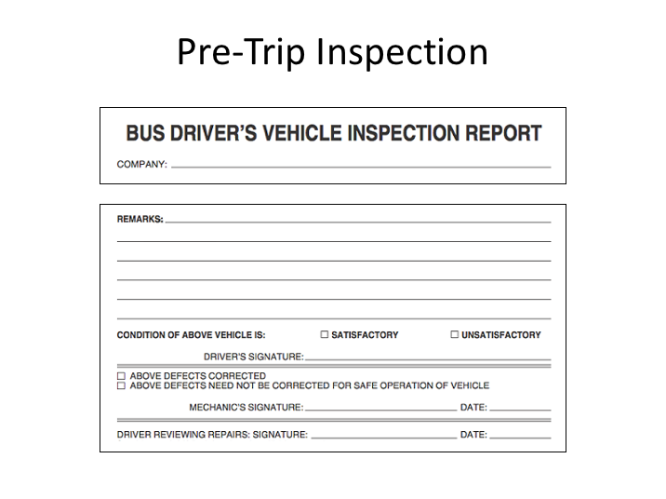

**PRE-TRIP INSPECTION NARRATIVE (continued)**

A major component of the pre-trip inspection process involves the last inspection report documented for any vehicle. At the end of the day, for each vehicle operated, a driver must complete an inspection report indicating vehicle deficiencies. At a minimum, the FMCSRs require the driver to report any defects or deficiencies that would affect the safe operation of the vehicle or might result in its mechanical breakdown - this involves performing a post-trip vehicle inspection as well. You will learn about completing these forms later.

*Display PowerPoint slide.*

**Instructor Note –**

It is okay to have a different pre-trip inspection order/process than shown below, as long as at least all elements indicated below are incorporated into your process. If you have a pre-trip inspection process that differs from this one, you should substitute custom PowerPoint slides and narrative to more accurately reflect your process.

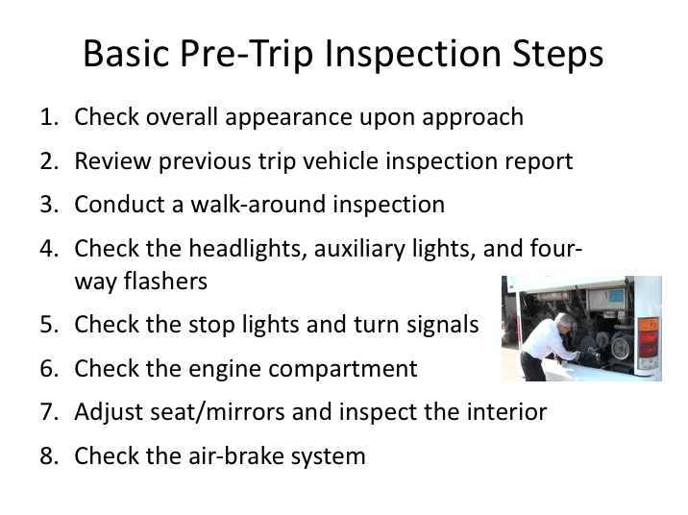

# BASIC PRE-TRIP INSPECTION STEPS NARRATIVE

A basic pre-trip inspection can be divided into eight steps:

1. Check the overall appearance of the coach when approaching

2. Review the previous trip vehicle inspection report

3. Conduct a walk-around inspection

**BASIC PRE-TRIP INSPECTION STEPS NARRATIVE (continued)**

4. Check the headlights, auxiliary lights, and four-way flashers

5. Check the stop lights and turn signals

6. Check the engine compartment

7. Adjust the seat/mirrors and inspect the interior compartment

8. Air-brake system check

## 1. CHECK THE OVERALL APPEARANCE

As you approach the coach, note its general condition.

* Do you notice any damage?
* Is it leaning to one side?
* Is there anything hanging from underneath?

Look underneath the coach for any fresh fluids. If fresh fluid is observed under the engine area, a leak can be further investigated/confirmed by inspecting the engine compartment. If you see any confirmed leaks or suspicious fresh fluid puddles, try to determine the fluid type and have the leak evaluated by a mechanic or supervisor.

## 2. REVIEW THE PREVIOUS TRIP VEHICLE INSPECTION REPORT (VIR)

Check the previous VIR and make a mental note of any reported defects or issues – you will be checking the status of these during the rest of your inspection. Any safety-related defects must be corrected before the vehicle is used again and any repairs performed should be accompanied by the mechanic’s signature.

After verifying that any safety deficiencies have been repaired, you must sign the appropriate area at the bottom of the VIR (Driver’s Signature).

## 3. CONDUCT A WALK-AROUND INSPECTION

* Enter the coach and unlock all luggage bays. Exit the coach, checking to see that the stairwell is clear of debris. Once outside, check to see that the door(s) opens and closes properly.
* Check to make sure the mirror support brackets are firmly fixed.

**BASIC PRE-TRIP INSPECTION STEPS NARRATIVE (continued)**

* As you walk around the coach, check the condition of each tire and wheel. Check each tire to ensure it is not flat. Also check for:
* Loose or missing lug nuts, rust marks, and cracked wheels
* Oil on tires or wheels
* Cuts, bulges, cracks, not enough tread, or uneven tread wear on the tires
* Loose or separated treads
* As you walk around the coach, make sure that all auxiliary lights and reflectors are clean and not broken.
* Check the windshield for cleanliness and damage. The following are allowable conditions:
* Any crack not over 1-inch wide, as long as it’s not intersected by any other crack.
* Any damaged area that can be covered by a quarter, as long as it’s more than three inches from any other damaged area.
* Check the spring tension on the wiper arms and check the wiper blades for damage and signs of age (stiff rubber).
* Check each luggage and service access bay for unusual objects or packages, utilizing door pins or other locking mechanisms when present to ensure the bay doors remain open. Check door operation in the process.
* Check the exterior safety equipment:
* Spare tire
* Tire chains or similar traction aides (if needed)
* Reflective triangles (three) and spare fuses (if not kept inside passenger compartment)

As you walk around the coach, check for damages or missing parts.

If you find a problem during any of the above checks, have the condition checked/fixed if it would affect the safe operation of the coach. You should not use a coach that is not in safe operating condition.

**BASIC PRE-TRIP INSPECTION STEPS NARRATIVE (continued)**

## 4. CHECK HEADLIGHTS, AUXILIARY LIGHTS & FOUR-WAY FLASHERS

With the engine off and the parking brake on, turn on your four-way flashers, headlights, and all auxiliary lights (parking, clearance and identification lights).

Exit the coach, checking the operation of the stairwell and landing lights. Walk around the coach and check to see operation of all the headlights, tail lamps, four-ways and auxiliary lights. Go back inside and, watching the light patterns in front of the coach, toggle your high beams to ensure they are operational.

## 5. CHECK THE STOP LIGHTS AND TURN SIGNALS

* Enter the coach and turn off all lights.
* Activate the left turn signal and go back outside, checking both the front and rear turn signal for proper operation. Repeat for the right turn signal. If available, you may have a helper assist with the turn signal check as well as a brake light check. If you do not have a helper for a brake light check, attempt to verify proper brake light function by watching light reflections off a close object.

See to it that any defective lights are replaced before starting your trip.

## 6. CHECK THE ENGINE COMPARTMENT

* Check the overall condition of the belts and hoses. Are any of the belts loose or frayed? Are any of the hoses cracked, loose, or rotting?
* Look for signs of leaking fluids in engine compartment and underneath the coach.
* Check the engine bay for unnecessary or unusual buildup of grease, oil, dirt or other materials that could fuel a potential fire. If the engine is equipped with a fire suppression system, check disbursement nozzles for cleanliness and potential obstruction.
* Locate the alternator. Ensure that all battery cables leading to/from the alternator are secured and not chaffed or free to rub against another component.

**BASIC PRE-TRIP INSPECTION STEPS NARRATIVE (continued)**

* With the engine off, check the oil level by taking the dipstick out, wiping it with a paper towel, re-inserting it all the way, and examining the dipstick. If the level is low, oil should be added and a close inspection for leaks should be performed before the trip.
* With the engine turned off, check the coolant level using the sight glass or alternate method. If it is low on a pre-trip inspection, have it serviced and inspect closely for any evidence of leaks.
* Turn the engine on. Check the transmission fluid level after letting the engine idle for at least two minutes.

CAUTION: Never remove the radiator cap when the engine is hot or has recently been running. Severe steam burns could result.

## 7. ADJUST SEAT/MIRRORS AND INSPECT THE INTERIOR

* Adjust the seat for yourself and check the seat belt for proper operation.
* After you have adjusted your seat, adjust your mirrors for optimal vision.
* Make sure that the parking brake is on and the gearshift is in "neutral."
* Turn on the master control switch and ensure the engine is running.
* Check the oil pressure. If you have a gauge, you should have pressure immediately; if you have a warning light only, the warning light should go off. If not, shut the engine off; otherwise, leave the engine running. If you have an oil gauge, the oil pressure may not reach its normal level until the engine warms up. Listen for any unusual noises.
* Check the coolant temperature gauge: temperature should begin to climb to the normal operating range. If you only have a coolant temperature warning light, the light should go off.
* Check the voltmeter/battery gauge to see that alternator is charging. If you only have a battery/alternator warning light, the light should go off.
* Check that the air pressure gauge indicates that air pressure is building.

**BASIC PRE-TRIP INSPECTION STEPS NARRATIVE (continued)**

* Operate the windshield wipers and washer. Inspect the windshield for damage.
* Check that the coach's heating, air conditioning, defroster and ventilation system is working properly.
* Check the public-address system and adjust as necessary.
* Test your horn.
* Check the play in your steering wheel. As you turn the wheel left and right, you should feel tension after turning the wheel 1 to 2 inches. Listen for unusual noises.
* Check the instrument and other panels for any warning lights, such as anti-lock braking system (ABS), tire pressure monitor, etc.
* Release and re-apply the parking brake.
* Check emergency equipment:
* Check the fire extinguisher for proper mounting and charge.
* Locate emergency triangles and spare fuses (if these are kept in a storage area outside/under the coach, they should be checked during the exterior walk-around).
* Check the passenger seats and seat belts (if equipped) for damage.
* Check that emergency exit windows and roof hatches are marked and releases are functional. Re-secure any unlatched emergency exit windows and hatches.
* Check each overhead rack (if so equipped) and areas under seats for any suspicious objects or packages.
* Check the restroom for damage, cleanliness and supplies, such as toilet tissue and paper towels. Check the restroom door lock and "occupied" sign.

If you find a problem during any of the above checks, have the condition checked/fixed if it would affect the safe operation of the coach. You should not use a coach that is not in safe operating condition.

**BASIC PRE-TRIP INSPECTION STEPS NARRATIVE (continued)**

## 8. CHECK THE AIR BRAKE SYSTEM

**Instructor Note –**

This section pigtails on the back end of the previous section (Seat/Mirrors Adjustment and Interior Inspection) and assumes that the engine is still running, and the coach has built up full air pressure in the airbrake system. If this is not true, then that should be accomplished first to begin in the order presented here.

If you do the following tests in a different order, or the actual pressure (psi) values for your coaches are different from those given, make the appropriate corrections to the lecture notes.

Brakes are a critical safety component. If any of the following tests are not passed, be sure the condition is corrected before starting your trip.

*When conducting brake system checks, be sure the coach is on a flat surface, as there will be times when no brakes are engaged. If the coach is not or cannot be located on a flat surface, wheel chocks should be used from the beginning of the system check until just prior to the “parking brake test”.*

**Static Leakage Test**

* Place the transmission in neutral, apply the parking brake (if not already applied) and stop the engine. Take note of the air pressure reading and wait for one minute - the air pressure must not drop more than 2 psi during this minute. Now release the parking brake and wait another minute. The air pressure gauge must not drop more than 2 psi in this second minute. Reapply the parking brake.

**Applied Leakage Test**

* With the engine still off and the parking brake released, apply the service brake firmly and hold. The initial drop in air pressure must not be more than 10 psi. After the system settles (needle stops moving) continue to hold the pedal down for one full minute. The pressure should not drop by more than 3 psi in this minute. Re-apply the parking bra**BASIC PRE-TRIP INSPECTION STEPS NARRATIVE (continued)**

**Low Air Warning System Test**

The purpose of this test is to be sure that the low-air pressure warning system is functioning properly.

* With the engine still off, release the parking brake, apply and release the service brake repeatedly to reduce the air pressure. When the air pressure gauge reaches 80 psi, turn on the master control switch, but do not turn on the engine. Continue reducing the air pressure until the low air pressure warning light and buzzer come on. This should occur between 75 psi and 55 psi.

**Emergency Brake Test**

* Next, continue reducing the air pressure. When the system air pressure reaches about 20 psi, the parking brake knob should "pop out" to indicate that the emergency brake system has activated the spring/parking brake.

**Air Pressure Build-Up Test**

* Start the engine - the air pressure should begin building. Let the air pressure build up until the low air pressure warning buzzer stops. Continue to let the air pressure build. It should not require more than about one minute for the air pressure to go from discharged (5-20 psi) up to between 120 and 130 psi.

**Governor Cut-Out Test**

* When the pressure has climbed to between 120 and 130 psi, the governor should cause the air compressor to cut out. When it cuts out, the compressor sound will stop, and the gauge needle will stop moving.

**Governor Cut-In Test**

* Reduce the air pressure by making applications of the service brake. Before the pressure drops below 85 psi, the compressor should cut-in and begin to build air into the system.

**Parking Brake Test**

* With the parking brake still engaged, place the bus into gear and try to move the coach – applied parking brakes should keep the coach from moving.

**BASIC PRE-TRIP INSPECTION STEPS NARRATIVE (continued)**

**Service Brake Test**

* Release the parking brake and drive forward slowly – the coach should move freely with no brake drag.
* Apply the service brake while holding the steering wheel lightly to determine whether the brakes apply without pulling to either side. Drive forward slowly a third time and apply the service brake gradually to check for smoothness (make sure there is no unusual jerkiness when stopping).

*Display PowerPoint slide.*

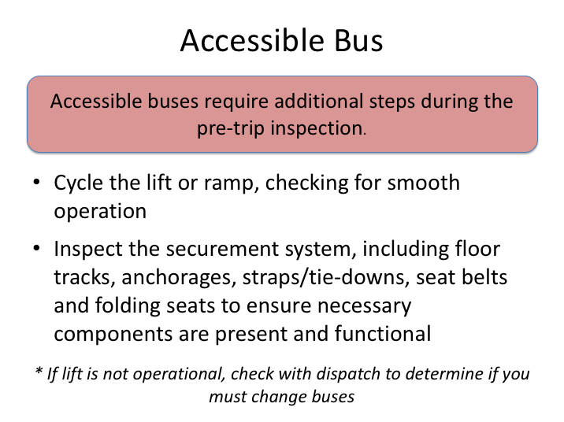

# ACCESSIBLE BUS NARRATIVE

If the bus you are inspecting is an accessible bus, there are additional steps that must be taken to ensure it is operational and all necessary accessories are present before embarking on your charter or trip.

This step is important - you may have been assigned an accessible bus because its equipment is necessary for one or more passengers. If the lift is inoperable, or any necessary accessories are not present or functional, you should notify your dispatch immediately so that a decision can be made as whether to assign you another coach or tend to the issues prior to disembarking.

If the lift is not necessary for the assigned trip, and dispatch notifies you to take the bus anyway, you must report the deficiencies found on the vehicle inspection report.

*Display PowerPoint slide.*

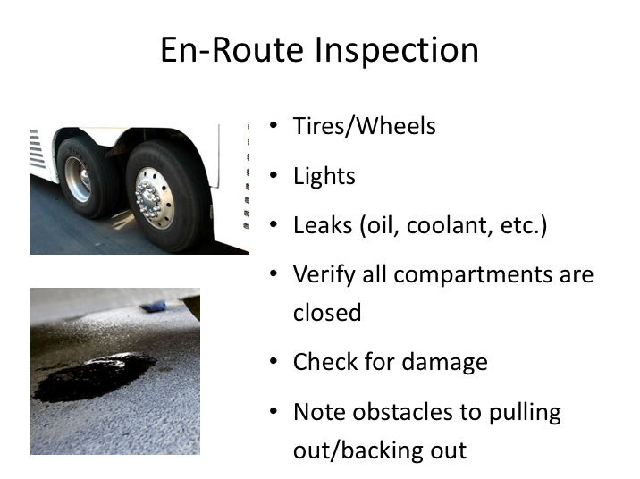

# EN-ROUTE INSPECTION NARRATIVE

At the completion of each day’s trip, you must complete a post-trip inspection of the coach, similar to the pre-trip inspection. However, what about any interim stops on the way to the final stop of each day?

Each time you stop en-route to that day’s destination provides another opportunity to check your coach for any obvious issues which could literally lead to trouble down the road. Here is what to look for:

1. Check the tires and wheels. Make sure that there aren’t any flat tires or tires that are low on, or leaking, air. Look for any signs of hub oil on the wheels and check each tire/wheel for excessive heat. Any of these conditions could lead to a tire failure or fire and further investigation is warranted.
2. Check that all lights are working, especially at or near dusk or night. Remember, you rely on lights not only to see, but also to be seen.

**EN-ROUTE INSPECTION NARRATIVE (continued)**

1. Check for fluid leaks and any unusual odors, especially at the rear of the coach near the engine area. Fluid leaks in the engine compartment can also lead to fires depending on the source and location of the leak.
2. Be sure that all compartments are closed, especially the baggage bins.
3. Check for any new damage to the outside of the coach.

If you find anything seriously wrong, have it checked at that stop, or call your company and ask for further instructions.

Finally, remember to check for any obstacles around your coach that could give you trouble when leaving your stop, especially if you have to do any backing.

LESSON 2

POST-TRIP INSPECTIONS

AND DOCUMENT PREPARATION

**Lesson Objectives:**

By the end of this lesson, students will know how to conduct a proper post-trip inspection, including completing a vehicle inspection report.

**Instructional Methods**: Classroom and On-Board Exercise

**Approach:**

Using the PowerPoint graphics provided, discuss the process of a post-trip inspection and completion of the vehicle inspection report. Following classroom discussion, take students out to the vehicle and walk them through the inspection process reviewed in the classroom. As you review stages of the inspection, solicit student involvement in identifying areas to inspect, especially from those who may have previous experience conducting trip inspections.

**LESSON INTRODUCTORY NARRATIVE**

*Student Guide reference here*

Post trip inspections are critical in managing the vehicle safety process. They provide an opportunity for drivers to detail any issues they experienced with the vehicle during operation that day. .

Drivers should be a specific as possible with any of their information provided on the daily vehicle inspection reports. Maintenance personnel need to understand the issue clearly so that they can investigate, duplicate the defect if necessary, and correct unsafe conditions.

This process is also important to the next driver who will be operating the same motorcoach. He or she will be relying on your detailed information with regard to safety issues to cue the maintenance staff to remedy. If a driver doesn’t take the time to properly document issues on the vehicle inspection report, maintenance staff won’t know of any pertinent issue(s), and the next driver may take the coach on a trip without knowing any issues existed, jeopardizing the safety of everyone on-board and potentially the general public.

*Display PowerPoint slide.*

**Instructor Note –**

Ideally, this should be an image of your Company DVIR, rather than the generic provided.

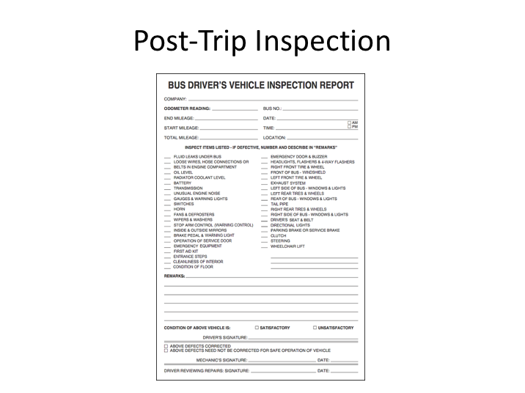

# POST-TRIP INSPECTION AND DRIVER VEHICLE INSPECTION REPORT NARRATIVE

The procedures for doing a pre-trip and post-trip inspection are very similar.

After performing the post-trip inspection, at the completion of a driver’s day, you will fill out a form called the Daily Vehicle Inspection Report, sometimes abbreviated and called a ‘DVIR’ or ‘VIR’ (these are the forms reviewed during the pre-trip inspection process) . The report must be filled out and signed whether or not any defects or deficiencies are discovered. The daily vehicle inspection report must contain all defects discovered or reported to the driver during the course of the day. Defects discovered during all inspections, pre-trip, en-route and post-trip inspections, as well as any defect reported to the driver by an inspector, is documented on the DVIR.

Vehicle inspection reports differ by company, but there are certain items they are required to have/document. In general, the report must identify the vehicle and list any defect or deficiency discovered by or reported to the driver that would affect the safe operation of the vehicle or result in its mechanical breakdown. Specifically, the condition of the following components must be noted (at a minimum):

* Service Brake
* Parking Brake
* Steering Mechanism
* Lighting Devices & Reflectors
* Tires
* Wheels & Rims
* Mirrors
* Horn
* Windshield Wipers
* Emergency Equipment

In addition to vehicle component condition, drivers should report any unusual occurrences or issues observed while driving, even if they do not know the cause or component affected. For example, experiencing a loss or reduction of power or the vehicle pulling to one side under certain circumstances.

If there are no defects, deficiencies or concerns to report, the report has a location to indicate this. The driver must sign the report.

On two/co-driver trips, only one driver needs to sign the vehicle inspection report, provided both drivers agree as to the defects or deficiencies identified. If a driver drives more than one vehicle, a report must be prepared for each vehicle operated.

**Instructor Note –**

Review your specific VIR used and detail how the driver is to complete it. Also, detail company procedures with regard to turning in VIRs once completed.

**EXERCISE**

Issue each student a blank VIR and provide a trip scenario detailing an issue with the coach, then have them complete the VIR and review.

Take the students to a coach and conduct pre-trip, en-route and post-trip inspections, describing each step as it is performed. Detail the differences between inspection types. Show and explain how a component looks when safe and unsafe. Emphasize the air-brake system tests.

During the instructor-led coach inspection, consider asking questions to the students throughout the inspection to assess lesson competency and evaluate inspection knowledge. (e.g., How many reflective triangles should we have on the vehicle?)

Following your inspection, each student should conduct an inspection, describing each step as it is performed. Provide feedback as necessary.

**This inspection process should be repeated daily with students until they have mastered the process.**

**VEHICLE INSPECTIONS**

**QUIZ**

*Instructor’s Note – Correct answers are highlighted*

1. Safety regulations require a vehicle inspection every time a vehicle is used. The inspections are the responsibility of the driver.

1. **True**
2. False
3. A driver is not required to review the previous trip vehicle inspection report unless notified that there was a defect reported.
4. True
5. **False**
6. What is the maximum width of a crack in the windshield where the vehicle can still be operated (assuming no intersecting crack)?
7. ½ inch
8. ¾ inch
9. **1 inch**
10. 1 ½ inches
11. 2 inches
12. How many reflective triangles (emergency equipment) should you have available?
13. 2
14. **3**
15. 4
16. 5
17. 6
18. If you are on a multi-day trip, you only need to complete a vehicle inspection report for the last day (when you return).
19. True
20. **False**
21. If the mobility lift on an accessible bus is not working properly, and dispatch notifies you to take the bus anyway since the lift is not necessary for the assigned trip, you should report the deficiencies found on the vehicle inspection report.
22. **True**
23. False
24. When should you complete your vehicle inspection report?
25. When deficiencies are found
26. **After the post-trip inspection**
27. At the beginning of the trip
28. After the pre-trip inspection
29. During an en-route walk-around inspection, you should:
30. Check the tires for unusual heat and proper inflation
31. Check for obstacles to pulling/backing out
32. Check lights and ensure compartments are closed
33. Check for leaks and damage
34. **All of the above**
35. If you find no defects or deficiencies, you do not need to complete or sign a post-inspection report form.
36. True
37. **False**
38. If you have two/co-driver trips, both drivers need to sign the vehicle inspection report.
39. True
40. **False**