**Trip Preparation**

|  |  |  |
| --- | --- | --- |
| Clipart of road signs | Clipart of clock and skull | Clipart of smiley face |

**Purpose:**

The objective of this training module is help you understand that there is considerably more to being a driver than simply showing up and getting behind the wheel. We’ll review steps you’ll need to consider to prepare for a successful and safe trip. Preparation includes physical and mental health and readiness, as well as trip planning or verification.

**Module Overview:**

This module contains three classroom lessons. The first lesson will address getting proper rest, healthy eating, and emotional well-being. The second lesson will address alcohol, controlled substance, and medication use. It will include a review of applicable safety regulations as well as discussions regarding use of prescription and over-the-counter medicines. The third lesson will address trip planning and verification.

Lesson 1: Physical Preparation

Lesson 2: Alcohol, Controlled Substances & Medications

Lesson 3: Trip Planning & Verification

LESSON 1

PHYSICAL PREPARATION

**Lesson Objectives:**

By the end of this lesson, you will understand the physical and mental demands of driving a motorcoach and ways to prepare physically and mentally for a safe and trouble-free trip.

**Instructional Methods**: Classroom

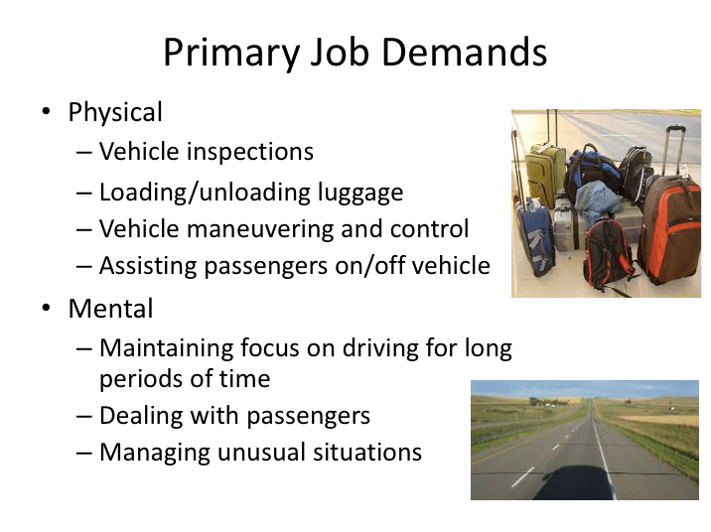

**PRIMARY JOB DEMANDS**

Being a motorcoach driver is a physically and mentally demanding job. Physical demands include inspecting the vehicle, loading/unloading luggage and other cargo, maneuvering and controlling a large vehicle, and assisting passengers during the boarding and alighting process.

Mental demands for a driver include maintaining focus on the driving task for extended periods of time, passenger management, and managing unusual situations, such as crashes or breakdowns.

Physical and mental fatigue, external interference, poor physical conditioning, and medication influences can negatively affect a driver’s ability to handle any of these demands.

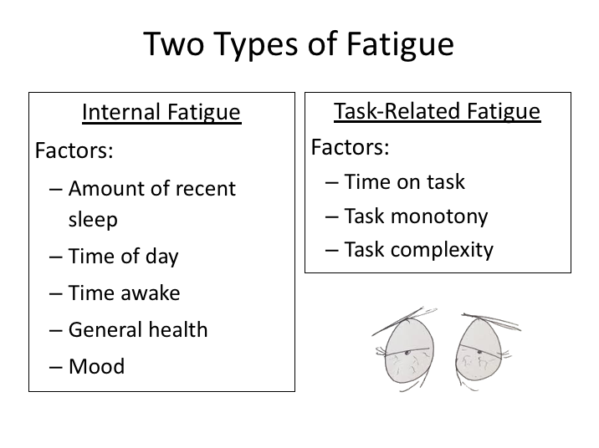

**FATIGUE**

Fatigue is closely related to sleep.  There are two types of fatigue – internal fatigue, related to body physiology, and task-related fatigue, which is related to a specific task.

The amount of recent sleep is one of the largest influences on internal fatigue levels.  Other influences include the time of day, time awake, general health and mood.  While there are individual differences in susceptibility to internal fatigue, it’s safe to say that it’s experienced by everybody - just at different levels and severity.

Task-related fatigue levels are driven by the specific task being conducted. Factors include time on task, task monotony, and task of complexity.  For a commercial driver, time on task would be related to the hours of driving or working, while task monotony would also be a concern for lengthy driving time periods.

|  |
| --- |
| Clipart |

What type of fatigue do you think a commercial motorcoach driver is most likely to experience? What practices affect fatigue potential the greatest?

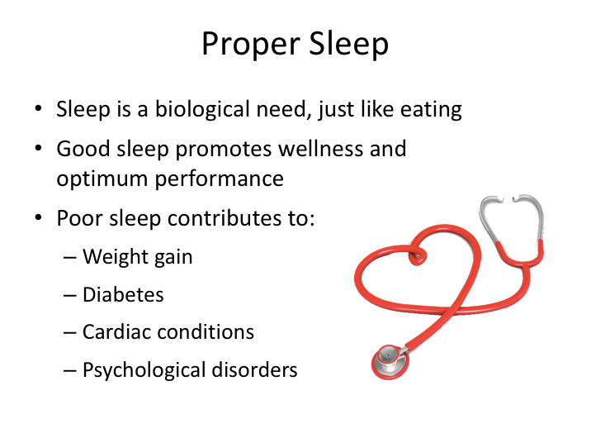

**PROPER SLEEP**

The single biggest factor in reducing fatigue is getting proper sleep. Sleep is a biological need – when you don't get enough sleep, your risk of disease and health issues increases along with fatigue and associated crash risk. On the other hand, getting proper amounts of sleep will allow you to perform at peak levels and generally be happier!

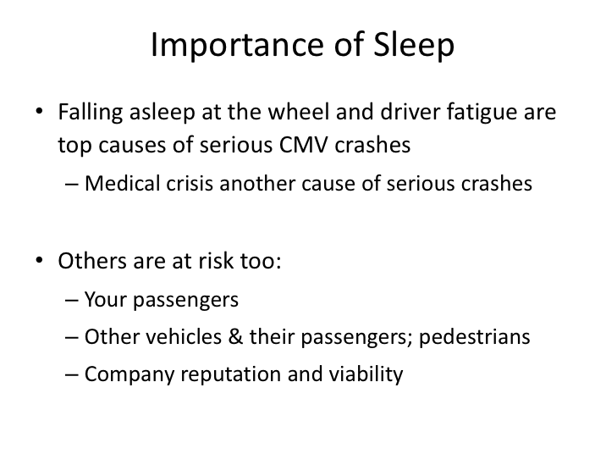

**IMPORTANCE OF SLEEP**

Preparing for driving by getting proper sleep is critical. Falling asleep while driving and fatigued driving due to lack of proper rest are some of the common causes of commercial vehicle crashes and driver deaths. Additionally, medical conditions often associated with poor sleep account for even more commercial vehicle crashes. Commercial drivers should understand that collisions caused by fatigue not only affect them, but also their passengers, other bystanders, and their company.

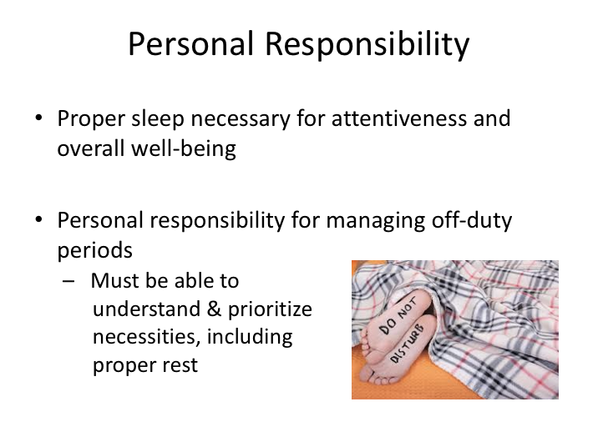

**PERSONAL RESPONSIBILITY**

Part of the responsibility that goes with being a motorcoach driver includes how you manage yourself when you’re not driving the motorcoach. Proper sleep is necessary to be awake and attentive – two absolute requirements for a motorcoach driver. It’s also necessary to maintain overall wellness, including physical, mental, and emotional health. Without proper sleep, you won’t be able to perform at levels necessary for successful drivers or attain a level of well-being and happiness necessitated by the job functions.

Finding time to get proper rest, as well as carry out other personal tasks, should not be an issue when you have significant time off between trips. However, during busy seasons, and generally while on many multi-day trips, you will be allotted shorter off-duty periods between driving periods.

While employers (and regulations) can ensure time off between and during trips, it is the personal responsibility of a commercial driver to use that time wisely. Using available off-duty time to wisely manage your sleep, health, and lifestyle are keys to being successful.

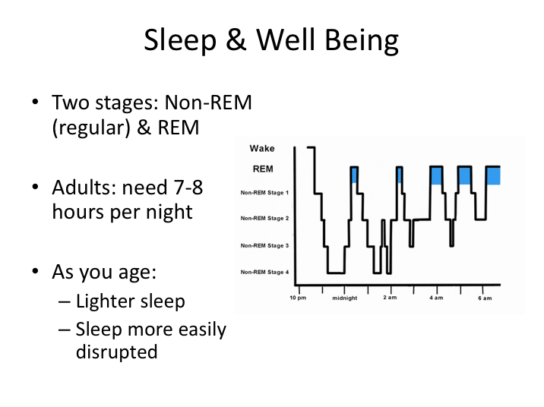

**SLEEP AND WELL BEING**

There are two stages of sleep: regular sleep (NREM) and rapid eye movement sleep (REM). Your body functions differently in both of the stages, and both are critical for restoring both your physical and mental well-being. During the deep stages of NREM sleep, the body repairs and regenerates tissues, builds bone and muscle, and appears to strengthen the immune system.

As you get older, you sleep more lightly and get less deep sleep. Aging is also associated with shorter time spans of sleep, although the amount of sleep needed remains the same.

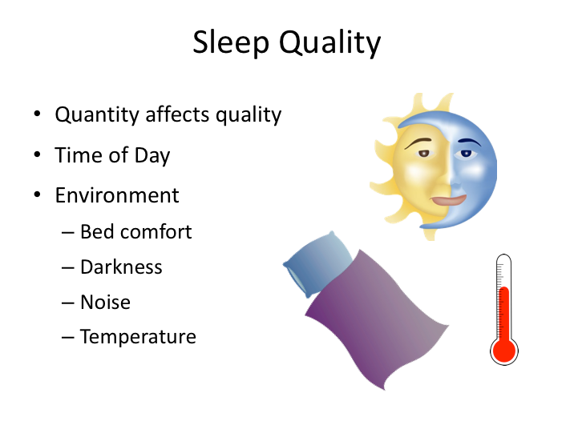

**SLEEP QUALITY**

The quantity of the sleep you get certainly affects the quality. In order to reach the deep stages of non-REM sleep and reap its benefits you must be asleep long enough to cycle through the stages of sleep several times. The time of day also affects the quality and quantity of sleep.

Sleep can also be greatly affected by your environment. Bed comfort, noise, darkness, and temperature are major environmental factors to consider when trying to obtain quality sleep. As a commercial driver, this can be a very challenging obstacle to getting quality sleep on multi-day trips where you may experience a different environment every night.

Many drivers find it beneficial to take sleep aids with them when traveling on a longer trip. Common sleep aids include ear plugs to block out ambient noise and sleep masks to block out unwanted ambient light.

|  |
| --- |
| Clipart |

Which factors do you think affect your quality of sleep the most?

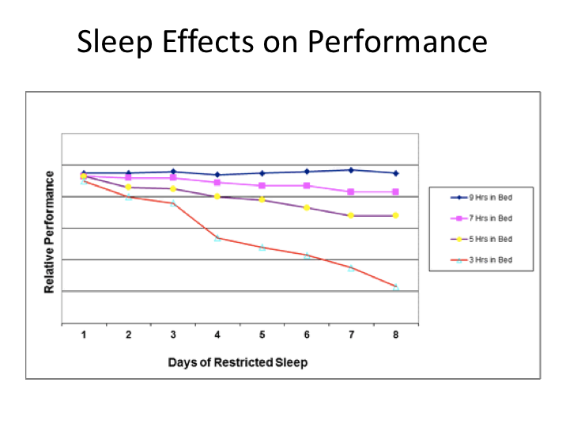

**SLEEP EFFECTS ON PERFORMANCE**

Not getting enough sleep will negatively affect your performance. This graph shows performance and it’s degradation over consecutive days of less than optimal sleep. You’ll notice that the performance levels for the adults who spent seven to nine hours in bed remain relatively steady over the eight days monitored, with a slight reduction in performance over the time period for the adult who only received seven hours in bed.

However, the adult who only received five hours of sleep had a significant and consistent drop off in performance over the eight days of the study. The adult who only received three hours a night experienced a very large and steep drop off in performance over the eight days.

As you can see from the chart, you may be able to get away with one or two days of restricted sleep without significant effects, however anything beyond will likely result in noticeable performance differences. The bottom line is that sustained performance can only be achieved by getting appropriate rest.

**EXERCISE**

Here are five questions to self-evaluate if you are chronically sleep deprived. Write down your answers (yes or no).

1. Do you fall asleep in 5 minutes or less? _______
2. Can you nap almost anywhere, any time? _______
3. Do you feel sleepy when you are bored? _______
4. Do you fall asleep easily while watching TV or in movies? _______
5. Do you ever fall asleep while stopped for traffic lights? _______

While there is no scoring to the self-test, multiple “yes” answers probably indicates chronic sleep deprivation. In other words, you have a sleep debt. Like a financial debt, you need to start paying it off. There’s only one-way to pay your debt: Sleep. You don't have to pay back sleep hour-for-hour, but, like paying off other debts, it may take some time.

Recovery begins following one good sleep. However, recovery may not be complete until you have several nights of good sleep. The real solution involves life-style changes. Don't get sleep deprived to begin with and whenever possible “bank” extra sleep.

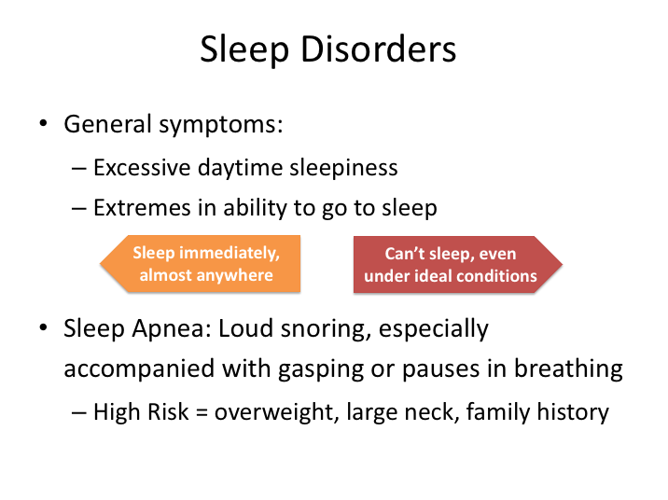

**SLEEP DISORDERS**

Sleep disorders can obviously be very dangerous if afflicting a motorcoach or commercial vehicle driver. Sleep disorders interrupt sleep patterns and stages, and result in tired and fatigued states, even when a person has spent eight hours per night in bed.

There are different symptoms for different sleep disorders, however there are some prevalent signs that you may have a sleep disorder, the most obvious being excessive daytime sleepiness. Also, if you fluctuate between extremes in the ability to go to sleep, you may suffer from a sleep disorder. Loud snoring, especially with gasping or pauses in breathing, may be a sign of obstructive sleep apnea, a dangerous sleep disorder which affects many commercial drivers. Those at high risk for sleep apnea include overweight and obese individuals, those with hypertension, large neck circumferences, recessed chins or small jaws, and family history of sleep disorder.

If you feel that you are potentially suffering from a sleep disorder, you should notify dispatch, see a physician, and possibly consider a sleep study.

**SLEEP DISORDERS (continued)**

Sleep studies have become much easier to accomplish, have become more reasonably priced, and are sometimes covered by insurance. Remember, it wouldn’t be prudent or responsible to operate a motorcoach full of passengers knowing or suspecting you may be suffering from a sleep disorder.

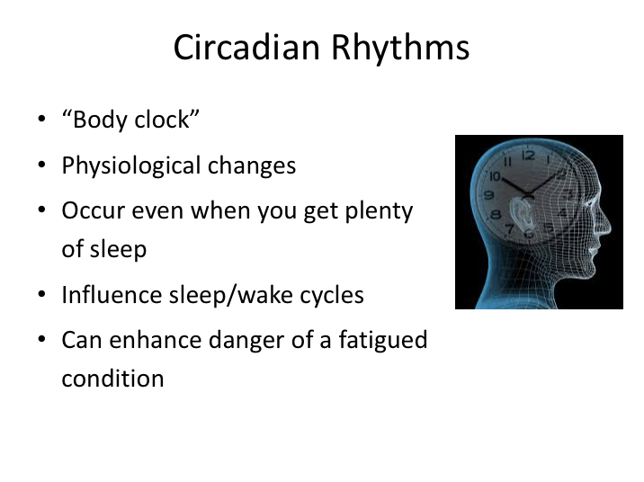

**CIRCADIAN RHYTHMS**

Circadian rhythms are physical, mental and behavioral changes that follow a roughly 24-hour cycle and can influence sleep/wake cycles. They are typically referred to as the body clock. These physical changes occur even when you get plenty of sleep, but also can serve to enhance the danger associated with lack of sleep and fatigue, especially during the circadian valleys.

Circadian rhythms influence sleep patterns through the release of a sleep–inducing hormone (melatonin) - primarily at night, when there is less light.

Perhaps the best example of circadian rhythms at work is jet lag. Jet lag occurs when travelers suffer from disrupted circadian rhythms. When you pass through different time zones, your body's clock will be different from your wristwatch. For example, if you fly from California to New York, you "lose" 3 hours of time. So, when you wake up at 7:00 a.m., your body still thinks it's 4:00 a.m., making you feel groggy and disoriented. Your body's clock will eventually reset itself, but this often takes a few days.

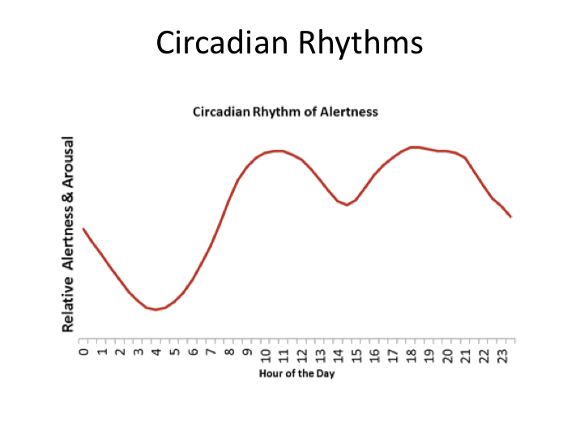

**CIRCADIAN RHYTHMS (continued)**

This graphic shows a typical circadian cycle, detailing levels of alertness and peaks and valleys at various periods of time. Peak performance times include mornings after 8 a.m. and evenings. “Circadian valleys”, which represent low performance levels and sleepiness, include early mornings before sunrise and a time period in the early to mid-afternoon.

This typical cycle represents the circadian rhythm for a person who gets proper rest and sleep. Sleep loss makes the circadian valleys deeper, which can increase their effect on a fatigued driver.

One of the challenges in the motorcoach industry is the desire for many groups to travel at night. As you can see from the chart above, this is the most dangerous time according to a normal circadian cycle. There are people whose circadian cycles are naturally different from the typical cycle – in common terms, these folks are often referred to as night owls or larks (early bird, morning person). However, for most persons, driving through the night will require advanced preparation and intentional adjustment of your circadian cycle.

**CIRACADIAN RHYTHMS (continued)**

There are many drivers who successfully operate at night, but their circadian cycle has been modified over time to prepare them for this. In addition, they must usually take steps to maintain their circadian cycle, such as ensuring very dark rooms for daytime sleep and rest.

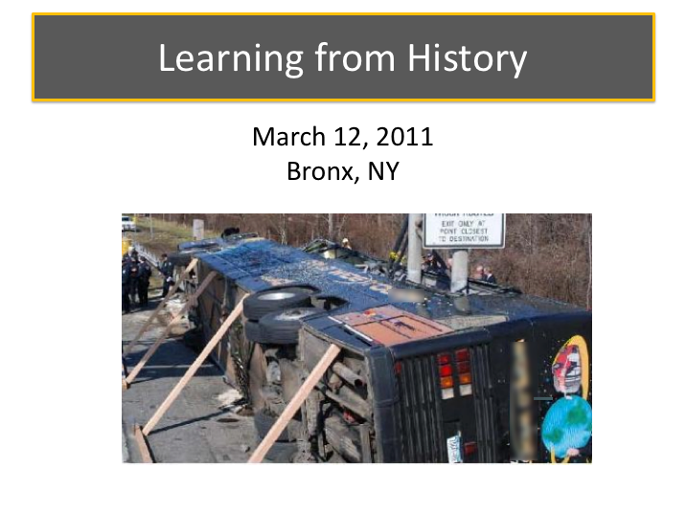

**LEARNING FROM HISTORY**

Carriers must follow hours of service regulations and allot at least eight hours off-duty between driving assignments, but what a driver does on his/her off-duty time is not controlled by the company.  It’s the driver’s responsibility to obtain proper rest during their off-duty periods.

A crash that occurred on March 12, 2001, in the Bronx, NY, illustrates the dangers of operating a motorcoach without sufficient rest and what could go wrong if commercial drivers do not take their responsibilities seriously.

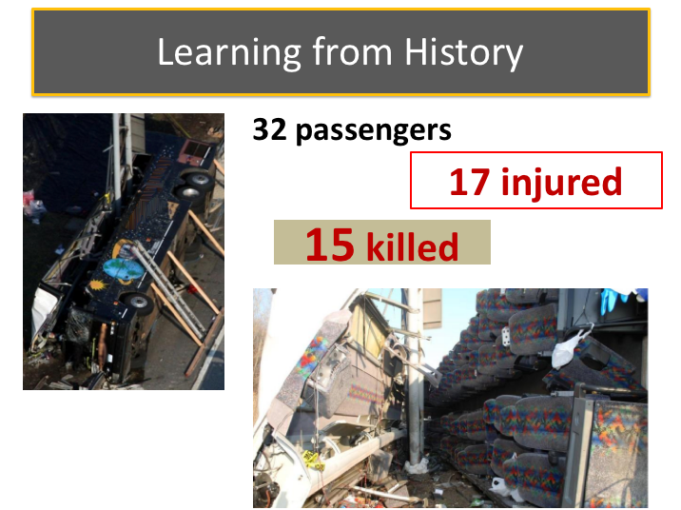

**LEARNING FROM HISTORY (continued)**

On March 12, 2011, about 5:38 a.m., a 56-passenger motorcoach was traveling southbound on Interstate 95, en-route from the Mohegan Sun Casino in Uncasville, Connecticut, to New York City, and carrying 32 passengers. While in the vicinity of mile marker 3.2, the motorcoach departed from the travel lanes to the right, driving over the rumble strips on the right shoulder edge. The motorcoach then crossed over the 10-foot-wide paved shoulder and struck a guardrail, traveling about 480 feet alongside and on the guardrail, before finally overturning 90° onto its right side and flattening the guardrail. The front of the vehicle subsequently collided with a vertical highway signpost. Two poles from the signpost entered the passenger compartment along the base of the passenger windows as the vehicle slid forward. The impact resulted in the roof panel being torn from the bus body for almost the entire length of the bus. As a result of this accident, 15 passengers were killed, 17 passengers received serious-to-minor injuries, and the bus driver received minor injuries.

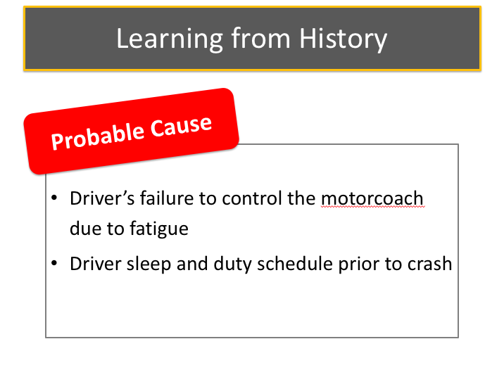

**LEARNING FROM HISTORY (continued)**

The ensuing National Transportation Safety Board (NTSB) investigation established that the driver was afforded required off-duty periods by his employer for the three days prior to this trip. Off-duty periods between driving assignments varied from approximately 8.5 hours to 12 hours in length.  The driver self-reported at least eight hours of sleep during each of the two days prior to the crash, though the sleep occurred during two periods – one at night and one during the day.  The daytime sleep occurred at home; while the nighttime sleep occurred on the bus overnight at the casino. At the time of this crash, the driver had been on the road approximately two hours.

The National Transportation Safety Board determined that the probable cause of the accident was the motorcoach driver's failure to control the motorcoach due to fatigue. While reviewing cell phone records of the driver, multiple calls and activities were noted to have taken place during the periods of self-reported sleep, indicating that the reported sleep and rest obtained was inaccurate.

|  |
| --- |
| Clipart |

Besides not getting enough sleep, what other issues and concerns related to sleep and proper rest may have played a part in this crash?

5 factors of wellness. Include:
Sleep, nutrition, posotive relationships, positive behaviors, and exercise.

**WELLNESS**

Proper sleep is the foundation for an overall healthy lifestyle and outlook. However there are more factors which drivers must consider to operate at peak performance. These include proper eating and nutrition, exercise, positive relationships, and other positive behaviors.

Just like getting proper sleep, each one of these areas can have their challenges incorporating into the lifestyle of anyone. Some of these can be even more difficult to accomplish as a commercial driver. However, many times, it’s simply about committing to improve your lifestyle by changing habits.

How you look and feel, alertness and performance while driving, longevity on the job, and overall life expectancy are all affected by your overall wellness.

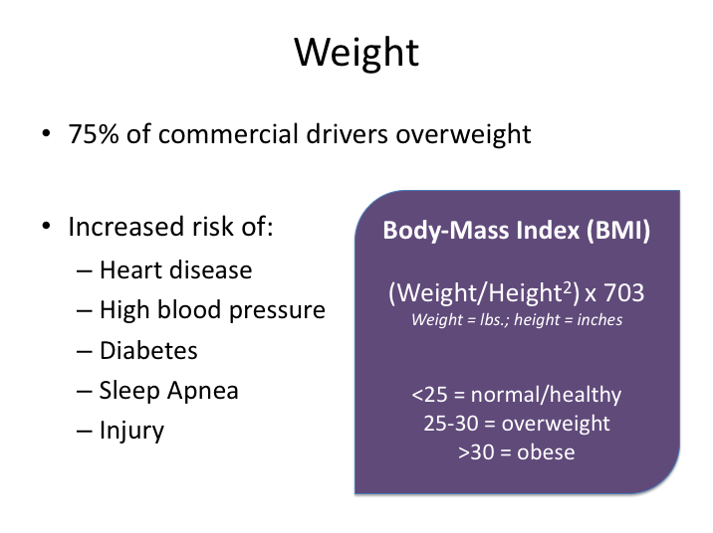

**WEIGHT**

Perhaps the biggest clue that you or anyone else may not be leading an overall healthy lifestyle is your weight. Americans in general have weight problems, which are the result of many influences. The proportion of commercial drivers who are overweight is astonishing – nearly 75% of commercial drivers are considered overweight. One might assume that this fact is a result of the nature of the job and the environment. The sedentary nature of driving means minimal physical activity for long periods of time, as well as eating out often.

There are obviously consequences to being overweight. These include increased risk of heart disease, high blood pressure, diabetes, obstructive sleep apnea, and injury. Additionally, there are other driving related consequences. Specifically, obtaining and maintaining medical certification as a commercial driver can be more difficult for those who are overweight.

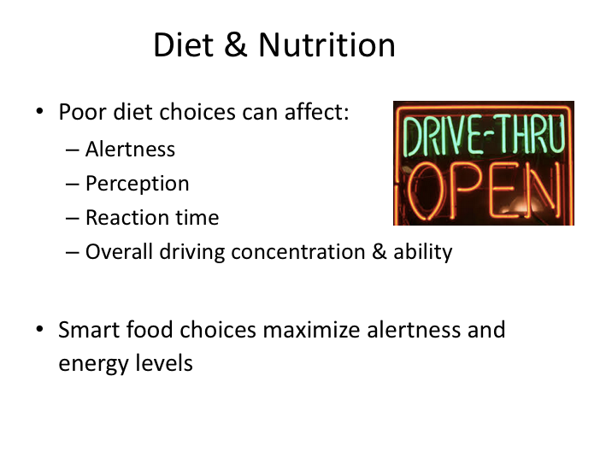

**DIET & NUTRITION**

As a motorcoach driver, it’s easy to fall into poor eating habits. You are frequently on the road at meal times and sometimes have to skip meals or choose from limited options at or near wherever the tour or group is scheduled to stop. Bad eating habits include eating the wrong foods, eating too much, and eating too fast – these can cause fatigue, headaches, lack of energy and indigestion.

Not eating well can cause you to gain weight and increase your risk of disease. It can also affect the driving task. Alertness, perception, and reaction time can all be affected by a poor diet. On the other hand, a good diet can help a driver stay alert and have enough energy to competently perform his/her required tasks.

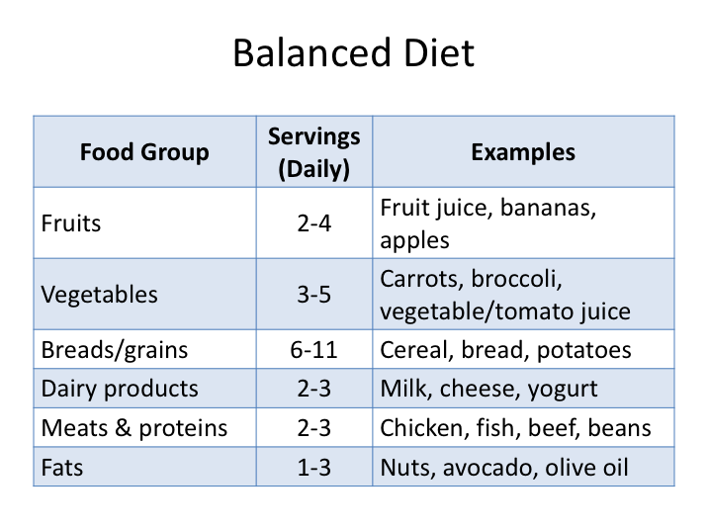

**BALANCED DIET**

A balanced diet means eating different kinds of healthy foods each day. Balanced diets will provide your body with the necessary fuels, vitamins and nutrients to keep your body and mind operating at peak levels and keeping you healthy.

There are six basic food groups with recommended daily servings. Recommended serving sizes are important to understand and are not as large as you might assume. For instance, one slice of bread would equal one serving from the Grains group, and 2 tablespoons of nuts would equal one serving from the Fats group.

While it may seem daunting, eating a balanced diet is actually very simple once you understand the food groups and available options. Consider it a game to assess everything that you eat (determine its food group) and ensure that you meet all your daily servings.

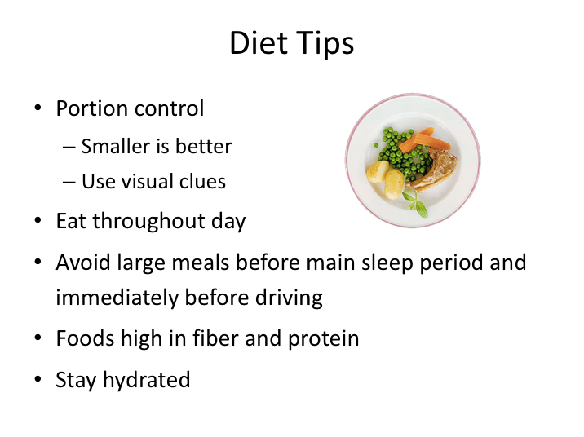

**DIET TIPS**

This slide isn’t meant for the diet as you may traditionally think of it. When we talk about diet here, we are talking about eating properly in general.

People often think of healthy eating as an all or nothing proposition, but a key foundation for any healthy diet is moderation. But what is moderation? In essence, it means eating only as much food as your body needs. You should feel satisfied at the end of a meal, but not stuffed. This may be easy to achieve at home when you’re in total control, but much more difficult when you are eating on the road. When dining out, choose a starter instead of an entree, split a dish with a friend, and don't order supersized anything. If you don't feel satisfied at the end of a meal, try having another portion of vegetables or rounding off the meal with fresh fruit instead of dessert. Speaking of dessert, save that treat for 1-2 times per week.

One thing you should always remember about eating out – restaurants have a vested interest in you enjoying your food and wanting to come back, but no interest in your overall well-being. They will often load up food with fats, sodium,

and other ingredients to make the taste exceptional. They’ll also likely give you much more than you should eat.

**DIET TIPS (continued)**

It will take some discipline, but smart diners will investigate the nutritional content of their meals, as well as find ways to manage the portion sizes – such as skipping on the breadsticks and eating all vegetables before the rest of the meal. Visual cues can help with portion sizes – your serving of meat, fish, or chicken should be the size of a deck of cards and serving of mashed potato, rice, or pasta about the size of a traditional light bulb. And, don’t be afraid to ask them to make minor changes to preparation, such as holding the butter on the broccoli.

Another good tip is to eat smaller meals throughout the day instead of just three large ones. Smaller meals will maintain a more constant digestive state within your body, which will help maintain energy levels and prevent blood sugar spikes and crashes. Avoid large meals immediately before your main rest period and before any significant driving task.

Eating foods that are high in fiber and protein will make you feel fuller longer. Also, make sure you stay hydrated. Sometimes a body’s desire for water and hydration is confused for hunger.

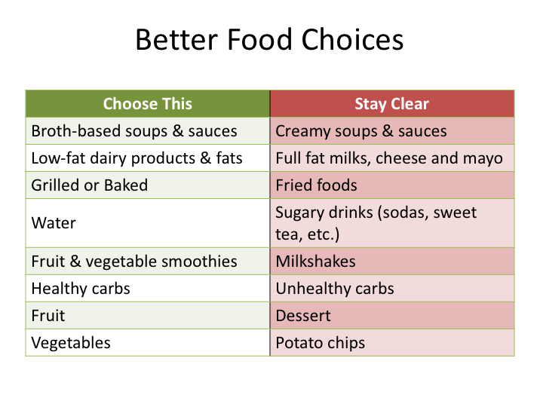

**BETTER FOOD CHOICES**

Of course it’s very difficult to know the exact nutritional analysis and content of food you’re eating – especially when you’re eating at restaurants and on the road. Sometimes, nutritional information is not available.

Being educated on food nutrition and having a general sense of what is better for you will help you make the best choice in any situation. Some of the simplest choices revolve around types of sauces, preparation of the main protein, and what you drink. Remember that drinks have calories also, though none of the calories provide nutritional value. Trying to think about it this way - you should be eating your calories, not drinking them.

Carbohydrates are necessary, but different types of carbohydrates cause different reactions within your body. Healthy carbohydrates (sometimes known as complex carbs) include whole grains, beans, fruits, and vegetables. Healthy carbs are digested slowly, helping you feel full longer and keeping blood sugar and insulin levels stable. Unhealthy carbohydrates (or simple carbs) are foods such as white flour, refined sugar, and white rice that have been stripped of all

bran, fiber, and nutrients. Unhealthy carbs digest quickly and cause spikes in blood sugar levels and energy.

|  |
| --- |
| Clipart |

Have you ever made a focused effort to eat more fruits and vegetables? Did it work? What have you done to improve making better food choices?

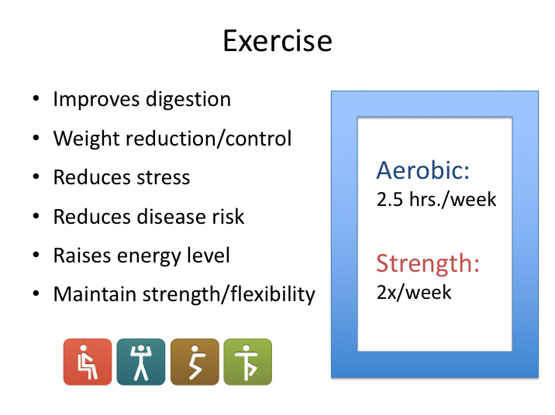

**EXERCISE**

Exercise is one of the easiest and most effective ways of improving both your physical and mental health. A little regular exercise can ease depression and anxiety, boost energy and mood, and relieve stress.

Exercise goes hand-in-hand with proper diet and nutrition – you cannot reach your optimum performance level if you do not exercise your body, including vital organs such as your heart and lungs.

Just 20 minutes of aerobic exercise has shown to significantly reduce stress levels. Aerobic exercise also increases your heart rate, in essence exercising your heart muscle, and also increases breathing and exercises lung capacity. Another benefit of getting aerobic exercise is the release of endorphins, which are chemicals in the brain that reduce the feeling of pain and make a person feel better. During any exercise there is increased blood flow to the muscles and tissues as well as increased oxygen flow to the brain.

It’s recommended that adults get approximately 2 ½ hours of aerobic/cardiovascular exercise (jogging, bicycling, stair climbing, fast walking) per week. Aerobic exercise should be complemented with strength training, such as lifting weights or yoga, two times per week.



**EXERCISE TIPS**

Despite all the life-changing benefits many of us still think of exercise as a chore, either something that we don’t have time for or something that’s only suitable for the young or the athletic. The key to maintaining an exercise regimen is to determine what you like to do and set goals. If you’re just starting exercising, these goals should be relatively simple and you can increase goal difficulty as you achieve each.

As a motorcoach driver you’ll likely find it harder to find time to exercise on the days you’re working, just like everybody else does. You may find it easier to conduct more vigorous workouts on your days off. However, this doesn’t mean not to exercise on other days when you are working. It simply means that you may have to adjust your length of workout and intensity level to match your schedule and environment.

Even just a few minutes of physical activity are better than none at all. If you don’t have time for 15 or 30 minutes of exercise, or if your body tells you to take a break after 5 or 10 minutes, that’s okay, too. Start with 5- or 10-minute sessions and slowly increase your time.

**EXERCISE TIPS (continued)**

The more you exercise the more energy you’ll have, so eventually you’ll feel ready for a little more. The key is to commit to do some moderate physical activity, however little, on most days. As exercising becomes habit you can slowly add extra minutes or try different types of activities. If you keep at it, the benefits of exercise will begin to pay off.

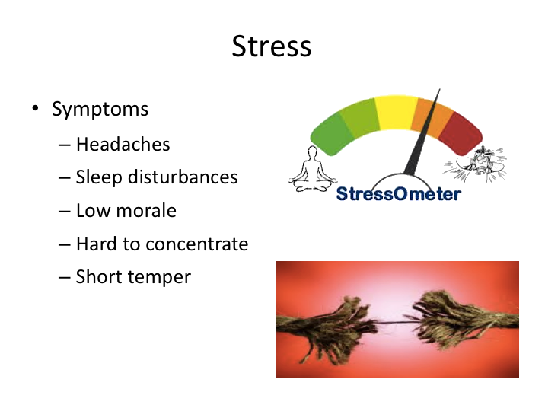

**STRESS**

Proper diet and exercise help maintain physical readiness and well-being for driving. However, there’s also a mental well-being component that must be addressed in order to be a safe driver.

Stress is a normal physical response to events that make you feel threatened or upset your balance in some way. Whether it’s response to a dangerous situation or a pressure-to-perform situation, stress, when working properly, helps you stay focused, energetic, and alert. In emergency situations, stress can save your life -giving you extra strength to defend yourself or spurring you to slam on the brakes to avoid a crash.

But beyond a certain point, stress stops being helpful and starts causing major damage to your health, your mood, your productivity, your relationships, and your quality of life. Unbeneficial stress can affect driving behavior and performance, and lead to symptoms and conditions that compound the dangers even more.

If you notice physical or mental changes in your attitude or well-being, stress maybe one of the causes. Symptoms of stress include headaches, sleep disturbances, difficulty concentrating, and short temper.

**STRESS (continued)**

Exercise should serve to help manage stress levels. But there are components that are not physical nature – these are more mental. Nonetheless, they add to stress and can result in unhealthy stress levels.

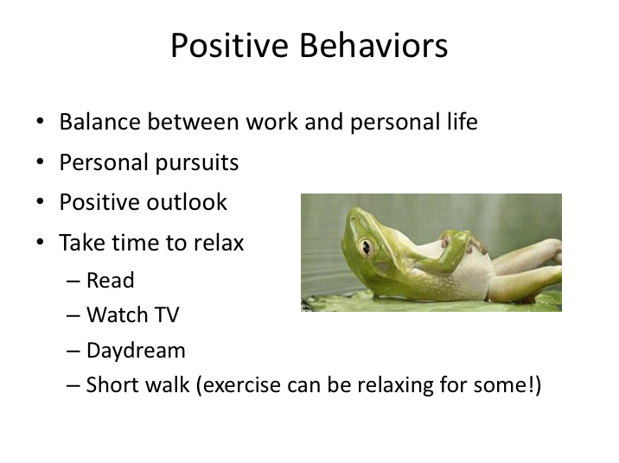

**POSITIVE BEHAVIORS**

In addition to exercise, striking a balance between personal and work life is an important tool in maintaining overall wellness and fighting stress. Granted, there will be times that work will make this difficult as it does for almost everyone, but prolonged periods of imbalance can affect positive outlook and attitude, which can negatively affect safe driving habits and other aspects of your life, such as relationships.

Pursuing activities and behaviors you like to do is important in maintaining the correct balance and positive outlook. It’s also important to relax, so you can unwind and manage any building stress levels. Relaxing can be difficult to do while operating a multi-day motorcoach trip or navigating a very busy schedule. However, as with exercise, you should try to find time on a regular basis to get serious about relaxing – even if it’s only for a very short time!

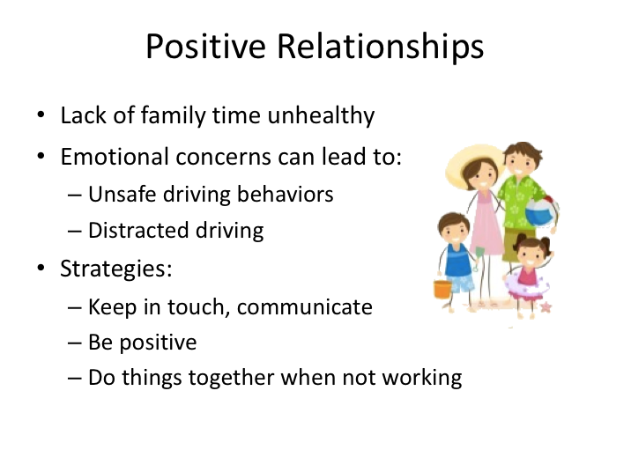

**POSITIVE RELATIONSHIPS**

Just like any other distraction, having personal problems or personal issues on your mind while driving can be disastrous. While you’re thinking about issues and concerns, you may be missing important clues to recognize potential hazards.

In commercial driver surveys, lack of family time was one of the biggest single health and wellness concerns. While prolonged time periods away from family and loved ones is more pronounced in the trucking industry, it can also happen in the motorcoach industry. Even drivers who stay close to home or operate locally may be working during hours which prevent them from spending much time with their family – especially during busy seasons.

However, maintaining positive personal relationships with family and friends is important in overall health and wellness.

LESSON 2

ALCOHOL, CONTROLLED SUBSTANCE

AND MEDICATIONS

**Lesson Objectives:** Following this lesson, you will understand safety regulation prohibitions regarding the use of controlled substances and alcohol when driving a motorcoach. You will also be provided insight on the potential dangers of permitted prescription and over the counter medications.

**Instructional Methods**: Classroom

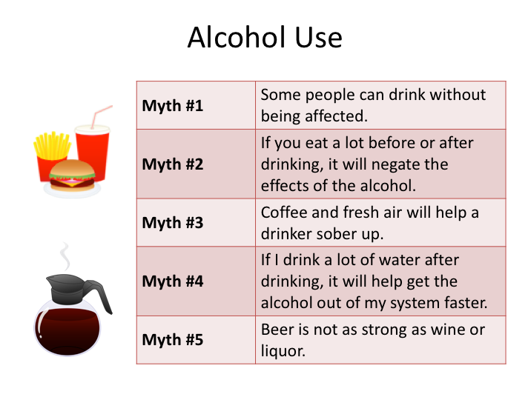

**ALCOHOL USE**

Everyone knows that drinking and driving is a serious safety concern and risky behavior. Each year, thousands of people are killed in crashes where a driver has been drinking.

There are a number of false beliefs about the use of alcohol, including that alcohol can increase mental or physical ability. The person who believes these myths is more likely to misuse alcohol. Here are some more myths:

**Myth:**

Some people can drink alcohol without being affected.

**Truth:**

Not true. Any person who drinks alcohol is affected by it. Some persons may be slower to show the effects because of greater body weight or tolerance.

**ALCOHOL USE (continued)**

**Myth:**

If you eat a lot before or after drinking, it will negate the effects of the alcohol.

**Truth:**

Not true. Food will slow down the absorption of alcohol because it starts the digestive process, but it will not prevent it. In fact, it can prolong the amount of time that alcohol is in your system.

**Myth:**

Coffee and fresh air will help a drinker sober up.

**Truth:**

Not true. If you drank enough coffee to speed up your metabolism enough to affect the processing of alcohol, you'd give yourself heart palpitations and the side effects of mega-dosing on caffeine would dwarf the side effects of drinking or a hangover. Only time without consuming alcohol can sober up a drinker.

**Myth:**

If I drink a lot of water after drinking, it will help get the alcohol out of my system faster.

**Truth:**

Not true. Water hydrates you, while alcohol is dehydrating. The water makes you feel better, but it won’t flush out the alcohol any faster – the alcohol must be processed by your body. However, drinking water throughout a night when drinking *can* lower your overall intake.

**Myth:**

Beer is not as strong as wine or liquor.

**Truth:**

Can be true, depending on the size of the portions and composition. A 12-ounce glass of 5% beer is equivalent to a 5-ounce glass of 12% wine and a one and a half ounce shot of 80-proof liquor. It really varies - many beers these days have higher alcohol content than they traditionally contained, many glasses of wine exceed 5 ounces, and many cocktails are made with much more than one and a half ounces of liquor.

In any scenario, alcohol affects you. The body requires about one hour to get rid of each drink. However, as noted, this calculation is based upon traditional serving measures, which may not be applicable in many places. If you have more than one drink per hour, alcohol builds up in your system. Time is needed to clear the alcohol out of your system – there is no shortcut.

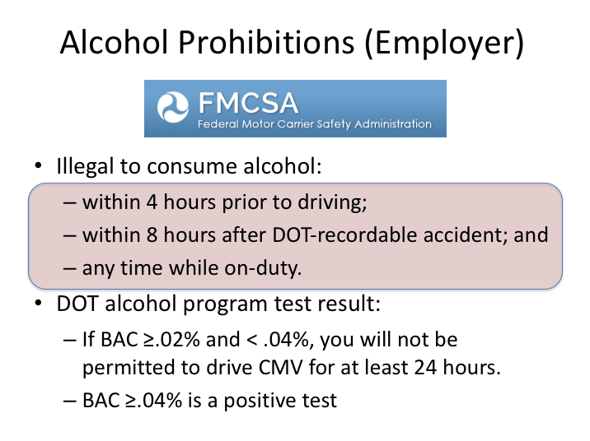

**ALCOHOL PROHIBITIONS (EMPLOYER)**

The alcohol regulations in FMCSR Part 382 state that no driver shall drink any intoxicating beverage while on-duty or within:

* 4 hours of going on-duty in a safety-sensitive position; and
* 8 hours following a DOT-reportable accident.

Safety regulations require random and reasonable suspicion testing for both controlled substances and alcohol.  Random alcohol tests can occur at any time immediately prior to, during, or immediately following performance of safety-sensitive functions.

For employer DOT-regulated alcohol tests:

* If BAC is ≥.02% and <.04%, an employee cannot perform safety-sensitive functions (includes driving a CMV) for at least 24 hours.

**ALCOHOL PROHIBITIONS (EMPLOYER) (continued)**

* If BAC is ≥.04%, this is considered a positive test and the driver must be removed from safety-sensitive functions (includes driving a CMV) until completion of a designated substance/alcohol abuse program and return-to-duty testing process.

If a current employer terminates a driver for testing positive, as many do, a driver must still complete the designated counseling program and return-to-duty process before being allowed to drive a CMV for any other carrier.

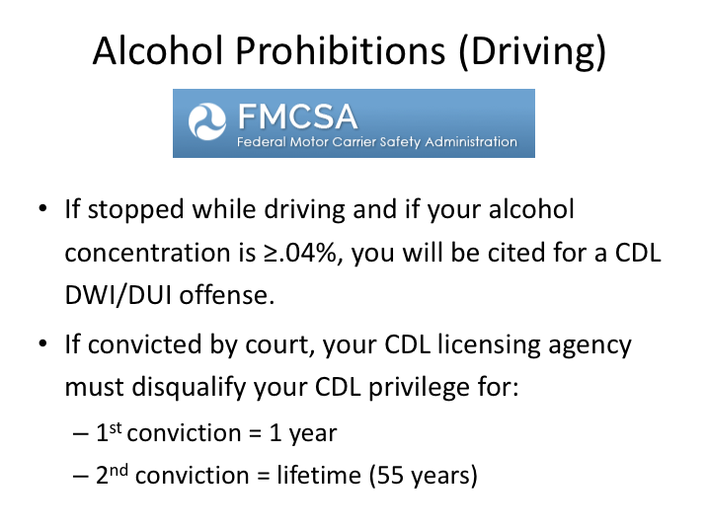

**ALCOHOL PROHIBITIONS (DRIVING) NARRATIVE**

Positive DWI/DUI determinations are made by an alcohol test ordered by a law enforcement officer; it is not determined by a random or other employer/DOT-sanctioned test.  For such officer ordered tests, if a driver’s blood alcohol concentration is determined to be ≥.04%:

* The officer will write a citation for a CDL DWI/DUI offense;
* The offense will be adjudicated in court; and

If convicted, the driver’s CDL will be disqualified by the State driver licensing agency:

* 1st conviction – one year,
* 2nd conviction – lifetime (55 years)

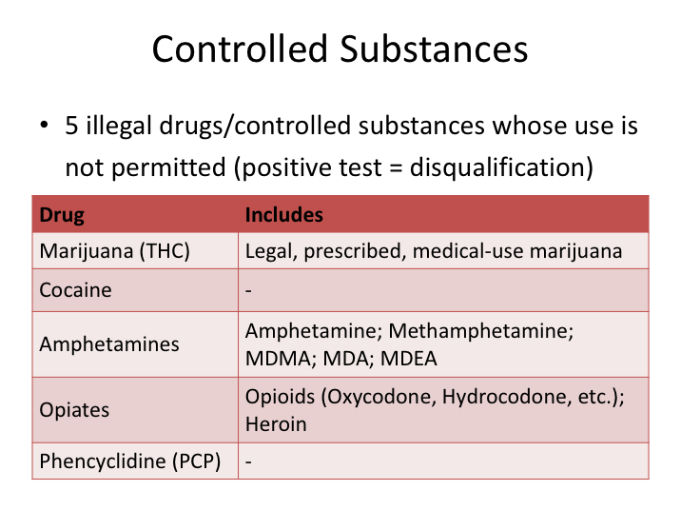

**CONTROLLED SUBSTANCES**

The FMCSRs prohibit driving of commercial motor vehicles, including motorcoaches, by a driver who is under the influence of a dangerous controlled substance. There are five illegal drugs/controlled substances whose use is not permitted by commercial vehicle drivers (limited exceptions apply, as determined by a Medical Review Officer). These include: marijuana; cocaine; amphetamines; opiates; and PCP. Drivers should be aware that medical–use marijuana, even where legal and when prescribed by a physician, is not permitted to be used by commercial vehicle drivers.

Enforcement actions for positive determinations for controlled substances are similar to positive determinations for alcohol, namely:

* If the positive determination is made by an employer-required random or other drug test, the driver must not perform safety-sensitive functions (including driving) until they have completed a designated abuse program and the return-to-duty process.

**CONTROLLED SUBSTANCES (continued)**

* If the positive determination is made by a test ordered by an officer who stopped you while driving, then the officer will:

1. Write a citation for positive drug use;
2. The citation will be adjudicated by the court.

If convicted, it will be reported to your State’s driver licensing agency, which will disqualify your CDL privilege for:

* 1st conviction – one year,
* 2nd conviction – lifetime (55 years)

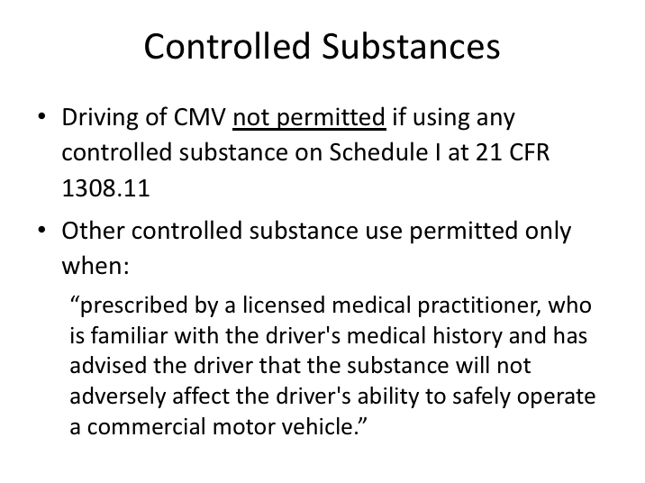

**CONTROLLED SUBSTANCES (continued)**

Federal Motor Carrier Safety Regulations also prohibit any safety sensitive function or driving of a commercial vehicle, including motorcoaches, by any driver who uses any drug or substance identified in 21 CFR 1308.11 Schedule I.

For any other controlled substances, use by commercial drivers is permitted only when the controlled substance has been prescribed by a licensed medical practitioner who is familiar with the driver's medical history and has advised the driver that the substance will not adversely affect the driver's ability to safely operate a commercial motor vehicle.

Many people think that anything prescribed by a doctor is safe to use. Some products, however, can be dangerous. This is especially true if they are used with other prescription or nonprescription drugs. Combining drugs and alcohol can be very dangerous.

**CONTROLLED SUBSTANCES (continued)**

When a doctor prescribes a drug, always ask if there are any side effects and if it is safe to drive when using the drug. Take only the amount prescribed and be aware that not all people react in the same way to drugs. When prescribed a new drug, it is strongly advised that drivers should not operate a motorcoach unless they have already been using the drug for a couple days and have been able to gauge their personal reaction and any side effects.

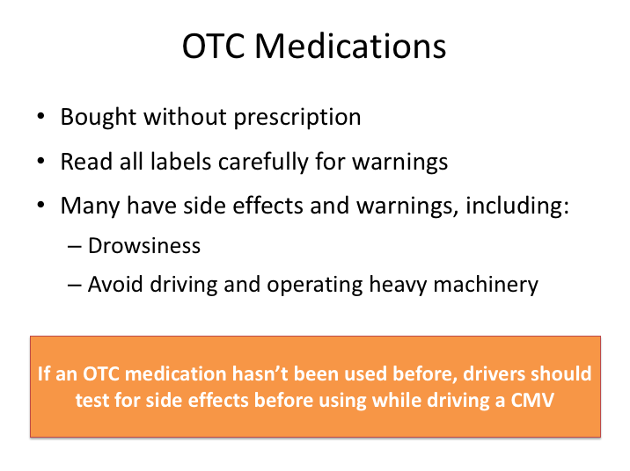

**OTC MEDICATIONS**

Over-the-counter (OTC) drugs are medications that can be bought at a store without a prescription. Drivers should also be aware of the potential side effects from these types of medications. Some products, like antihistamines used for colds and allergies, can make the user drowsy. Read all warning labels carefully and follow dosage instructions carefully, including any specifications of when the drug should be taken (e.g., bedtime). Some OTCs will advise to avoid driving when using the product. If you’re uncertain, check with the pharmacist or physician.

Even for OTC medications that don’t have any specific warnings or side effect notifications, it is still considered wise for a commercial driver to try the medication and evaluate it for side effects prior to driving a commercial vehicle while using it. Remember, it is your personal responsibility to ensure that you are fit to drive when you are dispatched on a trip.

Drivers should also be aware that employers of commercial drivers are permitted to require drivers to notify them when they are under therapeutic use of any drug or medication.

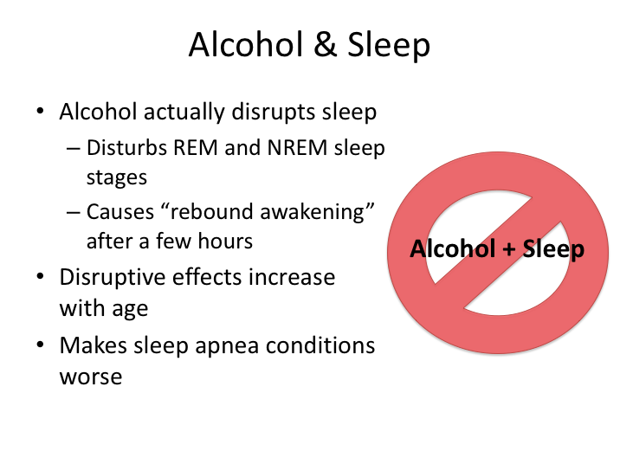

**ALCOHOL & SLEEP**

Due to its sedative effect, alcohol is a common choice for those who have a hard time finding a way to fall asleep.  It’s important to consider the *other* effects, however, that alcohol will have - namely on the very sleep people use it to achieve. While it may make you sleepy, alcohol actually disrupts sleep patterns.

Alcohol disturbs both NREM and REM stages of sleep, and also causes rebound awakening after a few hours, when your body tries to return to a non-alcohol induced metabolic state.

Alcohol can also make sleep disorders more frequent or increase your susceptibility to acquire them. The most common sleep disorder that occurs as a result of the consumption of alcohol before bedtime is obstructive sleep apnea (OSA). And, if you already have OSA, alcohol can make it worse.

Alcohol and driving motorcoaches doesn’t mix even when done significantly before you take the wheel. Refrain from alcohol use while on multi-day trips and save the drinking for home when you don’t have to drive the following day. And remember, regulations prohibit alcohol on-board commercial motor vehicles, with limited exceptions for motorcoaches.

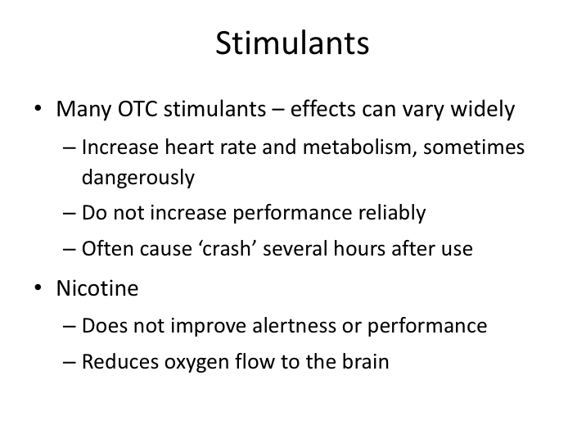

**STIMULANTS**

Sometimes, drivers turn to stimulants to try to stay awake, especially if they are feeling fatigued. As you know, amphetamines are illegal or available only with a prescription. However, there are scores of OTC stimulants available that are found easily in travel centers, drug stores, etc.

The effects of these stimulants can vary widely, and it is not suggested you use them unless you are familiar with them and their effects on you. Many of them dangerously increase heart rate and do not reliably and consistently increase performance. Often, the short-term alertness resulting from use of these medications is followed by a drastic and sudden decrease, or “crash”, when the medication wears off. And, they can affect main sleep periods if taken within hours of them.

Many commercial drivers also smoke. The dangers of smoking are well documented, but it’s important for the commercial driver to understand that smoking actually reduces oxygen flow to the brain. Smoking does not help wake a driver up or make him or her more alert.

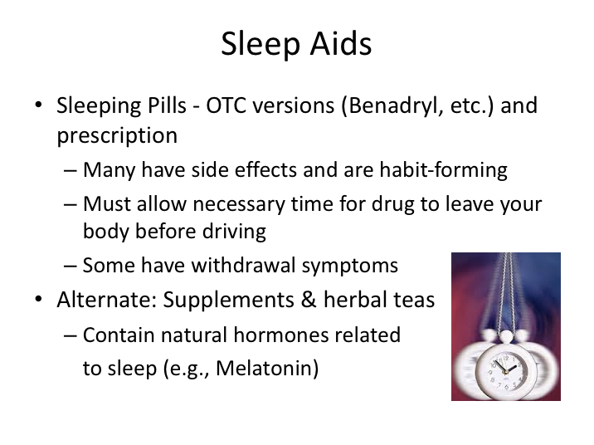

**SLEEP AIDS**

Sleeping pills contain hypnotics – drugs used to induce sleep. Some sleeping pills are also used to treat anxiety and stress disorders.

Sleeping pills can be either over-the-counter versions or prescribed. Many of them have side effects and most are habit-forming; some even cause withdrawal symptoms if you try to stop taking them even after using them for only short periods. Always be aware of side effects and the potential for becoming addicted to them. If you do use a sleeping pill, be sure you allow enough time for the drug to leave your body before driving a motorcoach.

If you are looking for a sleep aid, a better option instead of a sleeping pill may be a supplement or herbal tea. These contain natural hormones secreted in your body that are related to sleep. Small doses can facilitate nightly sleep and there are no serious side effects known, though they are not tested or regulated by the government. Examples include Melatonin and Valerian Root.

LESSON 3

TRIP PLANNING & VERIFICATION

**Lesson Objectives:** At the end of this lesson, you will have a basic understanding of how to plan a trip and also how to review trips assigned where most of the planning has already been performed by dispatch. You will understand how to obtain necessary trip-specific knowledge, such as applicable state laws and weather forecasts.

**Instructional Methods**: Classroom

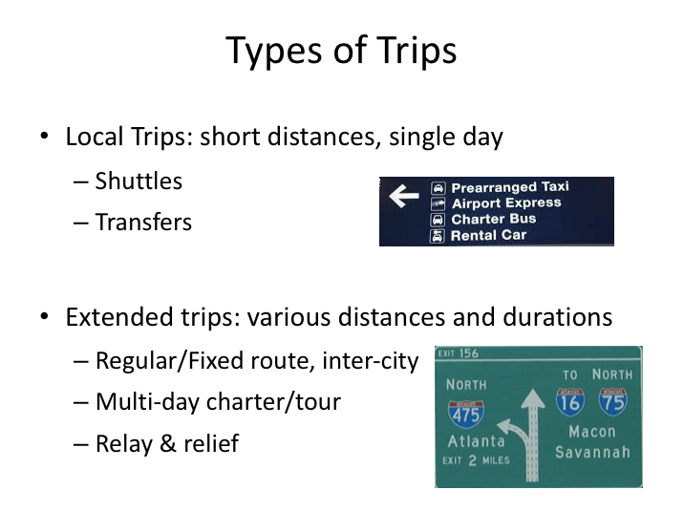

**TYPES OF TRIPS**

There are times when trip planning will be necessary and should be undertaken; at other times it won’t be very critical. Some carriers operate only a single type of trip. Other carriers operate many types. Let’s review the types of trips operated in the industry and identify the ones where trip planning may be wise.

Local trips are trips that are of relatively short distances, and generally are accomplished in a single day/duty period. Some examples are:

**Shuttle Operations**: In shuttle operations, drivers transport passengers between nearby points. The route and stops are usually repetitive.

**Transfers:** Transfers are local charters where a group is taken between points, or round trip to and from a local attraction or destination. An example would be a transfer from an airport to a hotel, or a round-trip from a school to/from a nearby historic attraction.

**TYPES OF TRIPS (continued)**

Extended trips are trips of various distances and durations. There is more variation to these types of trips, but they are generally characterized by an overnight stay and multiple driving/duty periods by the driver. Examples include:

**Regular/Fixed-Route**: A regular route refers to transporting passengers between specified origins and destinations using assigned highways. The highways to be used may be set forth in the company’s operating authority or established through company policy. Intermediate stops are well-defined and established by schedule and return trips may be operated by the same driver on the same or next day, depending on the distances involved.

**Multi-day Charter/Tour (Irregular Route)**: An irregular route describes transporting passengers between a combination of origin and destination points using any suitable route. The customer, in conjunction with the sales or operations department, often determines the destination points and schedule.

**Relay/Relief Runs:** Relay and relief runs are similar. A relay run refers to a trip in which a driver drives for up to 10 hours to a prescribed point from which another driver takes the trip to the next point. This cycle may be repeated several times as several different drivers drive the coach from origin to final destination. A relief run is similar, but the driver is pre-positioned and takes over the coach for the relay driver. These terms are often used interchangeably since the trips are similar – either the driver is taking the bus to another driver or taking over for another driver at a pre-determined position/location.

**Sleeper Operations:** The driver(s) of a coach that has a legal sleeper berth can accumulate the required off-duty time in two qualified periods in the sleeper berth itself, usually while a second driver who has rested takes over. After getting necessary rest, the original driver switches with the second driver and the cycle repeats. Utilizing two drivers, this type of coach can roll continuously without stopping for significant distances. In team operations, drivers usually exchange duties every 4-5 hours so one driver can rest in the sleeper berth while the other drives. Coaches equipped in this manner are not common in the U.S., and they are generally purpose-specific.

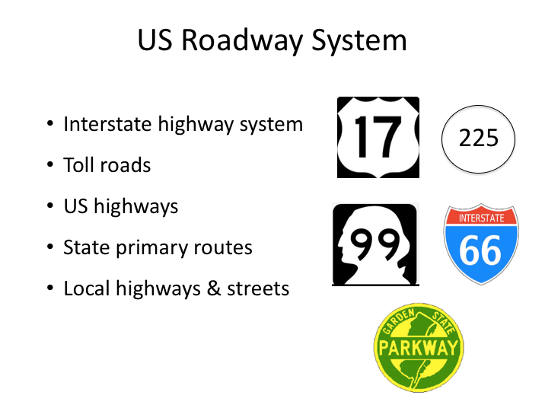

**US ROADWAY SYSTEM**

The types of trips where you are likely to be involved in trip planning, or at least verification, are the multi-day charter/tour trips and any sleeper operations, if your company operates those. Local trips require little planning, and fixed-route and relay/relief trips are pre-planned. In many cases, even on multi-day charter/tour trips, company management will specify a particular route because they’ve determined it best. Companies have usually operated similar trips in the past and have experience operating in those areas. When this occurs, you should follow the company-provided route unless you have a good reason to deviate from it. Going off an assigned route without a very good reason is usually against company policy.

Drivers should know how to plan a trip – even though it may be something they never do from scratch. In today’s technological environment the skill of trip planning by the driver is somewhat of a lost art. However, the most prepared drivers will know trip details well in advance and verify plans detailed by company dispatch (especially if they are unsure of, or unfamiliar with, any of the assignment details).

**US ROADWAY SYSTEM (continued)**

Before we even get to choosing or verifying a route, let’s discuss the road system in the United States. While you’re familiar with it, a review as it relates to accommodating motorcoaches and preferred roadway types will be beneficial.

There are many types of highways, with each type coded/labeled on maps and programs. If you understand this code, you will be able to determine which roads are interstate highways, which are state highways, or which may only a country road. The types of highways are described in the following section. They are listed in order of preference of use.

**Interstate Highways**: These routes are usually preferred because they separate opposing traffic, have limited access, and bypass many small communities. Although they are the safest type of highway, drivers must be aware that these highways can be snarled up by bad weather or traffic congestion, especially in urban areas. In selecting the interstates, drivers should note other available routes in case of a major traffic problem on the interstate.

**Toll Roads**: Except for having to pay a toll, these roads are similar to the interstates. In many states, toll roads are part of the interstate system. Whether to use a toll road must be based on many factors in addition to price. Considerations include differences in time and distance over alternative routes; terrain; road conditions; ability to avoid congested traffic areas; potential of stop-and-go driving; and fuel usage.

**U.S. Numbered Routes**: These major through-routes were the major highways prior to establishment of the interstate system. Those that parallel the interstate roadways may be good alternatives in case of delays on the interstate.

**State Primary Routes**: These are the major routes within each state. In some instances, a state primary route may be as good as, or even better, than a nearby U.S. numbered highway.

**Local Streets and Highways**: Drivers will have to use other types of roads to reach a loading or unloading point. In general, major local through routes are designated by a number or letter and better able than other local streets to safely handle large vehicles, including motorcoaches.

Of all the roadways you will travel, a driver must use extreme care when driving on local streets that often were not designed for coach traffic. Drivers should avoid using side streets because they may have hazards such as low clearances, unsafe railroad crossings, poor road surfaces, and sharp turns that are not apparent.

|  |
| --- |
| Clipart |

Match the sign images on the slide to the type of roadway. See if you can identify what state the State Highway Route sign is from.

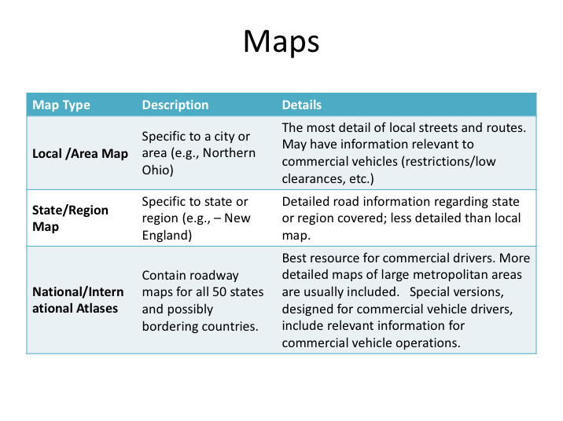

**MAPS**

Map reading may be a largely lost art, but every professional driver should know where to find maps - and how to read one. Sooner or later, the driver will have to locate unfamiliar pickup and delivery points and will need a map - especially for local route access and also for reference when something unexpected occurs that would require you to deviate from a planned route. Personal GPS systems and internet maps reviewed on phone screens allow one to browse the map, but the screen size limitations make it difficult to see complementary or alternate roadways which may be better suited for a large vehicles, such as a motorcoach.

There are several types of maps available including local and state specific, national maps, and atlases of various types. Here is a description of each:

**Local or area map**: A local or area map can be useful to a driver because it will show local streets in detail. However, finding local maps is becoming harder as electronic maps replace printed ones. Some show a single city, while other types may show one or two counties or a region. Because of the rapid growth in many areas, these maps can become dated quickly.

**MAPS (continued)**

**State/region map**: State maps can often be found free at visitor information centers along the interstates. They also can be bought at truck stops and travel centers. While less detailed than local maps, they will provide more finite road details with regard to the state or region they are covering.

**Atlas**: A driver who expects to cover a large territory should consider purchasing an atlas. The atlas contains maps of all the states, the Canadian Provinces and, in some cases, Mexico. Detailed map inserts of large cities and metropolitan areas are also included. While local and state maps are the most detailed, drivers will likely find these national atlases, developed specifically for commercial drivers, the most informative and sufficient for most needs. These atlases have state-specific information relevant to commercial drivers, including information on weight station protocols, speed limits, lane restrictions, low clearances, size and weight limits, state-specific laws, and other relevant topics.

Primary and secondary roadways do not change quickly, so these maps can be relevant for quite some time. Considering this, drivers may want to spend the money to get a deluxe copy that will last for a long time, such as a spiral-bound, laminated commercial driver atlas. These atlases can be found at truck stop/travel centers or purchased online.

**Software/Internet**: Mapping software allows you to map your route from street address to street address, or in some cases local attractions. Some software is interactive and will update road construction information along your route, allowing you to plan for delays or select another route. It will give you the mileage, even breaking it down to the distance between turns, and some software will estimate your expenses for you. Information provided on these types of maps is the most dynamic and up-to-date. However, these mapping programs do not provide ancillary information that atlases do and are difficult to view when traveling and quick access is needed. Perhaps most importantly, software mapping may not take into account the large size of your motorcoach, and therefore ignore any applicable route, height, or weight restrictions.

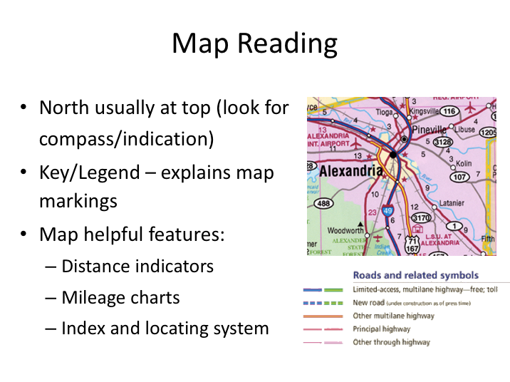

**MAP READING**

The following pointers will help you when reading a map.

In most cases, **North** is at the top of the map. Often it is also indicated by an arrow symbol with the letter N or a symbol showing all four points of the compass. In some cases, a map of a small area may be printed with North to one side. North will always be shown by some symbol.

Read thekey, or legend, that explains the symbols and colors used to show the interstates, federal, state, and local routes, rest areas, interchanges, distances, and other important features.

You can figure the distance between points by adding the mileage figures shown along the route. Using the scale of the map is not accurate because measuring with a ruler will give only the straight-line distance, which is shorter than driving distance. Many maps have mileage charts showing approximate distances between principal cities and towns. Many atlases have a special matrix showing distance and estimated driving times between principal cities in a state or region.

**MAP READING (continued)**

Learn to use the grid coordinates to locate points on a printed map. Numbers are printed across the top and bottom of maps, and letters are printed down each side. Most maps also have an index. On a state map, the index will list names of cities, towns, and villages. On the map of a city or region, the index will list street names. In each case, the location will show a letter and a number, for example C-6 or C6. To find the location, look down from 6 and across from C. The point will be near where the imaginary lines from the number and letter cross on the map.

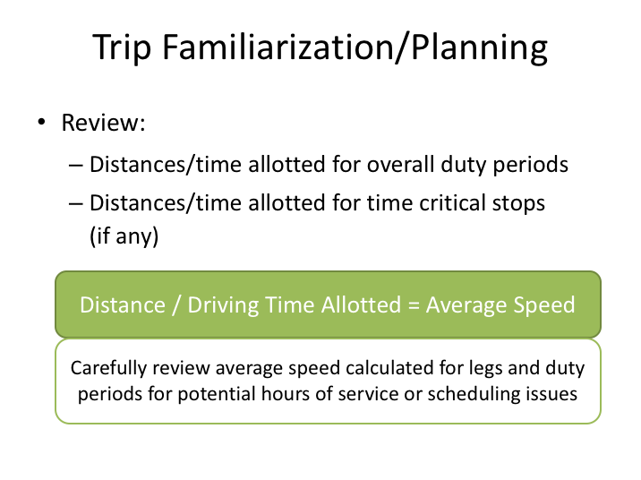

**TRIP FAMILIARIZATION/PLANNING**

Whether you’re actually planning a trip/route yourself or simply verifying dispatch orders, the process should be somewhat similar. There are several things you’ll need to know before beginning to determine or review a route. Information required includes the height of the motorcoach you’ll be operating, the anticipated gross weight, the fuel tank capacity, and an average miles per gallon (MPG) estimate. Companies should be able to provide this information to you prior to the trip since they usually schedule/allot motorcoaches to trips beforehand in the dispatch system.

You should try to obtain your dispatch orders as soon as possible before you begin the trip – often times they will be available at least a day before. If you have not received them prior to the trip, you’ll want to show up early so that you can allot time to review the details.

Your first step is to review the origin and destination/intermediate points and the route provided. This process is to verify that you can complete the trip as scheduled within legal driving time restrictions and ensure that time schedules are reasonable.

**TRIP FAMILIARIZATION/PLANNING (continued)**

You should initially verify several items: distances for each duty period (driving day), travel time, and route chosen (duty period refers to the time period in between receiving consecutive eight hours off as prescribed by the hours of service regulations). When determining whether there could be mileage/time issues, some rough calculations can be helpful.

Drivers must comply with speed limits and DOT hours of service limitations. When a driver’s record of duty status (driver’s log) is checked, enforcement personnel will often determine the average speed; this will tell them if the driver may have been speeding or may have falsified the record of duty status.

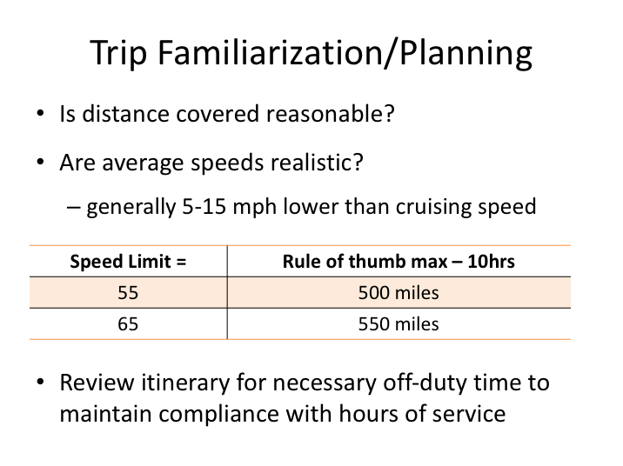

**TRIP FAMILIARIZATION/PLANNING (continued)**

The Department of Transportation has published these standards to determine if a driver has been speeding or there are other hidden issues.

Where the predominant speed limit is 55 mph:

* A trip of 450 to 500 miles in 10 hours is open to question. This means the driver had an average speed of 45-50 miles per hour.
* A trip of 500 to 550 miles in 10 hours (average speed of 50 miles per hour or more) will be considered not in compliance with the hours of service and the speed limit.

Where the predominant speed limit is 65 mph:

* A trip of 500 to 550 miles in 10 hours is open to question (average speed 50-55 miles per hour).
* A trip of more than 600 miles in 10 hours (average speed of 60 miles per hour or more) is considered not in compliance with the hours of service and the speed limit.

**TRIP FAMILIARIZATION/PLANNING (continued)**

The distance that can be covered in 10 hours of driving will depend on the speed limits and other factors such as heavy traffic, travel through urban areas, hilly terrain, adverse weather, or anything that can reduce the safe operating speed. Generally, the average speed for a trip will be 5-15 mph below the cruising speed.

The trip itinerary should also be reviewed to ensure that appropriate hours off-duty are allotted in between duty/driving cycles to ensure compliance with hours of service regulations. Also make sure there are enough rest stops allotted, especially if driving during the night. If a driver has safety concerns after reviewing a trip itinerary, they should be brought to management’s attention immediately.

If you are planning a trip yourself, you should begin by determining the routes you will take between the origin and the final destination. Then, determine where you will be stopping en-route, for either intermediate rest stops or overnight stops.

**EXERCISE**

You will be provided an atlas with beginning and end points for a trip greater than 900 miles. Plan the route, including intermediate stops.

Important data: cruising speed = 48 mph.

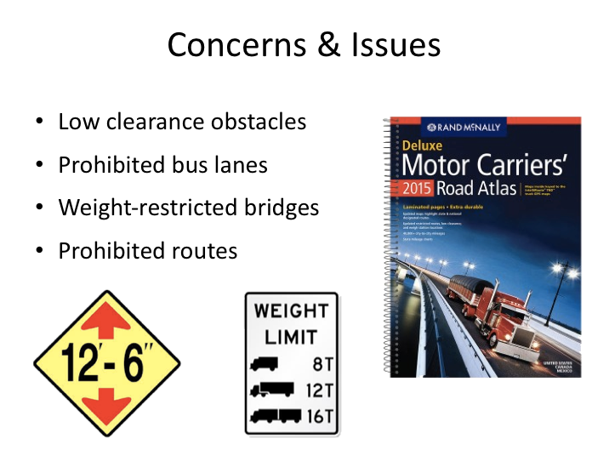

**CONCERNS & ISSUES**

After ensuring that the average speeds and the distances are reasonable, drivers should review the route for any routing issues. Some of the special situations you may find are:

**Low clearance obstacles on local roadways:** Height restrictions/clearance issues may prevent you from using some of the planned/routed local roads. This issue is generally not found along major US or state interstates/highways, so a search can be reasonably limited to local roads. However, drivers should always be on the lookout for clearance issues on any roadway, whether they’ve reviewed a map/atlas in advance or not.

**Prohibited bus lanes**: Some routes redirect certain lanes for bus use. This happens frequently in construction zones. If you use restricted lanes, you may get a ticket. Stay alert for signs informing you of these restrictions.

**Posted bridges**: Many bridges have special weight restrictions. Do not cross a bridge if your coach’s weight is more than the weight that is posted. Some fines are as much as $10,000.

**CONCERNS & ISSUES (continued)**

**Prohibited routes**: Always heed posted prohibitions, even if it means driving to a point where you can obtain information. If you do drive on the road, you may be faced with a hazardous condition or be unable to avoid a crash.

Even when checking for these concerns ahead of time, it is not possible to foresee every restriction or travel issue a driver may encounter. It is up to the driver to be on the lookout for these and similar situations and to remedy the situation using common sense and advice from dispatch as necessary (or instructed).

|  |
| --- |
| Clipart |

Look at the weight limit and clearance signs on the slide. Indicate in your study guide whether or not you can proceed under the clearance obstacle and over the bridge. You should assume you are operating a 57-passenger coach and you are empty.

If you should find yourself on a road, or approaching a bridge, and there are signs saying “Weight Limit 10 Tons,” you have a weight problem, even if you are empty. What do you do in this situation?

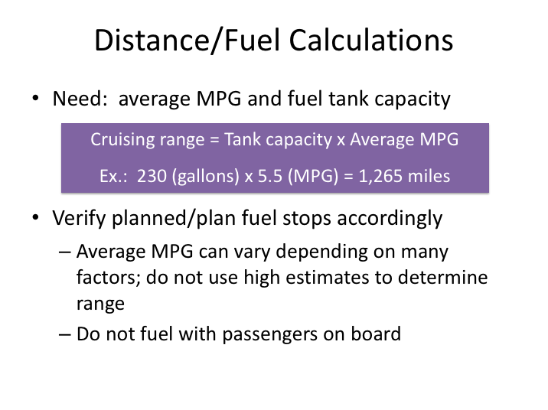

**DISTANCE/FUEL CALCULATIONS**

The next step in verifying or planning a route is to determine when you’ll need to fuel.

Fuel consumption for any given motorcoach will depend on a variety of factors. However, the company should have a decent idea of the average expected fuel mileage for any given make, model, and year coach they operate. Using the estimated average miles per gallon (MPG), and the size of the fuel tank, the cruising range of the motorcoach can be established.

Example:

Cruising range = Tank capacity x mpg

Tank capacity = 230 gallons

Miles per gallon = 5.5

**Cruising range** = 230 (gallons) x 5.5 (mpg) = 1,265 miles

**DISTANCE/FUEL CALCULATIONS (continued)**

Once you’ve established the cruising range of the motorcoach, you can verify that you are able to travel between planned fuel stops or you can use the information to plan the fuel stops yourself. Fueling the motorcoach should always be done without passengers on board, so the fuel stop should coincide with either an intermediate rest stop, or more likely, the destination of the day.

The driver must be aware that under actual operating conditions many factors can increase fuel usage. Some of the more important factors include:

* Prolonged idling
* Driving too fast
* Extended operation in low gears
* Stop-and-go driving
* Mountainous terrain
* Headwinds
* Incorrect tire pressures
* Defects in the engine or fuel system

In addition to refilling the fuel tank, you may have other fluids to replace/refill occasionally, such as diesel exhaust fluid (DEF).

If you’d like to calculate your actual fuel mileage at some point, you will need to know how much fuel has been used and the distance traveled. If you start a trip segment with a full tank, you can use the refill information when you refuel to determine how many gallons of fuel have been used. Then, utilizing the mileage traveled during that time period, you can calculate your average MPG by dividing the gallons of fuel used by the miles traveled.

**Distance covered / Gallons of fuel used = Average MPG**

Example: 510 miles (distance covered) / 102.7 gallons (fuel added) = 4.96 Average MPG

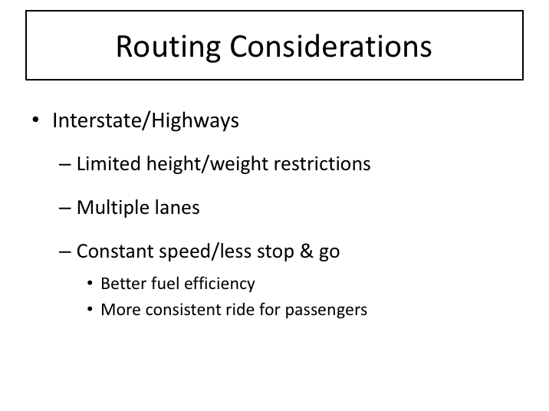

**ROUTING CONSIDERATIONS**

In general, traveling on interstate/highway routes will be the routing that provides the most benefits.  Height and weight restriction concerns are limited, and less stop-and-go will equate to the best fuel efficiency.  Plus, the more consistent ride will be more comfortable for passengers.

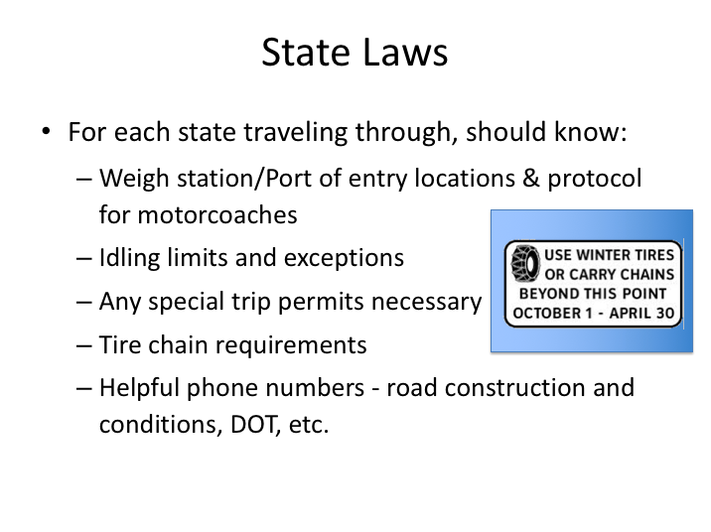

**STATE LAWS**

The itinerary should be reviewed to determine what states the trip will be traveling through. If drivers are unfamiliar with commercial vehicle rules and regulations in the states the trip will be operating through, they should consult resources such as commercial vehicle specific atlases or state Department of Transportation (DOT) websites for necessary information, including:

* Weigh station/Port of entry locations and protocol for motorcoaches – some states require motorcoaches to stop at weigh stations and ports of entry if they are open, while others do not. Not stopping at these scales is a serious offense, so make sure you know when to stop.
* Idling limits and exceptions – each state generally has an idling restriction for commercial vehicles. These idling restrictions are sometimes excepted if there are passengers on board.
* Any special trip permits necessary - any required trip permits will likely have been attained by the company prior to beginning the trip. However you should be aware of where these are required and where you may need to produce them.

**STATE LAWS (continued)**

* Tire chain requirements during winter months – some states not only require the use of tire chains in certain circumstances, but they also may require chains to be on-board during certain times of the year - even when use is not required at any specific moment.
* Helpful phone numbers such as construction hotlines, departments of transportation, weather conditions etc. – having a list of state-specific phone numbers to various information and assistance lines can be helpful when you find yourself in unusual or unfamiliar situations.

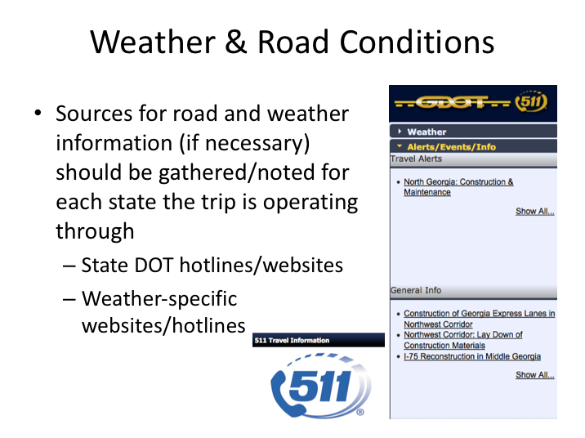

**WEATHER & ROAD CONDITIONS**

Prepared drivers like to know about road conditions, including construction, as well as any potential weather issues prior to initiating their trip. Being mentally prepared for such circumstances can help alleviate the stress that can accompany them and alternate plans, if necessary, can be developed ahead of time.

There are several sources for information. Since these conditions are constantly changing, atlas maps and internet mapping sites will not have the most up-to-date information.

For construction information and any last minute road closures or issues, state department of transportation (DOT) websites or hotlines are your best source for information.

For weather, state DOT websites or general weather related information services and websites, such as the Weather Channel, are your best sources for up-to-date information.

**WEATHER & ROAD CONDITION (continued)**

If you foresee any potential weather issues or concerns, you should confer with dispatch. They can generally monitor situations and provide you updates as you proceed and, if necessary, develop alternate plans in the event they are necessary.

Many states have a very specific number for any type of roadway information, such as North Carolina’s (and others) 511, though these numbers will usually only be recognized when calling from within that state.

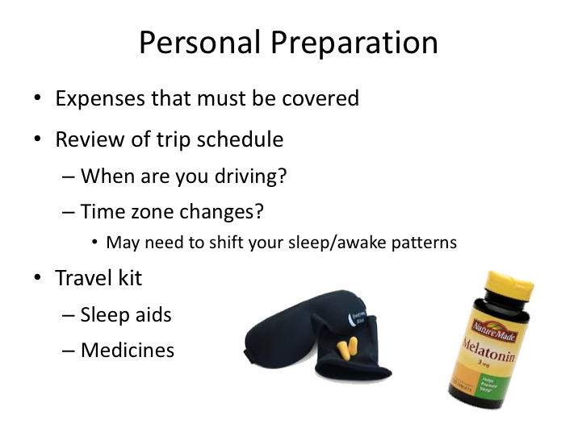

**PERSONAL PREPARATION**

Drivers should prepare for personal needs prior to each trip, especially multi-day trips. Personal preparation includes anticipating expenses he or she must meet while on the trip, and determining how payment will be made. Most trip expenses will usually be covered or paid by the company or the group. For any out-of-pocket expenses, drivers must usually retain receipts for reimbursement. In general, the only expenses not covered or reimbursed will be driver meals, unauthorized tolls, and any violations!

Review the trip schedule to determine driving periods. How do these driving periods relate to your current sleep/wake cycle? If they are vastly different, you may need to shift/adjust your sleep/awake pattern ahead of time to more closely match the driving pattern of the trip. The same holds true if there are significant time zone changes. If there are significant time zone changes throughout the trip, you’ll want to ensure that there is proper time allotted off so you can adjust. Sometimes, if it is a short trip, it is best to stay on your “home” time zone sleep/awake pattern, if schedule permits.

Also ensure that you take any necessary medicines with you, as well as sleeping aids in the event they are needed to obtain proper rest.

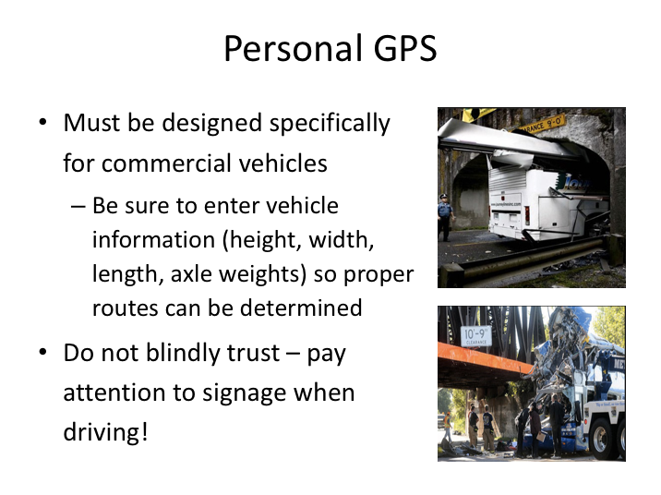

**PERSONAL GPS**

Let’s discuss personal GPS systems. These have become very prevalent and are used widely by drivers of all types of vehicles. Some companies do not permit their use while driving a motorcoach, others do.

Commercial drivers must understand that most of these GPS systems are not designed specifically for commercial vehicles. Using a GPS system that is not specific to commercial vehicle operations can result in tragedy. There have been several collisions where drivers failed to recognize a low clearance situation because they were following a personal GPS that was not designed specifically for commercial vehicles. Tragically, some of these collisions have resulted in deaths and serious injuries. If you use a navigation system that does not provide you with important route restrictions, the shortcut you thought would save you time and fuel may, in fact, end up costing you much more than you bargained for.

Systems design for commercial vehicles will generally be marked or marketed as such. While they may cost more than a personal GPS, the information they provide is invaluable. Generally, they will require you to input information about your vehicle including length, width, and height.

**PERSONAL GPS (continued)**

They also may request your axle weights. This information is used to determine routes that can accommodate a vehicle given the specifications provided.

Even if you have one of these specially-designed GPS systems, you should always obey traffic signs and advisories – especially if they provide restrictions that the navigation system did not warn you about.

Also, refrain from using and manipulating any GPS system while driving. Distracted driving is dangerous and can result in serious collisions.

**TRIP PREPARATION**

**QUIZ**

1. The single biggest factor in reducing fatigue is getting proper sleep.
2. True
3. False
4. What are the two peak periods of sleepiness for most people, according to circadian rhythms?

1. 3-5 am and 3-5 pm
2. 2-6 am and 12-2 pm
3. 4-7 am and 2-4 pm
4. 1-4 am and 1-3 pm
5. The average adult needs how many hours of sleep per night?
6. 4-5 hours
7. 5-6 hours
8. 6-7 hours
9. 7-8 hours
10. 8-9 hours
11. Which of the following affects sleep quality?
12. Quantity
13. Bed comfort
14. Time-of-day
15. Darkness of room
16. All of the above
17. Circadian rhythms are often referred to as the body clock.
18. True
19. False
20. Which would be considered a task-related fatigue factor?
21. Insufficient prior sleep
22. Being awake for 18 hours straight
23. Driving on a boring road
24. Overall mood
25. All of the above
26. Which of the following is the most important foundation for an overall healthy lifestyle?
27. Proper sleep
28. Proper eating and nutrition
29. Exercise
30. Positive relationships
31. Positive behaviors
32. What percentage of commercial drivers are considered overweight?
33. 25%
34. 40%
35. 55%
36. 75%
37. 80%
38. Your ability to maximize alertness and energy levels highly depends on the food choices that you make.
39. True
40. False
41. Which of these protein dishes is lowest in fat?
42. Broiled rib eye
43. Chicken-fried steak
44. Shrimp sautéed in butter
45. Bacon-wrapped scallops
46. Grilled snapper
47. If you can’t devote to at least 30 minutes of physical activity for exercise, then it’s not worth doing any at all.
48. True
49. False
50. Stress is a normal physical response that is always bad for performance and health.

1. True
2. False
3. Coffee and fresh air will help a drinker sober up.
4. Myth
5. Fact
6. Every person who drinks is affected by alcohol.
7. Myth
8. Fact
9. What is the threshold for a positive blood alcohol concentration determination for a CDL commercial vehicle driver?
10. .02%
11. .03%
12. .04%
13. .05%
14. .08%
15. If a doctor prescribes a drug, it is safe to assume that it is okay to drive when using the drug.
16. True
17. False
18. Alcohol disrupts REM and NREM sleep stages.
19. True
20. False
21. Since GPS’s are now available, there is no need to learn how to read a road map.
22. True
23. False
24. How can fatigue affect your driving performance?
25. Reduces concentration
26. Slows reaction time
27. Impairs judgment
28. A & B
29. All of the above
30. All GPS’s are designed the same for vehicle cars and commercial vehicles.
31. True
32. False