**Motorcoach Orientation & Familiarization**

|  |  |  |
| --- | --- | --- |
| Screen Shot 2014-09-25 at 5.18.54 PM.png |  | Screen Shot 2014-09-25 at 4.53.50 PM.png |

**Purpose:**

The purpose of this training module is to familiarize students with motorcoaches and, when possible, the specific coaches they will be operating. Students will gain an overview of motorcoaches including configuration and common nomenclature and will learn key concepts regarding seat and mirror adjustments. Students will be oriented to vehicle controls and displays in the driver cockpit area, as well as exterior components and compartments.

**Module Overview**:

The training module contains four lessons - two classroom and three on-board exercises. The first lesson will provide students with an overview of motorcoach configuration and nomenclature. The second lesson will provide detailed instructions for seat and mirror adjustments. The third lesson gives the students hands-on experience with coach controls and practice in identifying and operating/reading interior controls and displays. The fourth lesson identifies exterior components and compartments as well as gives students a detailed walkthrough where name, location and function can be identified.

Lesson 1: Motorcoach Configuration and Nomenclature

Lesson 2: Seat and Mirror Adjustment

Lesson 3: Interior Controls and Displays

Lesson 4: Exterior Components and Compartments

LESSON 1

MOTORCOACH CONFIGURATION AND NOMENCLATURE

**Lesson Objectives**:

By the end of this lesson, the students will understand motorcoach design, specific areas of importance, and have a foundation for on-board familiarization exercises.

**Instructional Method:** Classroom

**Approach:**

Utilizing the generic motorcoach graphics provided, walk students through motorcoach design and nomenclature. At a minimum, your review should include the items noted for each view, with emphasis on noted components.

**Instructor Note –**

If available, substitute similar photographs of your own coaches into slides, replacing the generic ones chosen.

**LESSON INTRODUCTORY NARRATIVE**

*Student Guide reference here*

Motorcoaches are complex and complicated machines, and they are ever evolving. If you’re new to the motorcoach industry, it will take you some time to become familiar with the various terminology, components, and systems in the modern motorcoach.

Even if you’ve been around the industry for a while, there is still much to learn - and perhaps even share with others - during the familiarization/orientation process. Different makes of motorcoaches can be vastly different, from both a vehicle controls standpoint as well as vehicle operating dynamics. There are constantly changing and evolving safety technologies on vehicles, such as electronic stability control, fire suppression, and collision avoidance. Other systems continue to evolve also, such as exhaust filter regeneration and associated diesel exhaust fluid.

No matter what your experience level and with what types of motorcoaches, you can always learn something new by paying close attention to the orientation and familiarization process and asking questions.

*Display PowerPoint slide.*

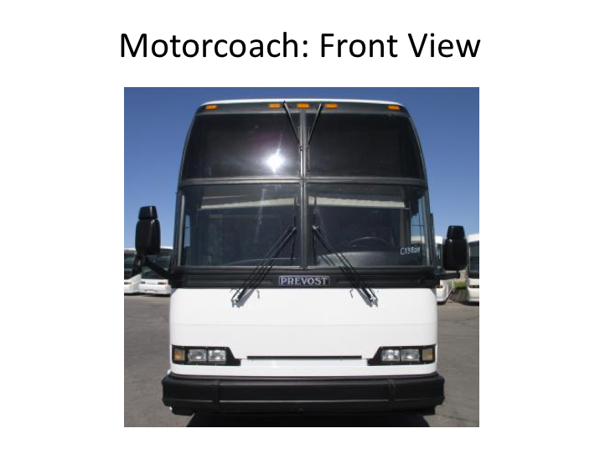

**MOTORCOACH – FRONT VIEW NARRATIVE**

Items/components to detail - motorcoach front pictorial:

* Overall height (point out differences in fleet if you operate buses with significant height differences)
* Ground clearance (note differences if you operate vehicle classes with substantial clearance differences)
* Mirrors (stress importance of these safety devices)
* Steer wheels
* Lighting (headlamps, clearance lights, etc.)
* Windshield
* Windshield wipers
* Bumper (tire storage if applicable)

Sample narrative:

It’s critical for any driver to understand the various components and nomenclature of the vehicle you’re driving. Let’s review some basic components of a motorcoach.

In this image, you’re obviously looking at the front of the motor coach.

* Take note that a motorcoach is tall. Sometimes, a motorcoach can be too tall for some of the clearances of bridges and other fixed objects such as hotel canopies. You should know the height of every motorcoach you operate so you are sure that you can navigate any low clearances safely.
* Next, note that the motorcoach sits very low to the ground. Ground clearance is minimal.
* You’ll know that there are two side view mirrors. These mirrors are a driver’s best friend – getting to know them well, and how to use them properly, can make or break your career as a motorcoach driver.
* You can’t see them very well here, but your steering wheels are the front axle tires and wheels on a motorcoach.
* Headlights, parking lights, & turn signals are seen just above the bumper. Clearance lights are present across the very top of the motor coach.
* Note the large windshields, which may be one or multiple pieces of glass.
* Along with the windshield are the windshield wipers. There are up to four (as seen here), depending upon the coach you are be operating.
* Finally, a note about the bumper. On many motorcoaches, the front bumper swings downward, allowing access to an area that holds the spare tire.

*Display PowerPoint slide.*

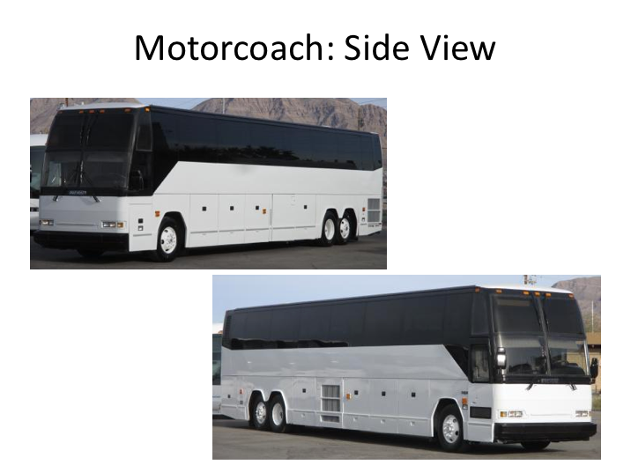

**MOTORCOACH – SIDE VIEW NARRATIVE**

Items/components to detail - motorcoach side pictorials (show both sides):

* Overall length
* Overall height
* Ground clearance
* Side marker lights
* Mirrors
* Wheels & Axles (include nomenclature – i.e., steer, driver, tag, etc. and discussion of axle weight limits)
* Service door
* Windows/emergency exits
* Rear overhang (discuss relation to tail swing)
* Luggage bays (for bays containing specific equipment, indicate)
* Compartment doors other than luggage bays (electrical, engine service, etc.
* Side cameras (if applicable)

Sample narrative:

Now, let’s look at the side of a motorcoach.

While this image also shows the height and low ground clearance of the motorcoach, it also shows the length - which is another key variable that you should know as a driver.

* Take note again of your friends - the side view mirrors - in each of these images.
* In addition to a better view of the steering wheel and axle, you can now see the drive and tag axles. The drive axle is the forward axle in the rear of the coach. The tag axle is the axle closest to the back of the coach – its main function is to support weight.
* The main door used for entry for the driver and passengers is typically called the service door and is on the right side of the coach.
* The black windows that you see running the length of the sides of the motorcoach are great for passenger viewing. But they also serve another purpose – some of these are designated emergency exits and can be accessed and opened for emergency egress.
* The length of the coach from the tag axle to the rear bumper is called the rear overhang. The amount of rear overhang on different motorcoaches will vary; this is another important dimension for a driver to know understand.
* There are various doors along the bottom sides of the motor coach. Many of these access storage bays for luggage or other specific equipment. There are also doors that allow for easier access to various mechanical components, such as fuse panels, batteries, etc.
* Some coaches may even have technology-related items on the sides, such as side view cameras.

*Display PowerPoint slide.*

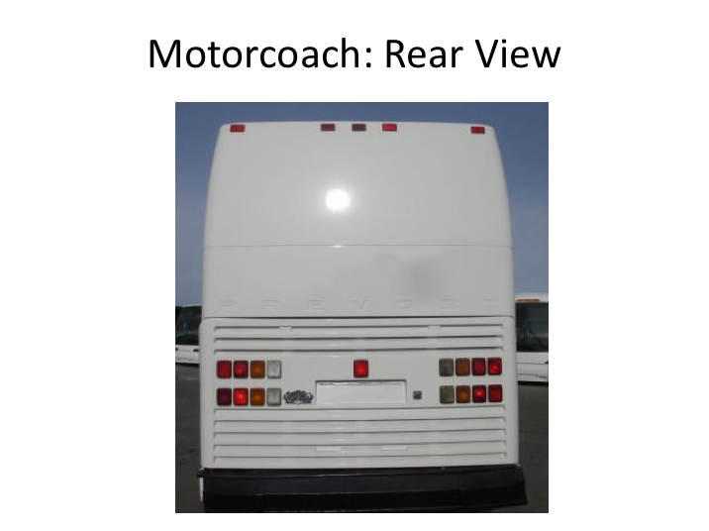

**MOTORCOACH – REAR VIEW NARRATIVE**

Items/components to detail - motorcoach rear pictorial:

* Overall height
* Ground clearance
* Engine compartment
* Lighting (tail light assemblies, clearance lights, etc.)
* Visible wheels/axle
* Back up camera (if applicable)

Sample Narrative:

Now let’s take a look at the rear of a motorcoach.

* Again, note that it’s tall and low to the ground.

**MOTORCOACH – REAR VIEW NARRATIVE (continued)**

* This rear panel with the louvers surrounding the lights actually opens upward to reveal, and allow access to, the engine.
* You’ll notice lighting assemblies both on the lower portion, as well as additional clearance lights at the very top.
* Sometimes you may notice additional technology equipment on the back of the motor coach, such as a backup camera.

*Display PowerPoint slide.*

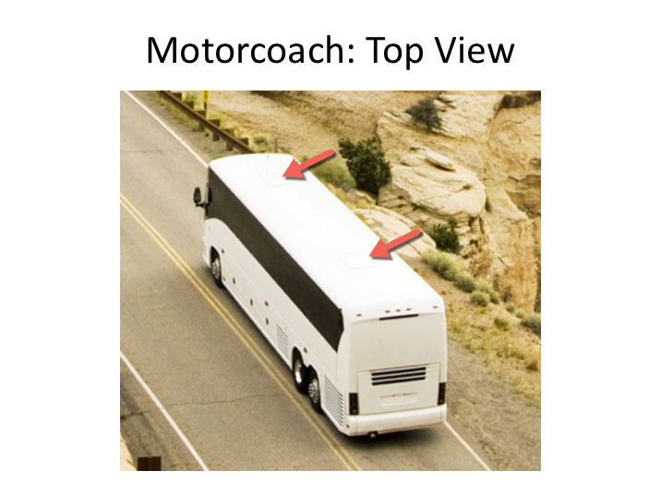

**MOTORCOACH – TOP VIEW NARRATIVE**

Items/components to detail - motorcoach top pictorial:

* Emergency exit(s) (roof hatches)

Sample Narrative:

Finally, let's look at the top of the motor coach. There's not much to describe or see here, except for one important attribute – motorcoaches typically have at least one roof hatch. Roof hatches serve as additional emergency exits and are particularly useful as exits if a coach rolls over onto its side.

*Display PowerPoint slide.*

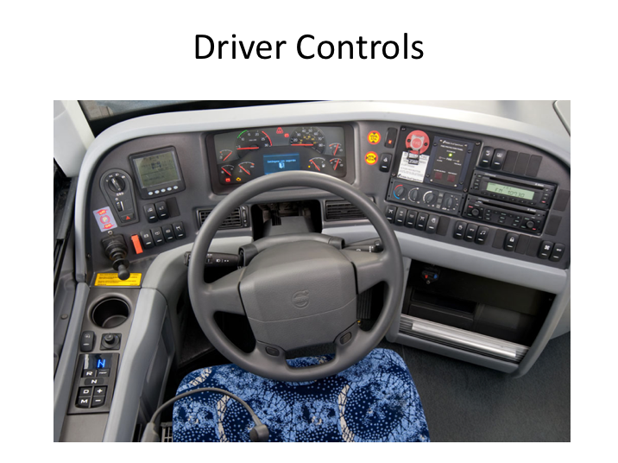

**DRIVER CONTROLS NARRATIVE**

You’ll need to familiarize yourself with all of the driver controls in each of the coaches you operate. When seated, you’ll be in the vehicle cockpit, with control panels situated all around you. We’ll review each of these controls both here in the classroom and also when touring the coach(es).

**EXERCISE**

Next, as part of classroom handouts and homework, provide each student a cockpit control pictorial for various model coaches in your fleet.

Briefly review in class the cockpit controls and displays and encourage the students to study the instrument and control pictorials and be familiar with them before you plan on conducting the on-board exercise.

**Instructor Tip –**

These pictorials are generally available from the coach manufacturer, either through their website or a sales or service representative. You should have one for each make and model year coach you operate.

You can also make your own by simply taking pictures of control clusters and labeling them by hand or with graphics or word processing software.

*Display PowerPoint slide.*

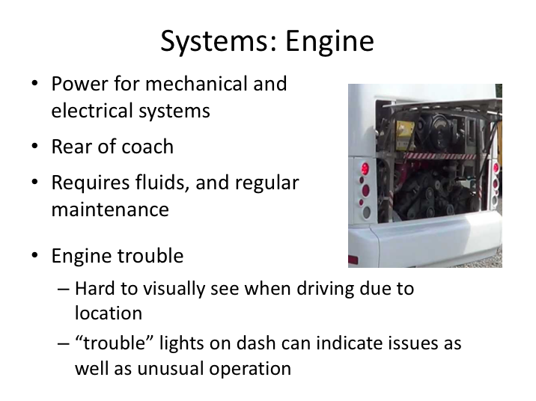

**SYSTEMS: ENGINE NARRATIVE**

Let’s discuss some major vehicle systems of a motorcoach.  Like other motor vehicles, the engine provides power for the the mechanical and electrical systems of the vehicle. The engine is located in the rear of the motorcoach.

In order for engines to operate properly, they must be properly serviced and maintained, and key fluids, such as gas, oil, and coolant, must be present.  There are various manufacturers of engines found on motorcoaches; when the vehicle inspection process is reviewed, your instructor will explain how to tell if fluid levels are appropriate on each engine type in the fleet.

Issues with the engine are often indicated via trouble lights on the dashboard or may be indicated simply by abnormal or unusual operation, such as experiencing low power.

*Display PowerPoint slide.*

*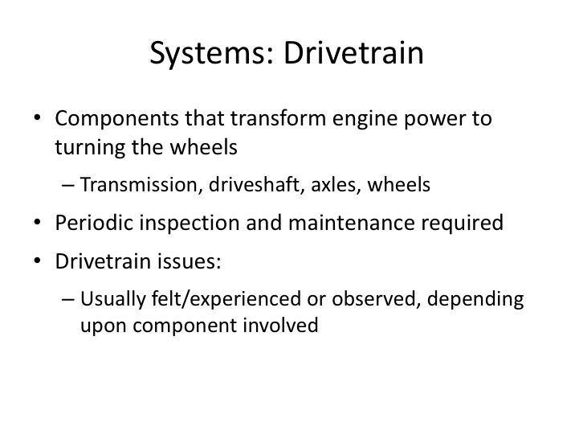***SYSTEMS: DRIVETRAIN NARRATIVE**

The drivetrain converts the power generated by the engine into forces that propel the coach forward or backward.  Drivetrain components include the transmission, driveshaft, axles and wheels.

Periodic inspection and maintenance are required to insure proper drivetrain operation; inspections are usually done by maintenance personnel, since most drivetrain components are not fully visible to the driver.  However, it is likely that a driver will experience or “feel” unusual operation if a drivetrain component is malfunctioning.  Drivers may also see issues on visible components during vehicle inspections or a dash trouble light may indicate a problem.

*Display PowerPoint slide.*

*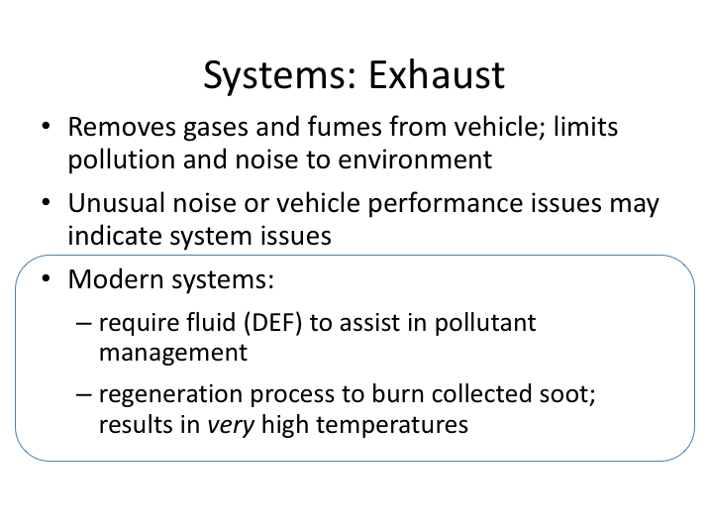***SYSTEMS: EXHAUST NARRATIVE**

The exhaust system moves the gases and fumes created during engine combustion away from the vehicle.  Exhaust gases pass through filters and a muffler before being discharged through the tailpipe.  The exhaust system is exceptionally "hot" when the engine is running.

Regular inspections of the system by maintenance personnel help determine developing issues.  Sudden issues may be detected by a driver or passengers; exhaust smells in the passenger cabin indicate a probable leak; sudden vehicle performance issues and excessive noise also may be indicative if exhaust system issues.  These issues may or may not also be indicated via dashboard trouble indicators.

Modern exhaust systems require diesel exhaust fluid to assist in managing pollutant discharge.  Many exhaust systems now also use a “regeneration” process to burn off soot collected in filters when critical levels are present.  This process may need to be initiated by a driver while on a trip and, in some cases,

**SYSTEMS: EXHAUST NARRATIVE (continued)**

can start independently.  Dashboard lights usually indicate when this process is needed.  A word of caution – this regeneration process results in extremely hot temperatures throughout the exhaust system, including at the discharge area of the tailpipe.

*Display PowerPoint slide.*

*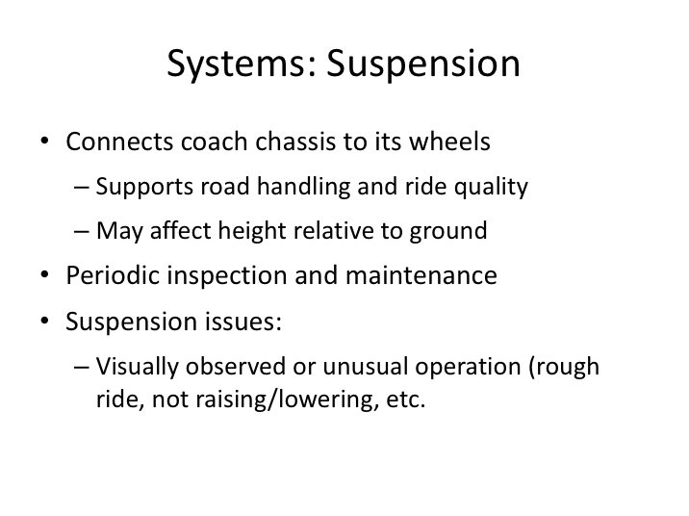***SYSTEMS: SUSPENSION NARRATIVE**

The suspension is the system of components that connects the coach to its wheels and allows the coach body to move relative to the tires.  Suspension systems are most often associated with road handling and ride quality.  On many motorcoaches, air suspensions can significantly affect the height and ground clearance of the coach.

Suspension components are maintained through periodic mechanical inspections, though drivers may notice issues by experiencing unusual differences in ride quality or visually observing unusual listing, leaning, or height positioning of the coach during vehicle inspection.

*Display PowerPoint slide.*

*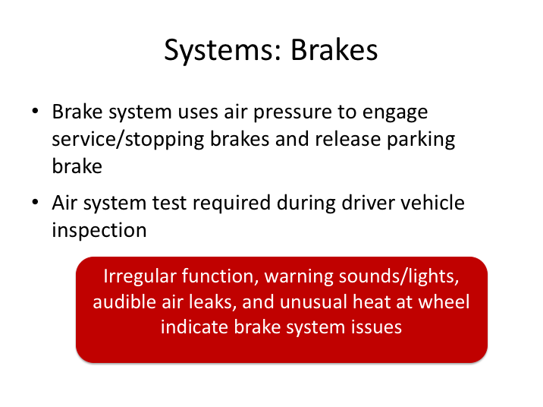***SYSTEMS: BRAKES NARRATIVE**

Motorcoaches are equipped with air brake systems that rely on an air supply and release system to actuate the service or parking brake.  Air storage tanks are filled with compressed air by the compressor, which is powered by the engine. When the driver steps on the brake pedal, airs flows from the storage tanks into the brake chambers, causing the brake to engage.  For parking brakes, air is depleted from the system, allowing decompression of springs that cause the parking brake to engage.

The air brake system is required to be tested during driver pre-trip inspections.  An air pressure gauge located on the dashboard indicates the availability of air pressure for safe vehicle operation, and the system includes warning tones and/or lights to warn of low air pressure.  Proper brake system inspection procedures will be taught during the vehicle inspection module and related practice.

**SYSTEMS: BRAKES NARRATIVE (continued)**

As with all critical components, regular inspections are required by mechanics.  Drivers are generally alerted to system issues via air system warning tones, unusual operation, or audible air leaks from the system.  Dragging brakes caused by partially-released parking brakes will result in unusual heat buildup and possible tire failure and fires.

LESSON 2

SEAT AND MIRROR ADJUSTMENT

**Lesson Objectives**:

By the end of this lesson, the students will be able to:

1. Adjust the driver's seat for optimal comfort, operation of controls and visibility.
2. Adjust left and right flat and convex mirrors for optimal view.

**Instructional** **Methods**: Classroom and On-Board Exercise

(On-board exercise in conjunction with lessons 3 & 4)

**Approach:**

Review with students, seat adjustment controls and proper seat setting for vehicle control. Explain the methodology behind mirror settings and differences in types of mirrors. Provide hands-on experience in proper seat and mirror adjustment.

**LESSON INTRODUCTORY NARRATIVE**

*Student Guide reference here*

Proper seat and mirror adjustment cannot be stressed enough when it comes to the ability to operate a motorcoach without incident. Your ability to see what is around you in general, and specifically in critical areas, will allow a skilled driver to operate a coach without incident.

Unless you keep track of what is going on around the coach, you cannot correctly make the decisions you have to make while driving it. The front windshield gives you a panoramic view of what is in front of you; but you have to rely on your mirrors to see what is happening behind and alongside your coach. The size, shape, location, and adjustment of the mirrors determine what you can see in these critical areas.

Seat adjustment is important because you need to be comfortable and alert for the many miles you will be driving. It is also important because of the relationship between seat adjustment and mirror adjustment. You should adjust the seat when you first sit in the coach, before adjusting your mirrors. Only after your seat is adjusted should you adjust the mirrors. Your view in the mirrors is dependent upon your seated position; any changes to the seating position will require a corresponding adjustment to the mirror positions. So, be sure you take the time to get the seat adjustment correct for your needs!

*Display PowerPoint slide.*

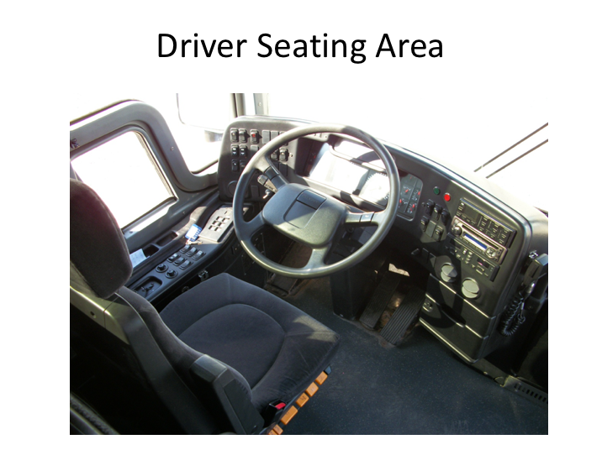

**SEAT ADJUSTMENT NARRATIVE**

When we get out to the coach you’ll be shown the seat adjustment controls that will allow you to adjust the seat as necessary. For now, let’s simple review the options and considerations in adjusting the seat.

The seat is adjusted in two major ways: up and down (height) and forward and back. Both adjustments should permit you to reach and operate the accelerator, brake, and any other foot controls easily; the seat position should allow you to depress the brake pedal all the way to the floor. The height adjustment should eliminate pressure to the bottom of your thigh when your foot is on the accelerator. A seat that is too high can affect circulation to your legs and feet. The forward and back adjustment should let you easily touch the top of the steering wheel. When this is set properly, your elbows will be slightly bent when your hands are at the 8 and 4 o'clock positions on the steering wheel.

*Display PowerPoint slide.*



**INTRODUCTION: STEERING NARRATIVE**

One of the reasons for setting your seat adjustment is so you can comfortably *and correctly* steer the coach. Steering a coach is a bit different than steering a car. You’ll steer the coach as follows:

* Keep your hands on the wheel in the 8 o'clock and 4 o'clock positions.

* Use a push-pull technique to steer. One hand pushes and the other hand pulls. For example, in turning the wheel to the right, the left hand pushes and the right hand pulls.
* Do not put your hands over the top of the wheel. Your hands shouldn’t cross over/under each other as you make a turn.

* Don't use the heel of your hand in the spokes of the wheel to help you turn.

**INTRODUCTION: STEERING NARRATIVE (continued)**

You will notice that the steering wheel is a lot larger than a car's steering wheel. It is lower, and oriented in the horizontal plane. It is just as easy to turn as a car's wheel, but it takes many turns to go from a full right turn to a full left turn.

Avoid turning the wheel when the coach is not moving - you can damage the steering components.

*Display PowerPoint slide.*

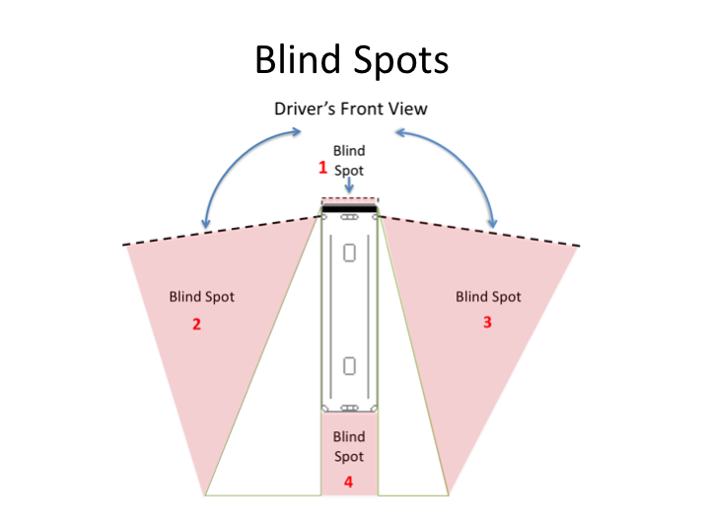

**BLIND SPOTS NARRATIVE**

This picture shows the width of view for the right and left flat mirrors. Notice that you get a wider field of view from the left mirror than from the right mirror - this is because the driver sits closer to the left mirror.

Notice also that you have four blind spots:

* One immediately in front of the coach. It is possible for a child or small adult, animal or other object to be immediately in front of the coach and hidden from view.
* One on the coach’s left side. Cars passing or holding position in the left lane may be hidden from your view.
* One on the coach’s right side. Cars in the right lane may not be visible to you, especially a small car up close to your door.
* A large one at the rear of the coach. It is possible that three or four small vehicles could be in this blind spot, and you wouldn't be able to see them.

*Display PowerPoint slide.* 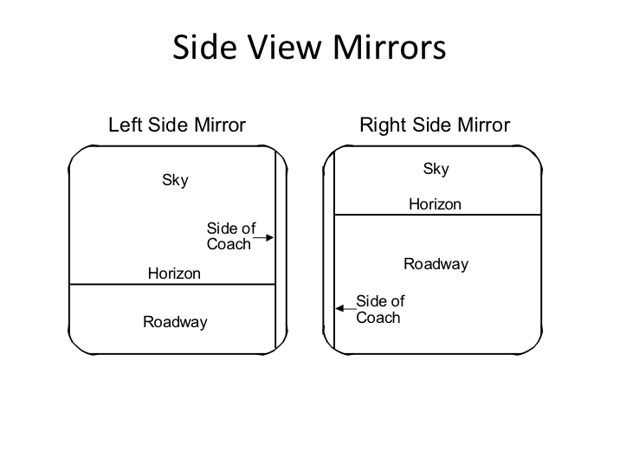

**MIRROR ADJUSTMENT - FLAT MIRRORS NARRATIVE**

Setting your mirrors properly will minimize, but not eliminate, the blind spots to the sides of the coach.

The steps for mirror adjustment are very simple:

* If necessary, move the arm holding each mirror so that you have an unobstructed view of the entire mirror.
* Rotate both flat mirrors horizontally until the inside edges pick up the rear corners of the coach body. This is just to permit you to see what is happening right next to the coach. Rotating them inward any further is a common mistake and will limit their benefit – you don't need to see the side of the coach – you need to see what is *along the outside of the coach*.
* Rotate the left (driver side) flat mirror vertically until the bottom one third of the mirror shows the roadway. That is, the horizon is about one-third of the way from the *bottom* of the mirror.

**MIRROR ADJUSTMENT - FLAT MIRRORS NARRATIVE (continued)**

* Rotate the right flat mirror vertically until the bottom two-thirds of the mirror shows the roadway. The horizon should be about one-third of the way from the *top* of the mirror. You should be able to see the right rear wheel(s) of the coach.

*Display PowerPoint slide.*

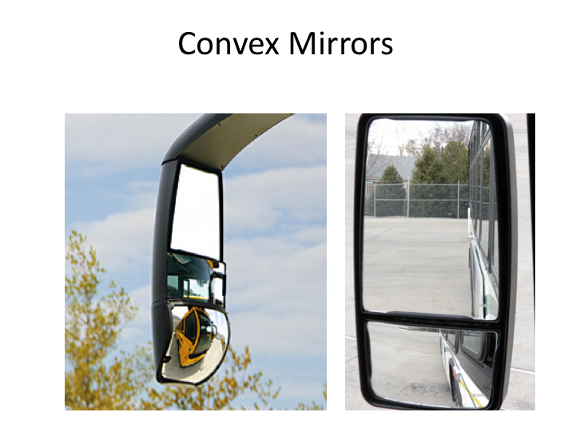

**MIRROR ADJUSTMENT - CONVEX MIRRORS NARRATIVE**

Because of their curvature, convex mirrors can show you areas that the flat mirrors do not. They help you see further out to the left and right and they allow you to see the roadway closer to the front of the coach, minimizing, but not eliminating, the left and right blind spots.

They are very common, though not all coaches may have them – so be sure you always set your flat mirrors properly even if you have convex mirrors on most coaches you operate. If you use convex mirrors to habitually compensate for incorrect flat mirror adjustment and you find yourself on a coach without the benefit of convex mirrors, you will have difficulty driving the coach without incident.

You probably have seen this warning: OBJECTS IN THIS MIRROR ARE MUCH CLOSER THAN THEY APPEAR. If so, you were looking in a convex mirror.

It is difficult to judge depth with convex mirrors and generally, the more severe the curve on the surface of the mirror, the harder it is to tell exactly how far away

**MIRROR ADJUSTMENT - CONVEX MIRRORS NARRATIVE (continued)**

an object visible in the mirror is. The best approach is to not use them at all to judge distance; rather just use them to alert you that something is, or is not, there.

Some convex mirrors are mounted on flat mirrors and are not adjustable. If your convex mirrors can be adjusted independently of your flat mirrors, follow this procedure to set them:

* Rotate each convex mirror horizontally until the inside edge of its field of view overlaps with the outside edge of the flat mirror's field of view. Drivers with separately adjustable convex mirrors frequently set them in such a way that the views in the convex mirrors overlap a lot with the views in the flat mirrors. There should always be some overlap, but there should not be much.
* Tilt the left (driver’s side) convex mirror vertically until a point 40 feet from the mirror can be seen in the top edge of the mirror. (The end of the coach is about 40 feet away.)
* Tilt the right convex mirror vertically until the bottom edge of its field shows the roadway just behind the door.

The convex mirrors should supplement the information provided by the flat mirrors. When set this way, they will let you see areas that the flat mirrors cannot show you. If you can see a vehicle in your convex mirror but not in your flat mirror, you can be sure it is beside the coach, not in back of the coach.

**Instructor Note –**

Having a mirror station available is perhaps the best way for students to understand proper mirror adjustment. Use one if you have it; if you do not have one, but can set one up, mirror station setup dimensions and information is in the Appendix of this module.

LESSON 3

INTERIOR CONTROLS AND DISPLAYS

**Lesson Objectives**:

By the end of this lesson, students will know the location and nomenclature of all the coach's interior controls and displays. They will also gain hands-on experience with seat and mirror adjustment.

**Instructional Method:** On-Board Exercise

**Approach:**

Limit this on-board exercise to no more than three students at a time. It is important for each student to be able to clearly observe the controls you are describing and operating, so schedule students accordingly.

**EXERCISE**

Sit in the driver's seat and adjust the seat and mirrors. As you are setting the seat and mirrors, review how you are adjusting them and why; to reinforce what was discussed in the lecture.

Next, point out the major controls, and the groupings of the secondary controls and instruments (panels and clusters). Then, within the groupings of secondary controls and instruments, name and demonstrate each specific control and instrument display.

Each student should have three turns sitting in the driver's seat. When students are not in the seat, they should still be watching and paying attention.

1. On the first turn, have each of them look at the mirrors you’ve adjusted to get a feel for the fields of view they should be aiming for when doing their own adjustments. Then, name each control and instrument and point to it.
2. On the student's second turn in the seat, have them adjust the seat. Once they have it adjusted, ensure they can reach the foot controls and the steering wheel.

Next, have the student adjust the available mirrors to suit them specifically. Provide coaching and feedback as necessary during this process. Once they are done, verify that they are comfortable, able to reach all controls, and have an unobstructed view of all displays, the roadway in front and the mirrors.

1. The third time around, have each student name the control or display when you point to it. You should repeat those controls and instruments that any student is having trouble identifying.

**Instructor Note –**

For operations with multiple makes and models of coaches, a similar review of features and controls should be undertaken at a minimum for each make of coach. The same should be considered for vastly different models within a manufacturer family, especially for new drivers with no previous experience in a particular make or model coach.

A minimum listing of the interior controls and displays to cover in this exercise is shown below.

Vehicle Controls:

Master control switch

Start

Gear Selector/Shift

Brakes (service, parking & emergency)

Steering

Accelerator

Retarder Control

Lighting (interior & exterior, including high beam and 4-way/hazards)

Windshield washer/wiper

Warning lights/buzzers – ABS, etc.

Gauges (oil, air, temperature, fuel, etc.)

Door controls

Tag axle control (if equipped)

Cruise control

Interlocks

Engine regeneration controls (if equipped)

Other applicable vehicle technology, as equipped:

* Tire Pressure Monitoring System
* Electronic Stability Control
* Electronic Logging Devices
* Crash Event Recorders
* Lane Departure Warning System
* Collision Avoidance

Comfort & Convenience:

Seat adjustment

Mirror adjustment

Climate controls - Heating, ventilation and air conditioning system

Passenger address system

Audio/Video system

Sunshades

Lavatory

LESSON 4

EXTERIOR COMPONENTS AND COMPARTMENTS

**Lesson Objectives**:

By the end of this lesson, students will know:

* Name and function of each major exterior component and compartment of the motorcoach.
* Name and location of each of the fluid-intake points and what type of fluid is to be used at each point.

**Instructional Method:** On-Board Exercise

**Approach:**

Limit this on-board exercise to no more than four students at a time. It is important for each student to be able to clearly observe the components and features the instructor is describing and operating.

**Instructor Tip –**

It may be beneficial for maintenance staff to assist with this exercise as they may be able to provide additional insight into components and potential issues.

**EXERCISE**

Beginning at the front and moving clockwise around the coach, the instructor should open each compartment and name the compartment and each major component behind the door. The methods for opening the doors and latching them open (as appropriate) should be reviewed.

The class should then proceed around the coach a second time. This time they should take turns in opening the compartment doors and naming what is behind each door. Provide feedback as necessary.

Continue until each student has correctly named each of the components and compartments. If your company uses more than one motorcoach make and model, repeat the above procedure, identifying differences on the other vehicles.

A listing of the minimum content to be covered in this exercise is shown below.

Exterior Compartments & Components:

Entrance door control

Spare tire compartment

Electrical panel door

Fuel door (state type of fuel to be used)

Battery compartment

Auxiliary heater

Luggage compartments & door pins (if equipped)

Engine & lavatory service doors

Engine compartment & main engine components

Remote control box & controls (remote disable/start)

Belts

Radiator, including servicing

Oil (type and weight used)

Alternator

Turbocharger

Applicable sight glasses

Fire suppression system (if equipped)

Wheels & tires (axle sight glass if equipped)

Drive axle

Tag axle and dynamics (lifting vs. fixed)

Wheel-chair lift (if coach is so equipped)

Various exhaust points (engine, regeneration, auxiliary heater)

Diesel exhaust fluid servicing

**MOTORCOACH ORIENTATION AND FAMILIARIZATION**

**QUIZ**

*Instructor’s Note – Correct answers are highlighted*

1. In addition to overall height and width, what other dimension is most important to know?
2. Ground clearance
3. Service door clearance when opening
4. **Rear overhang**
5. Mirrors extending from coach sides
6. Your first adjustment in the cockpit should be the adjusting the mirrors.

1. True
2. **False**
3. Methods for steering a coach are the same as steering a car.
4. True
5. **False**
6. Using the steering wheel spokes to turn is okay as long as you can wrap your hand around the spoke.
7. True
8. **False**
9. What is the preferred position (clock position) on the steering wheel for your hands?
10. 10 and 2
11. 10 and 4
12. 9 and 3
13. **8 and 4**
14. 7 and 5
15. How many blind spots do you have when you are driving a coach?
16. 1
17. 2
18. 3
19. **4**
20. 5
21. Which side of the vehicle has the bigger blind spot?
22. **Right (service door) side**
23. Left (driver’s) side
24. Setting your mirrors properly will eliminate the blind spots to the sides of the coach.
25. True
26. **False**
27. When considering the width of your coach, you can disregard the mirrors since they are higher off the ground.
28. True
29. **False**
30. Because of the airbag suspensions, when loaded with passengers you can subtract 2 inches off the ride height when determining overall height for clearance purposes.
31. True
32. **False**

**Motorcoach Orientation & Familiarization**

**Instructor Guide Appendix**

This Appendix includes information on mirror station setup for a 45’ motorcoach.

**Mirror Station Dimensions**

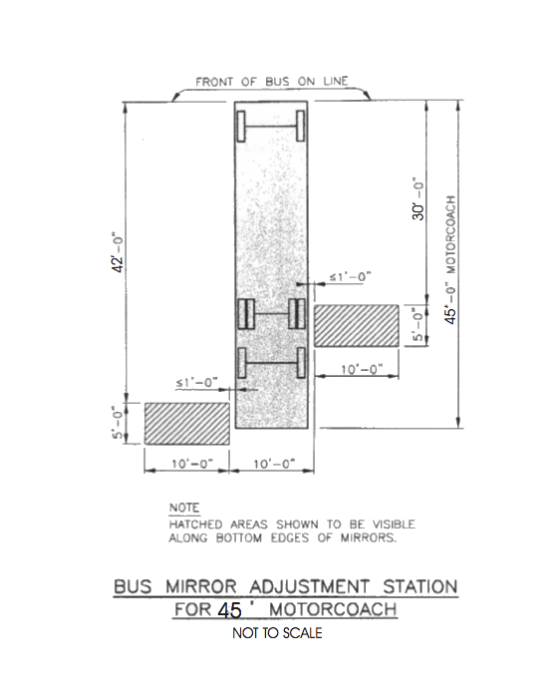

**Mirror Station Instructions**

