**Regulatory Overview & Key Requirements**

|  |  |  |
| --- | --- | --- |
| Heart Monitor | Safety Managment Cycle | Clock |

**Purpose:**

The purpose of this training module is to provide you with background on regulatory authority in the motorcoach industry and also review key regulations not addressed elsewhere in other modules. You will learn about carrier oversight, including how oversight affects your job duties. You will also learn minimum qualifications that a commercial driver must meet and their responsibilities in the qualification process. Finally, you will learn about the hours of service rules and driving limitations as well documenting your duty status on driver logs.

**Module Overview**:

The training module contains three classroom lessons and three training exercises. The first lesson provides background on regulatory authority and applicability to motor carriers and motor carrier operations. The second lesson details minimum driver qualifications as detailed in the Federal Motor Carrier Safety Regulations and review driver responsibilities in meeting the regulations and operating safely. The third lesson reviews hours of service regulations, driving limitations, and documentation of driver activities, including proper completion of records of duty status.

Lesson 1: Background & Applicability

Lesson 2: Driver Qualifications & Responsibilities

Lesson 3: Hours of Service

LESSON 1

BACKGROUND & APPLICABILITY

**Lesson Objectives**:

By the completion of this lesson, you will understand various agencies which have a regulatory oversight over the operation of commercial vehicles in surface transportation operations. You will understand that regulations apply to both carriers and drivers, thereby reinforcing safety and other operational requirements.

**Instructional Method:** Classroom

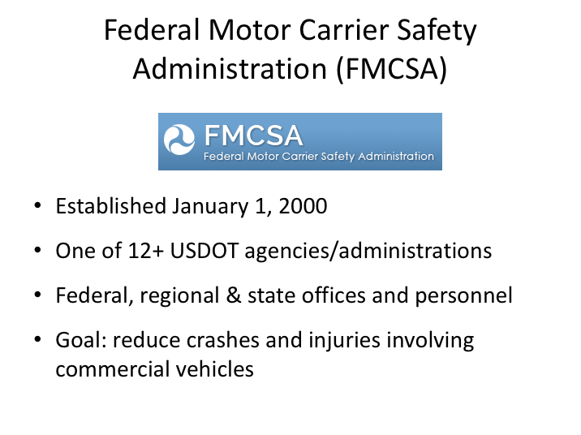

**FEDERAL MOTOR CARRIER SAFETY ADMINISTRATION (FMCSA)**

The Federal Motor Carrier Safety Administration began operations on January 1, 2000. It is one of over a dozen administrations housed under the United States Department of Transportation. The primary mission of the Federal Motor Carrier Safety Administration (FMCSA) is to reduce crashes, injuries and fatalities involving large trucks and buses.

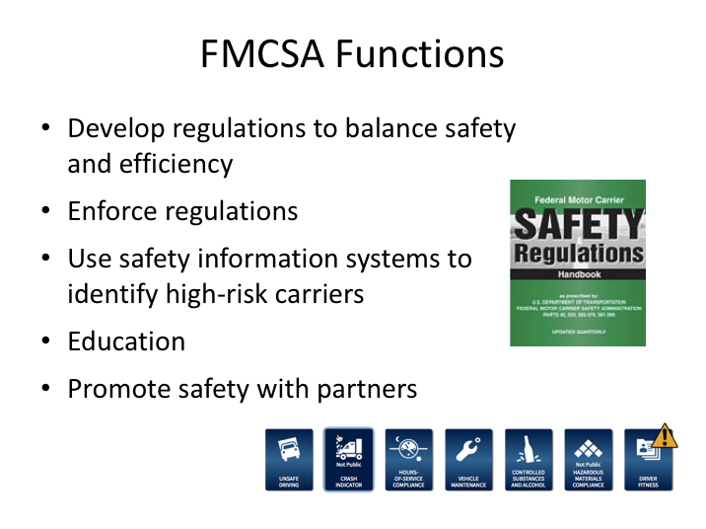

**FMCSA FUNCTIONS**

In carrying out its safety mandate to reduce crashes, injuries, and fatalities involving large trucks and buses, FMCSA develops regulations that balance motor carrier (truck and bus companies) safety with efficiency. They develop and harness safety information systems to focus on higher risk carriers in enforcing the safety regulations, though enforcement is not limited to only identified high-risk carriers.

FMCSA functions also include educating carriers, drivers, and the public on regulations and safe practices, as well as partnering with stakeholders including federal, state, and local enforcement agencies, the motor carrier industry, safety groups, and organized labor on efforts to reduce bus and truck-related crashes.

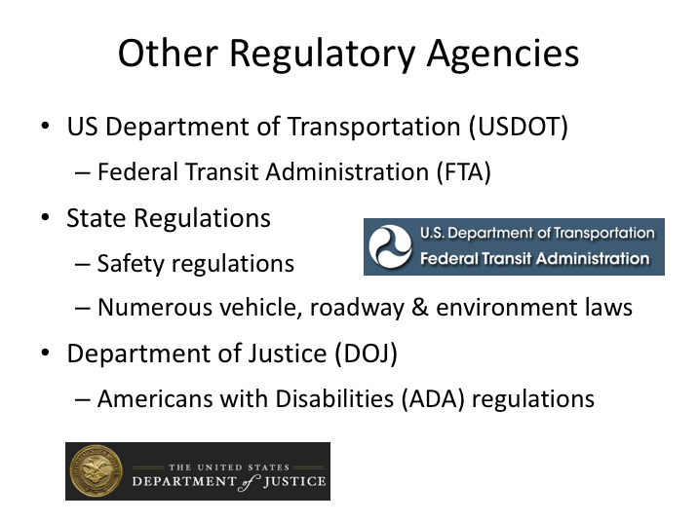

**OTHER REGULATORY AGENCIES**

In addition to the FMCSA, there are other agencies with regulations applicable to motorcoach operations, though these regulations may be applicable only to certain types of motorcoach operations. For example, motorcoach operators that provide public transit services that are funded by the Federal Transit Administration must also comply with their regulations.

At the state level, there are safety regulations for operations not governed by the FMCSA, as well as numerous vehicle, roadway, and environmental laws applicable to any vehicle operating within each state.

The Department of Justice, as well as the Department of Transportation, enacts regulations specific to transportation of passengers with disabilities.

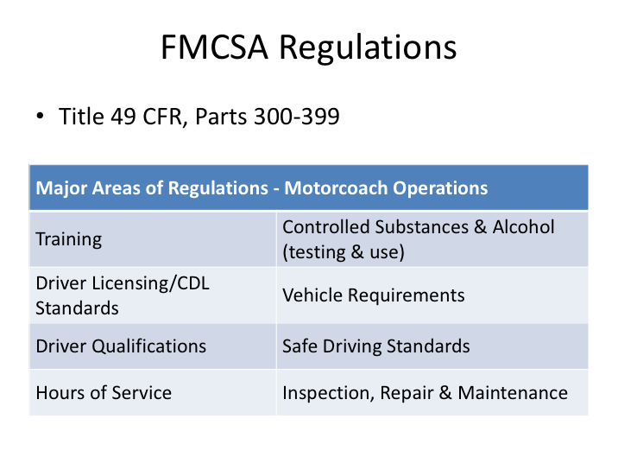

**FMCSA REGULATIONS**

There are hundreds of FMCSA regulations applicable to commercial vehicle operations, some of them more specific to transportation modes other than motorcoach. FMCSA-promulgated regulations are found in Title 49, Parts 300-399 of the Coded Federal Regulations.

Significant areas of regulation pertinent to motorcoach operations include:

Part 380: Special Training Requirements

Part 382: Controlled Substances & Alcohol Use & Testing

Part 383: Commercial Driver’s License (CDL) Standards

Part 391: Qualifications of Drivers

Part 392: Driving of Commercial Vehicles

Part 393: Parts & Accessories Necessary for Safe Operation

Part 395: Hours of Service of Drivers

Part 396: Inspection, Repair, and Maintenance

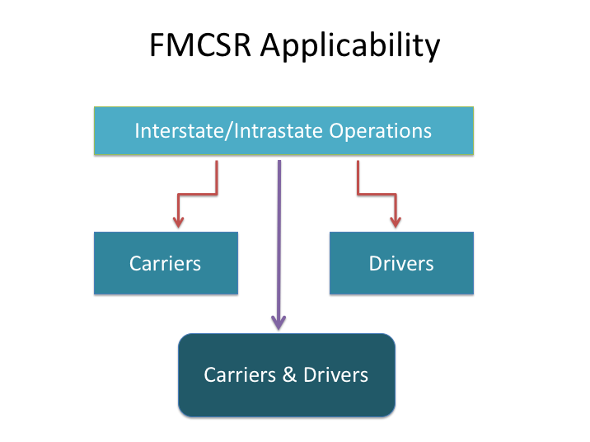

**FMCSR APPLICABILITY**

There are some Federal Motor Carrier Safety Regulations which are applicable to all types and instances of commercial vehicle operations, such as regulations pertaining to CDLs, drug and alcohol testing and use, and hazardous material. However, there is some variability in the applicability of other FMCSRs depending largely on what type of operation is being conducted (for-hire or private) and whether the operation is occurring within a single state (intrastate) or between states (interstate). When applicable, FMCSRs are generally directed toward motor carriers (transportation companies), commercial vehicle drivers, or both.

For transportation conducted entirely within a single state that does not cross state lines and does not continue or originate a trip to/from out-of-state, the movement would be considered intrastate, and thus not subject to the FMCSRs. However, in instances where the FMCSRs are not directly applicable – such as an intrastate operation - they may still in fact be indirectly applicable. When FMCSRs do not apply due to the nature of the transportation, each state is responsible for, and has developed, their own carrier and driver safety regulations. In many cases, states have simply chosen to adopt the Federal Motor Carrier Safety Regulations, in part or in whole, as their intrastate safety regulations.

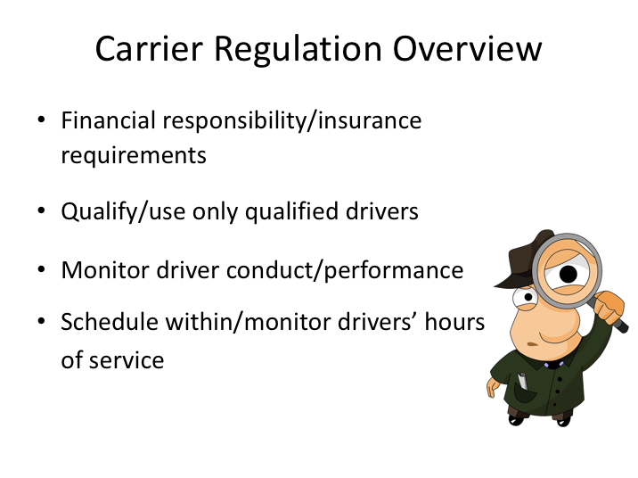

**CARRIER REGULATION OVERVIEW**

While we’ll mainly discuss driver responsibilities in this curriculum, now is a good time to briefly review regulations and the employer. Companies who operate commercial vehicles are bound by the same safety regulations as drivers. In fact, there are additional regulations for the employer. Not only must they be familiar with the driver regulations, but they also must oversee compliance with them in most cases.

Carriers must maintain a significant amount of liability insurance in the event there are injury incidents involving the operation of one of their commercial vehicles. They must ensure that any driver operating one of their commercial vehicles is properly qualified at the time of hire and remains properly qualified while driving a commercial vehicle for the company. Carriers must understand the hours of service limitations for commercial drivers - they may not dispatch a driver on a trip when they know driver is, or will be, in violation of these hours of service limitations.

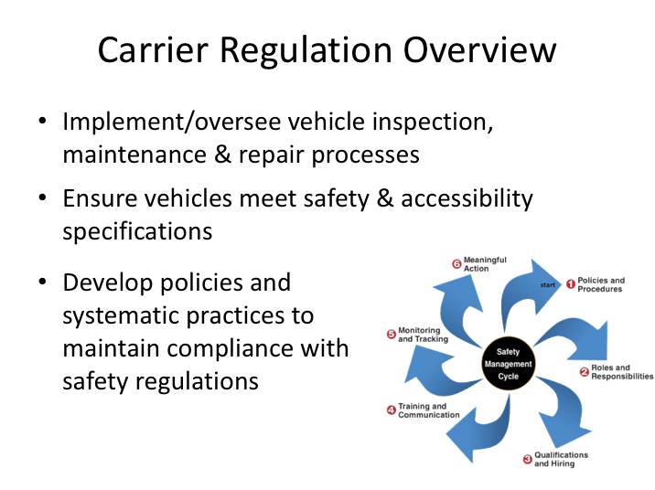

**CARRIER REGULATION OVERVIEW (continued)**

Employers must implement and oversee vehicle inspection, maintenance, and repair processes - many of which are specified in the safety regulations. There are also specific safety standards that each commercial vehicle must meet. While initial compliance with these standards is certified by the vehicle manufacturer, it is up to the carrier to ensure that vehicles continue to meet certain safety standards.

Finally, employers are required to develop policies and systematic practices to ensure compliance with all of the safety standards and regulations. This means that they must maintain specific documentation to show that they are maintaining compliance; and, as you might guess, this translates into documentation requirements of employees’ activities, including drivers. Drivers should understand that much of the documentation required by their employers is actually required to comply with the employer’s responsibility in meeting safety regulations.

LESSON 2

DRIVER QUALIFICATIONS & RESPONSIBILITIES

**Lesson Objectives**:

By the end of this lesson, you will know the minimum driver qualifications required of a commercial motorcoach driver, including licensing, medical certification, and driving history. You will gain an understanding of employer requirements with regard to drug and alcohol testing requirements and initial and ongoing driver qualification. Driver responsibilities with regards to qualification and safety regulation processes will also be discussed.

**Instructional Method:** Classroom

Minumum qualifications for drivers for federal regulations for commercial vehicle drivers in interstate operations. 
Explanation of this slide can be found below the image.

**MINIMUM DRIVER QUALIFICATIONS**

Federal regulations for commercial vehicle drivers in interstate operations include:

* Minimum age of 21 years old;
* Ability to read and speak the English language sufficiently to converse with the general public, understand traffic signs and signals, and interact with officials (enforcement);
* Be capable of making entries on reports and records (completing paperwork required by regulation);

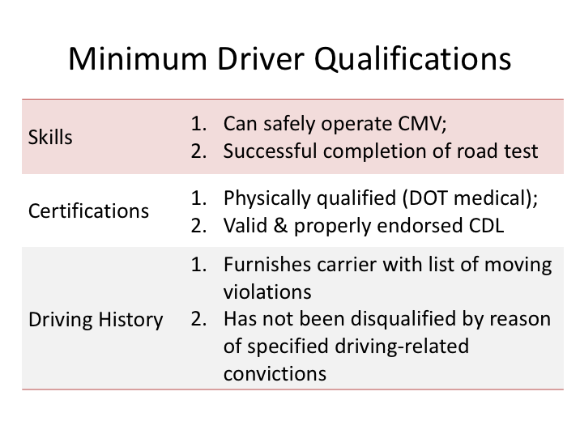

**MINIMUM DRIVER QUALIFICATIONS (continued)**

Additional qualifications include:

* Can, by reason of experience, training, or both, safely operate the type of commercial motor vehicle he/she drives;
* Is physically qualified to drive a commercial motor vehicle as evidenced by a valid medical examiner's certificate;
* Has a state-issued, currently valid, and properly endorsed commercial driver’s license;
* Has provided carrier with information on moving violations; and
* Is not currently disqualified due to conviction of specified driving-related violations (391.15).

Also, if the carrier chooses to conduct a road test – and most do - successful completion is required.

**MINIMUM DRIVER QUALIFICATIONS (continued)**

While these qualifications are specific to interstate drivers, they may still apply indirectly for intrastate drivers in the many states that adopt the FMCSA regulations in whole or in part. Almost every motorcoach employer qualifies drivers to federal standards since wholly intrastate operations not directly required to comply with the FMCSRs are rare in the over-the-road motorcoach industry.

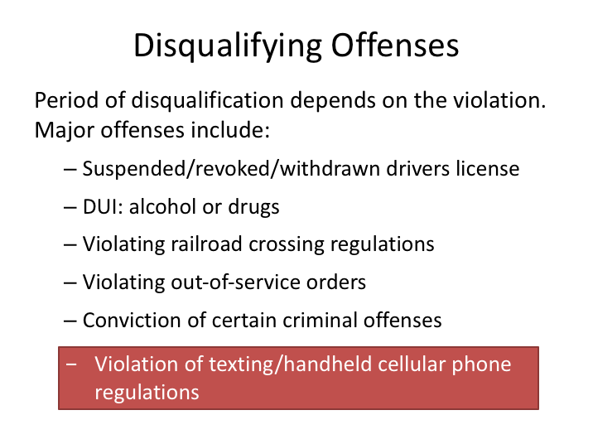

**DISQUALIFYING OFFENSES**

There are numerous instances when a driver is disqualified from operating a commercial vehicle due to violations for which he/she is convicted. The period of disqualification varies depending upon the violation(s), but can include disqualification for life. Examples include:

* Operating a motor vehicle while under the influence of alcohol, or any illegal/controlled substance
* Transportation, possession, or unlawful use of certain drugs
* Violating railroad crossing requirements
* Violating out-of-service orders issued by enforcement officials
* Conviction of certain criminal offenses, including leaving the scene of a crash resulting in injury or death and causing injury or death by negligent operation

Disqualifying offenses also include violation of texting and handheld cellular phone safety regulations.

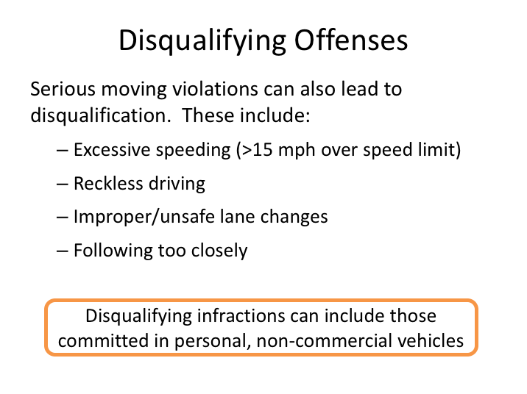

**DISQUALIFYING OFFENSES (continued)**

In addition to major offenses, being convicted of certain serious moving violations can also lead to driver disqualification from operating a commercial vehicle. Examples of these include excessive speeding, reckless driving, improper or unsafe lane changes, and following too closely.

It’s important to note that in some instances, the regulations include violations committed while driving a commercial vehicle as well as a non-commercial vehicle. In other words, being convicted of offenses while driving a personal vehicle can also count toward disqualifying sanctions of your CDL.

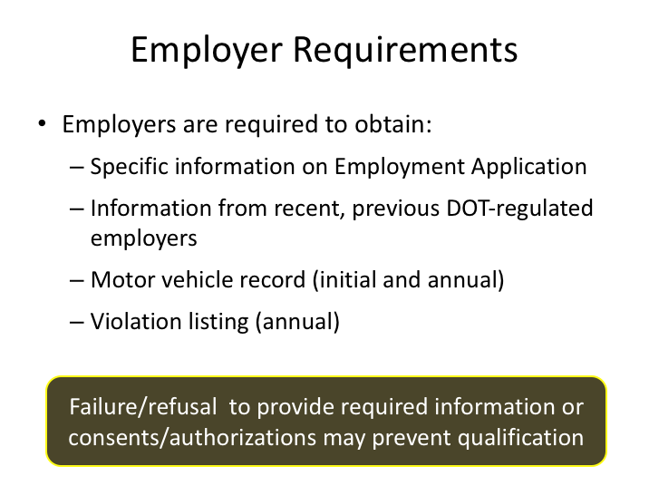

**EMPLOYER REQUIREMENTS**

Employers are required to obtain specific information and conduct specific actions to properly qualify commercial vehicle drivers. To begin with, the application must contain specific information to meet regulatory requirements. Employers are required to make specific inquiries of previous DOT-regulated employers for which an applicant has worked. Additionally, employers must obtain – both at the time of hire and annually thereafter – each driver’s motor vehicle record, as well as a list of moving violations in the previous 12 months.

Drivers who fail to provide required information or fail to provide necessary consent for the employer to obtain required information may not be able to be qualified as a commercial vehicle driver.

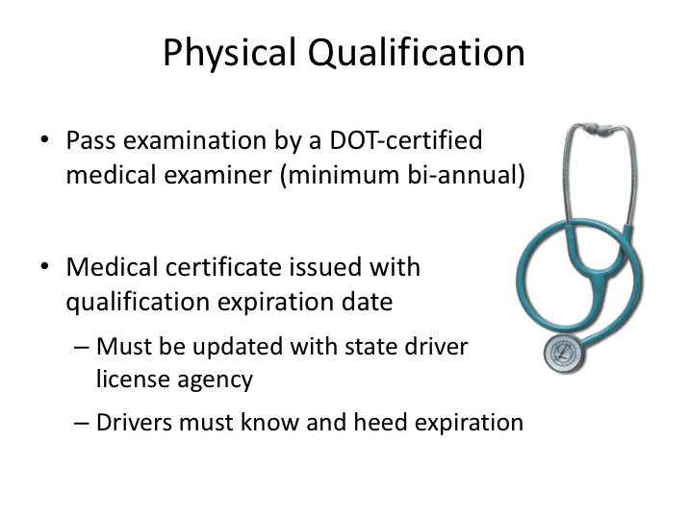

**PHYSICAL QUALIFICATION**

Physical qualification exams for drivers must be conducted by a medical examiner who is certified by the Department of Transportation and listed on the National Registry of Certified Medical Examiners (NRCME).  At a minimum, commercial drivers must pass a physical qualification/certification exam at least once every two years. Exams may be conducted more frequently due to the existence of certain medical conditions or by additional employment policy requirements.

Following the qualification exam, a medical certificate will be issued that contains the qualification expiration date.  This certificate must be provided to the driver’s state driver license agency or the driver record will not be updated appropriately.  Qualified drivers must be aware of this date and ensure they are re-certified prior to its expiration if they intend on driving commercial vehicles.

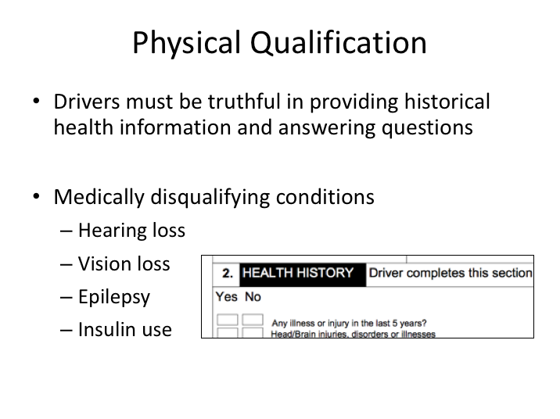

**PHYSICAL QUALIFICATION (continued)**

As part of the medical certification exam, the examinee will be required to provide historical health information, and the medical examiner may ask additional questions pertinent to the qualification process. Examinees are required to be truthful in providing information and answering questions during the process.

The medical examiner has significant leeway in qualifying a driver. However, there are four medically disqualifying conditions that can prevent a commercial driver from being physically qualified.  These conditions include: hearing or vision loss beyond specified thresholds, a diagnosis of epilepsy, or a diabetic condition requiring the use of insulin.  In some cases, DOT-issued waivers can be obtained that provide for an exception for these conditions.  Additionally, there are other conditions and diagnoses that may require special testing or waivers to be issued in order to obtain physical qualification.

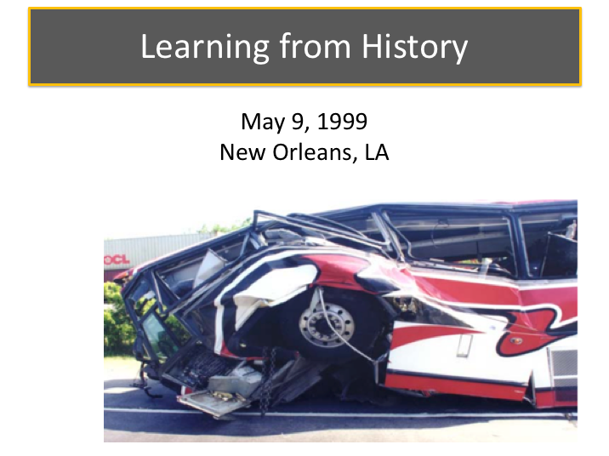

**LEARNING FROM HISTORY**

Occasionally drivers are not truthful when completing paperwork, including providing full disclosure during physical examinations.  A primary purpose of the medical certification process is to provide reasonable assurances that drivers will be able to operate commercial vehicles safely, without complications from medical conditions that could jeopardize their capable operation of the vehicle.

A crash that occurred on May 9, 1999, in New Orleans, LA, provides us a potent reminder of what could go wrong if commercial drivers do not take their responsibilities seriously.

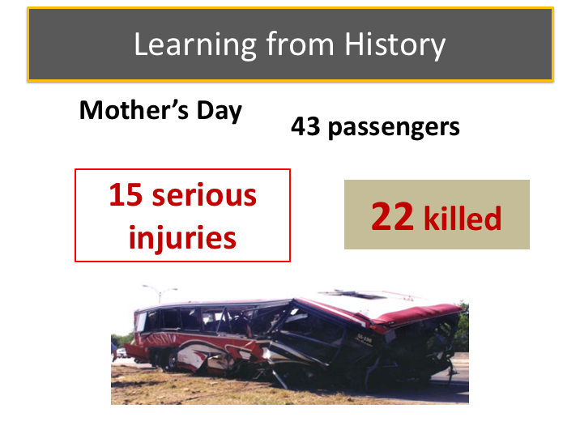

**LEARNING FROM HISTORY (continued)**

On May 9, 1999, about 9:00 a.m., a 55-passenger motorcoach was traveling eastbound on Interstate 610 in New Orleans, Louisiana. The bus, carrying 43 passengers, was en-route from La Place, Louisiana, to a casino approximately 80 miles away in Bay St. Louis, Mississippi. As the bus approached milepost 1.6, it departed the right side of the highway, crossed the shoulder, and went onto the grassy side slope alongside the shoulder. The bus continued on the side slope, struck the terminal end of a guardrail, traveled through a chain-link fence, vaulted over a paved golf cart path, collided with the far side of a dirt embankment, and then bounced and slid forward upright to its final resting position. Twenty-two passengers were killed; the bus driver and 15 passengers received serious injuries, and 6 passengers received minor injuries.

A witness riding in a van behind the bus stated that before the accident, she saw the bus drifting from the left lane to the center lane, then back to the left lane, before finally crossing the center and right lanes and departing the right side of the road.  Surviving passengers did not indicate anything unusual about the trip or recall any sudden vehicle movements or actions immediately prior to the crash.  One passenger recalled seeing the bus driver “slouch down”, come back up, then go down again.

Causes for the Mother's Day wreck:
Severe medical conditions
Failure to report medical history

**LEARNING FROM HISTORY (continued)**

The ensuing National Transportation Safety Board (NTSB) investigation established that the driver possessed a current commercial driver's license and medical certificate, but suffered from several life-threatening medical conditions of the kidneys and heart.

The NTSB determined that the probable cause of this crash was the driver's incapacitation due to his severe medical conditions (heart and kidney) and the driver’s failure to report his medical problems.  Drivers are required to report heart and kidney problems on the Medical Examination Report during the physical qualification process.  In a post-accident interview, the physician who performed the examination informed Safety Board investigators that the driver indicated that he had no heart problems.  The driver, who survived the crash, died several months later from a heart-related ailment.

**LEARNING FROM HISTORY (continued)**

|  |
| --- |
| 3 person clipart |

This driver likely had serious health issues for some time, and had “gotten away” with being dishonest on medical certifications without consequence for a long time.  Do you think he felt his dishonesty was not such a big deal after this crash?

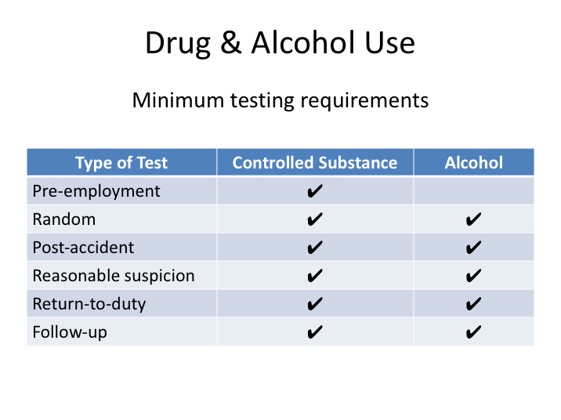

**DRUG & ALCOHOL USE**

DOT-regulated employers are required to administer a controlled substance and alcohol test program compliant with DOT regulations. Unlike many of the federal safety regulations, this requirement pertains to any driver operating a vehicle that requires a CDL, regardless of whether the operation is interstate or intrastate in nature.

The controlled substance and alcohol regulations require testing in specific instances. Testing for controlled substances, alcohol, or both, is required in the following situations: pre-employment, random, post-accident, reasonable suspicion, return to duty, and follow-up. Companies may choose to enact drug and alcohol use policies which are stricter than the requirements set forth in the DOT regulations.

Drivers are prohibited from operating commercial vehicles when under the influence of controlled substances or alcohol. Drivers who test positive or above specified thresholds during required tests (or refuse to test) are not permitted to operate commercial vehicles until they have successfully completed a treatment program specified by a substance abuse professional (SAP). In many cases, companies terminate driver employment if they test positive on a controlled substance or alcohol test. However, even if a driver is terminated by his/her

**DRUG & ALCOHOL USE (continued)**

employer, drivers are still required to successfully complete a SAP’s designated treatment program prior to driving commercial vehicles for any other DOT- regulated employer.

SAPs used to satisfy DOT drug and alcohol treatment requirements must be on an approved list by the National Association for Alcohol and Drug Abuse Counselors (NAADAC).

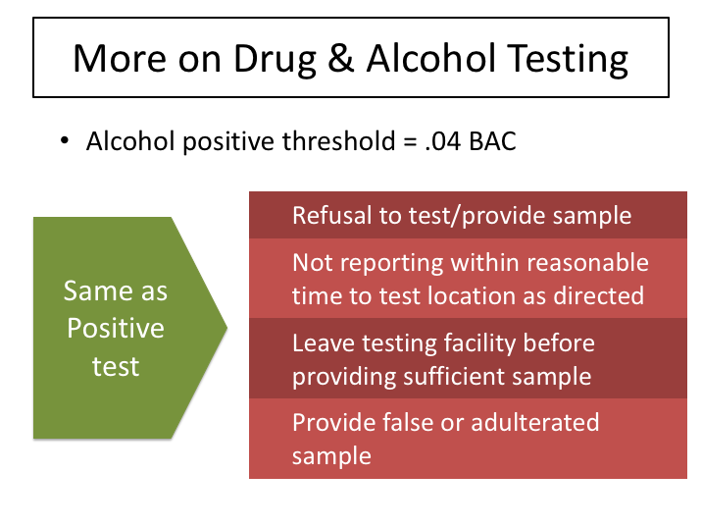

**MORE ON DRUG & ALCOHOL TESTING**

In addition to having to complete a SAP’s prescribed treatment plan, testing positive on a DOT-regulated test also requires that the driver be removed from safety-sensitive functions, which includes driving a commercial vehicle.

Regarding alcohol use, any blood alcohol concentration (BAC) equal to or greater than .04 is considered a positive test by the DOT. DOT regulations also forbid driving a commercial vehicle with any BAC of .02 or greater, and drivers are not permitted to consume any amount of alcohol within four hours before driving a commercial vehicle. When a driver tests above the .02 BAC threshold, but under the .04 BAC threshold, regulations require that a minimum of 24 hours must pass before a driver is again eligible to drive a commercial vehicle.

In addition to actually exceeding threshold limits for a positive test, there are other scenarios where the result will be considered a positive test. These include:

* Refusal to submit to test or provide a breath or urine sample.
* Failure to report within a reasonable amount of time to the test location as directed (in most cases, reasonable = immediately!).

**MORE ON DRUG & ALCOHOL TESTING (continued)**

* Leaving a test facility before the process is complete or a sufficient sample has been provided.
* Providing a false or adulterated sample, or failing to permit the observation/monitoring of a urine sample when required to do so.

There are occasions when a driver tests positive for a controlled substance and there is an acceptable explanation. Following any positive test, a driver will be contacted by a medical review officer (MRO) to check for any reasonable and acceptable explanation. For this reason, it’s important to provide reliable contact information at the time you are submitting to a substance abuse test – if the MRO cannot contact you within a specified timeframe, the result will be a classified as a verified positive test. Finally, all urine samples are collected as a split sample – this means that you have the ability/option to request a test on the split sample if the initial sample tests positive for a controlled substance.

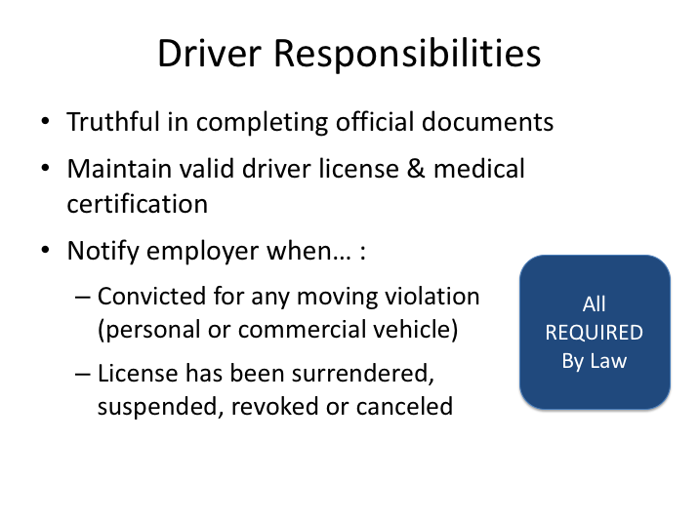

**DRIVER RESPONSIBILITIES**

Drivers have key responsibilities in complying with rules, being honest with their employer and other officials, and operating commercial vehicles safely. Drivers must be truthful in completing official documents, such as employment applications and medical questionnaires. Another important responsibility for drivers is to maintain necessary credentials for operating a commercial vehicle. This includes keeping your license in good standing and renewing when necessary, as well as maintaining valid medical certification. Drivers should report any health issues which may affect current certification to their employer and physician.

Safety regulations also require drivers to notify their employer when they are convicted for any moving violation in a personal or commercial vehicle. Additionally, the driver must notify the employer immediately if a commercial driver’s license has been suspended, revoked, or canceled.

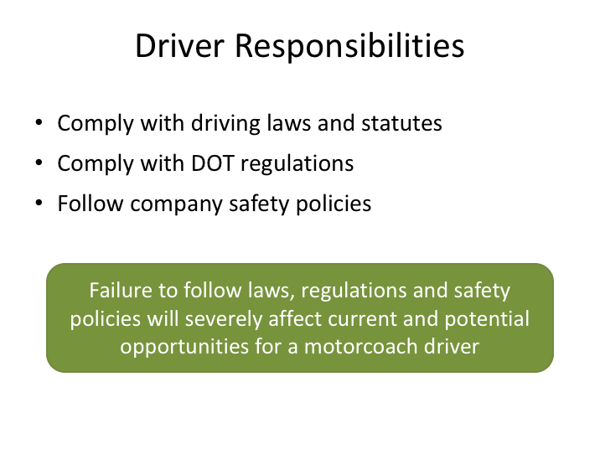

**DRIVER RESPONSIBILITIES (continued)**

Compliance with laws and policies is another key responsibility of the driver. They should know the driving laws of the states they are operating in, with an understanding that varying rules in different states may require some advance preparation. Drivers must be knowledgeable of federal and state safety regulations, as well as company policies.

Violation of any of these laws, regulations, or policies can severely affect the driver’s employability. Driving law infractions are generally reflected on motor vehicle driving records, which commercial motor carriers are required to review frequently. Violations of DOT regulations discovered by enforcement personnel are recorded in a driver database that employers can query when reviewing potential drivers. And, violation of company policies will certainly be subject to disciplinary actions that could include termination.

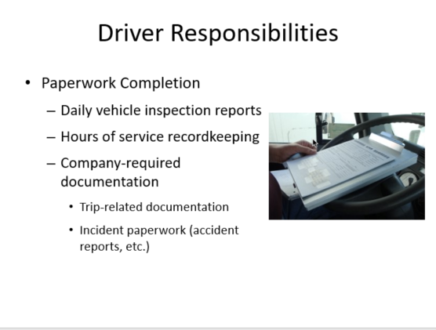

**DRIVER RESPONSIBILITIES (continued)**

Perhaps one of the least favored aspects of being a professional driver is the paperwork responsibilities that go hand-in-hand with the position. Many of the regulated functions and requirements that pertain to the driver and the company must be properly documented. Examples include vehicle inspection reports and driver hours of service logs or time records. There’s also trip related documentation which needs to be assembled, itemized, and turned in by the driver during or after the trip. It is also common for specific paperwork to be completed when any type of incident or collision occurs.

The amount of paperwork required will be dependent upon each company’s policies, practices, and the extent to which any technology has been deployed to assist in meeting regulatory requirements.

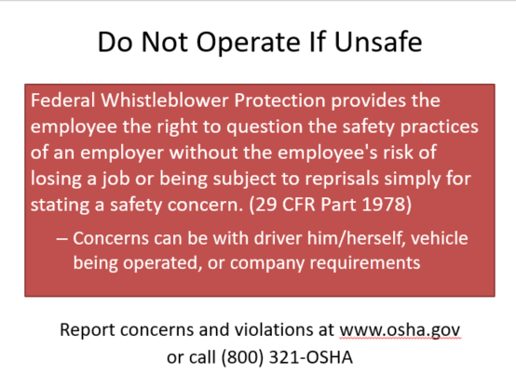

**DO NOT OPERATE IF UNSAFE**

The first and primary responsibility of a driver is safety.  There are a lot of factors that can affect safe operations.  The safety of the many passengers on-board a motorcoach and the public in general is a big responsibility.  Drivers knowledgeable about regulatory requirements and safe operations should not be afraid to voice safety concerns to their employer.  Federal whistleblower laws protect employees, including drivers, who question safety practices.

Employees whose jobs directly affect commercial motor vehicle safety or security are protected from retaliation by their employers for reporting violations of federal or state motor carrier safety or security regulations. They also are protected when refusing to operate a vehicle because of violations of federal safety or security regulations.

To file a complaint by phone, call OSHA toll-free at 1-800-321-OSHA, or contact your nearest OSHA office.  You can also report concerns online at www.osha.gov.

LESSON 3

HOURS OF SERVICE

**Lesson Objectives**:

By the end of this lesson, you will know and understand the federal hours of service rules and limitations, key definitions and duty classifications, and limited exceptions to the rules. You will learn how to manually document compliance with these regulations through completion of records of duty status, and will know how to assess your cumulative on-duty hours over the previous six or seven days.

**Instructional Method:** Classroom

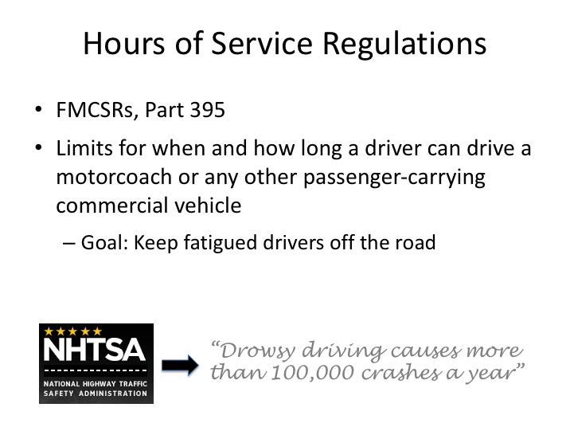

**HOURS OF SERVICE REGULATIONS**

The FMCSRs were developed to help ensure that commercial motor carriers were operating at higher standards than non-commercial carriers by enacting additional regulations that they are required to follow. One of the cornerstones of the FMCSRs are the hours of service regulations, which can be found in Part 395. These regulations were developed primarily to reduce the number of fatigued drivers on the public roadways. Fatigued drivers may be slow to notice or react to potentially dangerous situations and apt to fall asleep at the wheel and lose control of the vehicle. Hours of service regulations put limits in place for when and how long someone may drive a commercial vehicle, with the idea that these limits will help make sure that drivers are more likely to stay awake and alert while driving. Hours of service regulations differ for passenger and property-carrying commercial vehicles; it is important to note that the regulations covered in this lesson are for drivers of passenger-carrying commercial vehicles.

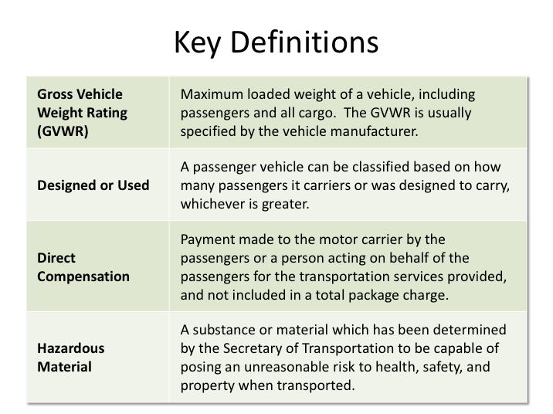

**KEY DEFINITIONS**

Applicability of the hours of service regulations (and many other safety regulations), depend on the whether a vehicle is classified as a commercial motor vehicle. Classification of passenger-carrying vehicles is dependent upon the weight of the vehicle, the passenger capacity, type of transportation provided, and whether specific amounts of hazardous material is being transported.

In general, one or more of the following characteristics is used to identify whether a passenger-carrying vehicle is designated as a commercial vehicle by federal (interstate) standards:

* Gross Vehicle Weight Rating - A vehicle’s gross vehicle weight rating (GVWR) is the maximum loaded weight of a vehicle, including passengers and all cargo. The GVWR is typically specified by the vehicle manufacture.
* Capacity - A passenger vehicle can be classified based on either how many passengers it is actually carrying or how many passengers it was originally designed to carry - whichever is greater.

**KEY DEFINITIONS (continued)**

* Type of transportation/compensation - There are different categories of passenger transportation, including for-hire and private. For-hire carriers receive payment for their transportation services. Payment or compensation can be either directly or indirectly received. A shuttle service where passengers pay a fare for the transportation is direct payment. A shuttle service included in the cost of another service such as lodging in a hotel or as part of a total vacation package is indirect payment. Both direct and indirect payment for interstate transportation service places the carrier into FMCSA jurisdiction.
* PrivateMotor carriers of Passengers(PMCP)-Business, or not for-hire carriers, provide transportation to designated persons, not for compensation, in furtherence of a commercial business. Other types of transportation fall under the private motor carrier of passengers (PMCP) -Non-business, such as churches, charities, etc. If a private motor carrier of passengers; business or non-business, accepts any type of compensation for transportation then the operation is no longer private and becomes for-hire. Compensation can have many forms; money, gifts, offerings, funds for gas only, etc.

Hazardous material cargo – A passenger vehicle can also be classified as commercial if it carries hazardous materials in quantities in excess of specified amounts. The USDOT determines both what materials are considered hazardous, and their threshold amounts. If a hazardous material is carried above the specified threshold amount, the exterior of the vehicle must be marked, or placarded. Also, the driver must have hazardous materials training and may be required to have a hazardous materials endorsement on their CDL. Motorcoaches do not routinely carry significant quantities of hazardous materials and are limited from carrying quantities that would require such placarding.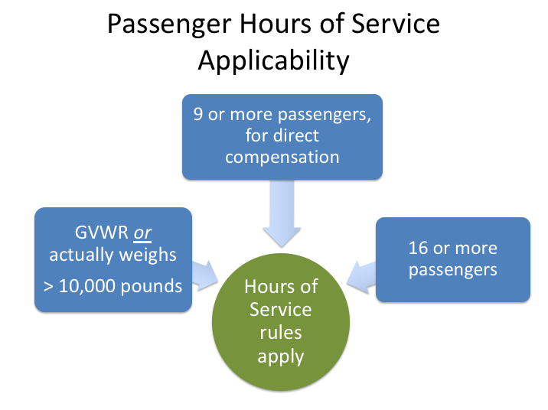

**PASSENGER HOURS OF SERVICE APPLICABILITY**

Federal hours of service limitations apply to drivers of specific commercial vehicles. Passenger-carrying vehicles whose drivers must comply with the hours of service rules include:

* Vehicles involved in interstate commerce that have a gross vehicle weight rating (GVWR) *or* actually weigh more than 10,000 pounds (including passengers and cargo). If towing a trailer, the combination weight of the vehicle and the trailer would be combined to determine the vehicle weight.
* Vehicles that are designed or used to transport nine or more passengers, including the driver, for direct compensation.
* Vehicles that are designed or used to transport 16 or more passengers, including the driver.

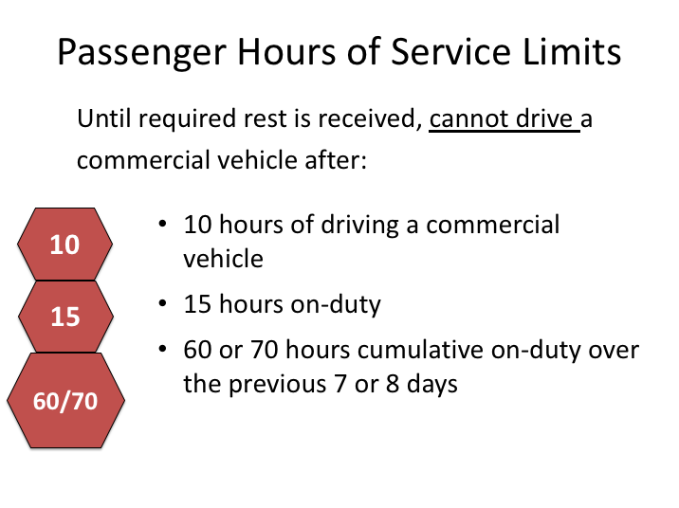

**PASSENGER HOURS OF SERVICE LIMITS**

The passenger hours of service limitations establish the amount of time you can spend driving a passenger-carrying commercial vehicle over various time frames.

**10-hour driving limit.** A driver is allowed 10 hours of actual driving time before a required rest period; after driving for 10 hours, a driver cannot drive a commercial vehicle until they receive the required rest. There is no limit on how many of those hours can be driven at one time – a driver may drive for as little as a few minutes or as much as 10 hours in a row. However, once he/she has driven a total of 10 hours, the driving limit has been reached and a required rest period of at least eight consecutive hours is necessary before driving a commercial motor vehicle again.

**15-hour on-duty limit.** A driver is not permitted to drive a commercial motor vehicle after being on-duty (including driving time) 15 hours. Work other than driving a commercial vehicle may be done after the 15th hour, but until the required rest period has been met, he/she may not drive. Any off-duty time taken during the day, such as a lunch break or nap, does not count toward this 15-hour limit as long as the off-duty period meets all the requirements (more detail on this coming up).

**PASSENGER HOURS OF SERVICE LIMITS (continued)**

**The 60/70-hour on-duty limit.** This limit is based on a 7-day or 8-day period, depending on how many days a motor carrier operates. In simple terms, once a driver works the specified number of on-duty hours (60 or 70) in the specified time frame (7 or 8 days), the driver can no longer drive a commercial vehicle until they are under the applicable threshold.

This limit is sometimes thought of as a “weekly” limit. However, this limit is not based on a “set” week, such as Sunday through Saturday. The limit is based on a “rolling” or “floating” 7-day or 8-day period. The oldest day’s hours drop off at the end of each day when you calculate the total on-duty time for the past seven or eight days. For example, if you operate on a 70-hour/8-day schedule, the current day would be the newest day of your 8-day period and the hours you worked nine days ago would drop out of the csalculation.

Drivers are required to follow whichever rule is applicable to the motor carrier for which they are driving. Motor carriers that do not operate vehicles seven days a week must follow the 60-hour/7 days rule, while motor carriers that operate commercial vehicles every day of the week can choose to operate under either limit. The majority of passenger transportation companies that operate seven days a week choose to operate under the 70-hour/8 days limit.

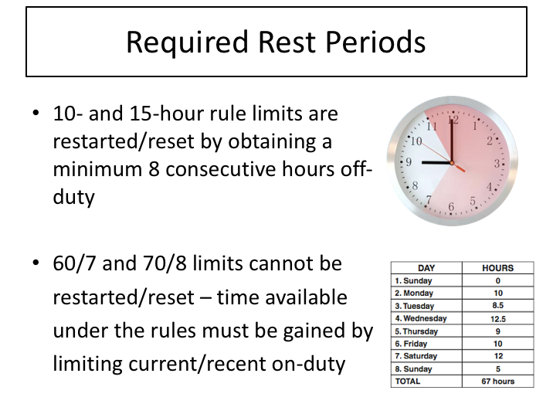

**REQUIRED REST PERIODS**

An eight-hour consecutive off-duty period resets/restarts both the 10-hour driving limit and the 15-hour cumulative on-duty limit. Until this eight-hour consecutive off-duty period is achieved, driving time and cumulative on-duty time continues to add up – even across days/work periods and jobs.

The cumulative on-duty limit cannot be reset to zero/restarted– it is a rolling computation that can only be affected by the passage of days and associated recalculation of on-duty hours. Days are based on a 24 hour period as set by the motor carrier. They can be noon to noon or midnight to midnight. Most companies choose to operate on a midnight to midnight shift.

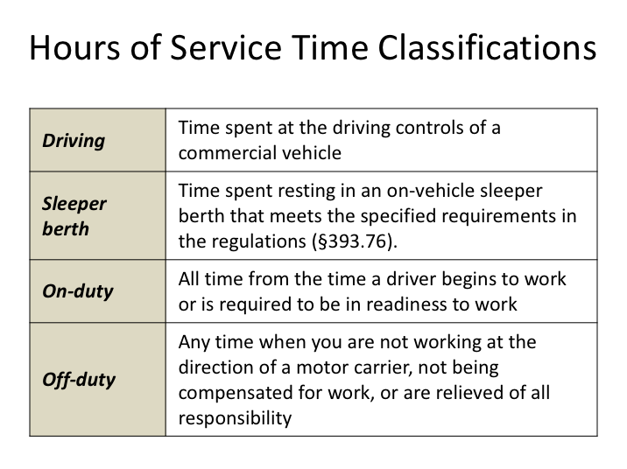

**HOURS OF SERVICE TIME CLASSIFICATIONS**

There are specific classifications of time and duty that will be used when discussing hours of service and associated recordkeeping requirements. Understanding these terms is essential to complying with the regulations.

*Driving* means all time spent at the driving controls of a commercial vehicle in operation. In essence, if you’re in the driver’s seat, your time would be classified as driving time.

*On-duty* time is all time from when a driver begins to work or is required to be in readiness to work until the time the driver is relieved from work and all responsibility for performing work. This classification is a little more complicated than driving time, so additional explanation and exceptions will be provided throughout the rest of this lesson.

Time classified as *sleeper berth* is time spent resting in and on a vehicle’s sleeper berth that meets all applicable requirements.

*Off-duty* time is time spent when you’re not being compensated for work or are relieved of all responsibility. Additional clarification of this classification will be made throughout this lesson.

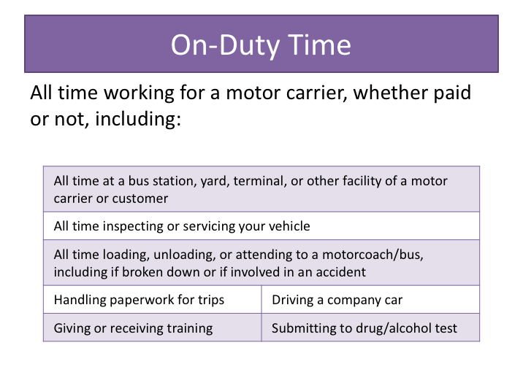

**ON-DUTY TIME**

The 15-hour and 60/70-hour limits are based on how many hours you are on-duty over a period of time. Just what kind of work is included in on-duty time? It includes all time you are working or are required to be ready to work, for any employer. Specifically, it includes the following activities:

* All time you are required to be at a bus station, yard, terminal, or other facility of a motor carrier or customer, unless you have been relieved from duty by the motor carrier;
* All time inspecting or servicing your vehicle, including fueling it and washing it;
* All driving time;
* All time loading, unloading, supervising, tending to your motorcoach/ bus, or handling paperwork for trips;
* All time taking care of your vehicle when it is broken down;

**ON-DUTY TIME (continued)**

* All time spent providing a breath, saliva, or urine sample for drug/alcohol testing, including travel to and from the collection site; and
* All time spent doing any other work for any motor carrier, including giving or receiving training and driving a company car.

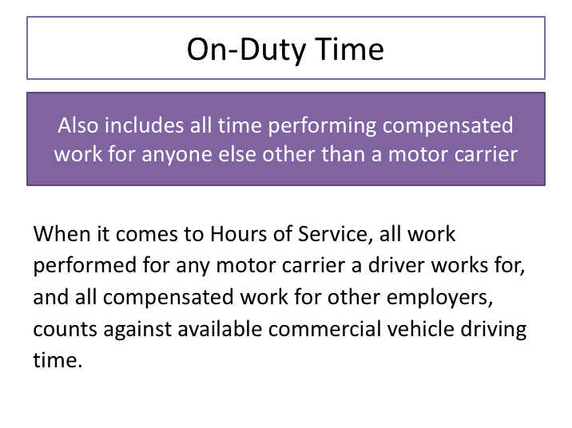

**ON-DUTY TIME (continued)**

On-duty time also includes all time performing compensated work for anyone else other than a motor carrier. This would include any job, even those not associated with commercial vehicles operations - such as working in a restaurant.

It is not unusual for many drivers to work for several motor carriers on a part-time basis. For instance, someone may drive a school bus during the week, and motorcoach charters on the weekend. When considering hours of serviceavailability, all on-duty time for any motor carrier must be included and recorded on time records as appropriate, along with any compensated work/duty time for non-motor carriers.

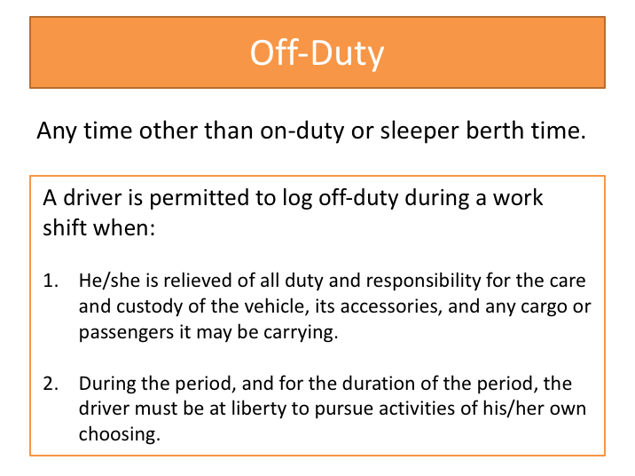

**OFF-DUTY**

By understanding the definition of on-duty time, you will get a good idea of what is considered off-duty time.

If you are relieved of duty and not doing any work (paid or unpaid) for a motor carrier, and you are not being compensated for work by anyone else, the time can be recorded as off-duty.

Passenger hours of service regulations also permit drivers to record routine stops and other portions of time during a work shift (when they are relieved of all duties) as off-duty. In order for this time to be considered off duty, a driver must be relieved of all duty and responsibility for performing work. The driver must be free to pursue activities of their own choosing and be able to leave the place where the commercial vehicle is parked. A driver may show off-duty time on a stationary (parked) commercial motor vehicle.

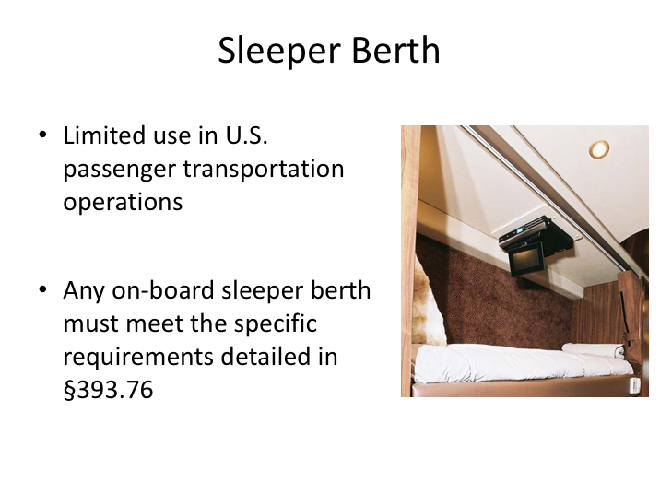

**SLEEPER BERTH**

In general, sleeper berths are not common in U.S. motorcoach operations. When they do exist, they frequently do not physically meet the necessary requirements to be recognized as an official sleeper berth as defined in §393.76 of the Federal Motor Carrier Safety Regulations. Nonetheless, it is possible to have a regulatory-compliant sleeper berth in a motorcoach.

Existence of a sleeper berth can slightly affect hours of service compliance. When a sleeper berth is present, a driver can accumulate the eight consecutive hours break time by combining off-duty time and time spent in the sleeper berth, as long as no on-duty time is between the sleeper berth period and the off-duty time.

The driver may also use a split sleeper berth schedule, using two separate sleeper berth rest periods to meet the eight hours off-duty requirement. When using the split sleeper berth option:

1. Neither rest period can be shorter than two hours, and the two periods must equal at least eight hours;

**SLEEPER BERTH (continued)**

1. The driving time in the period immediately before and after each qualifying rest period, when added together, cannot not exceed 10 hours;
2. The on-duty time in the period immediately before and after each qualifying rest period, when added together, cannot not include any driving time after the 15th hour;
3. The driver may not return to driving subject to the normal limits (non-sleeper berth split schedule) without taking at least eight consecutive hours off duty, spending at least eight consecutive hours in the sleeper berth, or a combination of at least eight consecutive hours off duty and sleeper berth time.

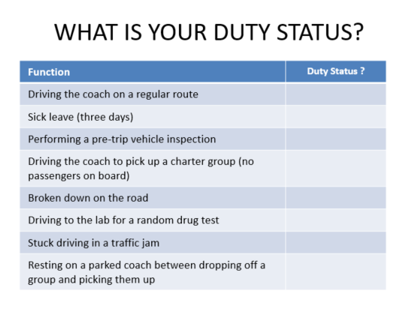

**EXERCISE**

Look at these scenarios and write in the duty status for each function. Your instructor will review the correct answers with you.

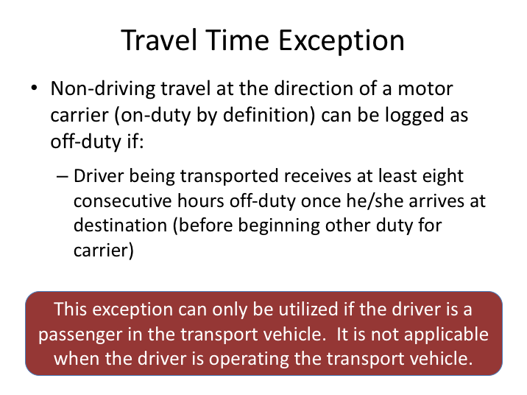

**TRAVEL TIME EXCEPTION**

“Travel time” refers to you being transported to a new location as part of your job, but you are not performing any of the driving on the trip. This could include riding in a motorcoach or bus passenger seat, or in any other type of transfer vehicle. While any travel done at the direction of a motor carrier is by definition considered on-duty time, this exception allows you to classify the travel time as off-duty when certain circumstances are met. Specifically, if you take at least eight-consecutive hours off-duty once you get to your destination, you may classify all of the time, including the travel time, as off-duty.

This exception can only be utilized if the driver is a passenger in the transport vehicle. It is not applicable when the driver does any of the driving him/herself.

**Example –**

Your company sends you on a bus for eight hours to a destination where you will later trade places with the driver so you can drive back. You are simply riding the bus and not doing any other work for your company. Before driving the bus you take eight consecutive hours off duty. In this case you may count all of the travel time as off duty as well.

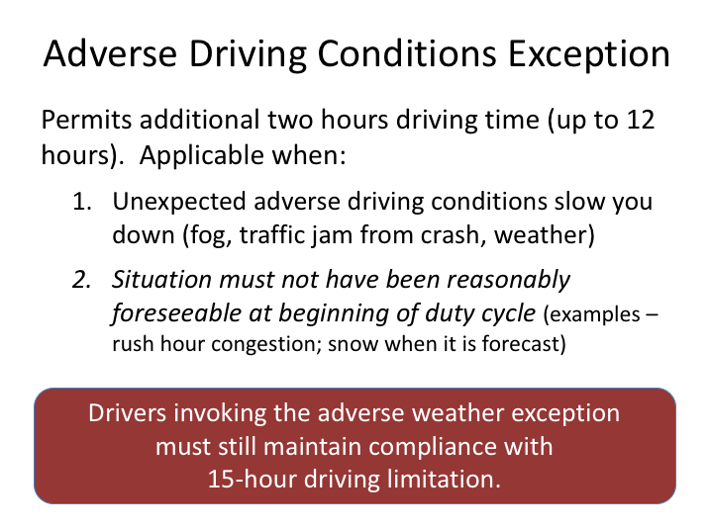

**ADVERSE DRIVING CONDITIONS EXCEPTION**

When unexpected adverse driving conditions affect a trip, a driver may drive up to two extra hours to complete what could’ve been driven in normal conditions. This exception extends the 10-hour driving limit up to a maximum 12 hours. Adverse driving conditions mean things that were not known when a trip was started, like traffic resulting from a crash. Weather can also cited as an adverse driving condition, but generally only when the weather could not have been reasonably anticipated or known. Conditions that could have been reasonably anticipated such as congested traffic during a typical rush hour period would not be an acceptable adverse driving condition.

This exception does not extend the 15-hour on-duty limitation on driving a commercial vehicle, so even when invoking the adverse driving conditions exception, drivers must continue to maintain compliance with the 15-hour driving limitation/rule.

**ADVERSE DRIVING CONDITIONS EXCEPTION (continued)**

**Example –**

You come to work at 7:00 a.m., start driving at 8:00 a.m., and drive eight hours when you are delayed by heavy fog at 4:00 p.m. for two hoursThe fog was not forecasted. At this point, the adverse driving conditions exception would allow you to drive for up to four more hours (two hours to get to 10 and two extra hours due to the fog), taking you to 8:00 p.m. for a total of 12 hours of driving.

If, however, you come to work at 7:00 a.m., start driving at 12:00 p.m. and drive into fog at 5:00 p.m.causing a two hour delay, you could only drive until 10:00 p.m. for a total of 10 hours of driving. You would have to stop driving at 10:00 p.m. because you would have reached the 15-hour on-duty limit.

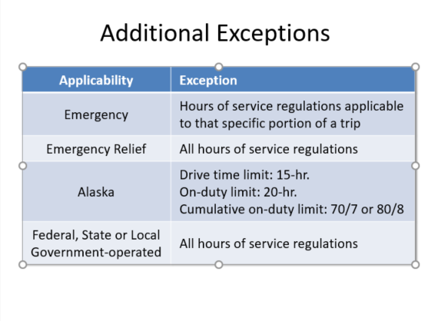

**ADDITIONAL EXCEPTIONS**

There are some other exceptions to the hours of service regulations. Similar to the adverse driving conditions exemption, a driver, in the event of an emergency, may complete his/her run without being in violation of the hours of service limitations, if such run reasonably could have been completed absent the emergency. Examples include a medical emergency or an accident that does not prevent the coach from finishing the run. Just like with the adverse driving condition exception, this exception cannot be claimed if the driver or carrier should have known of the emergency. For example, situations as a driver’s desire to get home, customers’ demands, shortage of drivers, or mechanical failures, are not considered emergencies.

Operations performed in connection with emergency relief, during declared national, regional, state, or local emergencies, are exempt from hours of service regulations. Examples include situations such as hurricane evacuation and response.

Coach operations conducted and operated by federal, state or local government are exempt from federal hours of service regulations. Local government operations are subject to state regulations that could affect this exception.

**ADDITIONAL EXCEPTIONS (continued)**

Drivers operating in Alaska are afforded longer duty periods due to the size of the state and limited development. In Alaska, the 10-hour driving limitation is extended to 15 hours before required rest is necessary. The 15-hour on-duty limit is increased to 20 hours. The 60/7 or 70/8 cumulative on-duty limits are also increased to 70 hours over 7 days and 80 hours over 8 days respectively.

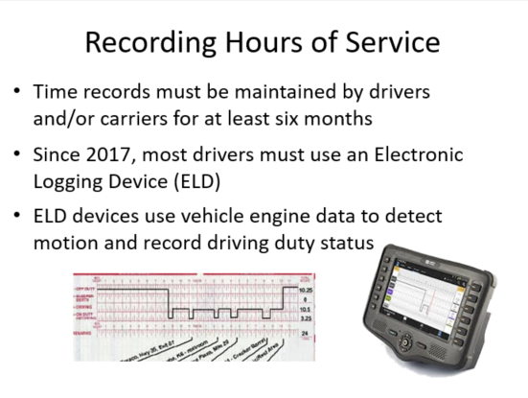

**RECORDING HOURS OF SERVICE**

In order to monitor compliance with hours of service limits, the DOT requires all commercial drivers to maintain daily records of their time, and all motor carriers to monitor drivers’ time.

There are multiple methods to recording hours of service, though each is meant to essentially record the same data.  Historically, paper logs were generally used to log/record drivers’ hours of service in a grid-type log as seen in the image here.  However, beginning in 2017, safety regulations mandated vehicle-integrated electronic logging devices - better known as ELDs - be used to record drivers’ hours of service for most commercial vehicle drivers.  ELD systems record hours of service more accurately than previous methods, though they still use the same style of grid log to do so.

While each approved ELD system must meet certain specifications, operational use of each still varies significantly.  Because of this, details on operating any specific ELD in use at this company will not be covered in this curriculum.

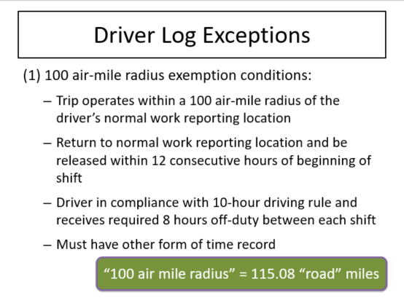

**DRIVER LOG EXCEPTIONS**

There are two general exceptions to the requirement to complete the grid-type logs we’ve been discussing.  The first is generally known as the 100 air-mile radius exemption or short-haul exemption.

Drivers and carriers have historically been exempt from completing/maintaining detailed records of duty status in limited short-trip circumstances. When these circumstances occurred, detailed time records meeting regulatory requirements could be maintained in lieu of the detailed records of duty status.  To use this exemption:

* The trip must operate within a 100 air-mile radius of the driver’s normal work reporting location.
* The driver must return to the normal work reporting location and be released within 12 consecutive hours of the beginning of the shift/trip.
* The driver/trip must comply with the 10 hour driving rule/limit and the driver must receive the required minimum eight consecutive hours off-duty time between each shift/trip.
* The motor carrier must maintain some other form of time record including the drivers time reported to work, the time relieved of work and the total hours on duty each day.

**DRIVER LOG EXCEPTIONS (continued)**

The obvious question that always arises is how to determine whether or not a trip operates within 100 air-mile radius.  If a destination’s distance is not known relative to the actual air-mile radius from the dispatch location, then conversions can be useful.  By definition, an air mile is a little longer than an “over the road” mile.  In fact, one air mile is the equivalent of 1.15 statute or “over the road” miles.  Accordingly, 100 air miles is the equivalent of 115.08 “over the road” miles.

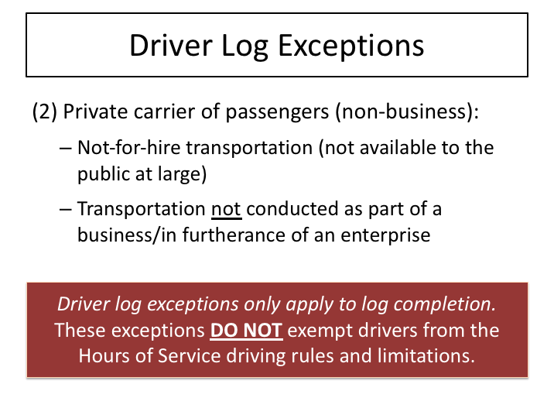

**DRIVER LOG EXCEPTIONS (continued)**

The second exception to completing driver grid logs is if the trip is being operated by a private motor carrier of passengers for a non-business purpose.  Private motor carriers of passengers (PMCPs) are motor carriers that are not available for hire to the general public.  There are two categories of PMCPs – business and non-business.  Many times, private motor carriers of passengers are businesses transporting employees, contractors or others as part of the necessity of the business or commercial enterprise – these are considered business-related PMCPs.  However, there are other times when a private motor carrier of passengers is transporting persons not done as part of a business – these are considered non-business PMCPs.  Examples may include churches, , civic organizations, and other charitable organizations that may purchase or lease vehicles for their own use in transporting their groups.

It is important to note that driver log exceptions only apply to completing driver logs. These exceptions do not exempt drivers (or companies) from the hours of service driving rules and limitations.  Additionally, PMCPs non-business are not subject to paperwork retention so they are not required to keep time records for each driver.

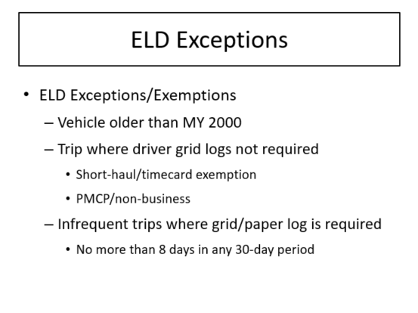

**ELD EXCEPTIONS**

While electronic logging devices are the required methodology to record driver hours, there are still times that paper logs or other methods to record hours of service may be used.

Drivers who use the 100-mile/short-haul/timecard exception and private, non-business carriers are not required to complete paper logs or use ELDs.

The following drivers are also exempted from using an ELD, though they must prepare logs on paper, or use another suitable electonic method, such as an Automatic On-Board Recording Device (AOBRD), or logging software program:

* Drivers of vehicles manufactured before 2000.
* Drivers who are required to keep Records of duty status (logs) not more than 8 days within any 30-day period.

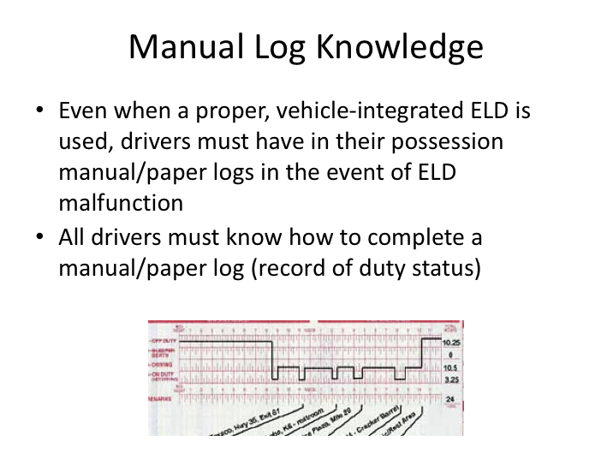

**MANUAL LOG KNOWLEDGE**

Even when ELDs are the primary system in use to record a driver’s hours of service, drivers must still know how to manually prepare a paper log in the event that the ELD malfunctions during a trip. If an ELD system malfunctions, and a driver cannot complete manual/paper logs as required, then the driver can be placed out of service for not maintaining a record of duty status as required by regulation.

So, it is important for drivers to understand how to complete manual, or paper logs in the event they are required.  For the rest of this section, we’ll review components of manual logs and their proper completion.

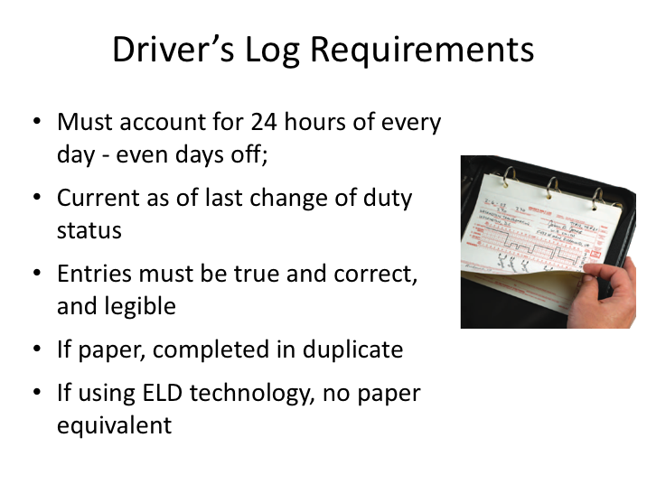

**DRIVER’S LOG REQUIREMENTS**

Driver logs need to be completed every day, whether you’re working or not. Each log must detail driver duty status during the entire 24 hours of each day. Log entries must be current to the last change of duty status, especially on days where you are driving a commercial vehicle. Information recorded on the log must be true and correct – there are significant ramifications for the driver and company if a log is discovered to have been falsified.

Paper logs are completed in duplicate – the original is submitted to the company, and the copy is kept by the driver Entries should be legible and made by the driver, in the driver’s writing, except for a custom log that has some of the information pre-printed (such as company address).

To many drivers, logs seem like a hassle (even more so if they have to do them only occasionally!). But you must remember, authorized government inspectors may check your logs at any time during a trip, or during an inspection at a motor carrier.

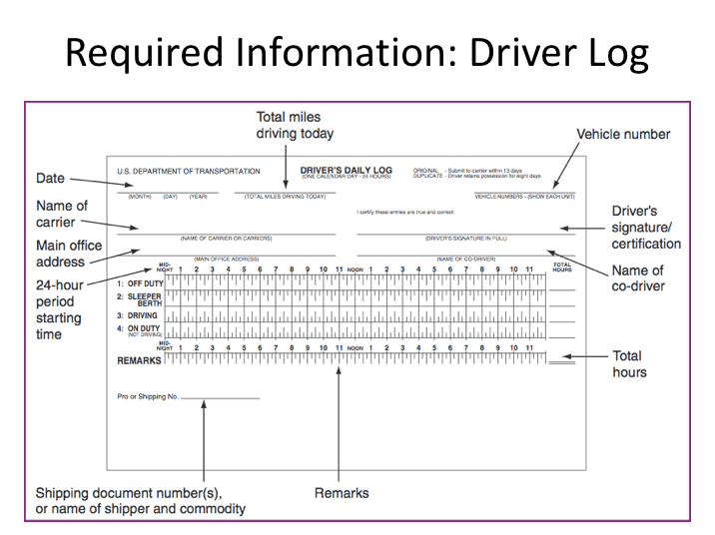

**REQUIRED INFORMATION: DRIVER LOG**

Even knowledgeable professional drivers have been tripped up filling out logs. Many of the violations that are found have nothing to do with driving too long or too often; they have to do with filling out the form incorrectly or incompletely.

Each label and arrow here is pointing to portions of the log that must be completed - in addition to the actual grid section in the center that details your duty status for every hour of the day. This graphic is representative of a driver log, though they can vary. Some companies have custom logs printed that may have some portions of the log pre-printed (Company Name, Main Address).

The top section is where general information is recorded. The middle section is where duty status is detailed for the whole day. The bottom section is for remarks – it is used to note the location of each change of duty status, detail any special circumstances, and record the charter/schedule number or the group name.

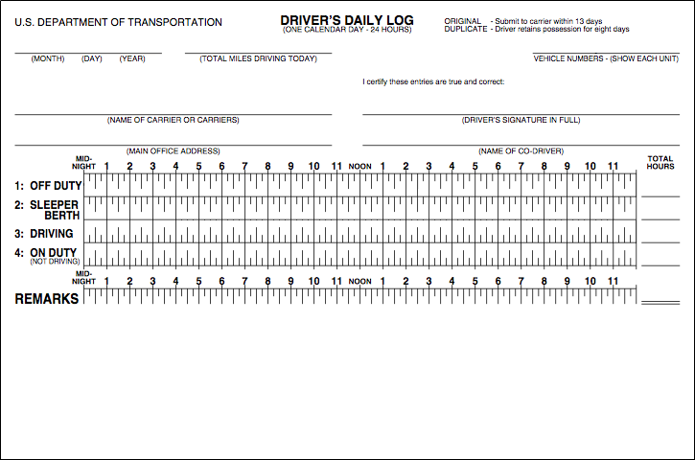

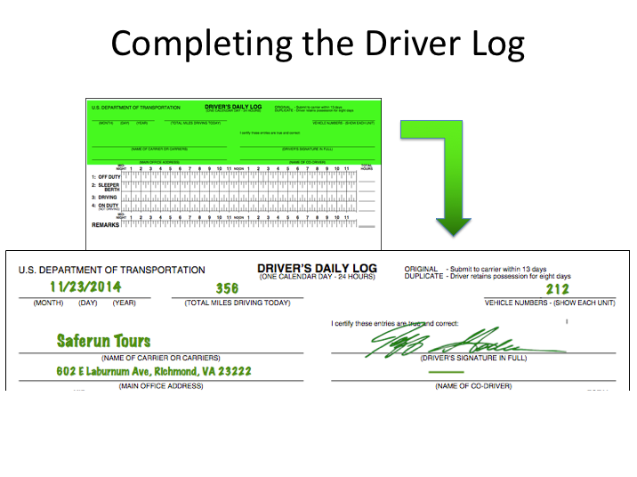

**COMPLETING THE DRIVER LOG**

Let’s review the top portion of the log and what a driver is responsible for completing.

**Date.** You must write down the month, day, and year for the beginning of each 24-hour period. (Multiple consecutive days off-duty may be combined on one log page, with an explanation in the “Remarks”.)

**Total miles driving today.** You must write down the total number of miles you drove during the 24-hour period.

**Motorcoach/bus number.** You must write down either the vehicle number(s) assigned by your company, or the license number and licensing state for each vehicle operated during the 24-hour period.

**Name of carrier.** You must write down the name of the motor carrier(s) you are working for. If you work for more than one carrier in a 24-hour period, you must list the times you started and finished work for each carrier.

**Main office address.** You must write down your carrier’s main office address.

**COMPLETING THE DRIVER LOG (continued)**

**Your signature.** You must certify that all of your entries are true and correct by signing your log with your legal name or name of record.

**Name of co-driver.** Sometimes there may be more than one driver operating a trip. If this is the case, you must write down the name of your co-driver. In our example, there is none listed.

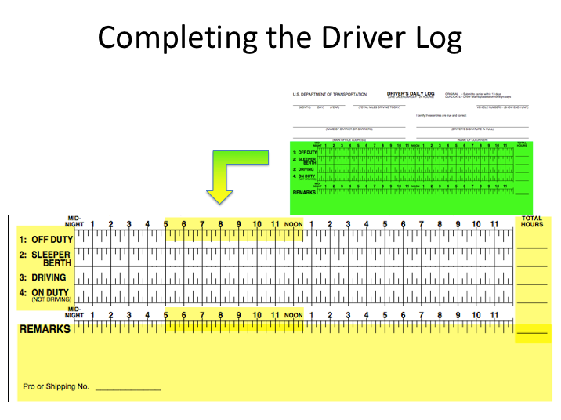

**COMPLETING THE DRIVER LOG (continued)**

Next, let’s look at the grid/duty status portion of the log as well as the remarks section.

Most log grids have four lines, though the second line – for sleeper berth – need not be present if a sleeper berth is not utilized. The grid will have lines for OFF-DUTY, DRIVING, and ON-DUTY (not driving) in all cases. The grid will also have the starting time and the hours marked above it – the vast majority of the time this is from midnight to midnight, though the carrier can change this, as long as the grid shows an entire 24 hour period and is consistent among all drivers.

Lines are drawn on the grid as follows:

**Off-Duty.** Draw a solid line between the appropriate time markers to show the periods of time you are off-duty.

**Sleeper Berth.** Draw a solid line between the appropriate time markers to show the periods of time you are resting in a sleeper berth.

**COMPLETING THE DRIVER LOG (continued)**

**Driving.** Draw a solid line between the appropriate time markers to show the periods of time you are behind the wheel of a commercial motor vehicle in operation.

**On-Duty (Not Driving).** Draw a solid line between the appropriate time markers to show the periods of time when you are on-duty, but not driving a commercial motor vehicle.

**Total Hours.** The total hours for each duty status must be added up and recorded at the right side of the grid. The total of the entries must equal 24 hours.

**Remarks.** This is the area where the city, town, or village, and state abbreviation should be recorded when a change of duty status occurs. You should also explain any unusual circumstances or log entries that may be unclear when reviewed later, such as encountering adverse driving conditions.

**Shipping document number(s), or name of shipper and commodity.** There is generally a location in the remarks area of the log to record a shipping or trip number. This is where a descriptive and definitive identification of the trip must be written – typically a charter order/number or the name of the company/group you are transporting is recorded.

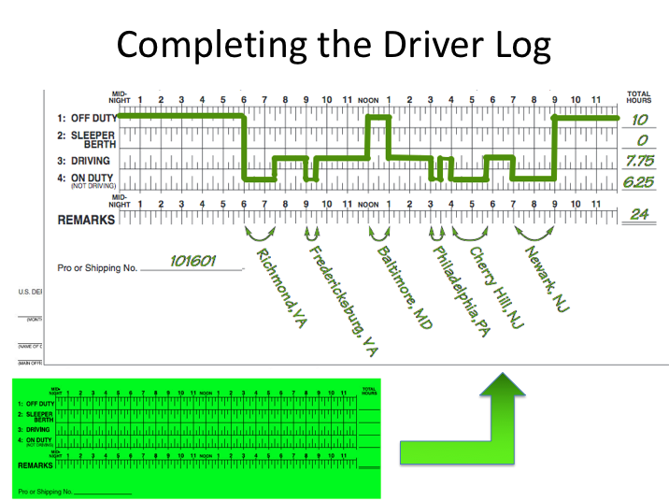

**COMPLETING THE DRIVER LOG (continued)**

Here is an example of a completed grid, along with other necessary information.

In this sample log grid, the driver (Jeff) went from Richmond, Virginia, to Newark, New Jersey. Jeff’s day went like this:

1. Reported for work at 6 a.m. He checked in, loaded some luggage, and did a pre-trip inspection. This is on-duty time. Jeff marked midnight to 6 a.m. as off-duty, then drew a line straight down to on-duty, not driving, and then drew a horizontal line from 6 a.m. to 7:30 a.m.
2. After driving 1½ hours, Jeff stopped to fuel his coach. Jeff marked the driving time on the driving line. The time at the fuel stop (½ hour) is marked on-duty, not driving.
3. Jeff then drove for 2½ hours to Baltimore where he had lunch. He again recorded his driving time. After lunch he recorded his lunch time as off-duty since he had instructions from his carrier to log his lunch time as off-duty and did not have any work responsibilities during this time.

**COMPLETING THE DRIVER LOG (continued)**

1. After lunch Jeff drove for two more hours and stopped in Philadelphia to discharge passengers. He recorded his time again. Following the ½ hour stop, which he recorded as on-duty, not driving, he started driving again.
2. Jeff then drove for 30 minutes to Cherry Hill, NJ, where he conducted a walking tour for 1¾ hours. Because he was working, he recorded this time as on-duty.
3. At 5:45 p.m. Jeff began driving again. He reached his destination in Newark at 7:00 p.m. Jeff spent two hours assisting passengers, inspecting the vehicle, and doing paperwork. He went off duty at 9:00 p.m.

In the Remarks Section, Jeff wrote down the locations of each duty status changes as follows:

* He reported for work at Richmond, VA.
* He stopped and fueled his coach in Fredericksburg, VA.
* He had lunch in Baltimore, MD.
* He made a stop in Philadelphia, PA.
* He exited the coach and worked for two hours in Cherry Hill, NJ.
* He drove to Newark, NJ, completed some work, and went off-duty.

Remember this when completing your log: You must keep the grid on your log current to your last change of duty status. For example, if an inspector stops you and asks to see your logbook, the final entry should show the time and place that you last started driving.

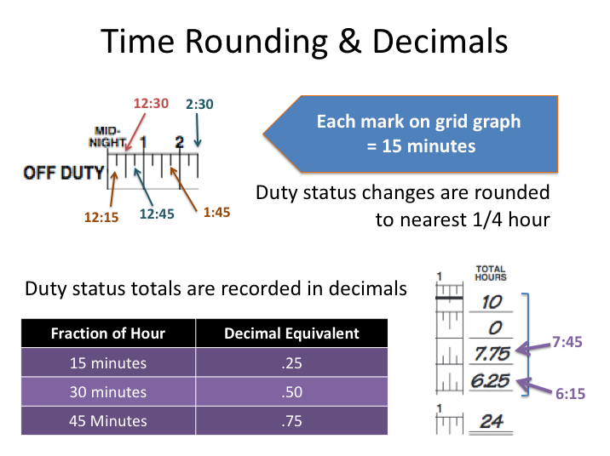

**TIME ROUNDING & DECIMALS**

Let’s look closer at the grid graph on the log. Notice that each hour on the graph is divided into four parts. In the example used on the previous page, all of the times used and duty status changes with driver Jeff happened at the top of an hour, or in quarter hour increments. That worked well when completing the grid log, where each of the vertical line stands for 15 minutes – or one quarter of an hour.

When filling in this graph, you always round everything to the nearest quarter hour. For example, if you changed from “Driving” to “On-Duty, Not Driving” at 1:41 a.m., you would show your duty status as “Driving” until 1:45 a.m. If you were to go from on-duty to off-duty at 12:36 a.m., you would show the duty status change to off-duty at 12:30 a.m. on the log.

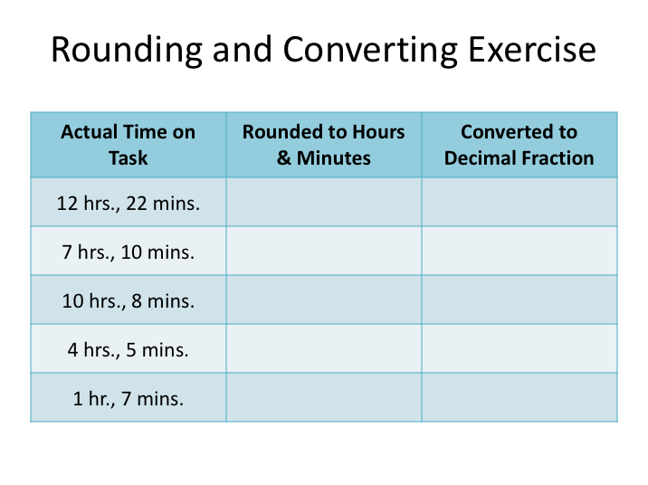

**EXERCISE**

For this exercise, you’ll be rounding actual time on task given to the nearest 15 minute increment/quarter hour. This step will be similar to what you would be doing when you round your duty status time up or down on a paper/manual log’s grid graph. After rounding the time on task, you’ll convert the rounded hours and minutes into a decimal representation of the hours and minutes.

Your instructor will review the answers and steps after a few minutes.

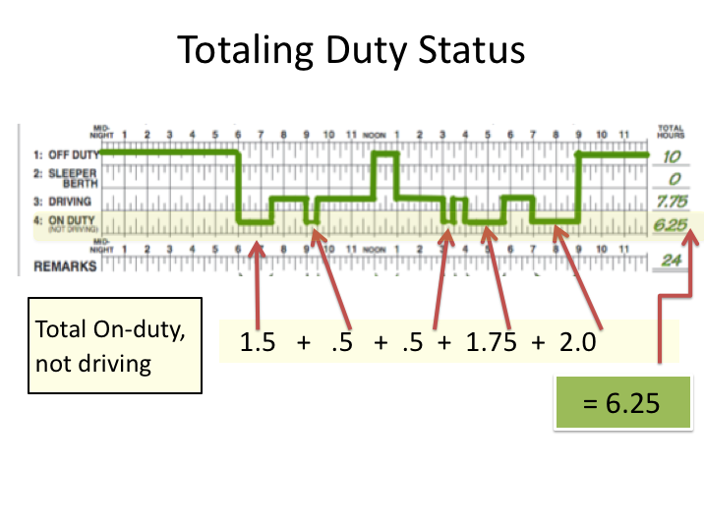

**TOTALING DUTY STATUS**

The last task a driver needs to master to understand how to complete paper/manual logs properly is adding decimals together. Let’s look again at our log example from earlier, where our driver Jeff began his day in Richmond, VA and ended in Newark, NJ. The graphic here shows the grid graph portion of his log from the trip. You’ll notice that he changes duty status several times throughout the day, which is typical for a driver of a motorcoach on a trip. To get the total hours for each duty status, several different increments of time from each duty status must be added together.

For example, the total “off-duty” time calculated for the day is the result of adding three separate time increments. His first period of off-duty was from midnight until 6 a.m. He was again off-duty from noon until 1 p.m., and he was also off-duty from 9 p.m. until midnight. To arrive at the 10 total hours logged off-duty, the six hours from midnight to 6 a.m. is added to the one hour from noon to 1 p.m. and the three hours from 9 p.m. until midnight. 6 hours + 1 hour + 3 hours = 10 hours total.

**TOTALING DUTY STATUS (continued)**

Drivers will have to do this for each line of the duty status – and they may not all be as simple. You could have several time periods with fractional hours – either .25, .5, or .75 - that need to be added together. For example, let’s add the total “on-duty, not driving” time represented on the grid graph in our example. There are five separate increments of on-duty, not driving:

1. The first is from 6 a.m. to 7:30 a.m. = 1.5 hours.
2. The second is from 9 a.m. until 9:30 a.m. = .5 hours.
3. The third is from 3 p.m. until 3:30 p.m. = .5 hours.
4. The fourth is from 4 p.m. until 5:40 p.m. = 1.75 hours.
5. The last is from 7 p.m. until 9 p.m. = 2.0 hours.

Adding up all of these on-duty, not driving increments results in the 6.25 total hours listed for the “on-duty, not driving” duty status line (1.5 +. 5 + .5 + 1.75 + 2.0 = 6.25).

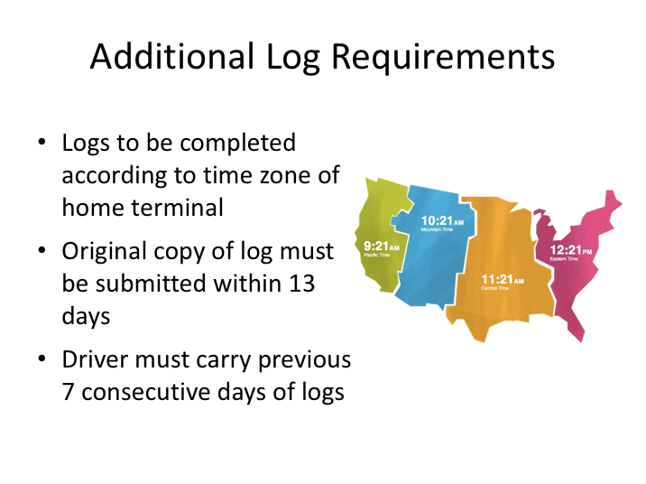

**ADDITIONAL LOG REQUIREMENTS**

There are other requirements of completing logs that must be mentioned.

Depending upon company operations, it may not be unusual for a driver to be out on an extended trip where he/she crosses in and out of multiple times zones. Logging according to various time zones presents obvious issues, so the DOT requires all logs to be completed in the native time zone of the home terminal. Even when a driver crosses into other time zones, he/she should record the time on the log as the time at the home terminal. While electronic logs are programmed to record in the home time zone, drivers will have to know the difference between the current time and their home time when completing paper/manual logs to avoid confusion and errors.  Drivers may find it easier to do this by keeping a watch or other manually set timepiece with them that they keep on their “home” time zone. Referring to such a timepiece when recording data on the driver log will help minimize confusion and any time errors.

In general, original copies of logs are turned into the company following a trip. However, if a trip lasts longer than 13 days, original logs will have to be submitted to the company via an alternate method. Regulations require that original logs be submitted to the carrier within 13 days of their completion.

**ADDITIONAL LOG REQUIREMENTS (continued)**

Remember that enforcement officials can stop a commercial vehicle to review compliance with regulations – both vehicle and driver. So, to demonstrate compliance with hours of service regulations, drivers must carry a record of their logs for the previous seven consecutive days so that compliance with the 60/7 or 70/8 rule can be assessed. The driver shall retain a copy of each record of duty status for the previous seven consecutive days which shall be in his/her possession and available for inspection while on duty.

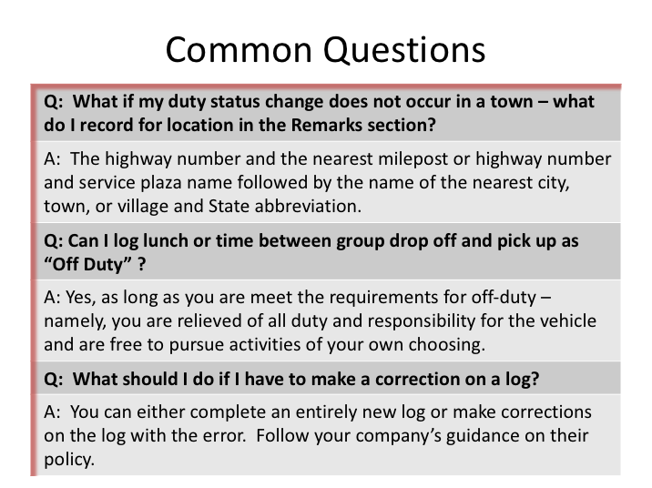

**COMMON QUESTIONS**

Completing a paper/manual log properly can be complicated as there are many scenarios that do not fit the examples that have been shown. Here are common questions that are frequently asked by drivers with regard to completing their log properly.

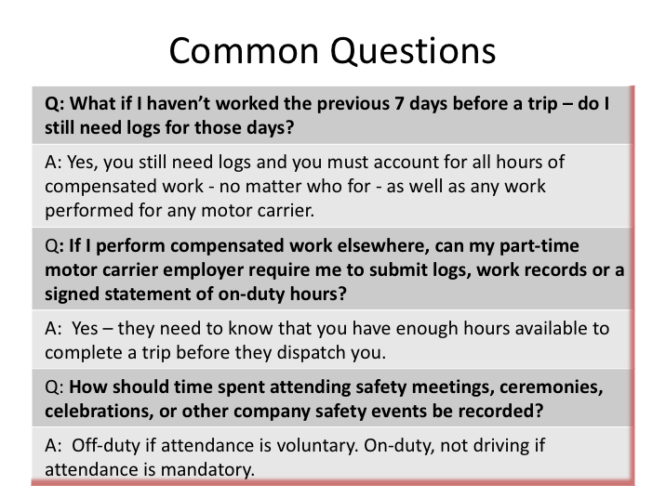

**COMMON QUESTIONS (continued)**

**EXERCISE**

Time to practice completing a paper/manual log. On the next page there is a description of a driver’s day, including changes in duty status, activities and locations, and the charter number. Use the activity detail provided to complete the blank log on the page following the activity description.

Use your name for the driver and current company for the carrier. The trip Is occurring today. The vehicle assigned is coach 146.

**LOG EXERCISE**

**Trip Activity for the Day**

Here is your trip activity for the day. Use your name and the company’s name and address when completing the log.

* Reported for work at 6:00 a.m. to carry out Charter Order #11461.
* Spent 15 minutes on paperwork and pre-trip inspection. The motorcoach’s odometer read 092,087.
* Drove 45 minutes to 100 Main Street, Anytown (this state) to pick up your group.
* Took 25 minutes to load.
* Had a front tire go flat, 84 minutes after leaving Anytown. You had to wait for the service truck to replace it. This delayed the trip by two hours. The breakdown location was milepost 180 on US 90 near Boulton, (this state).
* Arrived at the Mytown Summer Camp, Mytown, (this state) at noon.
* Logged 30 minutes of time for unloading the coach and 30 minutes for lunch, eaten at the camp. While at the camp, you still had responsibility for the vehicle and had to remain close by in the event it needed to be re-positioned.
* Drove 3 hours back to the home terminal.
* Spent 21 minutes on post-trip inspection and paperwork, then went off-duty. The odometer read 092,405.



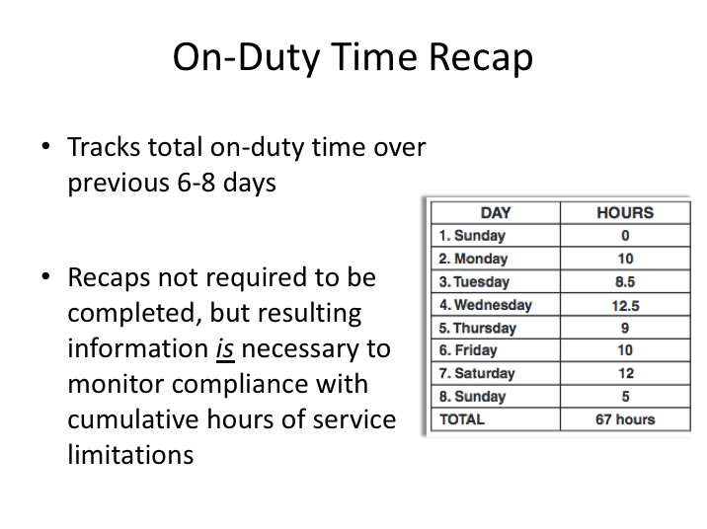

**ON-DUTY TIME RECAP**

In order to maintain compliance with the 60/7 or 70/8 rules, it is necessary to know the total number of on-duty hours logged over the previous six days (60/7 rule), or previous seven days (70/8 rule). **Since most motorcoach operations fall under the 70/8 rule, we will be using this rule in our examples. Calculations for the 60/7 rule are similar – with just one less day.**

Recapping on-duty time over the previous seven days allows you determine how much on-duty time you have available on the current day (day eight of the 70/8 rule) before you could be limited from driving a commercial vehicle (regardless of the 10 hour rule). Calculation of this on-duty time over the specified period has typically been known as a “log recap” or “log summary”. Log summaries or recaps are often included in log books, though their presence - or even completing them – is not a requirement. However, complying with the 60/7 or 70/8 rules *IS* a requirement, and, without knowing the previous on-duty summary, a driver could be in violation of this hours of service regulation.

With the advancement of technology, manually completing the recap is becoming far less common. Electronic log device software performs these calculations in real time and there are other software applications available on computers and mobile phone that also maintain a recap and performs calculations for a driver.

**ON-DUTY TIME RECAP (continued)**

Nonetheless, understanding the concept behind the recap is important, as is the ability to manually calculate it should the need arise.

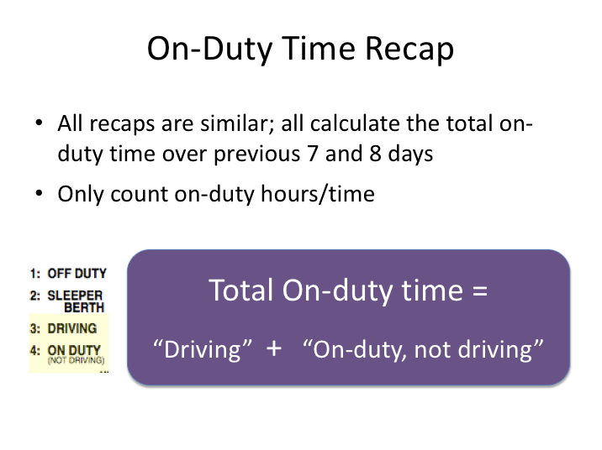

**ON-DUTY TIME RECAP (continued)**

Recaps used will vary by format and layout, but they all do the same thing: They help drivers and companies determine how many hours a driver can work tomorrow before reaching the 60- or 70-hour limit and are not allowed to drive a commercial vehicle anymore. Most recaps will summarize total on-duty hours recorded over the previous 7 and 8 days. A recap will not indicate when a driver is in violation of the 10- or 15-hour rules – drivers and companies must look at the daily log to determine those violations.

The time amounts used for the log recap are “on-duty” hours, which is time logged as “Driving” and “On-duty, not driving” on lines three and four of a daily log. The combination of these two duty status lines on a day’s log will give the total on-duty hours for any given day.

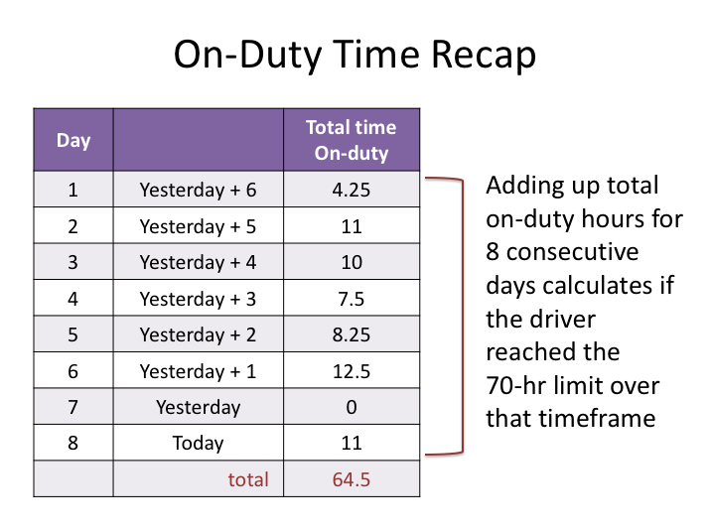

**ON-DUTY TIME RECAP (continued)**

Let’s review the 70/8 rule to determine why the recap is important to hours of service compliance. The 70/8 rule restricts a driver from driving a commercial vehicle after having been on-duty for 70 hours over the last eight days. The 70-hour limit is fixed and does not change, and neither does the consecutive eight day window.

As stated previously, many recaps track the total on-duty time for the previous seven and eight days. In the example above, the total on-duty times (“Driving” time + “On-duty, not driving” time) are provided for eight days, including today. You can see by the total that at the end of the eighth day, the driver has amassed 64.5 on-duty hours, and has not reached the 70-hour limit. Remember, the rule is over eight days, so the only information obtained by adding up any eight day period is whether or not a driver had reached the 70-hour limit in that eight day timeframe.

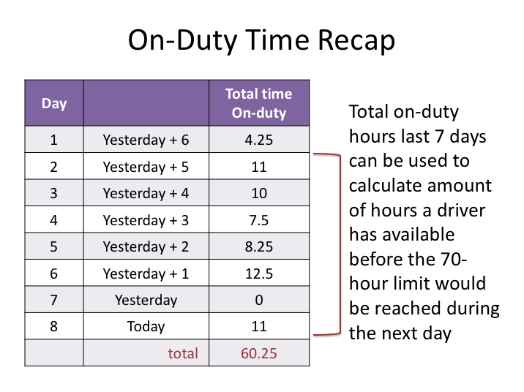

**ON-DUTY TIME RECAP (continued)**

If a company or driver discovered that the 70-hour limit was reached when looking back over eight days, the big question would then be whether or not the driver violated the hours of service rules by driving a commercial vehicle after having reached the 70th on-duty hour. This is not an ideal situation to be in, especially since the driver and company can easily forecast when the 70th on-duty hour will be reached – on the day it actually happens.

Using the same example, let’s look at the last seven days (including the current day). By calculating this number, we know how many total on-duty hours there have been the previous seven days and – more importantly – can calculate how many on-duty hours are available *tomorrow* before the 70th hour is reached and the driver can no longer drive.

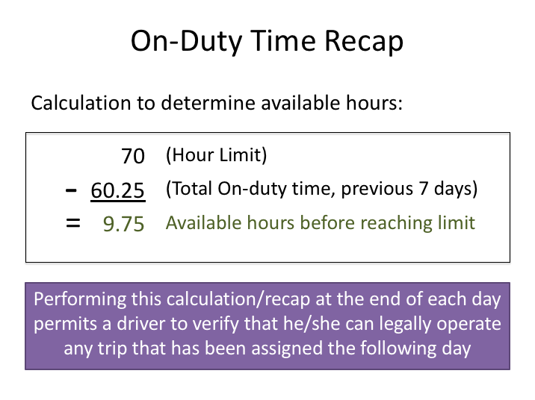

**ON-DUTY TIME RECAP (continued)**

The calculation is simple:

70 – (total on-duty time, last seven days) = (number of hours driver can be on-duty before cannot driver commercial vehicle)

70 – the hour rule limit – will never change. The total on duty time over the previous seven days will fluctuate based on a driver’s work schedule, and so will the available hours.

Using our example, 70 – 60.25 = 9.75. So, after being on-duty the next day for 9.75 hours, the driver would no longer be able to drive a commercial vehicle.

Using this information, a driver can verify that they have the necessary available hours to operate any trip scheduled for the following day by reviewing the hours available against schedule of the trip assigned.

**If you are ever assigned a trip for which you do not have the necessary hours available, you must notify dispatch immediately. Operating a trip when you know a violation will occur is against the law.**

**ON-DUTY TIME RECAP (continued)**

*Reminder – the examples used here are based on the 70/8 rule. If your company operates on the 60/7 limit rule, the calculations would be adjusted by subtracting the total on-duty time from the previous 6 days from the hour limit of 60.*

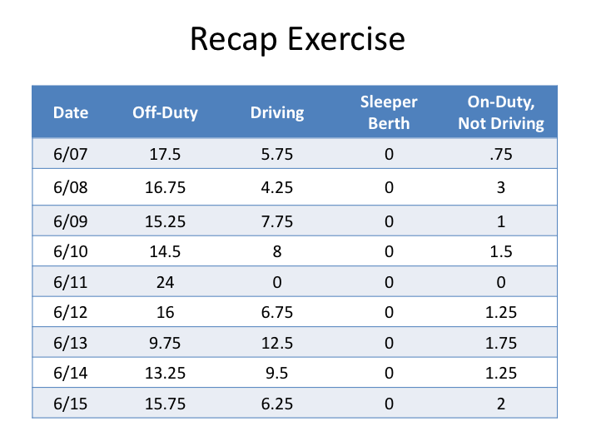

**EXERCISE**

*The busy summer season is in full swing at Brickyard Charters, which operates seven days a week and under the 70/8 hours of service rule. You’ve just completed your post-trip inspection and paperwork for today, June 15th. Your recent log summaries are included on this slide. Using the data provided, answer the following:*

|  |  |
| --- | --- |
| 1. *Total on-duty time for the previous eight days.* | *____________* |
| 1. *Total time available to work tomorrow before you cannot drive the motorcoach.* | *____________* |
| 1. *Were there any violations of the hours of service rules?* | *____________* |

**REGULATORY OVERVIEW & KEY REQUIREMENTS**

**QUIZ**

1. Companies who operate commercial vehicles are bound by the same safety regulations as drivers.
   1. True
   2. False
2. What is the minimum age of an interstate commercial vehicle driver?
   1. 18
   2. 19
   3. 20
   4. 21
   5. 25
3. Violating railroad-crossing requirements is an offense that can disqualify a driver from operating a commercial vehicle.
   1. True
   2. False
4. Employers are required to obtain specific information and conduct specific actions to properly qualify commercial vehicle drivers. Drivers who fail to provide required information or necessary consent to obtain information may not be able to qualify as a commercial vehicle driver.
   1. True
   2. False
5. There are four medically disqualifying conditions that prevent a commercial vehicle driver from being physically qualified. Which of the following is NOT one of these four medical conditions?
   1. Hearing loss beyond specified thresholds
   2. A diagnosis of epilepsy
   3. Vision loss beyond specified thresholds
   4. Hepatitis B
   5. A diabetic condition requiring the use of insulin
6. Which of the following situations may result in a “positive” controlled substance test result?
   1. Not reporting to the clinic immediately after being told to do so
   2. Coming back to the clinic later the same day after determining you couldn't provide a sufficient urine sample when you first got there
   3. Not providing an accurate phone number where you can be reached when providing sample
   4. All of the above
   5. None of the above
7. Regulations do not require commercial vehicle drivers to notify their employers when they are convicted for a moving violation in a personal vehicle.
   1. True
   2. False
8. Drivers who operate which of the following commercial vehicles in interstate transportation must comply with the hours of service rules:
   1. GVWR or actually weighs > 10,000 lbs.
   2. 9 or more passengers, for direct compensation
   3. 16 or more passengers, not for direct compensation
   4. Transporting hazardous materials requiring placards
   5. All of the above
9. *Hours of Service Limits*: A driver is allowed ________ hours of actual driving time before a required rest period.
   1. 8
   2. 9
   3. 10
   4. 11
   5. 12
10. *Hours of Service Limits*: A driver is not permitted to drive a commercial motor vehicle after being on-duty _________ hours.
    1. 8
    2. 10
    3. 11
    4. 13
    5. 15
11. *Hours of Service Limits*: An _________ hour consecutive off-duty period restarts both the 10-hour driving limit and the 15-hour cumulative on-duty limit.
    1. 6
    2. 7
    3. 8
    4. 10
    5. 12
12. *Hours of Service Classification*: There is no difference in the classification of driving time and on-duty time?
    1. True
    2. False
13. *Duty Status Classification*: Which of the following is classified as on-duty time?
    1. All time inspecting or servicing a commercial vehicle, including fueling and washing
    2. All time loading, unloading, supervising, or attending your motorcoach/bus, or handling paperwork for trips
    3. All time driving or at the controls of a commercial vehicle
    4. All time spent doing any work for a motor carrier
    5. All of the above
14. *Travel Time Exception*: You may claim the “Travel Time” exception as long as you are not driving a commercial vehicle when “positioning”.
    1. True
    2. False
15. When unexpected adverse driving conditions affect a trip, a driver may drive up to __________ extra hour(s) to complete what could have been driven in normal conditions. This exception extends the driving limit up to a maximum _______ hours.
    1. 1, 11
    2. 2, 12
    3. 3, 13
    4. 4, 14
    5. 5, 15
16. The Recap form lets you determine how many hours you can be on-duty tomorrow before you exceed the 60/70 hour limit.
    1. True
    2. False
17. Driver logs only need to be completed on the days that you are working.
    1. True
    2. False
18. Driver logs must be kept current to….
    1. the start of the day
    2. the nearest hour
    3. the last change of duty status
    4. the nearest location
    5. the start of on-duty status
19. Indicate the duty status for the following situation: Working at your other non-driving job:
    1. On-duty
    2. On-duty, not driving
    3. Sleeper Berth
    4. Off-duty
20. Which of the following sections is NOT included on a driver log.
    1. Date
    2. Total miles driving today
    3. Name of motor carrier
    4. Your signature
    5. Passenger count